Supporting Information
Ultrafast Polymerase Chain Reaction on MEMS Microheater
Hongjun Liu^{1,†}, Yu Liu^{1,2,†}, Rongyue Liu¹, Rifei Chen^{1,}, Weihao Li¹, Zijun Chen¹, Ji Tae Kim², Zhongren Chen³, and Xing Cheng^{1,*}
¹ Department of Materials Science and Engineering, Southern University of Science and Technology, Shenzhen, China.
² Department of Mechanical Engineering, University of Hong Kong, Hong Kong, China
³ Department of Chemistry, Southern University of Science and Technology, Shenzhen, China.
∗ Corresponding author.
^{1, *}Email: chengx@sustech.edu.cn
†H.L. and Y.L. contributed equally to this work.

Sample names | HBV-A | HBV-B | HBV-C
HBV copies | 7.5 | 0.75 | 0.075
Table S1. Estimated number of HBV DNA copies in a 3 nL PCR droplet for different standard samples.

To reveal the mechanism during thermal cycling of the liquid on MEMS heater, COMSOL Multiphysics V5.6 was used for the simulation. To simplify the calculation, symmetric structure was used. The 3D component was built by rotating the 2D map around the Z axis, as shown in Figure S3. In the physics setup, Heat Transfer in Solids and Fluids, Laminar flow and Multiphysics of non-isothermal flow were added in the model. To mimic the structure of two immiscible phase, the interface between liquid 1 and liquid 2 was set as a solid layer. The angle between the water and heater is set to 40 °. To study the dynamic behavior of the droplet, on the heater component, the heating power varied from 0.0022 W to 0.045 W with 0.5 Hz frequency and 50% duty cycle. In the Laminar flow setup, incompressible flow was selected with considering the gravity. The wall condition was set as slip.
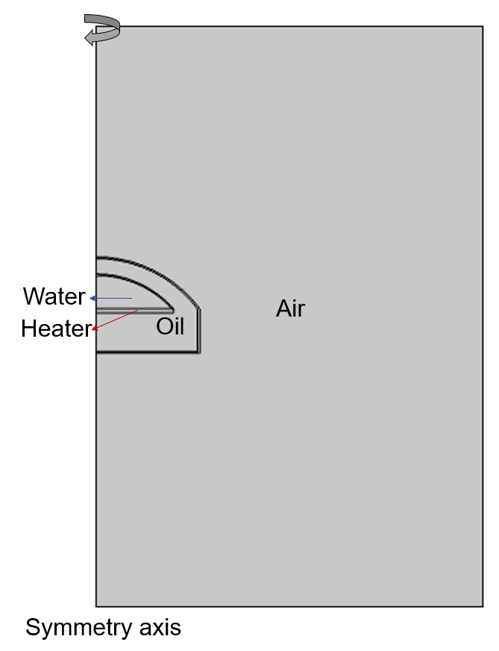
Figure S1. COMSOL Multiphysics simulation model.
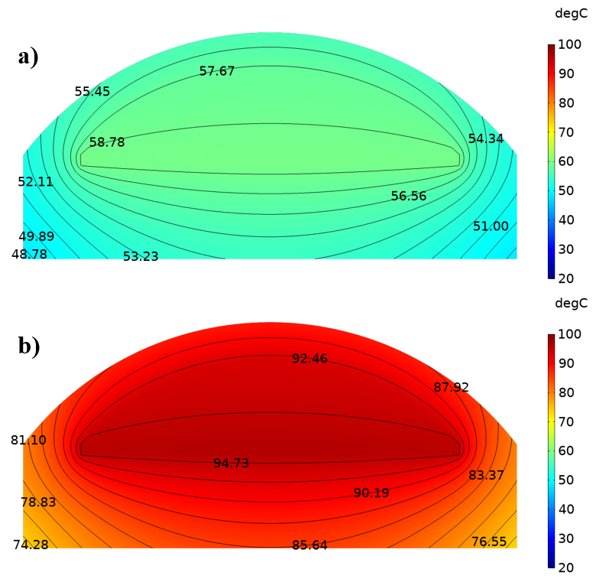
Figure S2. COMSOL simulation of the temperature distribution in the droplet at a) 58 °C and b) 95 °C.
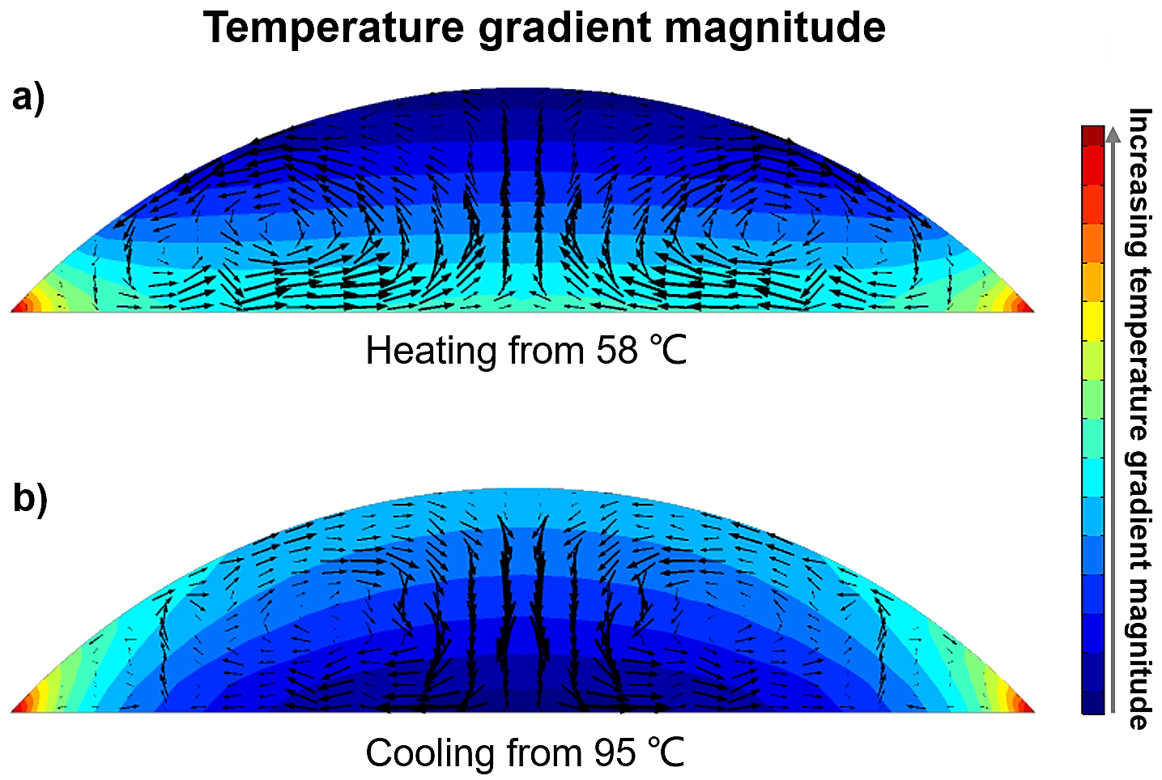
Figure S3. COMSOL simulation of the temperature gradient magnitude in the droplet at a) heating from 58 °C and b) cooling from 95 °C.
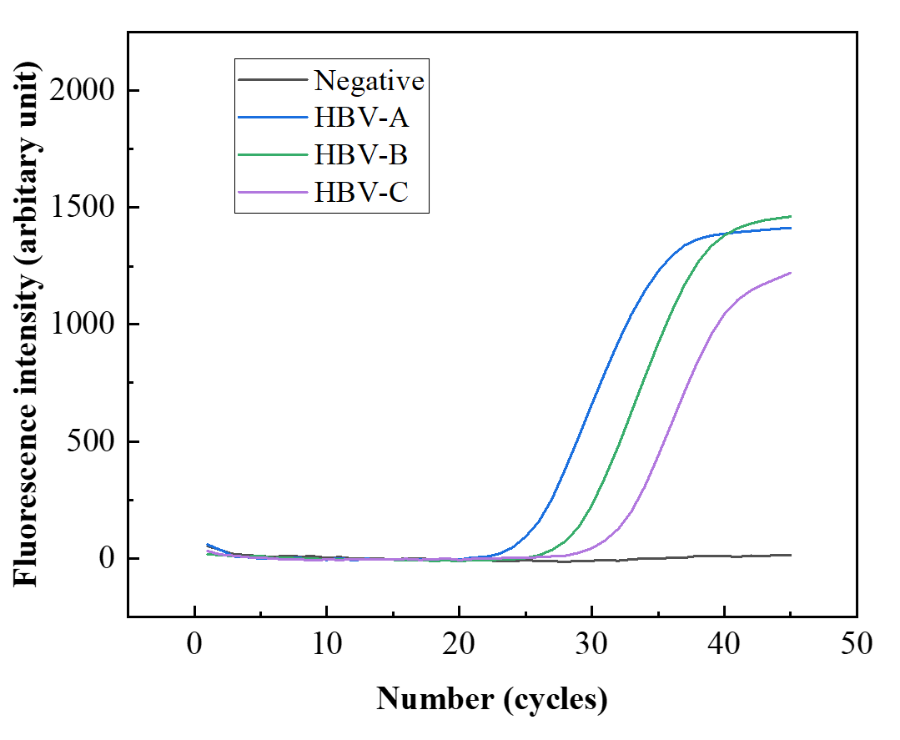
Figure S4. Fluorescence intensity versus cycles of HBV samples with different template concentration by commercial PCR equipment.

