Supplementary figure S1. Principal component analysis for QC samples of amino acid profiling. (A) Score scatter plot of QC samples with t1 and t2. (B) Score control chart of QC samples with t1 (upper panel) and t2 (lower panel).
A
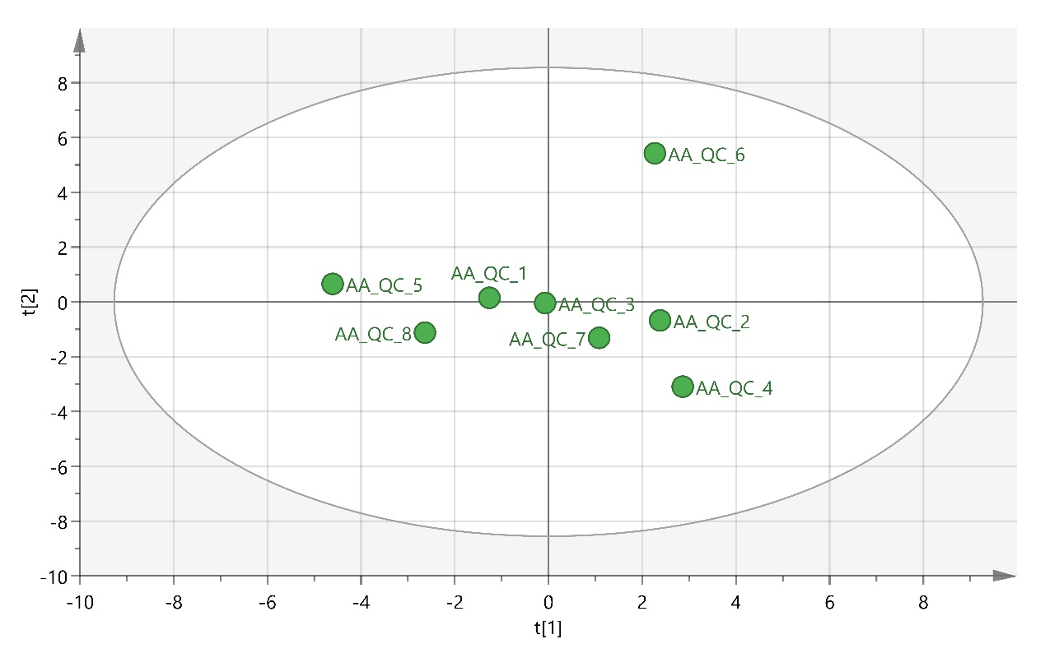

B

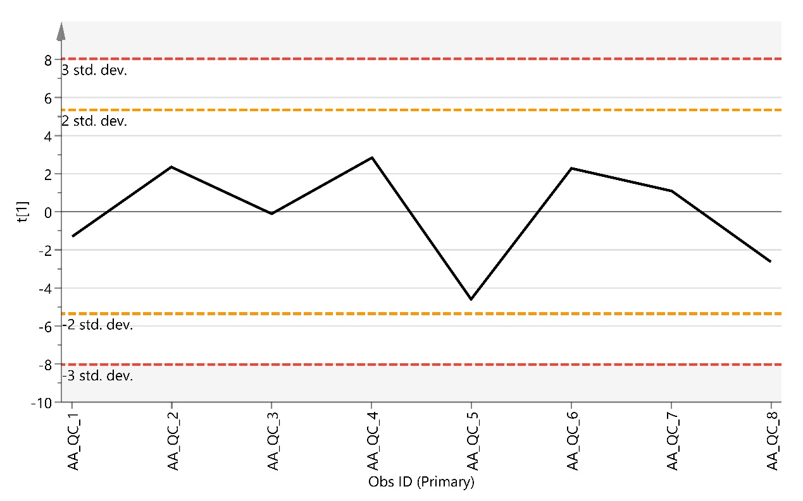

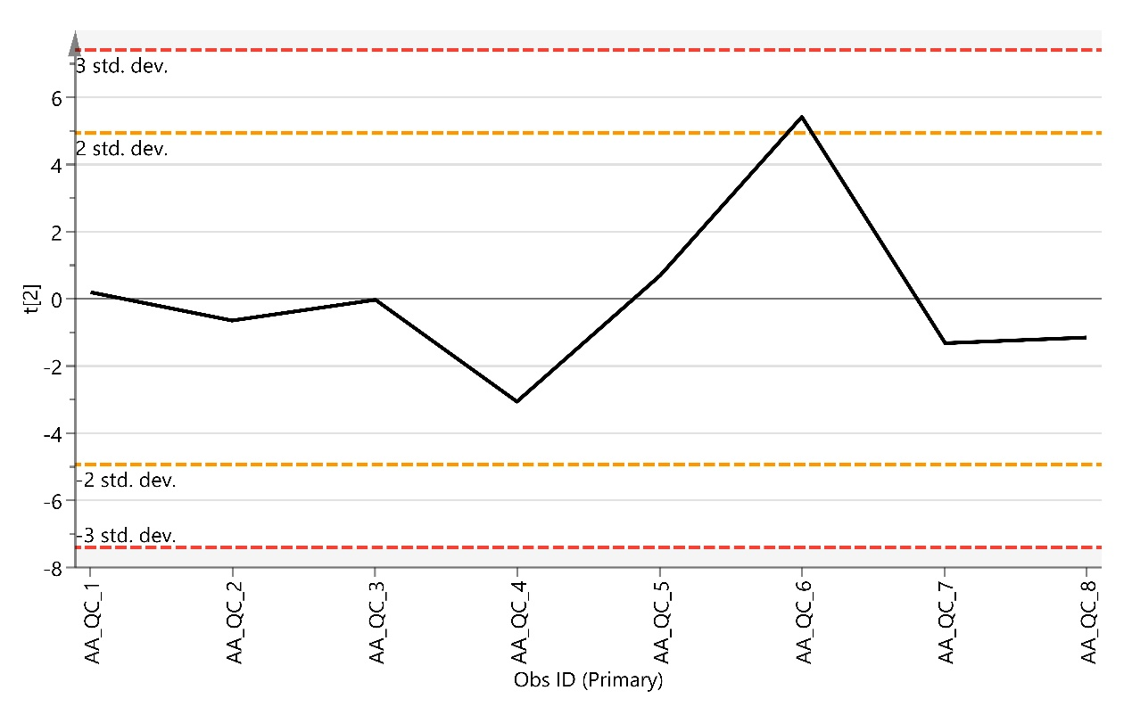

Supplementary figure S2. Principal component analysis for QC samples of bile acid profiling. (A) Score scatter plot of QC samples with t1 and t2. (B) Score control chart of QC samples with t1 (upper panel) and t2 (lower panel).

A
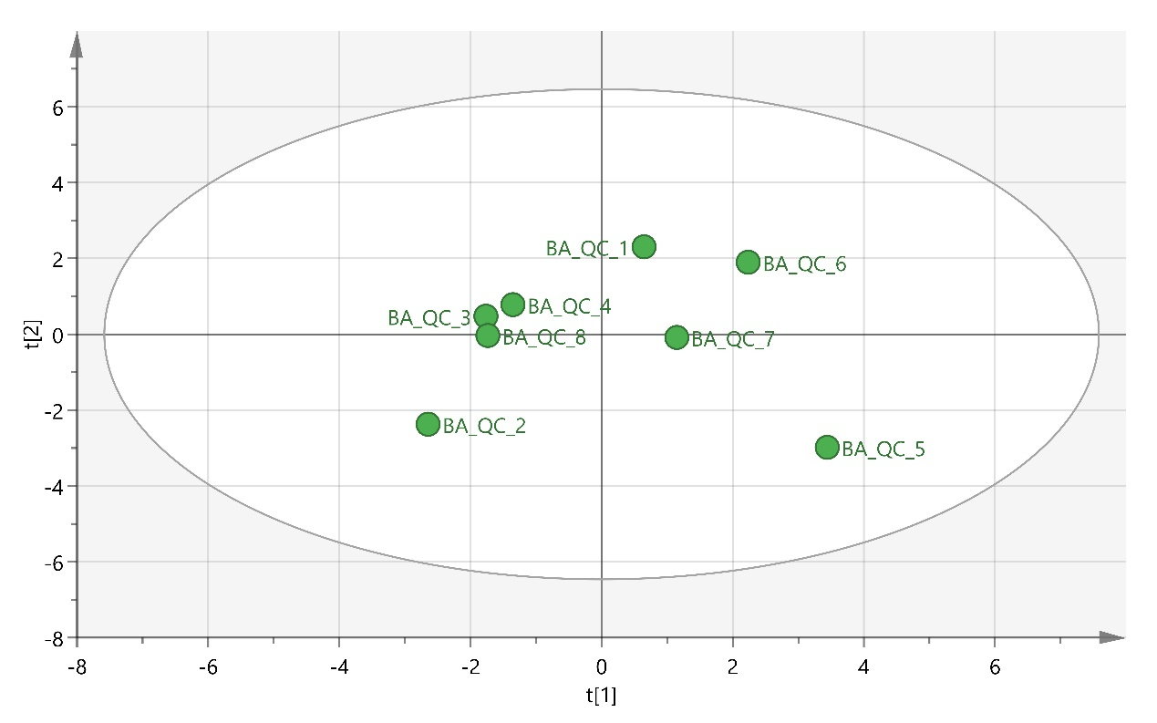
B
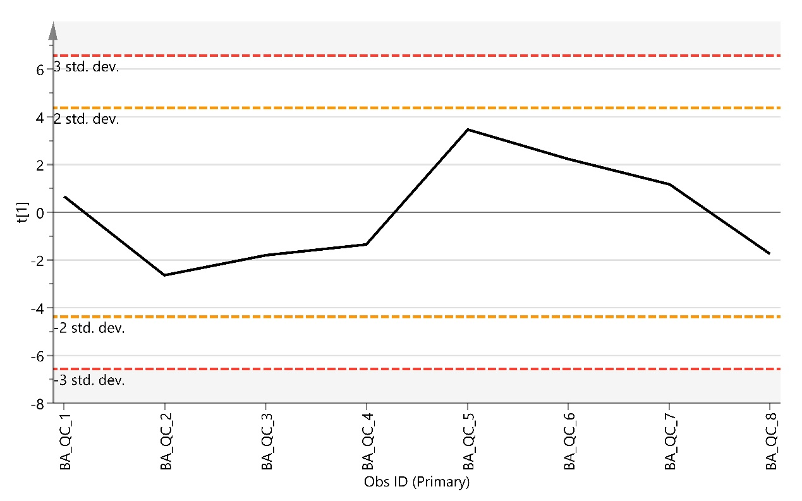

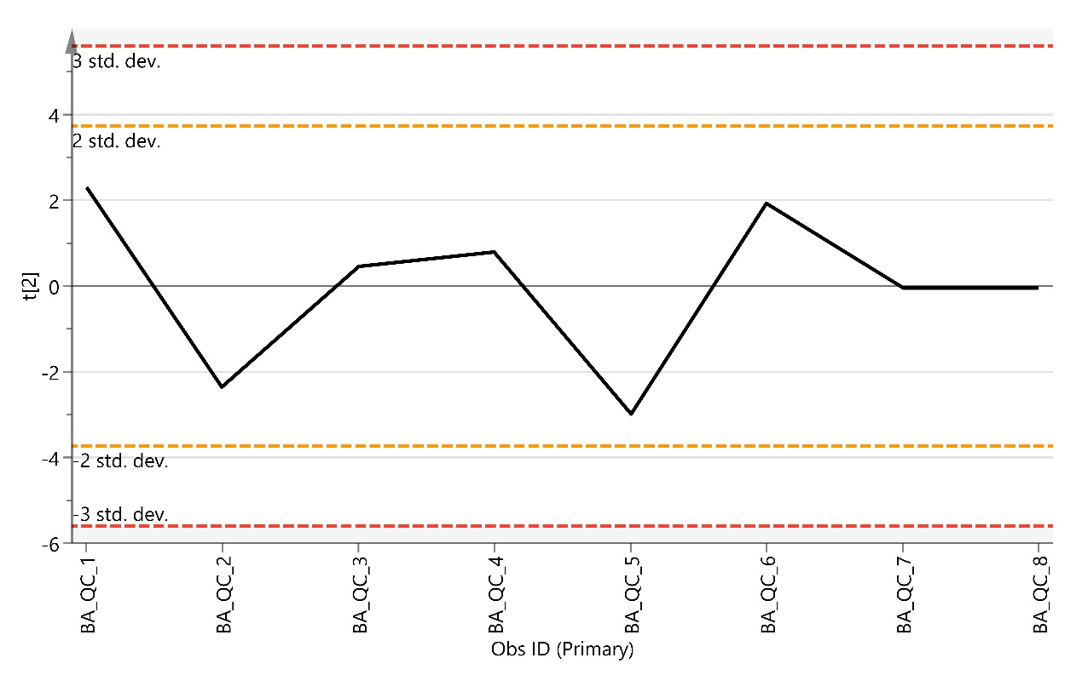

Supplementary figure S3. Principal component analysis for QC samples of free fatty acid profiling. (A) Score scatter plot of QC samples with t1 and t2. (B) Score control chart of QC samples with t1 (upper panel) and t2 (lower panel).
A
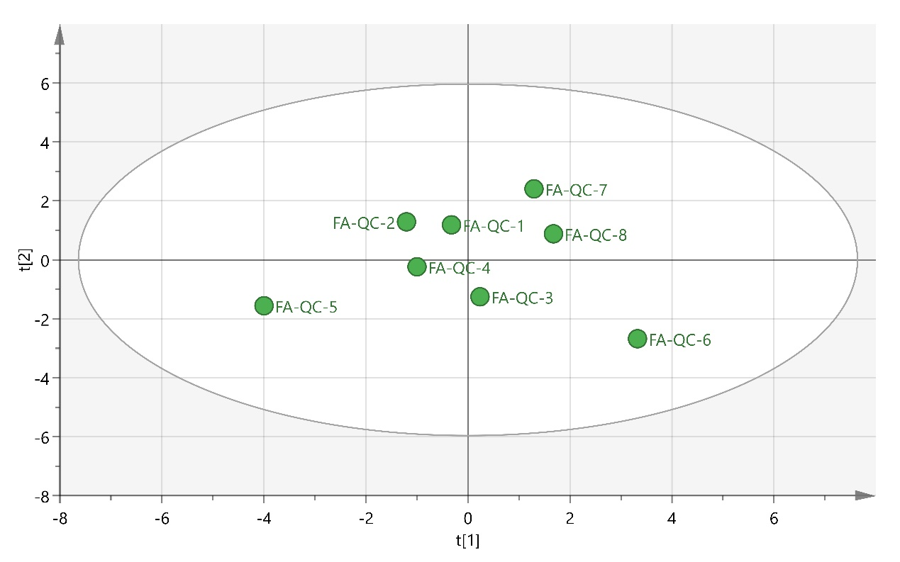
B
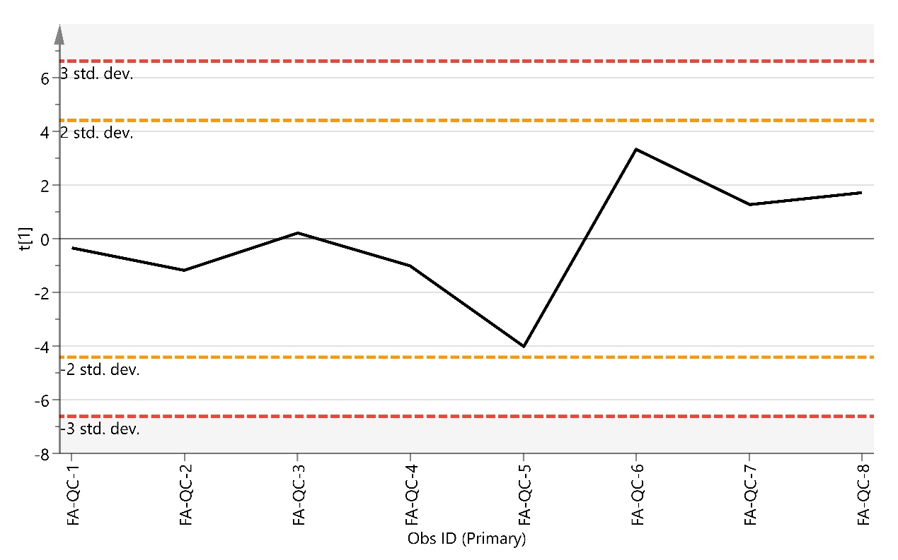

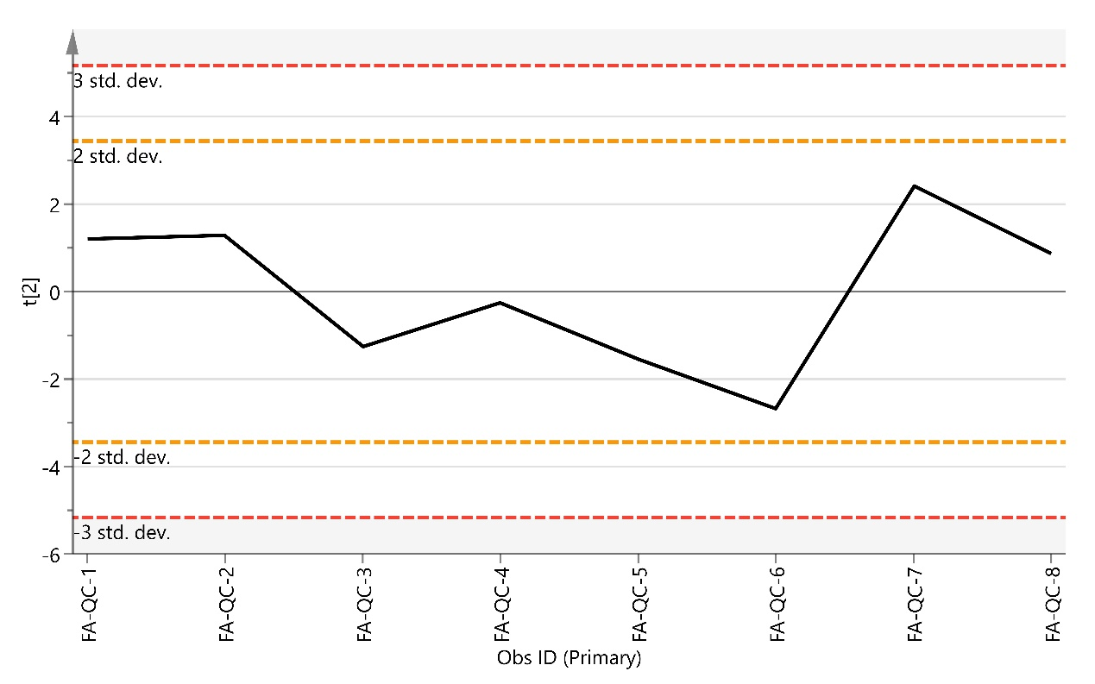

Supplementary figure S4. Principal component analysis for QC samples of lipid profiling. (A) Score scatter plot of QC samples with t1 and t2. (B) Score control chart of QC samples with t1 (upper panel) and t2 (lower panel).
A
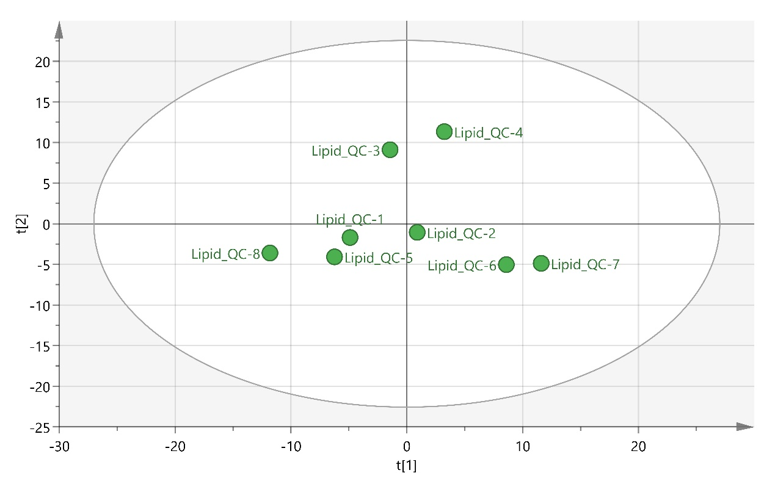

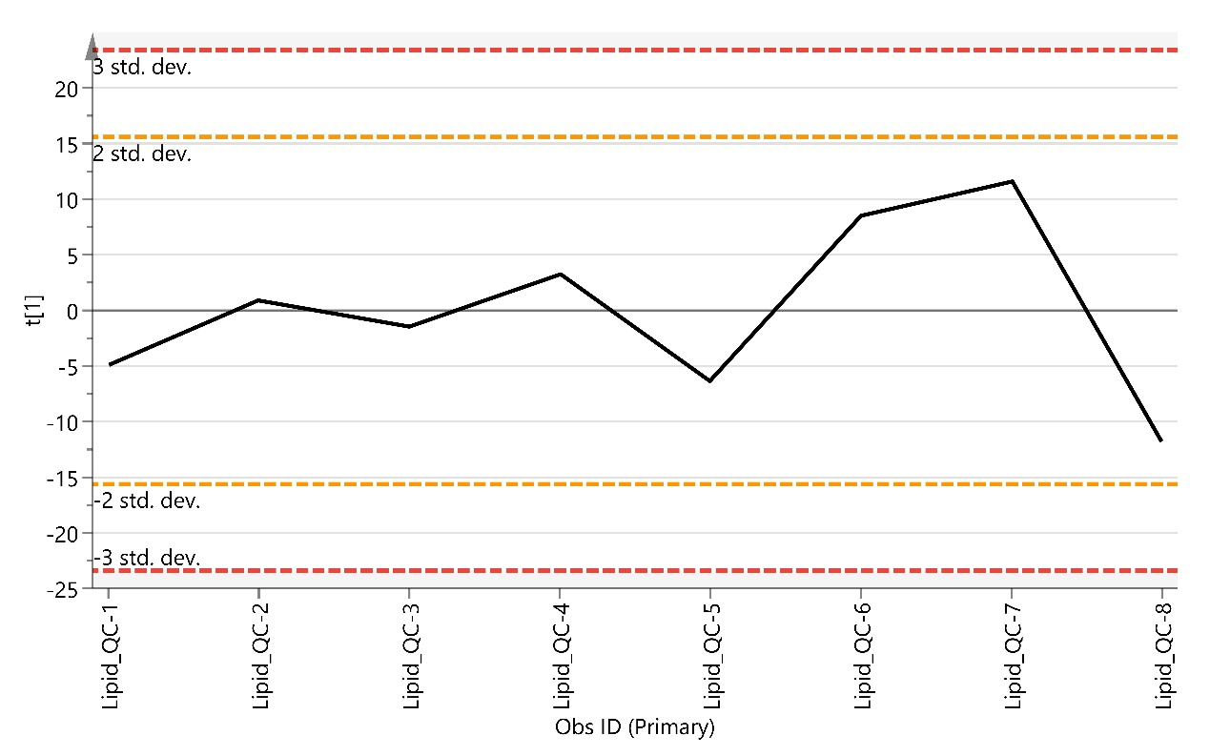

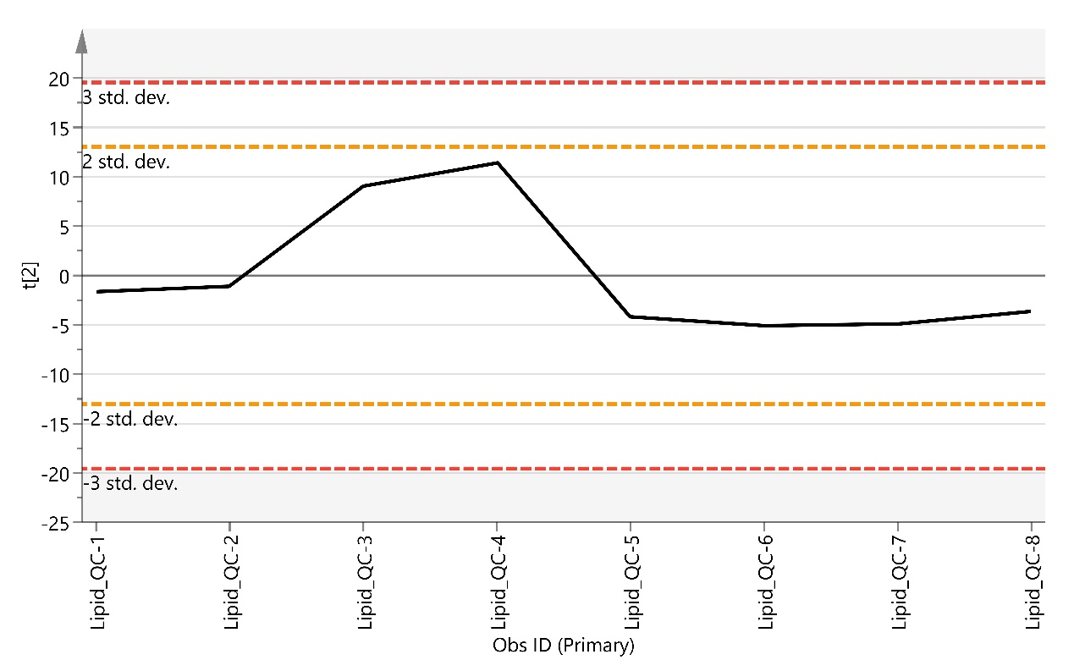

Table S1. The 197 metabolites were identified in all participants
Amino acids | Bile acids | Free fatty acids | Lipid
L-Hydroxyproline | Tauroursodeoxycholic acid | FA 14:0 | Cer (d18:1/18:0) | PC (16:0/18:2) | PC (21:0/22:5)
L-Asparagine | Glycoursodeoxycholic acid | FA 14:1 | Cer (d18:1/22:1) | PC (16:1/18:2) | PE (16:0/18:1)
Glutamine | Taurocholic acid | FA 15:0 | Cer (d18:2/24:1) | PC (16:1/18:3) | PE (16:1/18:1)
L-Serine | Glycocholic acid | FA 16:0 | Cer (d18:1/25:0) | PC (18:3/16:2) | PE (18:0/18:1)
Glycine | Ursodeoxycholic acid | FA 16:0-d3 | LPC 14:0 | PC (17:0/18:1) | PE (18:1/18:1)
L-Aspartic acid | Cholic acid | FA 16:1 | LPC 15:0 | PC (17:0/18:2) | PE (16:0/20:3)
L-Sarcosine | Glycochenodeoxycholic acid | FA 16:2 | LPC 16:0 | PC (17:1/18:2) | PE (16:0/20:4)
L-Glutamic acid | Taurodeoxycholic acid | FA 17:0 | LPC 16:1 | PC (15:0/20:4) | PE (18:0/20:3)
β-Alanine | Glycodeoxycholic acid | FA 17:1 | LPC 17:0 | PC (18:0/18:0) | PE (18:0/20:4)
L-Threonine | Chenodeoxycholic acid | FA 18:0 | LPC 17:1 | PC (18:0/18:1) | PE (16:0/22:5)
L-Alanine | Deoxycholic acid | FA 18:0-d3 | LPC 18:0 | PC (18:0/18:2) | PE (16:0/22:6)
L-Ornithine | Lithocholic acid | FA 18:1 | LPC 18:1 | PC (16:0/20:3) | PE (18:0/22:5)
L-Proline | Tauro-α-muricholic acid | FA 18:2 | LPC 18:2 | PC (16:0/20:4) | SM (d16:0/15:1)
L-Tyrosine | Tauro-β-muricholic acid | FA 18:3 | LPC 18:3 | PC (16:1/20:4) | SM (d16:0/16:1)
L-Methionine | Tauroursodeoxycholic acid | FA 19:1 | LPC 20:0 | PC (16:1/20:5) | SM (d16:1/16:1)
L-Valine | Hyodeoxycholic acid | FA 20:1 | LPC 20:1 | PC (16:2/20:5) | SM (d16:0/17:1)
L-Lysine | Taurolithocholic acid | FA 20:2 | LPC 20:2 | PC (18:2/19:0) | SM (d16:0/18:0)
Leucine |  | FA 20:3 | LPC 20:3 | PC (18:2/19:1) | SM (d16:0/18:1)
L-Isoleucine |  | FA 20:4 | LPC 20:4 | PC (17:0/20:4) | SM (d16:0/18:2)
L-Phenylalanine |  | FA 20:5 | LPC 20:5 | PC (15:0/22:6) | SM (d16:0/19:0)
L-Tryptophan |  | FA 22:4 | LPC 22:4 | PC (16:0/22:1) | SM (d16:0/19:1)
L-Histidine |  | FA 22:5 | LPC 22:5 | PC (18:2/20:0) | SM (d18:1/17:1)
L-Arginine |  | FA 22:6 | LPC 22:6 | PC (18:2/20:1) | SM (d16:0/20:1)
Taurine |  | FA 24:1 | LPC 24:0 | PC (16:0/22:4) | SM (d16:0/20:2)
L-Citrulline |  | FA 26:0 | LPE 16:0 | PC (18:0/20:5) | SM (d16:0/20:3)
Ethanolamine |  |  | LPE 18:0 | PC (18:2/20:4) | SM (d18:1/19:0)
L-α-Aminoadipic acid |  |  | LPE 18:1 | PC (18:2/20:5) | SM (d18:1/19:1)
δ-DL-Hydroxylysine |  |  | LPE 18:2 | PC (16:2/22:6) | SM (d16:0/22:1)
 |  |  | LPE 20:4 | PC(19:0/20:4) | SM (d16:0/22:2)
 |  |  | LPE 22:6 | PC (19:1/20:4) | SM (d16:0/22:3)
 |  |  | PC (12:0/16:0) | PC(17:0/22:6) | SM (d18:0/21:0)
 |  |  | PC (14:0/15:1) | PC (18:0/22:4) | SM (d20:0/19:1)
 |  |  | PC (14:0/16:0) | PC (18:2/22:3) | SM (d18:1/22:0)
 |  |  | PC (14:0/16:1) | PC (18:0/22:6) | SM (d16:1/24:1)
 |  |  | PC (15:0/16:0) | PC (18:1/22:6) | SM (d18:1/22:2)
 |  |  | PC (16:0/16:0) | PC (18:2/22:6) | SM (d18:1/23:0)
 |  |  | PC (16:0/16:1) | PC (19:0/22:6) | SM (d16:0/26:1)
 |  |  | PC (16:1/16:1) | PC (20:4/22:6) | SM (d18:1/24:1)
 |  |  | PC (16:1/16:2) | PC (20:1/22:4) | SM (d20:1/22:3)
 |  |  | PC (16:0/17:1) | PC (20:1/22:6) | SM (d20:1/22:4)
 |  |  | PC (15:0/18:2) | PC (20:2/22:6) | SM (d18:1/25:0)
 |  |  | PC (16:0/18:0) | PC (20:3/22:6) | SM (d18:2/25:0)
 |  |  | PC (16:0/18:1)
FA: free fatty acid; Cer: ceramide; LPC: lysophosphatidylcholine; LPE: lysophosphatidylethanolamine; PC: phosphatidylcholine; PE: phosphatidylethanolamine; SM: sphingomyelin.

