Supporting information

Peltogynoids contributing to discoloration in Peltogyne mexicana heartwood

Yusuke Taga¹・ Kosei Yamauchi^{1,2,3}・Tohru Mitsunaga^{1,2,3}

Authors and Affiliations
¹ The United Graduate School of Agricultural Science, Gifu University, 1-1 Yanagido, Gi-fu-shi, Gifu, 501-1193, Japan
² Graduate School of Natural Science and Technology, Gifu University, 1-1 Yanagido, Gifu-shi, Gifu, 501-1193, Japan
³ Faculty of Applied Biological Sciences, Gifu University, 1-1 Yanagido, Gifu-shi, Gifu, 501-1193, Japan

Corresponding authors
Kosei Yamauchi, Tohru Mitsunaga.
Kosei Yamauchi : yamauchi.kosei.p2@f.gifu-u.ac.jp
Tohru Mitsunaga: mitsunaga.tohru.u6@f.gifu-u.ac.jp

Index

Fig.S1-1 – 7. Fractionation scheme ・・・・・・・・・・・・・・・・・・・・・・・・・・・・・・・・・・P.2

Fig.S2-1 – 7. COSY and HMBC correlation of new isolated compounds・・・・・・・・・・・・・・・・・・・・P.2

Fig.S3-1 – 7. Structure analysis data of 3 ・・・・・・・・・・・・・・・・・・・・・・・・・・・・・・・P.3-6

Fig.S4-1 – 7. Structure analysis data of 5・・・・・・・・・・・・・・・・・・・・・・・・・・・・・・・P.7-10

Fig.S5-1 – 7. Structure analysis data of 6 ・・・・・・・・・・・・・・・・・・・・・・・・・・・・・・P.10-14

Fig.S6-1 – 7. Structure analysis data of 7 ・・・・・・・・・・・・・・・・・・・・・・・・・・・・・・P.15-18

Fig.S7-1 – 7. Structure analysis data of 9 ・・・・・・・・・・・・・・・・・・・・・・・・・・・・・・P.19-21

Fig.S8-1 – 6. Structure analysis data of 10・・・・・・・・・・・・・・・・・・・・・・・・・・・・・・P.22-24

Fig.S9-1 – 6. Structure analysis data of 11・・・・・・・・・・・・・・・・・・・・・・・・・・・・・・P.25-27

Table S1. CIE LAB value of methanol extract and each soluble part ・・・・・・・・・・・・・・・・・・・・・P.28

Table S2. CIE LAB value of isolated compounds ・・・・・・・・・・・・・・・・・・・・・・・・・・・・P.29

Fractionation scheme
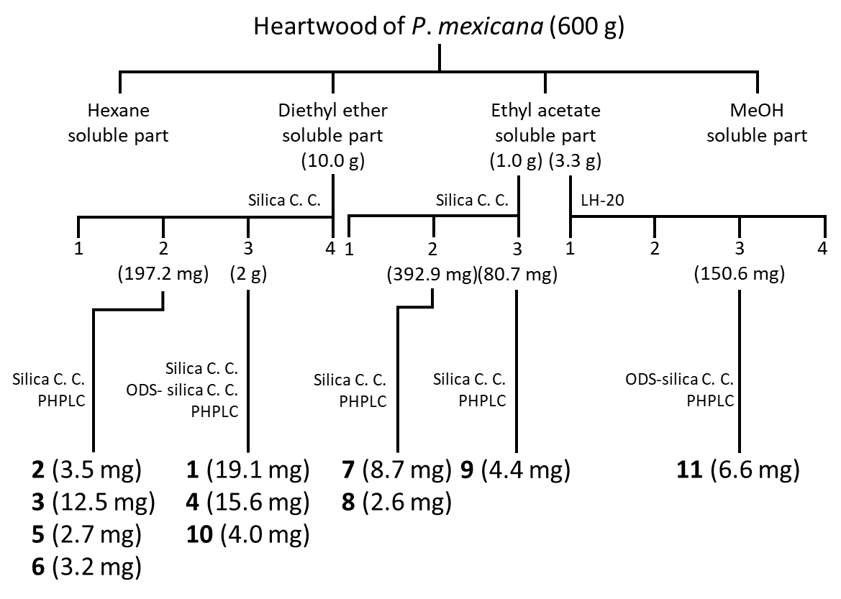
Fig.S1 Fractionation scheme

COSY and HMBC correlation of new isolated compounds
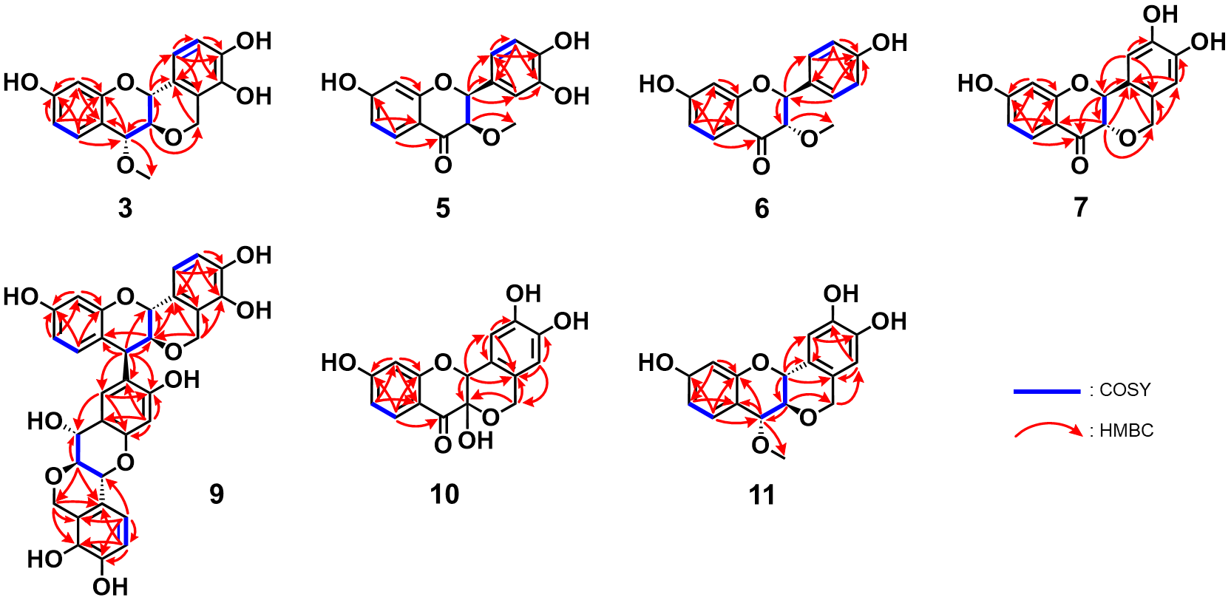
Fig.S2 COSY and HMBC correlation of new isolated compounds

Structure analysis data of 3
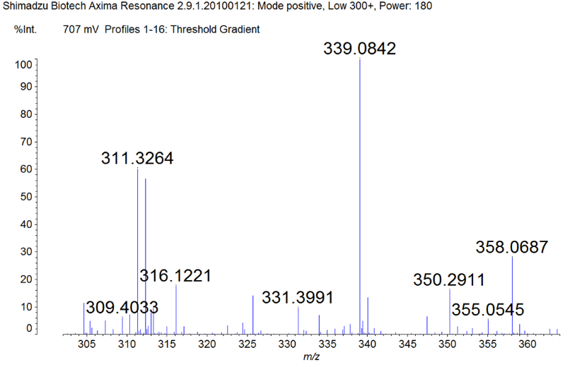
Fig.S3-1 MALDI-TOF MS spectrum of 3

Fig.S3-2 ¹H-NMR spectrum of 3

Fig.S3-3 ¹³C-NMR spectrum of 3

Fig.S3-4 HMQC spectrum of 3

Fig.S3-5 COSY spectrum of 3

Fig.S3-6 HMBC spectrum of 3

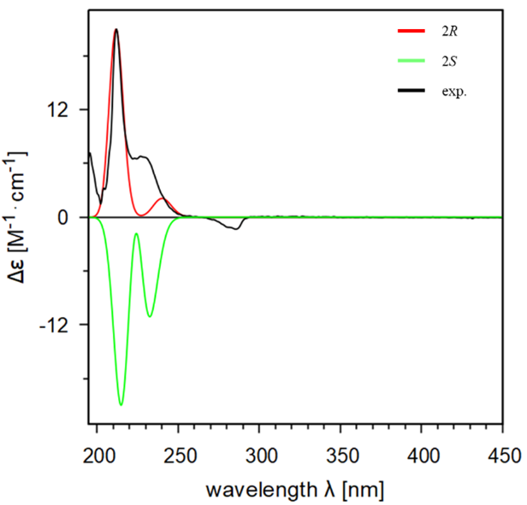
Fig.S3-7 ECD spectrum of 3

Structure analysis data of 5
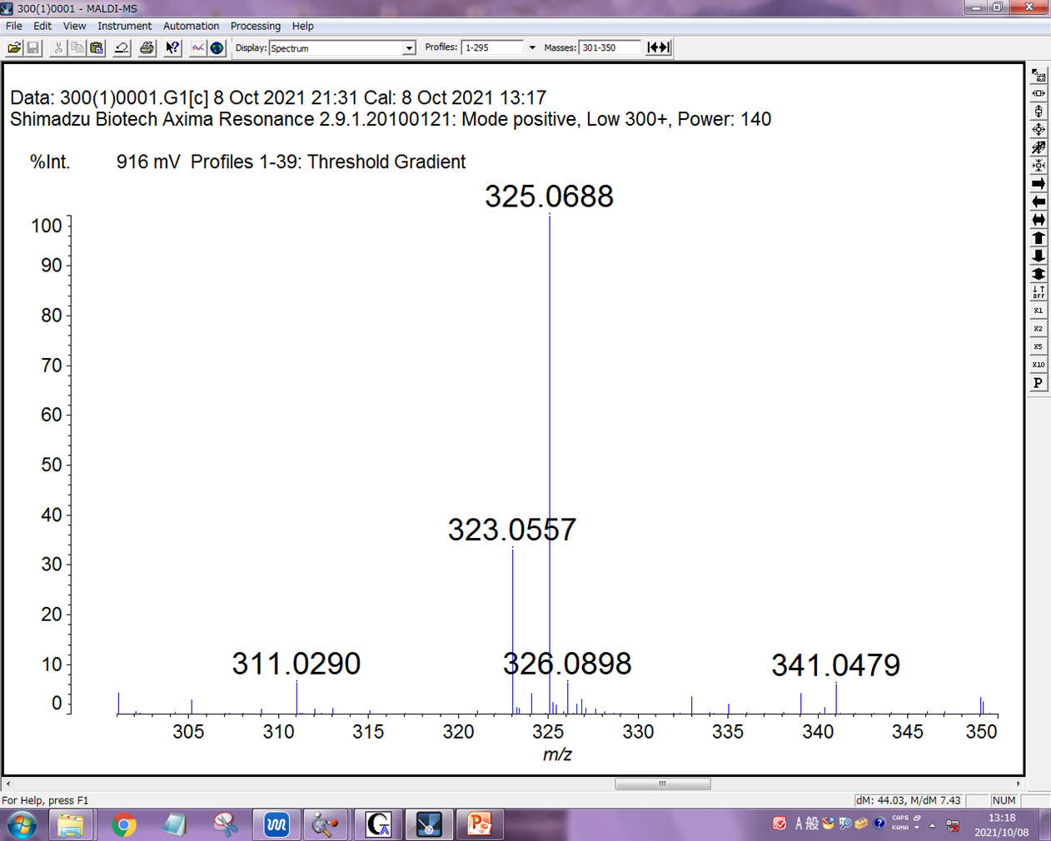
Fig.S4-1 MALDI-TOF MS spectrum of 5

Fig.S4-2 ¹H-NMR spectrum of 5

Fig.S4-3 ¹³C-NMR spectrum of 5

Fig.S4-4 HMQC spectrum of 5

Fig.S4-5 COSY spectrum of 5

Fig.S4-6 HMBC spectrum of 5

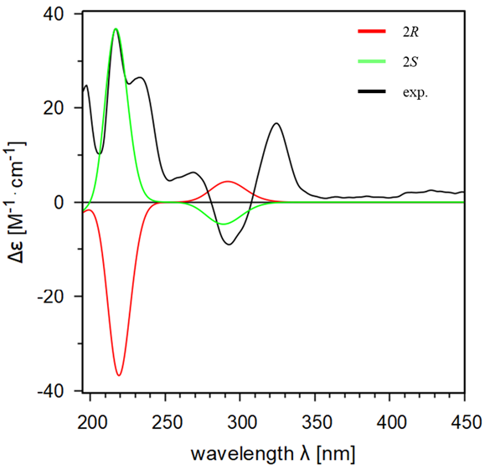
Fig.S4-7 ECD spectrum of 5

Structure analysis data of 6
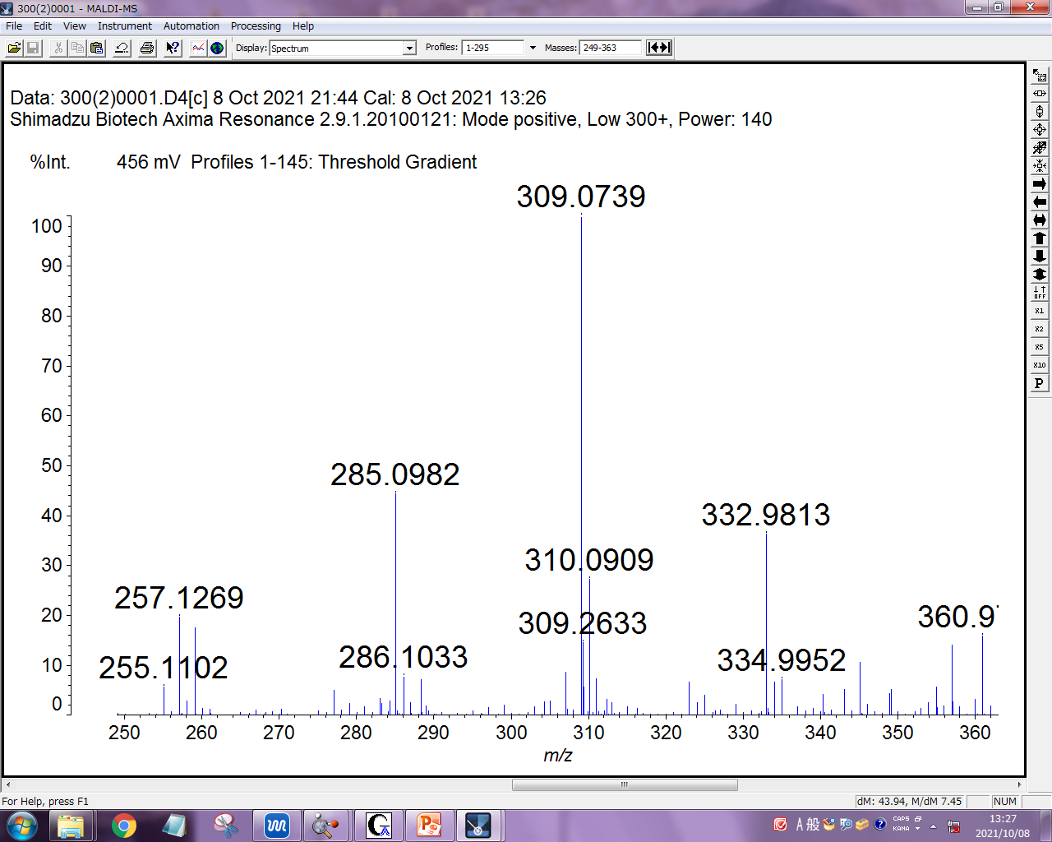
Fig.S5-1 MALDI-TOF MS spectrum of 6

Fig.S5-2 ¹H-NMR spectrum of 6

Fig.S5-3 ¹³C-NMR spectrum of 6

Fig.S5-4 HMQC spectrum of 6

Fig.S5-5 COSY spectrum of 6

Fig.S5-6 HMBC spectrum of 6

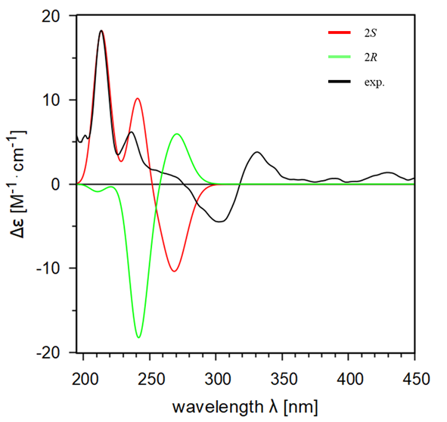
Fig.S5-7 ECD spectrum of 6

Structure analysis data of 7
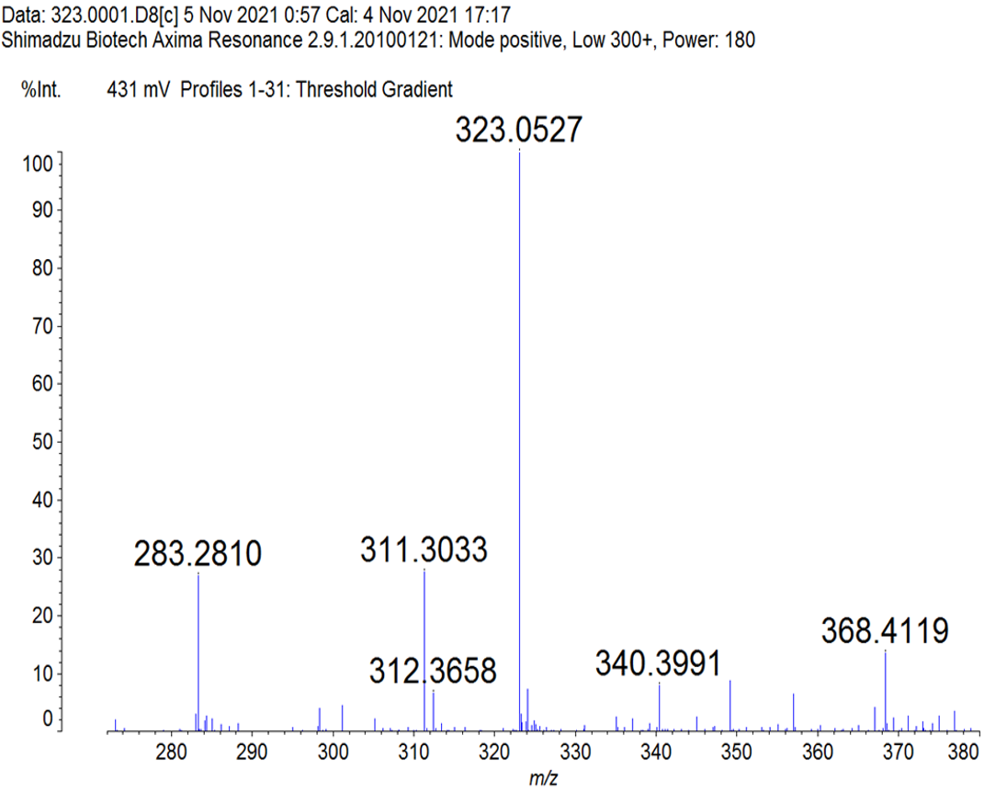
Fig.S6-1 MALDI-TOF MS spectrum of 7

Fig.S6-2 ¹H-NMR spectrum of 7

Fig.S6-3 ¹³C-NMR spectrum of 7
Fig.S6-4 HMQC spectrum of 7

Fig.S6-5 COSY spectrum of 7

Fig.S6-6 HMBC spectrum of 7

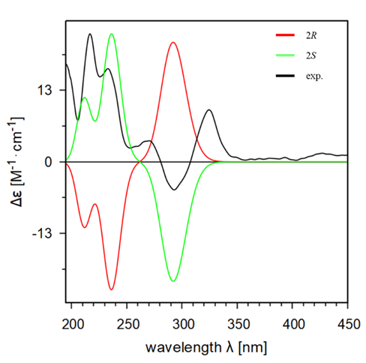
Fig.S6-7 ECD spectrum of 7

Structure analysis data of 9
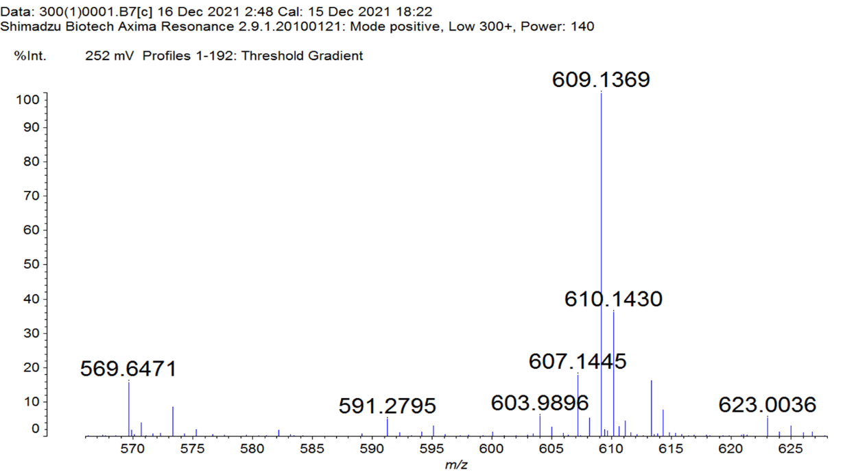
Fig.S7-1 MALDI-TOF MS spectrum of 9

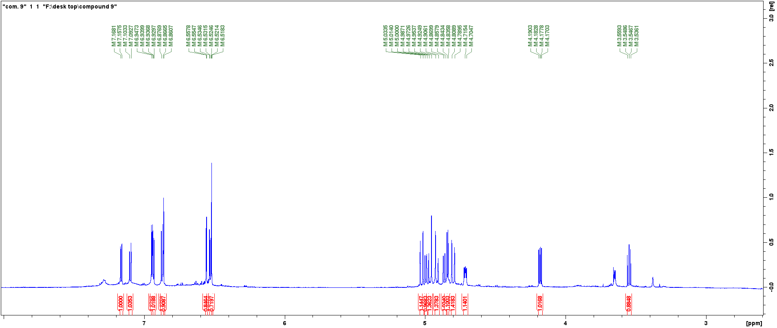
Fig.S7-2 ¹H-NMR spectrum of 9

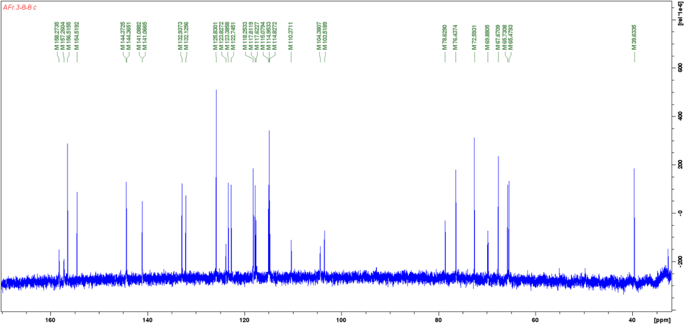
Fig.S7-3 ¹³C-NMR spectrum of 9

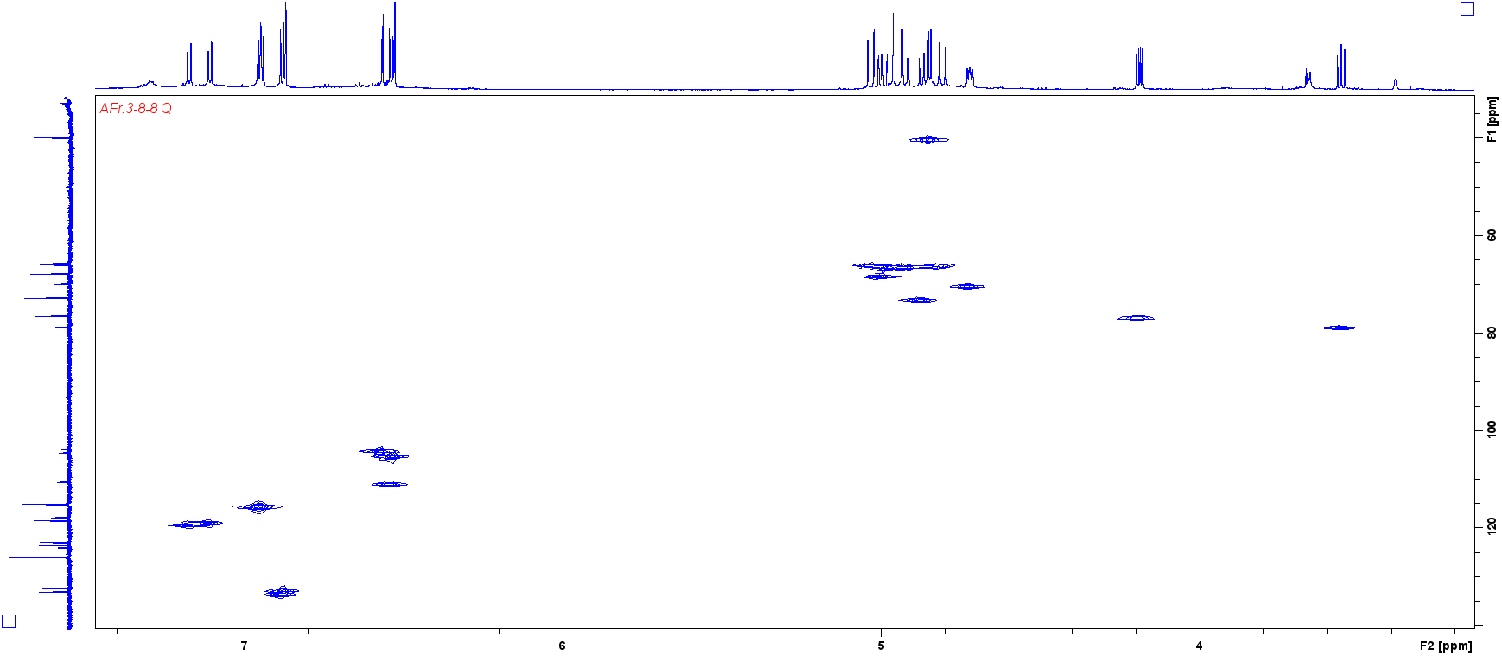
Fig.S7-4 HMQC spectrum of 9
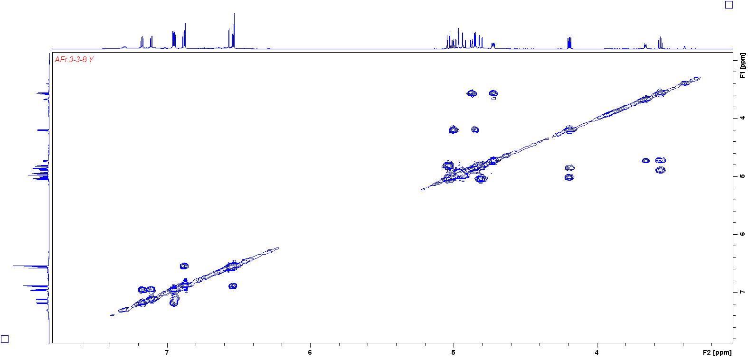
Fig.S7-5 COSY spectrum of 9

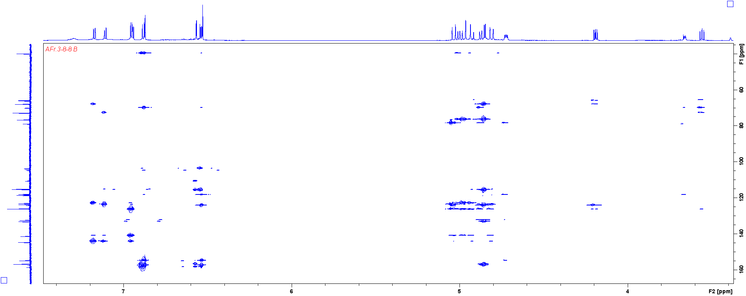
Fig.S7-6 HMBC spectrum of 9

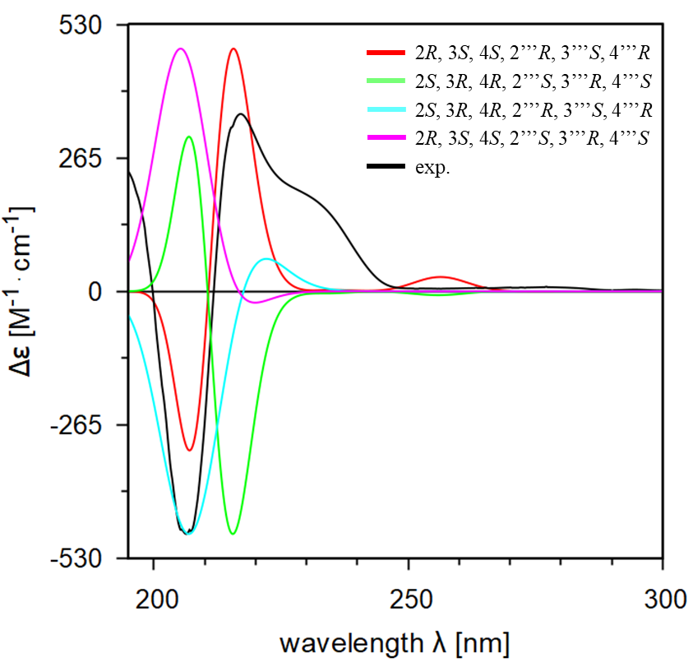
Fig.S7-7 ECD spectrum of 9

Structure analysis data of 10
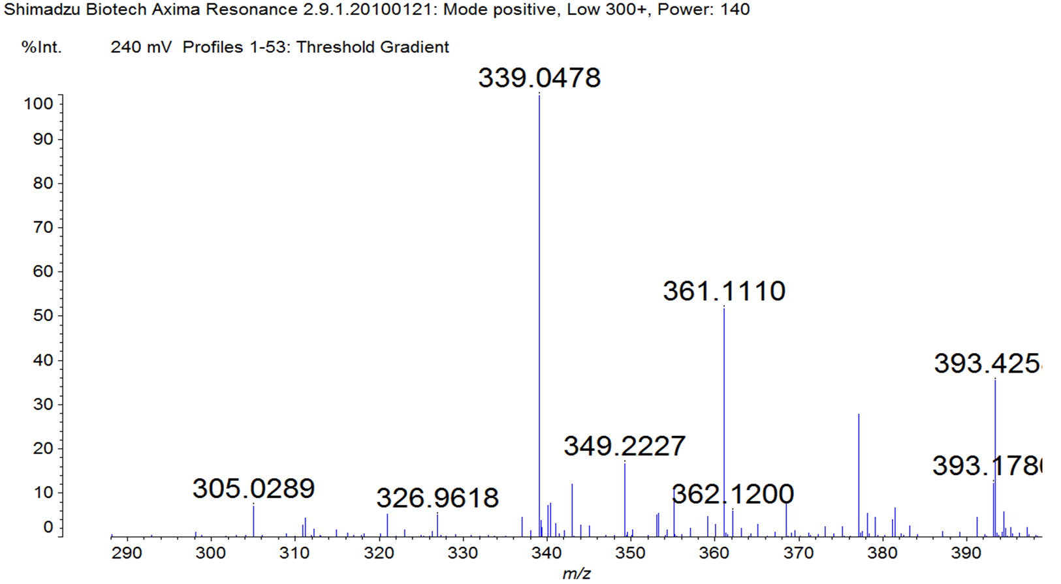
Fig.S8-1 MALDI-TOF MS spectrum of 10

Fig.S8-2 ¹H-NMR spectrum of 10

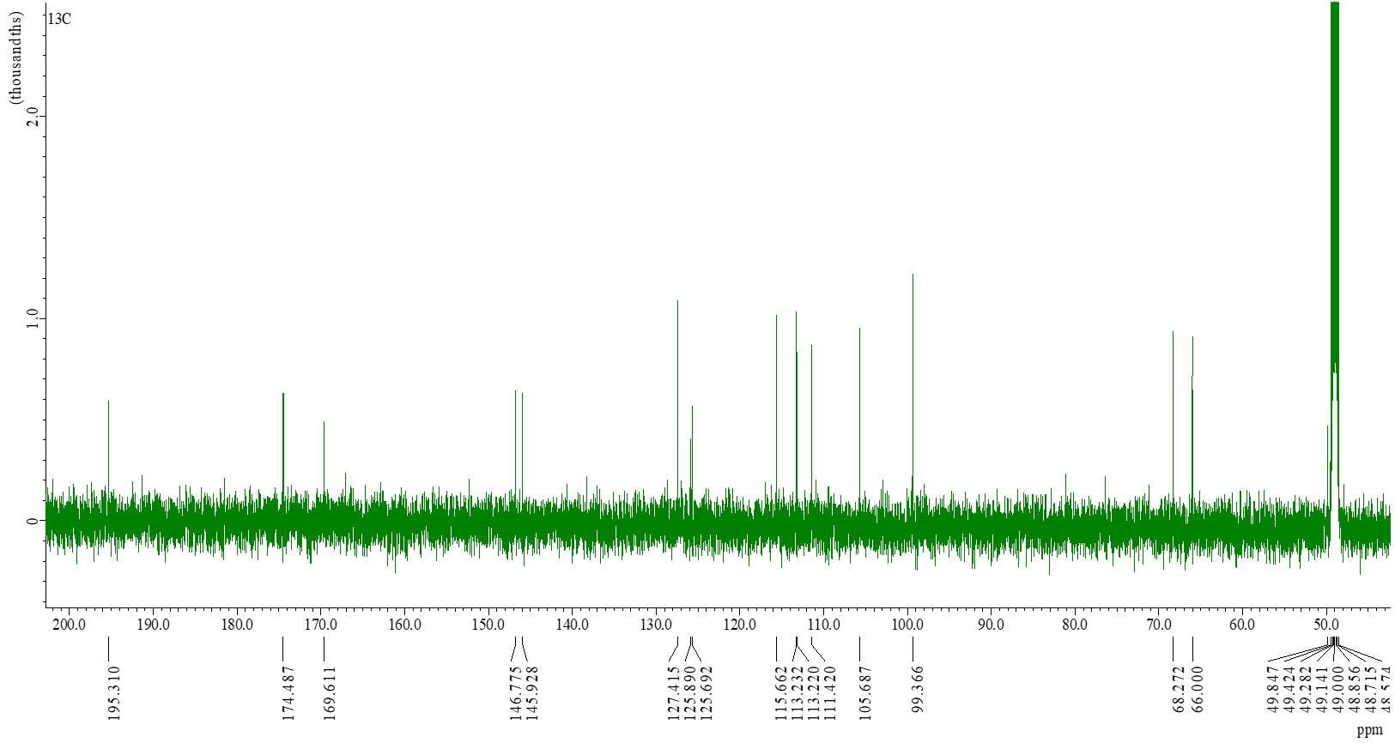
Fig.S8-3 ¹³C-NMR spectrum of 10

Fig.S8-4 HMQC spectrum of 10

Fig.S8-5 COSY spectrum of 10

Fig.S8-6 HMBC spectrum of 10

Structure analysis data of 11
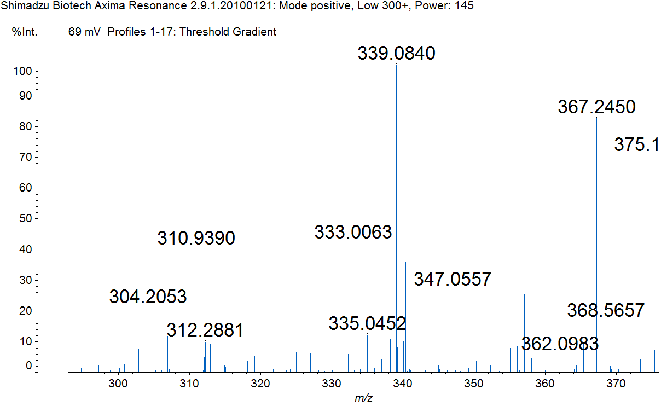
Fig.S9-1 MALDI-TOF MS spectrum of 11

Fig.S9-2 ¹H-NMR spectrum of 11

Fig.S9-3 ¹³C-NMR spectrum of 11

Fig.S9-4 HMQC spectrum of 11

Fig.S9-5 COSY spectrum of 11

Fig.S9-6 HMBC spectrum of 11

CIE LAB value of methanol extract and each soluble parts

Table S1 CIE LAB value of methanol extract and each soluble parts
 | 0h |  |  |  |  | 24h |  |  |  |  | ΔL*_{0h→24h} | Δa*_{0h→24h} | Δb*_{0h→24h} | ΔE_{0h→24h} | Δh*_{0h→24h}
 | L* | a* | b* | h* |  | L* | a* | b* | h*
Methanol ext. | 91.5 | 1.8 | 14.1 | 82.7 |  | 90.7 | 8.3 | -13.8 | -58.9 |  | -0.8 | 6.5 | -27.9 | 28.6 | -141.7
Hexane soluble part | 95.2 | 1.6 | 0.6 | 19.0 |  | 95.3 | 1.8 | 0.6 | 17.8 |  | 0.1 | 0.2 | 0.0 | 0.2 | -1.2
Ether soluble part | 89.1 | 4.9 | 6.3 | 52.1 |  | 93.2 | 7.4 | -8.2 | -47.9 |  | 4.1 | 2.6 | -14.5 | 15.3 | -100.0
Ethyl acetate soluble part | 94.6 | 2.9 | 12.3 | 76.6 |  | 91.7 | 7.3 | -9.0 | -51.2 |  | -2.9 | 4.3 | -21.3 | 21.9 | -127.8
Methanol soluble part | 90.6 | 8.4 | 18.4 | 65.4 |  | 88.8 | 9.9 | 19.4 | 62.8 |  | -1.8 | 1.5 | 0.9 | 2.5 | -2.6

CIE LAB value of isolated compounds

Table S2 CIE LAB value of isolated compounds
Compound | 0h |  |  |  |  | 24h |  |  |  |  | ΔL*_{0h→24h} | Δa*_{0h→24h} | Δb*_{0h→24h} | ΔE_{0h→24h} | Δh*_{0h→24h}
Compound | L* | a* | b* | h* |  | L* | a* | b* | h*
1 | 90.4 | 9.3 | 12.1 | 52.5 |  | 83.1 | 16.5 | -0.7 | -2.4 |  | -7.3 | 7.2 | -12.8 | 16.4 | -54.9
3 | 74.6 | 12.0 | 23.3 | 62.9 |  | 72.9 | 10.3 | 22.0 | 64.8 |  | -1.7 | -1.6 | -1.4 | 2.7 | 2.0
4 | 85.0 | 8.0 | 19.1 | 67.2 |  | 85.4 | 12.1 | -1.8 | -8.6 |  | 0.3 | 4.1 | -20.9 | 21.3 | -75.8
5 | 83.0 | 15.7 | 12.2 | 37.9 |  | 82.3 | 14.9 | 12.5 | 40.0 |  | -0.8 | -0.8 | 0.3 | 1.1 | 2.1
6 | 91.7 | 2.0 | 3.1 | 57.6 |  | 94.9 | 2.3 | 3.7 | 57.8 |  | 3.2 | 0.3 | 0.6 | 3.3 | 0.2
7 | 86.0 | 6.0 | 4.4 | 36.4 |  | 92.1 | 5.1 | 4.5 | 41.6 |  | 6.1 | -1.0 | 0.1 | 6.1 | 5.2
9 | 94.4 | 6.1 | 0.4 | 3.9 |  | 94.3 | 8.1 | 1.4 | 9.5 |  | -0.1 | 2.0 | 0.9 | 2.2 | 5.6
10 | 98.1 | 2.6 | 3.3 | 52.6 |  | 96.3 | 2.7 | 3.5 | 51.9 |  | -1.7 | 0.2 | 0.1 | 1.8 | -0.7
11 | 97.6 | 2.0 | 2.0 | 44.5 |  | 97.0 | 1.8 | 2.5 | 53.9 |  | 3.2 | 0.3 | 0.6 | 3.3 | 0.2

