Hydrological Connectivity Induces Changes in Macrobenthos Functional Feeding Groups in a Typical Tidal Creek System of the Yellow River Delta

Qinglu Fu¹², Li Chen¹, Debin Sun¹, Jiao Wang¹, Jing Chen¹, Baoquan Li¹, Linlin Chen^{1*}
¹ CAS Key Laboratory of Coastal Environmental Processes and Ecological Remediation, Yantai Institute of Coastal Zone Research, Chinese Academy of Sciences, Yantai 264003, China
² School of Ocean, Yantai University, Yantai 264005, China

*Corresponding author: * Linlin Chen
Affiliation: Yantai Institute of Coastal Zone Research, CAS.
E-mail: llchen@yic.ac.cn;
Telephone: + 86- 0535-2109259

Contents
1. Supplementary Figures 1-2
2. Supplementary Tables 1-6

Supplementary figures 1-2
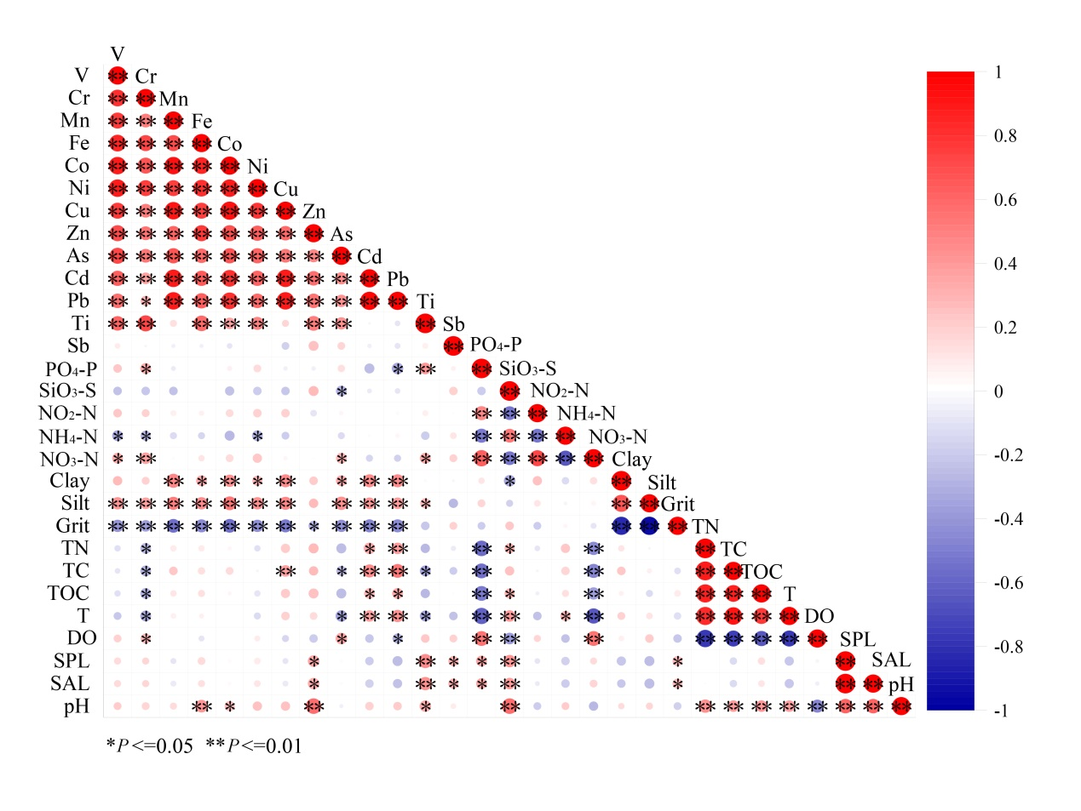
Fig. S1 Spearman correlation heat map of typical tidal creek environmental factors

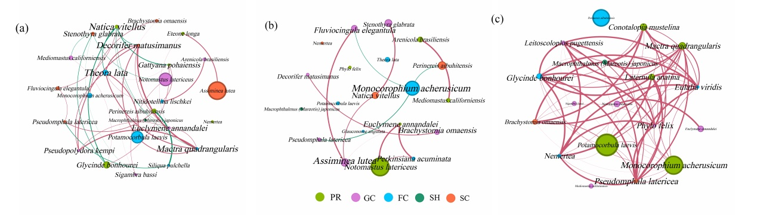
Fig. S2 Typical tidal creek FFGs seasonal co-occurrence network: (a) spring; (b) Summer; (c) Autumn
Note: Different nodes in the figure represent different FFGs; Node size represents the relative abundance of species; The edge color indicates positive and negative correlation, red indicates positive correlation, green indicates negative correlation; The size of the edge indicates the absolute value of the correlation coefficient. The label size represents the size of the degree.

Supplementary Table 1-6

Table S1 List of typical tidal creek macrobenthos species
phylum | order / genus | species | FFGs | S1 | S2 | S3
Mollusca | Stenothyra | Stenothyra glabrata | SC | + | + | +
 | Assiminea | Assiminea lutea | SC | + | + | +
 | Pseudomphala | Pseudomphala latericea | SC | + | + | +
 | Brachystomia | Brachystomia omaensis | SC | + | + | +
 | Fluviocingula | Fluviocingula elegantula | SC | + | + | +
 | Natica | Natica vitellus | PR | + | + | +
 | Decorifer | Decorifer matusimanus | SC | + | + | +
 | Batillaria | Batillaria attramentaria | SC |  | + | +
 | Umbonium | Umbonium thomasi | FC | + |  | +
 | Conotalopia | Conotalopia mustelina | FC |  | + | +
 | Agadina | Agadina stimpsoni | FC |  |  | +
 | Bullacta | Bullacta caurina | SC |  |  | +
 | Potamocorbula | Potamocorbula laevis | FC | + | + | +
 | Theora | Theora lata | FC | + | + | +
 | Glauconome | Glauconome angulata | FC | + | + | +
 | Nitidotellina | Nitidotellina lischkei | FC | + | + | +
 | Macoma | Macoma incongrua | FC |  |  | +
 | Iridona | Iridona iridescens | FC | +
 | Mactra | Mactra quadrangularis | FC |  | + | +
 | Cycladicama | Cycladicama tsuchi | FC |  | + | +
 | Meretrix | Meretrix petechialis | FC | + |  | +
 | Laternula | Laternula anatina | FC | + | + | +
 | Siliqua | Siliqua pulchella | FC | + |  | +
 | Solen | Solen strictus | FC |  | +
 | Sinonovacula | Sinonovacula constricta | FC |  | +
 | Magallana | Magallana rivularis | FC |  |  | +
 | Arcuatula | Arcuatula senhousia | FC |  |  | +
Arthropoda | Macrophthalmus | Macrophthalmus (Mareotis)- japonicus | SH | + | + | +
 | Helice | Helice tientsinensis | SH |  | +
 | Monocorophium | Monocorophium acherusicum | FC | + | + | +
 | Neomysis | Neomysis awatschensis | SH | + | +
 | Gammarus | Gammarus sp. | FC | + | +
 | Palaemon | Palaemon serrifer | PR | +
 | Cumacea | Cumacea sp. | SC | + |  | +
 | Ligia | Ligia oceanica | SH |  | + | +
 | Odonata | Odonata sp. | PR | +
 | Diptera | Diptera.sp. | GC | +
 | Chironomus | Chironomus sp. | GC | +
Annelida | Perinereis | Perinereis aibuhitensis | PR | + | + | +
 | Hediste | Hediste japonica | PR | + | +
 | Glycinde | Glycinde bonhourei | PR | + | + | +
 | Goniada | Goniada japonica | PR |  |  | +
 | Kuwaita | Kuwaita heteropoda | PR |  | + | +
 | Nereis | Nereis multignatha | PR |  | + | +
 | Glycera | Glycera onomichiensis | PR |  | + | +
 |  | Glycera chirori | PR | + |  | +
 | Nephtys | Nephtys californiensis | PR | + | + | +
 |  | Nephtys polybranchia | PR |  |  | +
 | Eteone | Eteone longa | PR | + | + | +
 | Eulalia | Eulalia viridis | PR | + | + | +
 | Notomastus | Notomastus latericeus | GC | + | + | +
 | Mediomastus | Mediomastus californiensis | GC | + | + | +
 | Euclymene | Euclymene annandalei | GC | + | + | +
 | Perkinsiana | Perkinsiana acuminata | FC | + | + | +
 | Chone | Chone infundibuliformis | FC |  | +
 | Leitoscoloplos | Leitoscoloplos pugettensis | GC |  | + | +
 | Scoloplos | Scoloplos armiger | GC |  | +
 | Pseudopolydora | Pseudopolydora kempi | GC | + | + | +
 | Phylo | Phylo felix | GC |  | + | +
 | Arenicola | Arenicola brasiliensis | GC | + | + | +
 | Gattyana | Gattyana pohaiensis | PR | + | + | +
 | Harmothoe | Harmothoe imbricata | GC | + | +
 | Sthenolepis | Sthenolepis sp. | GC |  | + | +
 | Typosyllis | Typosyllis sp. | GC |  |  | +
 | Sigambra | Sigambra bassi | GC | + | + | +
 | Ditrupa | Ditrupa sp. | FC |  | +
 | Lagis | Lagis neapolitana | GC |  |  | +
Nemertea | - | - | PR | + | + | +
Chordata | Acanthogobius | Acanthogobius flavimanus | PR | +
Note: "+" indicates that the species exists; "-" indicates that the species were identified only to the phylum level; FFGs: Feeding functional groups; SC: scraper; PR: predator; FC: filtering-collector; GC: gathering-collector; SH: shredder; S1: primary tidal creek; S2: secondary tidal creek; S3: tertiary tidal creek.

Table S2 Spatial and temporal distribution of FFGs species in typical tidal creek
FFGs | Spring | Summer | Autumn | S1 | S2 | S3
FC | 16 | 15 | 10 | 12 | 15 | 17
GC | 11 | 10 | 7 | 9 | 11 | 11
PR | 15 | 11 | 9 | 13 | 12 | 14
SC | 9 | 8 | 5 | 7 | 7 | 9
SH | 4 | 1 | 3 | 2 | 4 | 2
Total | 55 | 45 | 34 | 43 | 49 | 53

Table S3 Mean value (mean ± sd) of typical creek environmental parameters
Parameter | S1 |  |  | S2 |  |  | S3 |  |  | Test
 | Spring | Summer | Autumn | Spring | Summer | Autumn | Spring | Summer | Autumn | sites | seasons
Water chemistry
T/℃ | 32.05±1.65 | 34.60±0.01 | 17.75±0.35 | 25.20±2.30 | 30.00±0.01 | 18.05±0.95 | 22.95±0.05 | 29.55±0.15 | 17.20±0.02 | 0.03 | 0.00
DO/(mg/L) | 68.10±3.90 | 45.40±0.20 | 101.90±3.30 | 67.90±5.90 | 75.10±6.70 | 95.90±2.50 | 74.75±3.55 | 76.35±11.35 | 87.00±5.43 | 0.56 | 0.00
SPL/(mS/cm) | 60.15±4.05 | 24.41±0.01 | 36.84±0.13 | 52.16±7.44 | 23.24±0.28 | 35.36±2.08 | 44.41±0.40 | 25.97±2.13 | 32.31±1.28 | 0.57 | 0.00
SAL/(g/L) | 40.11±3.02 | 14.64±0.01 | 23.37±0.09 | 34.38±5.46 | 13.96±0.19 | 22.33±1.47 | 28.28±0.15 | 15.78±1.42 | 20.22±0.04 | 0.55 | 0.00
pH | 8.74±0.06 | 8.68±0.01 | 8.51±0.01 | 8.59±0.01 | 8.07±0.02 | 8.42±0.03 | 8.59±0.01 | 8.05±0.04 | 8.50±0.02 | 0.00 | 0.00
PO₄-P(ug/L) | 13.78±15.45 | 0.01±0.00 | 25.35±12.39 | 1.21±1.32 | 0.01±0.00 | 24.40±20.92 | 0.85±1.03 | 0.15±0.29 | 12.15±10.48 | 0.49 | 0.00
SiO₃-Si(mg/L) | 3.36±0.68 | 2.62±0.58 | 1.54±0.71 | 2.70±0.64 | 1.20±0.82 | 1.39±0.32 | 4.00±0.65 | 1.40±0.51 | 1.15±0.29 | 0.27 | 0.00
NH₄-N(ug/L) | 84.22±79.76 | 187.44±148.37 | 9.69±1.07 | 114.53±126.98 | 100.86±63.20 | 9.08±0.96 | 192.14±131.72 | 33.13±8.96 | 68.50±29.43 | 0.18 | 0.01
NO₃-N(ug/L) | 37.77±9.12 | 27.68±3.39 | 115.76±5.47 | 50.08±8.54 | 39.11±5.72 | 68.13±28.81 | 34.80±4.01 | 35.95±2.69 | 49.33±3.47 | 0.15 | 0.00
NO₂-N(ug/L) | 1.67±1.33 | 0.75±0.51 | 1.66±0.23 | 1.10±0.43 | 1.17±0.64 | 1.08±0.62 | 0.58±0.19 | 1.11±0.16 | 1.83±0.45 | 0.76 | 0.06
Sediment properties
TC/(g/kg) | 249.62±22.96 | 279.16±27.21 | 8.31±0.36 | 212.13±2.61 | 218.69±26.60 | 7.37±0.78 | 172.71±22.27 | 227.81±21.36 | 7.38±0.51 | 0.05 | 0.00
TN/(g/kg) | 4.50±0.86 | 5.19±1.23 | 0.09±0.02 | 3.57±0.80 | 3.52±0.86 | 0.06±0.01 | 2.91±1.00 | 3.32±0.87 | 0.07±0.02 | 0.16 | 0.00
TOC/(g/kg) | 33.63±24.93 | 20.95±12.20 | 0.66±0.06 | 16.17±2.09 | 15.20±6.33 | 0.59±0.06 | 12.22±3.39 | 15.20±6.33 | 0.49±0.07 | 0.05 | 0.00
Clay /% | 13.29±4.19 | 16.77±1.29 | 18.36±1.43 | 9.93±1.20 | 11.96±5.09 | 11.95±2.97 | 6.47±1.00 | 11.85±1.86 | 10.56±0.95 | 0.00 | 0.01
Silt /% | 63.11±9.97 | 70.89±3.31 | 68.87±2.00 | 49.97±10.25 | 62.30±1.33 | 67.57±3.21 | 39.33±15.12 | 55.04±8.85 | 62.57±4.75 | 0.00 | 0.00
Grit /% | 23.60±12.59 | 12.34±2.95 | 12.76±2.38 | 40.11±10.75 | 25.74±6.02 | 20.49±5.92 | 54.20±15.38 | 33.11±9.74 | 26.87±3.97 | 0.00 | 0.00
Note: "sites" indicates different levels of tidal creeks.

Table S4 Mean value (mean ± sd) of metal elements in typical tidal creek
Metals | S1 |  |  | S2 |  |  | S3 |  |  | Test
 | Spring | Summer | Autumn | Spring | Summer | Autumn | Spring | Summer | Autumn | sites | seasons
V/(ng/mL) | 27.13±5.50 | 28.91±5.62 | 29.94±2.22 | 26.73±3.65 | 23.69±3.21 | 27.78±1.93 | 23.46±1.64 | 21.25±4.02 | 25.76±0.78 | 0.05 | 0.04
Cr/(ng/mL) | 9.23±1.94 | 9.90±2.45 | 10.71±0.80 | 9.08±1.71 | 8.41±2.11 | 10.38±1.04 | 7.83±1.08 | 5.96±1.09 | 9.81±0.49 | 0.00 | 0.01
Mn/(ng/mL) | 591.07±10.00 | 727.83±146.54 | 657.10±66.96 | 585.40±104.79 | 551.78±103.66 | 584.09±116.28 | 391.76±57.30 | 539.21±126.15 | 557.11±18.20 | 0.00 | 0.28
Fe/(ng/mL) | 9019.18±141.80 | 10768.81±214.78 | 9463.43±440.55 | 8971.27±119.50 | 8267.23±140.80 | 9319.86±520.67 | 7781.69±111.12 | 6484.09±119.05 | 8634.62±50.13 | 0.00 | 0.42
Co/(ng/mL) | 7.72±1.28 | 9.57±2.39 | 8.45±0.75 | 7.43±1.22 | 6.71±1.23 | 8.02±0.96 | 5.61±0.54 | 6.13±1.45 | 7.18±0.21 | 0.00 | 0.13
Ni/(ng/mL) | 17.29±3.54 | 19.80±4.54 | 18.39±1.36 | 16.65±2.52 | 14.88±2.29 | 18.20±1.84 | 14.70±2.71 | 12.91±2.76 | 16.46±0.68 | 0.00 | 0.09
Cu/(ng/mL) | 17.68±4.84 | 20.29±4.35 | 15.93±1.73 | 15.17±2.77 | 14.83±3.68 | 15.64±1.94 | 10.38±1.44 | 13.01±3.14 | 13.95±0.57 | 0.00 | 0.09
Zn/(ng/mL) | 43.99±10.25 | 47.88±8.91 | 43.14±8.23 | 44.40±7.29 | 33.91±5.85 | 34.80±3.29 | 36.88±6.63 | 28.57±6.11 | 31.07±1.94 | 0.00 | 0.42
As/(ng/mL) | 8.28±1.82 | 9.69±2.13 | 10.53±0.97 | 9.90±1.58 | 9.11±1.32 | 9.68±0.58 | 8.09±0.76 | 8.17±1.62 | 9.59±0.22 | 0.02 | 0.01
Cd/(ng/mL) | 0.26±0.05 | 0.33±0.05 | 0.27±0.03 | 0.25±0.04 | 0.26±0.03 | 0.23±0.04 | 0.18±0.03 | 0.23±0.05 | 0.20±0.01 | 0.00 | 0.03
Pb/(ng/mL) | 24.01±4.47 | 33.37±5.95 | 24.06±3.13 | 22.96±4.54 | 24.24±4.44 | 19.59±3.53 | 15.43±1.70 | 21.97±5.12 | 18.01±0.37 | 0.00 | 0.01
Ti/(mg/L) | 72.85±16.58 | 58.74±20.25 | 74.42±20.94 | 69.93±23.76 | 42.89±13.05 | 88.67±6.57 | 64.76±17.89 | 27.95±3.12 | 77.04±7.68 | 0.02 | 0.01
Sb/(mg/L) | 0.19±0.04 | 0.17±0.02 | 0.53±0.18 | 0.32±0.17 | 0.21±0.05 | 0.17±0.01 | 0.68±0.15 | 0.19±0.04 | 0.18±0.01 | 0.62 | 0.09
Note: "sites" indicates different levels of tidal creeks.

Table S5 K-W test of biological co-occurrence network topology indicator
Network indicator | Test
Network indicator | Seasons | Sites
degree | 0.00 | 0.06
Closnesscentrality | 0.00 | 0.33
Harmonicclosnesscentrality | 0.002 | 0.09
Betweenesscentrality | 0.01 | 0.43
eigencentrality | 0.104 | 0.34
Hub | 0.32 | 0.64

Table S6 Topology parameters of biological co-occurrence network
Network parameters | ALL | Seasons |  |  | Sites
Network parameters | ALL | Spring | Summer | Autumn | S1 | S2 | S3
Nodes number | 29 | 25 | 20 | 18 | 18 | 27 | 32
Edges number | 115 | 38 | 12 | 66 | 32 | 39 | 95
average degree | 7.93 | 3.04 | 1.2 | 7.33 | 3.56 | 2.89 | 5.94
Network density | 0.28 | 0.13 | 0.06 | 0.43 | 0.21 | 0.11 | 0.19
average clustering coefficient | 0.63 | 0.53 | 0.38 | 0.87 | 0.82 | 0.63 | 0.74
average path length | 1.9 | 3.44 | 2.55 | 1.17 | 1.91 | 1.97 | 1.84
Positive correlation ratio（%） | 99.13% | 68.42% | 75% | 100% | 100% | 97.44% | 70.53%
Negative correlation ratio（%） | 0.87% | 31.58% | 25% | 0 | 0 | 2.56% | 29.47%
Note: "ALL" indicates biological co-occurrence networks in three seasons.

