Additional Information
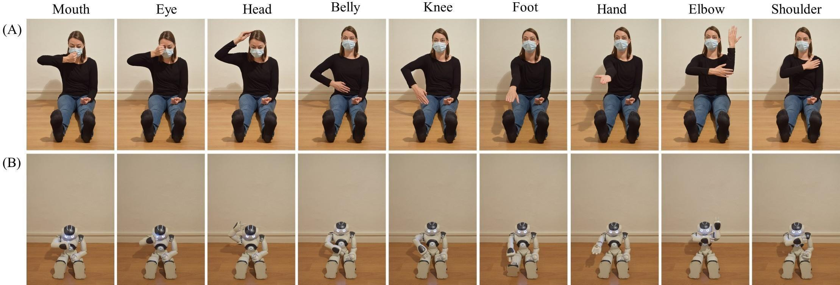

Figure 1. The 9 body parts pointed by the demonstrator in the imitation task: (A) human and (B) robotic.

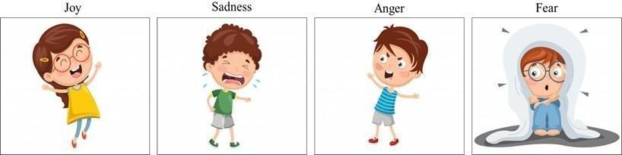
Figure 2. Images used in the task of emotions’ identification (source: https://fr.freepik.com/)

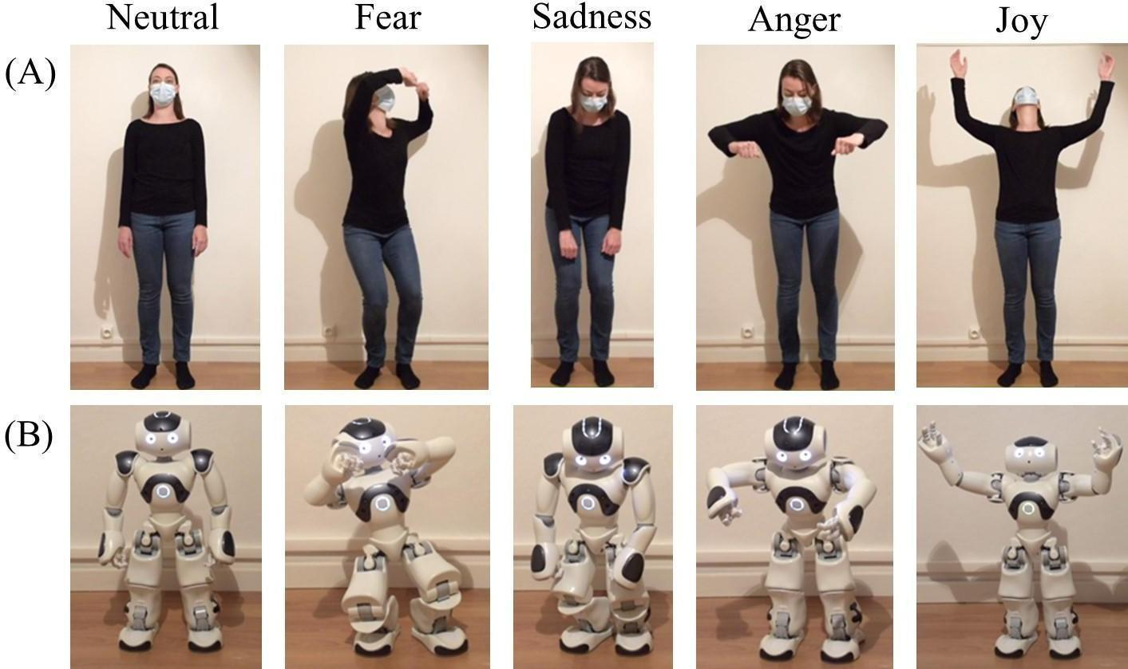
Figure 3. The neutral and emotional postures exhibited by the demonstrator: (A) human and (B) robot.
Task | Sub-task | Model | Distribution | Link | Predictors | Random effects | Results
Comprehension of BP labels | On the child’s body | GLM | Gamma | Log | Demonstrator type  Child’s age  Child’s age x demonstrator type  Child’s gender | No | No effect
Comprehension of BP labels | On the demonstrator’s body | GLM | Gamma | Log |  | No | Child’s age
Imitation of body parts sequences | Production of body parts labels | GLM | Gamma | Identity |  | No | Child’s age
Imitation of body parts sequences | Imitation | GLME | Gamma | Reciprocal |  | School  Experimenter | Child’s age
Emotions task | On images | GLM | Gamma | Log |  | No | No effect
Emotions task | Expression of emotions by the child | GLME | Gamma | Reciprocal |  | School  Experimenter | No effect
Emotions task | Identification of emotional key postures | GLME | Gamma | Reciprocal |  | School  Experimenter | Child’s age

Table 1. Models used for each task.

