SUPPLEMENTAL TABLES AND FIGURES

Variable | SiRFP-43/SiRHP | SiRFP-60Δ/SiRHP | SiRFP-60X/SiRHP
Expression | co-lysis | co-lysis | reconstitution
SiRFP variant | FNR domain | monomer with linker truncation (ΔAAPSQS) | Crosslinked monomer with four engineered variants: C162T, C552S, E121C, and N556C
Theoretical mass (kDa) | 107 | 123 | 124

Table S1. Expression system used for each construct.

Sample assembly | SiRFP-43/SiRHP | SiRFP-60Δ/SiRHP | SiRFP-60X/SiRHP
SiRFP-43/SiRHP | Titan Krios | Titan Krios | Titan Krios
Voltage (KV) | 300 | 300 | 300
Camera | K3 | K3 | Apollo
Magnification | 105 K | 105 K | 59 K
Total dose (e/Å²) | 60 | 60 | 60
Pixel size (Å) | 0.844 | 0.844 | 0.765
Number of movies | 14,628 | 25,488 | 9,963
Number of particles | 1,500,000 | 550,000 | 185,000
Resolution (Å) | 3.47* | 3.49 | 2.84
Data collection location | NYSBC | NYSBC | FSU BSIR

Table S2. Data collection parameters and final reconstruction information.
*Nominal resolution

Parameter | Value
B-factor (Å²) | 120.6
Map CC | 0.85
RMSD [bonds] (Å) | 0.003
RMSD [angles] (Å) | 0.623
All-atom clash-score | 10.90
Ramachandran plot
Favored (%) | 96.30
Allowed (%) | 3.51
Outliers (%) | 0.18
Rotamer outliers (%) | 2.64
C-β deviations (%) | 0.00
PDB ID | 9C91
EMDB ID | EMD-45359

Table S3. Model refinement and validation statistics.

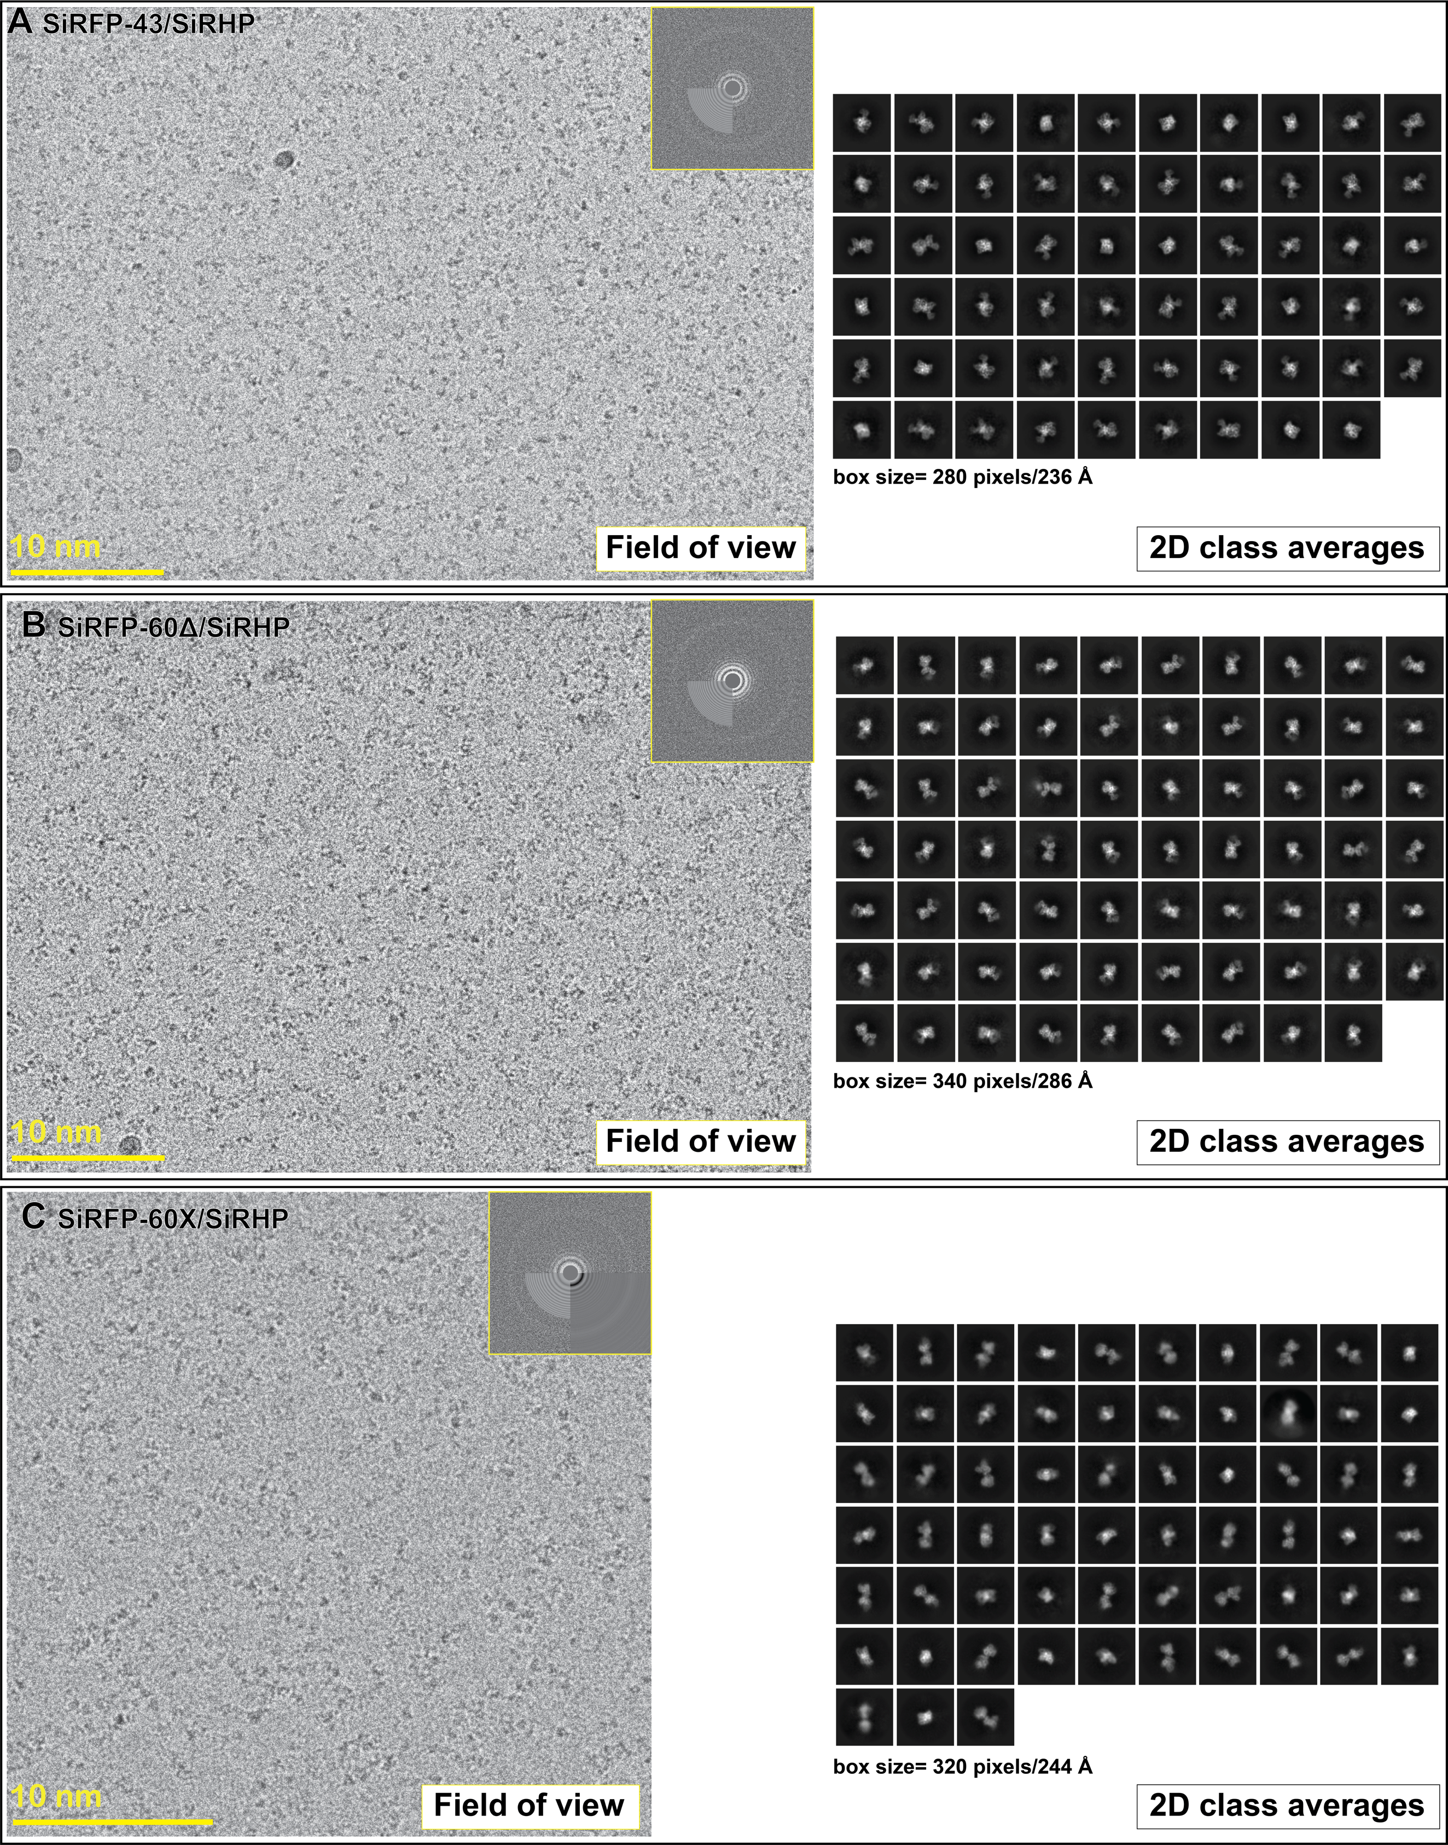
Fig S1. Raw data for each SiR dimer A) Exemplar micrograph and selected 2D class averages from SiRFP-43/SiRHP dataset. B) Exemplar micrograph and selected 2D class averages from SiRFP-60Δ/SiRHP dataset. C) Exemplar micrograph and selected 2D class averages from SiRFP-60X/SiRHP dataset.

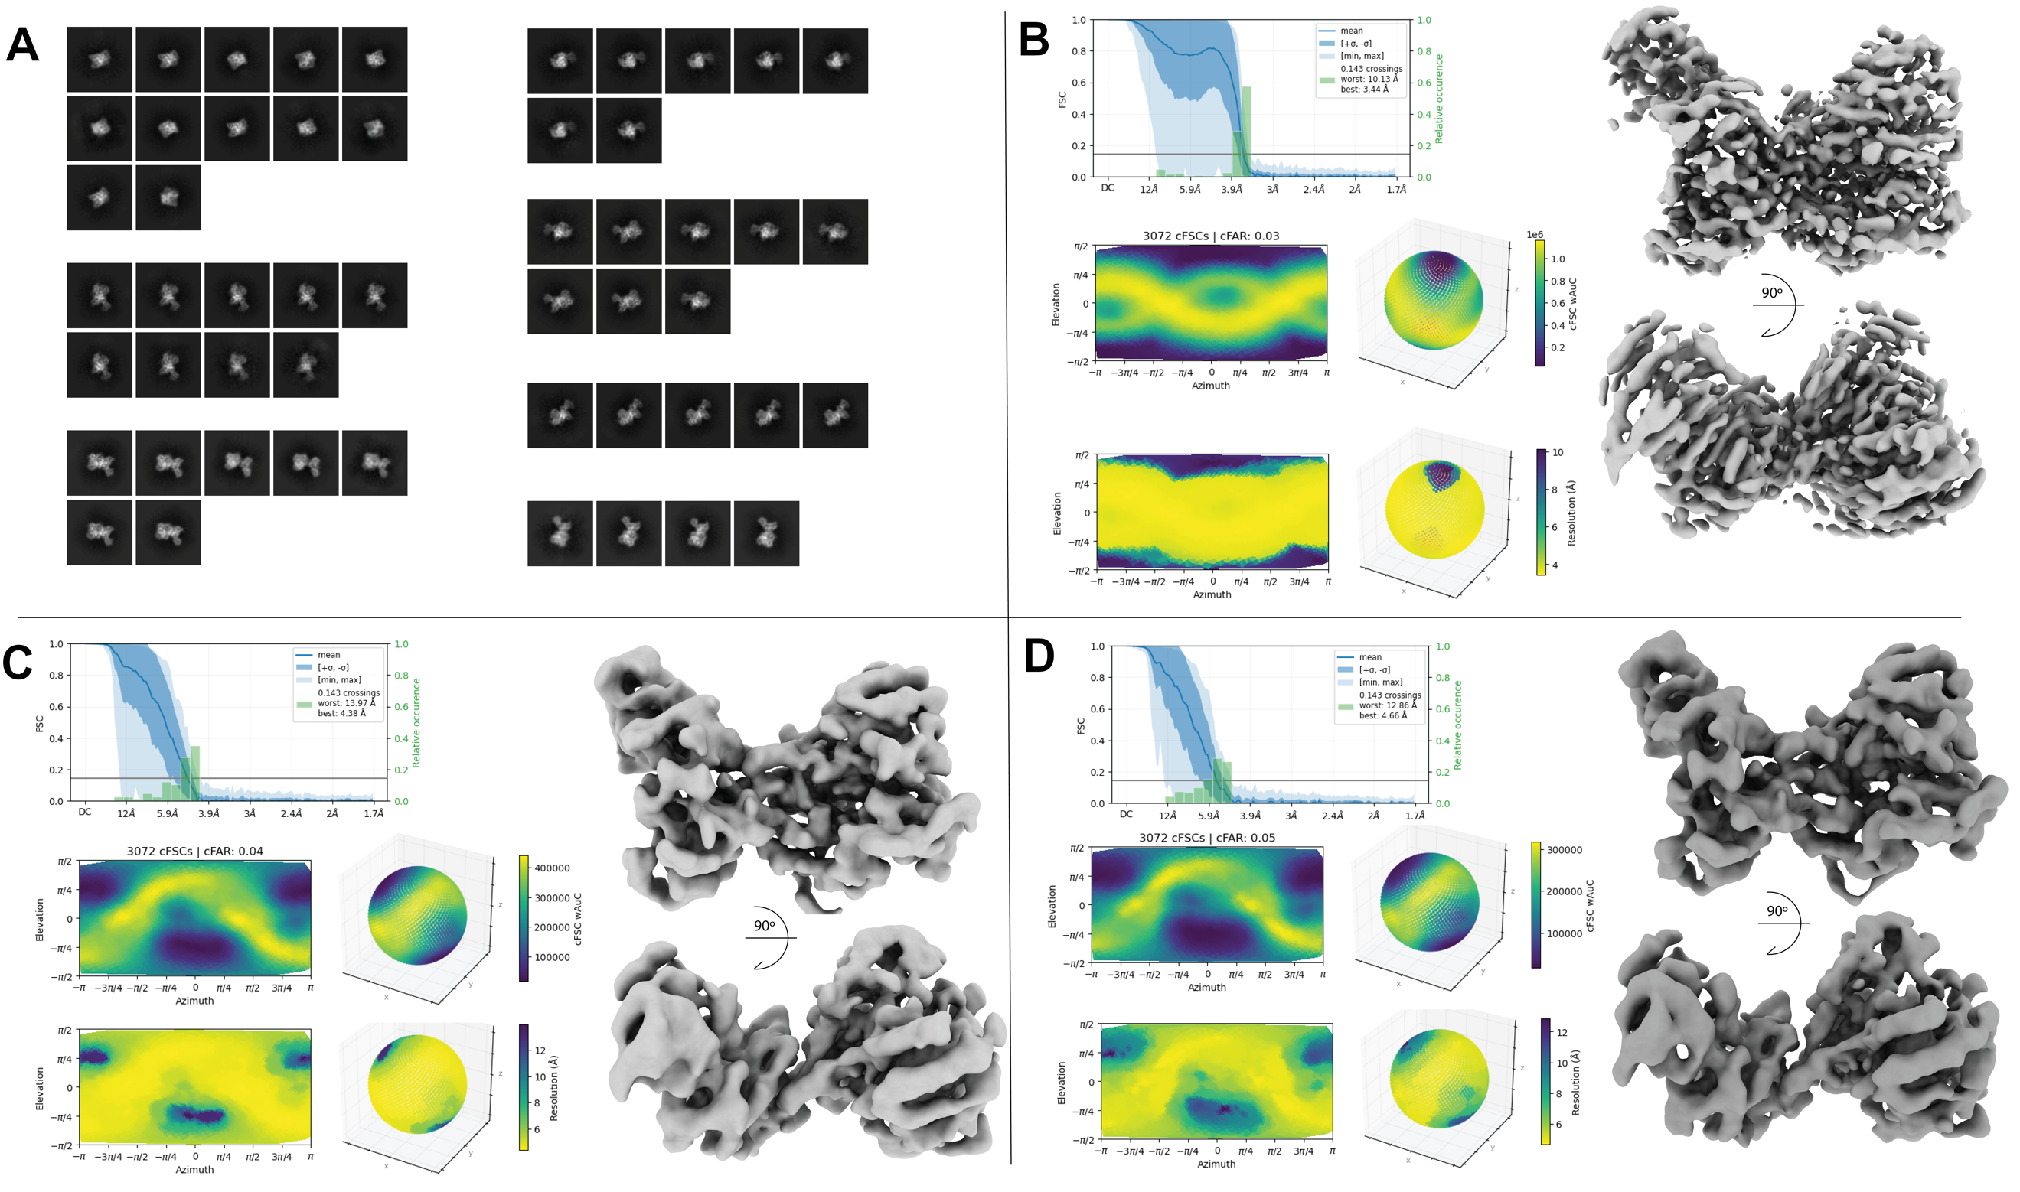
Fig S2. Orientation analysis of the SiRFP-43/SiRHP dimer A) 2D superclass averages from the SiRFP-43/SiRHP dataset used to reduce the particles in each cluster to block preferred orientation effect. B) Non-uniform refinement and orientation diagnostics results for all particles with good 2D class averages features (~1,500,000 particles). C) Non-uniform refinement and orientation diagnostics results for reduced number of particles based on 2D rebalance super classification 350,000 particles). D) Non-uniform refinement and orientation diagnostics results for reduced number of particles based on 2D rebalance super classification 105,000 particles).

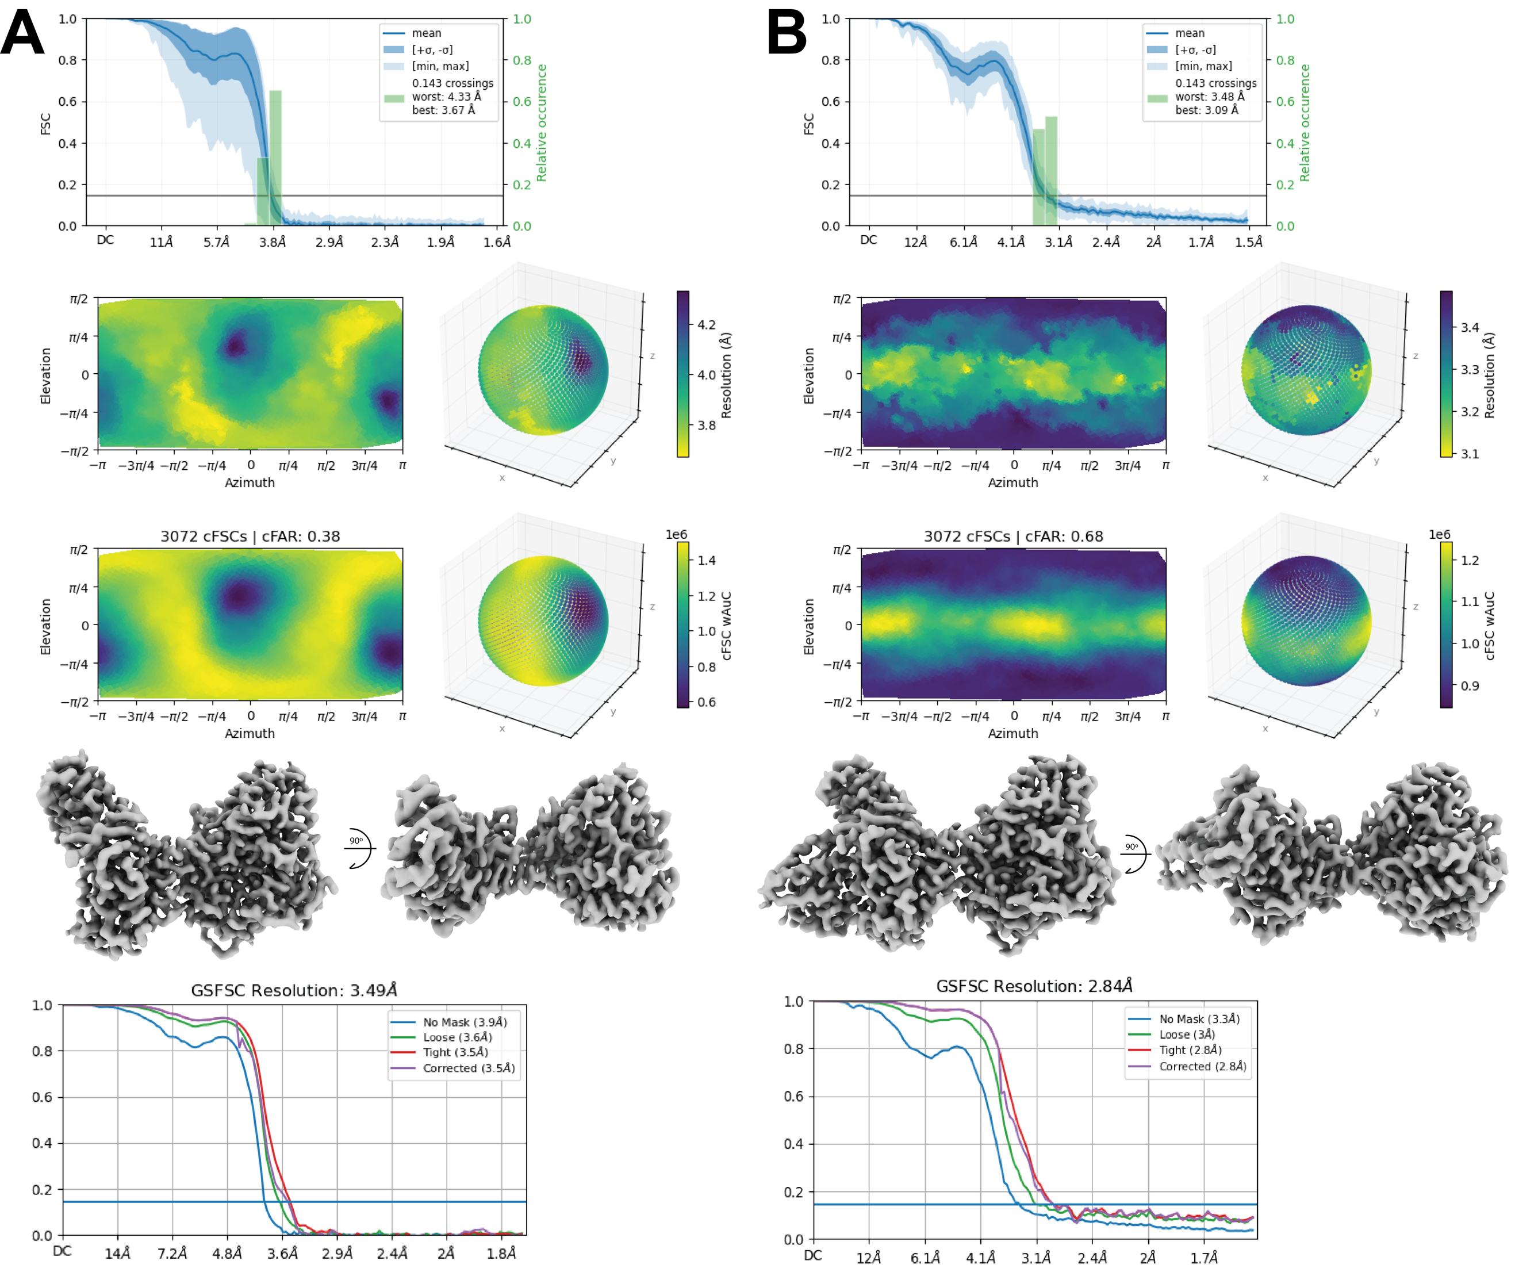
Fig S3. 3D orientation analysis for SiRFP-60Δ/SiRHP and SiRFP-60X/SiRHP
A) Orientation diagnostics results, highest resolution map and the refinement’s GSFSC curve for SiRFP-60Δ/SiRHP particles.
B) Orientation diagnostics results, highest resolution map and the refinement’s GSFSC curve for SiRFP-60X/SiRHP particles.

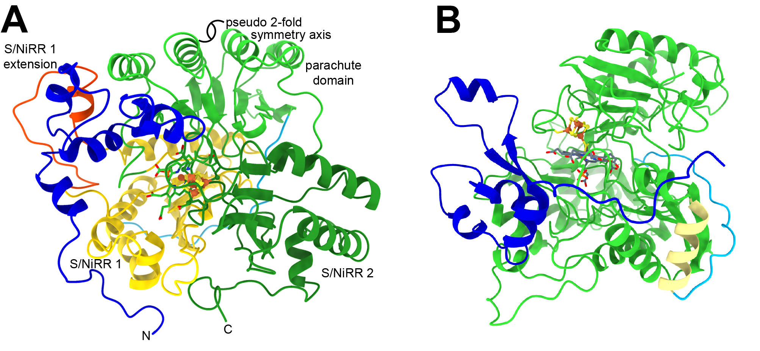
Fig S5. Path of SiRHP’s previously undetermined N-terminal 80 amino acids. A) The N-terminus of SiRHP (blue) breaks the pseudo 2-fold symmetry that relates S/NiRR 1 (domain 1, yellow + the N-terminus of the parachute domain, light green) and S/NiRR 2 (domain 2, dark green + the C-terminus of the parachute domain, light green. The S/NiRR 1 extension is orange. B) Blue: amino acids 1-80. Green: S/NiRR 1 and 2. Yellow: helix preceding the siroheme mimic (h11). Cyan: siroheme mimic joining S/NiRRs 1 and 2.

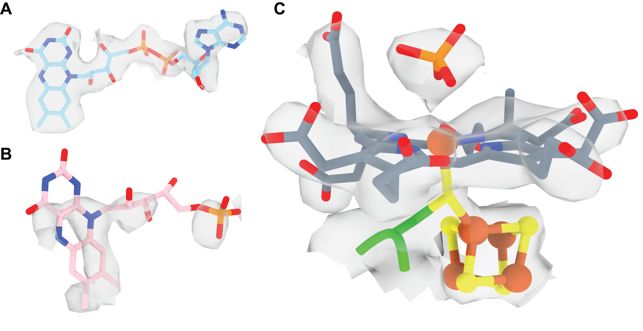
Fig S4. SiRFP-60X/SiRHP high resolution map (2.84 Å) with placed co-enzymes: A)
FAD, B) FMN, C) Siroheme-Fe₄S₄ cluster bound to a distal phosphate with the bridging h-Cys483.

Fig S6. An extensive network of hydrophobic interactions, ionic bonds, and hydrogen bonds bridge from the SiRFP/SiRHP interface to the active site.

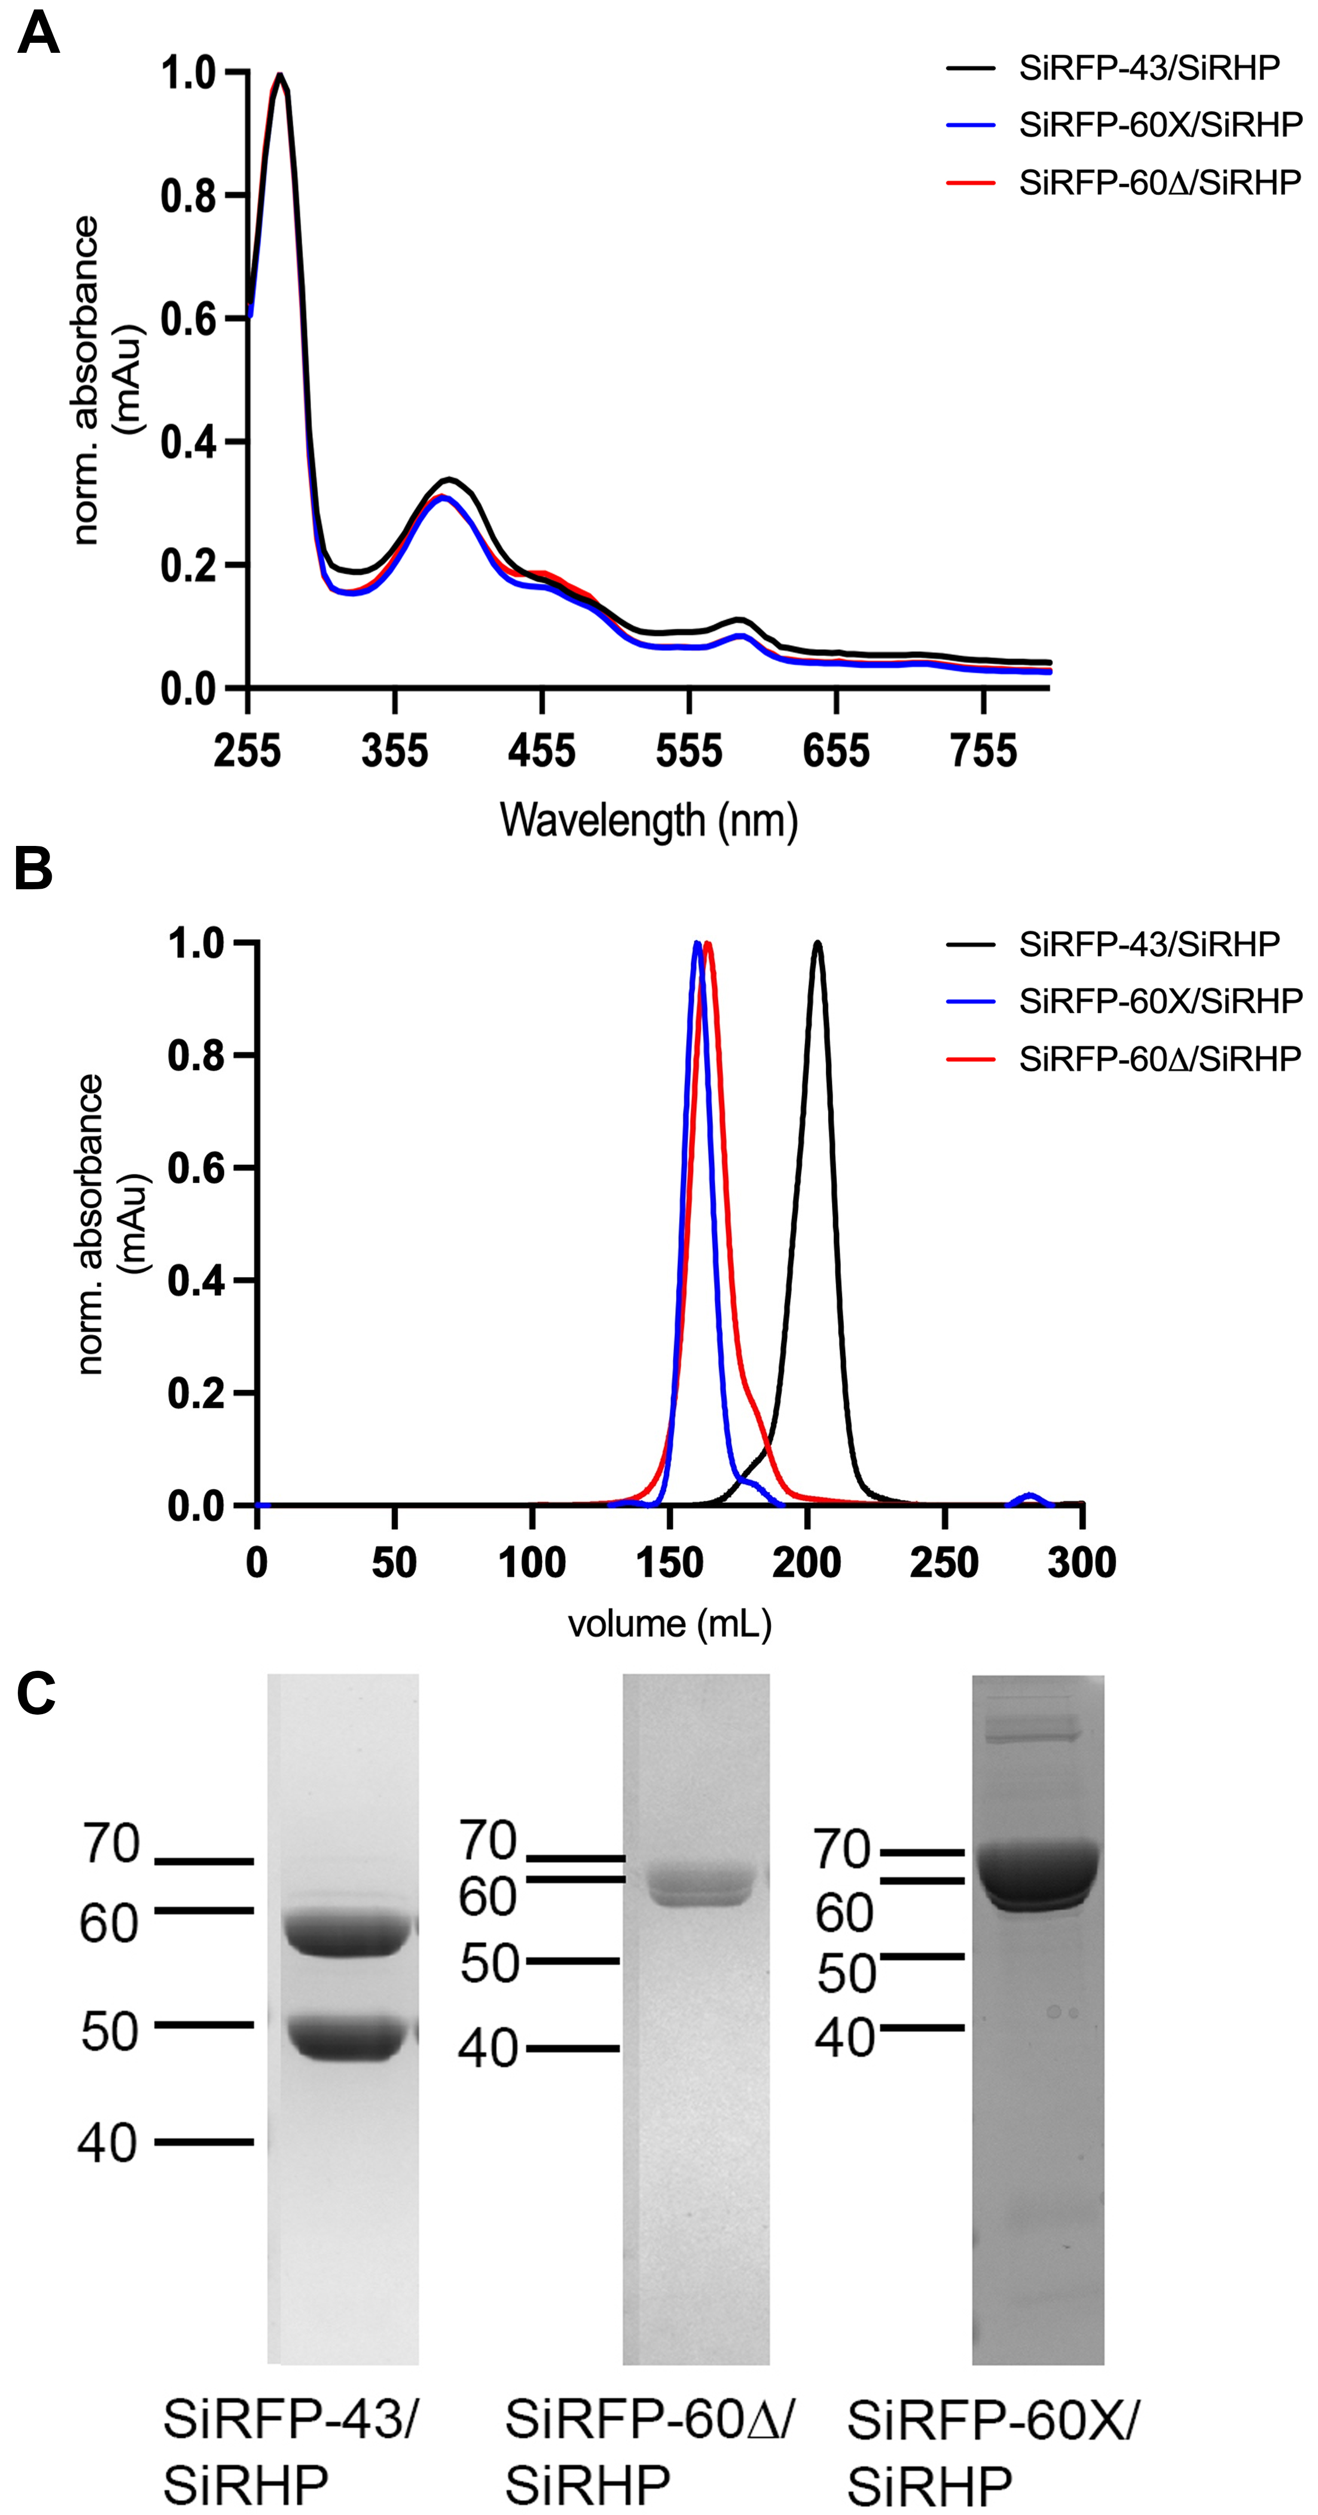

Fig S7. Biochemical analysis of each SiRFP/SiRHP variant shows that all are properly formed. A) UV-Visible spectra showed that all variants are properly folded with cofactors bound. B) Size exclusion chromatography profiles of all three variants with their characteristic elution profiles. C) SDS-PAGE analysis of the variants showed the expected molecular weights of the purified complexes.

Video1. Swinging Fld domain shown in motion, obtained from SiRFP-60Δ/SiRHP dataset via CryoDRGN showing one of the latent spaces out of two.

