Supporting Information: Spin Hall Nano-Antenna

Raisa Fabiha¹, Pratap Kumar Pal², Michael Suche¹, Erdem Topsakal¹, Anjan Barman¹ and Supriyo Bandyopadhyay¹
Department of Electrical and Computer Engineering, Virginia Commonwealth University, Richmond, VA 23284, USA
Department of Condensed Matter and Materials Physics, S. N. Bose National Center for Basic Sciences, Kolkata 700116, INDIA

- Time-resolved Magneto-Optical Kerr Effect Spectroscopy

The investigation of ultrafast magnetization dynamics of the samples is conducted by employing a custom-built TR-MOKE microscope based on a two-color collinear pump–probe technique under ambient conditions.
A small part of the fundamental laser beam (λ_{probe} = 800 nm, fluence = 2 mJ cm⁻², pulse width = 80 fs) from a mode-locked Ti-sapphire laser (Tsunami, Spectra-Physics) is used to probe the polar Kerr rotation (hereafter referred to as the probe beam) and its frequency-doubled counterpart (λ_{pump} = 400 nm, fluence = 16 mJ cm⁻², pulse width = 100 fs), referred to as the pump beam, is used to excite the magnetization dynamics of the samples. The Kerr rotation signal is measured using an optical bridge detector (OBD) as a function of the time delay between the pump and probe beams. Achieving spatial overlap of these two beams is critical. The slightly defocused pump beam (of diameter ~ 1 µm) at the focal plane of the tightly focused probe beam (of diameter ~ 800 nm), is made collinear and overlapping on the sample plane using a microscope objective of numerical aperture 0.65. The OBD isolates and simultaneously measures both the reflectivity and Kerr rotation in a phase sensitive manner with the help of two lock-in amplifiers to attain high sensitivity. To maintain temporal synchrony, the pump beam is subjected to periodic modulation at a frequency of about 2 kHz by a mechanical chopper. This modulation frequency serves as a reference frequency and is conveyed to the lock-in amplifiers, anchoring the phase relationships within the system. Further, the probe beam is systematically positioned at the precise center of the pump beam using an x–y–z piezoelectric scanning controller, guided by a feedback loop and a white-light illumination system, enhancing the fidelity of the experiment. The experimental time window of 2 ns was found to be sufficient to resolve the spin wave peaks with a temporal resolution of 10 ps from the fast Fourier transform (FFT) of the bi-exponential background subtracted time-resolved traces.

- Micromagnetic simulations

Micromagnetic simulations were carried out with the open source OOMMF software package. The discretized array featured rectangular parallelepiped-shaped cells (3 × 3 × 6 nm³) with a two-dimensional (2D) periodic boundary condition. The unit cell length was kept below the exchange length of Co (∼4.93 nm), to allow the incorporation of exchange interactions. Simulation parameters used included saturation magnetization, M_{s} = 1400 emu cc⁻¹, anisotropy constant, K = 0, gyromagnetic ratio, γ = 17.6 MHz Oe⁻¹, the exchange stiffness constant, A_{ex} = 3.0 × 10⁻⁶ erg cm⁻¹, and damping coefficient, α = 0.008.

- Sample Fabrication
The samples are fabricated with multi-level e-beam lithography for patterning using a Raith e-beam writer, followed by e-beam evaporation of metals (Co, Pt) and finally lift-off. Fig. S1 is a scanning electron micrograph of the nanomagnets showing the overlaying of the Pt strip on the ledges very clearly.

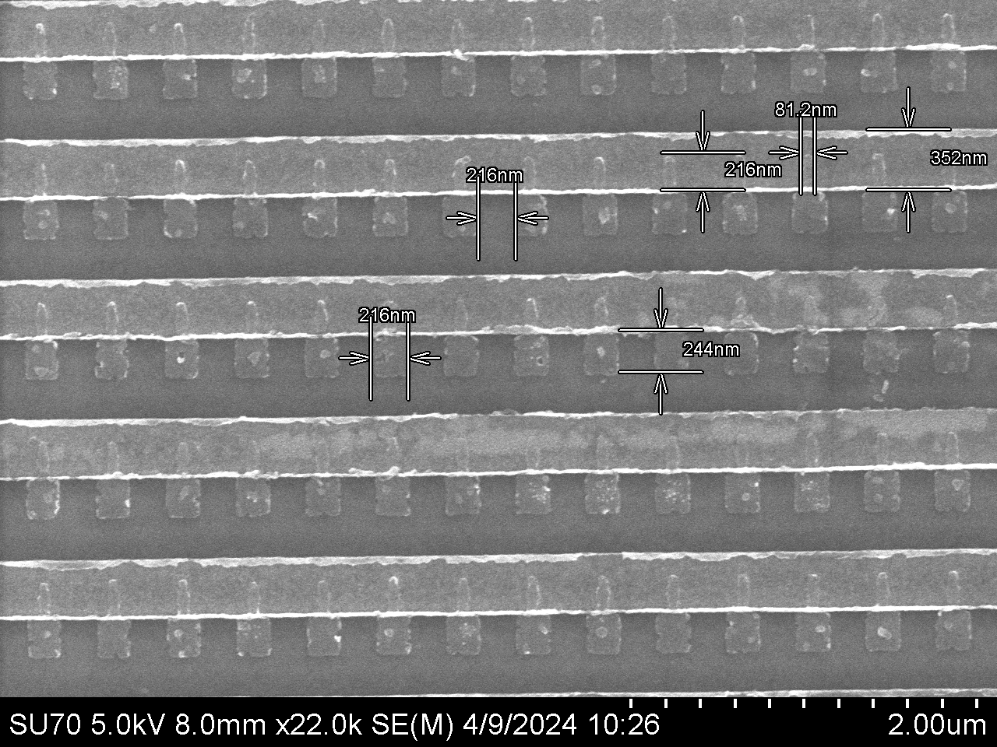

Fig. S1: Scanning electron micrograph of the samples showing the various dimensions.

- Variability of high frequency Kerr oscillation spectra
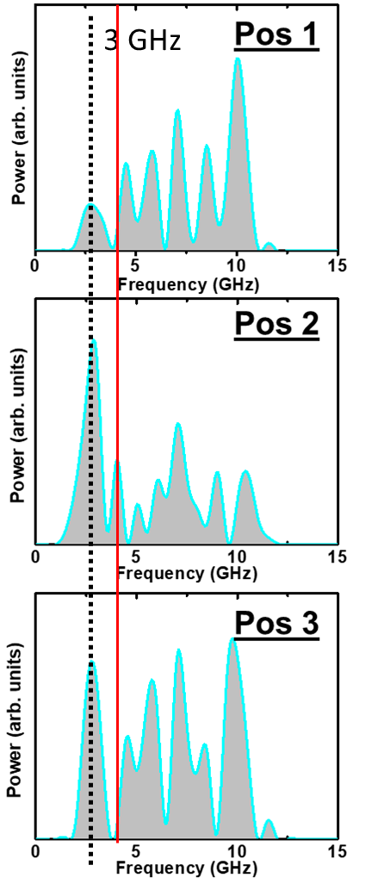
In the TR-MOKE measurements, only two neighboring nanomagnets are sampled at a time because of the laser spot size and the Kerr oscillations are measured within these two nanomagnets. When a different nanomagnet pair is sampled, the mode at the frequency of the driving ac current remains unchanged in frequency, but the others (occurring at higher frequencies) experience red or blue shift. For example, at 3 GHz excitation frequency, the spin wave mode at 3 GHz is found in all sampled nanomagnet pairs (or all laser spot position) as shown by the dashed black line, but the higher order mode at ~4 GHz is found only in one position (Position 2) and not in other positions (or other nanomagnet pairs) [as shown by the thin red vertical line in Fig. S2]. The higher frequency modes are not excited by the ac current (or the associated periodic spin-orbit torque) but are probably vortex modes generated by strain pulses [1] which are produced in the magnetostrictive nanomagnets by the periodic heating and cooling by the pump and probe laser beam in the TR-MOKE setup. The frequencies of these modes depend on the diameter and thickness of the nanomagnet [1] and since these two parameters vary slightly from one nanomagnet to another, there is some variability in the frequencies of the higher order modes. As a result, when these higher frequency peaks are ensemble averaged over ~570,000 nanomagnets in a sample, they wash out and consequently we do not see their signatures in the electromagnetic radiation spectra. We only see the signature of the mode at the frequency of the ac current since its frequency does not vary from one nanomagnet to another and hence it survives ensemble averaging.
Fig. S2: Spin wave spectra measured with TR-MOKE in three different nanomagnet pairs.

- Radiation pattern measurement setup
The radiation patterns were measured in an AMS-8701 Anechoic Chamber, Antenna Measurement System using a 3164-10 Open Boundary Quad-ridged Horn Antenna.

- Screenshots of the received electromagnetic spectra at the horn antenna detector from the real and control samples when the ac current frequency is 3 GHz

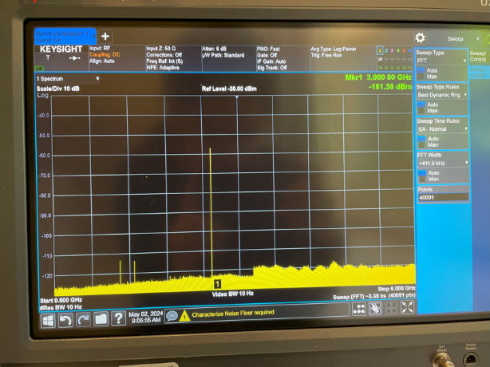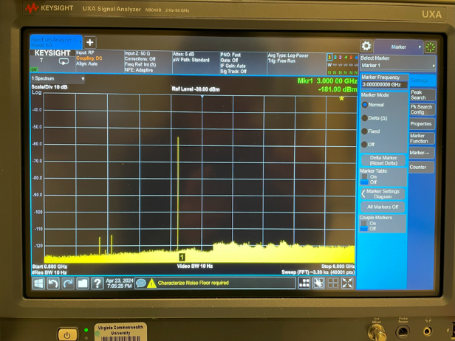
Fig. S3: Screenshots of the received radiation at the horn antenna taken from the spectrum analyzer. (Left) real sample and (right) control sample.

- Radiation patterns of the real and control samples at 3 GHz measured in the two planes that are transverse to the plane of the nanomagnets
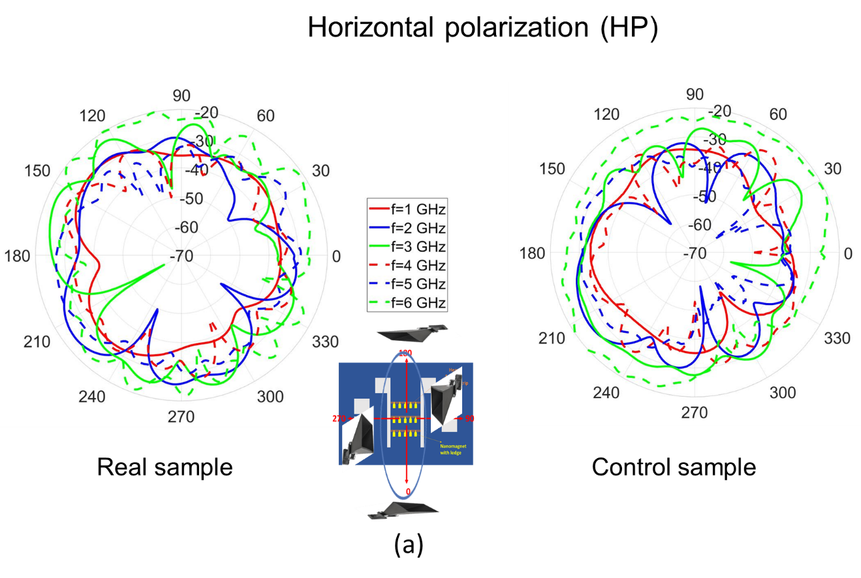
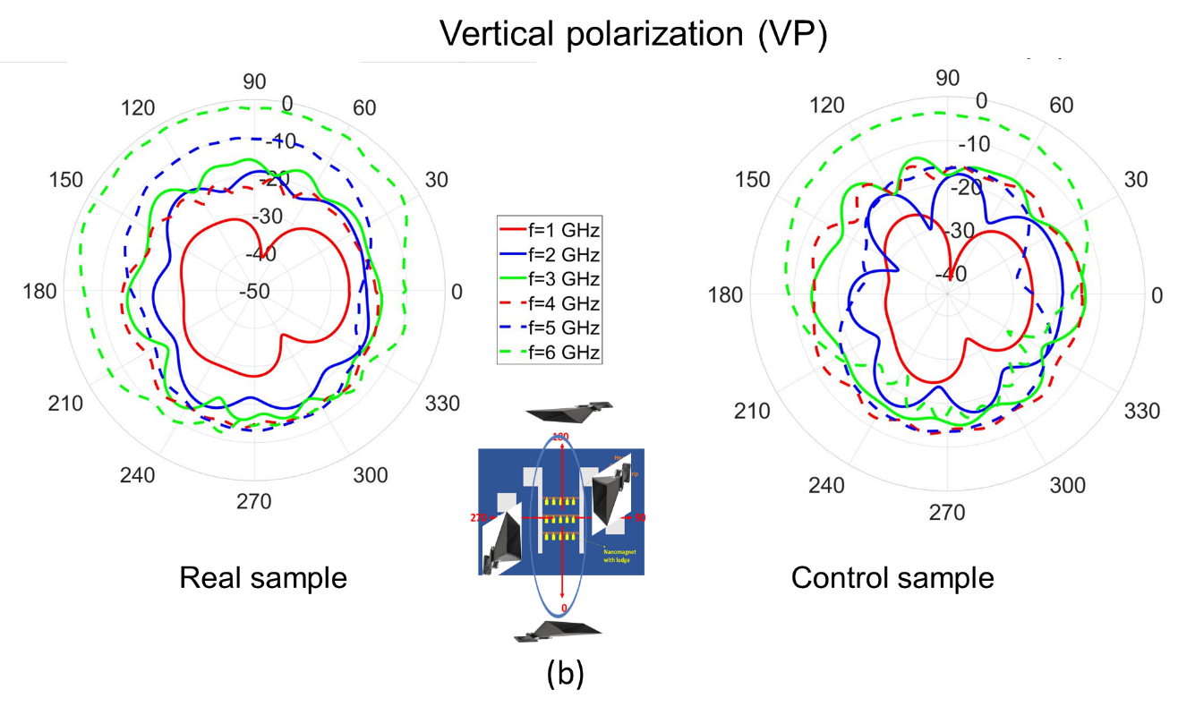
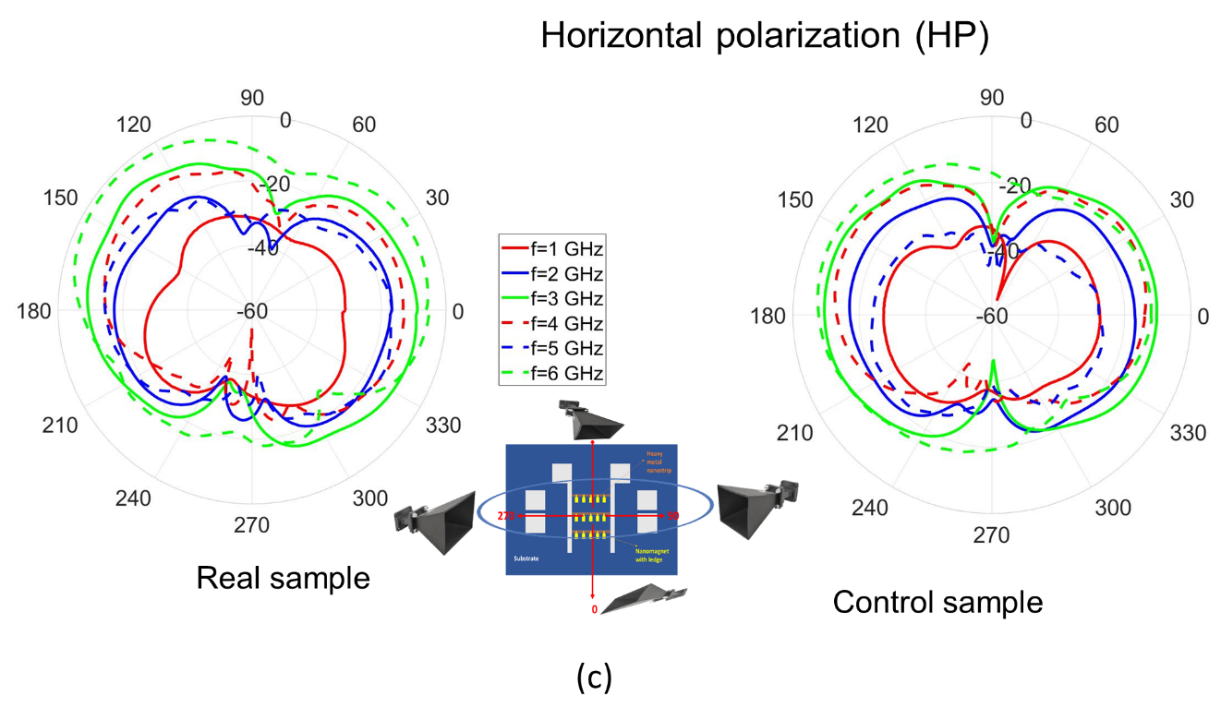
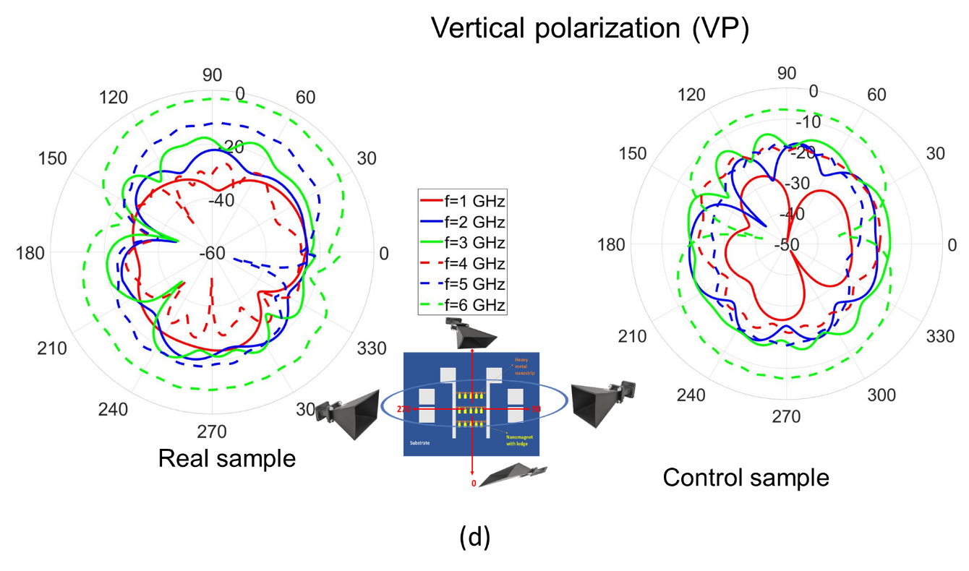
Fig. S4: Radiation patterns in the two planes perpendicular to the plane of the nanomagnets shown for both horizontal and vertical polarizations.

- Magnetization oscillations and the power/phase profiles of the spin waves excited within a nanomagnet at 4 GHz and 6 GHz ac current frequency

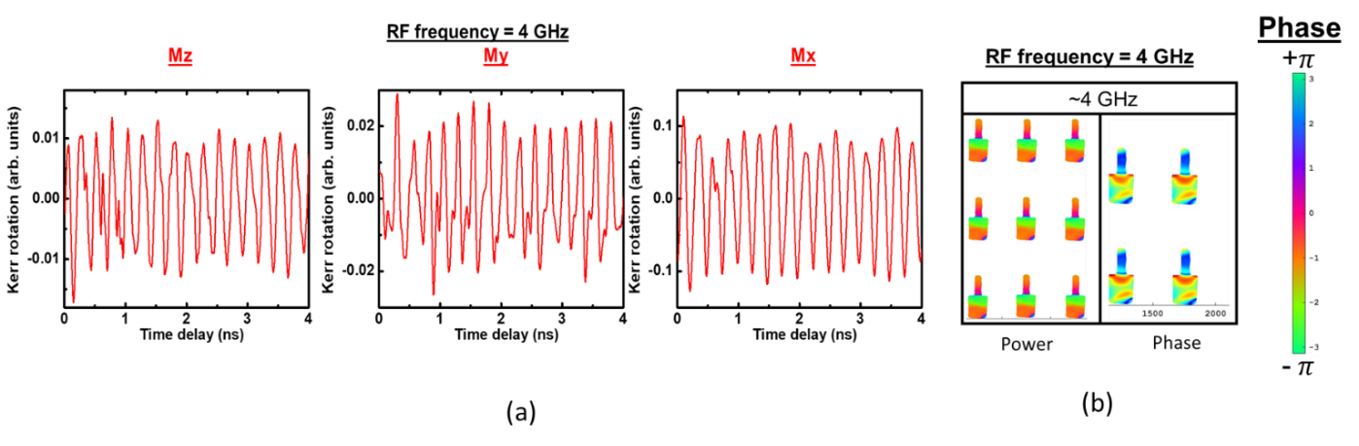
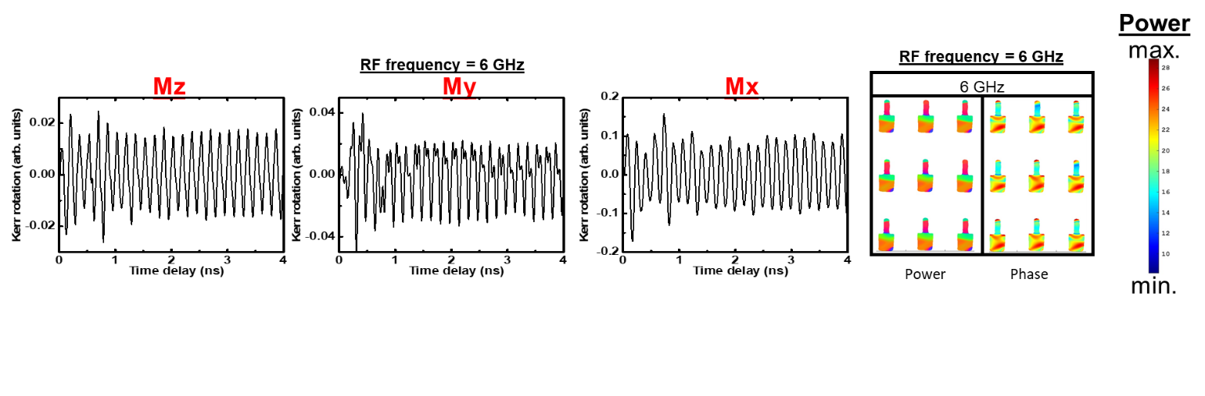
Fig. S5: (a) The oscillations of the three scalar components of the magnetization simulated from OOMMF and (b) the power/phase profiles of the associated spin waves in an array of 3 × 3 nanomagnets calculated with in-house software. The top panel shows the results for 4 GHz and the bottom panel for 6 GHz of ac current frequency (which is the frequency of the spin orbit torque). Note that the oscillation component in the direction perpendicular to the ledge (x-component) is always much larger than the other two components, making the spin waves anisotropic in nature. At both these two frequencies, the spin wave power is concentrated in the ledges and the edge of the nanomagnets facing away from the ledges.

- Scattering parameter S₁₁ spectrum

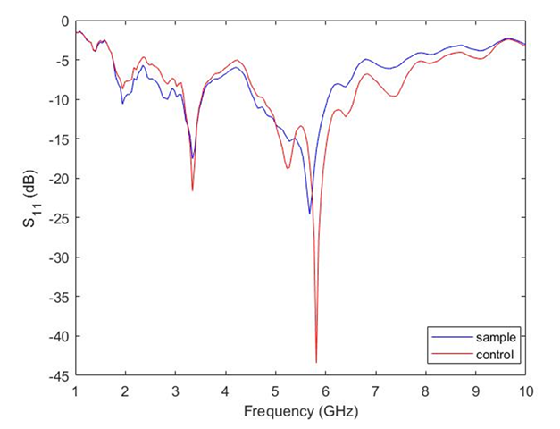
Fig. S6: Spectrum of the scattering parameter S₁₁ of the sample measured with a vector network analyzer.

