GROUP A  (KINESIO TAPE GROUP) | GROUP B  (RIGID TAPE GROUP)
Following Physiotherapy Protocol:  - Applying TENS and Hot pack for 10 minutes.  - Performing Knee isometric exercises with roller beneath knee joint. Straightening leg, and maintaining the pressure for 10-15 seconds with 10 repetitions.  - Stretch was maintained on hamstrings and gastrocnemius muscles for 20 seconds, and 7 repetitions should be performed.  - Performing Tibio-femoral glides and patellar mobilizations.  - Performing kinesio taping at knee joint for inhibition.  In all follow ups Same procedure will be followed at day 1, 14 and 28. 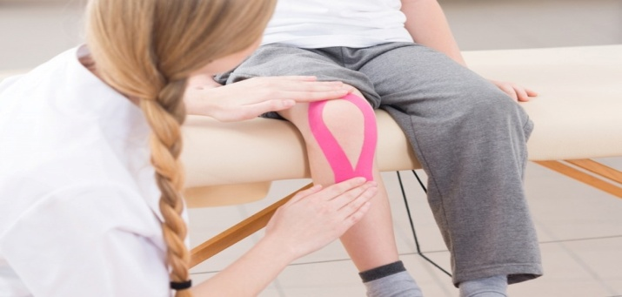 | Following Physiotherapy Protocol:  - Applying TENS and Hot pack for 10 minutes.  - Performing Knee isometric exercises with roller beneath knee joint. Straightening the leg, and maintaining the pressure for 10-15 seconds with 10 repetitions.  - Stretch was maintained on hamstrings and gastrocnemius muscles for 20 seconds, and 7 repetitions should be performed.  - Preforming Tibio-femoral glides and patellar mobilizations.  - Performing rigid on knee joint to provide stability.  In all follow ups Same procedure will be followed at day 1, 14 and 28.  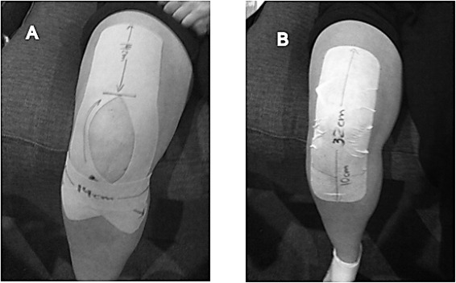
Table 2: Physiotherapy Procedure Applied

