Table 1: Schematic and optimized structures of the compounds

Name of the Compound | Molecular Structure | Optimized Structure
OrthoVanillin |  | 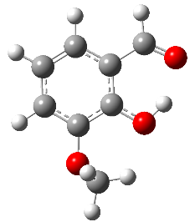
Salicylaldazine |  | 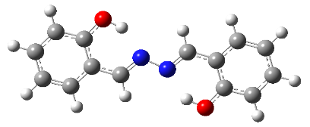
2-((E)-(ethylimino)methyl)-6 methoxy phenol  (2EM6MP) |  | 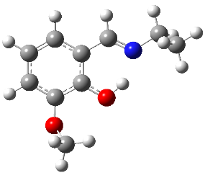
Bis 2-((E)-(ethylimino)methyl)-6 methoxy phenol (B2EM6MP) |  | 