Appendix I:

Table 7: Gender-stratified Poisson regression with robust SE analysis for problem drinking in gender-typed industries

Gender-typed Industry Categories | Men |  | Women
Gender-typed Industry Categories | aPR (95% CI) | P-value | aPR (95% CI) | P-value
Female Dominated
Health and Social Care | Ref |  | Ref
Education | 1.16 (0.66-2.02) | 0. 61 | 1.43 (1.02-2.01) | 0.04
Gender mixed
Public Administration | 0.90 (0.51-1.59) | 0.72 | 1.28 (0.86-1.90) | 0.23
Labour Intensive Services | 1.08 (0.67-1.74) | 0.74 | 1.45 (1.00-2.10) | 0.05
Knowledge-intensive Service | 1.04 (0.65-1.67) | 0.86 | 1.38 (0.92-2.07) | 0.11
Male Dominated
Goods and Energy Production | 0.92 (0.57-1.48) | 0.74 | 1.55 (0.97-2.48) | 0.07
Machinery Operations | 0.78 (0.47-1.29) | 0.33 | 1.35 (0.68-2.67) | 0.39
Adjusted for age, civil status, education

Appendix II:

Sensitivity analysis by categorising industries into three categories based on gender composition only.

Table 8: Adjusted prevalence ratio of problem drinking in Swedish workforce in gender-typed industries stratified by gender

Gender typed Industries | Total |  | Men |  | Women
Gender typed Industries | aPR (95% CI) | P- Value | aPR (95% CI) | P-Value | aPR (95% CI) | P-Value
Female-Dominated | Ref |  | Ref |  | Ref
Gender-mixed | 1.12 (0.92-1.36) | 0.26 | 0.95 (0.69-1.31) | 0.77 | 1.16 (0.91-1.49) | 0.22
Male-dominated | 1.03 (0.81-1.32) | 0.80 | 0.79 (0.56-1.12) | 0.19 | 1.27 (0.86-1.86) | 0.23
Adjusted for age, civil status, and education

Appendix III:

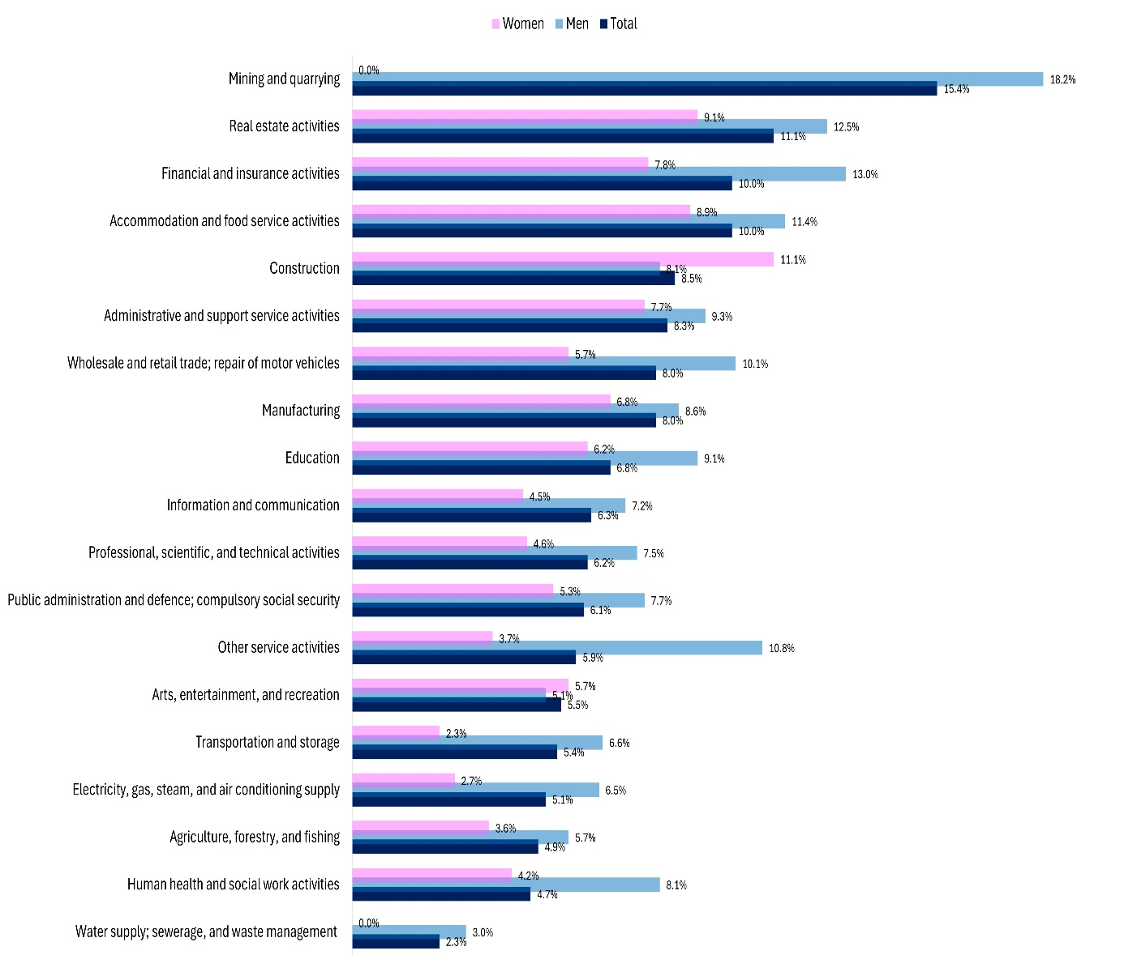

Figure 2. Prevalence of Problem Drinking in Labour Market Industries in Sweden, 2020: Overall and by Gender

