The following serves as supplementary material for the manuscript entitled:
“Landscape fragmentation and agricultural context impact pollination dynamics of native annual plants”

Authors:
Manuel Sevenello¹, Zac C. Walker¹, and Margaret M. Mayfield¹
Affiliation:
¹School of BioSciences, The University of Melbourne, Parkville, Victoria, Australia;
e-mail: jsevenellomo@student.unimelb.edu.au

Supplementary material:

Supplementary Table S1. Transect locations and remnants characteristics.
Site | Area (km²) | Transect | Crop | Species | Coordinates | Distance to crop (m)
WA12427 | 1.1 | Edge | Wheat | LARO, GORO, POAR | -29.735011, 116.562464 | 69.7
WA12427 | 1.1 | Core | Wheat | LARO, POAR, POGN | -29.735011, 116.562466 | 294.5
WA12427 | 1.1 | Core | Wheat | GORO | -29.735011, 116.562467 | 344
WA12427 | 1.1 | Edge | Canola | GORO, LARO, POAR, POGN | -29.738463, 116.556468 | 28.6
WA12427 | 1.1 | Core | Canola | LARO, GORO, POAR, POGN | -29.735011, 116.562465 | 205.1
Latham | 0.81 | Edge | Wheat | POGN | -29.775530, 116.531727 | 3.4
Latham Private | 2.72 | Edge | Wheat | POGN | -29.782675, 116.530883 | 24.2
Maya Private | 6.38 | Edge | Canola | LARO, GORO, POAR | -29.811711, 116.531683 | 48.7
Maya Private | 6.38 | Core | Canola | LARO, GORO, POAR | -29.811489, 116.530483 | 166.1
Maya | 2.53 | Edge | Canola | GORO | -29.871695, 116.515318 | 32.3
Maya | 2.53 | Core | Canola | GORO | -29.868980, 116.512725 | 184
Maya | 2.53 | Core | Wheat | POGN | -29.868831, 116.513195 | 227
Buntine | 38.03 | Edge | Wheat | LARO, POAR, POGN | -29.966992, 116.584798 | 14.5
Buntine | 38.03 | Core | Wheat | LARO, POAR, POGN | -29.972873, 116.584919 | 671.6
Buntine | 38.03 | Edge | Canola | LARO, POAR, POGN | -29.966951, 116.605115 | 25.3
Buntine | 38.03 | Core | Canola | LARO, POAR, POGN | -29.968823, 116.603641 | 275.4
Milton | 4.14 | Edge | Wheat | GORO, LARO | -30.214090, 116.823316 | 55.8
Milton | 4.14 | Core | Wheat | GORO, LARO | -30.217727, 116.819857 | 459.2
Xantippe East | 2.6 | Edge | Wheat | GORO, LARO, POAR | -30.275382, 117.031002 | 22.7
Xantippe East | 2.6 | Core | Wheat | GORO, LARO, POAR | -30.272558, 117.027148 | 332.1
Xantippe Tank | 2.07 | Edge | Canola | LARO | -30.285941, 116.970297 | 15.6
Xantippe Tank | 2.07 | Edge | Canola | POGN | -30.283872, 116.969793 | 9.6
Xantippe Tank | 2.07 | Core | Canola | LARO, POGN | -30.288813, 116.965168 | 607.2

Supplementary Table S2. Results of the glm.nb followed by multiple comparisons with glht function contrasting pollination treatments for each focal species; open (OP), open and pollen-supplemented (OPSup), bagged (Bag), and bagged and pollen-supplemented (BagSup) treatments.
Species | Pair | Estimate | Std. Error | Z | P
GORO | OP - Bag | 0.31 | 0.09 | 3.44 | 0.003
 | OP - BagSup | 0.14 | 0.09 | 1.58 | 0.359
 | OP - OPSup | -0.13 | 0.09 | -1.42 | 0.457
 | OPSup - Bag | 0.44 | 0.09 | 4.8 | < 0.001
 | BagSup - Bag | 0.17 | 0.09 | 1.85 | 0.227
 | OPSup - BagSup | 0.27 | 0.09 | 2.96 | 0.016
LARO | OP - Bag | 1.44 | 0.11 | 13.21 | < 0.001
 | OP - BagSup | 0.5 | 0.1 | 4.77 | < 0.001
 | OP - OPSup | -0.1 | 0.1 | -0.95 | 0.752
 | OPSup - Bag | 1.54 | 0.11 | 14.16 | < 0.001
 | BagSup - Bag | 0.94 | 0.11 | 8.57 | < 0.001
 | OPSup - BagSup | 0.6 | 0.1 | 5.72 | < 0.001
POAR | OP - Bag | 1.73 | 0.16 | 11.07 | < 0.001
 | OP - BagSup | 1.1 | 0.16 | 7.02 | < 0.001
 | OP - OPSup | 0.04 | 0.16 | 0.23 | 0.995
 | OPSup - Bag | 1.69 | 0.16 | 10.86 | < 0.001
 | BagSup - Bag | 0.63 | 0.16 | 4.03 | < 0.001
 | OPSup - BagSup | 1.06 | 0.16 | 6.83 | < 0.001
POGN | OP - Bag | 1.24 | 0.13 | 9.47 | < 0.001
 | OP - BagSup | 0.72 | 0.13 | 5.58 | < 0.001
 | OP - OPSup | -0.07 | 0.13 | -0.54 | 0.942
 | OPSup - Bag | 1.31 | 0.13 | 10.04 | < 0.001
 | BagSup - Bag | 0.52 | 0.13 | 3.98 | < 0.001
 | OPSup - BagSup | 0.79 | 0.13 | 6.13 | < 0.001

Supplementary Table S3. Mean seed production (±S.E.) per treatment, crop type and transect.
Species |  | Canola |  | Wheat
 | Treatment | Edge | Core | Edge | Core
LARO | Bag | 4.1 (±0.7) | 8.3 (±1.8) | 3.8 (±0.9) | 4.4 (±0.8)
 | Bag supplemented | 12.3 (±1.7) | 12.5 (±2.4) | 16.5 (±2.6) | 11.6 (±2)
 | Open | 21.5 (±3.2) | 25.2 (±3.1) | 23.4 (±4.5) | 16.7 (±2.3)
 | Open supplemented | 25.3 (±2.6) | 21.5 (±3) | 25.8 (±3.7) | 20.7 (±2.4)
GORO | Bag | 61.13 (±9.02) | 65.36 (±8.89) | 50.4 (±6.9) | 70.8 (±9.8)
 | Bag supplemented | 78.26 (±8.86) | 62.06 (±7.6) | 70.8 (±7.5) | 81.5 (±13.8)
 | Open | 90.66 (±14.22) | 67.83 (±8.59) | 78.3 (±8.9) | 101.3 (±15.9)
 | Open supplemented | 101.5 (±16.41) | 88.34 (±14.35) | 87.3 (±11.8) | 109 (±13.5)
POGN | Bag | 170.8 (±66) | 65.2 (±13.9) | 75.7 (±17.4) | 140.3 (±36.4)
 | Bag supplemented | 252.4 (±45.4) | 146.4 (±23.6) | 117.4 (±22.9) | 207.5 (±37.3)
 | Open | 552.9 (±96.8) | 364 (±53.6) | 182 (±30.4) | 401.9 (±80)
 | Open supplemented | 497.7 (±90.1) | 337.4 (±68.2) | 233.6 (±45.2) | 502.1 (±105)
POAR | Bag | 110.2 (±30.2) | 68 (±17.3) | 68.9 (±13.8) | 67.5 (±15.3)
 | Bag supplemented | 142.1 (±27.5) | 128.8 (±24.5) | 194.6 (±33.5) | 96.7 (±20)
 | Open | 443.6 (±132.7) | 349.3 (±55.6) | 462 (±71.7) | 496.9 (±101)
 | Open supplemented | 358.5 (±82.6) | 356.5 (±60.6) | 435.4 (±79.3) | 419.9 (±76.2)

Supplementary Table S4. Bee abundance and community composition sampled by the blue vane traps and plant diversity per transect.
Site | Transect | Crop | Honeybees | Native bees | Bee abundance | Bee species | Bee Hill-Shannon | Plant species | Plant Hill-Shannon
Buntine | Core | Wheat | 10 | 1 | 11 | 2 | 1.36 | 16 | 10.3
Buntine | Edge | Wheat | 0 | 1 | 1 | 1 | 1 | 12 | 10.46
Buntine | Core | Canola | 29 | 12 | 41 | 4 | 2.16 | 14 | 6.21
Buntine | Edge | Canola | 1 | 5 | 6 | 5 | 4.76 | 14 | 10.13
Latham | Edge | Wheat | 12 | 4 | 16 | 5 | 2.48 | 12 | 5.72
Latham (private) | Edge | Wheat | 9 | 3 | 12 | 4 | 2.31 | 8 | 5.73
Maya (private) | Edge | Canola | 9 | 5 | 14 | 2 | 1.92 | 15 | 10.42
Maya (private) | Core | Canola | 16 | 6 | 22 | 3 | 2.09 | 15 | 8.73
Maya | Core | Canola | 42 | 9 | 51 | 10 | 2.35 | 14 | 9.96
Maya | Edge | Canola | 28 | 9 | 37 | 6 | 2.46 | 11 | 6.73
Milton | Core | Wheat | 11 | 2 | 13 | 3 | 1.71 | 12 | 6.28
Milton | Edge | Wheat | 14 | 2 | 16 | 2 | 1.28 | 13 | 8.94
WA12427 | Core | Canola | 14 | 10 | 24 | 4 | 2.92 | 16 | 8.88
WA12427 | Edge | Canola | 35 | 5 | 40 | 4 | 1.66 | 15 | 7.92
WA12427 | Core | Wheat | 4 | 4 | 8 | 3 | 2.65 | 12 | 8.11
WA12427 | Edge | Wheat | 6 | 6 | 12 | 4 | 3.32 | 13 | 8.53
Xantippe East | Core | Wheat | 2 | 2 | 4 | 3 | 2.87 | 16 | 8.62
Xantippe East | Edge | Wheat | 2 | 4 | 6 | 3 | 3 | 13 | 5.77
Xantippe Tank | Core | Canola | 3 | 12 | 15 | 3 | 2.02 | 8 | 6.65
Xantippe Tank | Edge | Canola | 4 | 5 | 9 | 5 | 4 | 10 | 8.27

Supplementary Table S5. Results of the GLM with plant diversity, all bee species diversity (including honeybees), and only native bee diversity as a response variable and crop type, landscape position, and patch area as independent variables.
Plant diversity  (Hill-Shannon index) | Estimate | Std. error | Z | P
Crop (wheat) | -0.52 | 0.75 | -0.70 | 0.496
Position (edge) | -0.02 | 0.75 | -0.02 | 0.983
Patch area | 0.04 | 0.03 | 1.66 | 0.117
Bee diversity
(Hill-Shannon index)
Crop (wheat) | -0.48 | 0.42 | -1.13 | 0.273
Position (edge) | 0.37 | 0.42 | 0.87 | 0.400
Patch area | 0.01 | 0.01 | -0.34 | 0.742
Native bee diversity
(Hill-Shannon index)
Crop (wheat) | -1.20 | 0.83 | -1.45 | 0.167
Position (edge) | 0.23 | 0.83 | 0.28 | 0.787
Patch area | -0.03 | 0.03 | -1.03 | 0.318

Supplementary Table S6. Results of the GLM with bee abundance (native bees, honeybees, and all bees) as a response variable and crop type, landscape position, and patch size as independent variables.
Native bee | Estimate | Std. error |  | Z |  | P
Crop (wheat) | -1.46 | 0.36 | -4.04 |  | < 0.001
Position (edge) | -0.52 | 0.23 | -2.24 |  | 0.025
Patch size | -0.01 | 0.01 | -0.72 |  | 0.472
Crop x position | 0.90 | 0.47 | 1.94 |  | 0.052
Honeybee
Crop (wheat) | -1.11 | 0.22 | -5.16 |  | < 0.001
Position (edge) | -0.30 | 0.15 | -2.00 |  | 0.046
Patch size | -0.01 | 0.01 | -1.75 |  | 0.089
Crop x position | 0.33 | 0.29 | 1.16 |  | 0.245
All bees
Crop (wheat) | -1.21 | 0.19 | -6.55 |  | < 0.001
Position (edge) | -0.37 | 0.13 | -2.90 |  | 0.003
Patch size | -0.01 | 0.01 | -1.86 |  | 0.063
Crop x position | 0.50 | 0.24 | 2.04 |  | 0.042

Supplementary Table S7. Results of the SEM for each focal plant species showing the direct and indirect interactions between the response variable seed set and the predictors from the best model.
Focal species | Response | Predictor | Estimate | Std. Error | DF | Crit Value | P | Std. Estimate
GORO | Seeds | Canola | 0.92 | 0.40 | 113 | 2.31 | 0.014 | 0.56
R²= 17 | Seeds | Position (core) | 0.94 | 0.40 | 113 | 2.37 | 0.018 | 0.57
 | Seeds | Patch size | -0.09 | 0.03 | 113 | -2.61 | 0.009 | -0.20
 | Seeds | PCA2 | 0.10 | 0.06 | 113 | 1.62 | 0.104 | 0.13
 | Seeds | Crop x position | -0.63 | 0.25 | 113 | -2.53 | 0.012 | 0.83
R²= 71 | All bees | Canola | 0.63 | 0.14 | 114 | 4.33 | < 0.001 | 0.43
 | All bees | Position (core) | -0.71 | 0.17 | 114 | 4.1 | < 0.001 | -0.48
 | All bees | Patch size | -0.09 | 0.01 | 114 | -8.9 | < 0.001 | -0.24
 | All bees | Crop x position | 0.39 | 0.10 | 114 | -4.05 | < 0.001 | 0.58
LARO | Seeds | Canola | -0.26 | 0.45 | 151 | 0.47 | 0.523 | -0.15
R²= 23 | Seeds | Position (core) | -0.37 | 0.42 | 151 | 0.88 | 0.378 | -0.21
 | Seeds | Patch size | -0.01 | 0.01 | 151 | -3.21 | 0.001 | -0.24
 | Seeds | All bees | 0.02 | 0.01 | 151 | 2.43 | 0.015 | 0.22
 | Seeds | PCA1 | -0.13 | 0.05 | 151 | -2.46 | 0.014 | -0.19
 | Seeds | Crop x position | 0.16 | 0.16 | 151 | 0.60 | 0.552 | 0.20
R²= 40 | All bees | Canola | 0.31 | 0.27 | 153 | 0.60 | < 0.001 | 0.21
 | All bees | Position (core) | -0.36 | 0.16 | 153 | 2.14 | 0.023 | -0.24
 | All bees | Patch size | -0.001 | 0.01 | 153 | -0.98 | 0.329 | -0.03
 | All bees | Crop x position | 0.36 | 0.09 | 153 | 4.00 | < 0.001 | 0.53
POAR | Seeds | Canola | -0.45 | 0.67 | 110 | -1.39 | 0.455 | -0.25
R²= 20 | Seeds | Position (core) | 0.22 | 0.60 | 110 | -0.37 | 0.713 | 0.12
 | Seeds | Patch size | -0.01 | 0.01 | 110 | -2.22 | 0.026 | -0.23
 | Seeds | All bees | 0.03 | 0.01 | 110 | 3.04 | 0.002 | 0.45
 | Seeds | PCA1 | 0.11 | 0.08 | 110 | 1.41 | 0.159 | 0.16
 | Seeds | Crop x position | -0.16 | 0.38 | 110 | 0.41 | 0.680 | -0.19
R²= 57 | All bees | Canola | 0.78 | 0.18 | 112 | 9.39 | < 0.001 | 0.46
 | All bees | Location (core) | -0.18 | 0.20 | 112 | 0.88 | 0.381 | -0.10
 | All bees | Patch size | -0.01 | 0.01 | 112 | -2.43 | 0.015 | -0.07
 | All bees | Crop x position | 0.27 | 0.11 | 112 | -2.46 | 0.014 | 0.35
POGN | Seeds | Canola | 2.21 | 0.52 | 112 | 4.22 | 0.013 | 0.75
R²= 33 | Seeds | Position (core) | 1.89 | 0.53 | 112 | 3.59 | < 0.001 | 0.65
 | Seeds | All bees | -0.01 | 0.01 | 112 | -0.02 | 0.984 | -0.01
 | Seeds | Floral abundance | 0.01 | 0.01 | 112 | 3.85 | < 0.001 | 0.22
 | Seeds | Crop x position | 1.16 | 0.33 | 112 | 3.54 | < 0.001 | -0.87
R²= 25 | All bees | Canola | 1.07 | 0.15 | 112 | 7.01 | 0.027 | 0.55
 | All bees | Position (core) | 1.30 | 0.15 | 112 | 8.61 | < 0.001 | 0.67
 | All bees | Patch size | -0.01 | 0.01 | 112 | -7.87 | < 0.001 | -0.18
 | All bees | Floral abundance | -0.01 | 0.01 | 112 | -4.29 | < 0.001 | -0.09
 | All bees | Crop x position | -0.45 | 0.09 | 112 | -5.07 | < 0.001 | -0.51

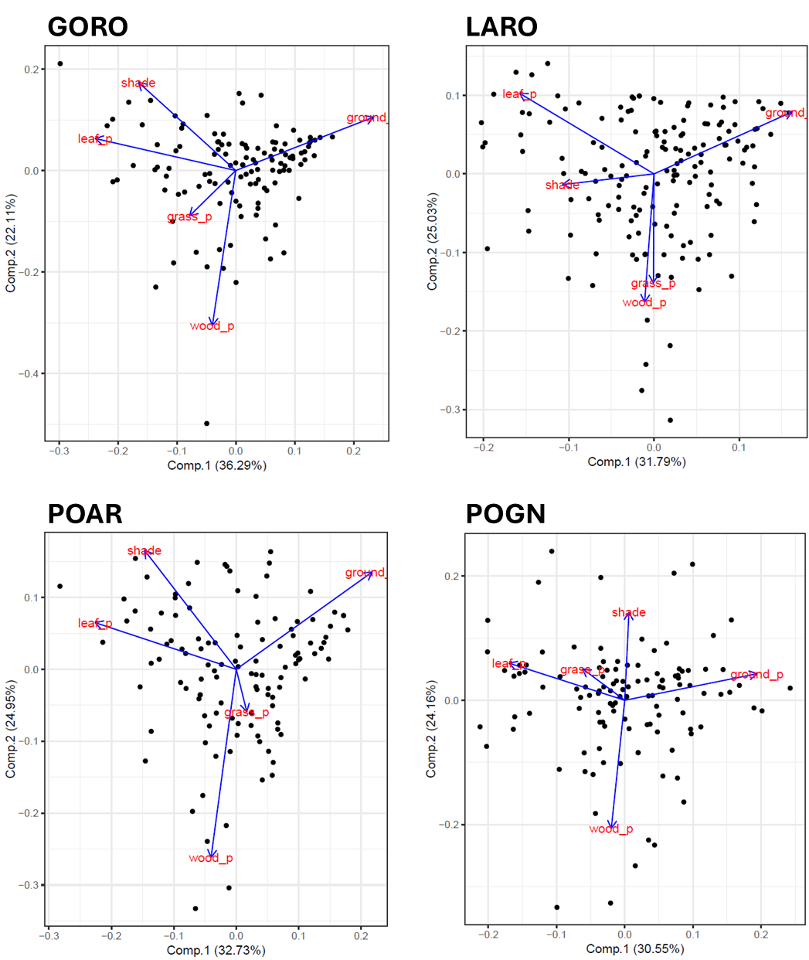
Supplementary Figure S1. Principal component analysis of local environmental factors (shade, grass, bare ground, wood, and leaf litter cover percentage) of each plot. Each panel represent a PCA biplot for different species: Goodenia rosea (GORO); Lawrencella rosea (LARO); Podolepis aristata (POAR); and Podotheca gnaphaloides (POGN). The first two principal components PCA1 (Comp 1) and PCA2 (Comp 2) explain on average across species 32% and 24% of the total variance, respectively. Vectors in blue show the direction of the local environmental variables. PCA1 and PCA2 axes for each species were used in our SEMs to account for plot level environmental factors.

