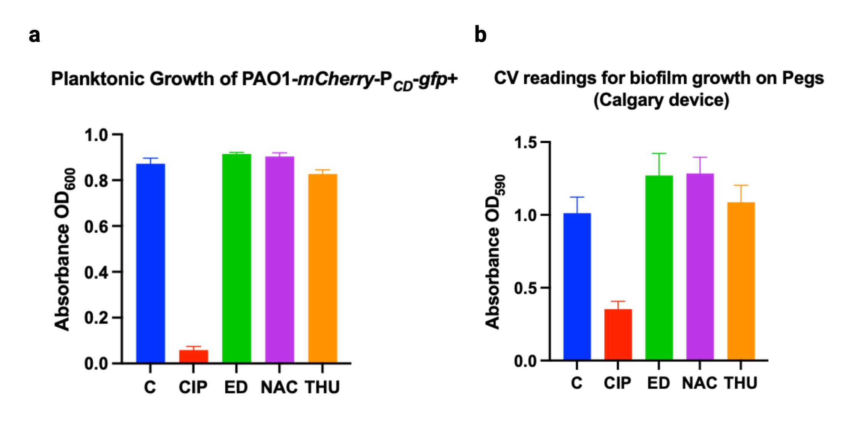

Fig. S1: The antioxidants used in the current study were tested for their effect on the growth of bacteria both planktonically a and in biofilm form b using the following concentrations (CIP+ ED 300 uM, CIP+NAC 2mM, and CIP+THU 100mM) and CIP= 0.02 ug/ml in the planktonic growth and 0.25 ug/ml for the Calgary biofilm growth on plastic peg lids.

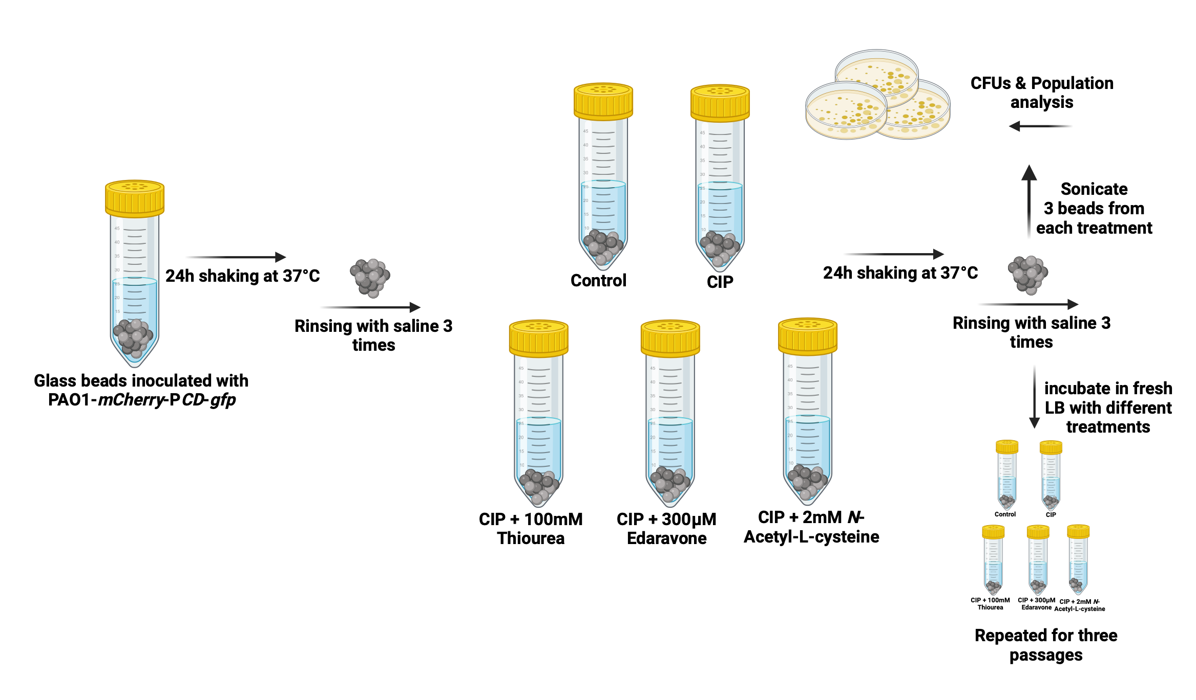

Fig. S2: Experimental setup for glass beads evolution study. The inoculated LB was incubated overnight in the presence of glass beads on a shaker at 37°C for 24h. The beads were then washed three times with saline, and fresh LB medium either without treatment, with CIP, or with a combination of CIP-AO treatment was added to the different falcon tubes (1ml/Bead). The tubes were then incubated for another 24h followed by washing, and then sonicated, the harvested bacterial populations after sonication were serially diluted and used for CFU counting and population analysis.

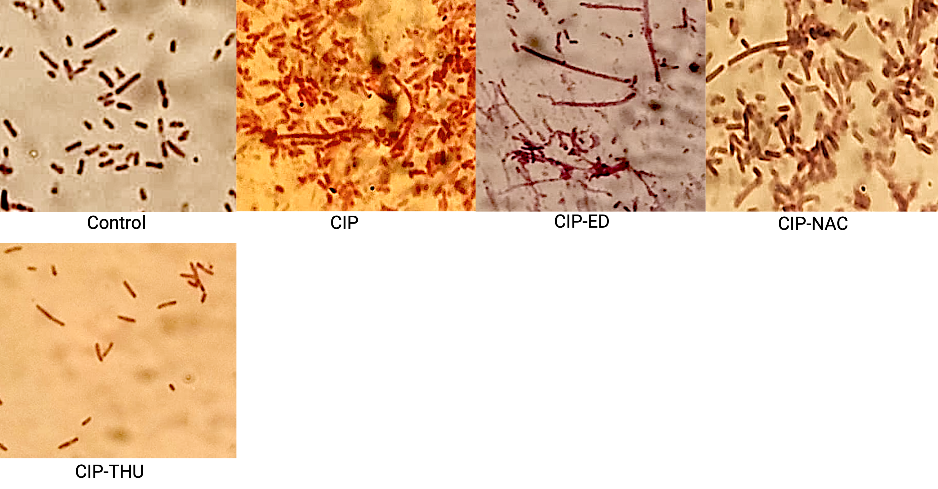
Fig. S3: Gram staining of PAO1-mCherry-P_{CD}-gfp+ from the last passage of a planktonic evolution experiment after exposure to different treatments.

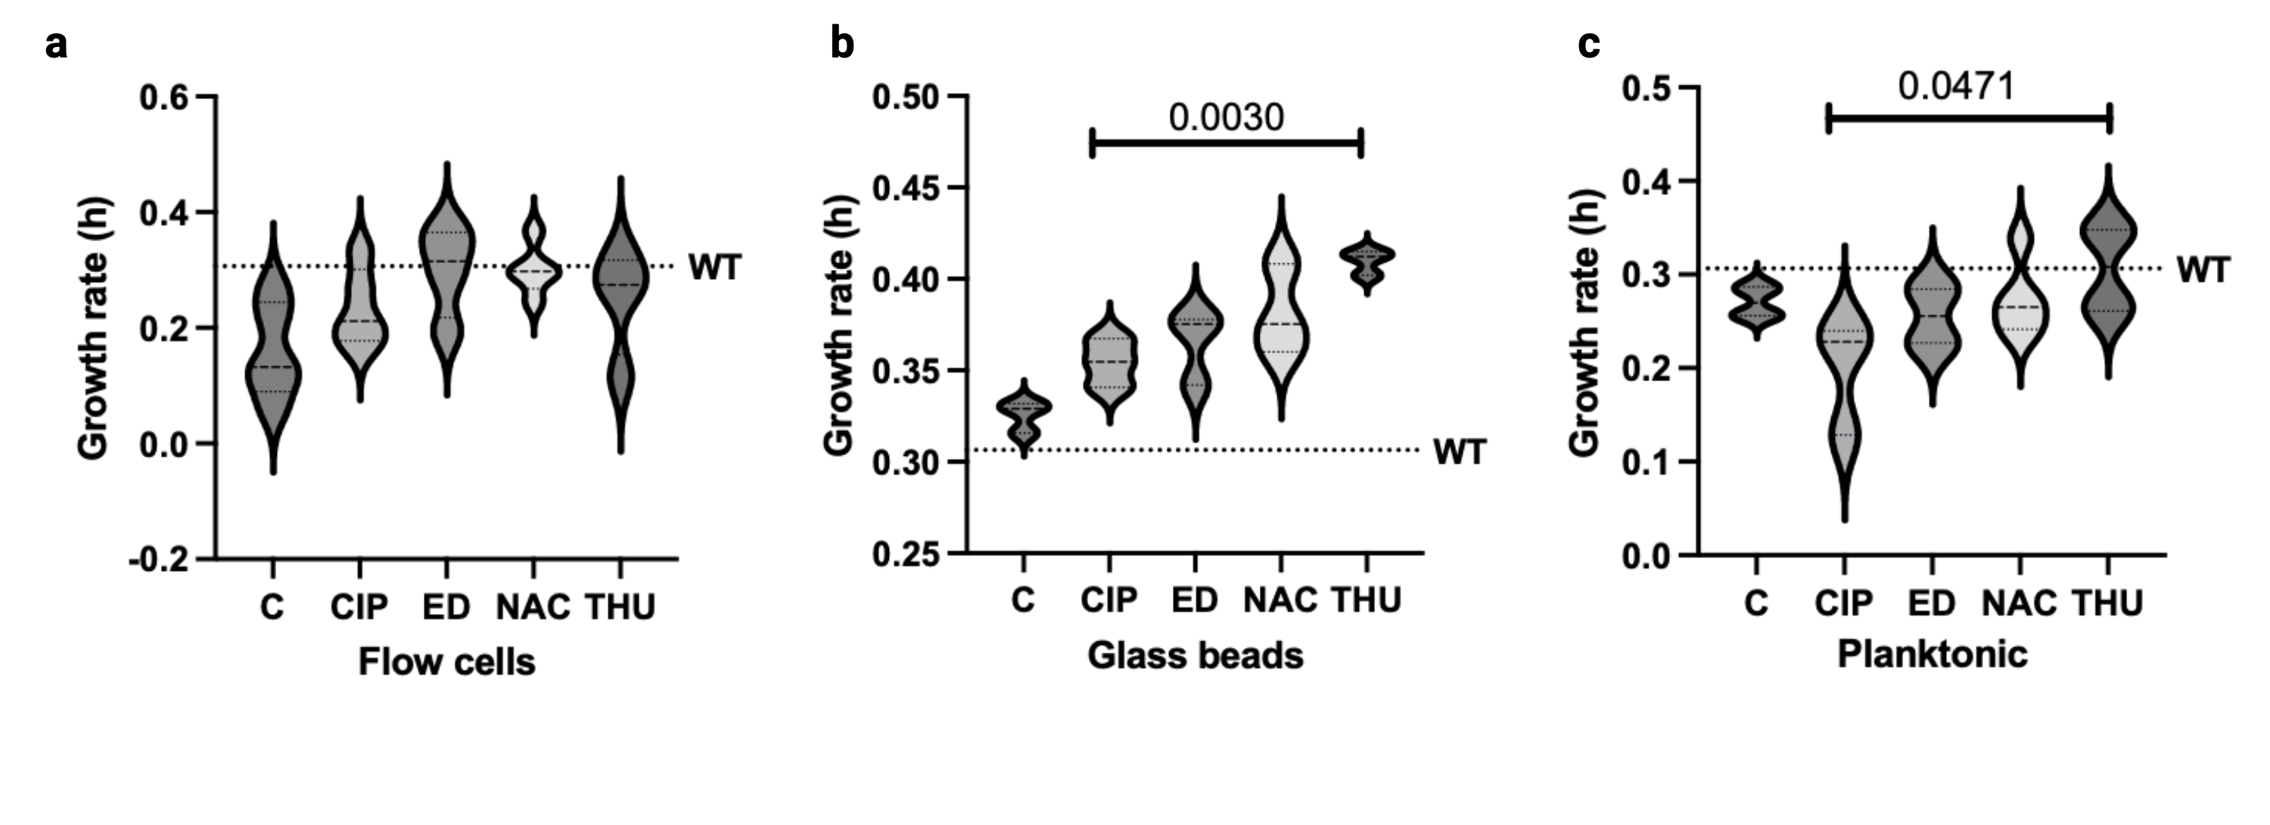
Fig. S4: Growth rates calculated from growth curves of selected isolates from the highest CIP plates of different PAP in three studied evolution experiments. The plate was incubated in an Infinite F200 Pro plate reader (Tecan) with the lid on, maintaining a temperature of 37 ºC and shaking at 225 rpm for 24 h. Absorbance (OD₆₀₀ nm) was measured using Magellan V 7.2 software, every 20 min during 24 h incubation. Growth rates were calculated from growth curves using the Gompertz fitting model.

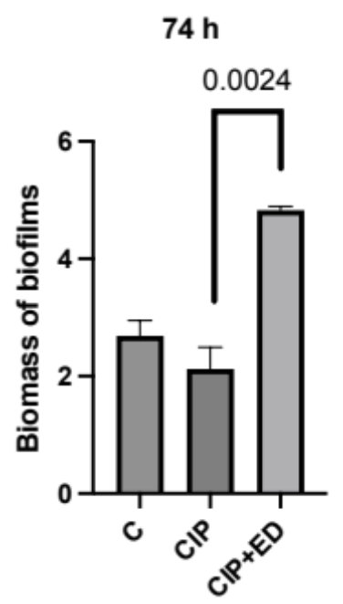

Fig S5: Total biofilm biomass in flow cells experiment represented in Fig. 4

