Online Data Supplement

Effects of ceramide accumulation in cardiomyocytes derived from human-induced pluripotent stem cells on mitochondrial function and mitophagy
Mohamed Bekhite^{1*}, Andres González Delgado¹, Tom Kretzschmar¹, Tina Müller², Jasmine M.F. Wu¹, Tarek Bekfani¹, Marcus Franz¹, Maria Wartenberg¹, Markus Gräler², Boris Greber³, P. Christian Schulze¹
¹Department of Internal Medicine I, Division of Cardiology, University Hospital Jena, FSU, Jena, Germany
²Clinic for Anesthesiology and Intensive Care Medicine, University Hospital Jena, FSU, Jena, Germany
³Max Planck Institute for Molecular Biomedicine, Münster, Germany

SUPPLEMENTAL MATERIAL AND METHODS
Maintenance of h-iPSCs
H-iPSCs were generated from fibroblasts using Sendai viruses carrying Oct3/4, Sox2, Nanog, and Lin28 factors (Life Technologies, Carlsbad, CA). The full characterization of h-iPSC was performed as described previously [1, 2]. The cells were expanded in cell culture flask 75 cm² without feeder cells in 1:80 diluted matrigel (BD Biosciences, Heidelberg, Germany), in essential 8 medium (Thermo Fisher Scientific, Darmstadt, Germany). Cells culture was carried out at 37 °C in a humidified environment containing 5% Co₂. Confluent h-iPSCs were washed with phosphate-buffered saline (PBS) without calcium and passaged by using ReLeSR (Thermo Fisher Scientific) according to supplied protocol and seeded out into matrigel-coated 6-well plates for differentiation in 2D, 3-4 million cells per well in essential 8 medium containing 19 µmol/L ROCK inhibitor Y-27632 (Santa Cruz Biotechnologies, Santa Cruz, CA).

Differentiation of h-iPSCs into CMs
Differentiation of h-iPSCs into CMs as the protocol described her efficiently directs h-iPSCs to produce a high yield CMs in 7 days from the h-iPSC without cell sorting or selection (Fig. S1). In brief, the h-iPSCs cultured in RPMI media (Thermo Fisher Scientific) supplemented with 4 ng/ml BMP4 (R&D Systems, Wiesbaden, Germany), 5 ng/ml activin-A (eBioscience, San Diego, CA), 2µM CHIR99021 (Axon Medchem BV, Groningen, Netherlands), and 1% B-27TM Supplement. The cells were then cultured in RPMI media (Thermo Fisher Scientific) supplemented with 4 ng/ml BMP4 (R&D Systems), 2% B-27TM Supplement (Thermo Fisher Scientific) and 2µM IWP-2 (Santa Cruz Biotechnologies, Santa Cruz, CA). Three days later, the cells were then cultured in RPMI media (Life Technologies) supplemented with 256 µg/ml ascorbic acid (Sigma-Aldrich, Taufkirchen, Germany) and 2% B27™ supplement (Thermo Fisher Scientific).

Recapitulate a lipotoxic cardiomyopathy phenotype in vitro
The h-iPSCs-derived-CMs were exposed to a diabetic-like environment to mimic lipotoxic cardiomyopathy [3]. To understand controlling cellular metabolism, CMs were exposed to either standard manufacturer’s maintenance medium (SM) or diabetic medium (DM) for 3 days. The DM was composed of 10 µg/mL insulin, 0.2 mM FAs (palmitic acid conjugated to BSA), 10 mmol/L glucose, 10 nmol/L endothelin-1 and 1µmol/L cortisol in DMEM.

Treatment with inhibitors
CMs differentiated from h-iPSCs were incubated in the presence or absence of DM with myriocin (0.5 µmol/L), rotenone (0.5 µmol/L) (both are from Sigma-Aldrich), Bisindolylmaleimide I (BIM-1, 10 nmol/L) (Calbiochem, Bad Soden, Germany, or with inhibitors of protein phosphatase 2A (PP2A) by using okadaic acid (100 pmol/L) (Santa Cruz Biotechnology) were used in the study.

Flow cytometry (FCM) analysis
Cells were collected using TrypLE (GIBCO, Karlsruhe, Germany) and Fixed with cold 4% para-formaldehyde, pH 7.4. CMs for FCM were incubated for 30 min with the primary antibodies (Table S1) and thereafter re-incubated for 20 min with either a CY3- or CY5 conjugated secondary antibody after washing with PBS supplemented with 2% FBS (Merck-Millipore, Darmstadt, Germany). FCM was carried out using a FACS Calibur (BD, Heidelberg, Germany).

Calcium transient quantification
Intracellular calcium (Ca²⁺) transient was measured in plated CM in serum-free medium at 37 °C loaded with 10 µmol/L fluo-4-AM (Molecular Probes, Karlsruhe, Germany) as previously described [4]. Changes in fluo-4- fluorescence was performed using a confocal laser scanning microscope (cLSM) 510 (Zeiss: Jena, Germany). Traces were analyzed to count the frequency of calcium transients using cLSM analysis software.

Lipid accumulation and ceramide content
The intracellular lipids were visualized by using BODIBY staining (Thermo Fisher Scientific) according to the manufacturer’s instruction. Ceramide content was determined by using mass spectrometry-based analysis for ceramide subspecies analysis. Measurements were performed using liquid chromatography coupled to triple-quadrupole mass spectrometry as previously described [5] . For detection, the QTrap triple-quadrupole mass spectrometer (Sciex, Darmstadt, Germany) interfaced with the Merck-Hitachi Elite LaChrom series 3.1.3 chromatography and autosampler (VWR, Darmstadt, Germany) was used and analyzed using Analyst 1.6.2 (Sciex).

Mitochondrial Superoxide staining
The superoxide production was measured by the fluorescent dye MitoSOX™ green (Thermo Fisher Scientific) following the manufacturer’s instruction, for live-cell imaging. Fluorescence imaging was performed using cLSM 510 (Zeiss). The intensities of fluorescence were quantified with cLSM-ZEN analysis software.

Seahorse metabolic profiling
Mitochondrial respiration and a complete bioenergetics profile were evaluated using a Seahorse XF96 analyzer (Seahorse Biosciences/Agilent Technologies, Waldbronn, Germany). The oxidative phosphorylation was measured through oxygen consumption rate (OCR) and glycolysis was measured though the extracellular acidification rate (ECAR). The system uses a plate combined with a sensor cartridge containing sensor probes (fluorophores) that are sensitive to either O₂ or H⁺.
The h-iPSCs-derived-CMs as a single cell was plated on XF96 microplates (Seahorse Biosciences/Agilent Technologies) at 3.0 × 10⁴ cells/well in the media and kept at 37 °C in a 5% CO2 humidified atmosphere 24 hours before assayed or SPTLC1 transfection. The CM respiration was assayed under basal conditions and after addition of electron transport chain inhibitors as following: mitochondrial inhibitor oligomycin (2 µmol/L), mitochondrial uncoupler carbonylcyanide p-trifluoromethoxyphenylhydrazone (FCCP; 0.3 μmol/L), and a respiratory chain inhibitor antimycin A (0.5 µmol/L) and rotenone (0.5 µmol/L). Respiratory parameters for values were quantified according to Seahorse Biosciences software.

Immunofluorescence studies
CMs were fixed for 30 min with methanol-acetone at -20 °C or 4% para-formaldehyde 4 °C and permeabilized if necessary for 10 min with PBS containing 0.1 Triton X-100 (PBST) (Sigma-Aldrich). Blocking against unspecific binding was performed using 0.01% PBST containing 10% milk for 1 h. CMs ore single cells were incubated with the respective primary antibody (Table S1) for 2 h at room temperature. After washing, samples were incubated with either a CY3- or CY5 (Merck-Millipore, Darmstadt, Germany) for 60 min. Nuclei were stained with Hoechst 33342 (Thermo Fisher Scientific). Immunofluorescence was recorded using a cLSM (Zeiss).

Western blot analysis
Samples were washed twice in ice-cold PBS and lysed in riba lysis buffer as described previously [6]. Protein aliquots (20 µg/lane) were separated in 8% or 12% SDS gels and transferred onto a nitrocellulose membrane. The membrane blocked with 5% BSA and incubated overnight at 4 C with primary antibodies (Table S1). Immunoreactive bands were visualized by using peroxidase-conjugated secondary antibody, ECL detection kit (Amersham, Freiburg, Germany) and captured by a digital imaging system LAS 3000 (Fujifilm, Tokyo, Japan).

Mitochondrial and lysosomes dynamics analysis
Cell was preincubated with MitoTracker green FM to detect mitochondria and LysoTracker™ Deep Red to detect lysosomes (both are from Thermo Fisher Scientific) following the manufacturer’s instruction. Images were captured with a cLSM 510 (Zeiss), using ZEN image software (Zeiss) with the X-40 oil objective. Each experiment was done 3-5 times and 15-20 cells were quantified. Within an image, four regions of interest of equal area were defined; mitochondrial and lysosomes positive area and colocalization analysis were measured using ZEN image software (Zeiss).

Real-time-polymerase chain reaction (RT-PCR)
Total RNA of h-iPSCs-derived-CM was prepared using QIAshredder columns and an RNeasy mini kit (both from QIAGEN, Hilden, Germany) as described previously [7]. PCR amplification was performed using the primer sets as in Table S2. RNA samples were analyzed in triplicate, and the mean value was calculated. For gene expression detection, Power SYBR Green PCR Master Mix (Thermo Fisher Scientific) was used. Expression value was calculated by normalizing the CT values of a tested gene to the CT values of RNA Binding Protein With Serine-Rich Domain 1 (RNPS1), as an internal standard gene, using the ΔΔCT-method.

Statistical analysis
The results depicted as an average of at least three independent experiments. Data are presented as mean values ± SD. GraphPad Prism 8 (GraphPad Software Inc., San Diego, USA) was applied for unpaired t-test, one-way and two-way ANOVA multiple comparisons data as appropriate. The p-value was considered < 0.05 significant.

Results
Inhibition of ceramide accumulation rescues morphological and function in diabetic CMs
Okadaic acid as an inhibitor of the PP2A pathway reduced diabetic-induced CMs intracellular lipid droplet accumulation (1660.87±228.72 µm² in DM versus 1030.42±309.40 µm² in DM with myriocin, p<0.025) and (1660.87±228.72 µm² in DM versus 533.36±153.48 µm² in DM with okadaic, p<0.001) (Fig. S2a and S2b). CMs only showed a rescue in cell area by inhibiting PP2A activation compared with the cells exposed the DM (2872.90±526.86 µm² in DM versus 1513.03±301.72 µm² in DM with okadaic, p<0.001) (Fig. S2a and S2b).
We next tested whether the increase the ROS production is dependent on the accumulation of ceramide or PP2A activity or the mitochondrial dysfunction. The SPT inhibitor, myriocin, inhibit the DM-induced mitochondrial superoxide production (2.3±0.2 in DM to 1.3±0.4 in DM with myriocin, p<0.001) (Fig. S2d and S2e). Similarly noticed when PP2A inactivated by an okadaic acid inhibitor (2.3±0.2 in DM versus 1.25±0.18 in DM with okadaic, p<0.001) (Fig. S2d and S2E). Further, assessment of mitochondrial complex I antioxidant, rotenone inhibitor, did not abolish (2.3±0.2 in DM versus 1.93±0.13 in DM with rotenone, p=0.6) the superoxide production (Fig. S2d and S2e), indicating that ceramide-PP2A pathway upstream of oxidative stress. As apoptosis indicator, active caspase-3 was significantly reduced by inhibiting the SPT with myriocin (2.4±0.11 in DM versus 1.6±0.4 in DM with myriocin, p<0.02) (Fig. S2f) or PP2A with okadaic acid (2.4±0.11 in DM versus 0.49±0.11 in DM with okadaic, p<0.001) (Fig. S2f).

SUPPLEMENTAL TABLES
Table S1. List of antibodies used in this study
Antibody |  | Host | Supplier
Light chain 3B(LC3B) |  | rabbit | Abcam
SPTLC1 |  | rabbit | Abcam
SPTLC2 |  | rabbit | Abcam
Caspase-3 |  | rabbit | Cell Signalling Technology
Cleaved Caspase-3 |  | rabbit | Cell Signalling Technology
CerS1 |  | rabbit | Abcam
CerS2 |  | rabbit | Abcam
LASS4 (CerS4) |  | rabbit | Abcam
LASS5 (CerS5) |  | rabbit | Abcam
LASS6 (CerS6) |  | mouse | Abcam
Protein kinase B (Akt) |  | rabbit | Abcam
P-AKT (Ser473) |  | rabbit | Abcam
AMPK |  | rabbit | Cell Signalling Technology
p-AMPKα |  | rabbit | Cell Signalling Technology
α-actinin |  | mouse | Sigma-Aldrich
MYL2 (MLC2v) |  | rabbit | Abcam
PPARα |  | rabbit | Abcam
PPARγ |  | rabbit | Abcam
GLUT-4 |  | rabbit | Abcam
Vinculin |  | rabbit | Abcam
PINK-1 |  | rabbit | Abcam
PGC-1 |  | rabbit | Abcam
 | Abcam, Cambridge, UK
 | Cell Signalling Technology, Frankfurt, Germany
 | Sigma-Aldrich, Taufkirchen, Germany

Table S2 List of human primers used in this study
Primer |  | Sequence | Size (bp)
CerS1 | Sense | 5'-CAATGTGGGCATCCTTGT-3' | 89
CerS1 | Antisense | 5'-CGCGGGACTTGAAGTAAAT-3' | 89
CerS2 | Sense | 5'-GGCCGTCATTGTGGATAAA-3' | 93
CerS2 | Antisense | 5'-TACCAATACTGGGAAGGGATAG-3' | 93
CerS4 | Sense | 5'-CTTCTTCGGCTACTACTTCTTC-3' | 117
CerS4 | Antisense | 5'-TCCATCTGGCCCTTCTT-3' | 117
CerS5 | Sense | 5'-CCTACAGCTTCTGCATGTC-3' | 93
CerS5 | Antisense | 5'-CTGCGATCATCCTTCGATAC-3' | 93
CerS6 | Sense | 5'-GGCTAAGCACAGGTCATAAG-3' | 95
CerS6 | Antisense | 5'-CCCTATGCTCAACATCCATAG-3' | 95
Akt1 | Sense | 5'- GCTACTTCCTCCTCAAGAATG-3' | 101
Akt1 | Antisense | 5'-CGCCACAGAGAAGTTGTT-3' | 101
Akt2 | Sense | 5'-CAAACTGTCCTCACCCTATG-3' | 94
Akt2 | Antisense | 5'-TGGAAGGAAGCCCTAGTAA-3' | 94
SLC2A4 (GLUT4) | Sense | 5'-GCCATGAGCTACGTCTCCATT-3' | 90
SLC2A4 (GLUT4) | Antisense | 5'-GGCCACGATGAACCAAGGAA-3' | 90
CD36 | Sense | 5'-GGTGATGAGAAGGCAAACA-3' | 94
CD36 | Antisense | 5'-CCACACCAACACTGAGTAAG-3' | 94
PDK4 | Sense | 5'-TCAGACAGAGGAGGTGGTGTT-3' | 117
PDK4 | Antisense | 5'-AAAACCAGCCAAAGGAGCATTC-3' | 117
DGAT1 | Sense | 5'-GGTCCCCAATCACCTCATCTG-3' | 165
DGAT1 | Antisense | 5'-TGCACAGGGATGTTCCAGTTC-3' | 165
DGAT1 | Sense | 5'-CCTCATAGCCGCCTACTCCG-3' | 122
DGAT1 | Antisense | 5'-ATCCAGTGCCCCATCTCCCA-3' | 122
CPT1ß | Sense | 5'- CATGTATCGCCGTAAACTGGAC-3' | 78
CPT1ß | Antisense | 5'-TGGTAGGAGCACATAGGCACT-3' | 78
BNP | Sense | 5'-CCTCCTGGTTTCCTCTAAACTG-3' | 98
BNP | Antisense | 5'-GCCTCAGTTTCCTCATCTGTAA-3' | 98
MFF | Sense | 5'-ACTGAAGGCATTAGTCAGCGA-3' | 144
MFF | Antisense | 5'- TCCTGCTACAACAATCCTCTCC -3' | 144
OPA1 | Sense | 5'-TGTGAGGTCTGCCAGTCTTTA-3' | 141
OPA1 | Antisense | 5'-TGTCCTTAATTGGGGTCGTTG-3' | 141
DRP1 | Sense | 5'- TTTGACACTTGTGGATTTGCCA-3' | 132
DRP1 | Antisense | 5'- AGTGACAGCGAGGATAATGGA-3' | 132
MFN2 | Sense | 5'-GGCAGCAGAGGCGTAAGG-3' | 199
MFN2 | Antisense | 5'-GTCCTGACTTCACCTTCCCG-3' | 199
PPARα | Sense | 5'-GGTCTCATGGCTGTTAGATG-3' | 99
PPARα | Antisense | 5'-CCCAGGTCTTAGTTTGCTATC-3' | 99
PPARγ | Sense | 5'-GGAGTCCACGAGATCATTTAC-3' | 115
PPARγ | Antisense | 5'-GCTTTCGCAGGCTCTTTA -3' | 115
SERCA2a | Sense | 5'-CATCAAGCACACTGATCCCGT-3' | 107
SERCA2a | Antisense | 5'-CCACTCCCATAGCTTTCCCAG-3' | 107
PGC-1α | Sense | 5'-GGCTGTCGGAAGACACCCTC-3' | 155
PGC-1α | Antisense | 5'-GCAGTCCAGGGGCAGAAAAGT-3' | 155
RNPS1 | Sense | 5'-TCCCGCTCCAAATCCAAACC-3' | 101
RNPS1 | Antisense | 5'-CGGGTGAGTCTCCCAATGTG-3' | 101

SUPPLEMENTAL MOVIES AND FIGURES

Online movie 1. The beaten of 28-day-old h-iPSCs-derived-CMs cultured in SM.

Online movie 2. The beaten of 28-day-old h-iPSCs-derived-CMs cultured in DM for 3 days.

Online movie 3. Calcium transient detected by fluo-4 fluorescence in 28-day-old h-iPSCs-derived-CMs cultured in SM.

Online movie 4. Calcium transient detected by fluo-4 fluorescence in 28-day-old h-iPSCs-derived-CMs cultured in DM.

Fig. S1
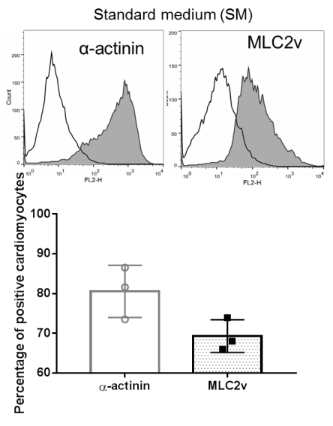
Fig. S1: Percentage of CMs markers using flow cytometry (FCM) analysis. 28-day-old CMs positive cells showed α-actinin and ventricular marker myosin regulatory light chain 2 (MLC2v) positive cells from the total number of cells. Graph under the FCM chart show mean values (± SD) of n=3.

Fig. S2
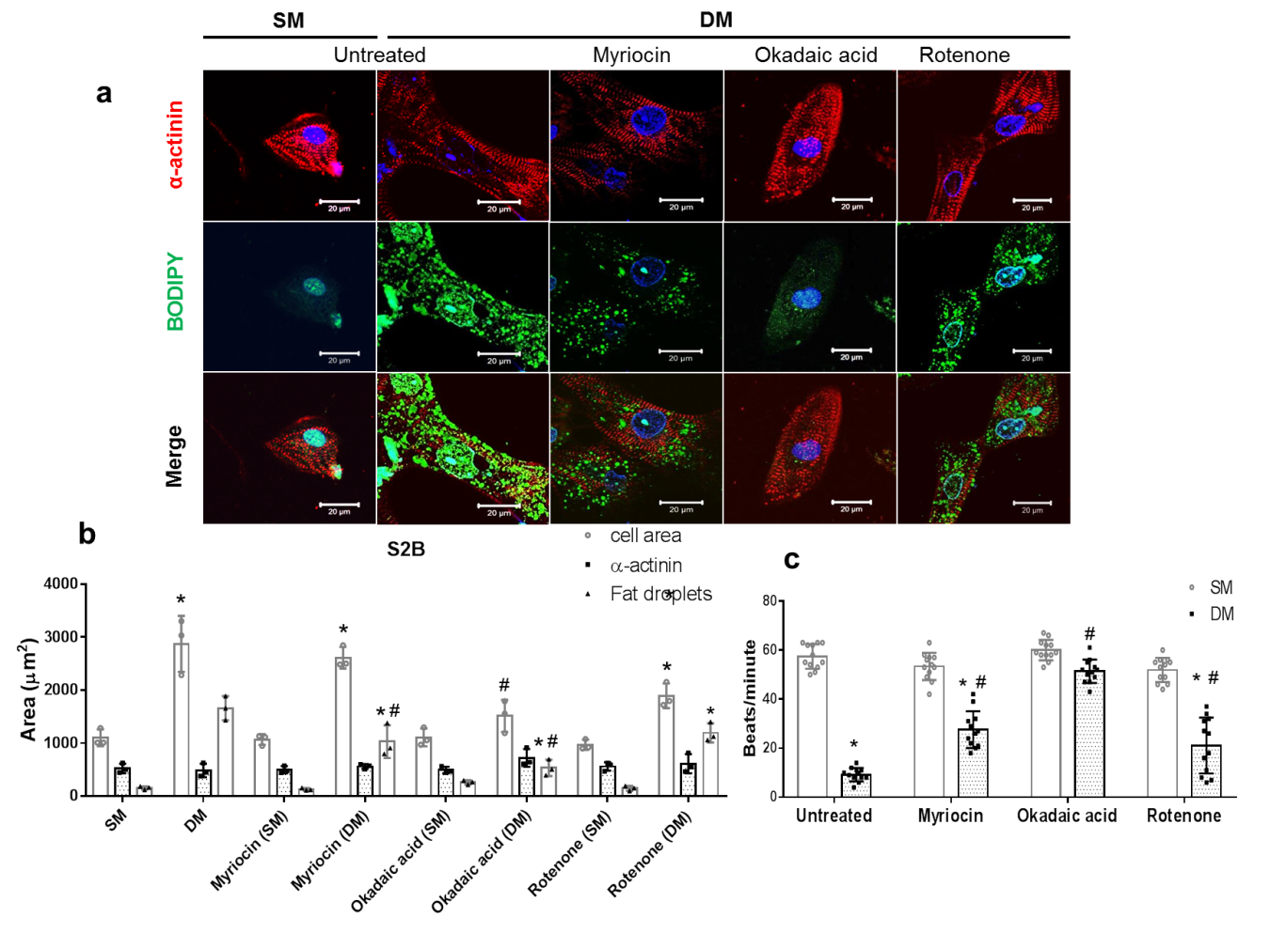
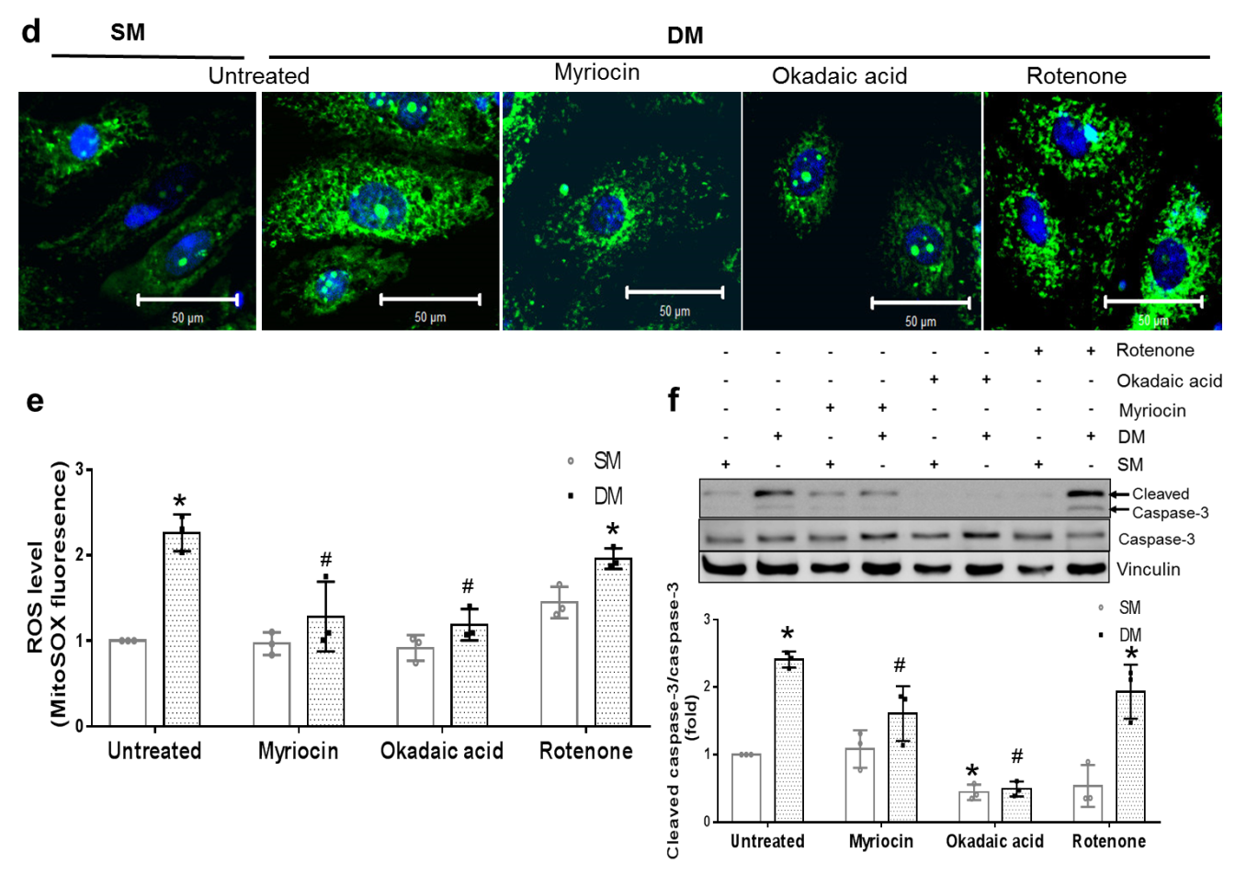
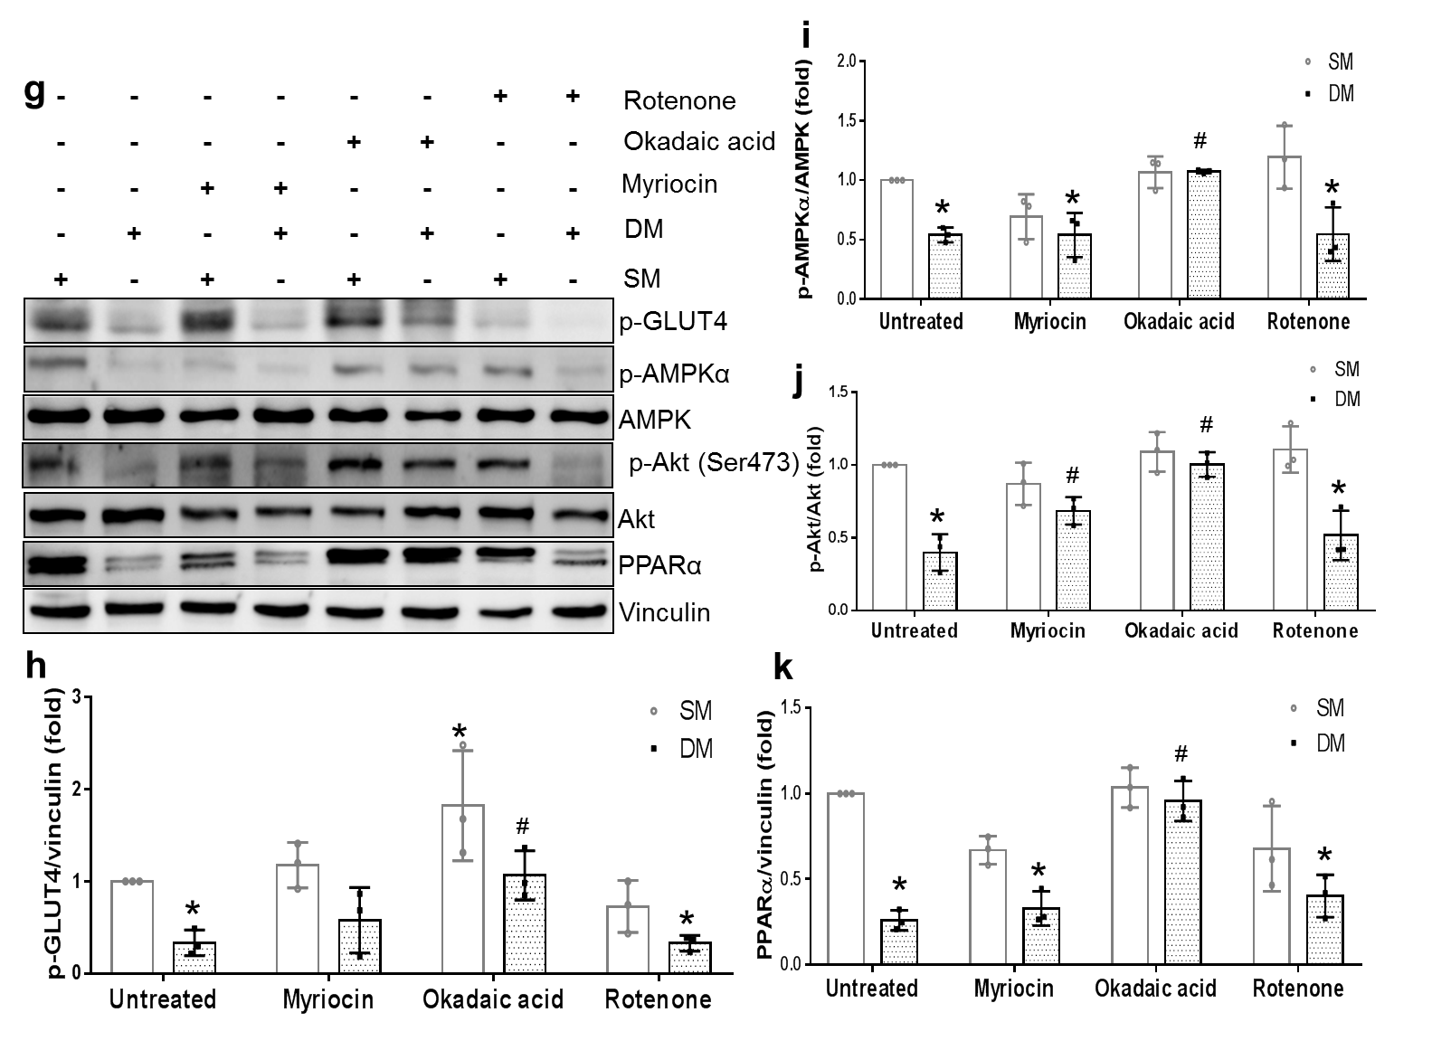
Fig. S2: Cultured CMs with an inhibitor of the de novo ceramides pathway or with an inhibitor of the PP2A pathway reduced diabetic-induced CMs intracellular lipid droplets accumulation. a Representative immunofluorescence images of cardiac sarcomeric proteins, α-actinin (red) and lipid droplets, BODIPY (green) in the single iPSCs-derived-CM cultured in DM compared to SM in the presence or absence of myriocin (0.5 µmol/L, a serine palmitoyltransferase inhibitor), okadaic acid (100 pmol/L, PP2A inhibitor) and rotenone (0,5 µmol/L, a mitochondrial electron transport inhibitor). Nuclei were stained with Hoechst (blue), and the scale bar represents 20 µm. b Quantification of the positive area of lipid droplets/cell, cell area, and α-actinin in the single iPSCs-derived-CM cultured in DM compared to SM in the presence or absence of myriocin, okadaic acid, and rotenone inhibitor; n=3. c Cardiac contractility frequency of iPSCs-derived-CM cultured in DM compared to SM in the presence or absence of myriocin, okadaic acid, and rotenone inhibitor; n=12. Prevention of ceramide accumulation leads to prevent oxidative injury in diabetic CMs. d Representative immunofluorescence images of MitoSOX staining for mitochondrial superoxide in h-iPSCs-derived-CMs cultured in SM and DM in the presence or absence of myriocin (0.5 µmol/L, a serine palmitoyltransferase inhibitor), okadaic acid (100 pmol/L, PP2A inhibitor) and rotenone (0,5 µmol/L, a mitochondrial electron transport inhibitor). Nuclei were stained with Hoechst (blue), and the scale bar represents 50 µm. e The graph shows fold changes (mean ± SD) for mitochondrial superoxide in h-iPSCs-derived-CMs cultured in SM and DM in the presence or absence of myriocin, okadaic acid, and rotenone inhibitor; n=3. f Active caspase-3 was detected by western blot in CMs cultured in SM and DM in the presence or absence of myriocin, okadaic acid, and rotenone inhibitor; n=3.
The expression level of protein using western blot for Akt insulin-sensitive and glucose oxidation related proteins in iPSCs-derived-CMs were cultured in SM and DM in the presence or absence of myriocin (a serine palmitoyltransferase inhibitor ), okadaic acid (PP2A inhibitor) and rotenone (a mitochondrial electron transport inhibitor). GLUT4 (g and h), p-AMPK (g and i), p-Akt (g and j) and PPARα (g and k); n=3. * p<0.05 compared to SM-CMs and # p<0.05 compared to DM-CMs using two-way ANOVA Tukey’s multiple comparisons test.

REFERENCES
1. Zhang M, D'Aniello C, Verkerk AO, Wrobel E, Frank S, Ward-van Oostwaard D, Piccini I, Freund C, Rao J, Seebohm G et al: Recessive cardiac phenotypes in induced pluripotent stem cell models of Jervell and Lange-Nielsen syndrome: disease mechanisms and pharmacological rescue. Proceedings of the National Academy of Sciences of the United States of America 2014, 111(50):E5383-5392.
2. Bekhite MM, Gonzalez Delgado A, Menz F, Kretzschmar T, Wu JMF, Bekfani T, Nietzsche S, Wartenberg M, Westermann M, Greber B et al: Longitudinal metabolic profiling of cardiomyocytes derived from human-induced pluripotent stem cells. Basic Res Cardiol 2020, 115(4):37.
3. Drawnel FM, Boccardo S, Prummer M, Delobel F, Graff A, Weber M, Gerard R, Badi L, Kam-Thong T, Bu L et al: Disease modeling and phenotypic drug screening for diabetic cardiomyopathy using human induced pluripotent stem cells. Cell reports 2014, 9(3):810-821.
4. Bekhite MM, Figulla HR, Sauer H, Wartenberg M: Static magnetic fields increase cardiomyocyte differentiation of Flk-1+ cells derived from mouse embryonic stem cells via Ca2+ influx and ROS production. Int J Cardiol 2013, 167(3):798-808.
5. Bode C, Graler MH: Quantification of sphingosine-1-phosphate and related sphingolipids by liquid chromatography coupled to tandem mass spectrometry. Methods Mol Biol 2012, 874:33-44.
6. Bekhite MM, Finkensieper A, Binas S, Muller J, Wetzker R, Figulla HR, Sauer H, Wartenberg M: VEGF-mediated PI3K class IA and PKC signaling in cardiomyogenesis and vasculogenesis of mouse embryonic stem cells. J Cell Sci 2011, 124(Pt 11):1819-1830.
7. Bekhite MM, Muller V, Troger SH, Muller JP, Figulla HR, Sauer H, Wartenberg M: Involvement of phosphoinositide 3-kinase class IA (PI3K 110alpha) and NADPH oxidase 1 (NOX1) in regulation of vascular differentiation induced by vascular endothelial growth factor (VEGF) in mouse embryonic stem cells. Cell Tissue Res 2016, 364(1):159-174.

