Supplementary Information

WTAP-mediated m⁶A methylation of PHF19 facilitates cell cycle progression by remodeling the accessible chromatin landscape in t(8;21) AML
Yu-Qing Li^{1,2*}, Di Liu^{3,4*}, Li-Li Wang^{1*}, Yang-Liu Shao^{1,2}, Hui-Sheng Zhou^{1,2}, Ya-Lei Hu^{1,2}, Kai-Li Min^{1,2}, Chun-Ji Gao¹, Dai-Hong Liu¹, Jie Zhou^{1,4}, Ji Lin² and Xiao-Ning Gao ^{1,4}

Supplementary Methods
Supplementary References
Supplementary Tables
Supplementary Figures
Supplementary Methods
Western blotting
The entire cellular lysates were prepared by harvesting the cells in 1 × RIPA lysis buffer (Solarbio #R0010, China), supplemented with 1 mM phenylmethane sulfonyl fluoride (Solarbio # P0100) and a protease and phosphatase inhibitor cocktail (Applygen #P1260, China). The proteins were resolved by sodium dodecyl sulfate-polyacrylamide gel electrophoresis (TGX Stain-Free™ FastCast™ Acrylamide Kit, 10%, BIO-RAD #1610183), transferred onto the PVDF membrane (Millipore # IPVH00010), blocked with 5% non-fat milk, and then probed with anti-PHF19 (1:1000, Cell Signaling #77271), anti-HIF1α (1:1000, Cell Signaling #14179), anti-WTAP (1:1000, Cell Signaling #56501), anti-H3K27me3 (1:1000, Cell Signaling #9733), anti-β-actin (1:1000, Cell Signaling #4970), and anti-GAPDH (1:1000, Cell Signaling #3683) antibodies. The secondary antibodies were: anti-mouse IgG, HRP-linked antibody (Cell Signaling #7076) and anti-rabbit IgG, HRP-linked antibody (Cell Signaling #7074). Relative fold changes in protein expression were quantified using ImageJ software.

Real-time quantitative reverse transcription PCR (RT-qPCR)
Total RNA was isolated from the cultured cells by employing the Ultrapure RNA Kit (DNase I) (CWBIO #CW0597S), and cDNA synthesis was carried out using the reverse transcription system (ES Science #RT001) in accordance with the manufacturer's instructions. Gene expression levels were determined using a THUNDERBIRDTM Next SYBR® qPCR Mix (TOYOBO #QPX-201). The levels of GAPDH were utilized for normalization, and the expression of the targets was calculated by means of the 2^{−ΔΔCt} method. The primers employed in this study are listed in Supplementary Table 6.

RNA-seq data processing
RNA sequencing data was processed as follows. Firstly, Fastp (version 0.20) [1] was employed to trim adaptors and filter low-quality reads. The trimmed reads were then mapped to the human genome (hg38) using Hisat2 [2] (version 2.1.0) with default mapping parameters. Finally, HTseq [3] (version 0.11.2) was utilized to estimate the read counts of each gene.

ATAC-seq data processing
FastQC (version 0.11.8) was employed to assess the quality of ATAC-seq sequencing data. Subsequently, Fastp [1] (version 0.20) was utilized to eliminate low-quality reads and adaptor sequences. Next, Bowtie2 [4] (version 0.2.4.1) was used to align the trimmed sequences with the hg38 reference genome. With the “MarkDuplicates” function in Picard (version 2.2.4), the unique mapping reads were identified for subsequent analysis. Finally, the “bamCoverage” function in Deeptools [5] (version 1.5.12) was applied to generate bigwig files for subsequent visualization in IGV or UCSC (https://genome.ucsc.edu/).

Identification of differentially expressed genes and differential peaks
All data processing was conducted using the R software. Differential expressed genes were identified with DESeq2 [6] (version 1.40.1). The MACS2 [7] software (version 2.2.6) was used to identify peaks in ATAC sequencing data. A signal was considered indicative of chromatin accessibility if its significant cut-off q-value was less than 0.01, referred to as peaks. The R software packages ChipSeeker [7] (version 1.20.0) and clusterProfiler [9] (version 4.7.1) were utilized for genome-wide annotation of enrichment peaks. In this study, peaks were annotated to the nearest genes within a 3 kb region flanking the transcription start site, both upstream and downstream. DiffBind (version 3.10.0) was employed to estimate differential peaks between two groups using the DESEQ2 method. When the fold change was greater than 1.5 and the false discovery rate (FDR) was less than 0.05, the peaks were regarded as differential peaks between two groups. Genes annotated by differential peaks were used for further GO enrichment analysis.

GSEA / Kyoto encyclopedia of genes and genomes (KEGG) analysis
We utilized clusterProfiler [9] (version 4.7.1) to conduct GSEA with the differentially expressed genes and KEGG gene sets (http://www.genome.jp/kegg/pathway.html) as input. We employed enrichplot (version 1.19.2) for the subsequent visualization of the selected KEGG pathway.

Cell cycle, apoptosis, cell differentiation assays
Cell apoptosis was determined by dual staining of cells with Annexin V (Miltenyi Biotec #130-118-499) / 7AAD (BD PharmingenTM #559925) followed by flow cytometry analysis. Cell differentiation was determined using anti-human CD11b antibody (Caprico Biotechnologies #S11BAP04) or anti-human CD15 antibody (Caprico Biotechnologies #S015PE04) staining followed by flow cytometry analysis. Cell cycle distribution was determined using a cell cycle kit with PI staining (Cytognos #CYT-PIR-25) followed by flow cytometry analysis.

Colony-forming assays
Colony-forming assays were conducted in MethoCultTM H4434 Classic medium (STEMCELL TECHNOLOGIES #04434CN). Briefly, cells were suspended in 0.3 mL of cell resuspension solution, mixed with human methylcellulose complete media, and then dispensed into 35 mm dishes. Colonies were counted within 7 - 14 days.

Cell viability assay
Cells were diluted to a density of 5 × 10⁵ /mL in each well of a 96-well plate. After culturing with histone methyltransferase inhibitors at a concentration of 10 μM for 24-, 48-, 72-, and 96-hour, the cell viability was evaluated according to the manufacturer's instruction using Cell Counting Kit-8 (DOJINDO #CK04). The absorbance at 450 nm was measured in triplicates using a microplate reader (Multiskan ascent, Thermo Fisher Scientific).

Tumorigenesis assay
Approximately 5 × 10⁶ Kasumi-1 cells with stable PHF19 knockdown or scramble control were injected subcutaneously into the unilateral flank of athymic nude mice (female, 6 - 8 weeks old). Mice were randomly divided into two groups of 3 mice each. The mice were maintained under the conditions established by Chinese PLA General Hospital and sacrificed when the tumor volume reached 1000 mm³. Unblinded measurements were conducted for the animal experiment. Sample sizes were predetermined by power analysis.

Statistical analysis
Student's t-test was applied to compare gene overexpression- or knockdown-induced changes to respective controls when the data met the test assumptions and the variance was similar between groups. Mann-Whitney U test was selected to determine the difference of PHF19 mRNA expression levels in patient samples. Spearman’s rank correlation test was used to analyze the correlation between WTAP and PHF19 mRNA expression levels. To compare clinical outcomes of patients with different PHF19 expression levels, the cohort was stratified using the quartile grouping method described previously [10]. Patients were grouped into quartiles based on PHF19 expression levels (Q1-Q4, each quartile containing 25% of patients) and divided into high expression group (Q4) and low expression group (Q1-Q3) based on the trend observed in clinical outcome after performing a log-rank test for OS with PHF19 quartile grouping as the variable. In this model, t(8;21) AML patients in the highest PHF19 quartile showed a significantly different OS compared with the remaining patients with lower PHF19 expression levels. The Kaplan-Meier method was used to calculate the OS and EFS. Clinical features across groups were compared using the 2-sided Fisher exact test for categorical data. The Cox proportional hazards model with stepwise forward selection was constructed to determine whether PHF19 expression was associated with outcome when adjusting for other prognostic variables. The full multivariate model used the variables significant at a 20% level in univariate analysis. OS was defined as the time from the date of diagnosis to death or last follow-up. EFS was defined as the time from the date of diagnosis to the date of relapse, death due to any cause, or last follow-up.
Supplementary References
- Chen S, Zhou Y, Chen Y, Gu J. fastp: an ultra-fast all-in-one FASTQ preprocessor. Bioinformatics. 2018;34(17):i884-i890.
- Kim D, Langmead B, Salzberg SL. HISAT: a fast spliced aligner with low memory requirements. Nat Methods. 2015;12(4):357-360.
- Anders S, Pyl PT, Huber W. HTSeq--a Python framework to work with high-throughput sequencing data. Bioinformatics. 2015;31(2):166-169.
- Langdon WB. Performance of genetic programming optimised Bowtie2 on genome comparison and analytic testing (GCAT) benchmarks. BioData Min. 2015;8(1):1.
- Ramírez F, Dündar F, Diehl S, Grüning BA, Manke T. deepTools: a flexible platform for exploring deep-sequencing data. Nucleic Acids Res. 2014;42(Web Server issue):W187-191.
- Love MI, Huber W, Anders S. Moderated estimation of fold change and dispersion for RNA-seq data with DESeq2. Genome Biol. 2014;15(12):550.
- Zhang Y, Liu T, Meyer CA, Eeckhoute J, Johnson DS, Bernstein BE, et al. Model-based analysis of ChIP-Seq (MACS). Genome Biol. 2008;9(9):R137.
- Yu G, Wang LG, He QY. ChIPseeker: an R/Bioconductor package for ChIP peak annotation, comparison and visualization. Bioinformatics. 2015;31(14):2382-2383.
- Wu T, Hu E, Xu S, Chen M, Guo P, Dai Z, et al. clusterProfiler 4.0: A universal enrichment tool for interpreting omics data. Innovation (Camb). 2021;2(3):100141.
- Gao XN, Yan F, Lin J, Gao L, Lu XL, Wei SC, et al. AML1/ETO cooperates with HIF1α to promote leukemogenesis through DNMT3a transactivation. Leukemia. 2015;29:1730-1740.

Supplementary Tables
Supplementary Table 1 Baseline characteristics of AML patients with t(8;21) and no complex karyotype at diagnosis
Variable | Total | PHF19^{low} | PHF19^{high} | P value
Number of patients | 105 | 40 | 65
Age, median, years (range) | 12.1 (2.2-29.2) | 12.5 (2.2-21.0) | 12.0 (2.7-29.2) | 0.654
Gender |  |  |  | 0.075
Male | 51 (48.6) | 15 (37.5) | 36 (55.4)
Female | 54 (51.4) | 25 (62.5) | 29 (44.6)
WBC at diagnosis, median, × 10⁹/L (range) | 13.1 (1.7 – 142.1) | 13.4 (1.7 – 142.1) | 13.1 (1.7 – 142.1) | 0.648
Bone marrow blasts, median, % (range) | 52.0 (0.0 – 91.0) | 52.0 (15.0 – 91.0) | 52.0 (0.0 – 91.0) | 0.555
Peripheral blasts, median, % (range) | 39.0 (0.0 – 96.0) | 35.5 (2.0 – 88.0) | 45.0 (0.0 – 96.0) | 0.482
Minus X |  |  |  | 0.425
No | 88 (83.3) | 32 (80.0) | 56 (86.2)
Yes | 17 (16.2) | 8 (20.0) | 9 (13.8)
Minus Y |  |  |  | 0.817
No | 79 (75.2) | 31 (77.5) | 48 (73.8)
Yes | 26 (24.8) | 9 (22.5) | 17 (26.2)
del7q |  |  |  | 0.295
No | 101 (96.2) | 40 (100.0) | 61 (93.8)
Yes | 4 (3.8) | 0 (0.0) | 4 (6.2)
Del 9q |  |  |  | 0.738
No | 10 (9.5) | 3 (7.5) | 7 (10.8)
Yes | 95 (90.5) | 37 (92.5) | 58 (89.2)
FLT3-ITD positive |  |  |  | 1.000
No | 102 (97.1) | 39 (97.5) | 63 (96.9)
Yes | 3 (2.9) | 1 (2.5) | 2 (3.1)
Chloroma |  |  |  | 0.753
No | 39 (37.1) | 14 (35.0) | 25 (38.5)
Yes | 10 (9.5) | 3 (7.5) | 7 (10.8)
Unkown | 56 (53.4) | 23 (57.5) | 33 (50.8)
MRD at end of course 1 |  |  |  | 0.679
Negative | 81 (77.1) | 32 (80.0) | 49 (75.4)
Positive | 19 (18.1) | 7 (17.5) | 12 (18.5)
Unkown | 5 (4.8) | 1 (2.5) | 4 (6.2)
MRD at end of course 2
Negative | 79 (75.2) | 32 (80.0) | 47 (72.3)
Positive | 5 (4.8) | 2 (5.0) | 3 (4.6) | 0.603
Unkown | 21 (20.0) | 6 (15.0) | 15 (23.1)
CR status at end of course 1 |  |  |  | 0.094
CR | 91 (86.7) | 37 (92.5) | 54 (83.1)
Not in CR/death | 13 (12.4) | 2 (5.0) | 11 (16.9)
Unkown | 1 (1.0) | 1 (2.5) | 0 (0.0)
CR status at end of course 2 |  |  |  | 0.813
CR | 99 (94.3) | 38 (95.0) | 61 (93.8)
Not in CR/death | 2 (1.9) | 1 (2.5) | 1 (1.5)
Unkown | 4 (3.8) | 1 (2.5) | 3 (4.6)
SCT in 1st CR |  |  |  | 0.386
No | 97 (94.2) | 38 (95.0) | 59 (90.8)
Yes | 5 (4.8) | 2 (5.0) | 3 (4.6)
Unkown | 3 (2.9) | 0 (0.0) | 3 (4.6)
CR, complete remission; MRD, minimal residual disease; SCT, stem cell transplantation; WBC, white blood cell.

Supplementary Table 2 Univariate analyses for risk factors of event-free survival and overall survival in patients with t(8;21) AML
Variable | 4-yr Event-free Survival |  | 4-yr Overall Survival
Variable | % (95% CI) | p value | % (95% CI) | p value
Age |  | 0.718 |  | 0.032
< 12-yr | 66.3 (51.5-77.6) |  | 90.9 (77.4-96.5)
≥ 12-yr | 63.9 (49.4-75.2) |  | 75.0 (60.8-84.7)
Gender |  | 0.901 |  | 0.781
Male | 64.0 (49.1-75.6) |  | 82.8 (68.4-91.1)
Female | 66.1 (51.5-75.6) |  | 82.9 (69.6-90.7)
WBC at diagnosis |  | 0.306 |  | 0.778
< 13.0 × 10⁹/L | 70.1 (55.3-80.8) |  | 83.5 (69.6-91.4)
≥ 13.0 × 10⁹/L | 60.6 (46.2-72.3) |  | 82.4 (68.9-90.5)
Bone marrow blasts |  | 0.705 |  | 0.783
< 52% | 62.5 (47.2-74.5) |  | 80.7 (66.0-89.5)
≥ 52% | 66.3 (51.9-77.2) |  | 84.4 (71.2-91.9)
Peripheral blasts |  | 0.949 |  | 0.902
< 39% | 64.5 (49.3-76.3) |  | 82.9 (68.6-91.1)
≥ 39% | 64.5 (50.1-75.7) |  | 82.4 (68.9-90.5)
Minus X |  | 0.078 |  | 0.052
No | 61.9 (50.8-71.2) |  | 79.6 (69.3-86.9)
Yes | 81.6 (53.0-93.7) |  | 100.0
Minus Y |  | 0.675 |  | 0.788
No | 63.9 (52.1-73.5) |  | 83.0 (72.5-89.8)
Yes | 68.8 (47.2-83.1) |  | 82.1 (58.5-93.0)
Del 9q |  | 0.071 |  | 0.904
No | 67.9 (57.3-76.3) |  | 83.6 (74.3-89.8)
Yes | 40.0 (12.3-67.0) |  | 77.8 (36.5-93.9)
Chloroma |  | 0.589
No | 66.0 (48.7-78.6) |  | 89.5 (74.5-95.9) | 0.608
Yes | 60.0 (25.3-82.7) |  | 78.8 (38.1-94.3)
PHF19 |  | 0.034 |  | 0.121
Low | 77.1 (60.6-87.4) |  | 89.6 (74.6-96.0)
High | 57.7 (44.6-68.7) |  | 78.7 (66.1-87.1)
CI, confidence interval; CR, complete remission; MRD, minimal residual disease; SCT, stem cell transplantation; WBC, white blood cell.

Supplementary Table 3 Multivariate analysis of risk factors for survival in patients with t(8;21) AML
Prognostic Factor | Hazard Risk (95% CI) | p value
Event-free survival
Minus X, Yes vs. No | 0.40 (0.12 – 1.32) | 0.134
Del 9q, Yes vs. No | 1.64 (0.67 – 4.01) | 0.282
PHF19, High vs. Low | 2.04 (0.95 – 4.38) | 0.066
Overall survival
Age, ≥ 12-yr vs. < 12-yr | 3.29 (1.67 – 9.26) | 0.024
Minus X, Yes vs. No | 1.75e-16 | 1.000
PHF19, Yes vs. No | 2.42 (0.79 – 7.37) | 0.121
CI, confidence interval.

Supplementary Table 4 The sequence of shRNA employed in the experiments
Name |  | Accession No. | Vector | Elements | Target Sequence (5' to 3')
HIF1α-RNAi | NM_001530 |  | GV112 | hU6-MCS-CMV-Puromycin | TGGCTCATTACCTAAAGCAGT
WTAP-RNAi#1 | NM_004906 |  | GV112 | hU6-MCS-CMV-Puromycin | GTTATGGCAAGAGATGAGTTA
WTAP-RNAi#2 | NM_004906 |  | GV112 | hU6-MCS-CMV-Puromycin | GGCAAGTACACAGATCTTAAC
WTAP-RNAi#3 | NM_004906 |  | GV493 | hU6-MCS-CBh-gcGFP-IRES-puromycin | GCTTCAATACTTCTGCCGCTT
PHF19-RNAi#1 | NM_015651 |  | GV493 | hU6-MCS-CBh-gcGFP-IRES-puromycin | GGTCAAGAACAACTTCAAAGA
PHF19-RNAi#2 | NM_015651 |  | GV493 | hU6-MCS-CBh-gcGFP-IRES-puromycin | GCAACATCTGCCTAGGGAAGA
PHF19-RNAi#3 | NM_015651 |  | GV493 | hU6-MCS-CBh-gcGFP-IRES-puromycin | CCTGAAATGGACAATCACTTT
Negative control |  |  |  |  | TTCTCCGAACGTGTCACGT

Supplementary Table 5 Construction of lentiviral vectors for gene overexpression
Gene | Accession No. | Vector | Elements | Primer for Gene Cloning (5' to 3')
HIF1α | NM_001530 | GV350 | Ubi-MCS-3FLAG-SV40-neomycin | Forward AGGTCGACTCTAGAGGATCCCGCCACCATGGAGGGCGCCGGCGGCGC  Reverse TCCTTGTAGTCCATACCGGTGTTAACTTGATCCAAAGCTCTGAG
WTAP | NM_004906 | GV350 | Ubi-MCS-3FLAG-SV40-neomycin | Forward AGGTCGACTCTAGAGGATCCCGCCACCATGACCAACGAAGAACCTCTTC  Reverse TCCTTGTAGTCCATACCGGTCAAAACTGAACCCTGTACATTTAC
PHF19 | NM_015651 | GV348 | Ubi-MCS-SV40-puromycin | Forward CCAACTTTGTGCCAACCGGTCGCCACCATGGAGAATCGAGCTC  Reverse CACACATTCCACAGGAATTTCAGTAAGGGGTGGTCCCTTCCC

Supplementary Table 6 The sequence of primers employed in experiments
Name |  | Primer Sequence (5' to 3')
HIF1a expression | Forward | CACCACAGGACAGTACAGGAT
 | Reverse | CGTGCTGAATACCACTCACA
WTAP expression | Forward | CTTCCCAAGAAGGTTCGATTGA
 | Reverse | TCAGACTCTCTTAGGCCAGTTAC
PHF19 expression | Forward | ACTCGGGACTCCTATGGTGC
 | Reverse | CCTCCGTCAGTTTGGACATCA
GAPDH expression | Forward | GGAGCGAGATCCCTCCAAAAT
 | Reverse | GGCTGTTGTCATACTTCTCATGG
PHF19 MeRIP-qPCR | Forward | GAAGGTGCAGAGGGTTATAAGG
PHF19 MeRIP-qPCR | Reverse | CACCTGGGAAGATAGCACAAG

Supplementary Figures 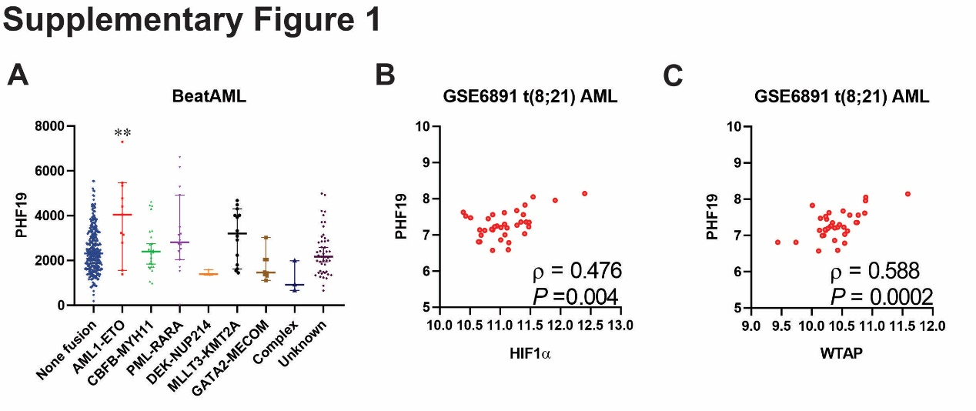
Supplementary Fig. 1 Selective high expression of the PHF19 gene in t(8;21) AML. A Normalized PHF19 expression in bone marrow specimens from 493 newly diagnosed AML patients according to WHO fusion subgroups (BeatAML database, http://www.vizome.org/aml). Samples were analyzed using Affymetrix gene expression arrays. Statistical significance was assessed by Mann-Whitney U test (**p < 0.01). B-C Correlation analysis between HIF1α (B) or WTAP (C) and PHF19 mRNA levels in bone marrow specimens from newly diagnosed t(8;21) AML patients (GEO database, GSE6891). Samples were analyzed using Affymetrix gene expression arrays. Statistical significance was assessed by Mann-Whitney U test. Statistical significance of correlation was assessed by Spearman’s rank correlation test.

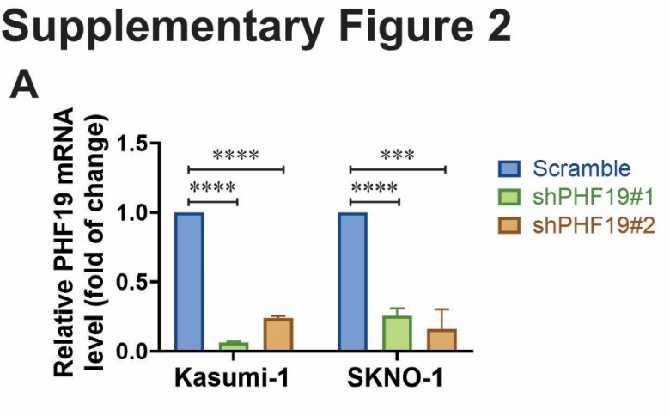
Supplementary Fig. 2 Silencing the expression of PHF19 via shRNA targeting PHF19. A The Kasumi-1 and SKNO-1 cell lines were respectively stably transfected with a lentivirus-mediated shRNA targeting PHF19 (shPHF19#1 or shPHF19#2) or a negative control scramble shRNA. The target sequences of PHF19 shRNA and the negative control scramble shRNA are presented in Supplementary Table 4. Forty-eight hours subsequent to transfection, cells were selected with puromycin (2 μg/mL) for at least 24 hours prior to RNA extraction for RT-qPCR analysis of WTAP expression levels. The primers utilized are listed in Supplementary Table 6. Data represent the mean ± SEM from 3 independent biological replicates. Statistical significance was evaluated by Student's t-test ( ***p < 0.001; ****p < 0.0001).
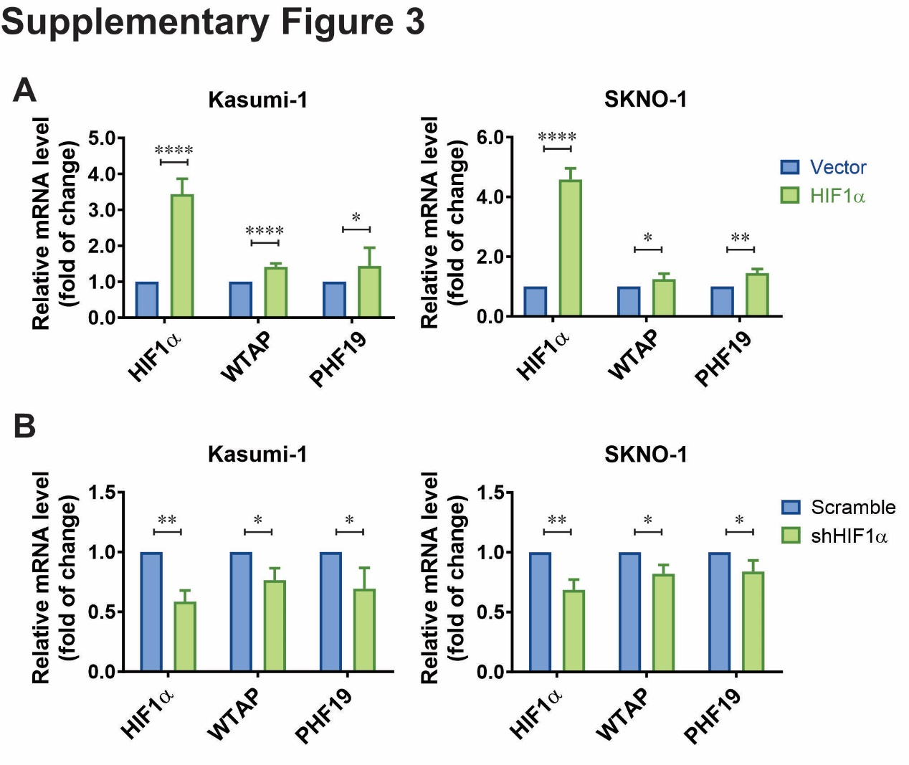
Supplementary Fig. 3 HIF1α induces the high expression of PHF19 through m⁶A methylation modification mediated by WTAP. A The lentiviral vector for stable ectopic expression of the human HIF1α gene was transfected into the Kasumi-1 or SKNO-1 cell line. Forty-eight hours post-transfection, cells were selected with neomycin (400 μg/mL) for at least 24 hours before RNA extraction for RT-qPCR analysis of WTAP and PHF19 expression levels. The primers used are listed in Supplementary Table 6. B Kasumi-1 and SKNO-1 cell lines were respectively stably transfected with a lentivirus-mediated shRNA targeting HIF1α or a negative control scramble shRNA. The target sequences of both are listed in Supplementary Table 4. Forty-eight hours post-transfection, cells were selected with puromycin (2 μg/mL) for at least 24 hours before RNA extraction for RT-qPCR analysis of WTAP and PHF19 expression levels. Data are the mean ± SEM from 3 independent biological replicates. Statistical significance was assessed by Student's t-test (*p < 0.05; **p < 0.01; ****p < 0.0001).
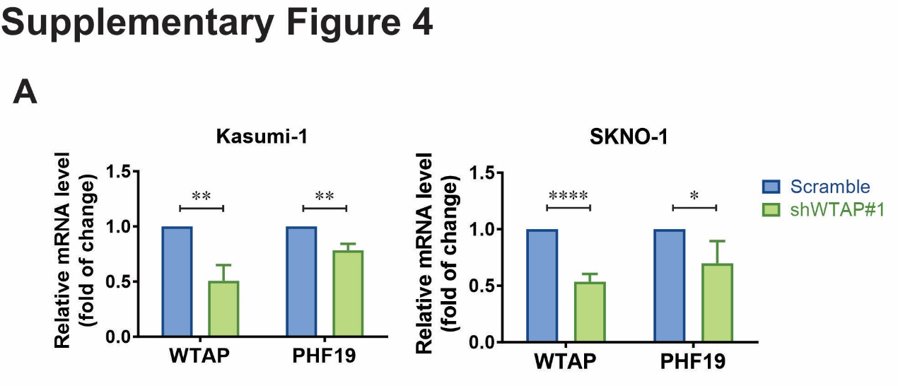
Supplementary Fig. 4 WTAP Knockdown leads to the down-regulation of PHF19 mRNA expression. A Kasumi-1 and SKNO-1 cell lines were respectively stably transfected with a lentivirus-mediated shRNA targeting WTAP or a negative control scramble shRNA. The target sequences are listed in Supplementary Table 4. Forty-eight hours post-transfection, cells were selected with puromycin (2 μg/mL) for at least 24 hours before RNA extraction for RT-qPCR analysis of PHF19 expression. Data are the mean ± SEM from 3 independent biological replicates. Statistical significance was assessed by Student's t-test (*p < 0.05; **p < 0.01; ****p < 0.0001).
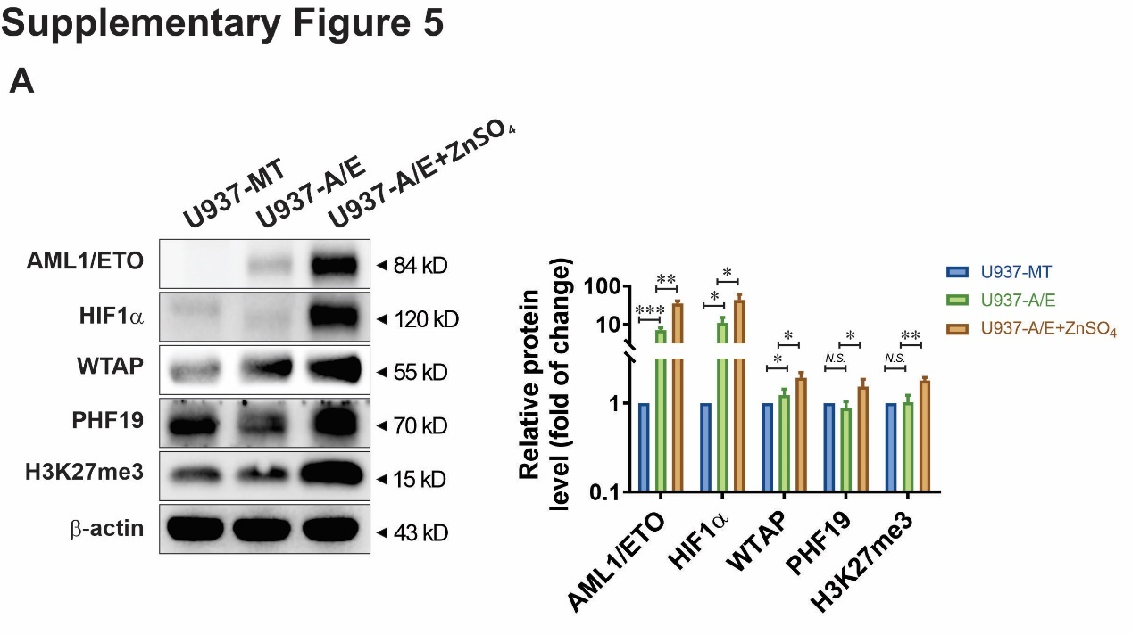
Supplementary Fig. 5 AML1/ETO-mediated upregulation of HIF1α enhances the expression levels of WTAP, PHF19 and H3K27me3. A The U937A/E cells were exposed to 100 μM ZnSO₄ for 16 h to induce AML1/ETO protein before cell lysis for immunoblot analysis with the indicated antibodies. The U937-MT cells and U937A/E cells without ZnSO₄ treatment served as negative controls. Data are the mean ± SEM from 3 independent biological replicates. Statistical significance was assessed by Student's t-test (*p < 0.05; **p < 0.01; ***p < 0.001; N.S., not significant).

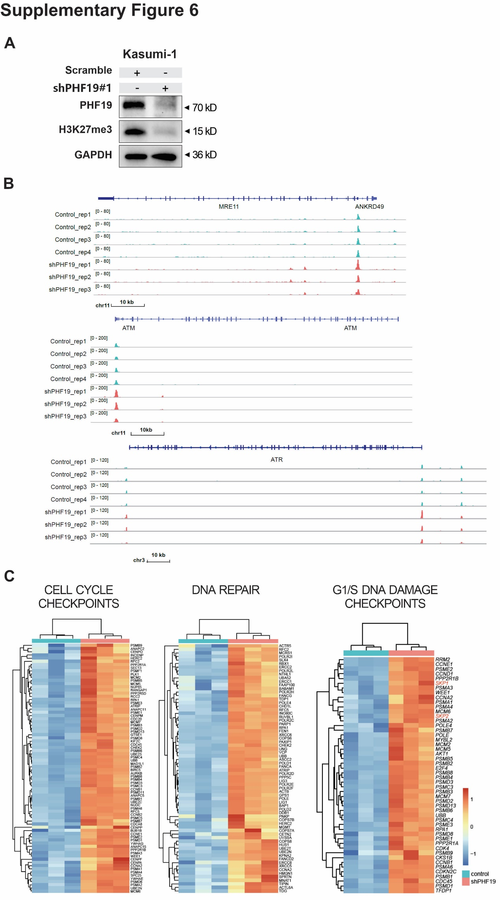
Supplementary Fig. 6 PHF19 silencing opens new chromatin regions in DNA repair and cell cycle checkpoint in t(8;21) AML. A Kasumi-1 cells were respectively transfected with the negative control scramble shRNA or PHF19 shRNA (shPHF19#1). The target sequences of PHF19 shRNA and the negative control scramble shRNA are listed in Supplementary Table 4. Forty-eight hours after transfection, cells were selected with puromycin (2 μg/mL) for at least 24 hours before cell lysis for immunoblot analysis with the indicated antibodies (A), ATAC-seq analysis (B) and RNA-seq analysis (C). A Results are representative of two independent experiments. B ATAC-seq peaks show the positions of accessible chromatin regions at the indicated genomic locus. C Heatmap shows the upregulation of DNA damage checkpoints, cell cycle checkpoints and DNA repair related genes upon PHF19 knockdown.

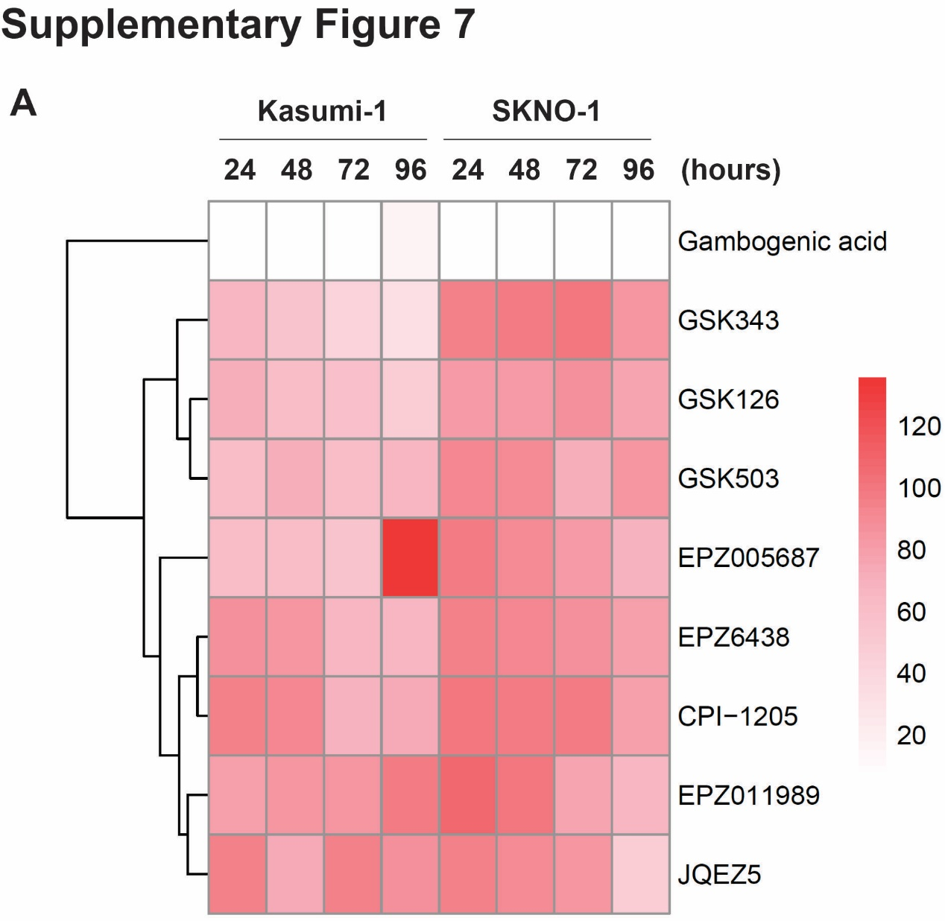
Supplementary Fig. 7 Inhibition of PRC2 histone methyltransferase activity reduces cell viability in t(8;21) AML. A The Kasumi-1 and SKNO-1 cells were respectively treated with indicated histone methyltransferase inhibitors at a concentration of 10 μM. The heatmap represents the average cell viability evaluated by the CCK-8 assay after 24-, 48-, 72- and 96-hour treatment (n = 4).

