Supplementary Materials
Engineering of mRNA vaccine platform with reduced lipids and enhanced efficacy
Xu Ma^{1,8}, Shaoli Liu², Shuhui Zhang^{1,8}, Zongran Liu¹, Hui Wang³, Wendi Luo³, Mali Zu¹, Hao Qin¹, Zhongxian Li^{1,8}, Jie Zhong^{1,8}, Junxi Li⁴, Qizhe Chen⁶, Jiaqi Lin⁷, Andong Liu², Xinzheng Zhang⁴, Hongjun Li⁵, Xueguang Lu⁶, Xinghua Shi³, Lele Li^{1,8}*, Zhen Gu⁵*, Tianjiao Ji^{1,8}*, Guangjun Nie^{1,8}*
¹CAS Key Laboratory for Biomedical Effects of Nanomaterials and Nanosafety, CAS Center for Excellence in Nanoscience, National Center for Nanoscience and Technology, Chinese Academy of Sciences, Beijing, China
²Hangzhou Jitai Pharmaceutical Technology CO., Ltd, Hangzhou, China
³Laboratory of Theoretical and Computational Nanoscience, National Center for Nanoscience and Technology, Chinese Academy of Sciences, Beijing, China
⁴National Laboratory of Biomacromolecules, CAS Center for Excellence in Biomacromolecules, Institute of Biophysics, Chinese Academy of Sciences, Beijing, China
⁵College of Pharmaceutical Sciences, Zhejiang University, Hangzhou, China
⁶Beijing National Laboratory for Molecular Sciences, CAS Key Laboratory of Colloid, Interface and Chemical Thermodynamics, Institute of Chemistry, Chinese Academy of Sciences, Beijing, China
⁷Key State Laboratory of Fine Chemicals, School of Bioengineering, Dalian University of Technology, Dalian, China
⁸School of Nanoscience and Engineering, University of Chinese Academy of Sciences, Beijing, China
Corresponding authors:
Correspondence to Tianjiao Ji, Ph.D. (jitj@nanoctr.cn), Lele Li, Ph.D. (lilele@nanoctr.cn), Zhen Gu, Ph.D. (guzhen@zju.edu.cn) and Guangjun Nie, Ph.D. (niegj@nanoctr.cn)
Table S1. mRNA loading efficiency in Mn-mRNA calculated by Quant-it™ RiboGreen RNA Assay Kit. Luciferase mRNA (mLuc) was used in the experiment. Data were presented as mean ± SD, n = 3.

Heating Time (min) | Participation Ratio (%)
5 | 88.03 ± 0.11
10 | 89.43 ± 0.38
15 | 89.16 ± 0.16
30 | 92.55 ± 0.05

Table S2. mRNA loading efficiency in Zn-mRNA calculated by Quant-it™ RiboGreen RNA Assay Kit. mLuc was used in the experiment. Data were presented as mean ± SD, n = 3.

Heating Time (min) | Participation Ratio (%)
5 | 13.30 ± 0.11
10 | 54.51 ± 0.49
15 | 89.81 ± 0.24
30 | 93.82 ± 0.47

Table S3. Size and PDI of Mn-mRNA with different molar ratio of manganese ions and mRNA (base number) measured by DLS. mLuc was used in the experiment. Data were presented as mean ± SD, n = 3.

Ratio | Size (nm) | PDI
20:1 | 257.5 ± 6.2 | 0.18 ± 0.03
10:1 | 194.4 ± 2.6 | 0.09 ± 0.04
8:1 | 152.8 ± 41.4 | 0.14 ± 0.05
6:1 | 57.7 ± 10.0 | 0.28 ± 0.03
5:1 | 49.9 ± 3.3 | 0.22 ± 0.03
4:1 | 35.5 ± 3.6 | 0.26 ± 0.02
2:1 | 19.0 ± 3.6 | 0.27 ± 0.01
1:1 | 130.5 ± 6.9 | 0.49 ± 0.06

Table S4. The proportion of each component in Mn-mRNA.

 | Procedure | Results
Mn ratio involved in the reaction | ICP-MS | 5%
Mn amount involved in the reaction | Mn Input × Mn ratio involved in the reaction | 0.825 μg
mRNA encapsulation efficiency | RiboGreen RNA Assay Kit | 88%
mRNA amount involved in the reaction | mRNA Input × mRNA encapsulation efficiency | 17.6 μg
The proportion of mRNA in Mn-mRNA | “mRNA involved (μg)” / “Mn involved (μg) + mRNA involved (μg)” | 95.6%
The proportion of Mn in Mn-mRNA | “Mn involved (μg)” / “Mn involved (μg) + mRNA involved (μg)” | 4.4%

Table S5. Size, PDI, and zeta potential of Mn-mRNA nanoparticles prepared by Mn²⁺ and different type of mRNA measured by using DLS. Data were presented as mean ± SD, n = 3.

Mn-mRNA | Size (nm) | PDI | Zeta (mV)
mSpike | 35.4 ± 2.4 | 0.25 ± 0.02 | -15.7 ± 1.2
mLuc | 49.9 ± 3.3 | 0.22 ± 0.03 | -10.8 ± 1.9
mOVA | 57.1 ± 3.2 | 0.25 ± 0.08 | -12.9 ± 4.6
mEGFP | 87.2 ± 2.9 | 0.26 ± 0.02 | -12.0 ± 2.8

Table S6. The mass ratio of components in LNP-mRNA and Lipid@Mn-mRNA.

Category | Our Platform | Pfizer BioNTech | Moderna
 | Lipid@  Mn-mRNA | LNP-mRNA (COVID-19 BNT162b2 vaccine) | LNP-mRNA (mRNA-1273 COVID-19 vaccine)
Molar Lipid Ratios (%) * | 50:38.5:10:1.5 | 46.3:42.7:9.4:1.6 | 50:38.5:10:1.5
Lipids: mRNA  (w/w) | 10:1 | 25:1** | 20:1***

* Ionizable lipid: cholesterol: neutral lipid: PEG-ylated lipid;
** The calculations are based on the mass of each component released by the Pfizer Inc. (https://www.pfizermedicalinformation.com/pfizer-biontech-covid-19-vaccine);
*** The calculations are based on the mass of each component released by the Moderna, Inc. (https://www.modernatx.com/en-US/products/spikevax-xbb.1.5)
Table S7. Size, PDI, and zeta potential of L@Mn-mRNA nanoparticles measured by DLS. Dlin-MC3-DMA ionizable lipid was used in formulations. Data were presented as mean ± SD, n = 3.

L@Mn-mRNA | Size (nm) | PDI | Zeta (mV)
mSpike | 120.6 ± 3.3 | 0.15 ± 0.01 | 18.2 ± 1.0
mLuc | 132.5 ± 1.8 | 0.18 ± 0.02 | 16.4 ± 1.6
mOVA | 141.9 ± 3.8 | 0.16 ± 0.03 | 18.1 ± 1.3
mEGFP | 189.0 ± 3.7 | 0.15 ± 0.04 | 12.3 ± 1.0

Table S8. Size, PDI, and zeta potential of LNP-mRNA detected by DLS. The encapsulation efficiency (EE) of LNP was measured using the Quant-it™ RiboGreen RNA Assay Kit. SM-102 ionizable lipid was used in formulations. Data were presented as mean ± SD, n = 3.

LNP-mRNA | EE (%) | Size (nm) | PDI | Zeta (mV)
LNP-mLuc | 91.1 ± 0.2 | 98.7 ± 7.8 | 0.19 ± 0.01 | 20.3 ± 0.3
LNP-mOVA | 93.5 ± 0.4 | 106.8 ± 1.7 | 0.17 ± 0.04 | 20.5 ± 0.7

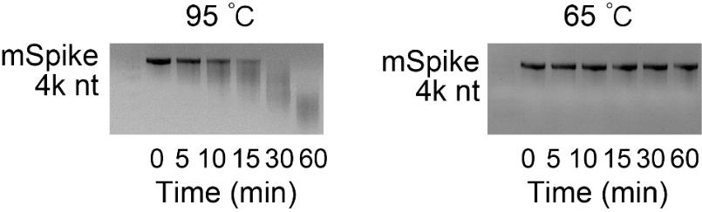
Figure S1. Integrity evaluation of Spike protein mRNA (mSpike) at 95 ℃ and 65 ℃ for different time duration analyzed by agarose gel electrophoresis.

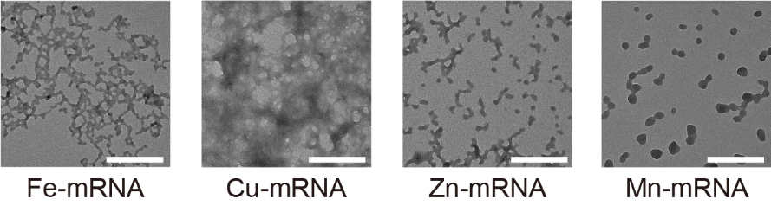
Figure S2. TEM images of Fe-mRNA, Cu-mRNA, Zn-mRNA and Mn-mRNA heating at 65 ℃ for 5 minutes. Luciferase mRNA (mLuc) was used in the experiment. The molar ratio of metal ions to bases (in mRNA) was 5:1. Scale bar, 200 nm.

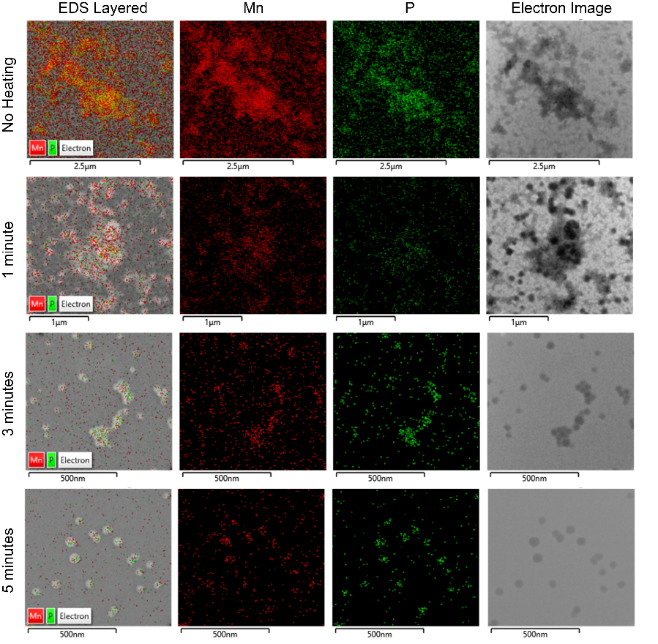
Figure S3. The distribution of phosphorus and manganese elements in Mn-mRNA complexes before and after heating with different durations detected by Energy-Dispersive X-ray Spectroscopy (EDS) element analysis. The first (no heating) and last (5 minutes) rows were the same with Figure 1J in the main text. mLuc was used in the experiment.

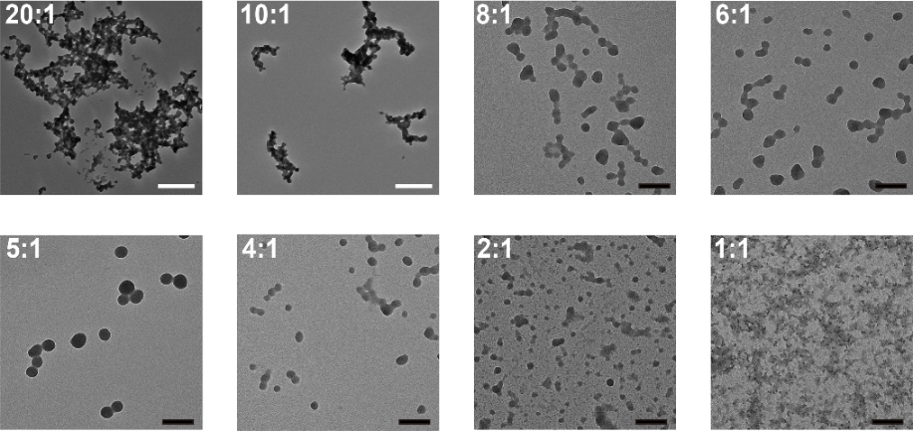
Figure S4. TEM images of Mn-mRNA with different molar ratios of Mn²⁺ to bases (in mRNA). mLuc was used in the experiment. Scale bar in 20:1 and 10:1 group, 500 nm, scale bar in other groups, 100 nm.
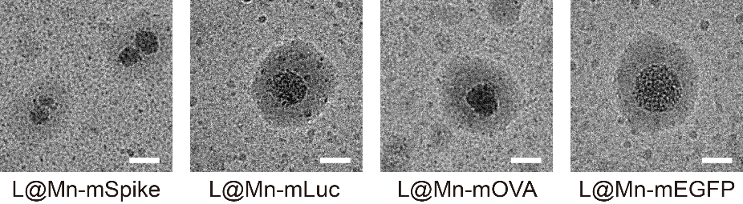
Figure S5. Cryo-EM images of L@Mn-mRNA. Spike protein, luciferase, OVA and EGFP mRNA were respectively used for L@Mn-mRNA preparation. Dlin-MC3-DMA ionizable lipid was used in each formulation. Scale bar, 50 nm.

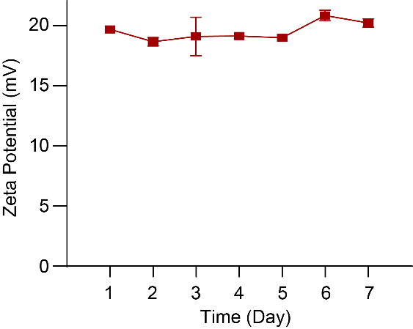
Figure S6. The stability evaluation of L@Mn-mRNA from zeta potential. The L@Mn-mRNA was placed in PBS at 4 ℃. The zeta potential had no significant changes in seven days. Data were presented as mean ± SD, n = 3. SM-102 and mLuc was used in the formulation.

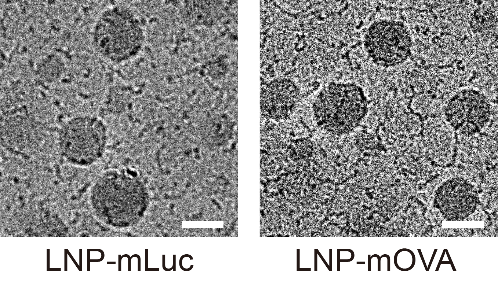
Figure S7. Cryo-EM image of LNP-mRNA. SM-102 ionizable lipid was used in the formulation. Scale bar, 50 nm.

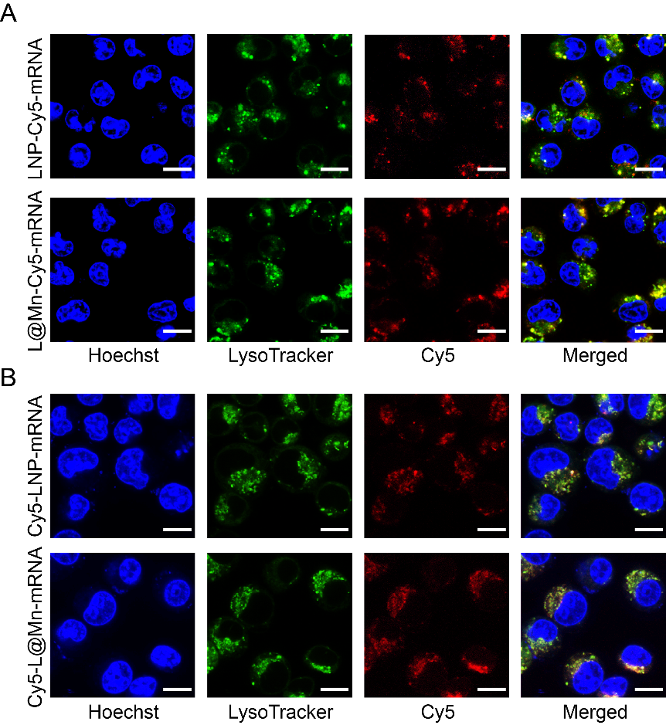
Figure S8. Cellular uptake of LNP-Cy5-mRNA and L@Mn-Cy5-mRNA after 10 hours incubation imaged by CLSM. Same mRNA dose (0.5 μg/mL) was used to incubate with DC 2.4 cells. Red, Cy5 labeled mRNA (A) / Cy5 labeled DMG-PEG2K (B); green, Lysotracker green; blue, Hoechst. Scale bar, 10 µm. SM-102 ionizable lipid and mLuc were used in the formulation.

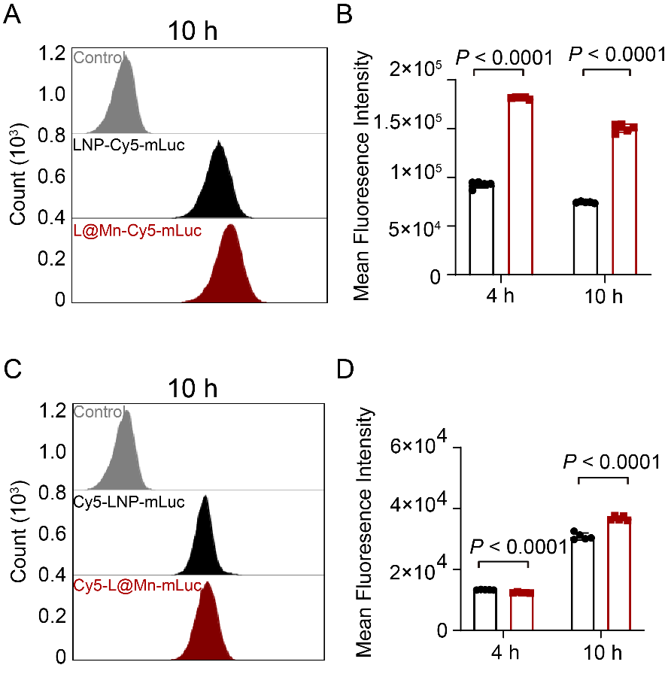
Figure S9. Flow cytometry analysis of Cy5 labeled nanoparticles entering DC2.4 cell line. A. Cellular uptake of LNP-Cy5-mRNA and L@Mn-Cy5-mRNA at 10 hours. B. Quantitative analysis of cellular uptake at 4 hours and 10 hours from flow cytometry. Mean fluorescence intensity of L@Mn-Cy5-mRNA was 2-fold of that in LNP-Cy5-mRNA. C. Cellular uptake of Cy5-LNP-mRNA and Cy5-L@Mn- mRNA at 10 hours. D. Quantitative analysis of cellular uptake after 4 hours and 10 hours from flow cytometry. Mean fluorescence intensity of Cy5-L@Mn-mRNA was similar with that in Cy5-LNP-mRNA. Data were presented as mean ± SD, n = 5. Statistical significance was analyzed by two-tailed t-test.

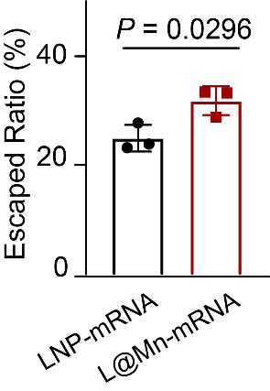

Figure S10.The lysosome escape efficiency of LNP-mRNA and L@Mn-mRNA. SM-102 and mLuc were used in the formulation. Data were presented as mean ± SD, n = 3. Statistical significance was analyzed through two-tailed t-test.
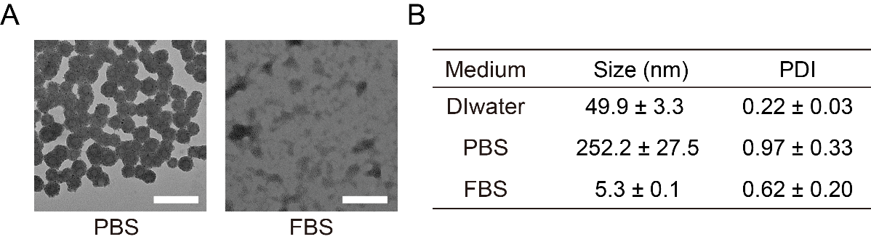
Figure S11. Morphologies of Mn-mRNA nanoparticles in PBS and FBS. A.TEM images of Mn-mRNA after incubation with PBS (pH 7.4) and FBS for 0.5 hour. Scale bar, 100 nm. B. Size and PDI of Mn-mRNA after incubation with PBS and FBS for 0.5 hour detected by DLS. Data were presented as mean ± SD, n = 3.

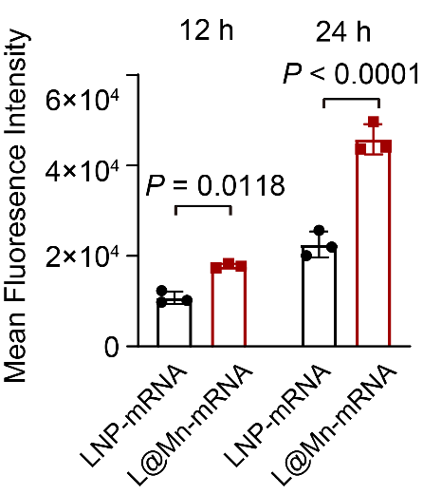
Figure S12. The bioluminescence intensity of LNP-mLuc and L@Mn-mLuc incubated with BMDCs for 12 hours and 24 hours. The mLuc dosage was 1 μg/mL. SM-102 ionizable lipid was used in the formulation. Data were presented as mean ± SD, n = 3. Statistical significance was analyzed by two-tailed t-test.

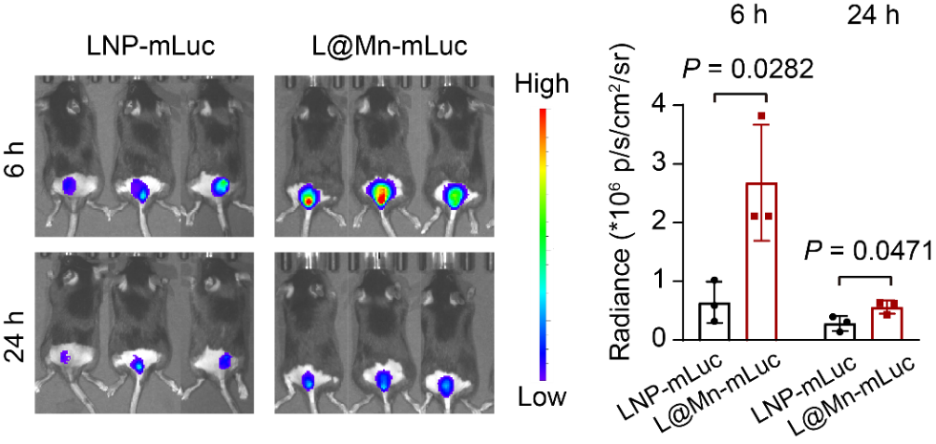
Figure S13. In vivo luciferase expression of LNP-mLuc and L@Mn-mLuc at 6 and 24 h time point after subcutaneous injection to mice imaged by IVIS. The dosage was 5 µg mLuc per mouse. SM-102 ionizable lipid was used in the formulation. Data were presented as mean ± SD, n = 3. Statistical significance was analyzed by two-tailed t-test.

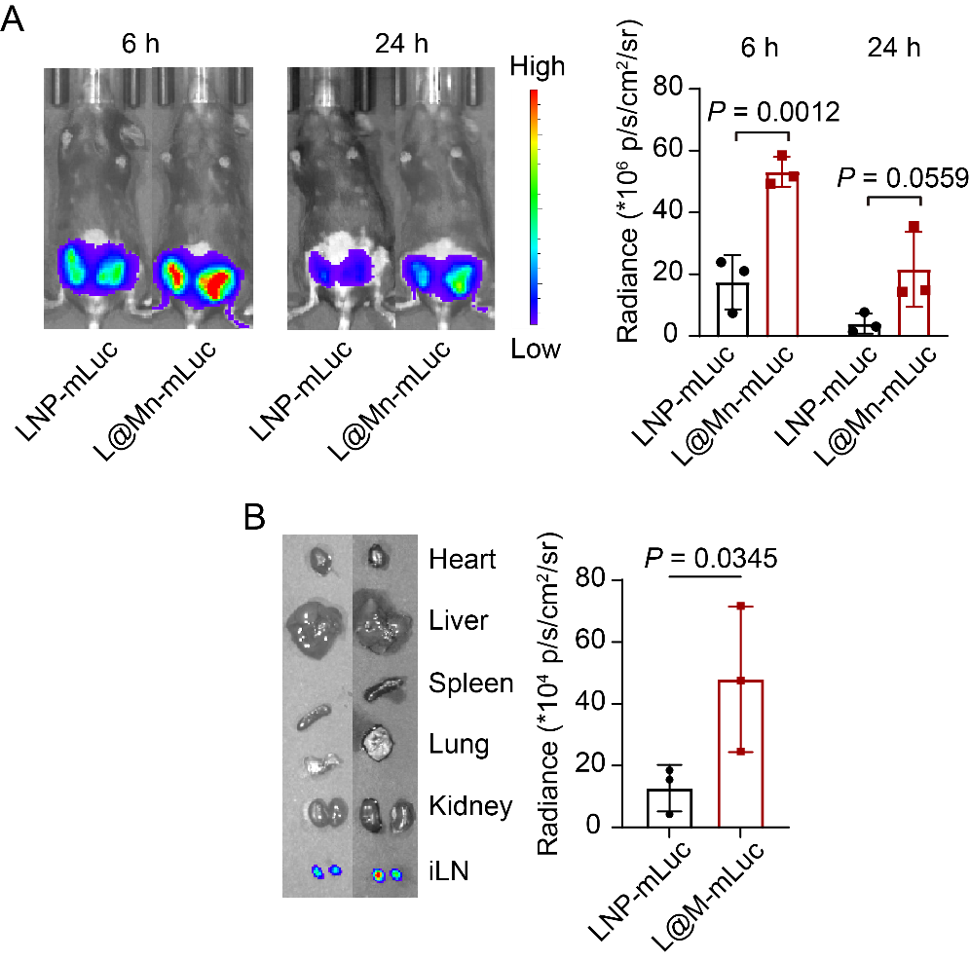
Figure S14. In vivo and ex vivo imaging of L@Mn-mLuc. A. The bioluminescence intensity of the bilateral inguinal regions of the C57BL/6 mice after 6 hours and 24 hours injection of LNP-mLuc (5 μg mRNA per mouse) and L@Mn-mLuc (5 μg mRNA per mouse). B. The bioluminescence intensity of the inguinal lymph nodes (iLN)and major organs, including heart, liver, spleen, lung and kidney, at 24 hours. SM-102 ionizable lipid was used in the formulation. Data were presented as mean ± SD, n = 3. Statistical significance was analyzed by two-tailed t-test.
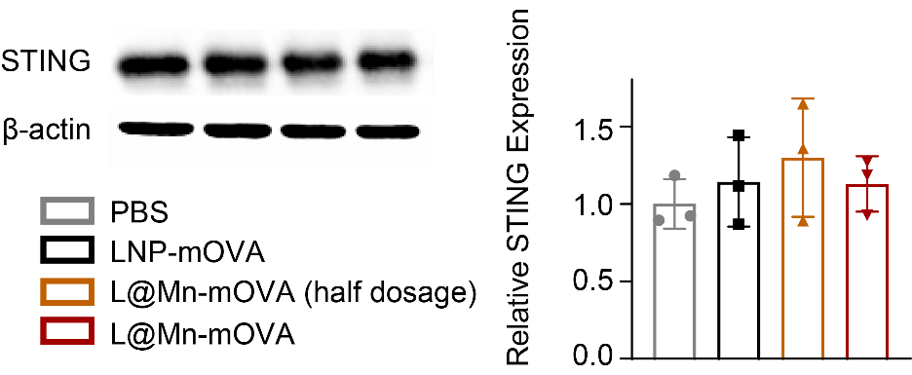

Figure S15. WB analysis of the STING protein expression in BMDCs. BMDCs were treated with PBS, LNP-mOVA (mOVA dose: 1 μg/mL), L@Mn-mOVA (mOVA dose: 0.5 μg/mL) and L@Mn-mOVA (mOVA dose: 1 μg/mL) for 24 hours. Data were presented as mean ± SD, n = 3. There was no significant difference. Statistical significance was analyzed by one-way ANOVA with Tukey’s correction.

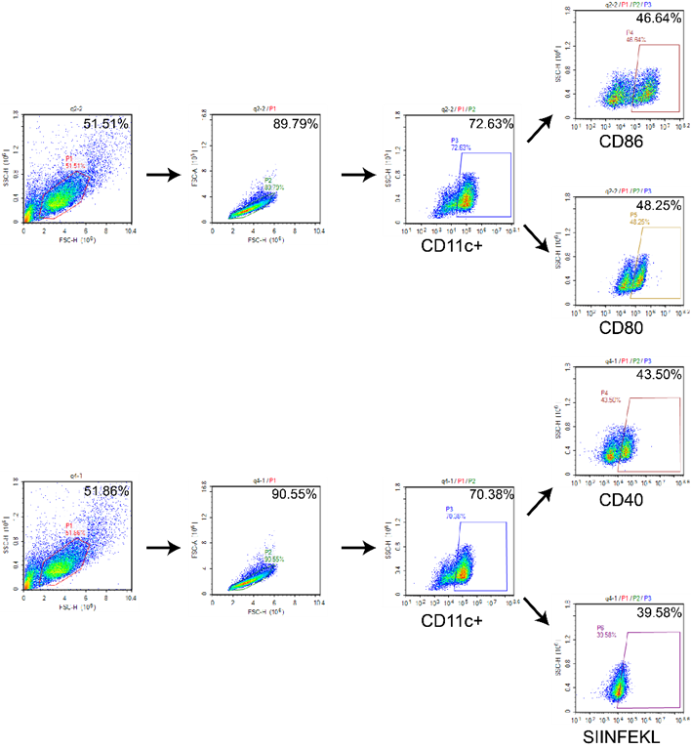
Figure S16. The gating strategy of dendritic cells maturation and antigen presentation.
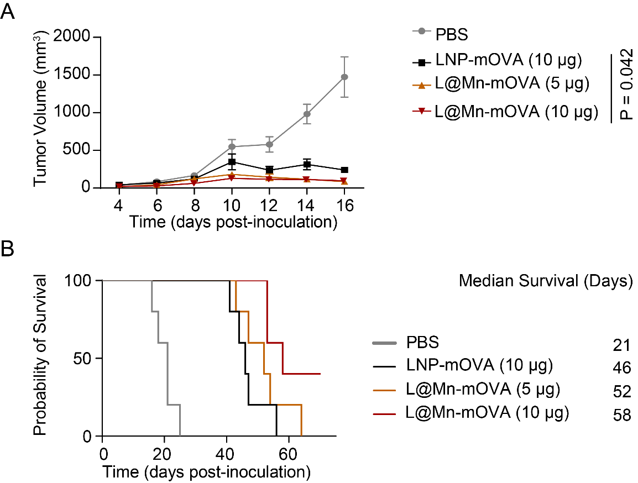
Figure S17. Tumor inhibition and survival curves of tumor, B16-OVA. A. Tunour growth curve of each group. B. Survival curve. Data were presented as mean ± SD, n = 5. SM-102 ionizable lipid was used in the formulation. Statistical significance was analyzed by two-tailed t-test.

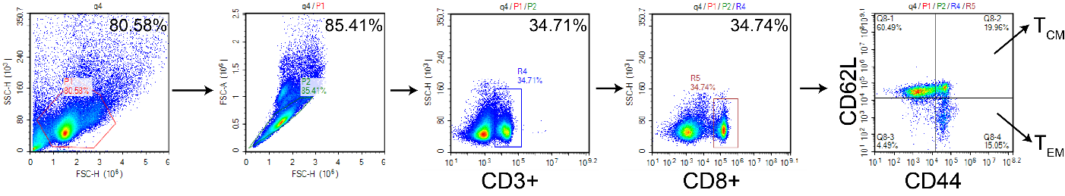
Figure S18. The gating strategy of effector memory T cells (CD3+CD8+CD44^{high}CD62L^{low}) and central memory T cells (CD3+CD8+CD44^{high}CD62L^{high}).

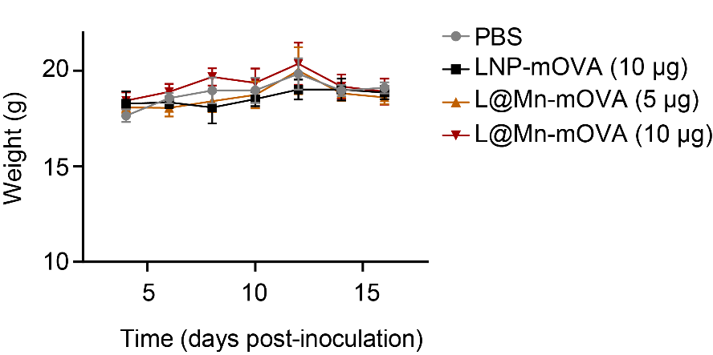
Figure S19. Weight changes during the treatment. Data were presented as mean ± SD, n = 5.

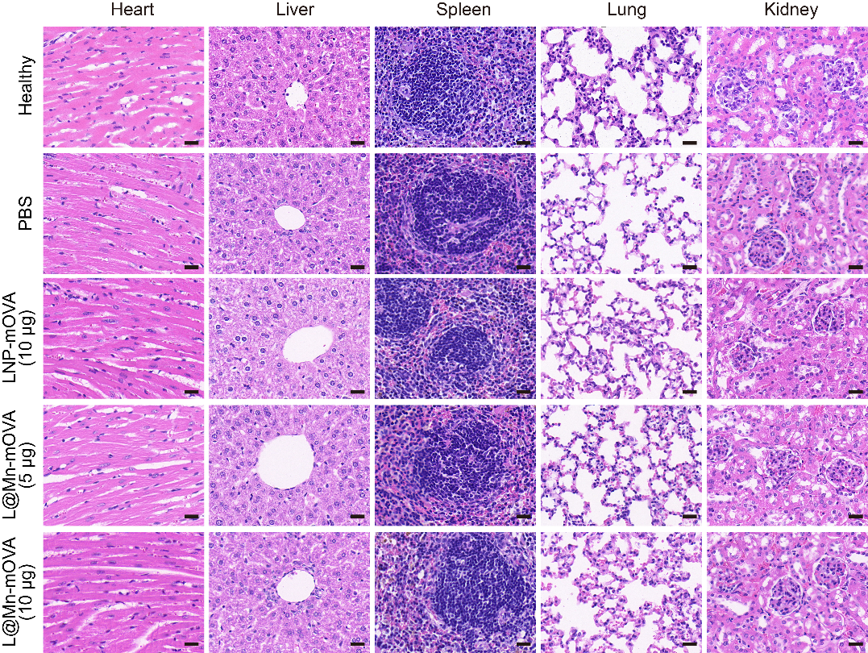
Figure S20. H&E analyses of major organs from each group mice at Day 17 (in the timeline of Figure 5A). Scale bars, 20 μm.

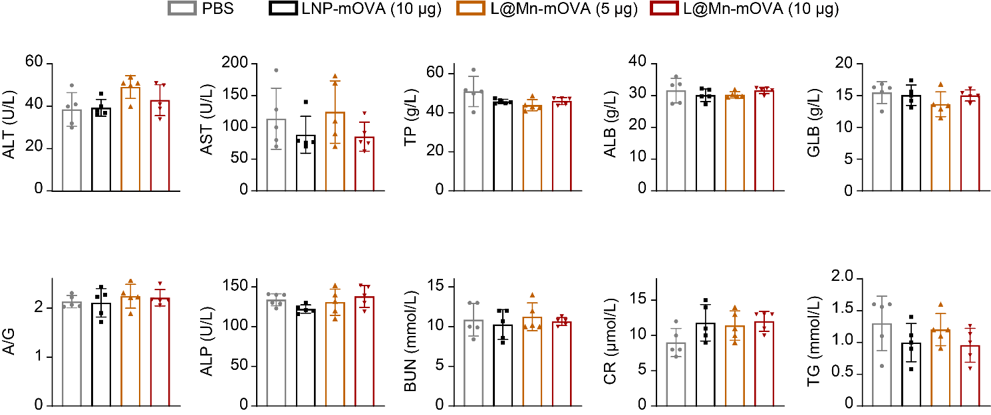
Figure S21. Blood biochemical marker analysis. C57BL/6 mice were subcutaneously injected with PBS, LNP-mOVA (10 μg mOVA per mouse), L@Mn-mOVA (5 μg mOVA per mouse) and L@Mn-mOVA (10 μg mOVA per mouse). After 24 hours, we collected blood samples for the analysis of blood biochemical parameters. Data were presented as mean ± SD, n = 5. There were no statistically significant differences among the groups. Statistical significance was analyzed by one-way ANOVA with Tukey’s correction.

