Supplemental Data
Pain Outcomes of Outside the Cage Robotic Thoracic Surgery: A prospective matched-cohort study
Table of Contents
Supplemental Table 1. Full List of Comorbidities
Supplemental Table 2. Full List of Complications

Abbreviations Used:
OTC: Outside the Cage
TT: Transthoracic
RATS: Robotic-assisted thoracoscopic surgery

Supplemental Table 1. Full List of Comorbidities
Comorbidities:  - COPD  - Lung cancer  - Diabetes  - Heart failure  - Coronaropathy  - Hypertension  - Cardiac arrythmia  - Peripheral vascular disease  - Stroke  - Chronic kidney disease  - Previous ipsilateral thoracic surgery  - Previous contralateral thoracic surgery  - Myasthenia  - Cirrhosis | OTC RATS  12  4  8  5  2  20  5  7  1  3  4  5  11  1 | TT RATS  8  4  11  1  4  13  1  7  1  1  6  5  4  0 | p-value  0.57

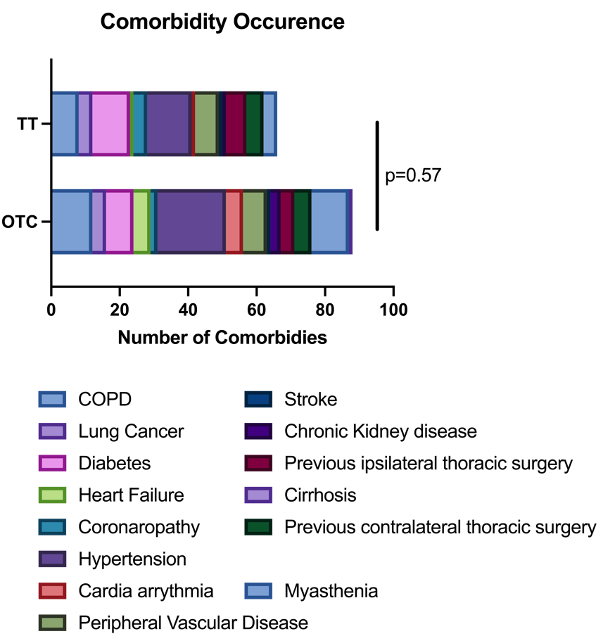
Supplemental Table 2. Full List of Complications. †= this patient pre-operatively presented to the clinic with chronic liver disease (Cirrhosis) and deteriorated during the post-operative course.
Post-operative complication  - Pain related complication  - Pneumonia  - Prolonged air leak  - Respiratory failure  - Atelectasis  - Pleural effusion  - Post operative pneumothorax  - Hemothorax  - Acute Liver Failure†  - Pulmonary embolism  - Atrial fibrillation  - Cardiac failure  - Wound infection  - Bowel obstruction | OTC RATS  0  6  3  2  4  2  2  1  1  2  2  2  0  0 | TT RATS  1  7  2  2  3  4  1  0  0  1  1  0  0  0 | p-value  0.94

