Appendix 1 – Focus group protocols
Preparation:
Location: Inform participants about the location and directions.
Participants: Homogeneous groups of care recipients, professional caregivers and informal caregivers. Maximum of five care recipients and eight caregivers per focus group.
Recording: Bring cameras and tripods.
Materials: A3 sheets, post-its, markers, printed characters.
Information letter and informed consent: Hand out information sheets and informed consent form to participants. Ask participants if all information is clear. If no further questions, ask participants to sign the informed consent form and turn on recorder.
Introduction:
- Welcome
- Explain objective of today: Talk about experiences with (providing) care and support as a [care recipient/professional caregiver/ informal caregiver].
- Explain duration of the focus group: maximum 2 hours with a break.
- Emphasize that there are no good or wrong answers.
- Introduction of the moderators and their roles in the focus group.
- Explain the ‘rules’: react to others, but wait until the other one is finished. Moderators will make sure every participant has the opportunity to share.

Questions (care recipients):
Care network
- Who around you helps you in your care?
Think about family, friends, counselor, neighbors, doctors, etc. If you want, use the animated characters.
- How do this people help you?
- Who does really help you?
- If care has to be organized, who helps you with that?
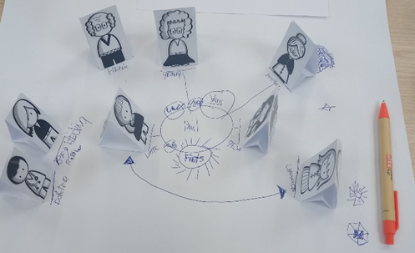
- Where do you put this people in a network?
Place yourself in the middle. Place the people that often help you close to you, and the ones that help you less further away
Figure 1: Example of a care network of a care recipient, using the printed characters.

- Which type of topics or questions do these people help you with?
  - Can you give an example of what went well in your care?
  - What is going less well?
- Who helps you if things are going less well?
- Could this be easier? What issues do you face?
- Why would you like that?
- What should change?
Future context
- Do you expect that your care will change in the coming year?
- How do you see your future of care?
- What changes, think about the organization of care, available personnel, counselors?
  - Why do you think that?
  - Does that affect you and how?
Ending
- Is there anything else that you would like to share about this topic? Something we didn’t discuss?
- What did you think about this focus group and the method we used?
  - How could we do it better next time? (Tips & Tops)

Questions (professional and informal caregivers):
Context of care
- What type of care recipients do you care for?
- Which type of care do you provide? / How do you help care recipients?
Ways of care requests
- In what manner do care recipients ask for help?
- What are differences in the way care recipients ask for help?
- How do you help care recipients in formulating their care request? Which questions do you ask to understand what it is that they need?
- How do you accommodate for the various care needs of diverse care recipients?
Future context
- Which development do you see in the context of care?
  - What is your view on these developments?
Needs caregivers
- What challenges do you face yourself in providing care to care recipients?
- What would support you to provide care?
Ending
- What did you think about this focus group and the method we used?

Concluding remarks:
- Explain confidentiality.
- Explain follow-up steps: analyze focus groups and use it for technology development.
- Thank participants.
- Stop recording.

