Supplementary Information for “Whole-brain functional photoacoustic/ultrasound localization (PAUL) imaging for monitoring blood-brain barrier modulation”
Shensheng Zhao^{1,2,3}, Sayantani Basu⁴, Ji Shi¹, Kewei Song¹, Pun Siripun⁵, Huan Huynh⁶,
Yang Zhao^{1-3,7,9}, Roy H Campbell⁴, Yun-Sheng Chen^{1-3,7-9,*}

¹Department of Electrical and Computer Engineering,
University of Illinois Urbana-Champaign, Urbana, IL, USA
² Beckman Institute for Advanced Science and Technology,
University of Illinois Urbana-Champaign, Urbana, IL, USA
³ Nick Holonyak Micro and Nanotechnology Laboratory,
University of Illinois Urbana-Champaign, Urbana, IL, USA
⁴ Department of Computer Science,
University of Illinois Urbana-Champaign, Urbana, IL, USA
⁵ Department of Mechanical Science & Engineering,
University of Illinois Urbana-Champaign, Urbana, IL, USA
⁶ Department of Neurology and Rehabilitation,
University of Illinois Chicago, Chicago, IL, USA
⁷ Department of Bioengineering,
University of Illinois Urbana-Champaign, Urbana, IL, USA
⁸ Department of Biomedical and Translational Sciences, Carle Illinois College of Medicine,
University of Illinois Urbana-Champaign, Urbana, IL, USA
⁹ Cancer Center at Illinois,
University of Illinois Urbana-Champaign, Urbana, IL, USA
*Corresponding author: yunsheng@illinois.edu

Supplementary Figures
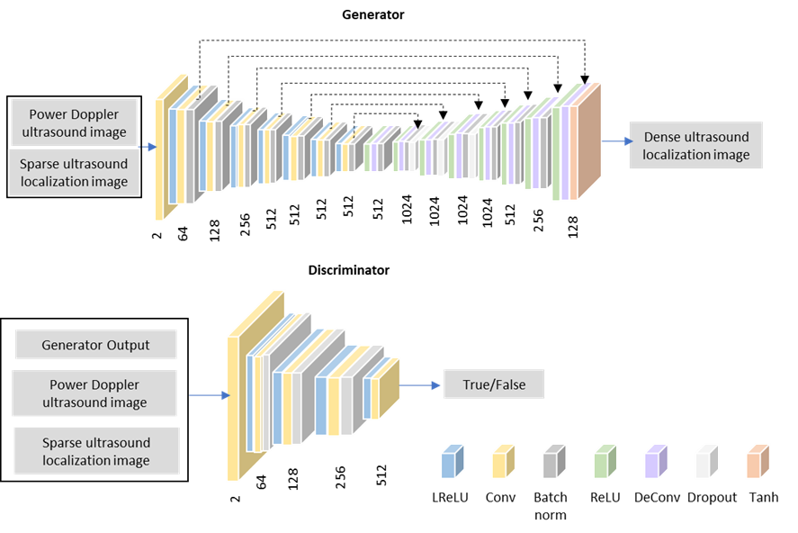
Figure S1| cGAN deep learning architecture for DL-UL imaging.

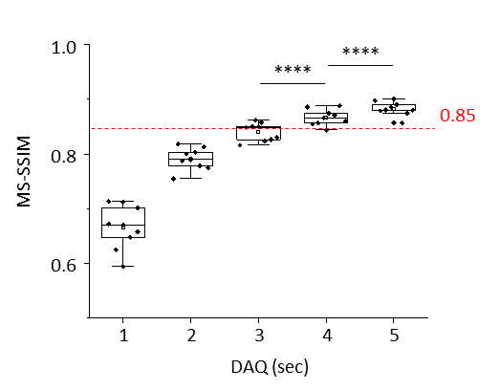
Figure S2| Multi-scale Structural Similarity (MS-SSIM) between DL-UL images and ground truth as a function of data acquisition time. N=9. **** p< 0.0001.

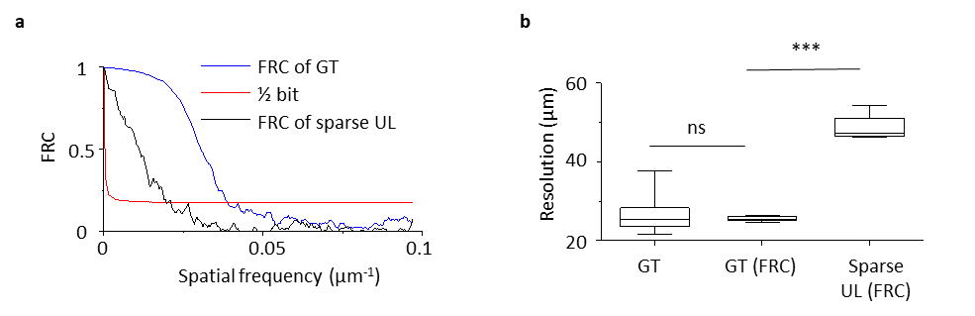
Figure S3| Resolution measurement of UL images. (a) Resolution measurements using the Fourier Ring Correlation (FRC) method for ground truth (GT) images (100-second acquisition time, Figure 2c) and sparse UL images (4-second acquisition time, Figure 2c). (b) Comparison of resolution measurements using amplitude profile and FRC methods. ns: no significant difference. *** p<0.001.

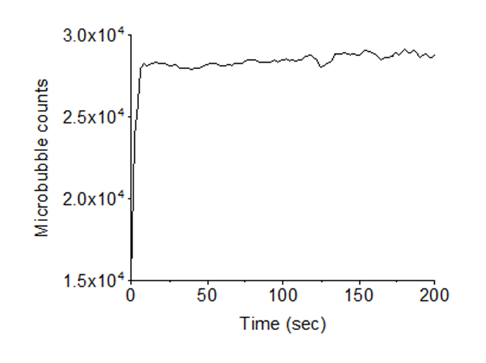
Figure S4| Microbubble counts as a function of injection during continuous perfusion using a syringe pump with the rate of 20 µL/min.

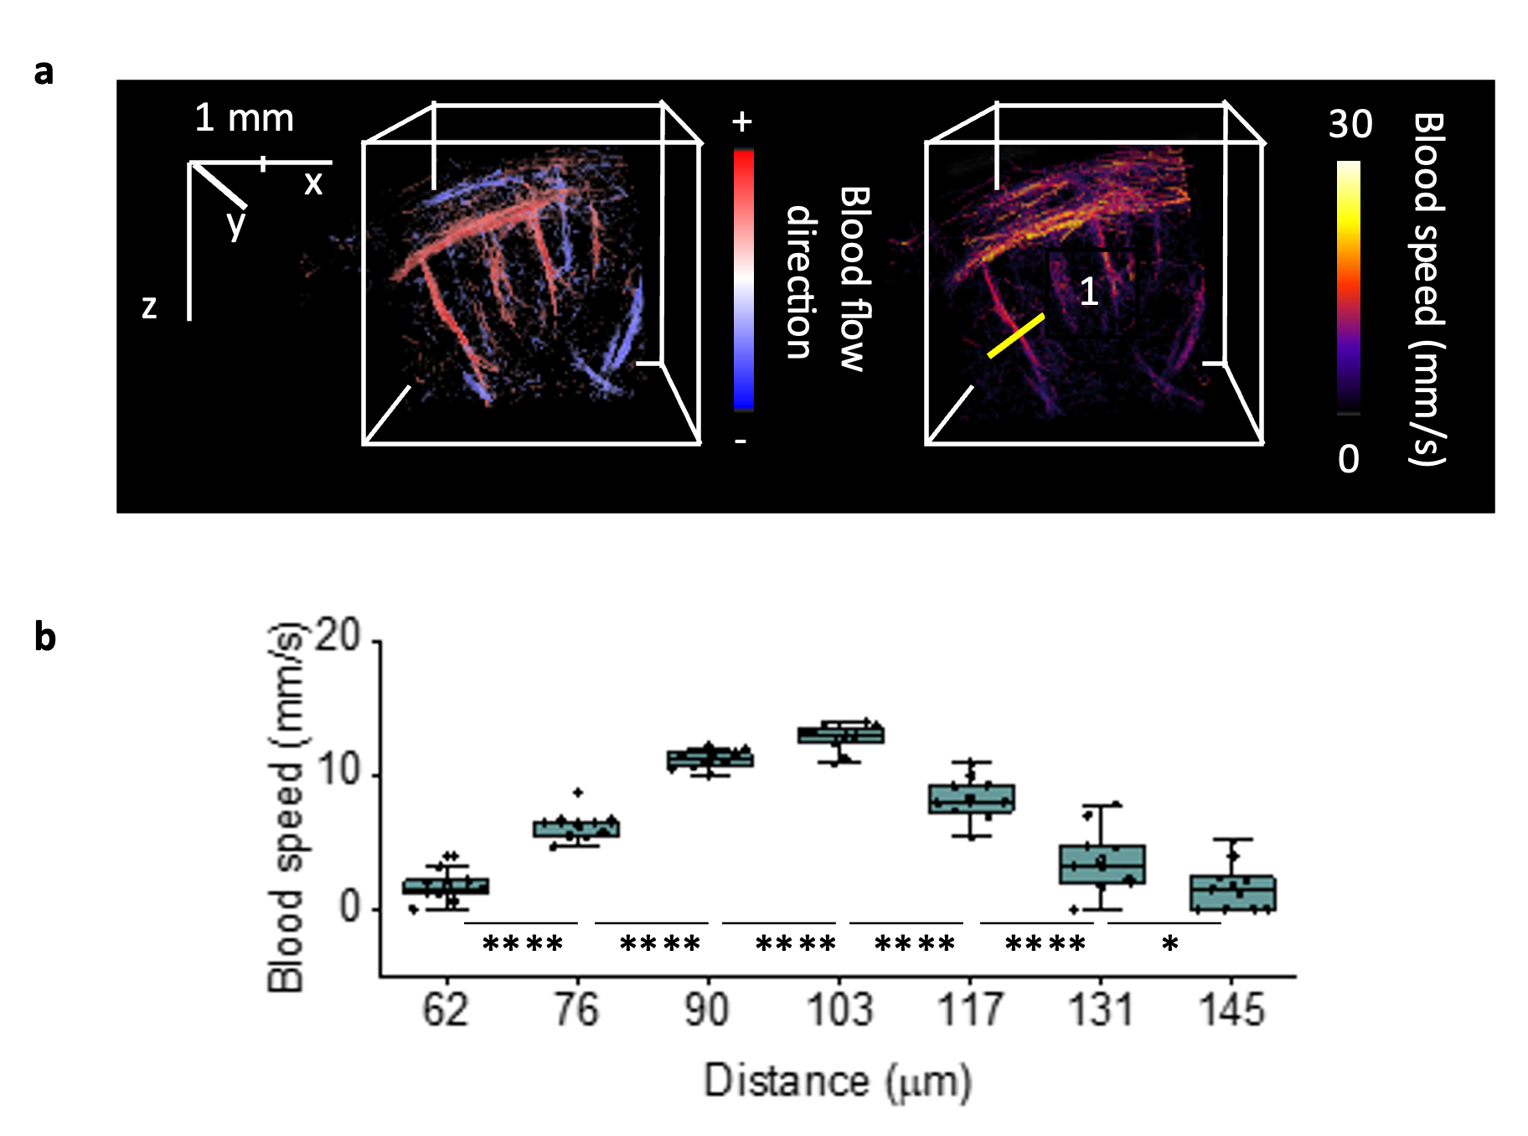
Figure S5| Analysis of the velocity profile shows a Poiseuille-like flow profile. (a) 3D directional blood flow map and 3D blood speed map showing a zoomed-in region of the mouse brain, as detailed in Figure 3a-b. (b) Analysis of the velocity profile of line 1 demonstrates a Poiseuille-like flow pattern. N = 10. ****p<0.0001, *p = 0.049.

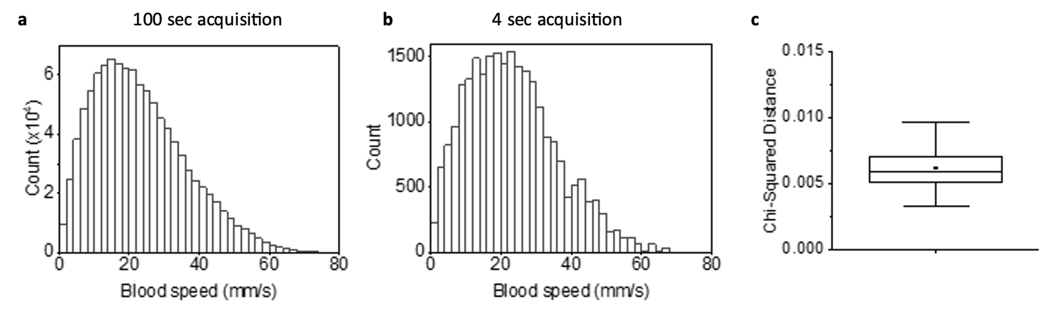
Figure S6| Comparison of blood speed distributions. (a) 100 seconds and (b) 4 seconds of data acquisition. (c) The Chi-Squared distance was calculated to measure the dissimilarity between the two histograms. N = 35.

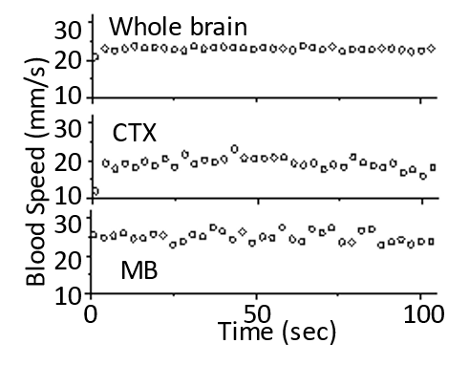
Figure S7| Analysis of brain blood speed in the whole brain and specific anatomical regions (CTX, and MB) for the brain slice shown in Figure 3h.

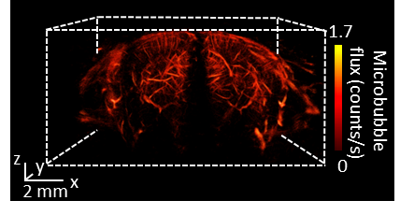
Figure S8| Coronal view of a 3D microbubble flux map of a mouse brain. The scanning step size is 50 µm.

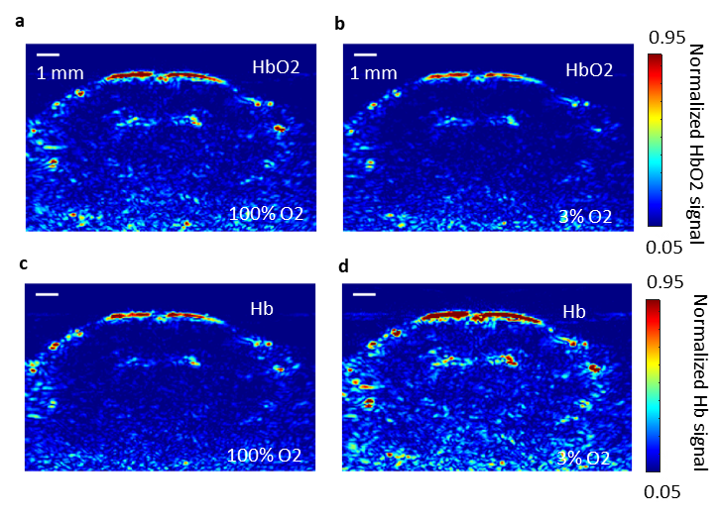
Figure S9| Changes in Hb and HbO2 levels in a mouse brain during an oxygen-challenge test. (a) HbO2 map while inhaling 100% oxygen. (b) HbO2 map while inhaling 3% oxygen. (c) Hb map while inhaling 100% oxygen. (d) Hb map while inhaling 3% oxygen.

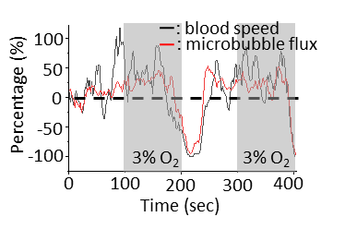
Figure S10| Percentage change in brain blood speed (black) and microbubble flux (red) in different vessels over two hyperoxia-hypoxia cycles.

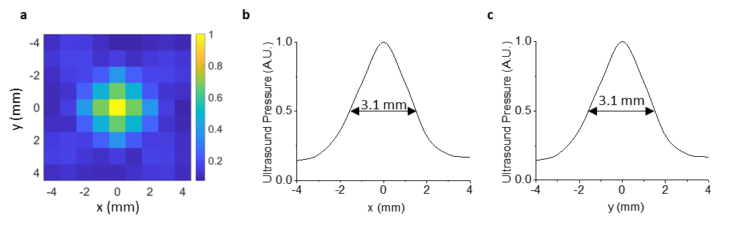
Figure S11| Characterization of FUS pressure. (a) Normalized acoustic pressure map at the FUS focal plane. (b) Normalized acoustic pressure profile along the y-axis at y = 0. (c) Normalized acoustic pressure profile along the x-axis at x = 0.

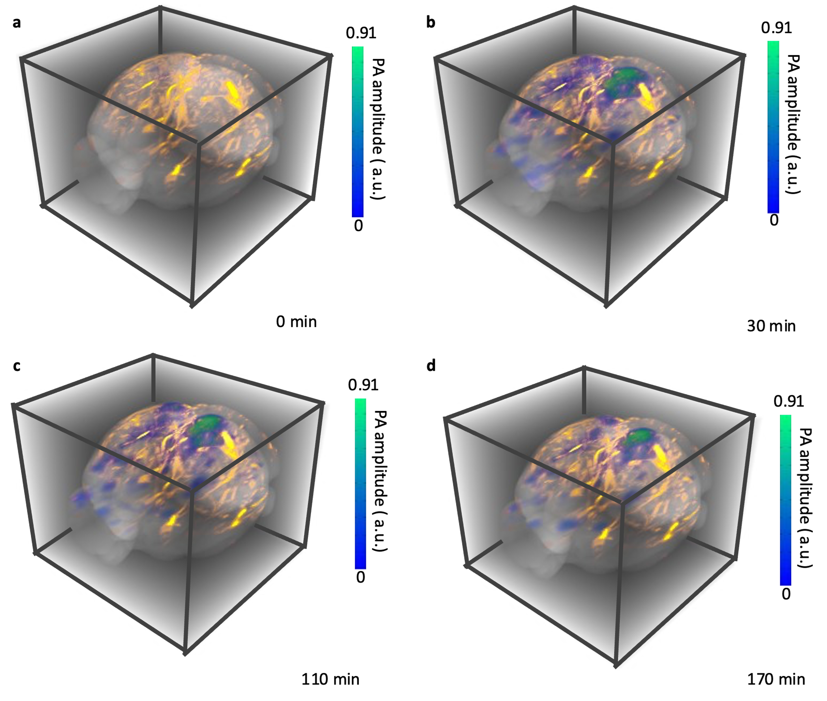
Figure S12| Longitudinal monitoring of ICG distribution in a living mouse brain after FUS BBB opening. (a) Before, and (b) 30 minutes, (c) 110 minutes, and (d) 170 minutes after BBB disruption with focused ultrasound. The brain microvascular image merged with ICG signals, was collected 110 minutes post-BBB disruption. The image dimensions are 12.5 mm x 12 mm x 10 mm (xyz). The scanning step size is 50 µm.

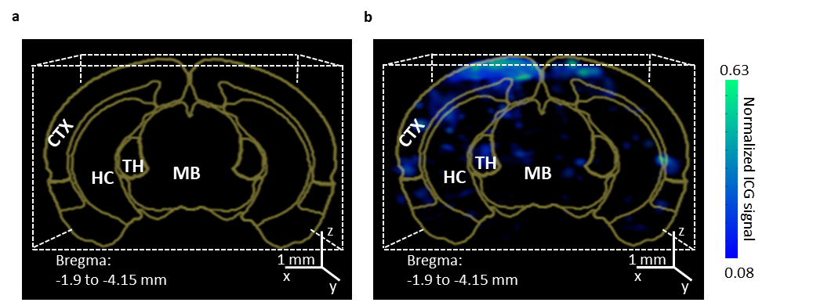
Figure S13| Coronal views of 3D PA images of ICG distribution in the brain (a) before and (b) 110 minutes after BBB disruption. The images cover the region from bregma -1.9 mm to -4.15 mm. The atlas map at bregma -3.3 mm (brown line) guides the identification of brain regions. The scale bar represents 1 mm. The scanning step size is 50 µm.

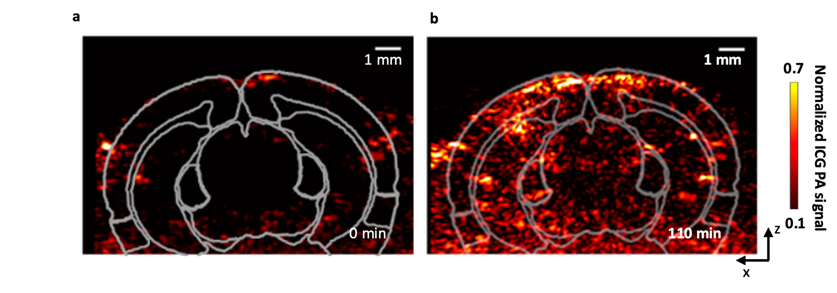
Figure S14| Coronal views of 2D PA image of ICG distribution in the brain at bregma -3.3 mm (a) before and (b) 110 minutes after BBB disruption. The scale bar is 1 mm. The atlas map at bregma -3.3 mm (white line) guides the identification of brain regions.

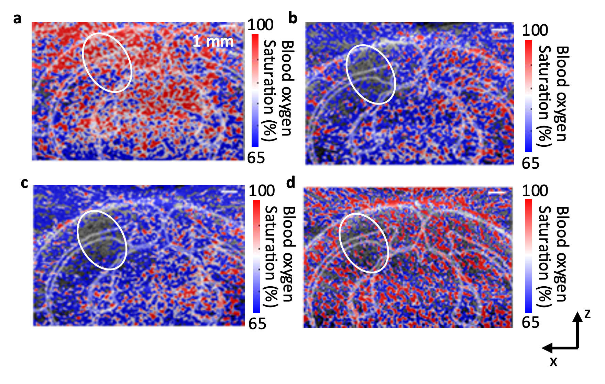
Figure S15| In vivo photoacoustic imaging of changes in brain blood oxygenation (percentage): (a) Before, (b) 30 minutes, (c) 110 minutes, and (d) 170 minutes after BBB disruption. The atlas map at bregma -3.3 mm (white line) guides the identification of brain regions.

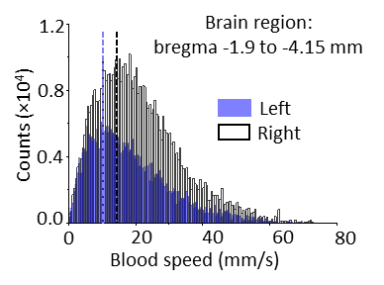
Figure S16| Velocity distribution of a mouse with FUS-mediated BBB disruption at the brain region from bregma -1.9 to -4.15 mm.

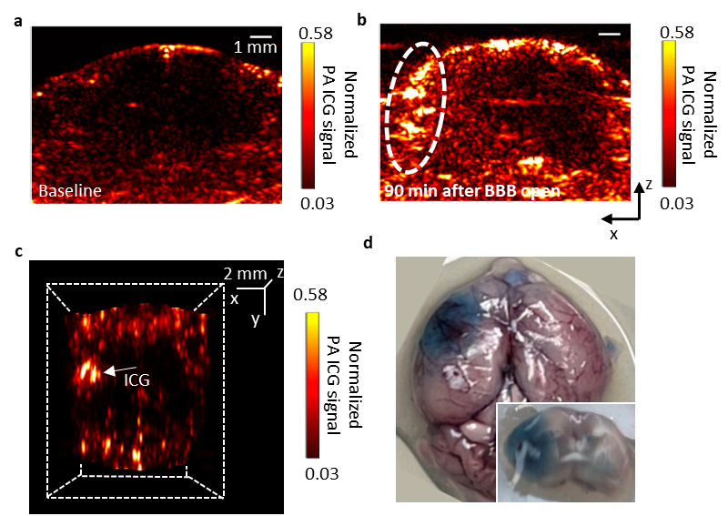

Figure S17| Validation of ICG as an effective BBB permeability tracer. (a) ICG signal before BBB opening. (b) ICG signal 90 minutes after BBB opening. (c) 3D distribution of ICG 90 minutes post-BBB opening after removing the skull. (d) Evans blue extravasation in brain tissues.

