Supplementary Information
Efficient tetracycline degradation using arbon quantum dot-modified TiO₂@LaFeO₃ hollow core-shell photocatalysts
Pengcheng Hao^{1,2}, Rui Shi², Xuanhang Wang², Juan Zhang³, Bo Li⁴, Jing Wang⁵, Bo Liu⁵, Yayuan Liu⁶, Xin Qiao¹, Zhongzhi Wang^{1,*}
Baotou Research Institute of Rare Earths, Baotou 014030, China.
*email:198322wzz@163.com

Contents
Characterization methods.
Page 3
Figure. S1. Core-shell structure of CDs-TLFO.
Page 4

Figure S2. Mass spectra of TC intermediates with different retention times.
Page 4

1. Characterization methods
Transmission electron microscope (TEM, JEOL 2010 HR & UHR (Japan)) images were obtained at an accelerating voltage of 100 kV. The freshly prepared sample was dispersed ultrasonically before the TEM imaging. Scanning electron microscope (SEM, JEOL JSM 6700F (Japan)) images were also obtained at a different magnification at an accelerating voltage of 15 kV. UV–visible diffuse-reflectance spectra (UV-vis DRS, UV-2450 spectrometer equipped with an integrating sphere) were recorded in the range of 200–800 nm. The powder X-ray diffraction (XRD; Bruker AXS D8 Advance diffractometer) patterns were recorded using a Cu-Ka source to investigate the crystal structure of the samples. The X-ray photoelectron spectroscopy (XPS, Axis Ultra DLD spectrometer (Kratos Analytical Ltd., England)) measurements were conducted with a monochromatized Al Ka X-ray source (hm = 1486.6 eV). Photoluminescence (PL) spectra (Perkin-Elmer LS-55 spectrofluorimeter) were measured at the excitation wavelength of 300 nm at room temperature. The time-resolved fluorescence decay spectra (Edinburgh FLS980 spectrophotometer) were collected at the excitation wavelength of 300 nm. The electronspin resonance (ESR; Bruker ER200-SRC spectrometer) signals of radicals spin-trapped by spin-trapped reagent 5, 5-dimethyl-l-pyrroline N-oxide (DMPO) and 2,2,6,6-Tetramethylpiperidinooxy (TEMPO) were examined under visible light irradiation (wavelength λ>420 nm). Photocurrent-time (PT, CHI 660C electrochemical station) was tested in a standard three electrode configuration. Zeta potential was measured using the Zeta-sizer Nano-ZS (Malvern, UK).
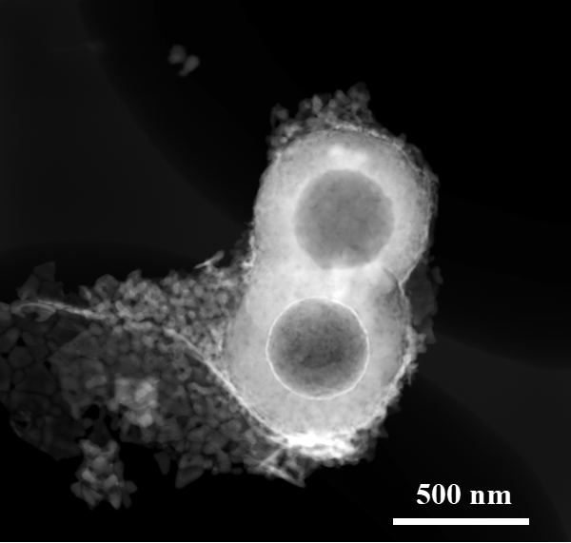
Figure S1. Core-shell structure of CDs-TLFO
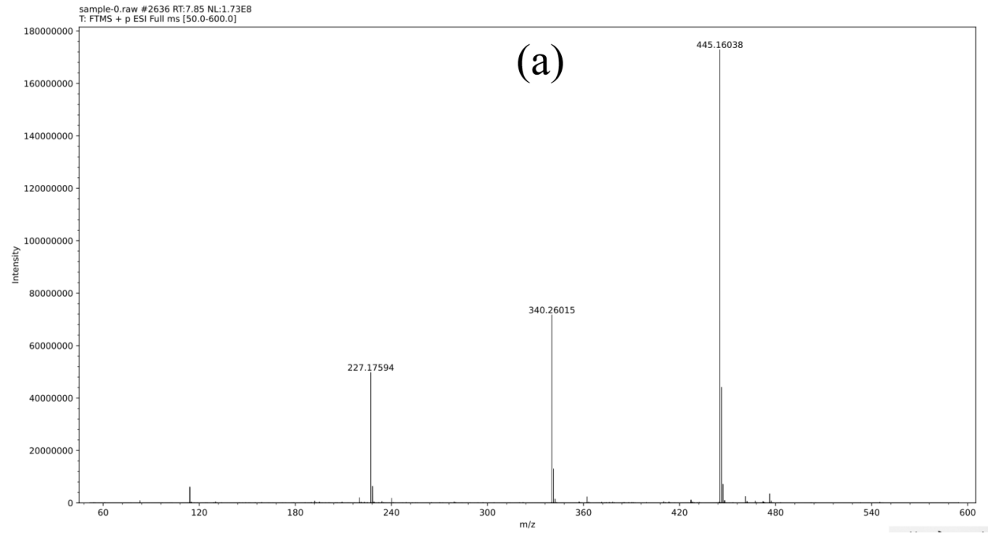
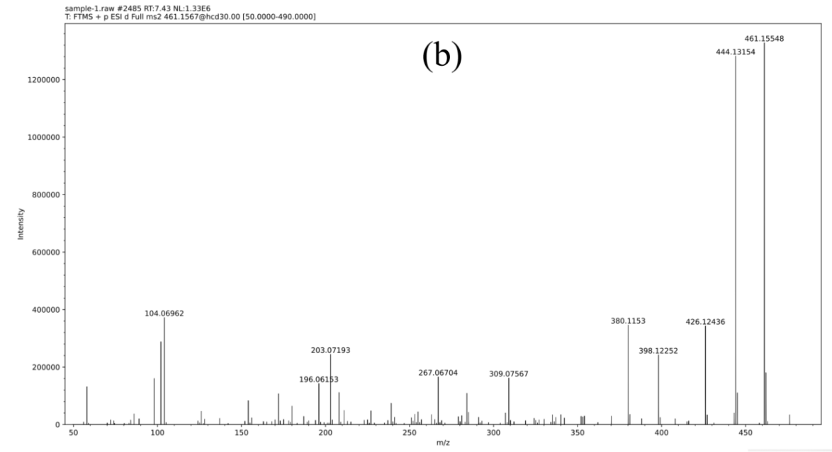
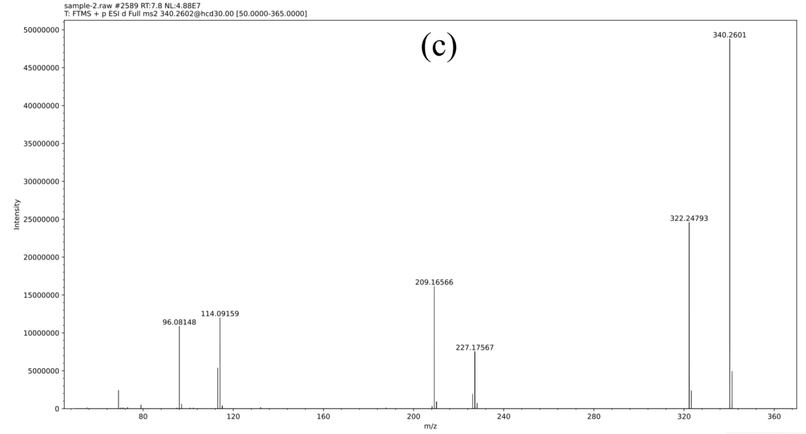
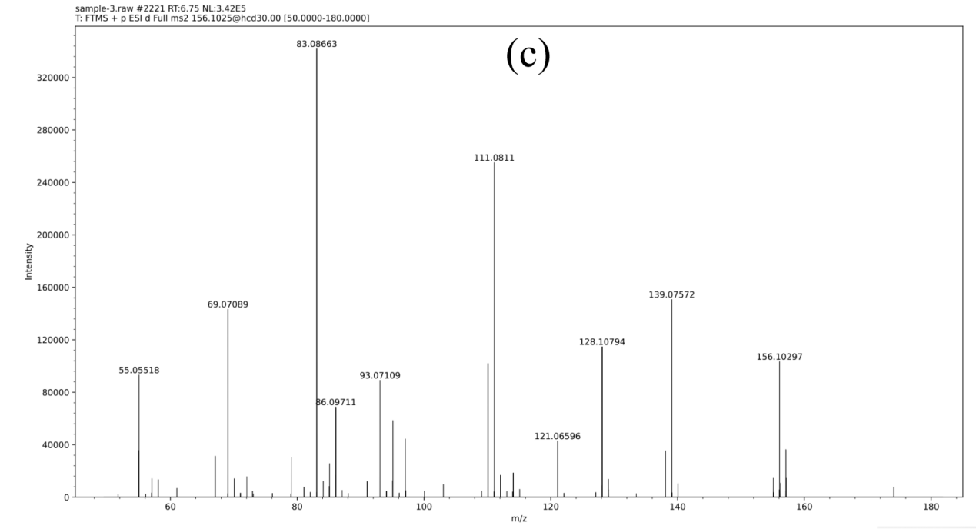
Figure S2. Mass spectra of TC intermediates with different retention times (a. 0min, b. 30min, c. 60min, d. 100min).

