Supporting Information

Freestanding membranes of hydrogen-bonded organic frameworks for efficient wound healing

Lingling Wu^{1,2}, Xue Yang^{1*}, Chang Gao¹, Haonan Jia¹, Zhiqi Hu¹, Jiao Wang¹, Yanan Guo¹, Lvyao Xiao¹, Shuiying Gao³, Rong Cao^{3,*}, Robert Chunhua Zhao^{1,2,4*}

¹ School of life sciences, Shanghai University, Shanghai 200444, China
²School of Medicine, Shanghai University, Shanghai, China
³State Key Laboratory of Structural Chemistry. Fujian Institute of Research on the Structure of Matter, Chinese Academy of Sciences. 350002, Fuzhou, Fujian, P. R. China.
⁴Institute of Basic Medical Sciences Chinese Academy of Medical Sciences, School of Basic Medicine Peking Union Medical College, Beijing, China
⁵School of Physical Science and Technology, ShanghaiTech University, Shanghai, 201210 (P. R. China)

E-mail: yangxue23@shu.edu.cn; rcao@fjirsm.ac.cn; zhaochunhua@vip163.com

Experimental Section
Synthesis of PFC-73 powders
The Synthesis of PFC-73 powders were performed according to the previous work¹. NiTCPP (40 mg, 0.05 mmol) was dissolved in 4 mL of DMF in a 15 mL glass bottle without a lid, followed by adding 8 mL of 1,2,4-trichlorobenzene (TCB). Then store the glass bottle at 100 °C in an oven for 1 day, and after cooling down to room temperature, soak the sample in CH₂Cl₂ for 3 days, centrifuge several times to replace fresh CH₂Cl₂, and finally dry it under vacuum at 100 °C for 8 h.
Synthesis of PMMA@PFC-73 membrane
The prepared PFC-73 powders were dispersed in ethanol solution (3 mg/mL), and poly (methyl methacrylate) (PMMA) was dispersed in chlorobenzene solution (10 mg/mL). PMMA@PFC-73 nanocomposite film was assembled by mixing 500 μL PFC-73 solution with 300 μL PMMA solution in a 50 mL (20 mL) vial on the surface of water. After completely evaporate the organic solvent for 2 h, PMMA@PFC-73 membranes of different diameters were obtained by different size iron wire rings.
Characterization
Scanning electron microscopy (SEM) images were recorded on a Zeiss Sigma 300 field emission scanning electron microscope. Their chemical components were examined using a FEI Super-X energy dispersive spectrum (EDS). The X-ray diffraction (XRD) spectra of samples were performed on a Rigaku SmartLab X-ray thin-film diffractometer with Cu Kα radiation (λ = 1.54 Å).
Water vapor transmission rate (WVTR)
The WVTR of PMMA@PFC-73 membrane and gauze were evaluated at room temperature according to ASTM E96-95. The experiment is performed by measuring the weight of evaporation at each point in time in a bottle whose opening is covered by prepared film and gauze.
In vitro hemolysis test
Fresh whole mouse blood was initially collected in an EDTA anticoagulant tube for in vitro hemolysis and coagulation assessment. Subsequently, different concentrations of PFC-73 and PMMA@PFC-73 membrane were co-incubated with PBS-diluted red blood cells at 37 °C for 4 h. PBS and Triton X-100 were used as negative and positive controls to evaluate the hemolysis rates of different materials.
Evaluation of blood coagulation ability in vitro
10 mg sample of Gauze, PMMA, and PMMA@PFC-73 membrane was placed into a 1.5 mL centrifuge tube, with a blank space serving as the control. 100 μL whole blood was dropped into the centrifuge tube and immediately 10 μL CaCl₂ (0.2 M) was added to reactivate the blood. After 10 min, 1 mL of deionized water was added to resuspend the uncoagulated blood components. The centrifuge tube was then turned upside down to observe the state of blood clotting at different time points. After 2 h, the OD 540 nm value of the supernatant was measured to evaluate the coagulation index of different materials. In addition, the adhesion of erythrocytes and platelets on PMMA@PFC-73 membrane was observed by scanning electron microscopy.
Immunofluorescence
Cell immunofluorescence was performed according to the manufacturer’s protocol². The primary antibodies used were as follows: Ki67 (Abclonal, Wuhan).
ROS elimination and cellular oxidative stress protection of PFC-73
HUVECs were seeded on 6-well plates and cultured for 24 h. For ROS elimination detection, cells were initially exposed to LPS (1 µg/mL), LPS plus PFC-73 (10 µg/mL), and LPS plus PFC-73 (50 µg/mL) for 24h. Subsequently, the cells were rinsed twice with PBS and stained with DCFH-DA solution (Servicebio, Wuhan, China) for 30 min at 37 °C. Then the unbound dye solution was washed with PBS and the stained cells were observed with an inverted fluorescence microscope. For cellular oxidative stress protection, H₂O₂ (650 µm), PFC-73 (50 µg/mL), and H₂O₂ plus PFC-73 treated cells for 2 h. Afterward, the cells were rinsed twice with PBS and stained with calcein-AM and propidium iodide (PI) solutions (Beyotime, Shanghai, China) for 30 min at 37 °C. Following a final wash with PBS, the cells were examined using an inverted fluorescence microscope.
Cell proliferation, migration assay of PFC-73
HUVECs were seeded in 96-well plates (2×10³ cells/well) and treated with PFC-73 (50 µg/mL). The cell proliferation ability at 1, 3, and 5 days was measured by Cell Counting Kit-8(Life-iLab, China). To evaluate the scratch healing effect of PFC-73 on HUVECs, a specified density of cells was seeded onto a 6-well plate. A scratch of defined width was created using a 200 µL pipette tip, followed by washing away cell debris with PBS. Subsequently, the cells were exposed to PFC-73 (50 µg/mL) for 24 h, and the rate of scratch closure was determined through microscopic image analysis.
The migration ability of PFC-73 on HUVECs was detected by transwell assay. Initially cell suspensions resuspended in serum-free medium were collected and seeded in the upper chamber of transwell. The cells were treated with PFC-73 (50 µg/mL) for 24 h and fixed with methanol at room temperature for 30 min. The fixed cells were stained with crystal violet for 30min, washed with tap water, and the number of cell migration was observed under a microscope.
RNA isolation and real-time PCR
Firstly, the cells were treated with LPS(1 µg/mL), PFC-73 (50 µg/mL), and LPS plus PFC-73 for 24 h. Total RNA was extracted by FreeZol Reagent (Vazyme, Nanjing, China), and RNA was reverse-transcribed into cDNA by Strand CDNA Synthesis (Vazyme, Nanjing, China).Real-time PCR was detected by SYBR Green qPCR Master Mix (Abclonal, Wuhan, China).The related information of gene primers are found in TableS1.
Cytotoxicity assay
The cytotoxicity assay of PFC-73 (50 µg/mL) and PMMA@PFC-73 membrane on HUVECs. First, HUVECs (5×10³ cells/well) were seeded on 96-well plates and treated with different concentrations of PFC-73 (0-200 µg/mL) and PMMA@PFC-73 membrane for 24 and 48 h. After washing the cells with PBS, 100 µl of the 10% cck-8 working solution (Life-iLab, China) was introduced, followed by incubation at 37℃ for 1.5 h. Cell density was measured using an enzymogram at an optical density of 450 nm.
Calcein-AM and PI staining assay
HUVECs were inoculated in 24-well plates overnight and treated with PFC-73 (50 µg/mL) and PMMA@PFC-73 membrane for 24 h, respectively. After three washes with PBS, 250µL Calcein-AM/PI working solution was added (0.25 µL Calcein-AM plus 0.25 µL PI) (Beyotime, Shanghai, China), and incubated at 37 ℃ for 30 min in the dark. The cells were washed three times with PBS and observed under fluorescence microscope.
In vivo wound healing assay
The mice were randomly divided into control group, PFC-73 group (3 mg/mL), PMMA@PFC-73 membrane group, isoflurane anesthetized mice. A circular wound about 6mm in size was formed on the back of each mouse, and the mice were kept in cages. Photographs were taken every two days to calculate the wound healing area. On day 9, the mice were euthanized, the tissues around the wound were collected, fixed with 4% paraformaldehyde, and then paraffin embedded sections were cut. The wound healing was observed by hematoxylin and eosin (H&E), masson and immunofluorescence.
In vivo biosafety experiment
The major organs (heart, liver, spleen, lung and kidney) of mice in control group, PFC-73 group and PMMA@PFC-73 membrane group were collected, fixed with 4% paraformaldehyde, paraffin sections, and observed by H&E staining. In addition, blood was collected from the three groups of mice for routine blood testing and biochemical analysis.
Institutional Review Board Statement
The animal study protocol was approved by NIH Guide-lines for the Care and Use of Laboratory Animals and approved by the Animal Care Committee of Shanghai University (ECSHU 2022–207).

Supplementary Figure
Supplementary Fig. 1 The FITR spectra of PMMA, PFC-73 and PMMA@PFC-73 membrane.

Supplementary Fig. 2 The UV–vis absorption spectrum of PMMA, PFC-73 and PMMA@PFC-73 membrane.

Supplementary Fig. 3 AFM image and thickness analysis of PMMA@PFC-73 membrane.
Supplementary Fig. 4 Energy loss spectra of PMMA@PFC-73 membrane.

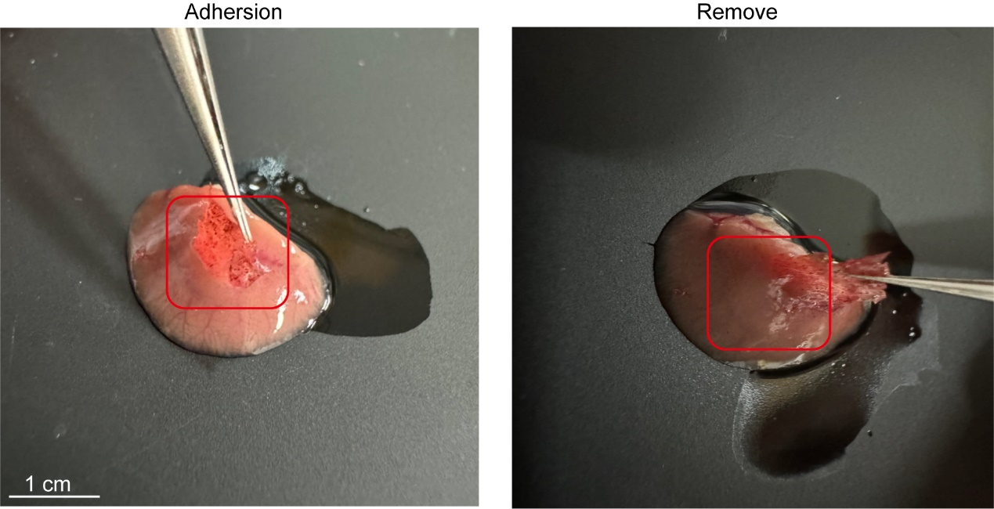
Supplementary Fig. 5 Representative image of the PMMA@PFC-73 membrane self-adhesive and remove onto the liver.
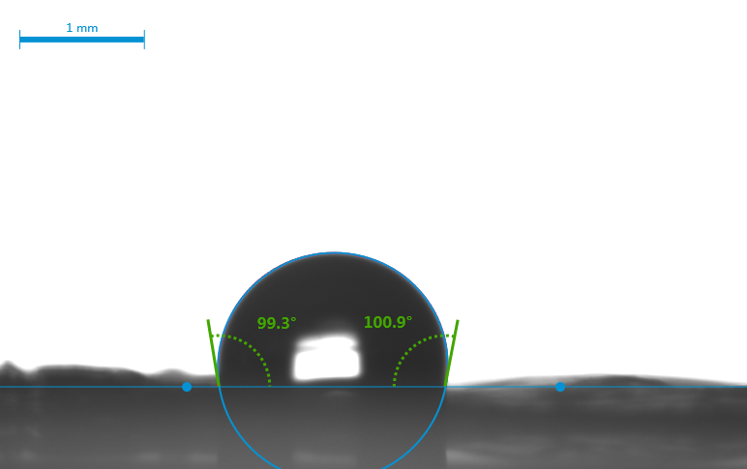
Supplementary Fig. 6 The water contact angle (WCA) of PMMA@PFC-73 membrane.

Supplementary Fig. 7 Hemolysis rate of PFC-73 at different concentrations. a Whole blood treated with PBS, PFC-73 (50,100,200 µg/mL), and Triton X-100. b Hemolysis rate of the samples (n = 7).

Supplementary Fig. 8 Biosafety of PFC-73 with different concentration. Cell viability of HUVECs incubated with different concentrations of PFC-73 for 24 h (n=4).

Supplementary Fig. 9 Live/Dead assay examine the biosafety of PFC-73 (50μg/mL). Calcein-AM/PI fluorescence staining to examine live/dead cells with PFC-73 treated for 72 h. Scale bar: 100 μm.
Supplementary Fig. 10 The expression of Vegf was detected by RT-qPCR. mRNA expression level of Vegf after co-culture of HUVECs with PFC-73 (n=3).

Supplementary Fig. 11 The expression of IL-1β was detected by RT-qPCR. Relative mRNA levels of IL-1β in HUVECs treated with PBS, LPS, LPS plus PFC-73 or PFC-73 (n=3).
Supplementary Fig. 12 Biosafety of PFC-73 and PMMA@PFC-73 membrane. a Blood routine analysis of mice treated with different materials (n=3). b H&E staining of the major organs from mice receiving treatments. Scale bar: 100 μm.
Supplementary Fig. 13 PCA and heat map of different genes between the three groups. a Principal component analysis (PCA). b Heatmap analysis of differentially expressed genes (DEGs).
Supplementary Fig. 14 Genetic ontological (GO) analysis of differential genes in PFC-73 treatment groups.
Supplementary Fig. 15 GO analysis of differential genes in PMMA@PFC-73 membrane treatment groups.
Supplementary Fig. 16 Differential gene analysis in PMMA@PFC-73 membrane treatment group. a-b CC and MF analysis of GO enrichment. c Kyoto Encyclopedia of Genomes (KEGG) enrichment analysis of DEGs.

Table S1. The primer se quences for Ki67,Vegf ,Il-6,Il-8,Il-1β and Gapdh.
Primer Name | Species | Sequence (5’ to 3’) | Length
Ki67-F | human | GCCTGCTCGACCCTACAGA | 19
Ki67-R | human | GCTTGTCAACTGCGGTTGC | 19
Vegf-F | human | AGGGCAGAATCATCACGAAGT | 21
Vegf-R | human | AGGGTCTCGATTGGATGGCA | 20
Il-6-F | human | ACTCACCTCTTCAGAACGAATTG | 23
Il-6-R | human | CCATCTTTGGAAGGTTCAGGTTG | 23
Il-8-F | human | ACTGAGAGTGATTGAGAGTGGAC | 23
Il-8-R | human | AACCCTCTGCACCCAGTTTTC | 21
Il-1β-F | human | ATGATGGCTTATTACAGTGGCAA | 23
Il-1β-R | human | GTCGGAGATTCGTAGCTGGA | 20
Gapdh-F | human | TGGGTGTGAACCACGAGAAAT | 22
Gapdh-R | Human | AGTTGTCATGGATGACCTTGGC | 22

Reference
1. Yang, X. et al. Solution-Processed Hydrogen-Bonded Organic Framework Nanofilms for High-Performance Resistive Memory Devices. Adv. Mater. 35, 2305344 (2023).
2. Tomimatsu, K. et al. Precise immunofluorescence canceling for highly multiplexed imaging to capture specific cell states.Nat. Commun. 15, 3657 (2024).

