Supplementary Table 1: The primers, primer sequences and fragment sizes to determine the VP4 and VP7 genotypes
REVERSE TRANSCRIPTION PCR PRIMERS (28-29)
VP4 (868 bp PCR fragment) | Con2 | ATTTCGGACCATTTATAACC
VP4 (868 bp PCR fragment) | Con3 | TGGCTTCGCTCATTTATATAGACA
VP7 (1067 bp PCR fragment) | sBeg | GGCTTTAAAAGAGAGAATTTC
VP7 (1067 bp PCR fragment) | End9 | GGTCACATCATACAATTCTAATCTAAG
GENOTYPING PRIMERS (28-31)
P[8] (345 bp) | 1T-1D | TCTACTGGRTTRACNTGC
P[4] (483 bp) | 2T-1 | CTATTGTT GAGGTTAGAGTC
P[6] (267 bp) | 3T-1 | TGTTGATTAGTTGGATTCAA
P[14] (543 bp) | 4943 | GGTGTAGT CCTGCGTA
G1 (749 bp) | aBT1 | CAAGTACTCAAATCAATGATGG
G2 (652 bp) | aCT2 | CAATGATATTAACACATTTTCTGTG
G3 (812 bp) | mG3 | ACGAACTCAACACGAGAGG
G4 (583 bp) | aDT4 | CGTTTCTGGTGAGGAGTTG
G8 (885 bp) | aAT8v | GTCACACCATTTGTAAAYTCAC
G9 (305 bp) | mG9 | CTTGATGTGACTAYAAATAC
G10 (396 bp) | mG10 | ATGTCAGACTACARATACTGG
G12 (558 bp) | newG12 | GGTTATGTAATCCGATGGCG
Key :R- either A/G N- either A/G/C/T Y- either C/T

Supplementary Table 2: VP7 Nucleotide and amino acid p-distance % similarity shared between studied G12P[6] and G12P[8] strains
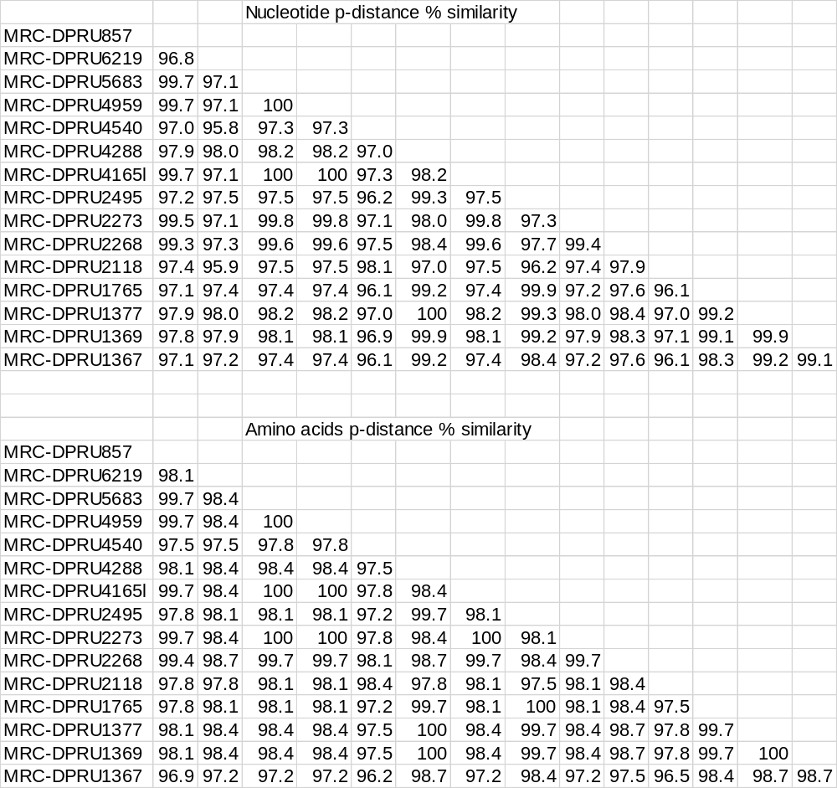

Supplementary Table 3: VP4 Nucleotide and amino acid p-distance % similarity shared between studied G12P[8] strains
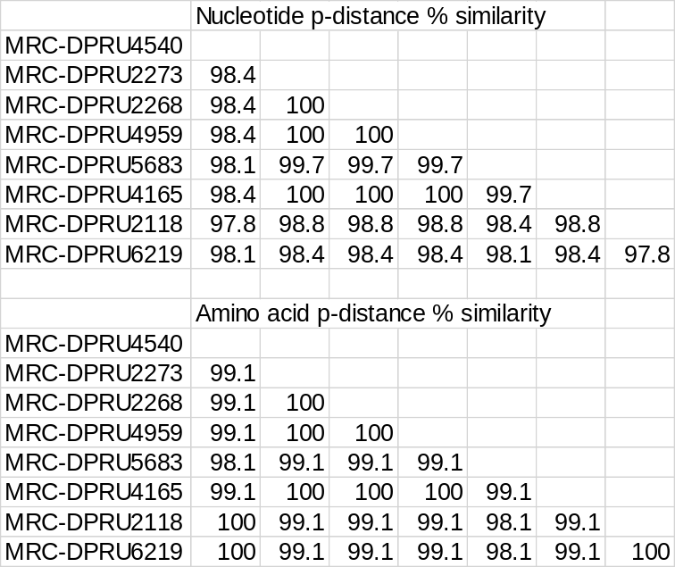

Supplementary Table 4: VP4 Nucleotide and amino acid p-distance % similarity shared between studied G12P[6] strains

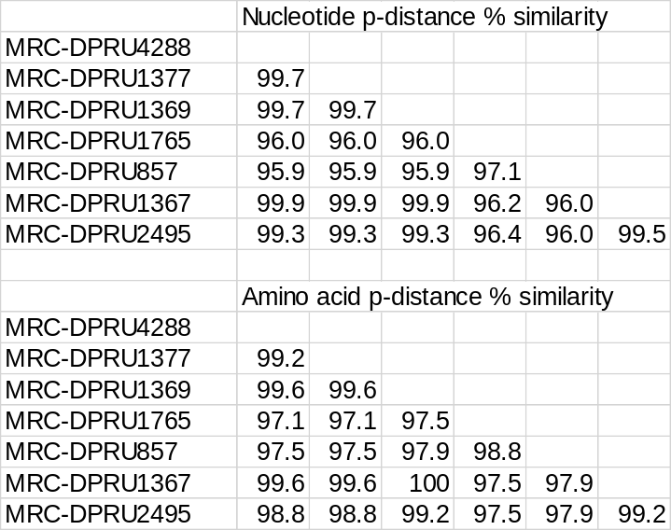

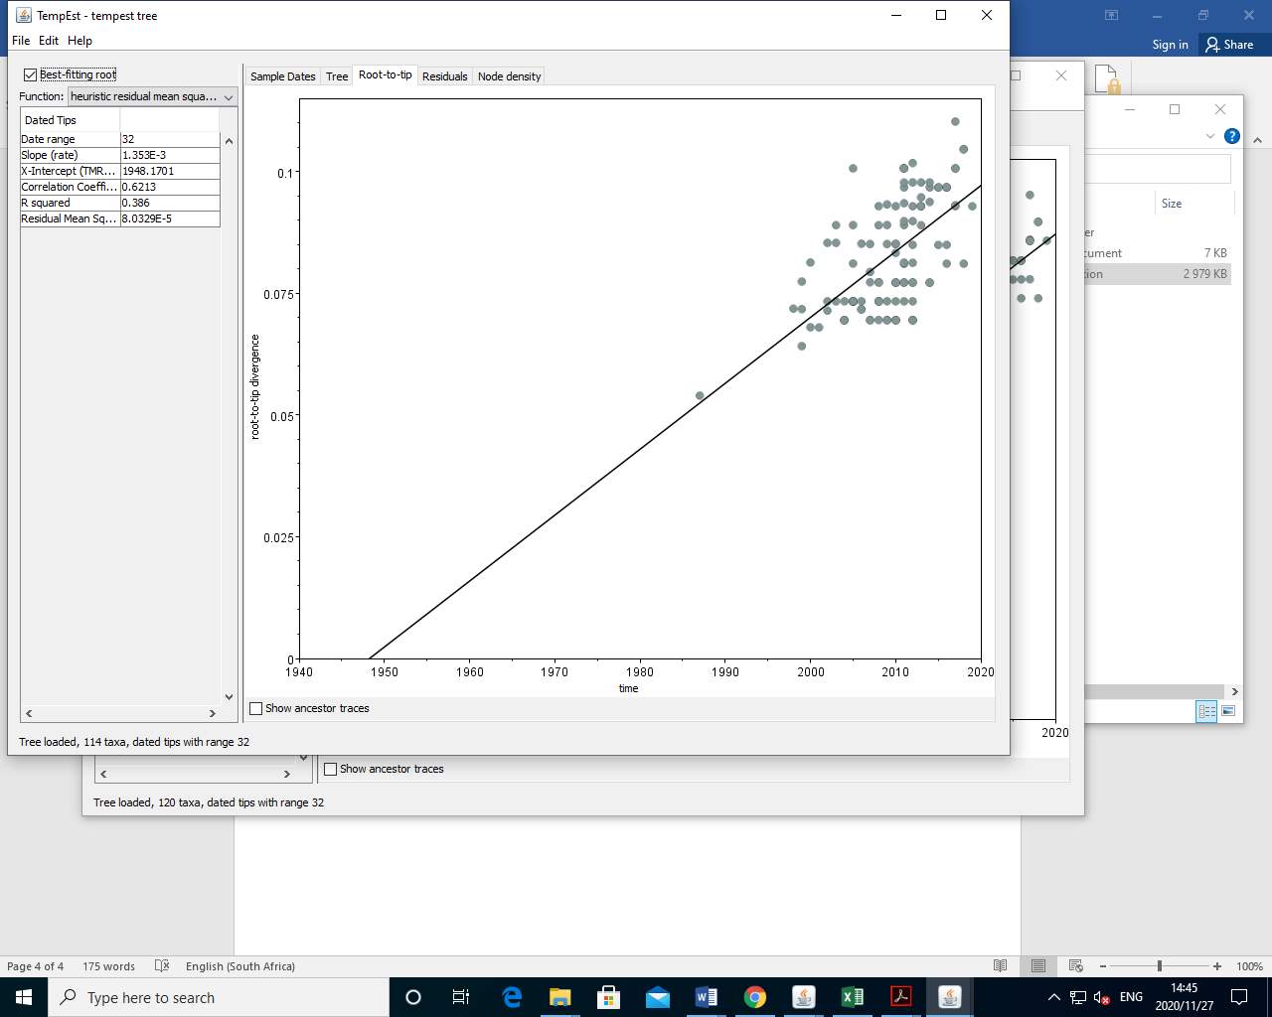

Supplementary Figure 1: Root-to-tip linear regression analysis of 114 global G12 strains including 51 African strains.

