Supplementary material
Prospective Study on the Association Between 36 Human Blood Cell Traits and Pan-Cancer Outcomes: A Mendelian Randomization Analysis

Jinghao Liang², Xinyi Zhou³ , Yijian Lin³, Yuanqing Liu³, Zixian Xie², Hongmiao Lin⁴, Tongtong Wu³, Xinrong Zhang³, Zhaofeng Tan⁴, Ziqiu Cheng², Weiqiang Yin², Zhihua Guo^{2,*}, Wenzhe Chen^{1,*}
¹Department of general surgery, Affiliated Qingyuan Hospital,The Sixth Clinical Medical School,Guangzhou Medical University, Qingyuan 511500, China
²Department of Thoracic Surgery, The First Affiliated Hospital of Guangzhou Medical University, Guangzhou 510120, China
³Second Clinical Medical College, Guangdong Medical University, Dongguan 523000, China
⁴Graduate School, Affiliated Qingyuan Hospital,The Sixth Clinical Medical School,Guangzhou Medical University, Qingyuan 511500, China

*Corresponding author:
Zhihua Guo, E-mail address: guozhihua84@126.com；
Wenzhe Chen, E-mail address: keven2005@126.com

Supplementary Figure 1. Genetic association of Eosinophil counts with Malignant neoplasm of colon
1) Forest plot
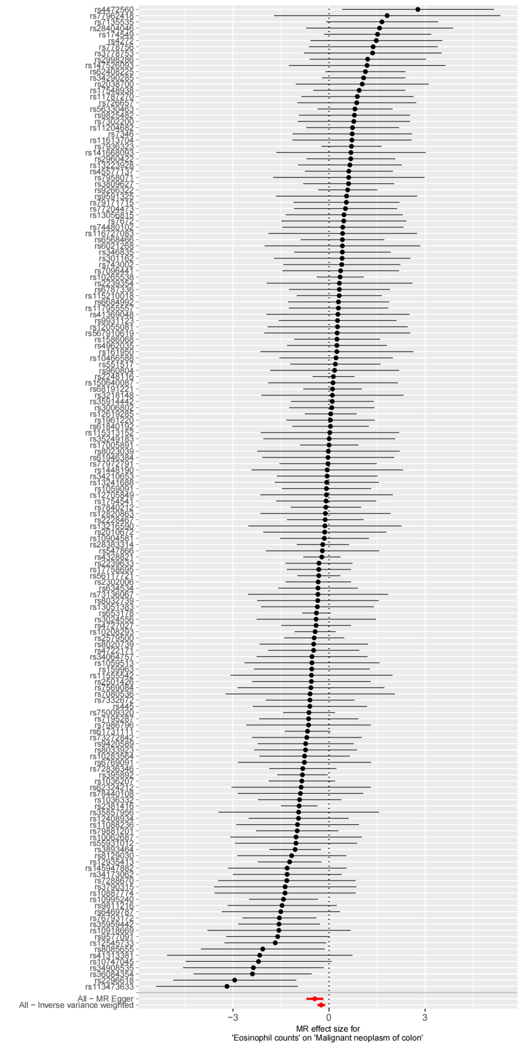
2) Leave-one-out plot
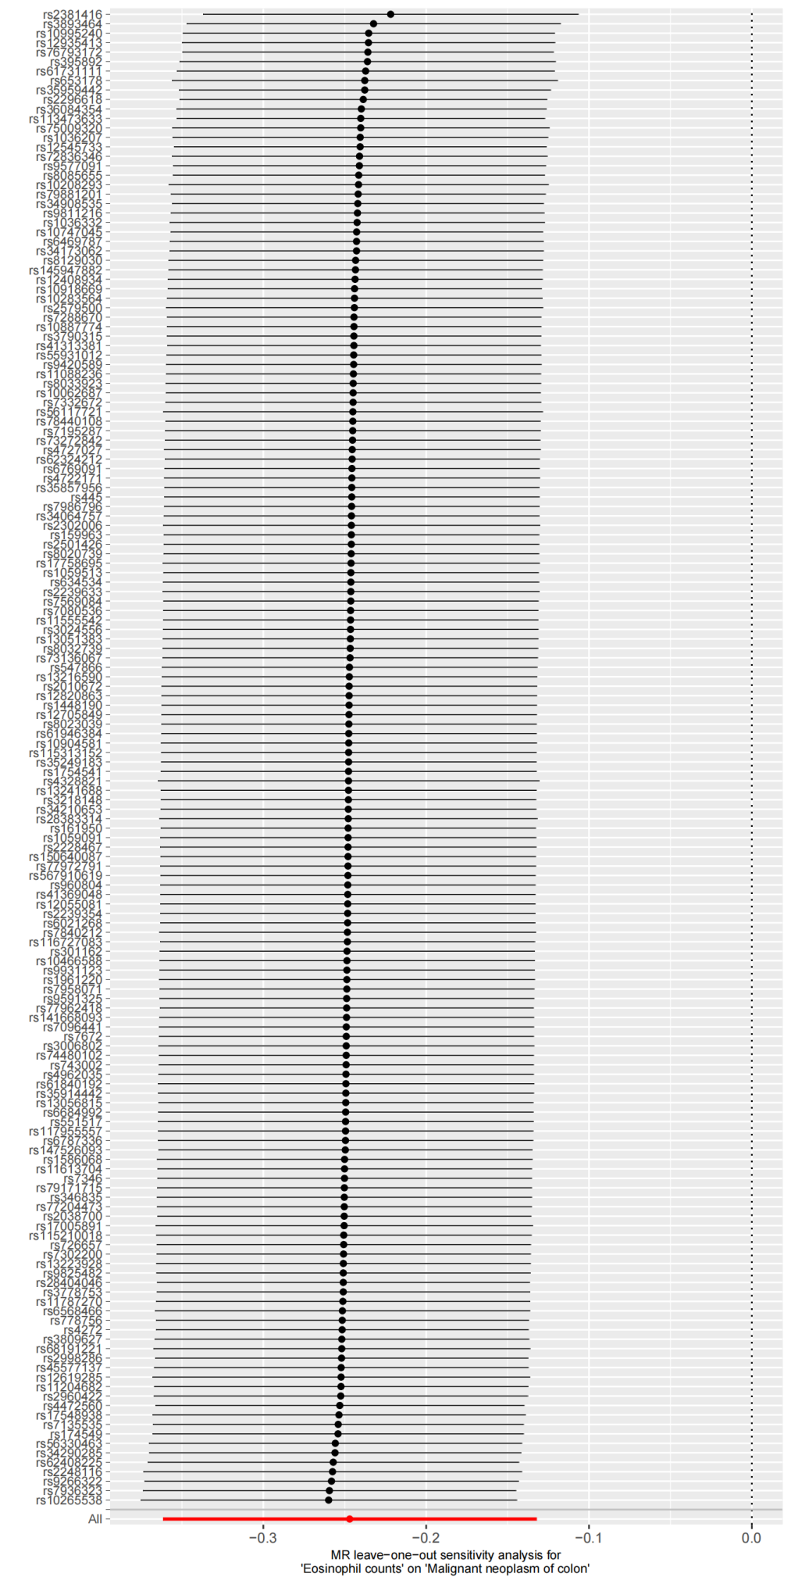
3) Scatter plot
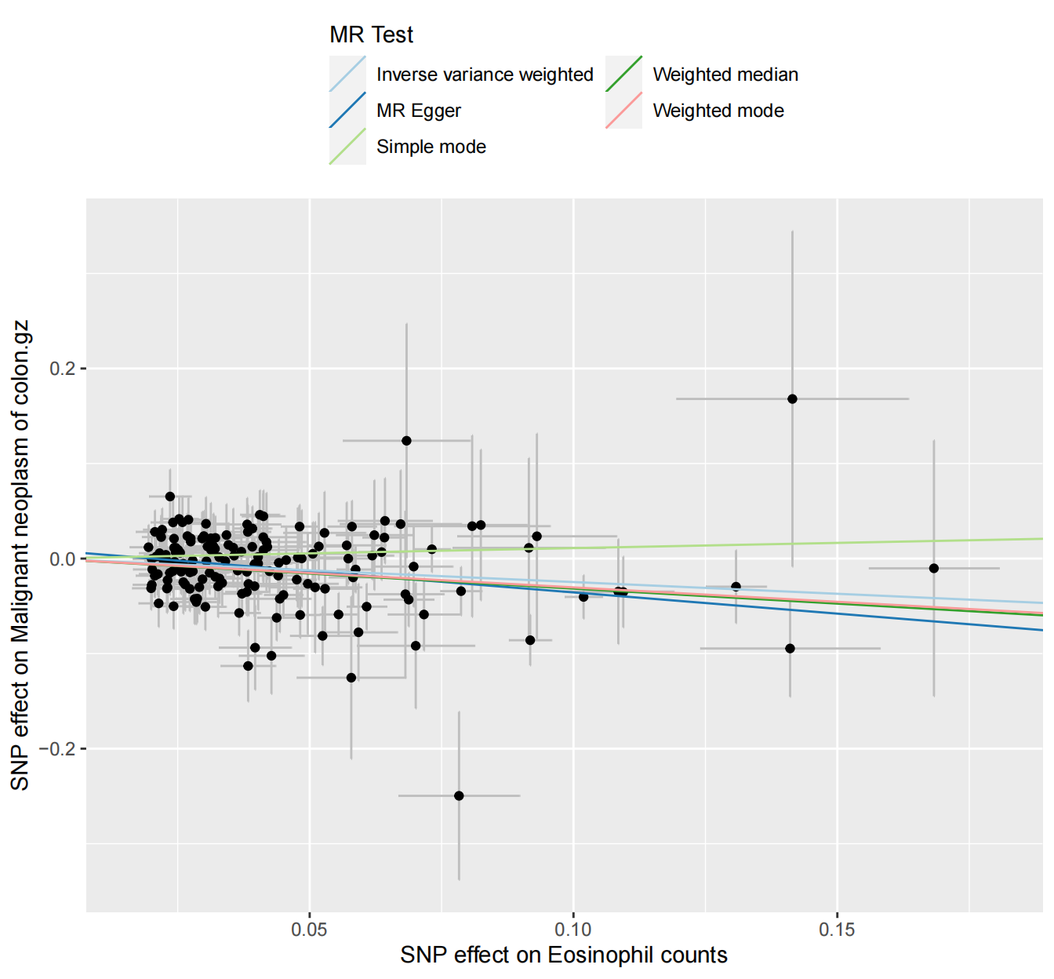
4) Funnel plot
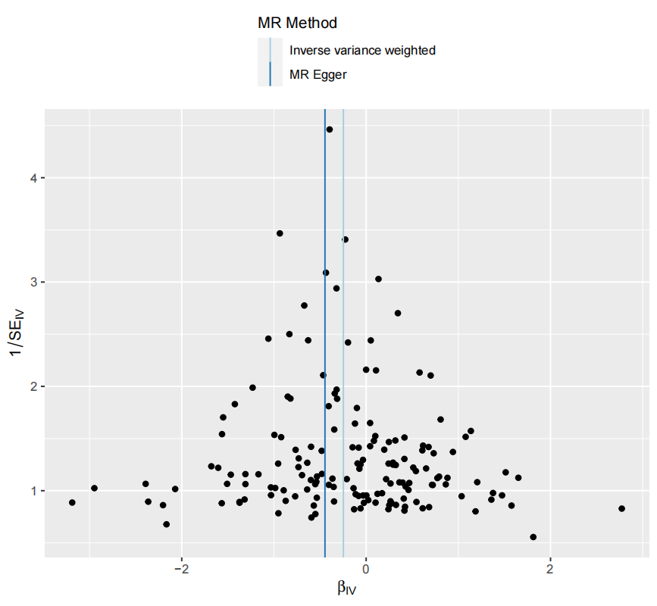

Supplementary Figure 2. Genetic association of Sum eosinophil basophil counts with Malignant neoplasm of colon
1) Forest plot
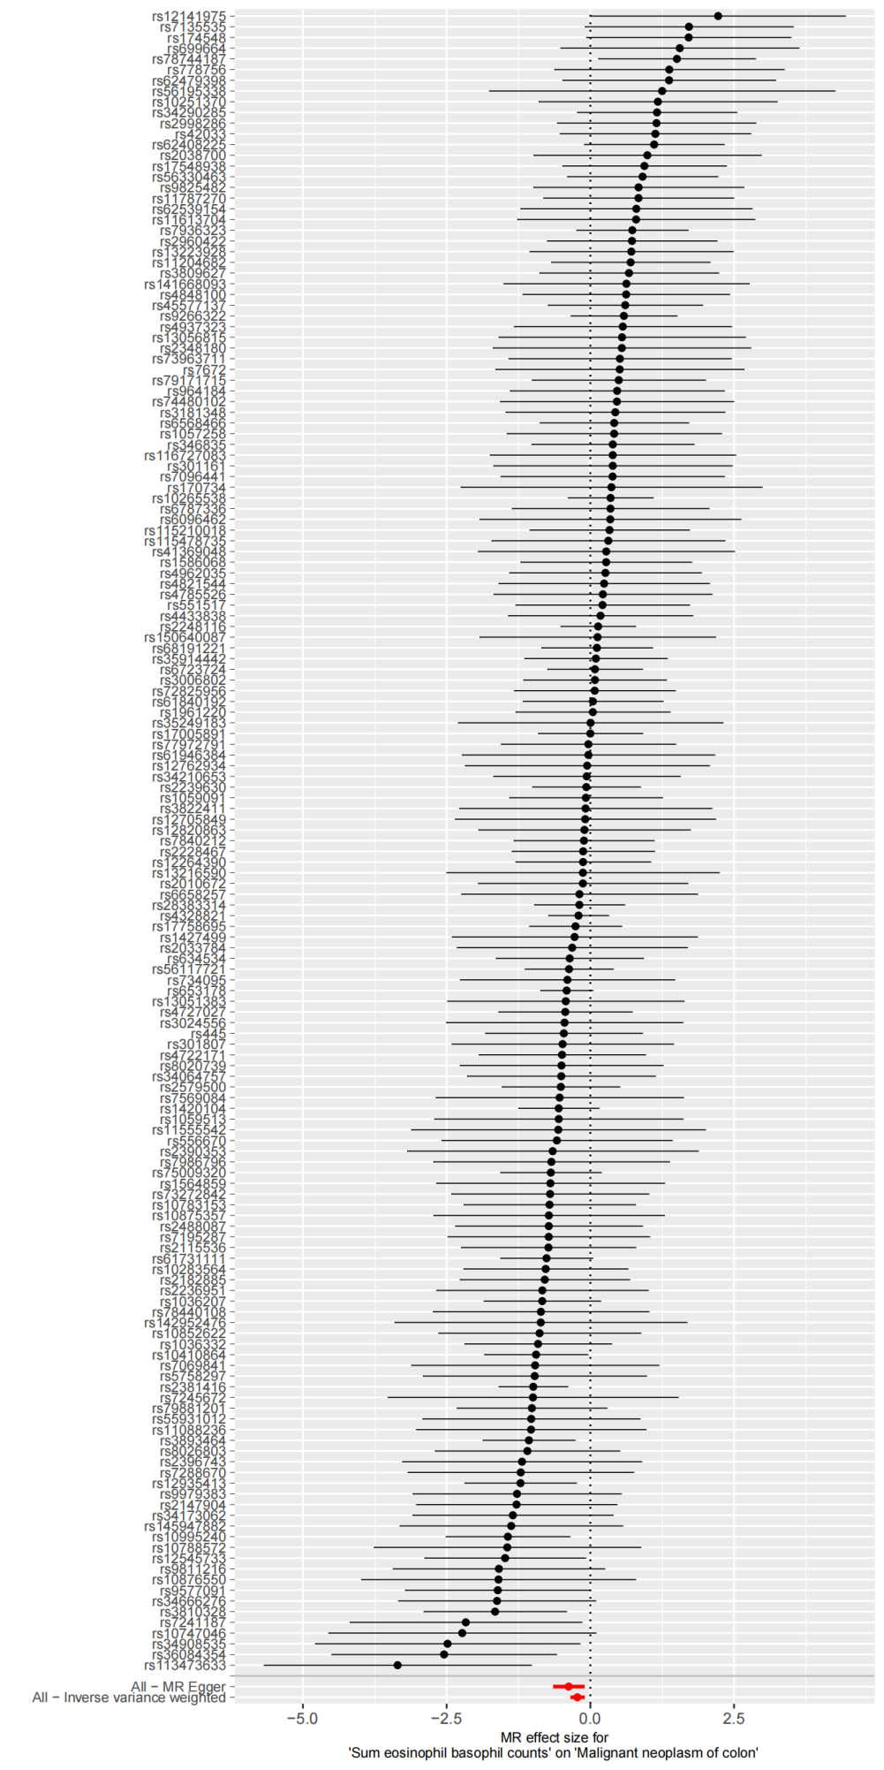
2) Leave-one-out plot
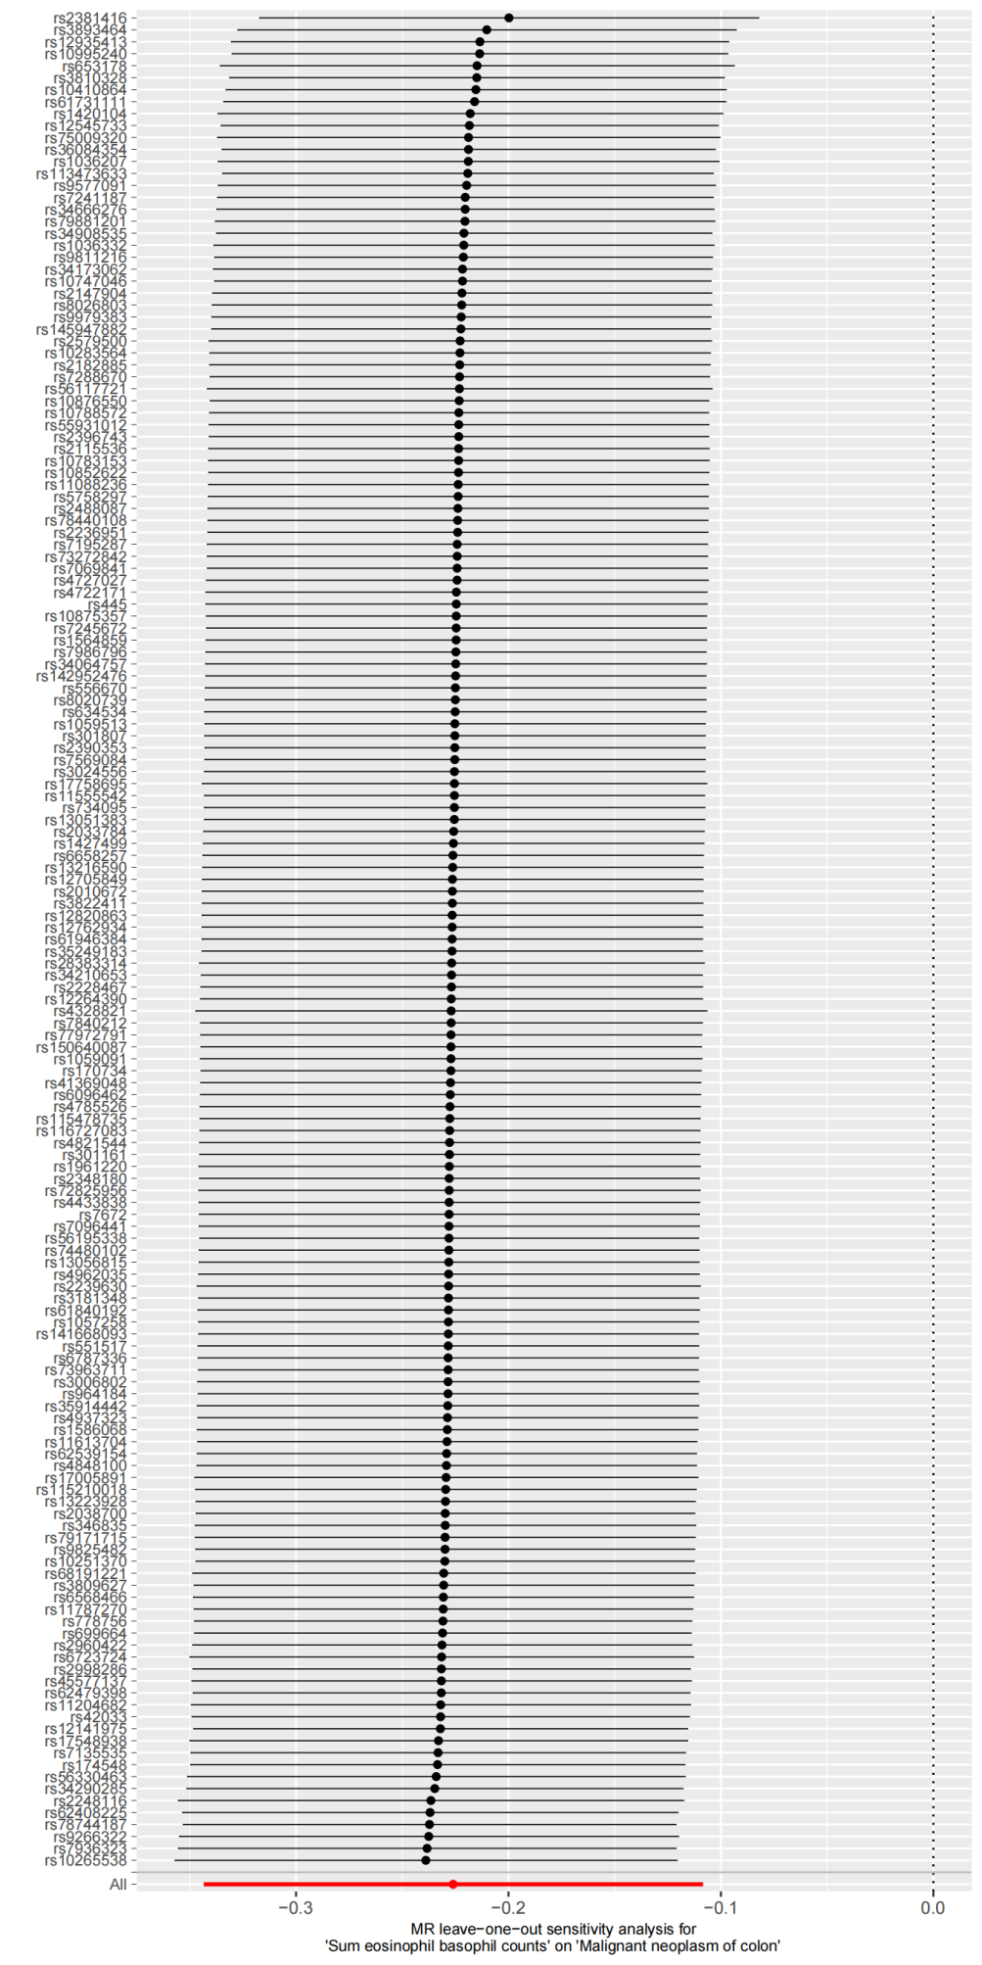
3) Scatter plot
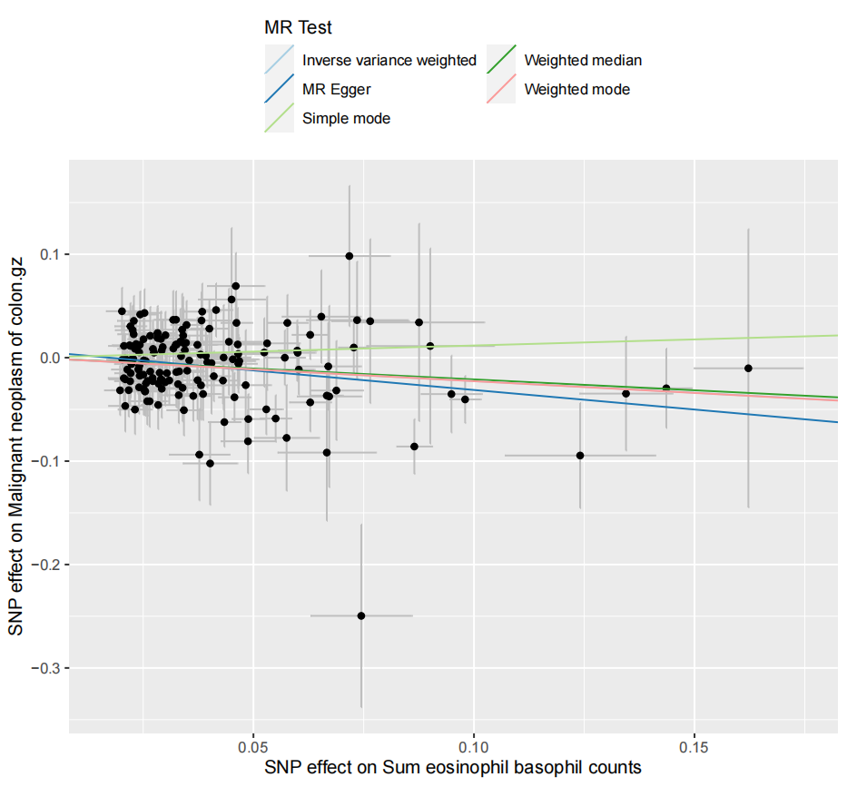
4) Funnel plot
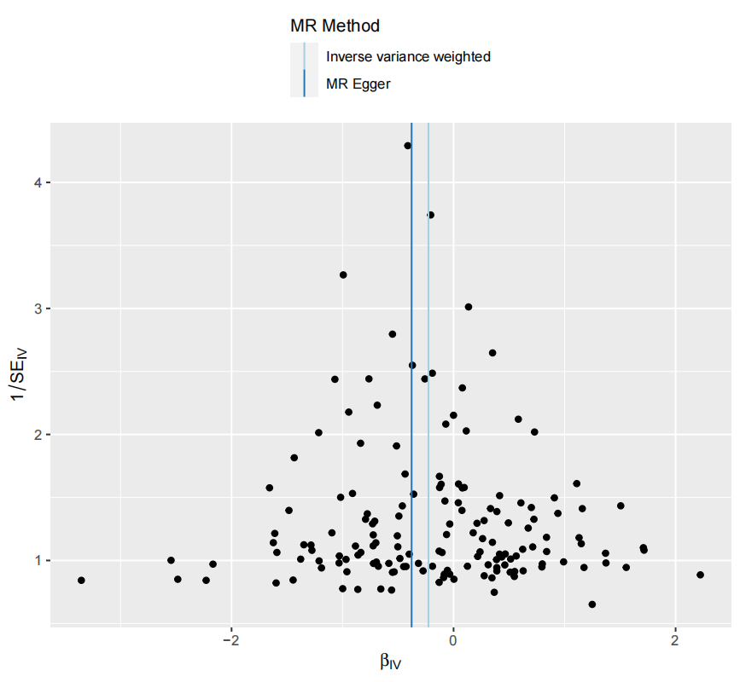

Supplementary Figure 3. Genetic association of Hematocrit with Malignant neoplasm of ovary
1) Forest plot
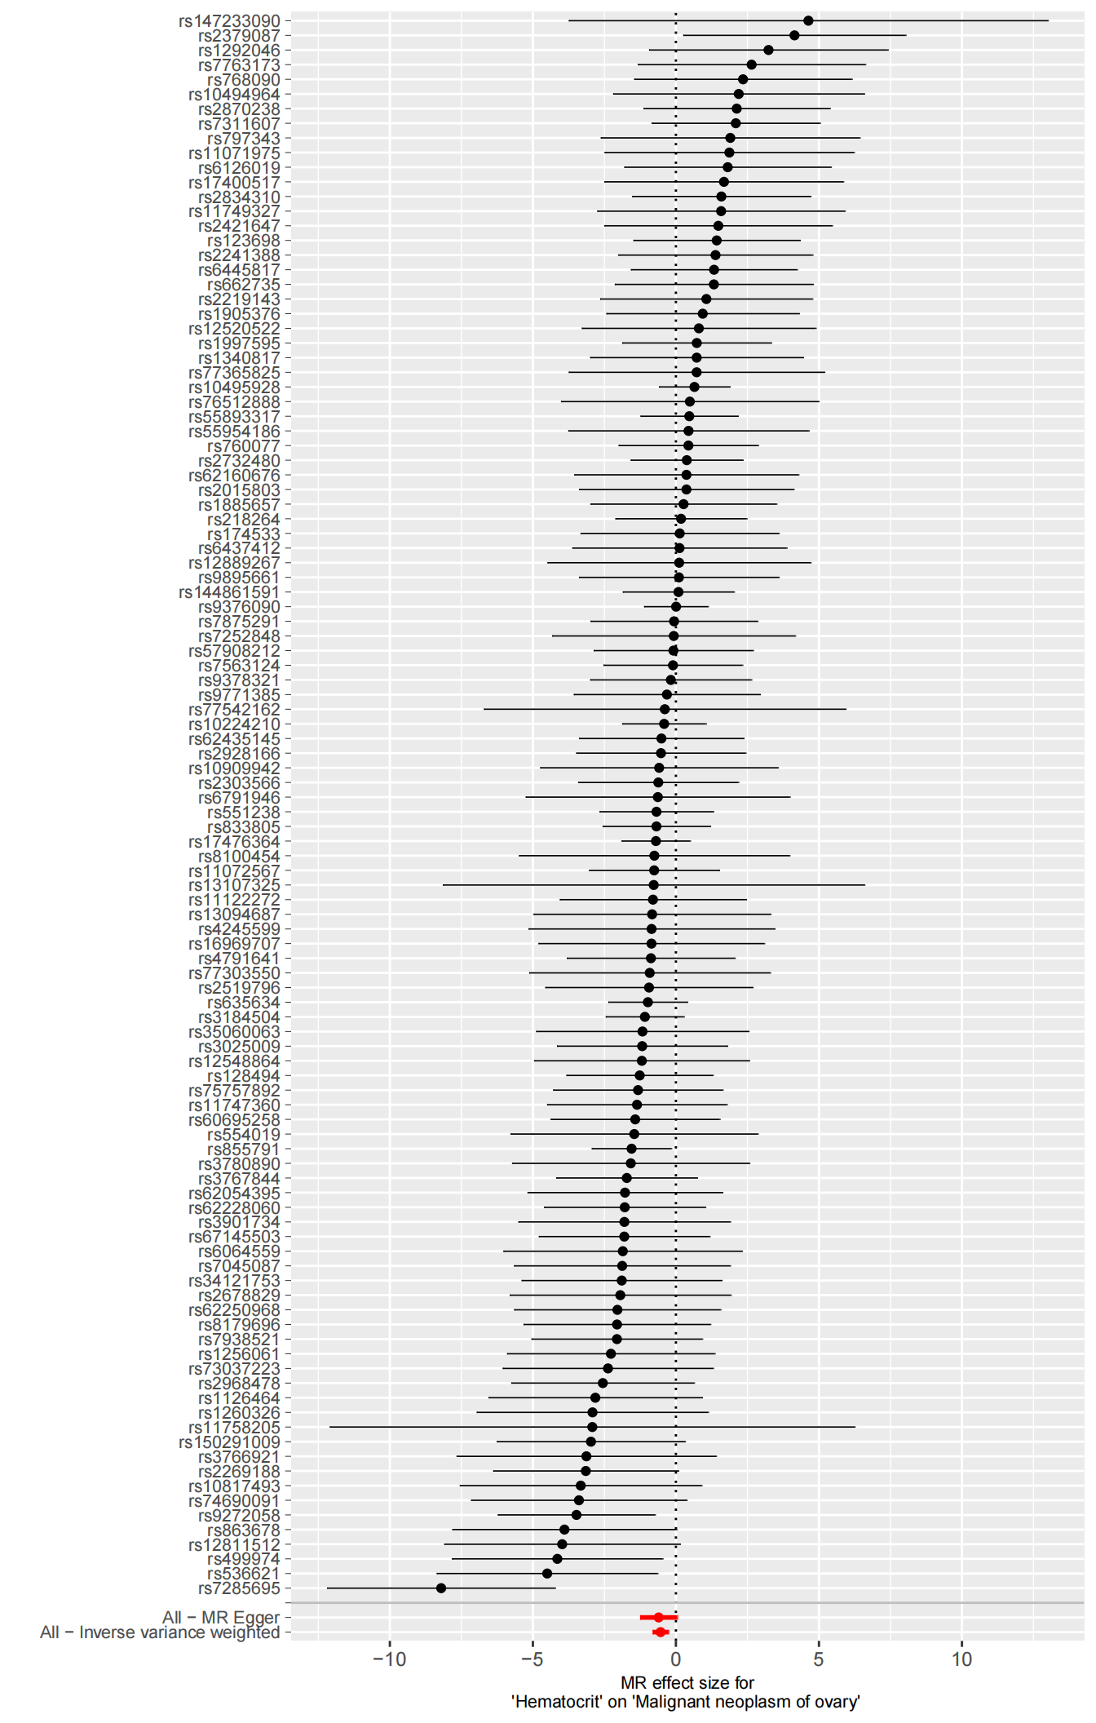
2) Leave-one-out plot
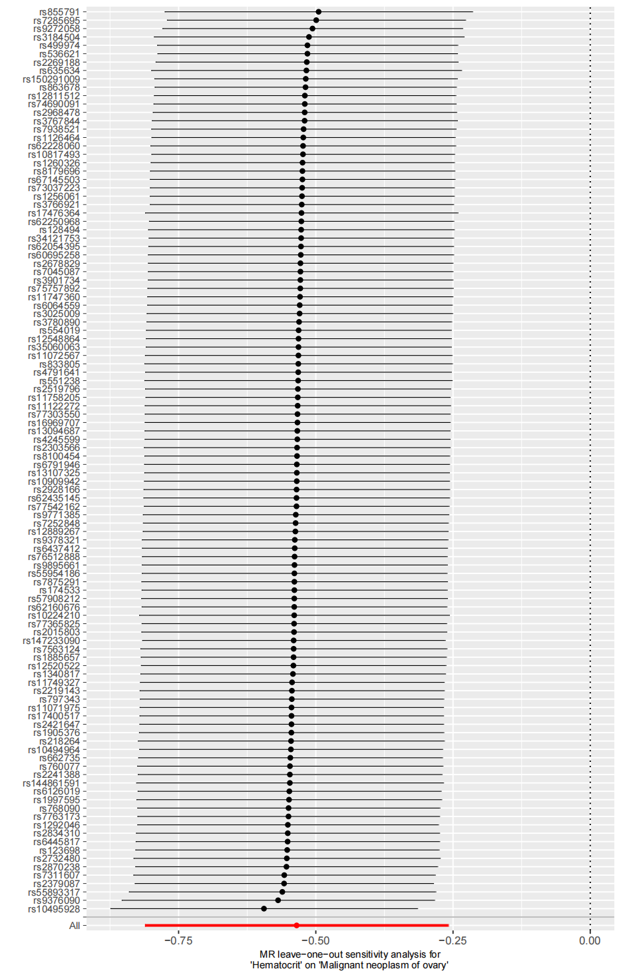
3) Scatter plot
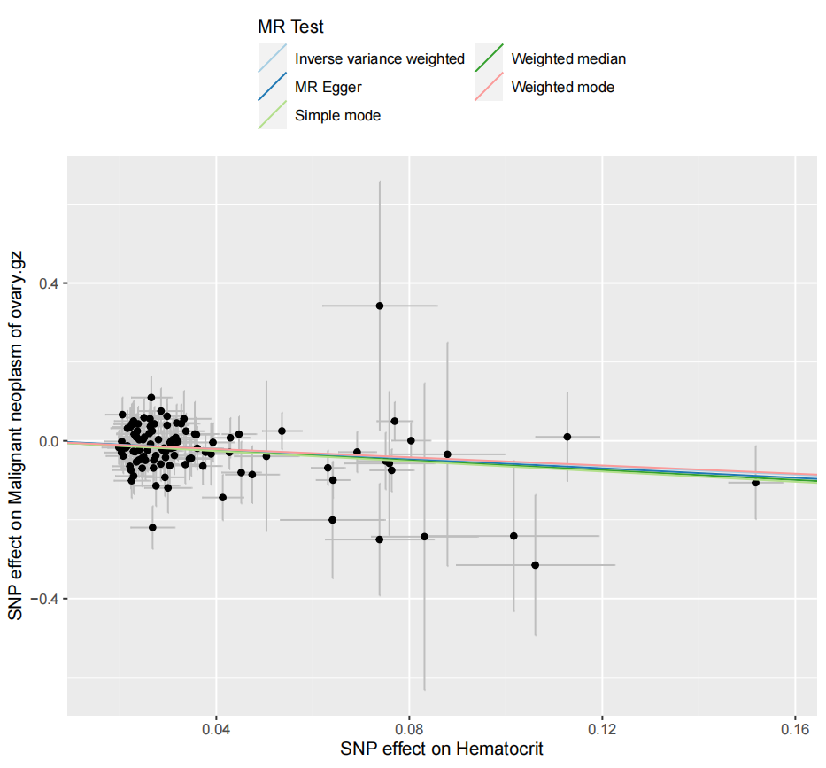
4) Funnel plot
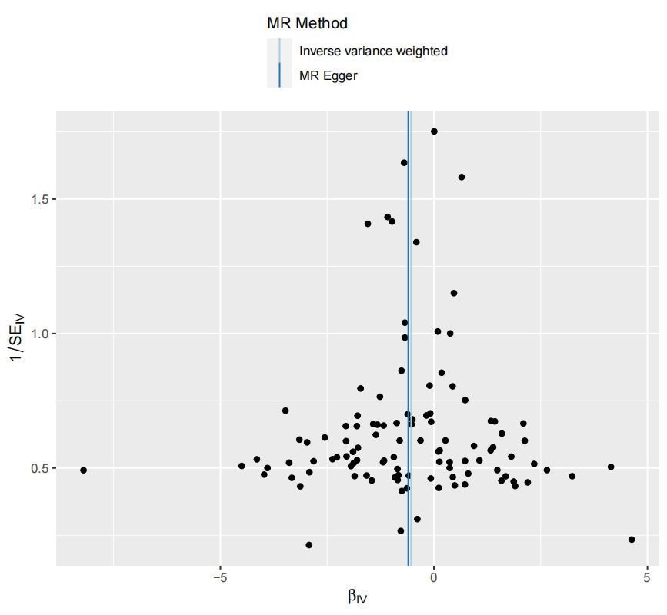

Supplementary Figure 4. Genetic association of Eosinophil percentage of white cells with Malignant neoplasm of colon
- Forest plot
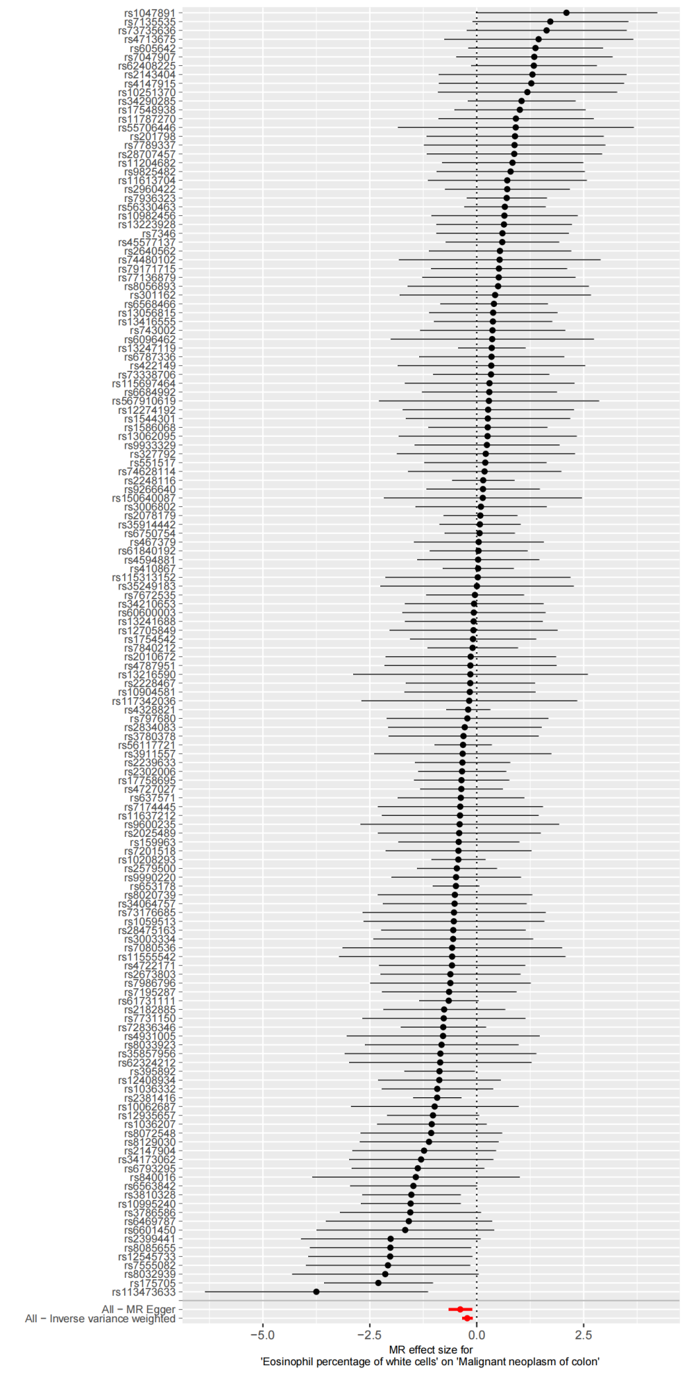
- Leave-one-out plot
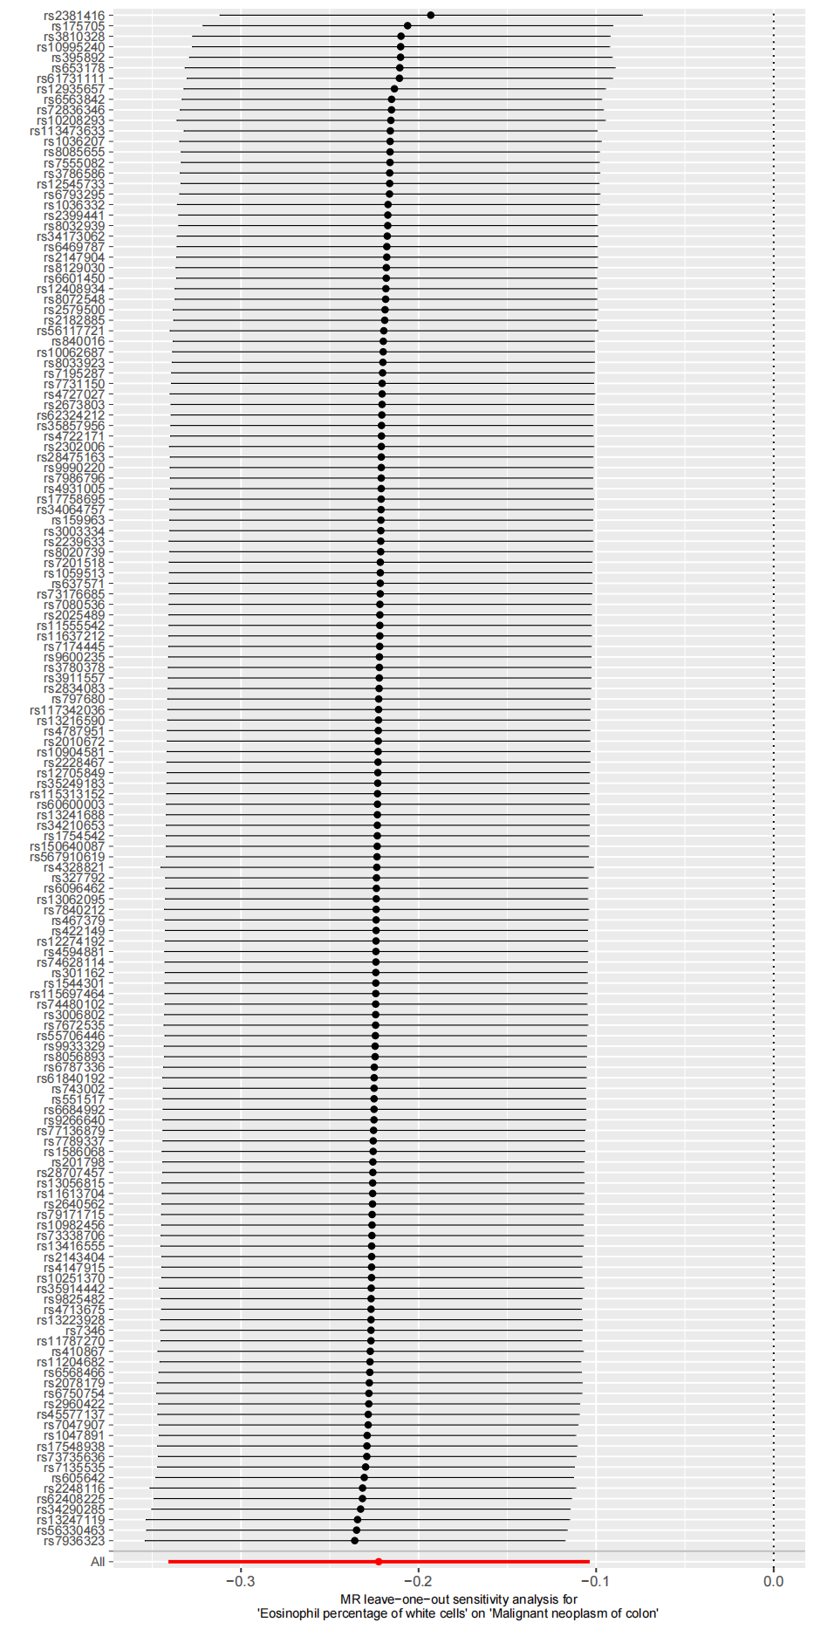
- Scatter plot
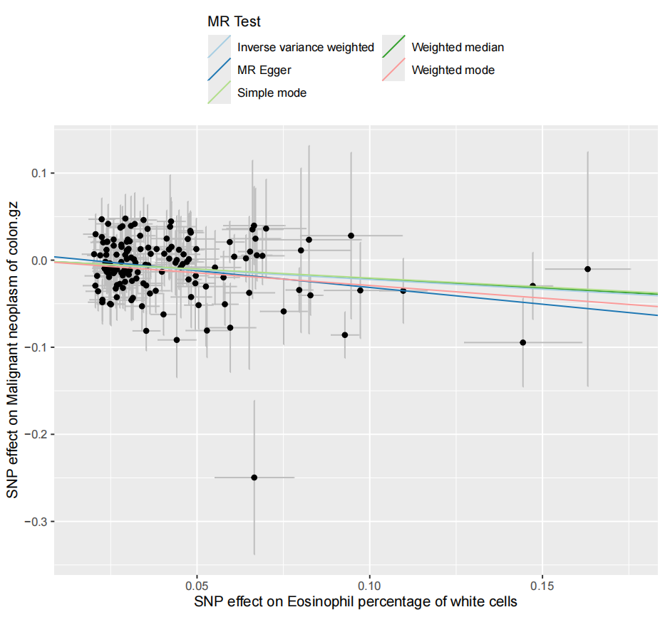
4) Funnel plot

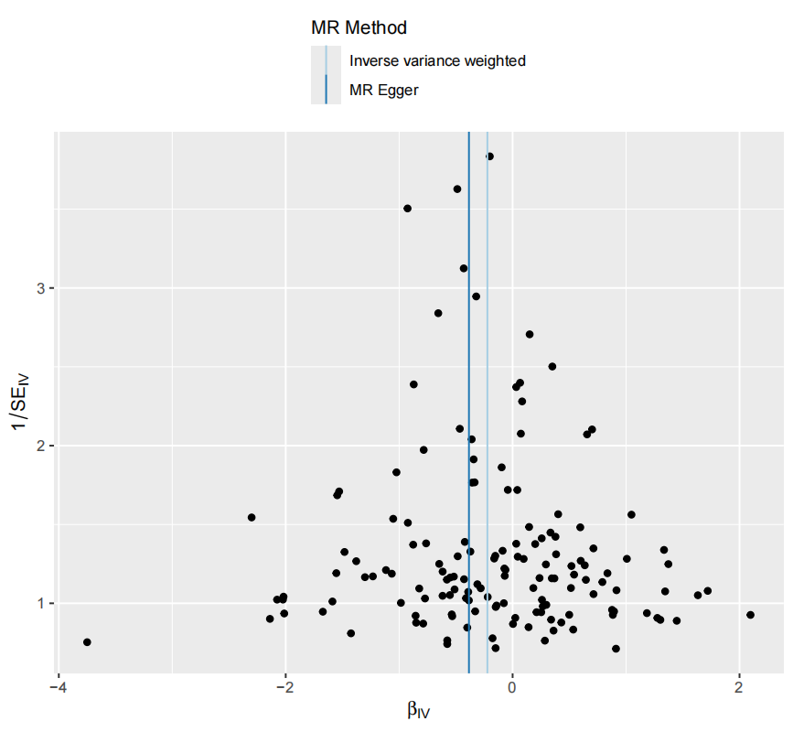

Supplementary Figure 5. Genetic association of Sum eosinophil basophil counts with Malignant neoplasm of vulva
1) Forest plot
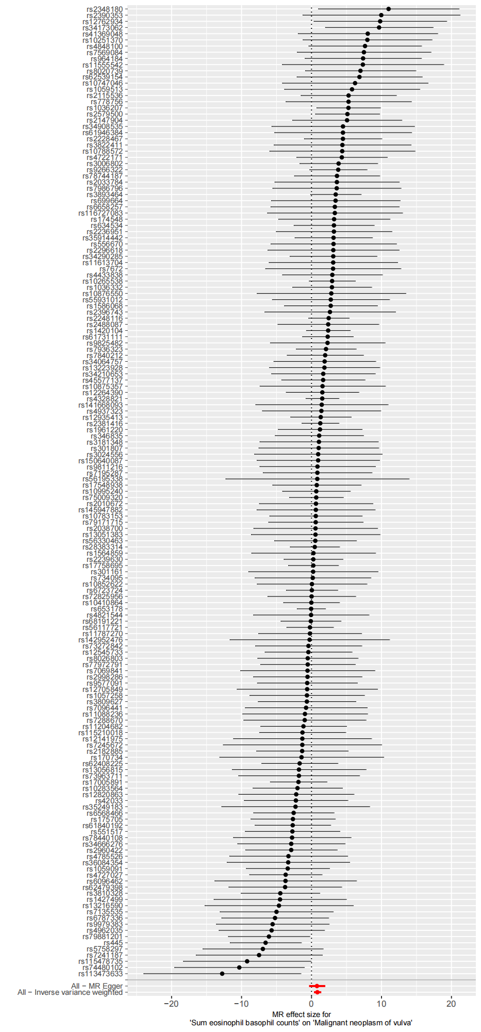
2) Leave-one-out plot
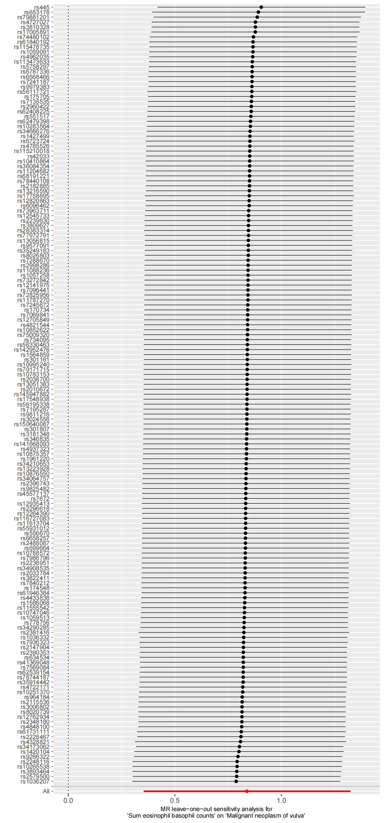
3) Scatter plot
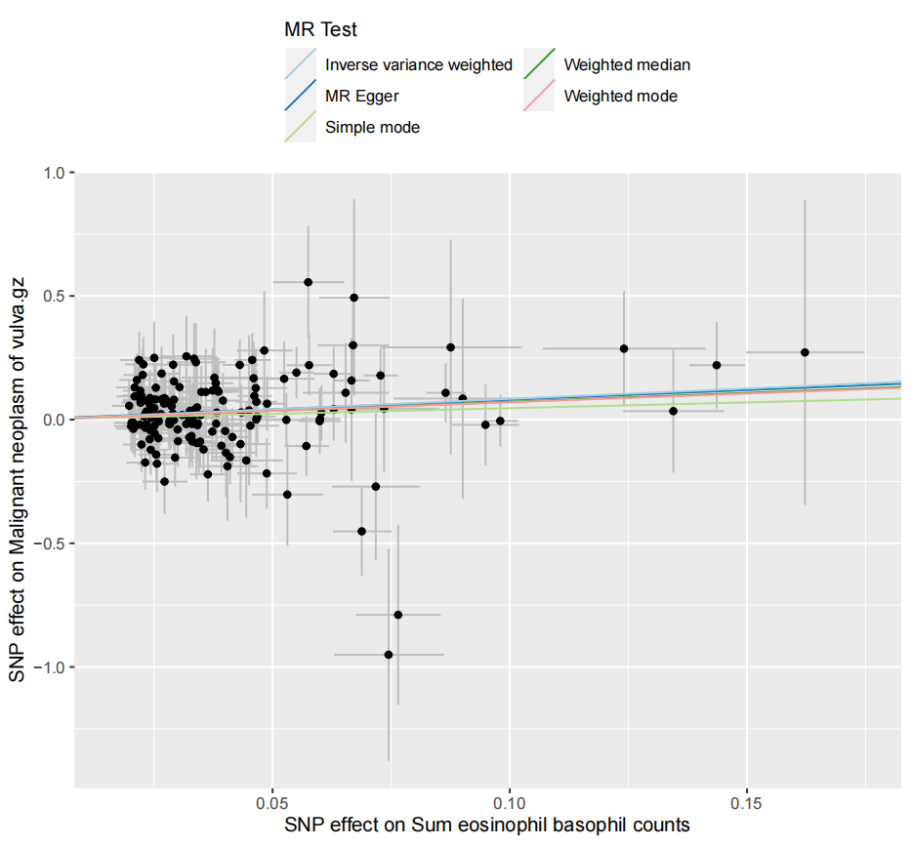
4) Funnel plot
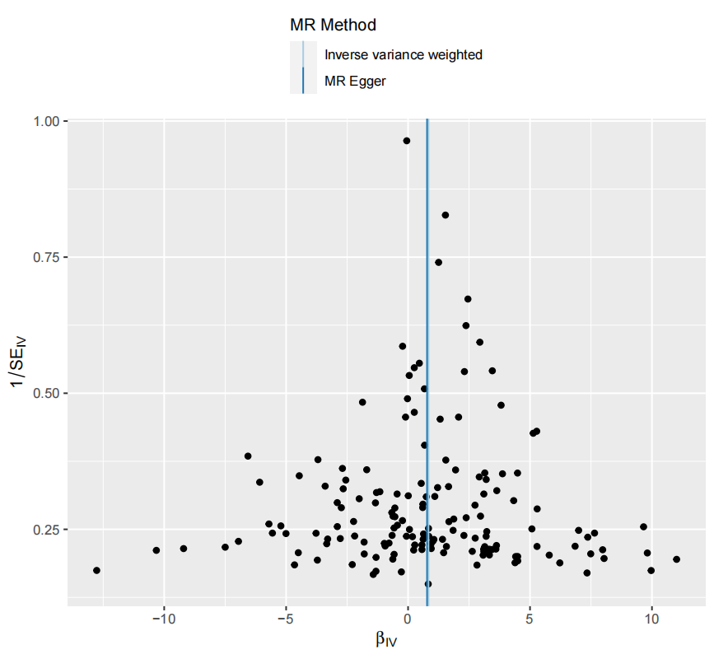

Supplementary Figure 6. Genetic association of Eosinophil percentage of granulocytes with Malignant neoplasm of colon
1) Forest plot
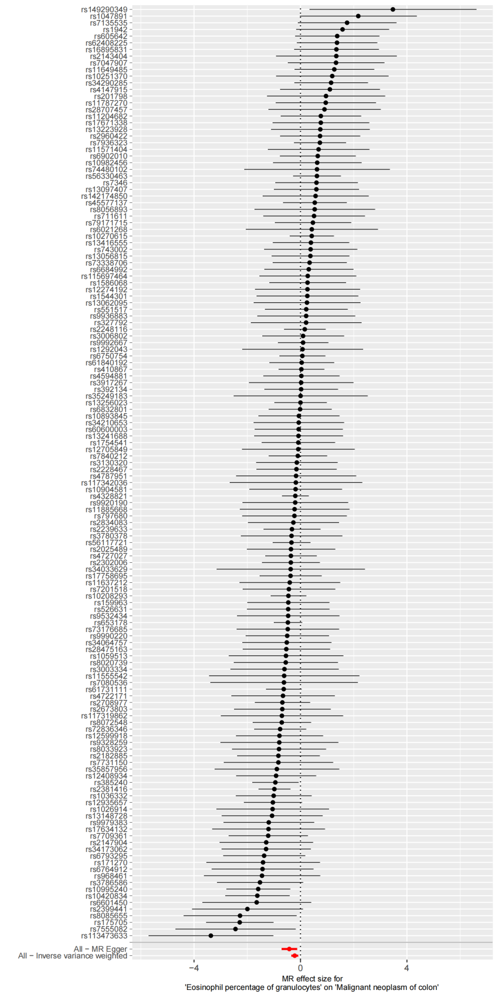
2) Leave-one-out plot
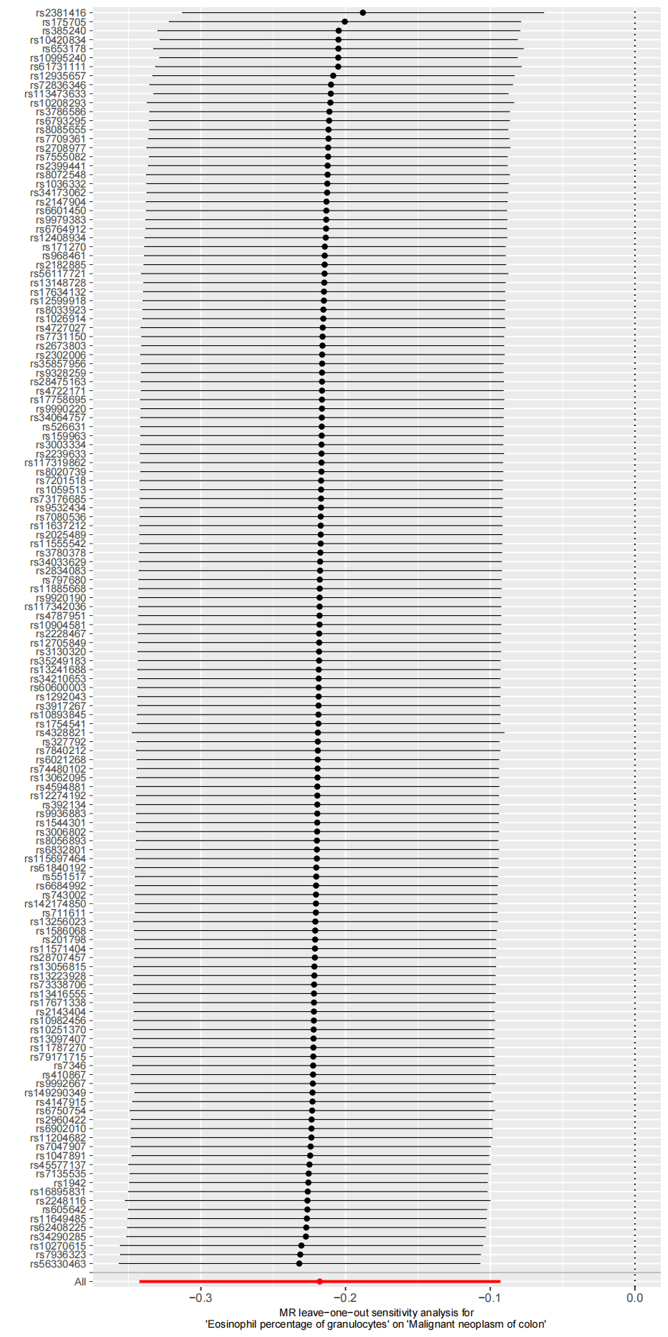
3) Scatter plot
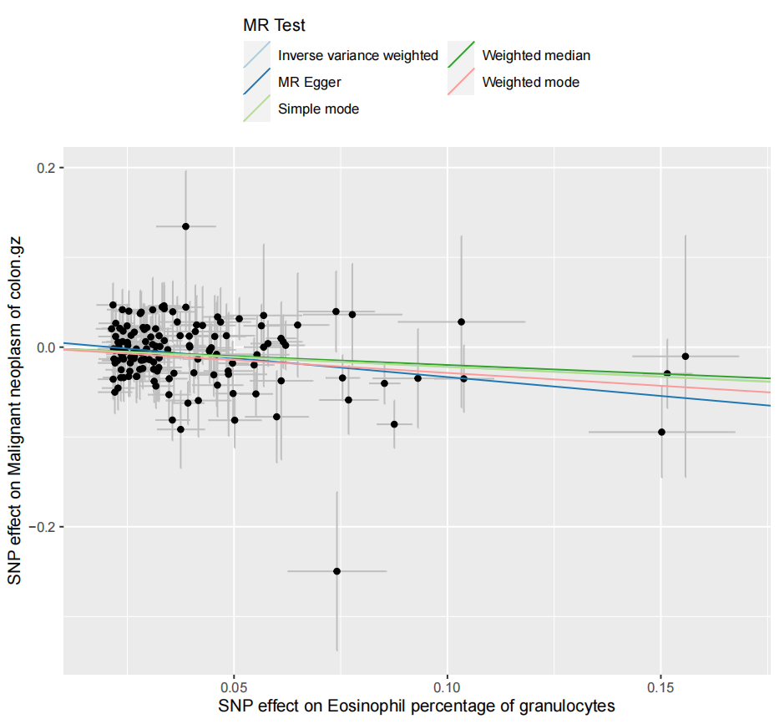
4) Funnel plot

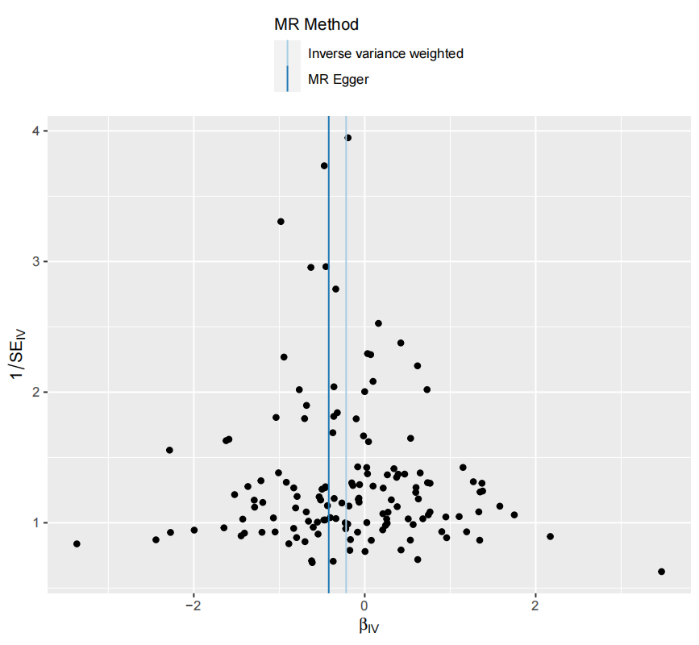

Supplementary Figure 7. Genetic association of Plateletcrit with Malignant cancer of tonsil and base of tongue
1) Forest plot
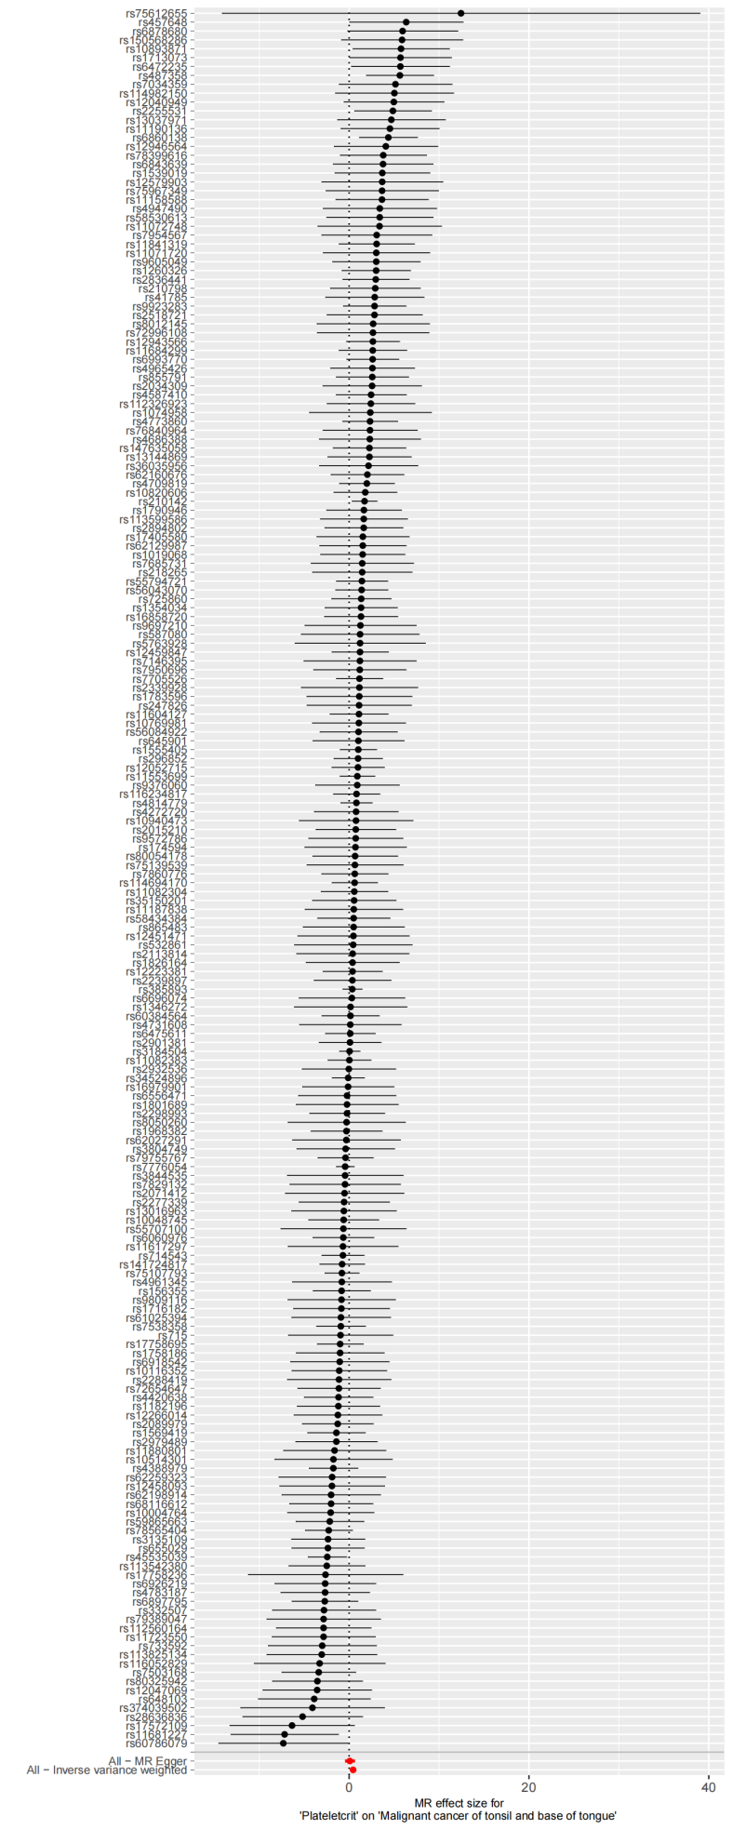
2)Leave-one-out plot
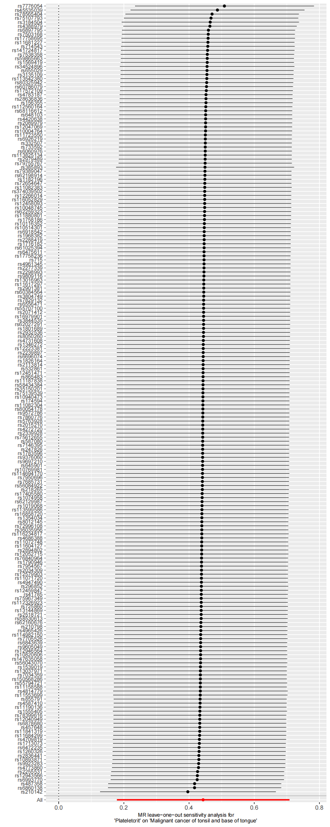
3)Scatter plot
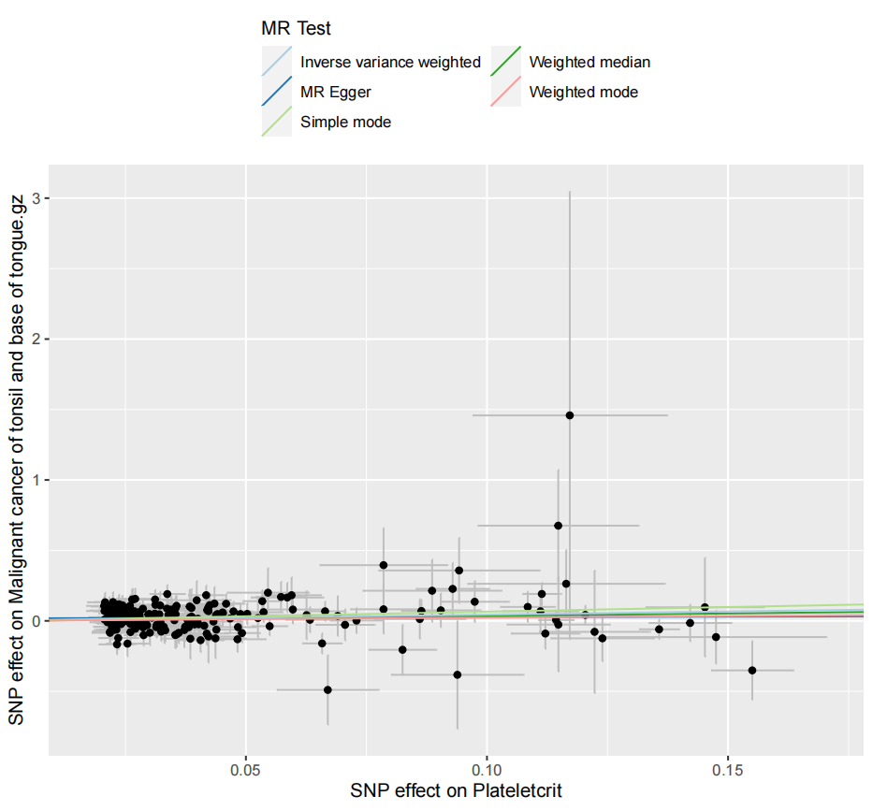
4) Funnel plot
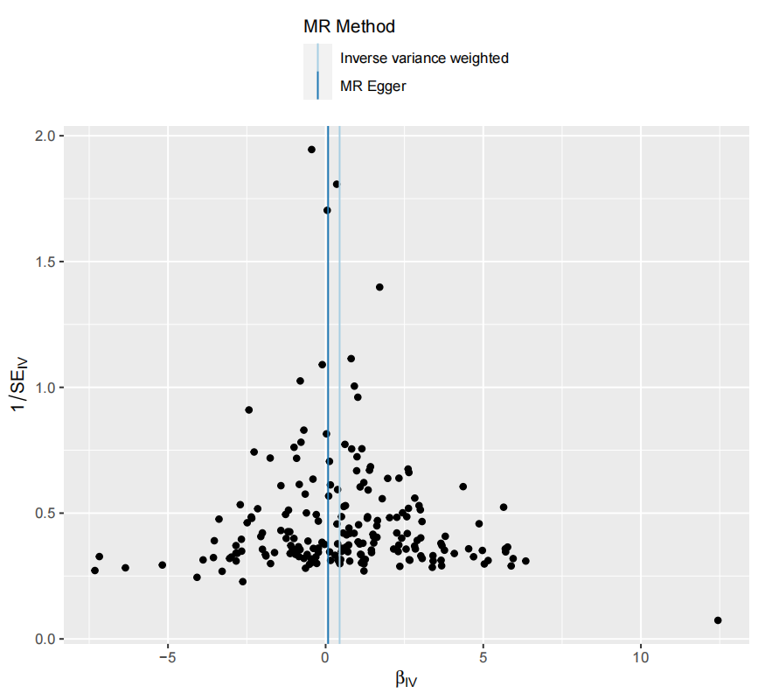

Supplementary Figure 8. Genetic association of High light scatter reticulocyte percentage of red cells with Malignant neoplasm of stomach
1) Forest plot
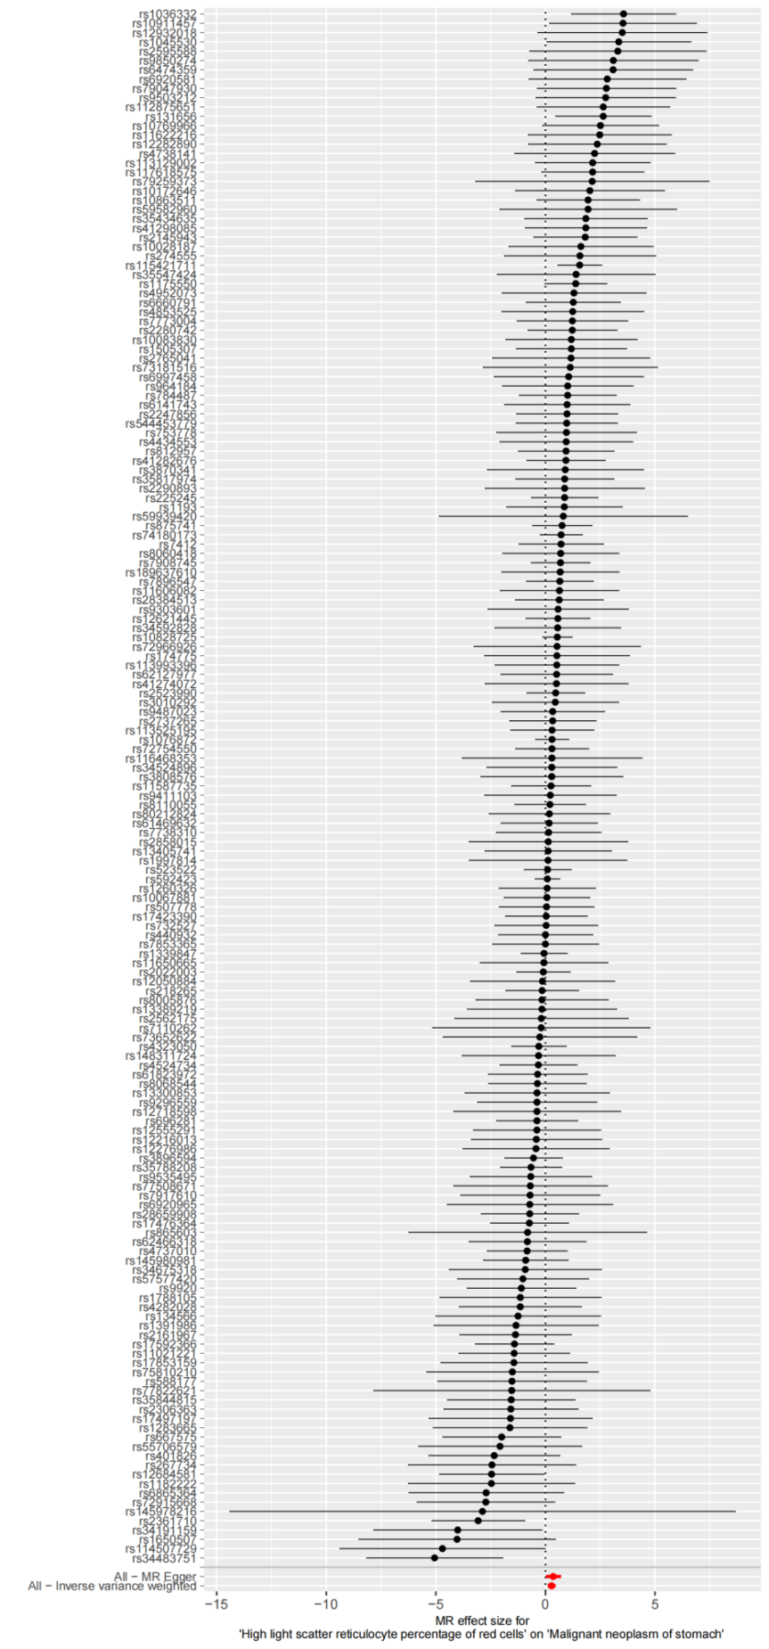
2)Leave-one-out plot
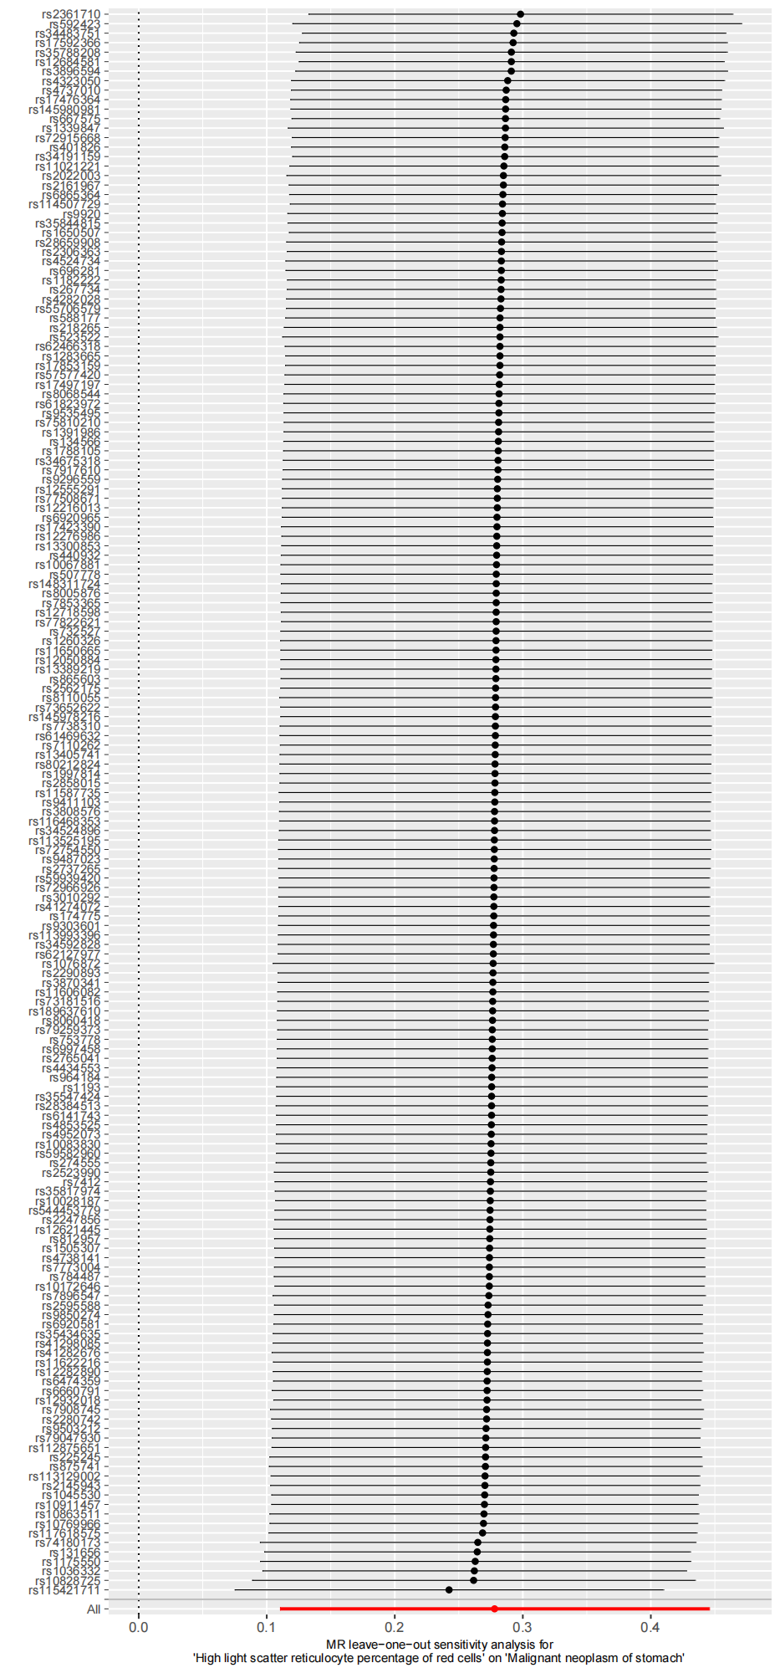
3)Scatter plot
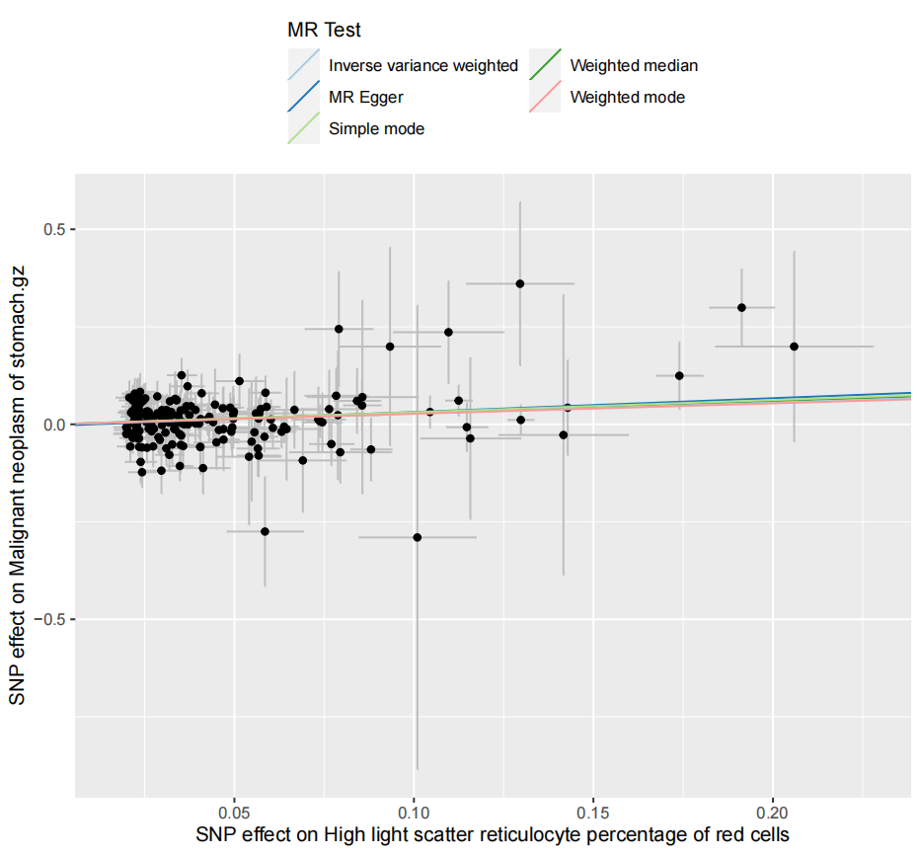
- Funnel plot
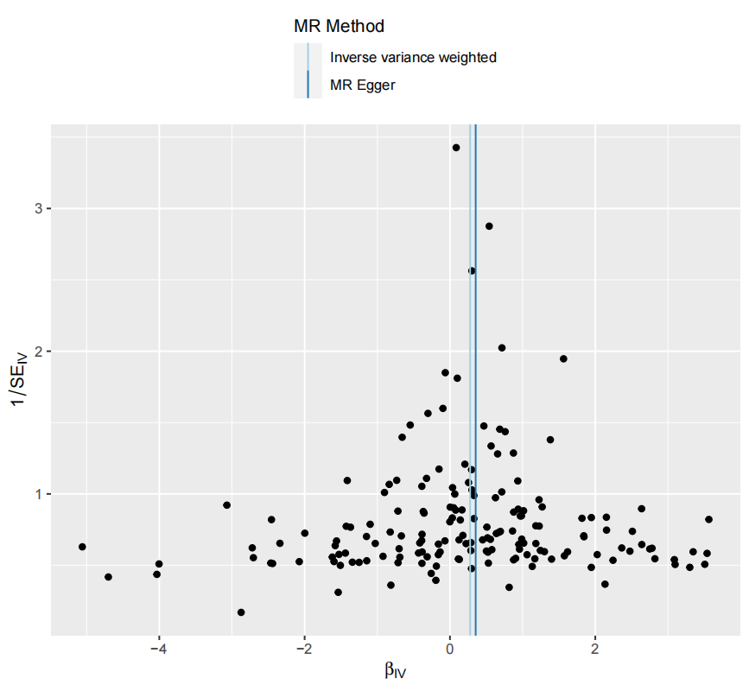

Supplementary Figure 9. Genetic association of Eosinophil percentage of granulocytes with Malignant melanoma
1) Forest plot
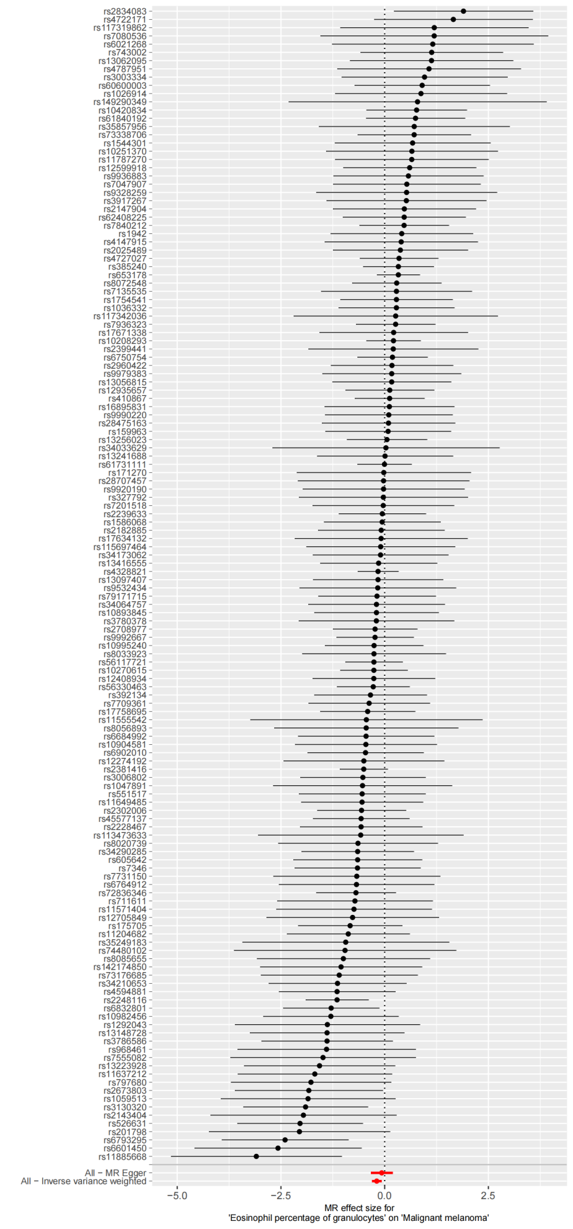
- Leave-one-out plot
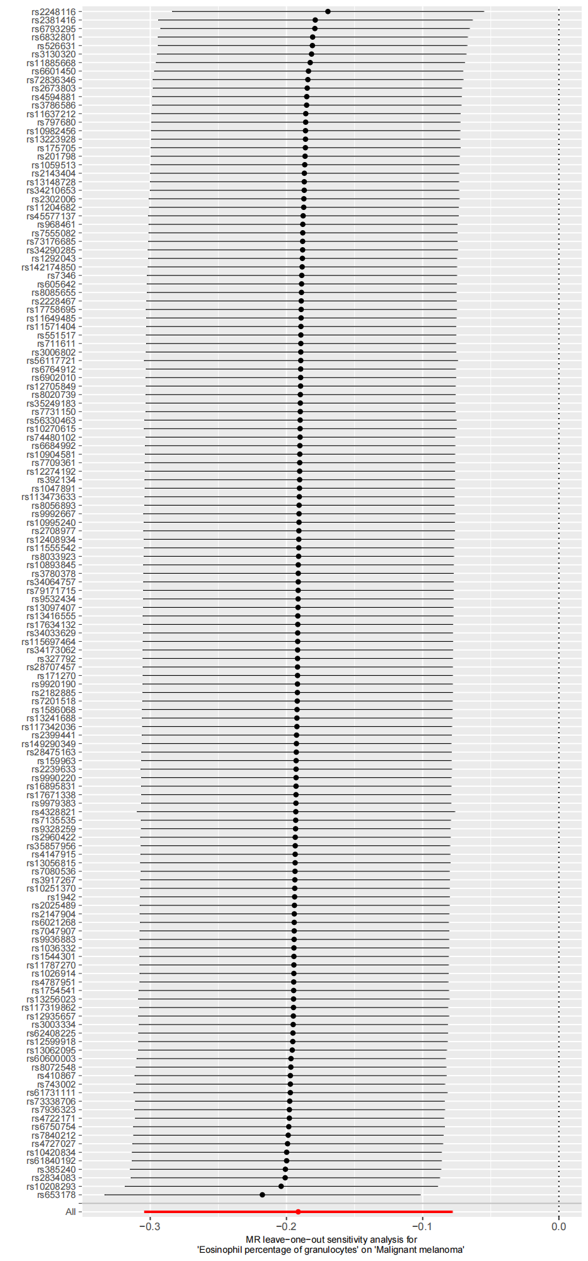
- Scatter plot
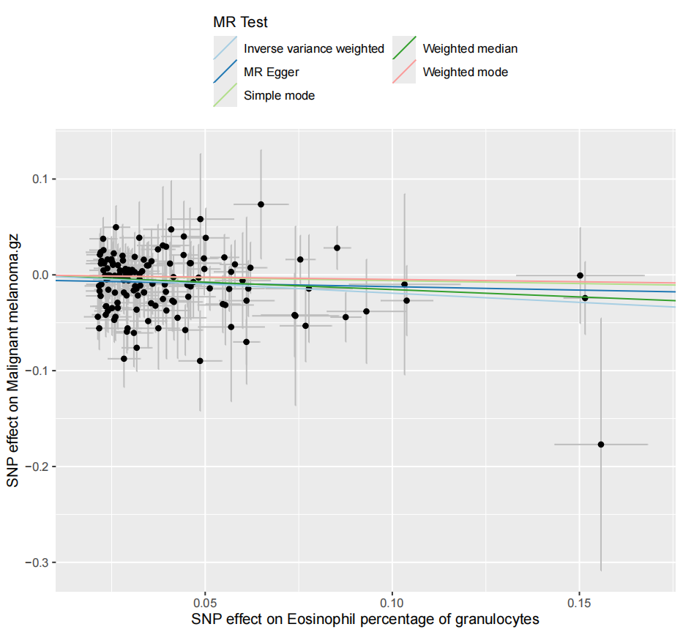
- Funnel plot
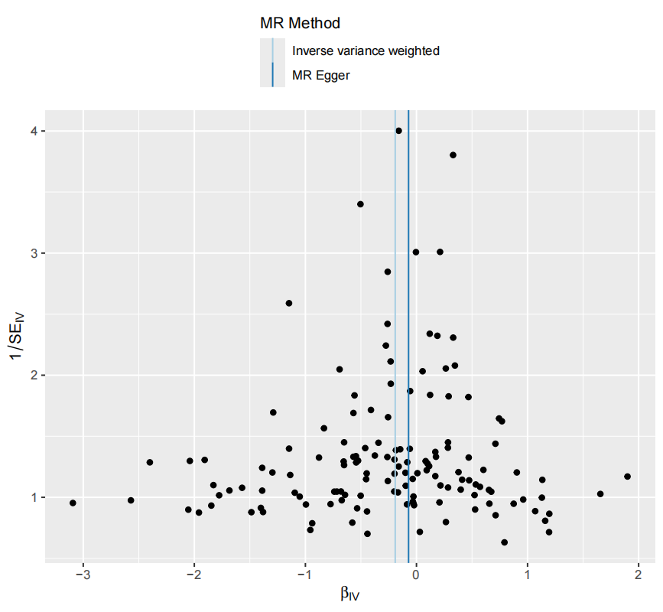

Supplementary Figure 10. Genetic association of Red blood cell count with Malignant neoplasm of head and neck
1) Forest plot
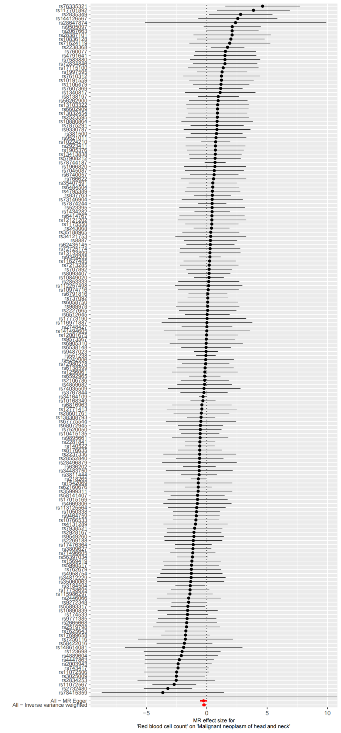
- Leave-one-out plot
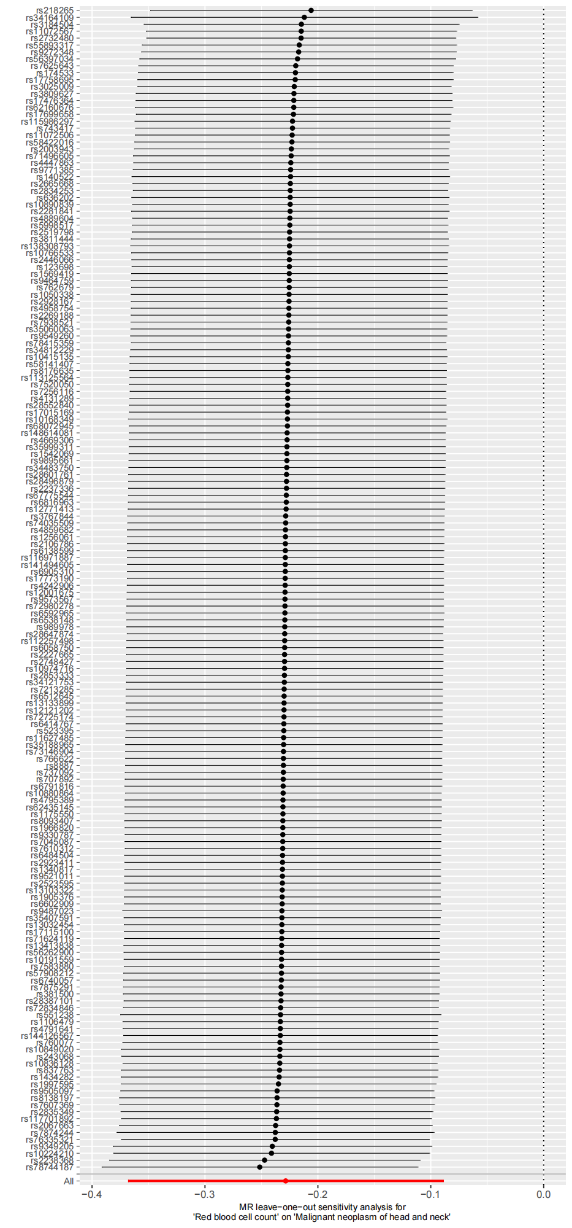
- Scatter plot
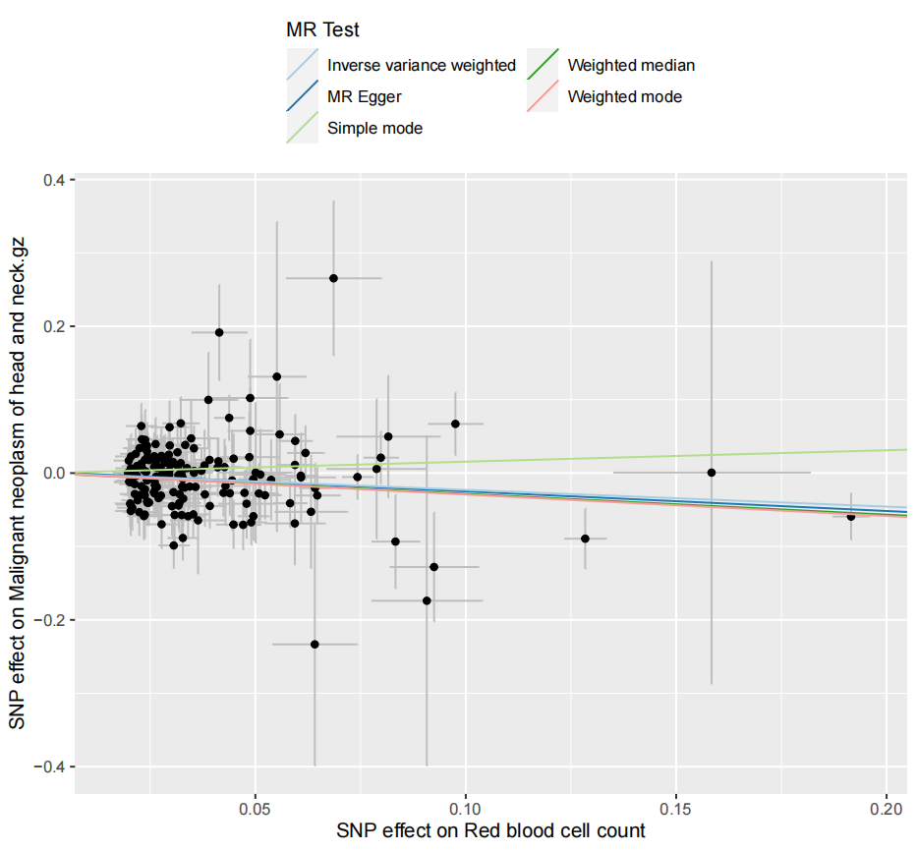
- Funnel plot
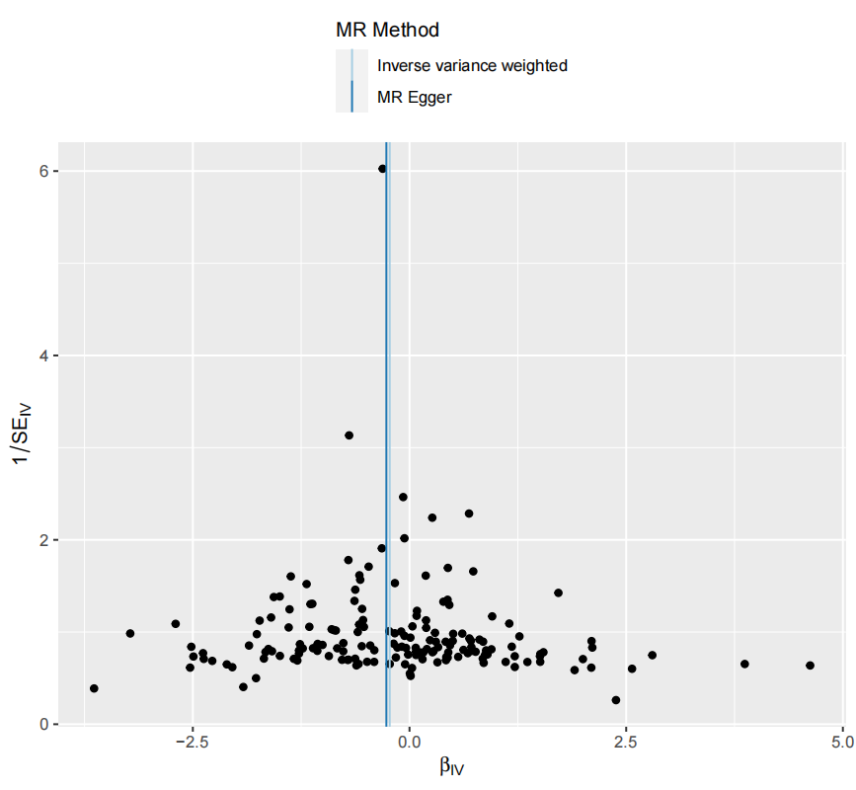

Supplementary Figure 11. Genetic association of Red cell distribution width with Malignant neoplasm of urinary organs
1) Forest plot
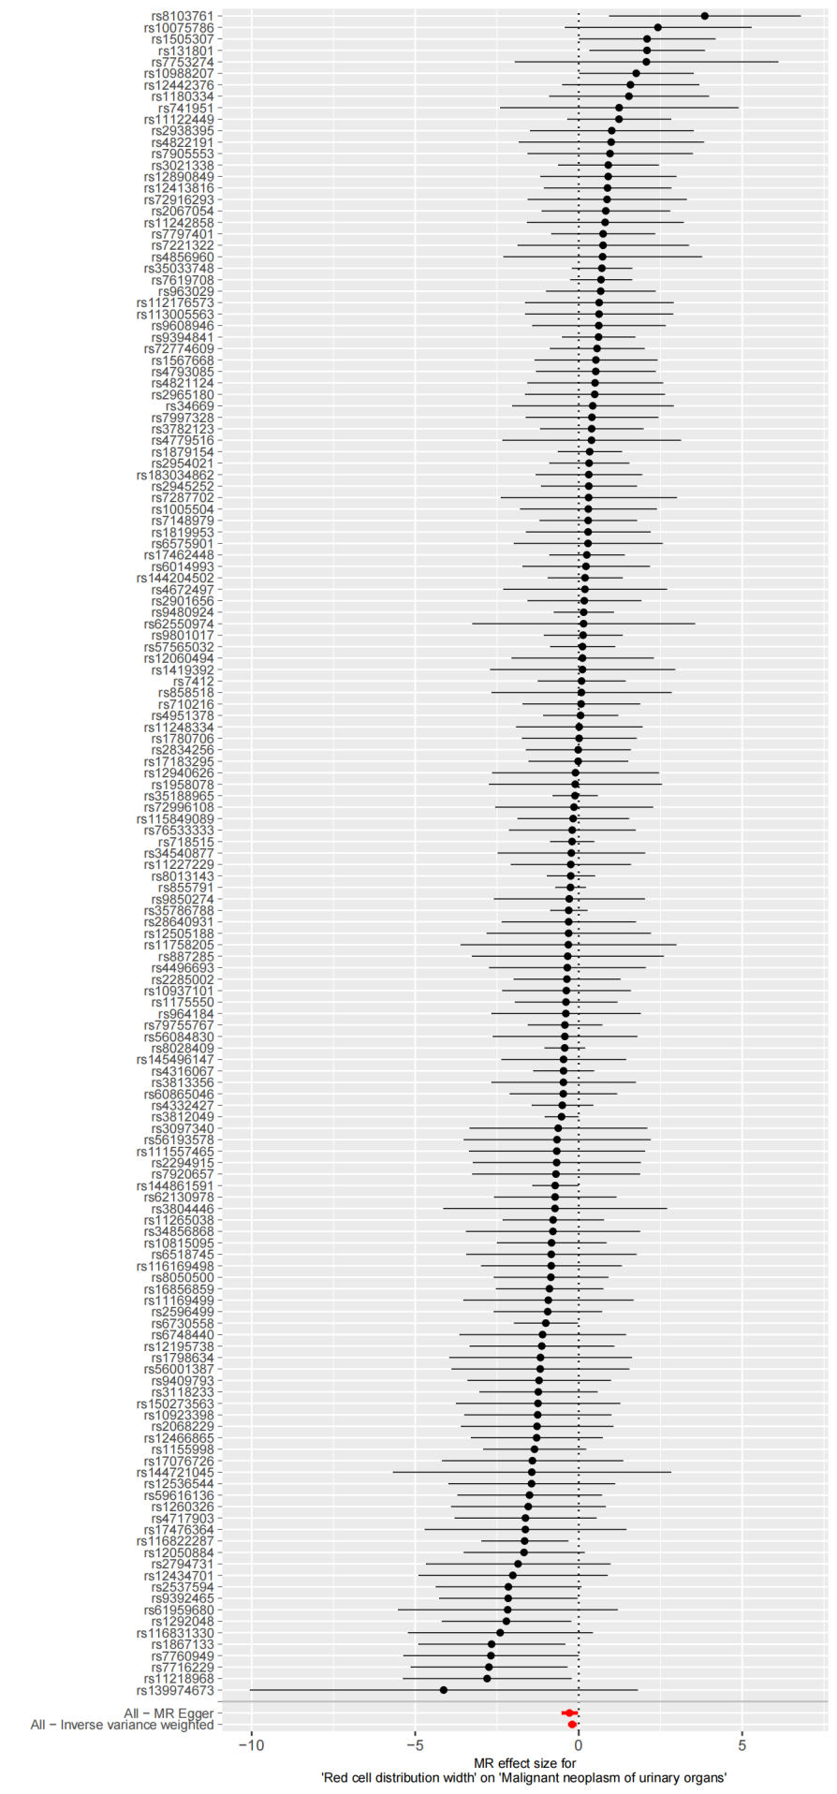
- Leave-one-out plot
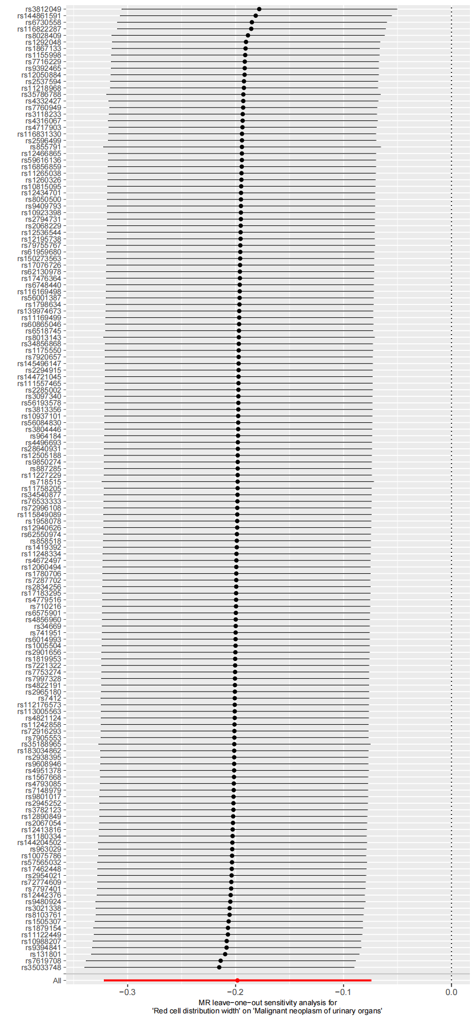
- Scatter plot
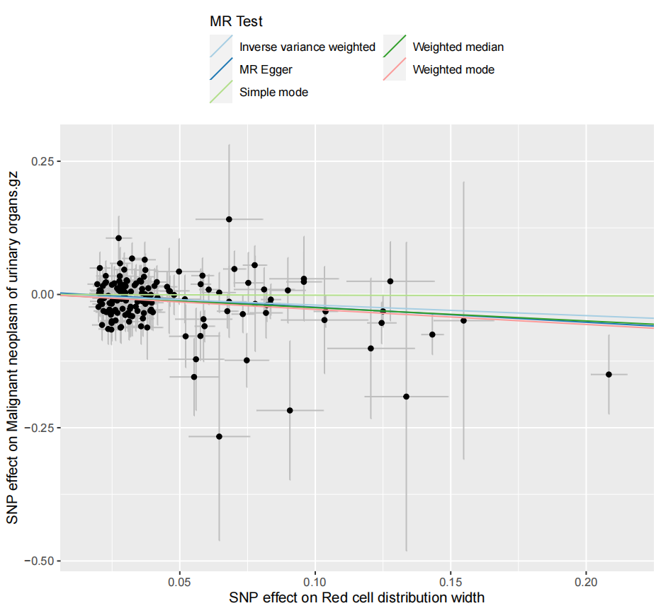
- Funnel plot
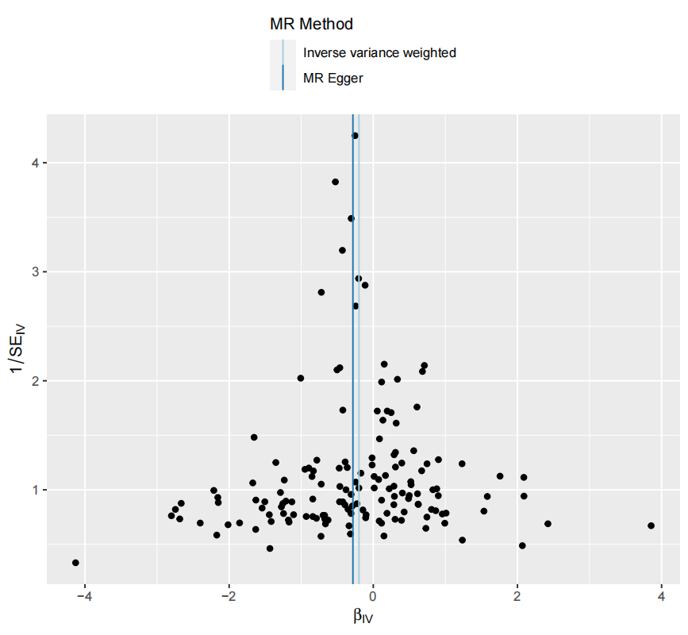

Supplementary Figure 12. Genetic association of White blood cell count with Malignant neoplasm of oral cavity
1) Forest plot
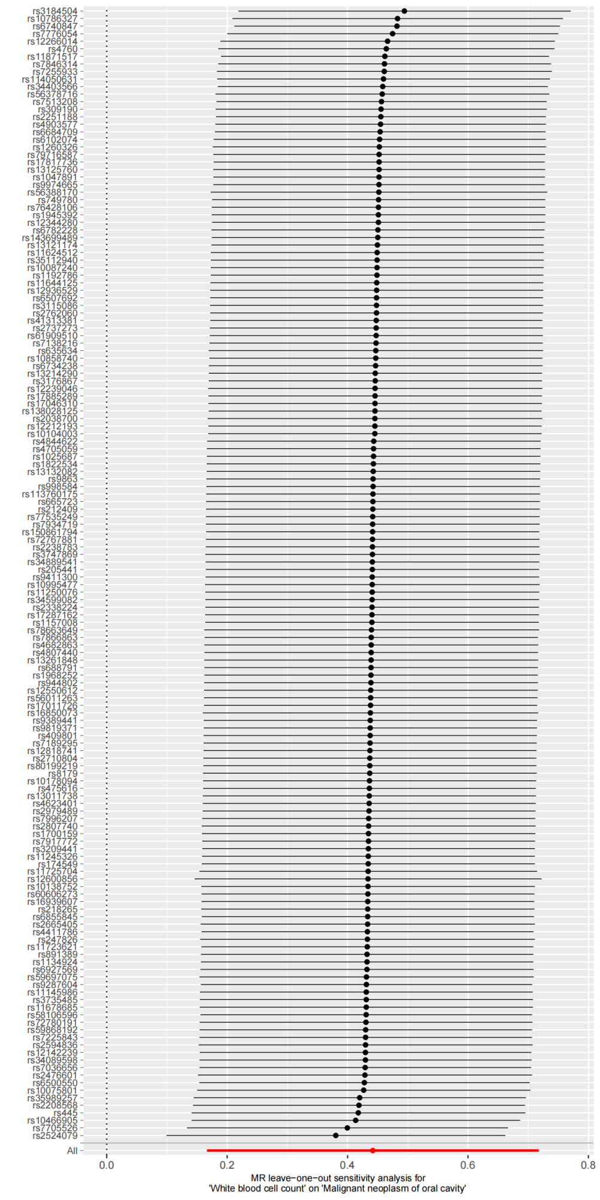
- Leave-one-out plot
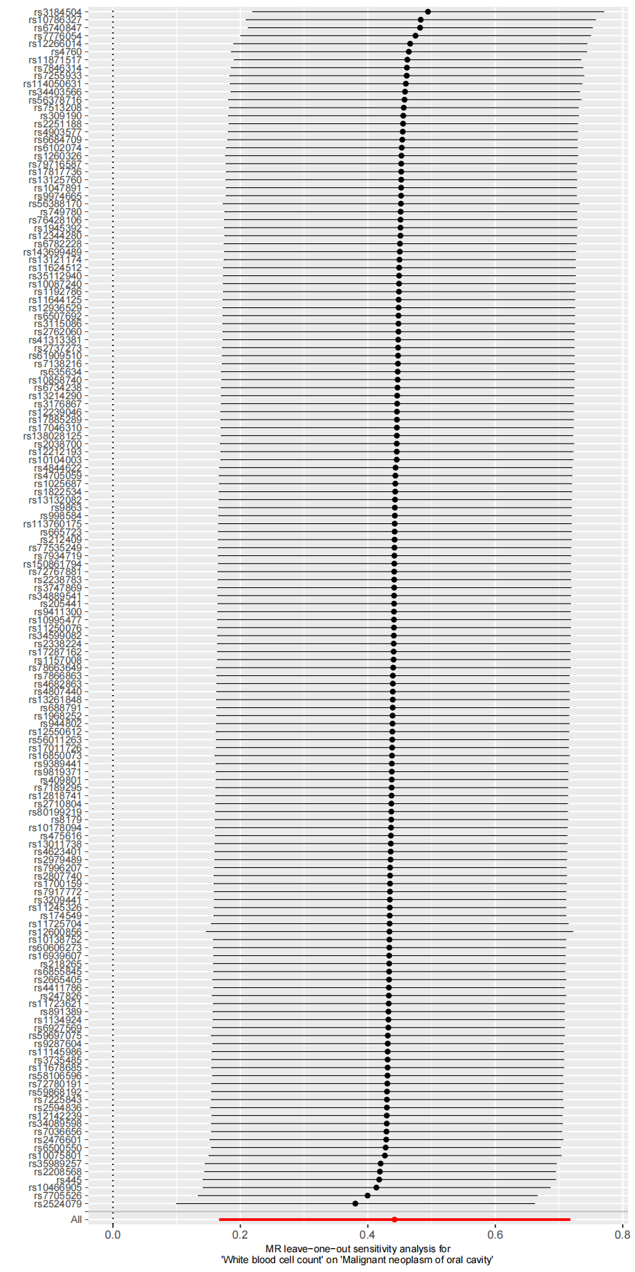
- Scatter plot
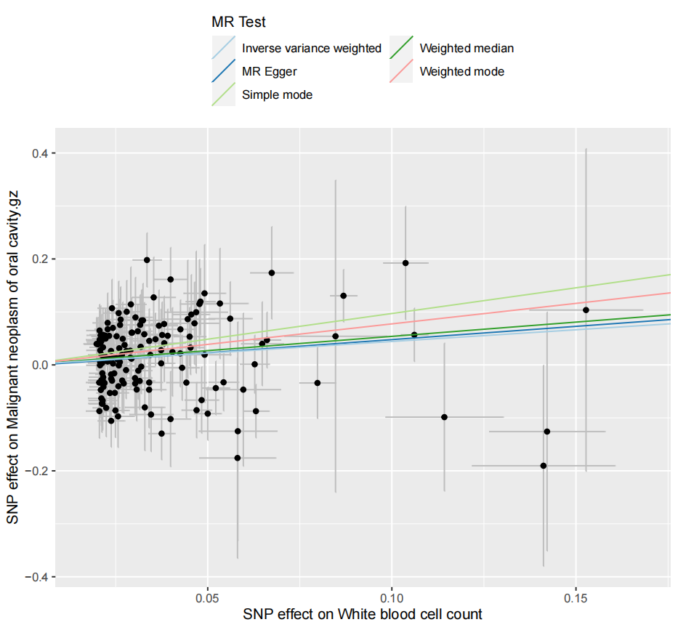
4) Funnel plot
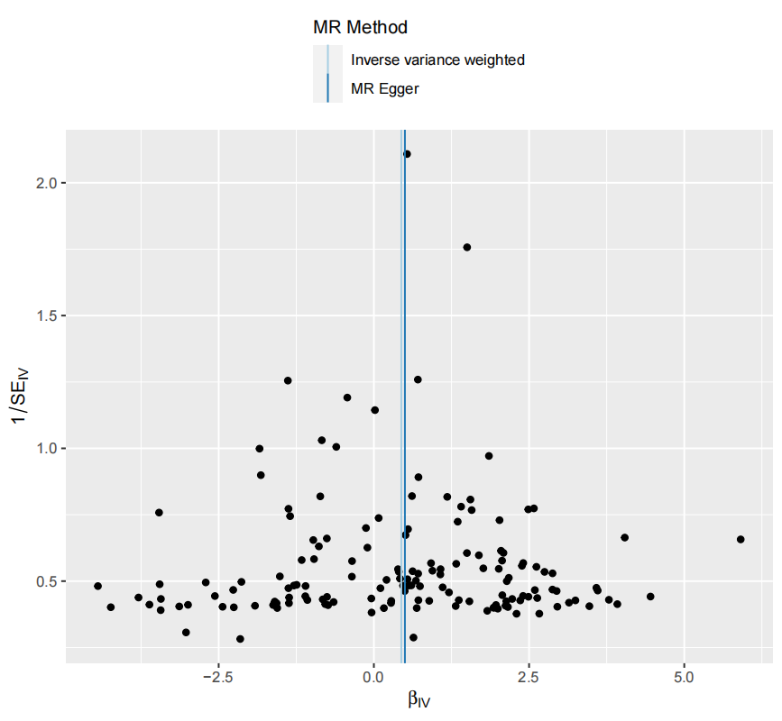

Supplementary Figure 13. Genetic association of High light scatter reticulocyte count with Malignant neoplasm of stomach
1) Forest plot
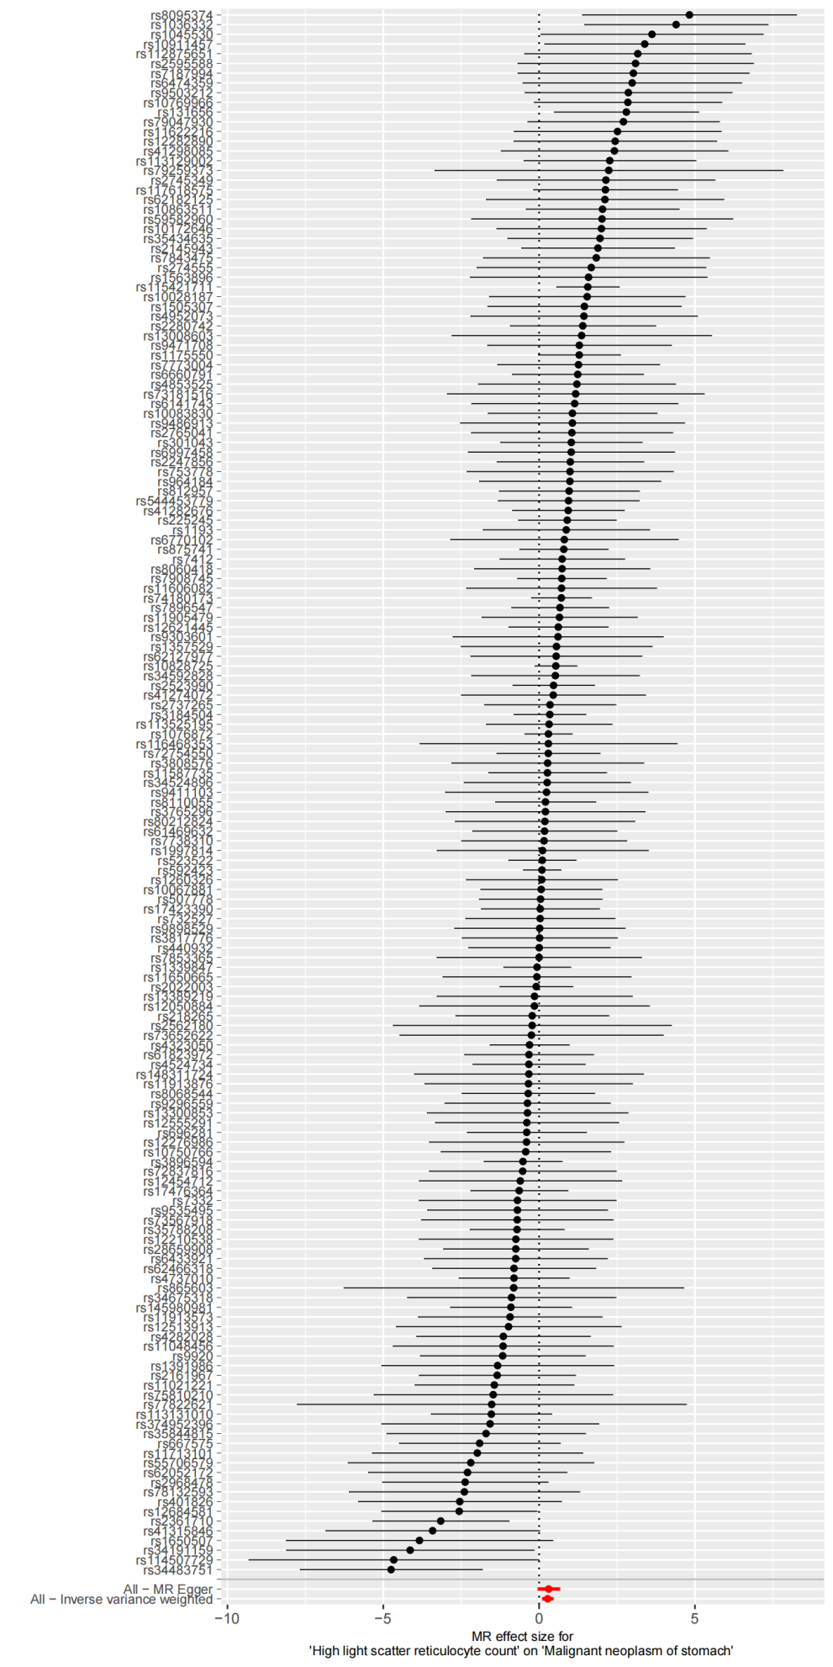
- Leave-one-out plot
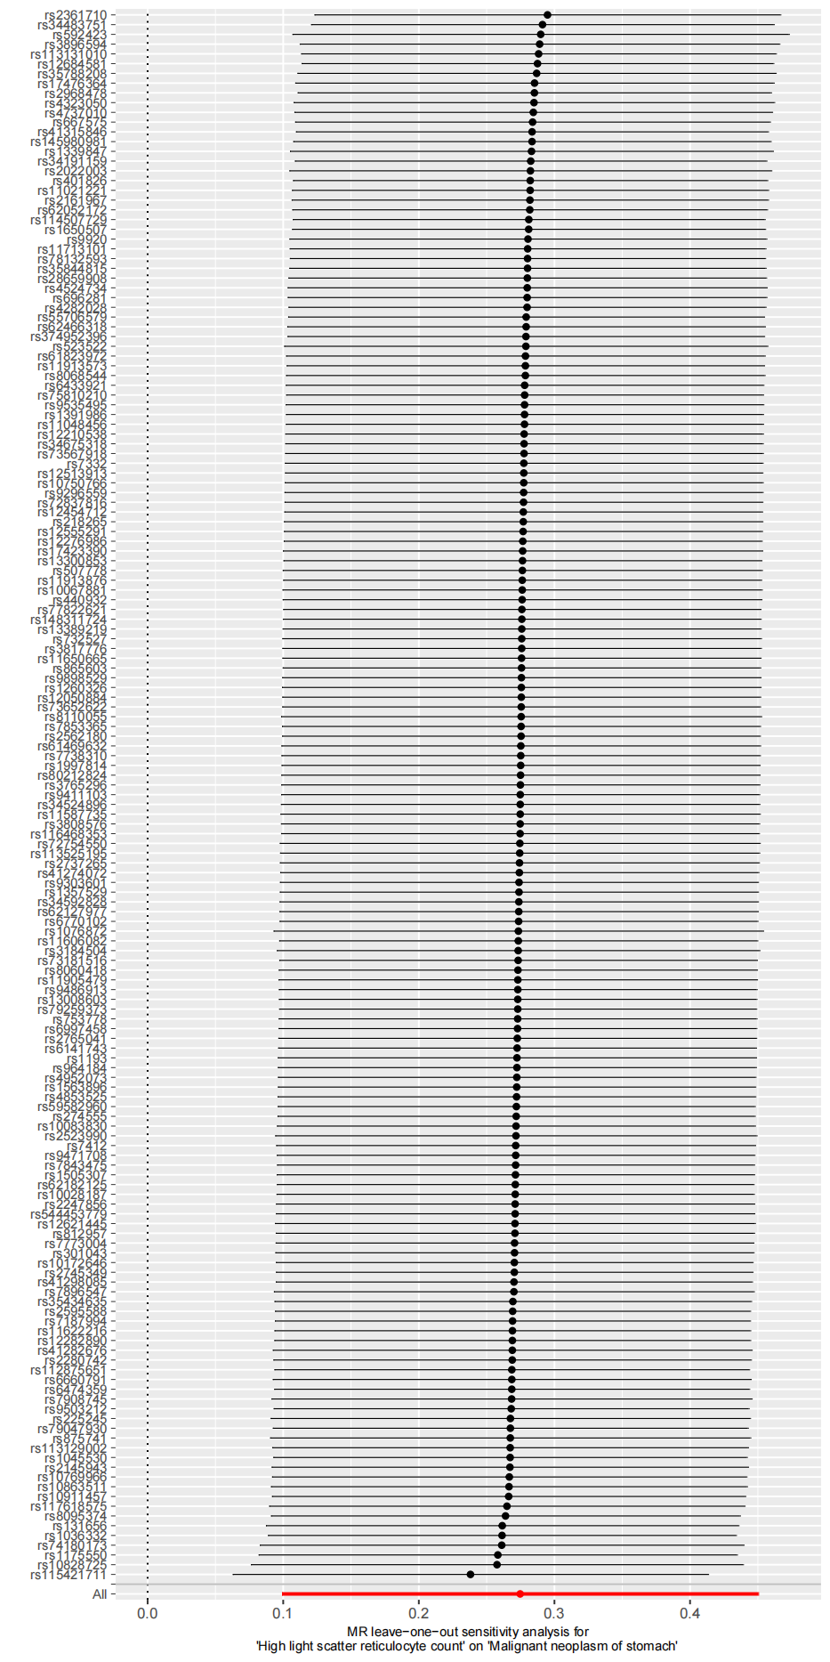
- Scatter plot
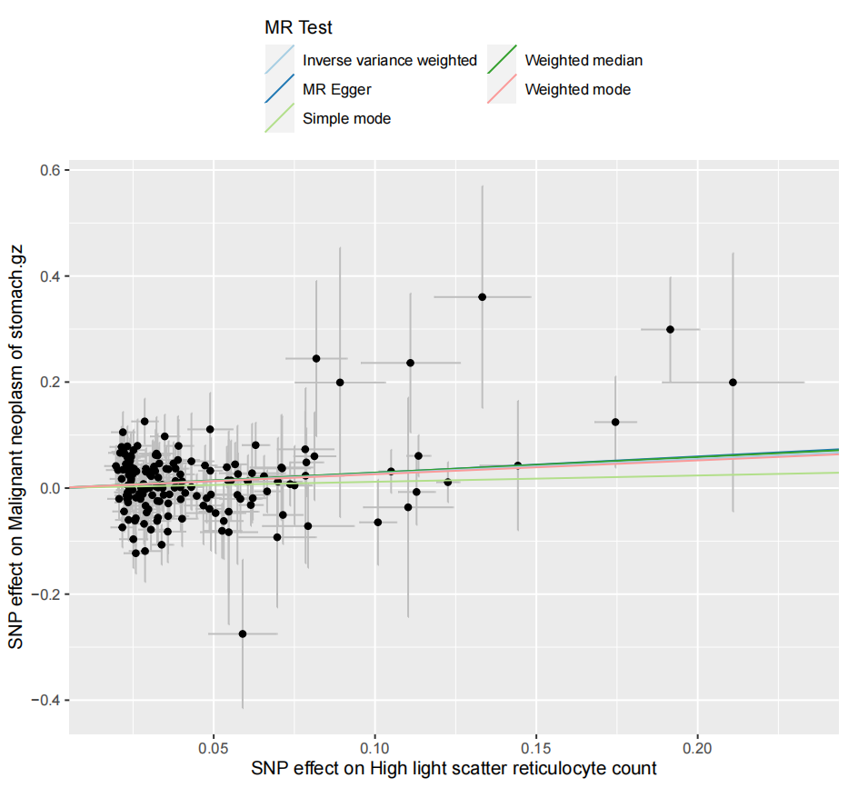
4) Funnel plot
