In regard to MATLAB:
For PCA/KMC:
- The first two sections of the code read the entire .xls/.xlsx files of the control and unknown ATR-FTIR spectra and writes them into the following variables: cell arrays (Z), text/headers (txt), and numeric data (num). The numeric data is assigned into x and y, the wavenumber and intensity, and then converted into a matrix.
- The second section of the code plots the files’ spectral data displaying all controls and samples in their respective graphs.
- The third section of the code truncates the wavelength from 400 1/cm to 600 1/cm for consistent analysis across controls and unknown samples. The “x” array is interpolated to match the length of the arrays across the plastic controls and unknown samples. The “y” dataset (unknown sample) is interpolated to fit the interpolated “x” array. The array, “d,” informs the PCA analysis where to compare the sample with the controls. Maxima locations in d are chosen based on sign change of y’s derivative meaning, when the y values decrease, the previous value is set as a maximum. Multiple values of the same type require the choice of the center of the values (odd) or the left/right center value (even). Once determined, the matrix for the PCA analysis is assigned. The variable is set in the built-in function which the coefficients, scores, latent variables Hotelling’s T-squared, variance explained in each PC, and mu. Only the variance explained, score, and “tsqaured” is needed for the purposes of the code.
- As for KMC, the clustering is based on the score of the samples chosen wavenumbers in the first 3 PCs. KMC results in the cluster indices as well as the cluster centroids with respect to some “k.” “idx” info is plotted based on the scores presented in the first 2 positions. The 3rd position, for a 3D graph, was not compatible with the formatting of the KMC function.
- PCA’s scores and its weighted score is calculated and plotted below the KMC as a scatterplot.
- Pearson’s correlational analysis is employed for the unknown samples against the control spectra with respect to the chosen “d” values.
For OpenSpecy (post-batch upload update)
- The first module of the code uploads .csv files of the spectra (wavelength vs. intensity) into the workspace of the program.
- The data is concatenated into a single matrix and is modified to fit a set range of wavelengths. (Note: Possible inconsistencies to FTIR makes interpolation valuable for array length matching).
- The next module extracts features from the continuous function into singular features (outlined in manuscript) for each plastic type.
- The module outputs the features from each spectrum that are subsequently implemented into tables for the MATLAB “Classification Learner” module to use. In a separate block of code, conversion of the cell arrays into a categorical array is needed before its usage in the machine learning applications.
- In the module, the table uploaded to the workspace can be called upon. Validation parameters are set where either cross-validation (folding of dataset) or holdout (set percentage left out) is chosen. After the model draft is set, for the latter, one can take any percentage of the dataset (10%, in our case) to calculate accuracy, total loss, and misclassification of the model. One can also set this data aside for later testing.
- Once finished, the program can train 33 machine learning algorithms to determine the most accurate model in a parallel fashion.
- After training, confusion matrices, 2D graphs of predictors, parallel coordinates plot (PCP), and so on can be used to assess the performance of the model. For example, the PCP showcases the strength of the features they display based on their ranges. The tighter and non-overlapping axes typically indicate higher predictive strength as opposed to more diffuse and overlapping axes. Predictors can also be added or subtracted to adjust the model’s performance using the “Feature Selection” module. Strength algorithms, such as minimum redundancy maximum relevance (MRMR), can help aid in this adjustment by scoring the comparative importance of the feature extractions.
- The model can be exported and further called in the command window or script for testing against an unknown spectrum formatted in the same way as the table used to build the model.
- The models can also be further optimized by means of finding the best hyperparameters for accuracy increase. These hyperparameters vary with model type and not all can be used to tradeoff for computational resources. Among those that can be optimized are Tree, Discriminant, Naïve Bayes, Support Vector Machine (SVM), Linear, K-Nearest Neighbors (KNN), Kernel, Ensemble, and Neural Network (NN).
SAS Viya’s Prediction Scheme:
- Tables from MATLAB are uploaded into SAS Studio in a local folder on the site’s server. They must be in .csv.
- On SAS Viya, a table can be loaded into memory which automatically categorizes the attributes of the data in the table “categorical versus numerical data.”
- Here, one can set the categorical variable “plastic type” as the “target” variable so that its correct partitioning can inform the model in its training, validation, and testing. Training, validation, and testing is set at 60%, 30%, and 10%, respectively.
- A set of steps, called “Pipelines,” in the software result in a comparison of multiple models. In the preliminary report, the pre-processing step was “clustering.” The models chosen were Forest, NN, Chi-square Automatic Interaction Detection (CHIAD), and Decision Tree (DT).
- Afterwards, the model decides a champion based on highest accuracy and displays data on its efficacy including: ROC, accuracy, misclassification by category, number of iterations, error, and neuronal weight (in the case of NN).
- Insights can be made on the predictor strength of the model which helps guide for further development in the case of lack of convergence, low accuracy, overfitting, and underfitting. Adding ensembles after the models in the pipeline can help optimize them further.
- Predictions can be made that help determine the nature of the sample. This can be done by repeating steps 1 through 3 for an unknown table of data. The categorical must be set as unique sample labels for each entry for user differentiation of predictions. In the “Pipeline Comparisons” Module you can score the unknown data as ”Holdout Data.” Predictions should be seen in “Nominal Classification.”

Guide for Classification Learner App:
Models Implemented
- Support Vector Machine (SVM):

One of the most widely used machine learning algorithms, SVM does well as a classified learner due to its optimizability and generalization capacities. Typically used in binary classification, the support vectors (subset of separately classified training dataset) form a hyperplane of a particular margin (maximum optimization of soft-margins) that aids in the separation of data points based on the feature extraction. As a result, the plane and the support vectors guide one another in determining a final classification result (the optimal plane of separation) (44).

Quadratic/Cubic (q-SVM/c-SVM):

Refers to the quadratic or cubic shape of the hyperplane that’s formed.

Medium Gaussian (mg-SVM):

According to MATLAB, the model flexibility of medium Gaussian is higher than traditional SVM meaning the weight of predictions is altered such that classification is stricter. Here, the weight of the predictor is substituted for its square root. The shape of the model’s hyperplane follows the Gaussian distribution (45).

Hyperparameter Optimization:

For MATLAB’s Classification Learner, optimizing SVM involves the following hyperparameters: Kernel function, which organizes the hyperplane as linear, quadratic, cubic, or fine gaussian/radial basis function (RBF); box constraint level, affects the Lagrange multipliers for the soft-margins of the model’s hyperplane; and kernel scale mode, subsamples data to determine an adjusted scale for the data; Multiclass coding, sets individual SVMs as binary classification problems where, for 1v1, which involved pairwise training (all combinations), and 1-v-all, which involves a single-wise training against all others classes (45).

- Tree (T):

Tree models are often used to help classify an object or a set of data points into a pre-defined set of classes. Multiple feature extractions help guide and train the model to output a classification prediction thus automating steps of classifying results based on weights. Weights may be adjusted by an algorithm to have more or less of an effect on the particularly trained outcomes. This algorithm is inherently hierarchical meaning that the strongest predictors guide the decision-making process at the start (46).

Fine (FT):

According to MATLAB, the “fine” tree version of the model adds more leaves thus increasing the accuracy of the model, however, this can lead to overtraining. This also affects accuracy on independent and unknown testing data sets set to be predicted (45).

Bagged (BT):

MATLAB implement’s Breiman's 'random forest' algorithm whereby a random set of sample data is chosen to train an ensemble of trees. These trees vote by popularity resulting in the final classification decision (47).

Medium (MT):

Coarser than traditional “tree.” According to MATLAB, the maximum number of distinctions per class is 20.

Hyperparameter Optimization:

In terms of SAS Viya for Learners, there are more advanced options for tuning the hyperparameters but, for “Decision Tree,” not all can be optimized. Hyperparameters that aren’t shared by MATLAB are as follows: maximum depth (length of the longest path from the first node to the ending leaf in steps), minimum leaf size (records of predictions in a particular leaf), missing values in comparisons and the minimum allowances, interval bin number and method (decides the number of child nodes resulted from a parent node; based on either quantile or bucket/fixed-width for predictors with large gaps and non-uniformity in range or for more uniform data, respectively), seed size (can be set to generate random values for selecting and assessing the training dataset), clustering-based split search, choice of number of inputs that can be used without replacement, surrogate split (whereby a “fake” decision tree is used in the event of missing data needed to guide a dataset to the correct prediction thusly overwriting the majority rule), subtree pruning (minimum leaf-penalty average square error (ASE)/reduced error/classification based pruning), selection method (optimizable for subtrees made across the entire model, the largest subtree according to the minimum leaf size, and cost-complexity alpha), cross validation folds (can be used to adjust the subtrees when validation dataset is not present with or without “1-SE” rule), growth criteria (optimizable and based on Shannon’s entropy, CHAID, Gini, chi-square, variance, information gain ratio, F test which aid in reducing redundant attributes in data selection, CHAID explained below, assessment in purity of data partitions, spread of data, aid in reducing bias in the event that information about a particular partition is gained maximally before successive splits, and significance test used ideally for numerical data variance difference) (48)(49)(50)(51)(52).

As for “Forest,” in SAS Viya, it has similar hyperparameters to “Tree.” Differences come into play with the voting method of a class target which can either be probability based (averages) or proportional-based (popular vote/majority rule), the leaf size can also be used as a proportion in addition to counts, the “In-bag” sample proportion can further divide the training data into a subset, the number of inputs from the dataset to be considered for each split, and Loh’s method can be used here as an algorithm that partitions the training datasets with bias (53).

- Naïve Bayes (NB): Bayes’ theorem makes its prediction based on the probability of a classification (event) taking place for a particular dataset by taking into account two probabilities: current (probability of a predictor) and prior: A and B.

$P\left(A | B\right)= \frac{P\left(B | A\right)P(A)}{P(B)}$ , (1)

where “A” is the probability of the classification event whereas “B” is the series of predictors’ probabilities. “Naïve” suggests that these predictors are independent from each other when calculating the conditional probabilities thus, the multiple predictor conditional probability of a classification eases in conjunction with computational time. Ex: P(Width, Prominence, …, AUC 2nd Derivative|LDPE) (54).

Kernel (KNB):

As for MATLAB, the “Kernal” version of Naïve-Bayes improves the model by four types: Gaussian, Box, Epanechnikov (parabolic), and Triangle. These types simply inform the shape of the hyperplane that is created as the data is moved into higher dimensions so, for a particular set of data with two dimensions, the plane can be translated to the third dimension in the shape of the four types mentioned above. This aids in flexibility of optimizing weights for the Kernal Naïve-Bayes’ classification (55)(55)(56).

- K-Nearest Neighbors (KNN)

The KNN algorithm classifies datasets by using k-nearest training data points, or neighbors, closest to a particle coordinate point query. The final result of classifying a cluster is by majority rule. Ex: The algorithm for two clusters of 5 data points each will most likely place two points in each of the centroids of the cluster since the minimized (optimization) distance determined the coordinate points’ proximity (57).

Subspace (SubKNN):

As for MATLAB, a specialized Subspace KNN ensembles a random subset of predictors from which to draw classifications. This is beneficial in the case of datasets with a multitude of predictors (45).

Fine (FKNN):

This involves increasing the detail of the cluster designation for the algorithm. In this case, the nearest neighbor limit is no greater than 1. A caveat is the loss of the model’s interpretability (45).

Hyperparameter Optimization:

For MATLAB’s Classification Learner, optimizing KNN involves the following hyperparameters: Number of neighbors, where an optimal number of neighbors is selected for the data; distance metric, whereby different formulas are used to find the centroid of clusters in data; distance weight, whereby no weight, inverse distance weight, or squared inverse distance weight is chosen; or standardized data, where the dimensions of the coordinate data points are scaled (especially helpful if predictor ranges are wide and dissimilar in variation). (45).

- Neural Network (NN):
NNs calculate a prediction based on the strength or connectivity of predictors and classifiers (neurons). An input, hidden, and output layer of neurons are arrayed whereby the connectivity is governed by the weights of the predictors on the neurons in the hidden layer. These layers then help segregate the data according to the supervised model for new/unknown data to be predicted. During training, validation, prediction error adjusts these weights. Moreover, some classifiers may heavily rely on one predictor versus another and this varies based on the range/tightness/uniqueness of the class in the predictor’s range. Often times, parallel coordinates plots can help relay the relationship as seen in the results (58). For more complicated NNs (CNNs), multiple hidden layers are used whereby a certain group of neurons will share a particular weight. This aids the algorithm in handling larger datasets (59).

Wide (WNN):

In MATLAB’s “Wide” version of NN, the size of the first layer is widened or enlarged in its neuronal density for better predictive capabilities (45).

Hyperparameter Optimization:
For MATLAB’s Classification Learner, optimizing NN involves the following hyperparameters: Number of fully connected layers, whereby 1 to 3 hidden layers can be chosen to increase the ability for predictors to tune classification predictions; 1st, 2nd, and 3rd layer size, specifies the activation for fully connected layers which are typically, ReLU (ramp/No Vanish Gradient Problem), Tanh (zero-centered activation function), None, and Sigmoid (various shapes/functions that mimic the activation threshold layer of neurons in the brain which mimics a step function – ReLU seems to possess faster learning as values away from the extremes don’t make obvious patterns for the others); iteration limit, which is self-explanatory for convergence; Regularization strength (Lambda), helps aid in the penalty of an overfitting model and/or ill-conditioned model meaning that any matrix operations done on the data may not lose accuracy; and data standardization, which aids in a set of predictors with dissimilar and large variance (45)(60)(61).
In terms of SAS Viya for Learners, there are more advanced options for tuning the hyperparameters but, for “Neural Network”, not all can be optimized: Standardization (where scale can be “midrange” or a “z” score to improve extremes in comparison of predictor’s ranges); hidden layer number (up to 10); choice of identical number of neurons in hidden layers, number of neurons per hidden layer, additional activation functions (exponential, identity, logistic, softplus, or differing activation functions on different levels); choice of direct connections (skip-layer network bypassing hidden layers); interval target error function (normal, Poisson, or gamma that helps transform the data in the layer); activation function for target layer (sine, tanh, or identity); optimization method (LBFGS and SGD, which optimize the parameters for large-scale log-linear models with L2 regularization and which optimizes and reduces error similarly for greater than 2 hidden layers); maximum tries/iteration/time are implemented for trainings and optimization; L1 (Lasso Regularization, L2 (Ridge Regularization) weight ratios, and Dropout (input/hidden) (norms to aid in overfitting such as absolute value/squared penalty term, and proportional removal of neurons for encouraging model to test more features); stagnation and error goal (set iterations for optimization when no improvement of accuracy is occurring and stopping criterion for model); optimizable L1, L2 regularization, learning rate, and annealing rate (previously explained L1 and L2, tunes rate of training and rate of decrease of training rate for optimized convergence and accuracy), other search methods that are similarly used to autotune hyperparameters with either optimized or set bounds for optimization, and various in-model validation methods that measure accuracy/misclassification based on target objective error (62)(63)(64)(61)(65)(66).

- Ensemble (E):

Ensembles combines multiple machine learning algorithms together (different types) and settles on a classification by popular vote. The benefit is in the diversity which may elucidate more by majority rule than one single algorithm. A tradeoff in the variance of results and bias is key to a well-performing ensemble with minimal error. Many times, models weak in predictive capabilities are combined in this manner (67).

Hyperparameter Optimization (also part of Trees):

MATLAB’s Classification Learner will find an optimal set of hyperparameters such that the highest accuracy is achieved. Hyperparameters that can be tuned are as follows: Number of splits, where the model can specify depth of the trees to increase complexity while controlling for drift; number of learners, where a set of learners can help up the predictive power of a model while controlling for computational time and power; learning rate, allows for more time to make predictions for the individual learners and is optimized for iterations, subspace dimension, chooses an optimal number of predictors to train each learner with each set being independent from the other, and lastly, predictor space limits, where you can choose to omit particular predictors from the ensemble as a whole.

- Chi-square Automatic Interaction Detection (CHAID)

CHAID performs a chi-square test that determines statistical significance of a target variable (sample dataset) against a particular predictor. The lowest p-value is used as a first-level variable in the algorithms decisions trees classification. Secondary and tertiary trees are based on sequentially larger p-values until the null hypothesis can no longer be rejected at a particular alpha. A particular target variable becomes easier to classify if a particular predictor is significant over the other for efficiency/predictive power (68).

The hyperparameters for the model, in SAS Viya for Learners, is shared by “Decision Tree” however, the default setting takes into account the Bonferroni correction for the significance threshold/classification criterion. This aids in mitigating false significance for a model that performs multiple independent statistical tests (69).

Feature Strength

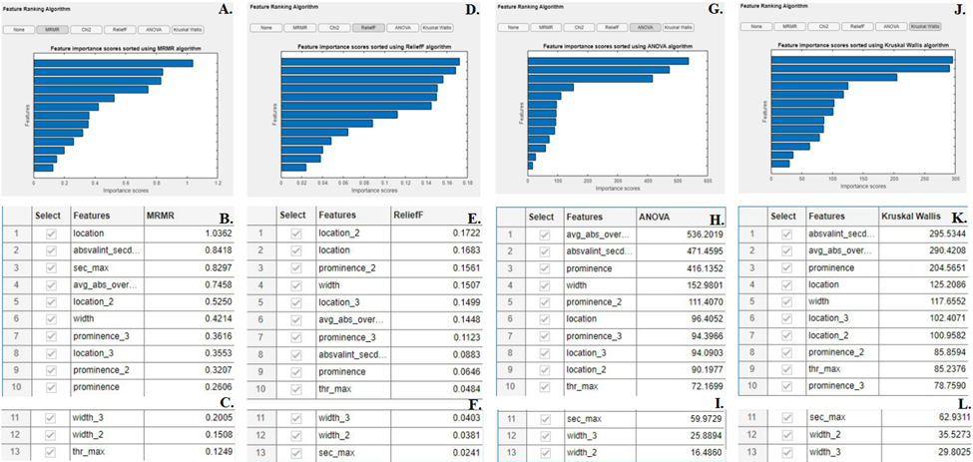

Figure S1. Strength of predictors from V1’s feature extracted dataset assessed by feature ranking algorithms

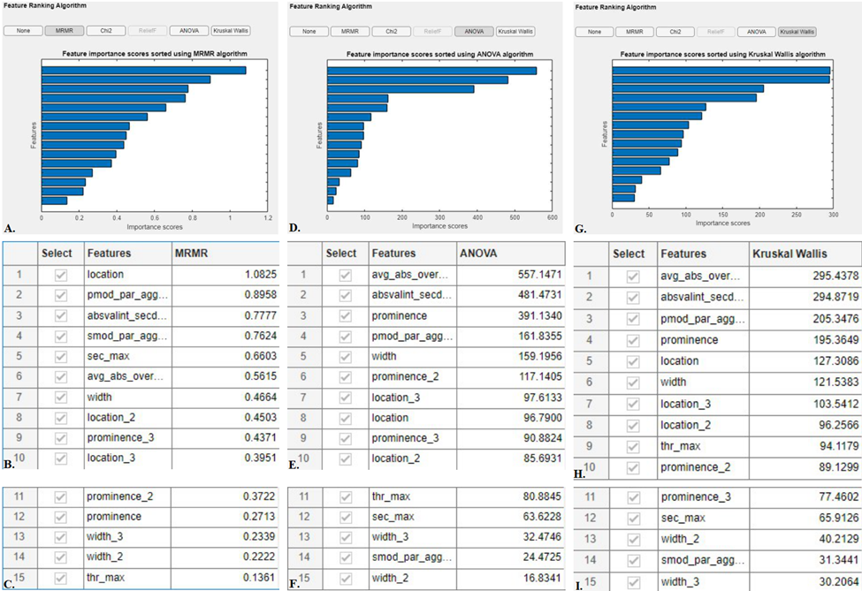

Figure S2. Strength of predictors from V2’s feature extracted dataset assessed by feature ranking algorithms (Note: ReliefF algorithm for V2 failed)

Figure S3. Strength of predictors from V3’s feature extracted dataset assessed by feature ranking algorithms

Figure S4. (from top to bottom) SAS Viya’s predictor strength ranking of the champion model from all versions [Top: NN, Middle: NN-Ensemble, Bottom: NN]

Figure S5. ATR-FTIR Data of PCA/KMC/OpenSpecy (pre-batch upload update) Control Data

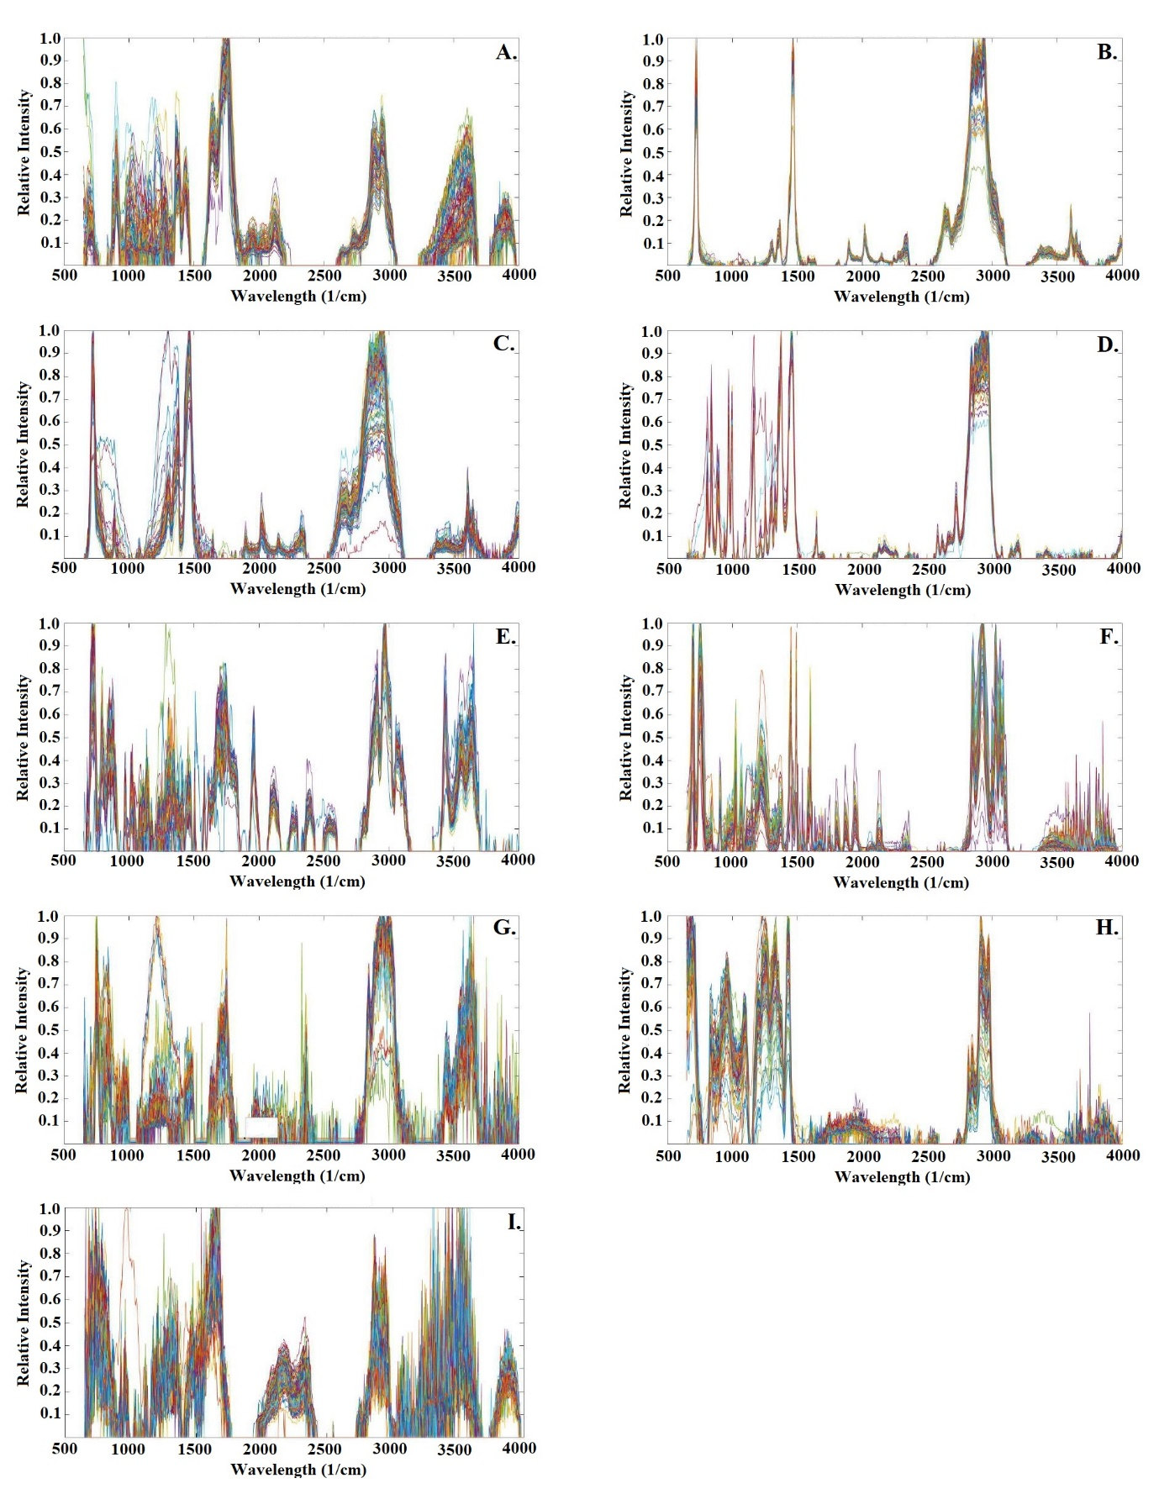

Figure S6. µ-FTIR Spectra of Commercial Samples (n = 100) where, A. CA, B. HDPE, C. LDPE, D. PP, E. PET, F. PS, G. PMMA, H. PVC, and I. PA6.
Statistics Guide:
- Shapiro-Wilk Test [Validation] (Version 1)
- Shapiro-Wilk Test [Validation Accuracies](MATLAB-v1)
- Kruskal-Wallis (Validation across all versions)
- Wilcoxon (unpaired) (MATLAB vs SAS Viya) [Validation]
- Shapiro-Wilk Test [Version 1] (Test)
- Shapiro-Wilk Test MATLAB-v1 (Test)
- Kruskal-Wallis (Test across all versions)
- Wilcoxon (unpaired) (Matlab vs SASViya) [Test]
- V1 Normality (Corroboration) - Corroborating Models
- Kruskal-Wallis (Corroboration Across All Versions)
- v1 ldpe inc (S-W Normal)
- v2 ldpe inc (S-W Normal)
- v3 ldpe inc (S-W Normal)
- ANOVA (LDPE)
Statistics Rationale:
Tests 1 and 2 were completed to assess normality for use of a parametric test of significance in assessing statistically significant differences in validation accuracies across all versions of the feature extraction algorithms and across software (tests 3 and 4). In a parallel manner, tests 5 and 6 were used to assess the normality for the test scenario with 7 and 8 being the assessment of significant differences. Test 9 assessed general normality for V1’s corroboration (unsupervised to supervised) alone since only 1 version is needed to reject the assumption of normality for the significance test (test 10.) Tests 11, 12, and 13 were completed to determine if normality held across all versions which resulted in the use of a parametric test of significance: test 14.

