Supplementary Information

Supplementary Tables

Table S1. Detailed description of the datasets used in the paper
Datasets | Platform | Data size | Source
Human Colorectal Cancer | Visium HD | 545,913 bins  18,085 genes | https://www.10xgenomics.com/datasets/visium-hd-cytassist-gene-expression-libraries-of-human-crc
Human Lung Cancer | Visium HD | 605,471 bins  18,085 genes | https://www.10xgenomics.com/datasets/visium-hd-cytassist-gene-expression-libraries-of-human-lung-cancer-if
Mouse Brain | Visium HD | 393,543 bins  19,059 genes | https://www.10xgenomics.com/datasets/visium-hd-cytassist-gene-expression-libraries-of-mouse-brain-he
Mouse Small Intestine | Visium HD | 351,817 bins  19,059 genes | https://www.10xgenomics.com/datasets/visium-hd-cytassist-gene-expression-libraries-of-mouse-intestine
Human Breast Cancer | Xenium | 167,780 cells  280 genes | https://www.10xgenomics.com/products/xenium-in-situ/preview-dataset-human-breast
Human Ovarian Cancer | Xenium | 247,636 cells  380 genes | https://www.10xgenomics.com/datasets/ffpe-human-ovarian-cancer-data-with-human-immuno-oncology-profiling-panel-and-custom-add-on-1-standard
Human Lung Cancer | Xenium | 161,000 cells  380 genes | https://www.10xgenomics.com/datasets/ffpe-human-lung-cancer-data-with-human-immuno-oncology-profiling-panel-and-custom-add-on-1-standard
Human Pancreatic Ductal Adenocarcinoma | Xenium | 235,099 cells  380 genes | https://www.10xgenomics.com/datasets/ffpe-human-ductal-adenocarcinoma-data-with-human-immuno-oncology-profiling-panel-1-standard
Human Colorectal Cancer | Xenium | 388,175 cells  380 genes | https://www.10xgenomics.com/datasets/ffpe-human-colorectal-cancer-data-with-human-immuno-oncology-profiling-panel-and-custom-add-on-1-standard

Supplementary Figures

Fig S1. Spatial clustering results for the Visium HD Human Lung Cancer slice

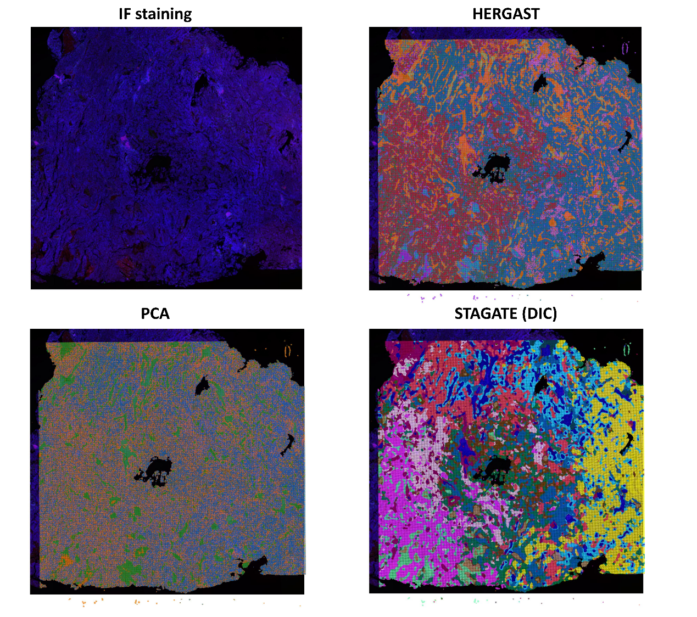

Fig S2. Spatial clustering results for the Visium HD Mouse Brain slice

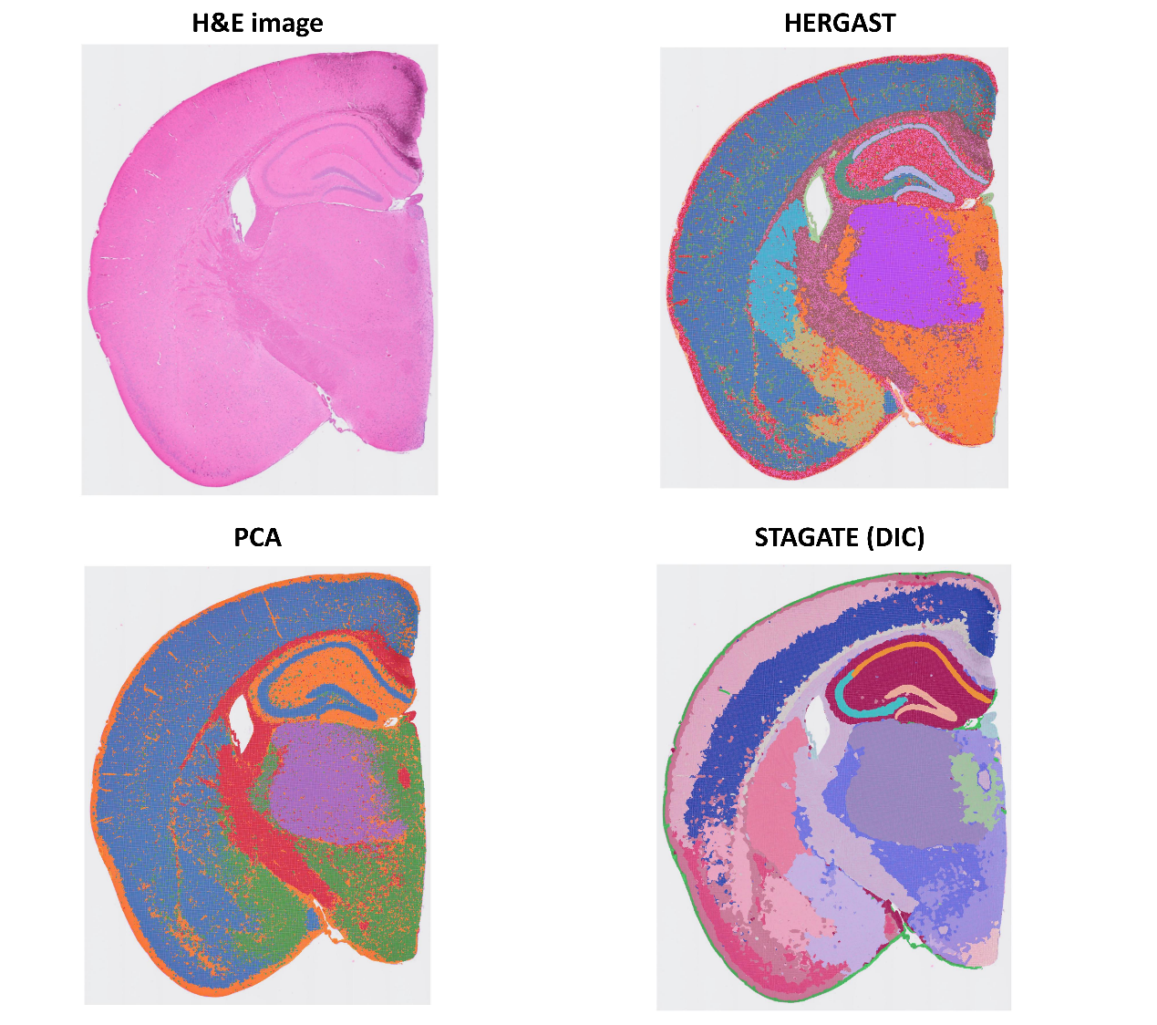

Fig S3. Spatial clustering results for the Visium HD Mouse Small Intestine slice

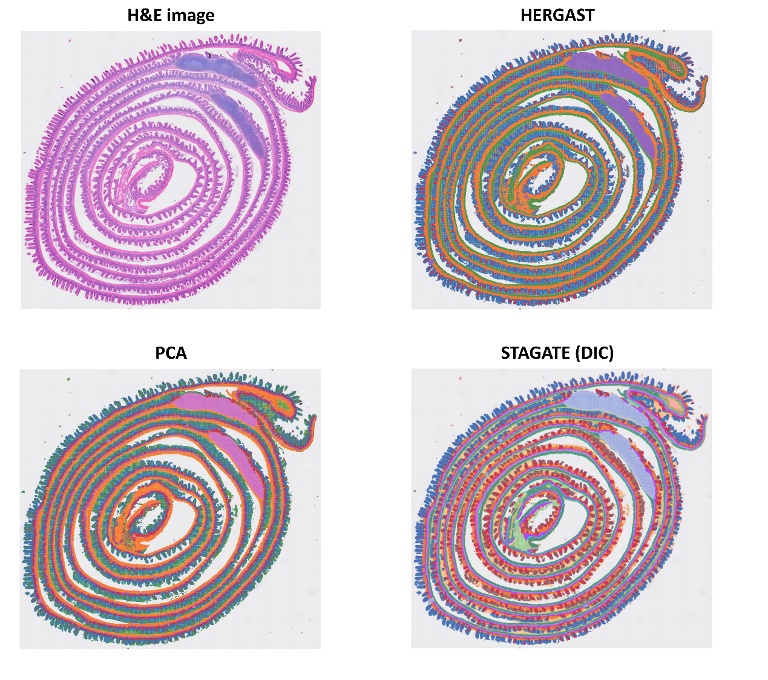

Fig S4. Spatial clustering results for the Xenium Human Colorectal Cancer slice

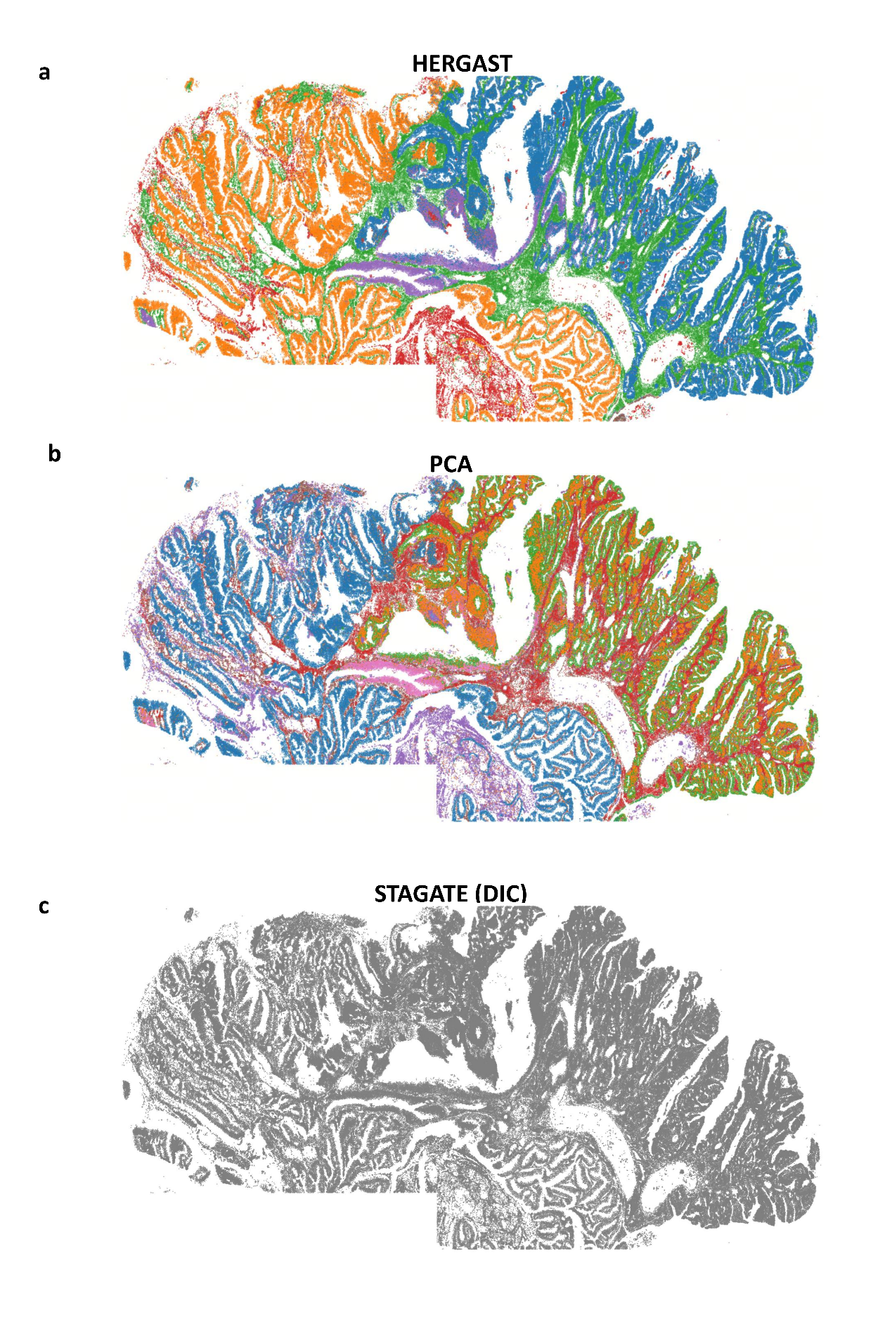
Gray images indicate that there are too many clusters (>100) to display in the panel.

Fig S5. Spatial clustering results for the Xenium Human Pancreatic Ductal Adenocarcinoma slice

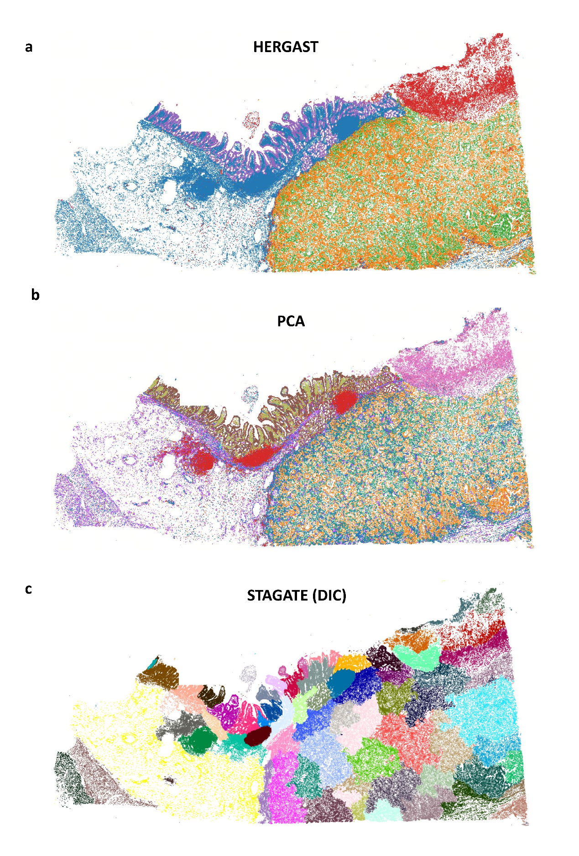

Fig S6. Spatial clustering results for the Xenium Human Lung Cancer slice

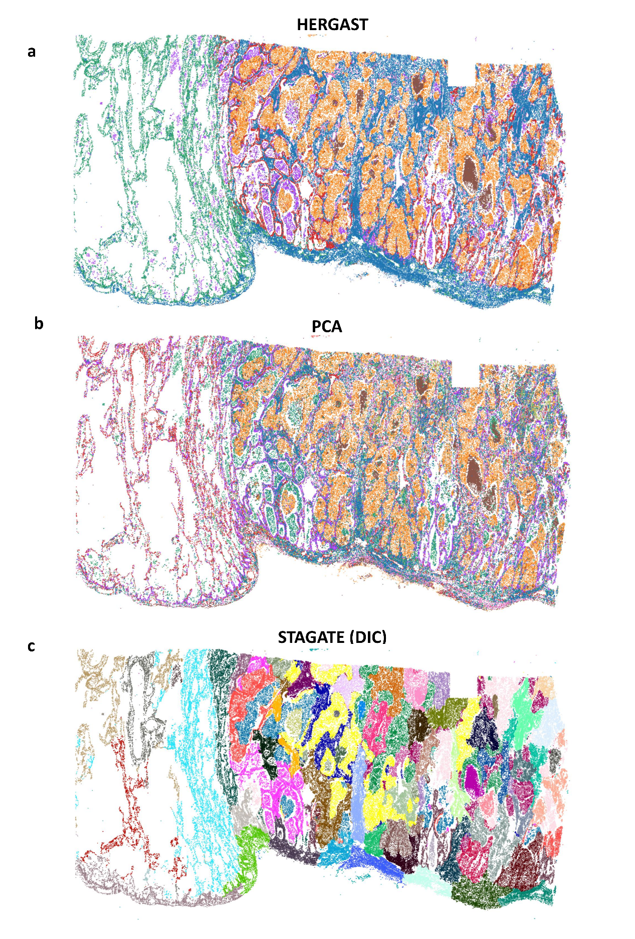

Fig S7. Spatial clustering results for the Xenium Human Ovarian Cancer slice

