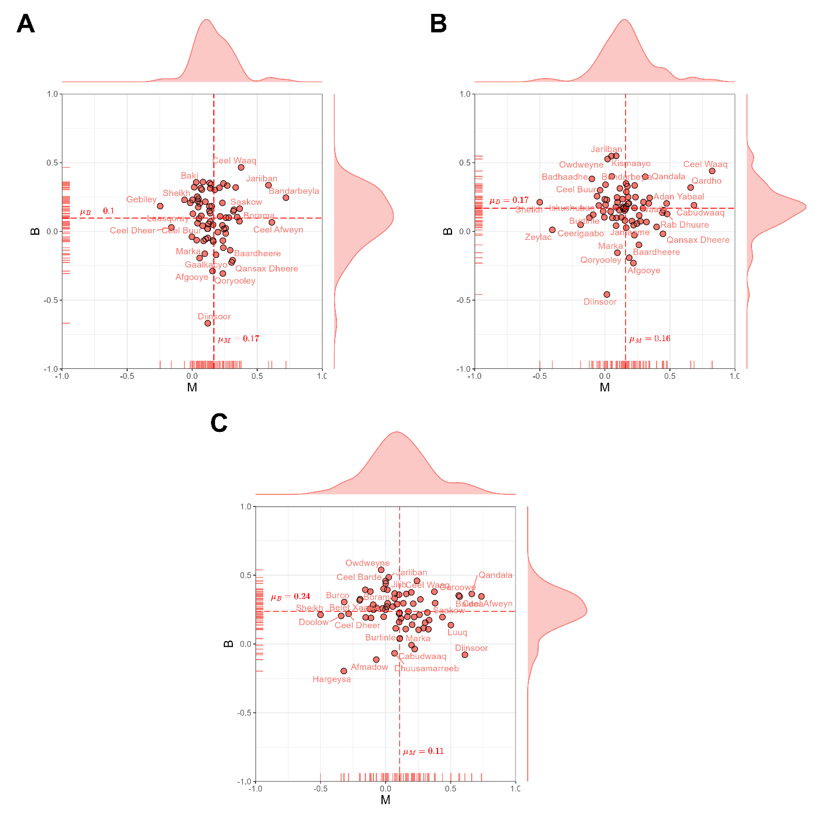
Supplementary Fig. 1: Burstiness-memory parameters in event time series of migration flows per district with different population size thresholds (h). Migration events with 25, 50, 75 percentiles of population size were removed in calculating burstiness and memory. Dashed lines indicate mean values of burstiness and memory.

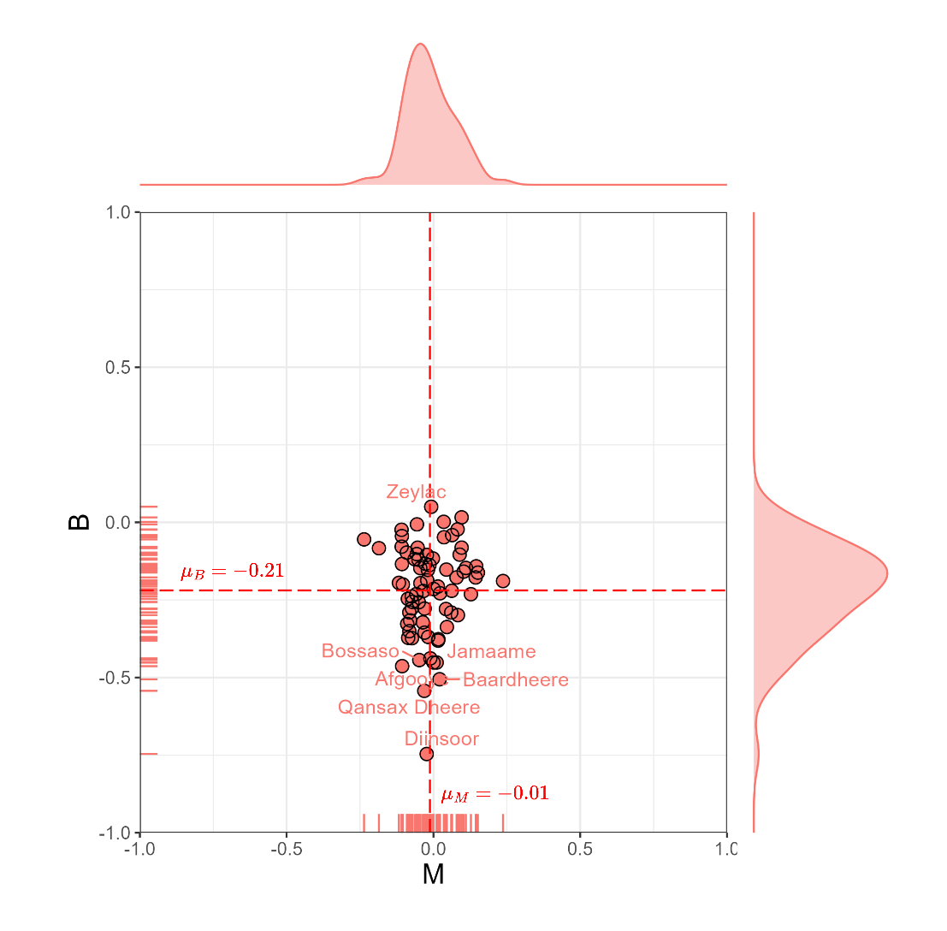
Supplementary Fig. 2: Burstiness-memory parameters in event time series of null model. Null model is developed by randomly shuffling migration timings with the same occurrence per district.
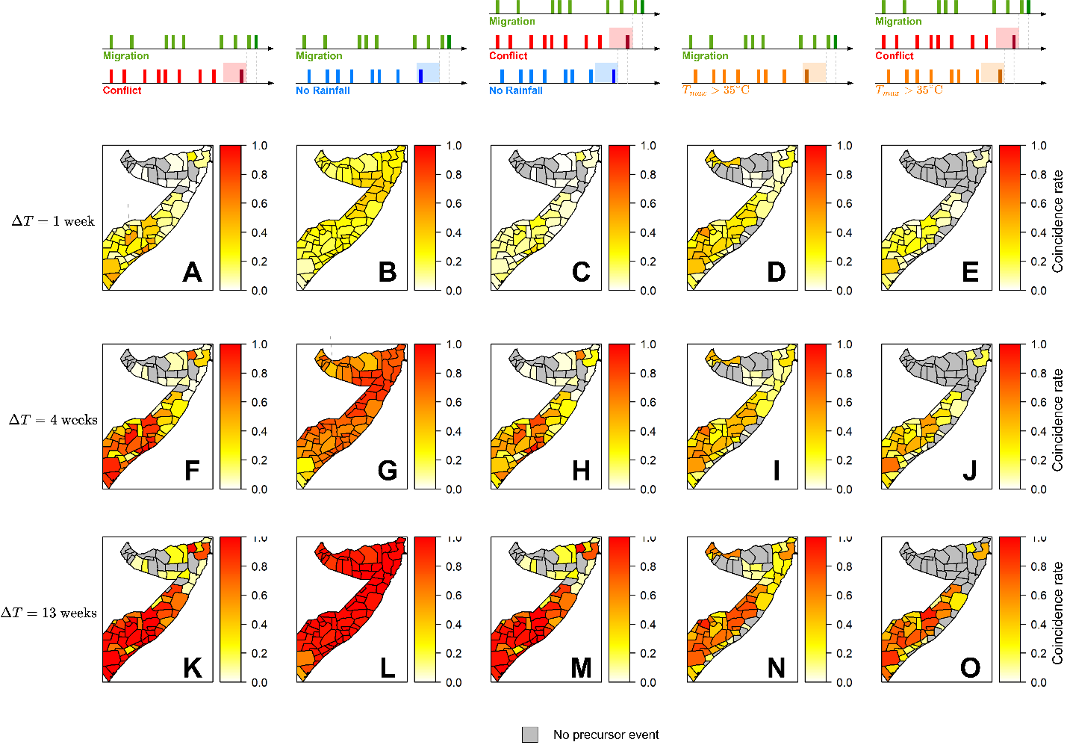
Supplementary Fig. 3: Expected coincidence rates (average of 100 realizations) of extreme weather, conflict, and migration events from a Poisson null hypothesis. Each row is results of different coincidence window $ΔT$ (1, 4, and 13 weeks), whereas each column presents coincidence of migration and external stressor events. Gray districts are those with no external stressor events as a precursor of migration events.

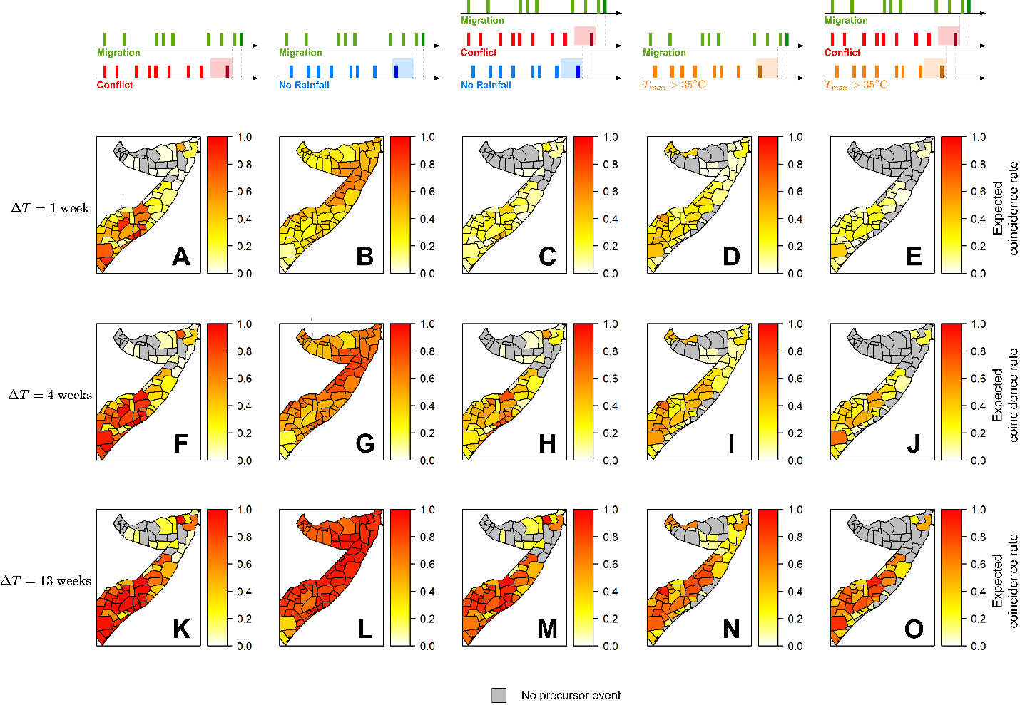
Supplementary Fig. 4: Expected coincidence rates (average of 100 realizations) of extreme weather, conflict, and migration events from a surrogate null hypothesis. Each row is results of different coincidence window $ΔT$ (1, 4, and 13 weeks), whereas each column presents coincidence of migration and external stressor events. Gray districts are those with no external stressor events as a precursor of migration events.

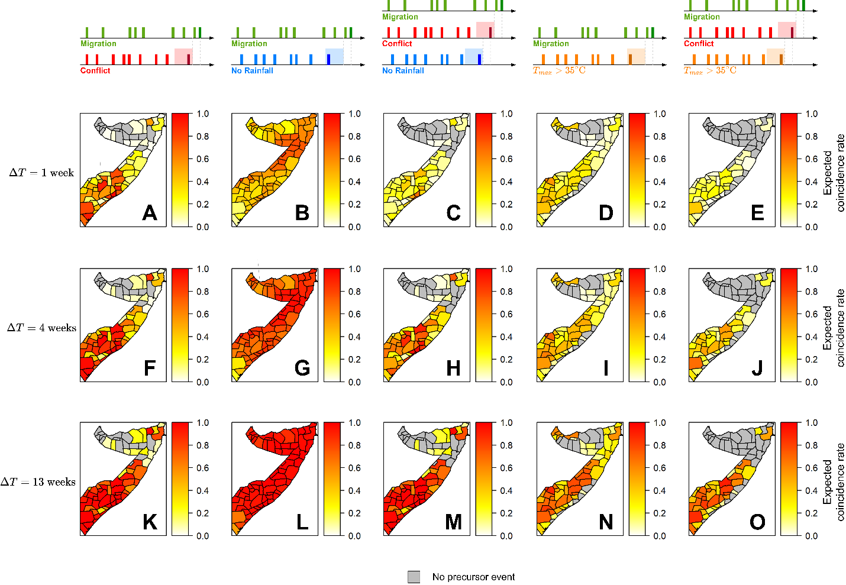
Supplementary Fig. 5: Expected coincidence rates (average of 100 realizations) of extreme weather, conflict, and migration events from a shuffling null hypothesis. Each row is results of different coincidence window $ΔT$ (1, 4, and 13 weeks), whereas each column presents coincidence of migration and external stressor events. Gray districts are those with no external stressor events as a precursor of migration events.

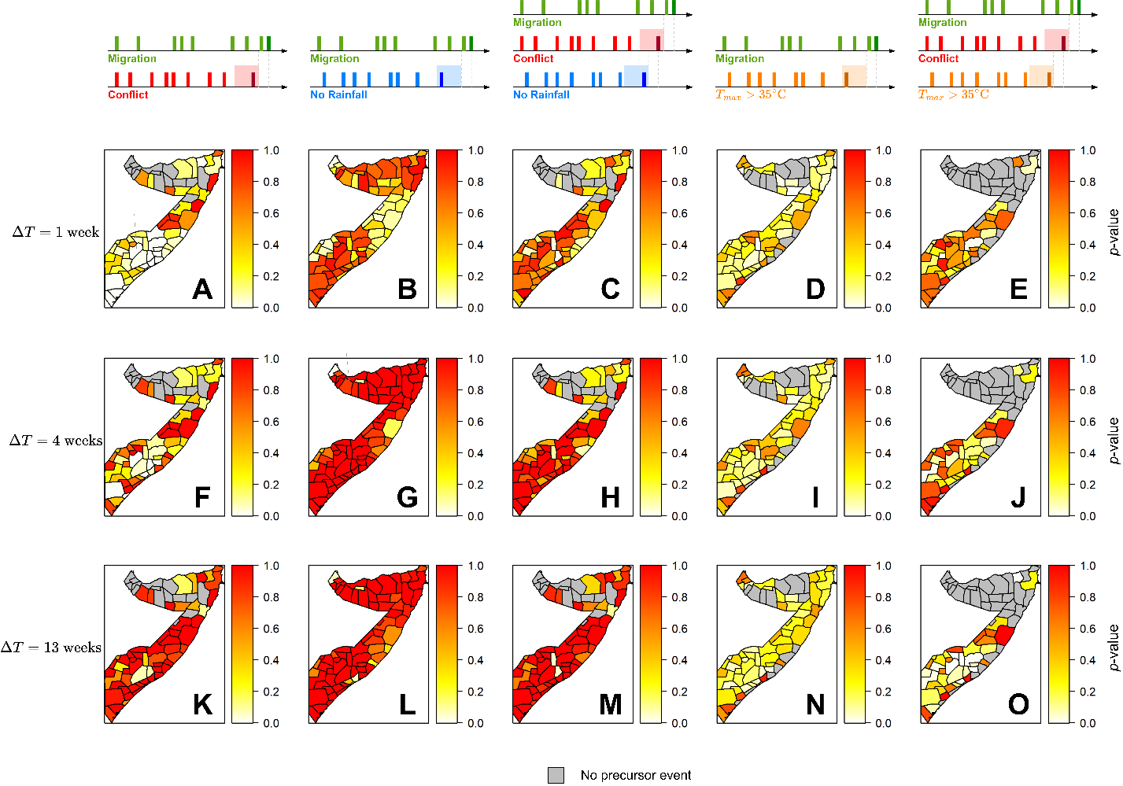
Supplementary Fig. 6: p-values of event coincidence analysis using a Poisson null hypothesis. Each row is results of different coincidence window $ΔT$ (1, 4, and 13 weeks), whereas each column presents coincidence of migration and external stressor events. Gray districts are those with no external stressor events as a precursor of migration events.

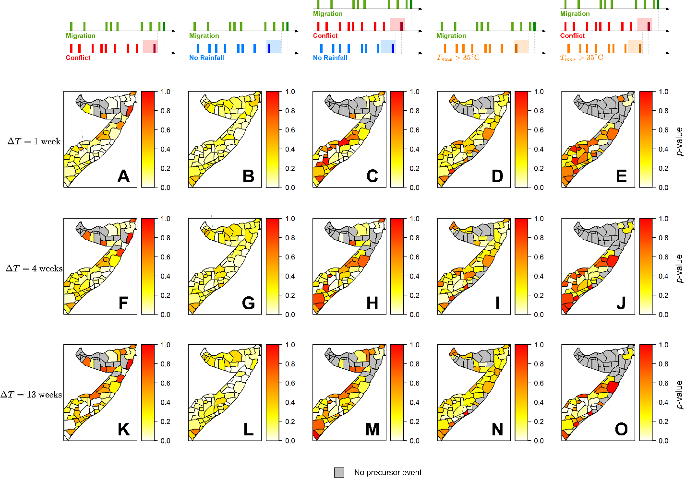
Supplementary Fig. 7: p-values of event coincidence analysis using a surrogate null hypothesis. Each row is results of different coincidence window $ΔT$ (1, 4, and 13 weeks), whereas each column presents coincidence of migration and external stressor events. Gray districts are those with no external stressor events as a precursor of migration events.

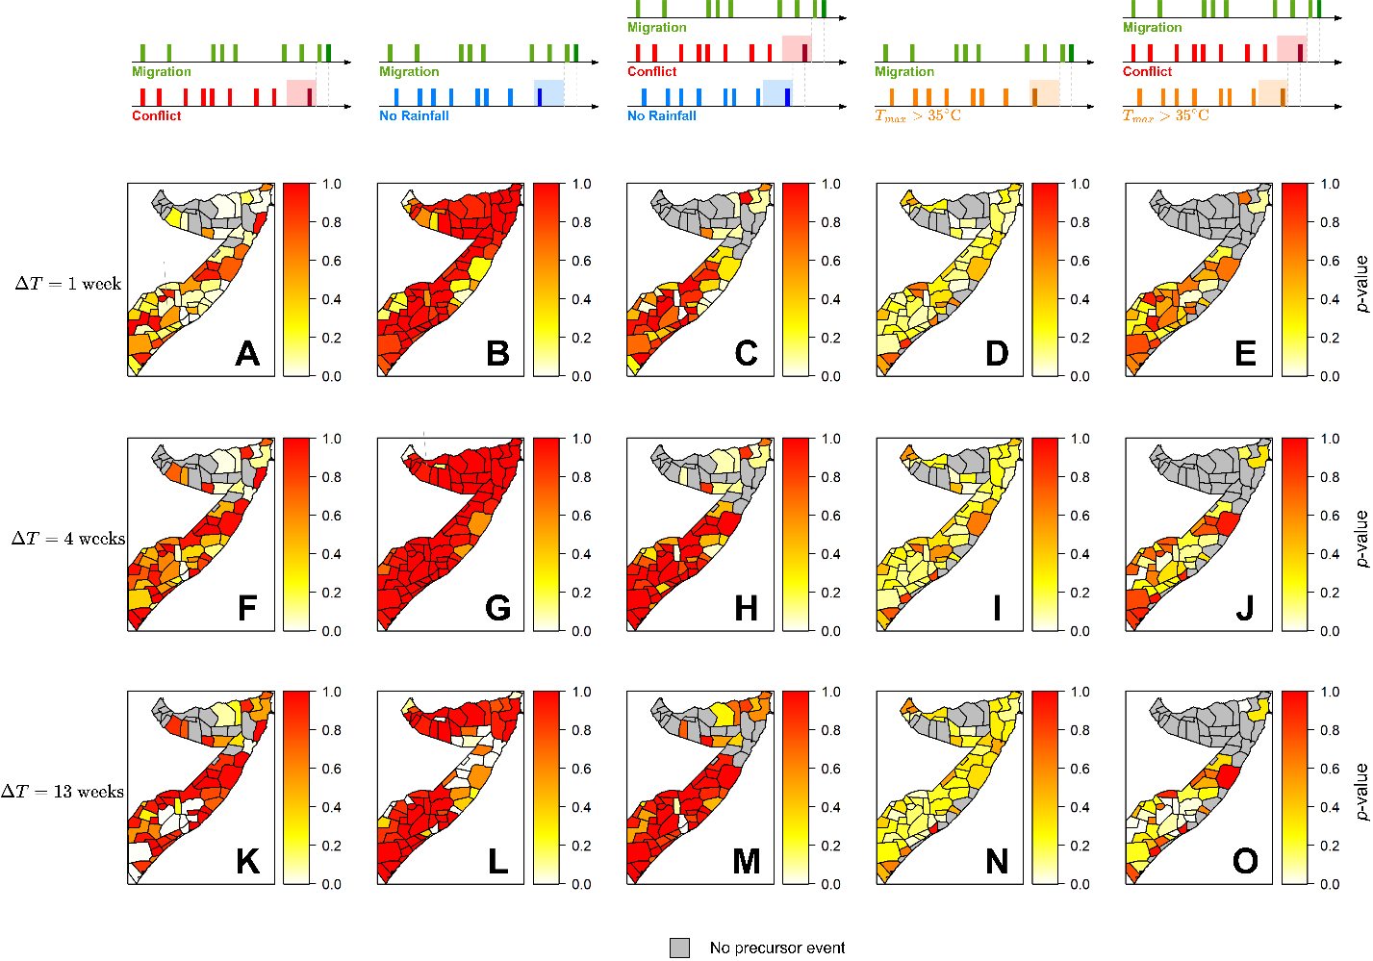
Supplementary Fig. 8: p-values of event coincidence analysis using a shuffling null hypothesis. Each row is results of different coincidence window $ΔT$ (1, 4, and 13 weeks), whereas each column presents coincidence of migration and external stressor events. Gray districts are those with no external stressor events as a precursor of migration events.

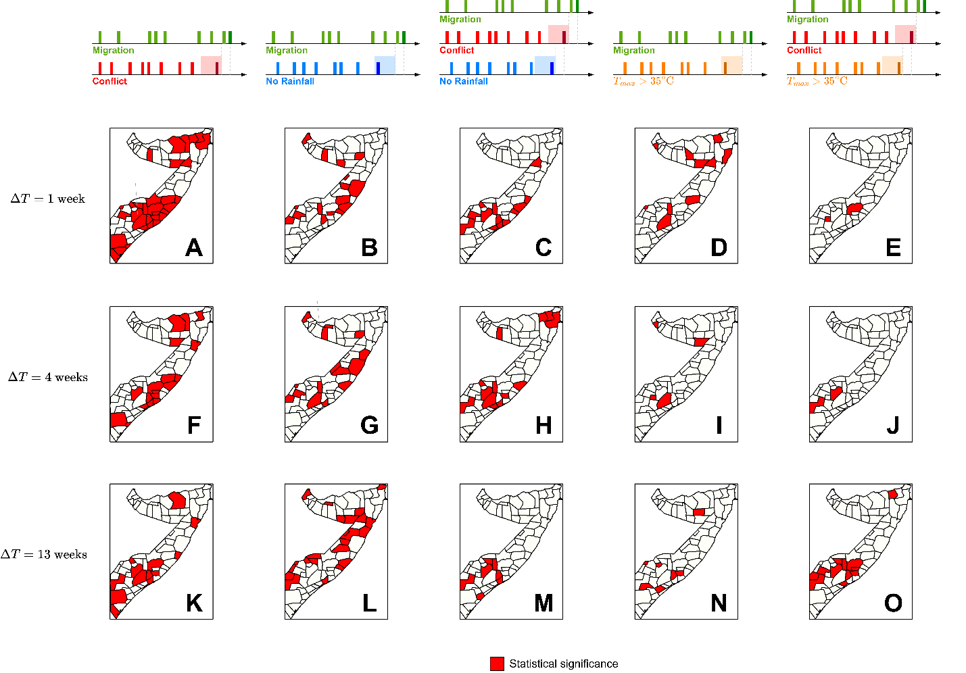
Supplementary Fig. 9: Statistical significance of event coincidence analysis. If event coincidence analysis in a district passes any of three null hypothesiss, the district is colored red. Each row is results of different coincidence window $ΔT$ (1, 4, and 13 weeks), whereas each column presents coincidence of migration and external stressor events.

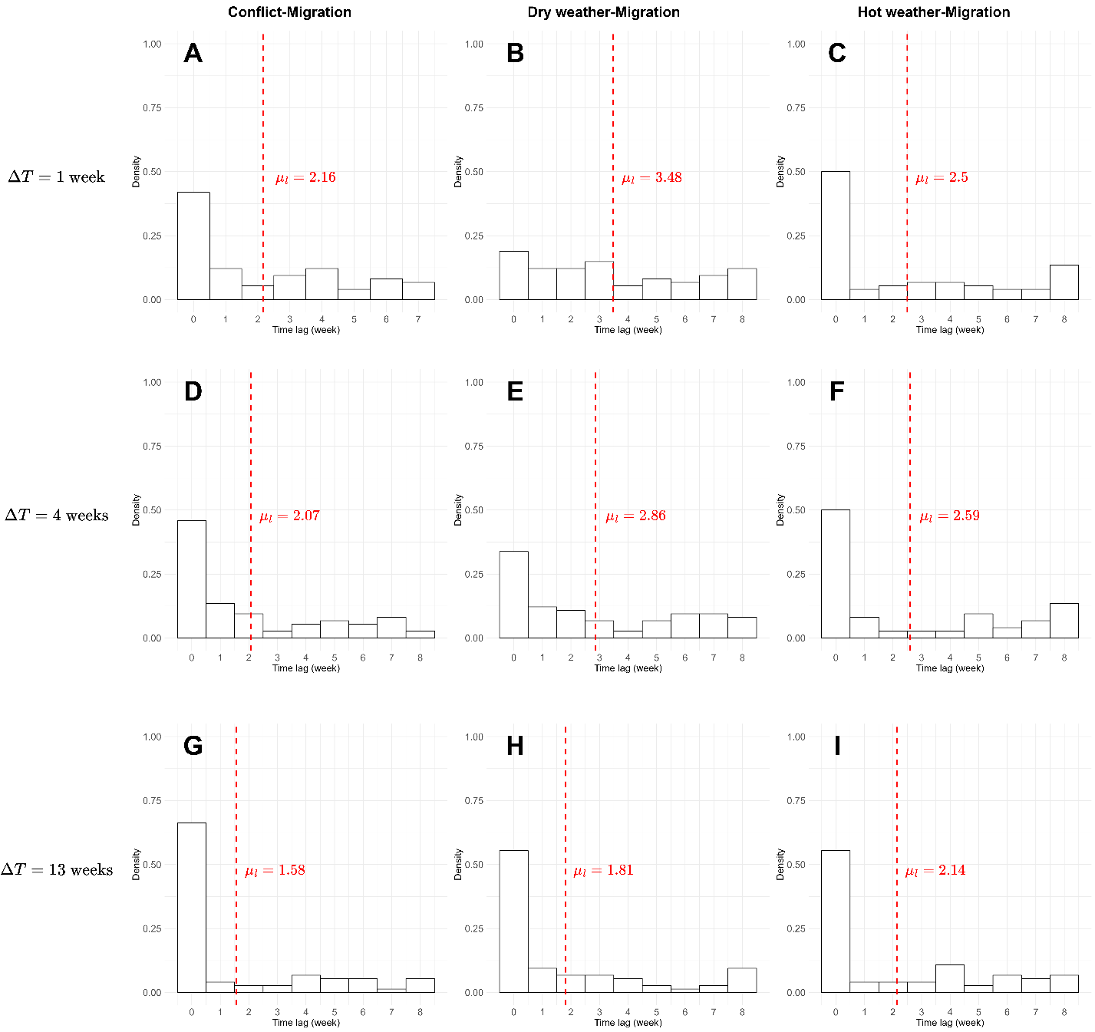
Supplementary Fig. 10: Time lag distributions for event coincidence analysis. Each row is results of different coincidence window $ΔT$ (1, 4, and 13 weeks), whereas columns represent conflict-migration (A, D, G), dry weather-migration (B, E, H), and hot weather-migration (C, F, I) coincidence.

Supplementary Table 1: A list of original and modified burstiness parameters and their differences.
District | $$B_{d}$$ | $$B_{d}^{M}$$ | $$B_{d}^{M}-B_{d}$$ |  |  | District | $$B_{d}$$ | $$B_{d}^{M}$$ | $$B_{d}^{M}-B_{d}$$
Adan Yabaal | 0.12 | 0.14 | 0.02 |  |  | Gaalkacyo | -0.38 | -0.39 | -0.01
Afgooye | -0.31 | -0.32 | -0.01 |  |  | Galdogob | 0.07 | 0.08 | 0.01
Afmadow | 0.07 | 0.08 | 0.01 |  |  | Garbahaarey | 0.15 | 0.17 | 0.02
Baardheere | -0.24 | -0.25 | -0.01 |  |  | Garoowe | -0.33 | -0.34 | -0.01
Badhaadhe | 0.11 | 0.13 | 0.02 |  |  | Gebiley | 0.38 | 0.51 | 0.13
Baidoa | -0.25 | -0.26 | -0.01 |  |  | Hargeysa | 0.30 | 0.34 | 0.04
Baki | 0.40 | 0.46 | 0.06 |  |  | Hobyo | 0.01 | 0.01 | 0.00
Balcad | 0.02 | 0.02 | 0.00 |  |  | Iskushuban | 0.04 | 0.05 | 0.01
Banadir | -0.34 | -0.35 | -0.01 |  |  | Jalalaqsi | -0.06 | -0.06 | 0.00
Bandarbeyla | -0.12 | -0.12 | 0.00 |  |  | Jamaame | -0.24 | -0.25 | -0.01
Baraawe | 0.09 | 0.10 | 0.01 |  |  | Jariiban | 0.17 | 0.20 | 0.03
Belet Weyne | -0.32 | -0.33 | -0.01 |  |  | Jilib | 0.01 | 0.01 | 0.00
Belet Xaawo | 0.07 | 0.08 | 0.01 |  |  | Jowhar | -0.24 | -0.25 | -0.01
Berbera | 0.13 | 0.14 | 0.02 |  |  | Kismaayo | 0.10 | 0.12 | 0.02
Borama | 0.16 | 0.18 | 0.02 |  |  | Kurtunwaarey | 0.01 | 0.01 | 0.00
Bossaso | -0.26 | -0.27 | -0.01 |  |  | Laas Caanood | -0.05 | -0.05 | 0.00
Buaale | -0.04 | -0.04 | 0.00 |  |  | Laasqoray | -0.04 | -0.04 | 0.00
Bulo Burto | -0.05 | -0.05 | 0.00 |  |  | Lughaye | 0.32 | 0.36 | 0.04
Burco | -0.03 | -0.03 | 0.00 |  |  | Luuq | 0.21 | 0.25 | 0.04
Burtinle | -0.07 | -0.08 | 0.00 |  |  | Marka | -0.21 | -0.22 | -0.01
Buuhoodle | 0.14 | 0.15 | 0.01 |  |  | Owdweyne | 0.06 | 0.07 | 0.01
Buur Hakaba | -0.08 | -0.08 | 0.00 |  |  | Qandala | 0.16 | 0.17 | 0.01
Cabudwaaq | 0.09 | 0.11 | 0.01 |  |  | Qansax Dheere | -0.41 | -0.42 | -0.01
Cadaado | 0.04 | 0.05 | 0.01 |  |  | Qardho | 0.21 | 0.23 | 0.02
Cadale | 0.11 | 0.13 | 0.02 |  |  | Qoryooley | -0.41 | -0.42 | -0.01
Caluula | 0.26 | 0.28 | 0.03 |  |  | Rab Dhuure | 0.05 | 0.06 | 0.01
Caynabo | 0.05 | 0.06 | 0.01 |  |  | Saakow | 0.08 | 0.08 | 0.01
Ceel Afweyn | -0.13 | -0.13 | -0.01 |  |  | Sablaale | 0.33 | 0.37 | 0.04
Ceel Barde | 0.22 | 0.25 | 0.03 |  |  | Sheikh | 0.14 | 0.18 | 0.04
Ceel Buur | 0.06 | 0.07 | 0.01 |  |  | Taleex | -0.15 | -0.16 | -0.01
Ceel Dheer | 0.04 | 0.06 | 0.01 |  |  | Tayeeglow | -0.06 | -0.06 | 0.00
Ceel Waaq | 0.28 | 0.32 | 0.04 |  |  | Waajid | -0.19 | -0.20 | -0.01
Ceerigaabo | -0.10 | -0.10 | 0.00 |  |  | Wanla Weyn | -0.16 | -0.17 | -0.01
Dhuusamarreeb | 0.14 | 0.17 | 0.02 |  |  | Xarardheere | 0.06 | 0.07 | 0.01
Diinsoor | -0.70 | -0.71 | -0.01 |  |  | Xudun | -0.02 | -0.02 | 0.00
Doolow | 0.19 | 0.24 | 0.05 |  |  | Xudur | -0.15 | -0.16 | -0.01
Eyl | -0.04 | -0.04 | 0.00 |  |  | Zeylac | 0.29 | 0.35 | 0.05

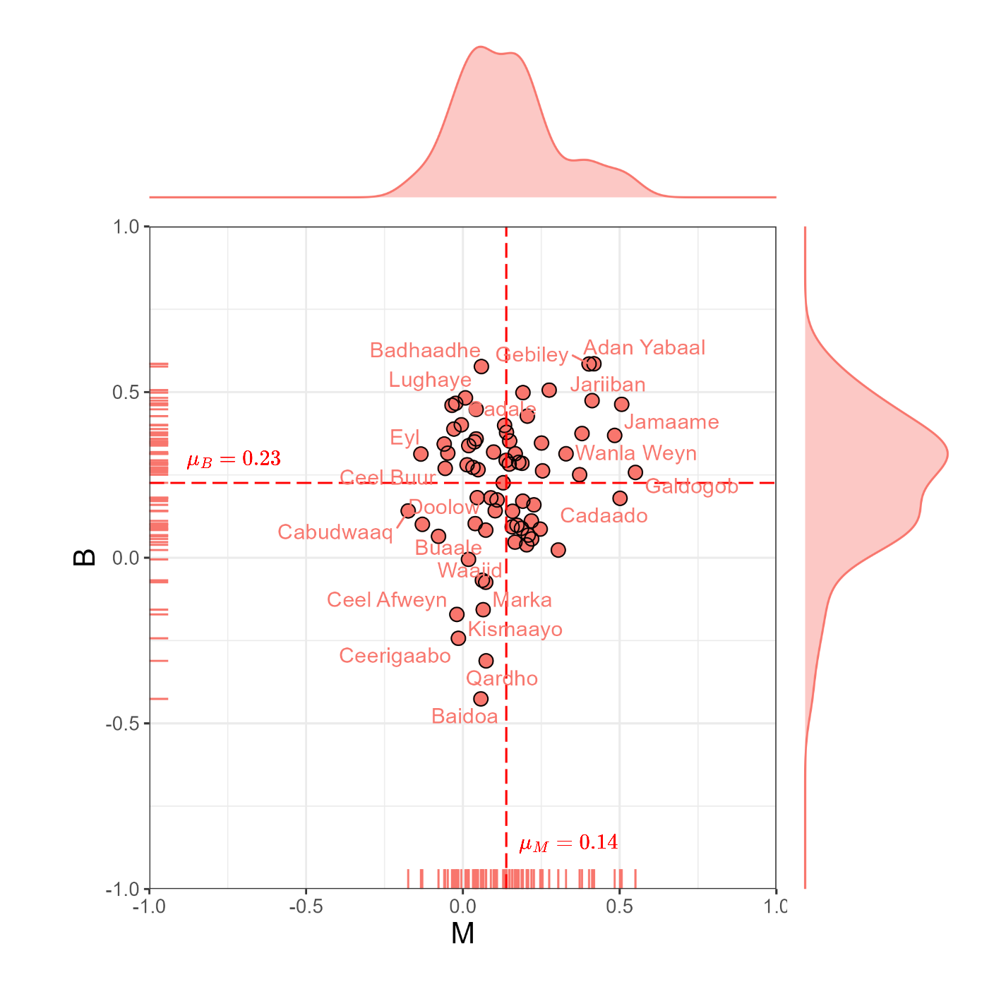
Supplementary Fig. 11: Burstiness and memory parameters in event time series of mobility flows per district in Somalia. Dashed lines indicate mean values of burstiness and memory.

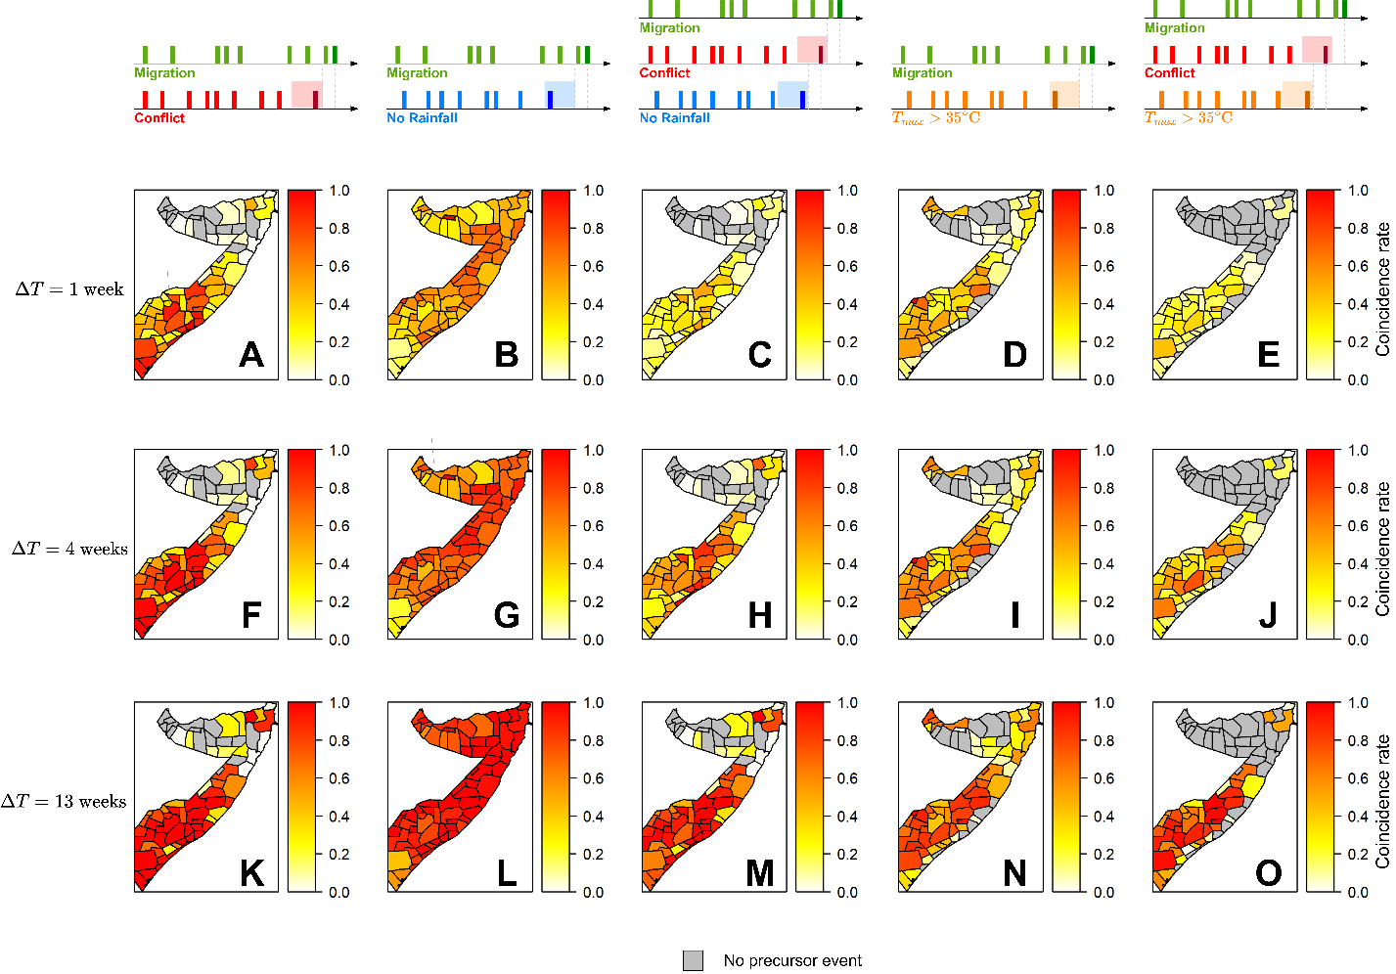
Supplementary Fig. 12: Coincidence rates of extreme weather, conflict, and mobility events. Each row is results of different coincidence window $ΔT$ (1, 4, and 13 weeks), whereas each column presents coincidence of mobility and external stressor events. Gray districts are those with no external stressor events as a precursor of mobility events.

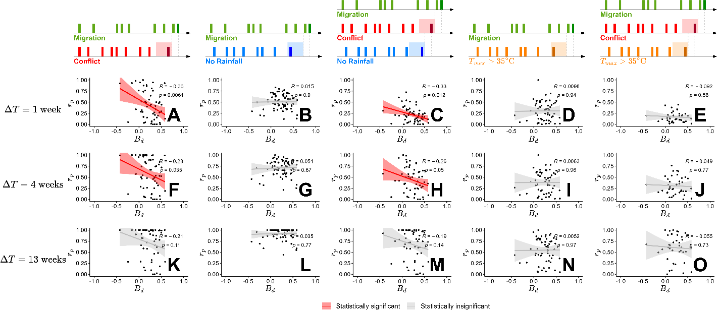
Supplementary Fig. 13: Correlation between burstiness and coincidence rates. Each row uses coincidence rates of different coincidence window $ΔT$ (1, 4, and 13 weeks), whereas each column uses coincidence rates of migration and different external stressor events. Each plot presents Pearson correlation coefficient R and its p-value. Red plots are cases when R is statistically significant ($p<0.05$), while gray plots are those when R is not statistically significant ($p≥0.05$).

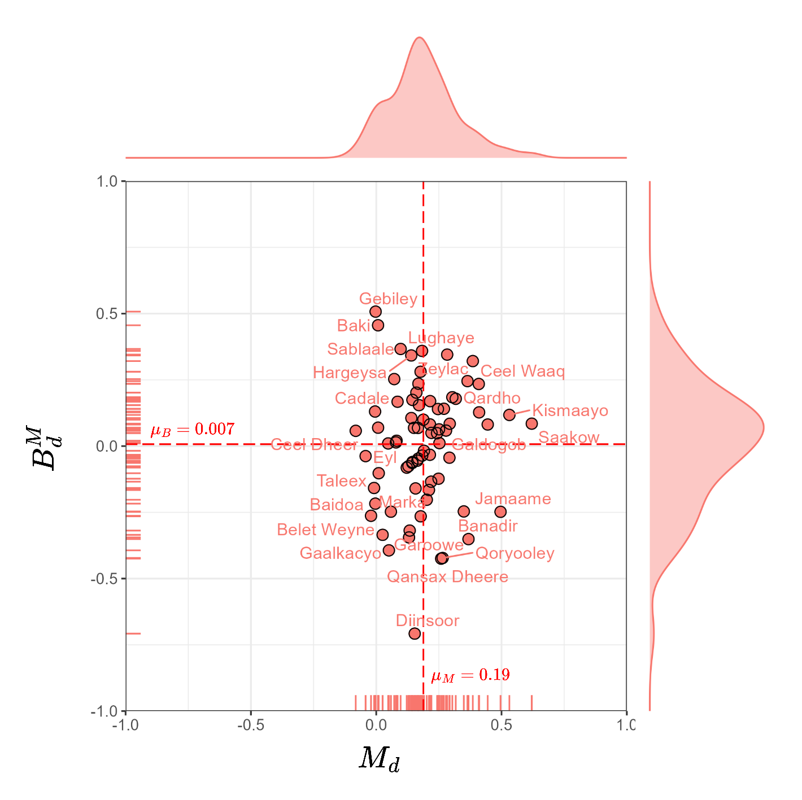
Supplementary Fig. 14: Modified burstiness and memory parameters in event time series of migration flows per district in Somalia. The burstiness parameter reflects the finite size of the events. Dashed lines indicate mean values of burstiness and memory.

