Supplementary information for:
Mesh-reinforced Vaseline-assisted graphene transfer compatible with industrial automation operations

Xiaomeng Guo^{1,2,3}, Fangzhu Qing^{1,2,3*}, Wei Liu⁴, Yaxin Liu³, Yiji Liang⁵, Runlai Li⁶, Pingjian Li^{1,2}, Changqing Shen¹, Xiaoming Tu¹, Chunlin Liu¹, Zhancheng Li⁷, Huaipeng Wang⁸, Yutong Ran⁹, Haofei Shi⁷, Dan Xie⁸, Hongwei Zhu⁹, Xiaobin Niu^{4*}, Zejia Zhao^{5*}, Xuesong Li^{1,2,3*}
Correspondence to: lxs@uestc.edu.cn; qingfz@uestc.edu.cn; zhaozejia@szu.edu.cn; xbniu@uestc.edu.cn

This supplementary information includes:
Supplementary Figure 1-8

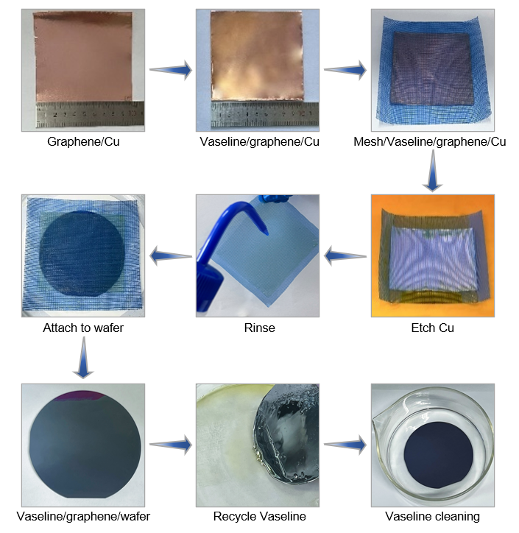
Supplementary Figure 1. Photographs of the key transfer steps.

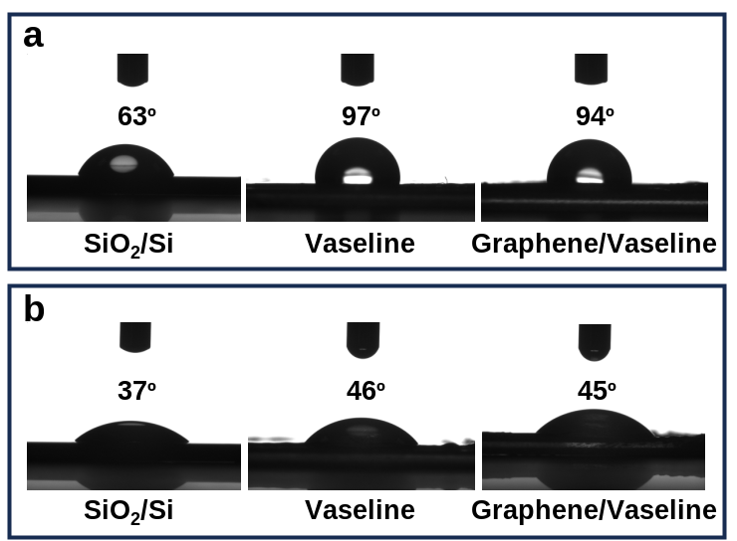
Supplementary Figure 2. Contact angle tests on SiO₂/Si, Vaseline and Graphene/Vaseline when using different solution. a, Water. b, Diluted ethanol.

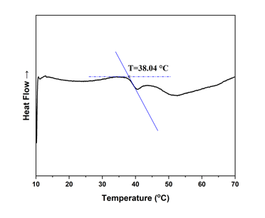
Supplementary Figure 3. Differential scanning calorimetry results of Vaseline.
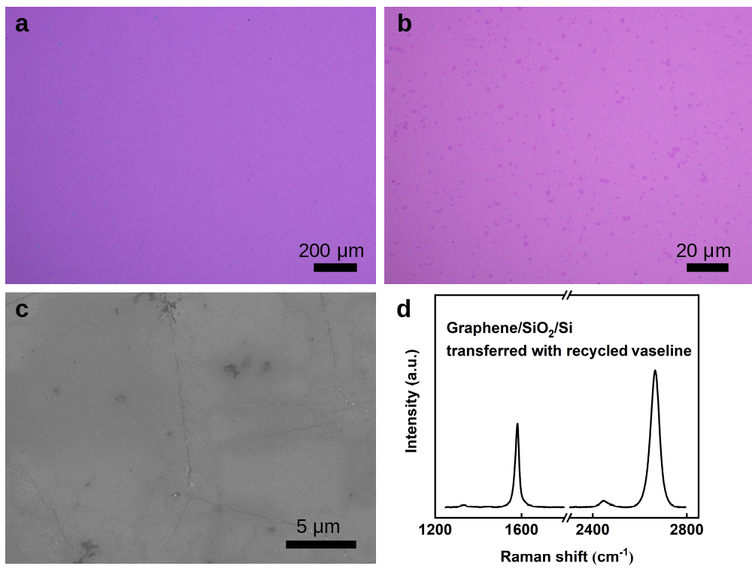
Supplementary Figure 4. Graphene transfer with recycled Vaseline. a-b, OM images of transferred graphene on a SiO₂/Si substrate. c, SEM image of transferred graphene. d, Raman spectrum of transferred graphene.

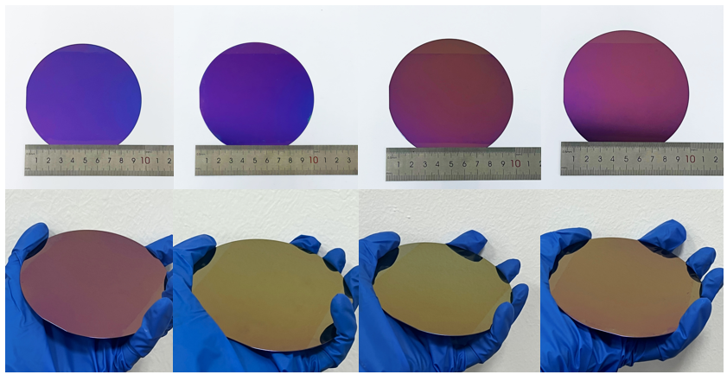
Supplementary Figure 5. Photographs of four 4-inch graphene wafers, indicating the reproducibility of graphene transfer.

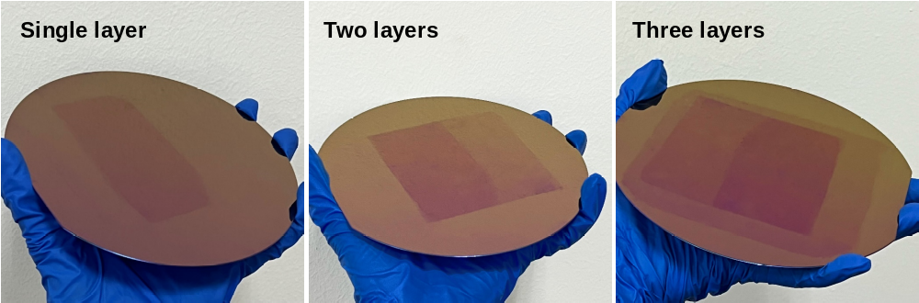
Supplementary Figure 6. Photographs of sequential transfer of three layers of graphene.

Supplementary Figure 7. Transfer characteristics of GrFETs with (a) Vaseline-transferred graphene and (b) PMMA-transferred graphene.
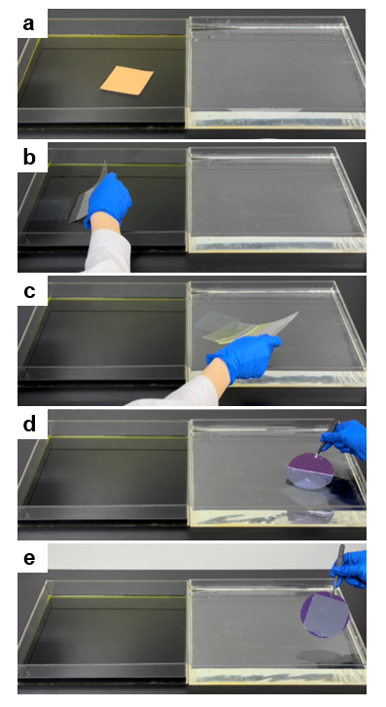
Supplementary Figure 8. Photographs of the key steps of PMMA-assisted graphene transfer. a, Etch Cu. b, Fish out the PMMA/graphene after Cu etching. c, Transfer PMMA/graphene to water surface. d-e, Fish out PMMA/graphene with the target substrate. Note: Ideally, robots can replace all manual operations even for the case of PMMA assisted transfer. However, as aforementioned, PMMA is too fragile to be processed. It has to float on liquid surface or lay on a substrate. This makes the process more complicated and not practical for robot. Instead, the mesh reinforced Vaseline layer is self-supporting and can be processed with simple mechanical systems.

