Supplemental Figure 1. Participants’ medication engagement diagram
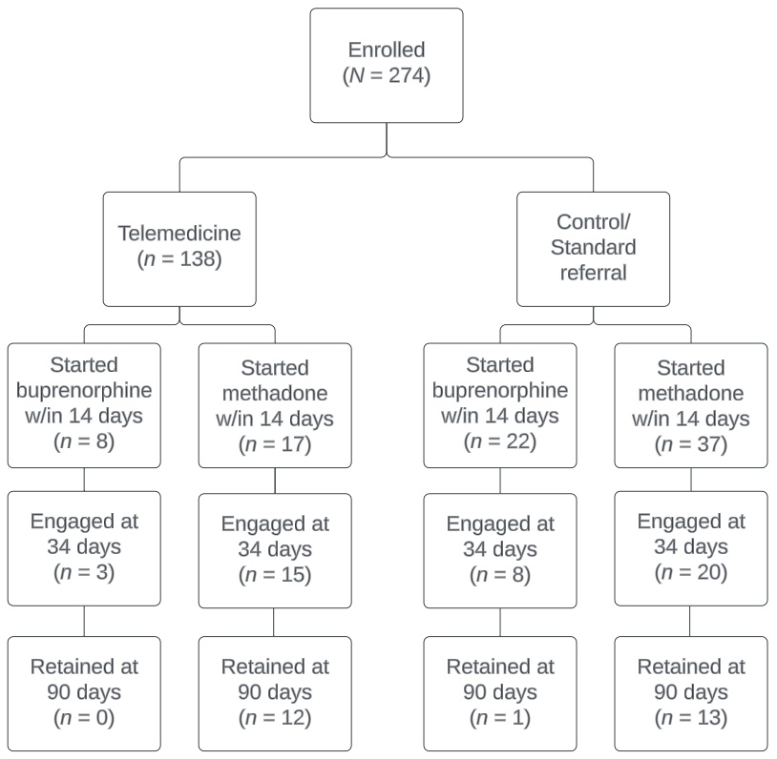
Note: Three participants, all in the telemedicine arm, selected naltrexone-based treatment but none started the medication.

