Supplemental materials
Psenicnik and Bennett Intraspecies variation in mycorrhizal response of Medicago sativa under abiotic stress

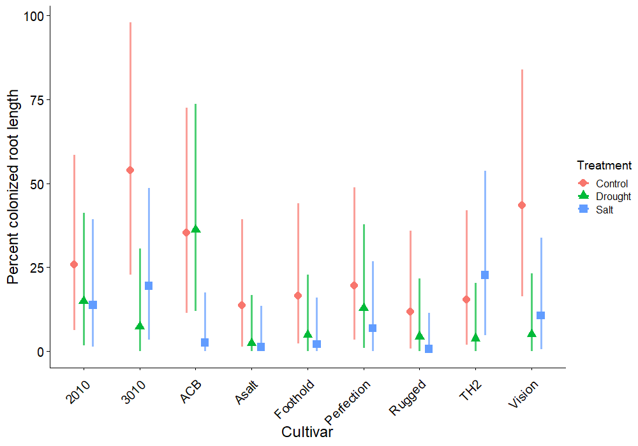
Figure S1. The mean percent colonization of each cultivar in each treatment group by AMF. Bars represent 95% confidence intervals.
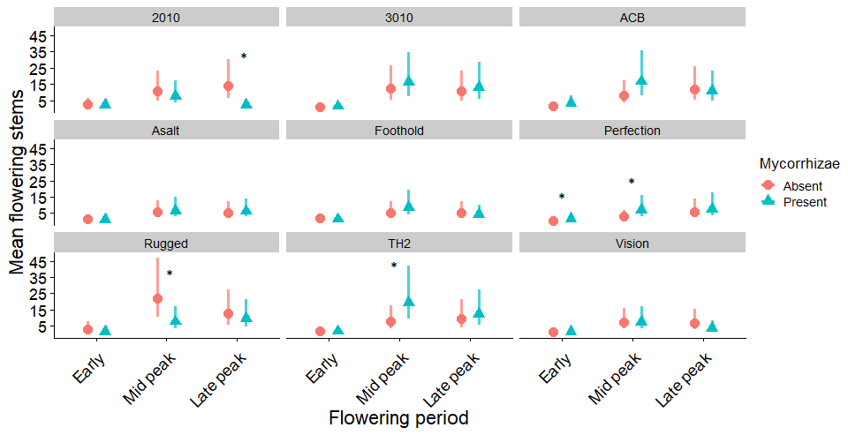
Figure S2. The mean number of flowering stems on unstressed alfalfa. Pink circles are the mean number of flowering stems on uninoculated alfalfa, blue triangles are the mean number on AMF inoculated alfalfa. Bars represent the 95% confidence intervals. Asterix mark the time periods where there were differences between inoculated and uninoculated plants with the following p values: 2010 p=0.002, Perfection early p=0.065, mid p=0.090, Rugged p=0.031, TH2 p=0.068.
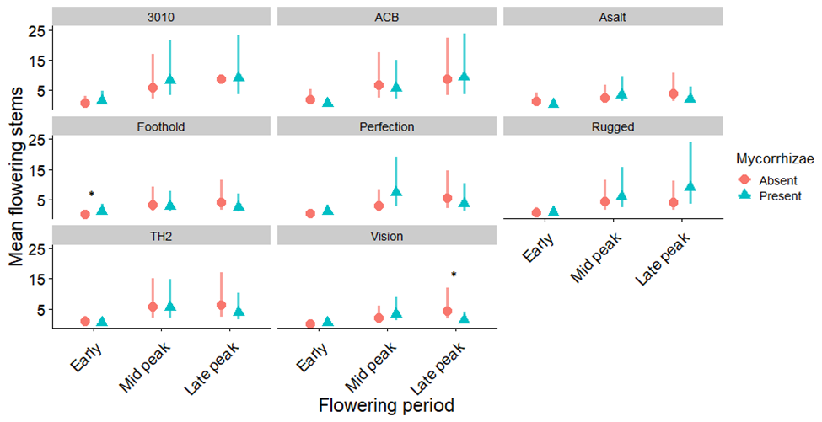
Figure S3. The mean number of flowering stems on drought stressed alfalfa. Pink circles represent the mean number of flowering stems on uninoculated alfalfa, whereas blue triangles represent the mean number on AMF inoculated alfalfa. Bars represent the 95% confidence intervals. Asterix mark the time periods where there were differences between inoculated and uninoculated plants with the following p values: Foothold p=0.065, Vision p=0.055.
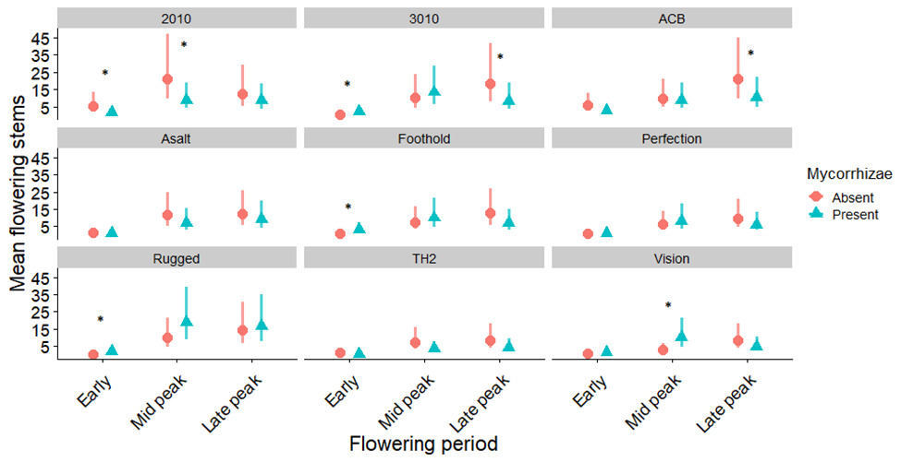
Figure S4. The mean number of flowering stems on salt stressed alfalfa. Pink circles represent the mean number of flowering stems on uninoculated alfalfa, whereas blue triangles represent the mean number on AMF inoculated alfalfa. Bars represent the 95% confidence intervals. Asterix mark the time periods where there were differences between inoculated and uninoculated plants with the following p values: 2010 early p=0.019, mid p=0.051, 3010 early p=0.032, late p=0.088, AC-Bridgeview p=0.092, Foothold p=0.070, Rugged p=0.041, Vision p=0.008.
Table S1. The alfalfa cultivars selected for this experiment with their attributes as listed on producer literature in 2020. Asterix indicate the cultivars selected for nutrient analysis.
Cultivar | Producer | Characteristics | Fall dormancy | Winter hardiness
2010 | BrettYoung | Branched roots  Suited to dry soil | 2 | 2
3010* | BrettYoung | Disease resistant  Deep crown | 2 | 2
AC-Bridgeview* | Agriculture and Agri-Food Canada | Salt tolerant  Deep crown | NA | NA
Assalt | DLF pickseed | Tolerant to high pH  High multifoliate expression  Disease resistant | 4 | 1.5
Foothold* | BrettYoung | Spreader root type  High leaf/stem ratio  High multifoliate expression  High yield | 2 | 1.7
Perfection | Northstar seed | Fast growth  High digestibility  High dry matter production | 4 | 2
Rugged* | Northstar seed | Deep set crown  Stress resistant  Salt tolerant | 3 | 2
TH2* | Northstar seed | High multifoliate expression  Disease resistant | 3 | 3
Vision* | DLF pickseed | High multifoliate expression  Tall  Fast regrowth | 4 | 1.5

Table S2. Statistical results of mixed models testing the interactive effects of AMF inoculation and cultivar identity on shoot biomass, root biomass, seed mass, leaf nitrogen, and leaf phosphorus. Degrees of freedom were estimated using Satterthwaite’s method.
Response | Factor | NumDF | DenDF | F | value
Shoot mass | AMF | 1 | 67.1 | 4.57 | 0.036
Shoot mass | Cultivar | 8 | 67.1 | 1.34 | 0.241
Shoot mass | AMF: Cultivar | 8 | 67.1 | 0.78 | 0.626
Root mass | AMF | 1 | 67.1 | 0.04 | 0.842
Root mass | Cultivar | 8 | 67.1 | 1.33 | 0.242
Root mass | AMF: Cultivar | 8 | 67.1 | 1.04 | 0.416
Seed mass | AMF | 1 | 16.0 | 0.61 | 0.447
Seed mass | Cultivar | 6 | 16.0 | 0.46 | 0.828
Seed mass | AMF: Cultivar | 6 | 16.0 | 0.87 | 0.540
Leaf N | AMF | 1 | 43.0 | 8.90 | 0.005
Leaf N | Cultivar | 5 | 43.0 | 2.28 | 0.063
Leaf N | AMF: Cultivar | 5 | 43.0 | 0.86 | 0.518
Leaf P | AMF | 1 | 47.0 | 3.26 | 0.077
Leaf P | Cultivar | 5 | 47.0 | 0.82 | 0.541
Leaf P | AMF: Cultivar | 5 | 47.0 | 0.51 | 0.769

Table S3. Summary of the ANOVA results for testing the effects of stress treatments and AMF inoculation treatments on alfalfa cultivar’s biomass stress response. Results separated by a double line are from separate models.
 | Treatment | Model terms | DF | F | p
Shoot | Drought | AMF | 1 | 5.363 | 0.023
 |  | Cultivar | 8 | 0.914 | 0.511
 |  | AMF: Cultivar | 8 | 0.863 | 0.552
 | Salt | AMF | 1 | 1.396 | 0.242
 |  | Cultivar | 8 | 1.543 | 0.160
 |  | AMF:Cultivar | 8 | 2.184 | 0.040
Root | Drought | AMF | 1 | 0.919 | 0.341
 |  | Cultivar | 8 | 0.932 | 0.496
 |  | AMF:Cultivar | 8 | 1.487 | 0.178
 | Salt | AMF | 1 | 0.265 | 0.609
 |  | Cultivar | 8 | 1.048 | 0.410
 |  | AMF:Cultivar | 8 | 0.854 | 0.559

Table S4. ANOVA summary table of models of the stress response in nitrogen and phosphorus concentrations. Results separated by a double line are from separate models.
Nutrient | Treatment | Model terms | DF | F | p
Nitrogen | Drought | AMF | 1 | 6.828 | 0.012
 |  | Cultivar | 5 | 0.597 | 0.703
 |  | AMF:Cultivar | 5 | 0.455 | 0.808
 | Salt | AMF | 1 | 3.799 | 0.058
 |  | Cultivar | 5 | 0.324 | 0.896
 |  | AMF:Cultivar | 5 | 0.612 | 0.692
Phosphorus | Drought | AMF | 1 | 5.493 | 0.024
 |  | Cultivar | 5 | 0.168 | 0.973
 |  | AMF:Cultivar | 5 | 0.289 | 0.916
 | Salt | AMF | 1 | 7.962 | 0.007
 |  | Cultivar | 5 | 0.151 | 0.979
 |  | AMF:Cultivar | 5 | 0.424 | 0.829

Table S5. Summary of the ANOVA results for testing the effect of AMF and cultivar on mean height of alfalfa at 40 days after planting. Results separated by a double line are from separate models.
Treatment | Model terms | DF | F | p
Unstressed | AMF | 1 | 4.631 | 0.035
 | Cultivar | 8 | 1.255 | 0.281
 | AMF:Cultivar | 8 | 0.506 | 0.848
Drought | AMF | 1 | 10.525 | 0.002
 | Cultivar | 8 | 0.703 | 0.688
 | AMF:Cultivar | 8 | 1.342 | 0.238
Salt | AMF | 1 | 1.4E⁻⁵ | 0.997
 | Cultivar | 8 | 1.652 | 0.127
 | AMF:Cultivar | 8 | 1.931 | 0.069

Table S6. Summary of ANOVA tables for models of the change in alfalfa height over the first five weeks of treatments. Results separated by a double line are from separate models.
Treatment | Model terms | DF | F | p
Unstressed | AMF | 1 | 6.011 | 0.016
 | Cultivar | 8 | 0.992 | 0.447
 | Week | 1 | 952.099 | < 2.2E⁻¹⁶
 | AMF:Cultivar | 8 | 0.654 | 0.731
 | AMF:Week | 1 | 21.003 | 6.50E⁻⁶
 | Cultivar:Week | 8 | 3.700 | 3.71E⁻⁴
 | AMF:Cultivar:Week | 8 | 3.196 | 0.002
Drought | AMF | 1 | 12.700 | 0.001
 | Cultivar | 8 | 1.397 | 0.202
 | Week | 1 | 732.468 | < 2.2E⁻¹⁶
 | AMF:Cultivar | 8 | 1.622 | 0.123
 | AMF:Week | 1 | 4.692 | 0.031
 | Cultivar:Week | 8 | 3.367 | 0.001
 | AMF:Cultivar:Week | 8 | 1.728 | 0.091
Salt | AMF | 1 | 0.063 | 0.803
 | Cultivar | 8 | 1.675 | 0.108
 | Week | 1 | 762.371 | < 2.2E⁻¹⁶
 | AMF:Cultivar | 8 | 1.289 | 0.253
 | AMF:Week | 1 | 0.150 | 0.699
 | Cultivar:Week | 8 | 3.148 | 0.002
 | AMF:Cultivar:Week | 8 | 1.368 | 0.210

Table S7. The sodium concentration in the leaf tissue of six alfalfa cultivars subjected to salt stress.
Cultivar | Mycorrhiza | Na (mg/g)
3010 | Absent | 9.16±5.1
 | Present | 16.46±7.8
ACB | Absent | 16.31±7.7
 | Present | 13.09±6.2
Foothold | Absent | 16.4±7.7
 | Present | 21.57±10.1
Rugged | Absent | 11.11±5.3
 | Present | 10.8±5.1
TH2 | Absent | 18.14±9.9
 | Present | 16.43±7.8
Vision | Absent | 17.57±8.3
 | Present | 10.82±5.1

Table S8. Summary of ANOVA table for models testing the affect of stress treatment and AMF on the mean mass of seeds produced by alfalfa. Results separated by a double line are from separate models.
Treatment | Model terms | DF | F | p
Unstressed | AMF | 1 | 1.270 | 0.268
 | Cultivar | 7 | 0.861 | 0.547
 | AMF:Cultivar | 7 | 0.258 | 0.966
Drought | AMF | 1 | 2.202 | 0.152
 | Cultivar | 7 | 1.490 | 0.222
 | AMF:Cultivar | 7 | 3.622 | 0.010
Salt | AMF | 1 | 2.494 | 0.123
 | Cultivar | 8 | 0.329 | 0.949
 | AMF:Cultivar | 8 | 0.809 | 0.600

