Supplementary material
Supplementary figures
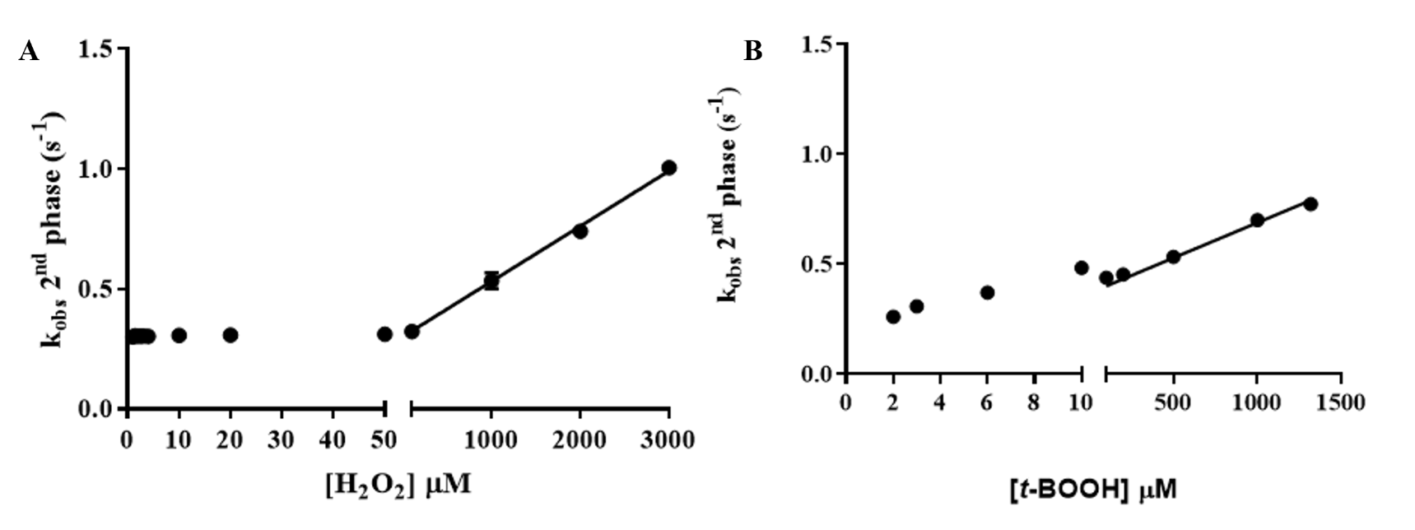
Fig. S1: Analysis of the second phase of the fluorescence change of reduced LsfA (1 µM) during its oxidation by increasing concentrations of (A) H₂O₂ and (B) t-BOOH. The second phase is illustrated in Figure 1D (for H₂O₂) and Figure 1H (for t-BOOH). To quantify these kinetics, we fitted the curves of the second phase with first-order exponentials to determine the k_{obs}.
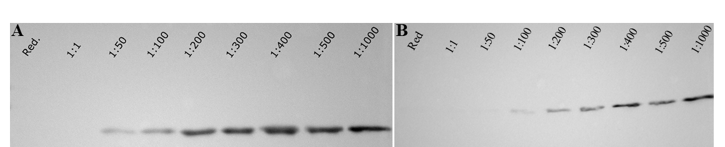
Fig. S2: Validation of LsfA hyperoxidation by western blotting. Hyperoxidation of reduced LsfA (1 µM) by increasing concentrations of H₂O₂ (A) or t-BOOH (B). The stoichiometric relationship between LsfA and peroxide concentrations is indicated above the blot. “Red.” means reduced state, i.e. LsfA was not treated with peroxides. Western blotting was conducted using an anti-HsPrx6-SO₃ antibody (AbFrontier LF-0005), diluted at a ratio of 1:2000 in TBS-T. Each experiment was repeated at least twice.

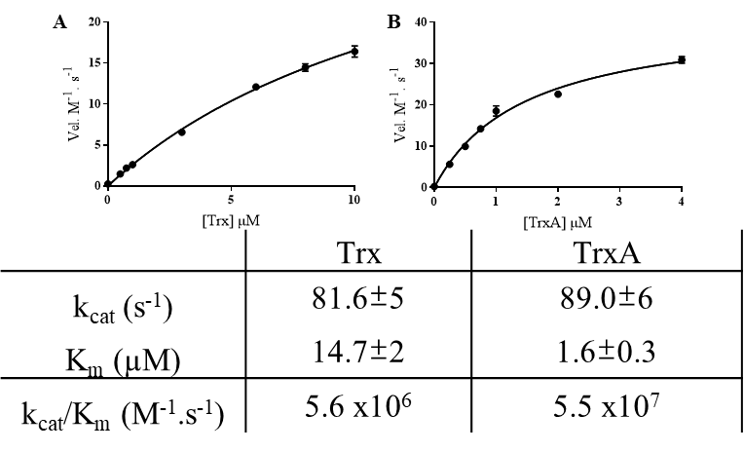
Fig. S3: Reconstitution of thioredoxin (Trx) systems from P. aeruginosa. Activities of Trx systems were assessed by their capacity to reduce DTNB (5,5′-Dithiobis(2-nitrobenzoic acid)), an artificial disulfide and reactions were monitored by the formation of the TNB (2-nitro-5-thiobenzoate)at 412 nm. The Trx systems investigated here were composed of thioredoxin reductase (PaTRRB2 = PA14_53290) plus PaTrx (A, PA14_11340) or plus PaTrxA (B, PA14_69200), in a coupled assay consisting of NADPH (250 µM), PaTRRB2 (0.38 µM), DTNB (250 µM) and different concentrations of PaTrx or PaTrxA. Each concentration is a means of a triplicate. The table below summarizes the results obtained by fitting the data with the Michaelis-Menten equation by GraphPad6.

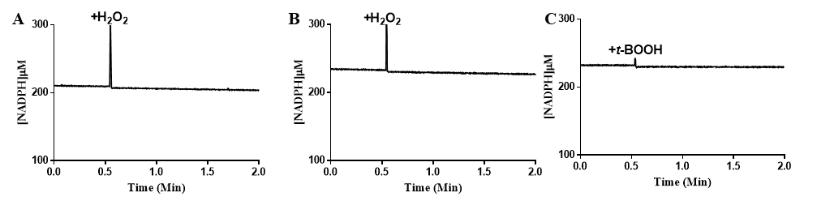
Fig. S4: Trx and Grx systems inability to support LsfA peroxidase activity. (A, B) Trx system coupled assay consisting of PaTRRB2 0.5 µM and, PaTrx (PA14_11340) 1 µM (A) or PaTrxA (PA14_69200) 1 µM (B), LsfA 5 µM and NADPH 250 µM, with the addition of 100 µM of H₂O₂ to start the reaction. (C) Grx coupled assay consisting of yeast glutathione reductase (Sigma, G3664) 1 U/mL, GSH 1 mM, monothiolic PaGrx (PA14_18650), 5 µM, LsfA 5 µM, and NADPH 250 µM, with the addition of 100 µM of t-BOOH to start the reaction. Assays were followed by 340 nm absorbance. All experiments were conducted in duplicate.

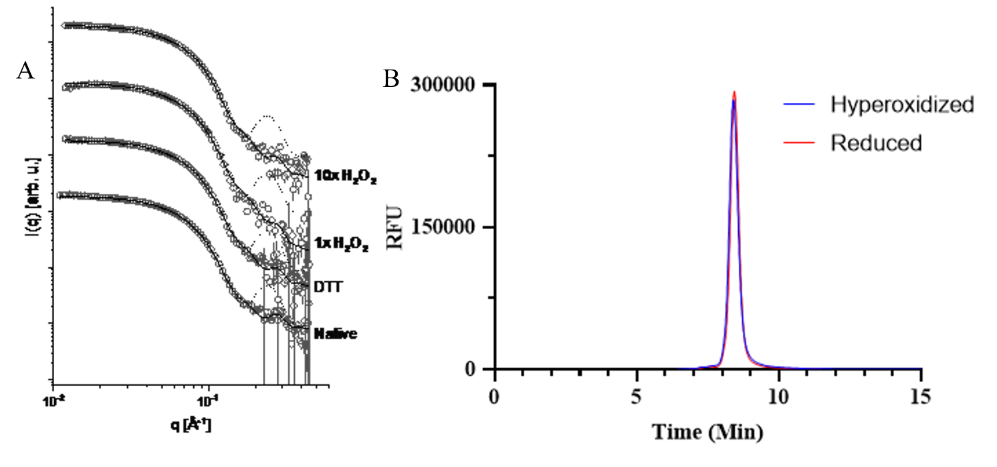
Fig. S5: LsfA is a dimer regardless of its oxidative state. A) Modeling of SAXS data using atomic resolution structures. Symbols represent experimental data, while the dotted lines indicate modeling using a monomer structure and the continuous line represents modeling using a dimer structure. The fitting using a template of dimers provided the best results. The curves were shifted for clarity. Similar results were obtained when LsfA (268 µM) was untreated, treated with 20x DTT (5.3 mM), oxidized (268 µM H₂O₂), or treated with a 10-fold excess of (2.68 mM) H₂O₂. B) Size exclusion chromatography (SEC) of LsfA. After the treatment with 20x DTT (3.1 mM) or 100x H₂O₂ (15.5 mM), 4.2 mg/mL of LsfA was analyzed by SEC, revealing the same retention time under both conditions. Data expressed in relative fluorescence units (RFU).
Figure S6 – Iterative Fourier Transform (IFT) fitting for the experimental data. (A) Experimental data (symbols) and IFT model fits (Solid lines). (B) Depicts the corresponding p(r) functions obtained from the fitting process.

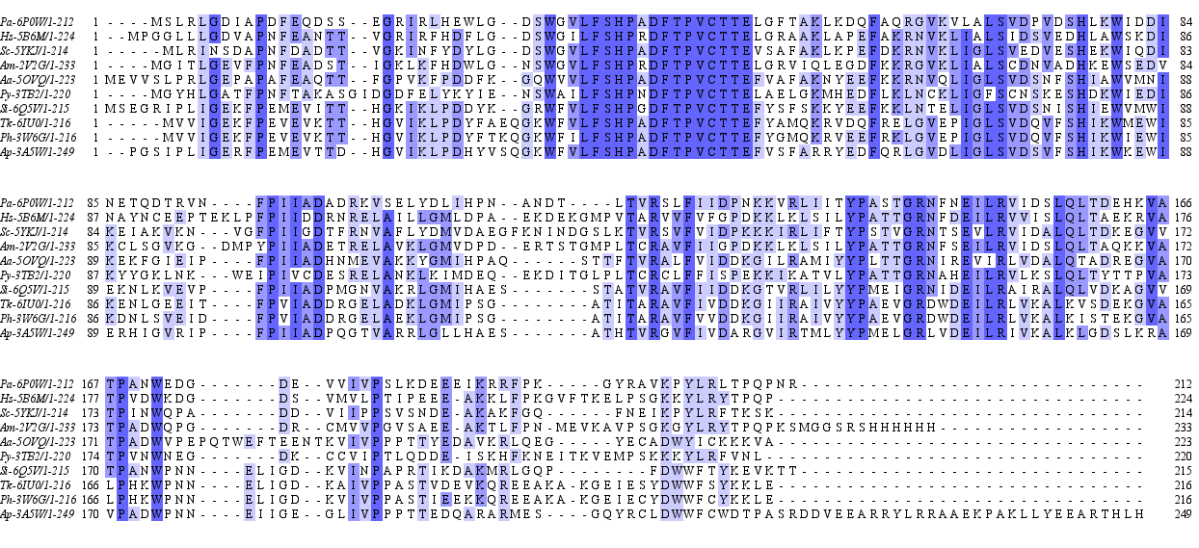
Fig. S7: Amino acid conservation among Prx6 proteins with crystal structures. Multiple sequence alignment of Prx6 proteins, where the degree of amino acid conservation is denoted by the intensity of blue color. The PDB codes are as follow: P. aeruginosa LsfA (7KUU and 6P0W), Homo sapiens Prdx6 (5B6M and 5B6N), Saccharomyces cerevisiae Prx1 (5YKJ), Arenicola marina Prx6 (2V2G), Aquifex aeolicus AhpC2 (5OVQ), Plasmodium yoelli 1-Cys (3TB2), Sulfolobus islandicus 1-Cys Prx (6Q5V), Thermococcus kodakaraensis Prx (6IU0), Aeropyrum pernix K1 Prx (2E2M and 3A5W) and Pyrococcus horikoshii Prx (3W6G). Alignment performed using Clustal Omega web service (https://www.ebi.ac.uk/Tools/msa/clustalo/) (SIEVERS et al., 2014), and the software Jalview (University of Dundee, Scotland, UK) (WATERHOUSE et al., 2009) was used for visualization.

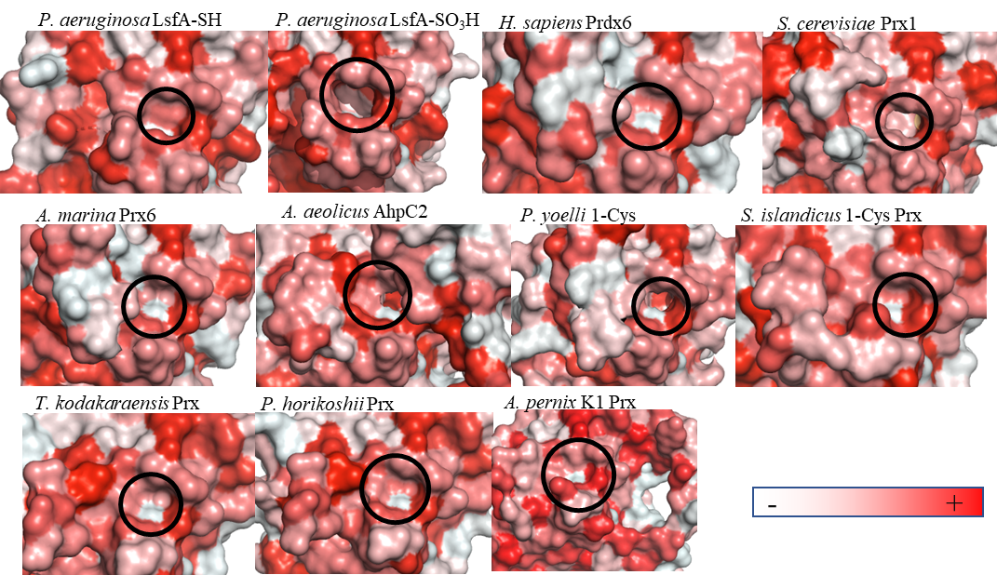
Figure S8: Hydrophobic surfaces nearby the active site of Prx6 proteins. Red scale of color represents the hydrophobicity around the active site. The black circles indicate the active site pockets. The PDB codes are as follow: P. aeruginosa LsfA (7KUU and 6P0W), Homo sapiens Prdx6 (5B6M and 5B6N), Saccharomyces cerevisiae Prx1 (5YKJ), Arenicola marina Prx6 (2V2G), Aquifex aeolicus AhpC2 (5OVQ), Plasmodium yoelli 1-Cys (3TB2), Sulfolobus islandicus 1-Cys Prx (6Q5V), Thermococcus kodakaraensis Prx (6IU0), Aeropyrum pernix K1 Prx (2E2M and 3A5W) and Pyrococcus horikoshii Prx (3W6G).

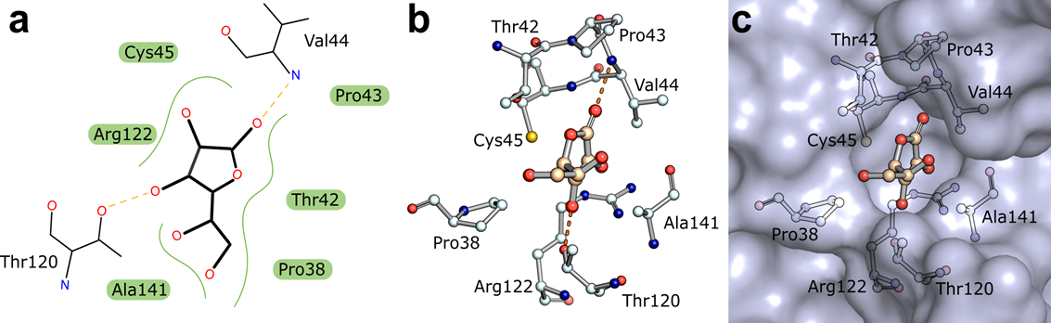
Fig. S9: Ascorbate and LsfA molecular interactions. A) Representation of LsfA residues interacting with ascorbate through hydrogen bonds (dashed red lines) and hydrophobic interactions (green lines). B) Representative computer simulation (using AutoDockVina), showing that ascorbate docked into the LsfA (6P0W) active site cavity showing B) amino acids interactions with ascorbate and C) the same showing the protein surface. Images were generated using PyMOL software.

Fig. S10: P. aeruginosa growth on ascorbate as the sole carbon source. PA14 Wild-type cultures in M9 media with different concentrations of ascorbate, incubated for 24 hours at 37°C under agitation and monitored via optical density at 600 nm. Each concentration was assessed in triplicate from two independent experiments.

Fig. S11: P. aeruginosa growth is not affected by ascorbate up to 10 mM. PA14 Wild-Type in M9 media supplemented with glucose (0.4%) and varying concentrations of ascorbate, incubated for 24 hours at 37°C with agitation, and growth monitored via optical density at 600 nm. Growth at each ascorbate concentration was assessed in triplicate in two independent experiments.

Supplementary Tables

Table S1: Structural parameters obtained from – Iterative Fourier Transform (IFT) modeling, consistent with LsfA assuming a dimer form regardless of its oxidative state.

Sample | Rg[Å] | Mw[kDa]
Native | 23.91±0.05 | 39±4
DTT | 23.86±0.05 | 38±4
1 x H₂O₂ | 23.93±0.05 | 39±4
10 x H₂O₂ | 23.98±0.05 | 40±4

Table S2: Crystallographic data from both solved structures generated using Phenix software (ADAMS et al., 2011)
 | 6P0W | 7KUU
Resolution range | 33.72 - 2.4 (2.486 - 2.4) | 29.28 - 2.0 (2.071 - 2.0)
Space group | P 61 2 2 | P 1 21 1
Unit cell | 82.427 82.427 102.859 90 90 120 | 41.569 95.239 59.83 90 105.923 90
Total reflections | 17104 (1664) | 52766 (5568)
Unique reflections | 8552 (832) | 26581 (2568)
Multiplicity | 2.0 (2.0) | 2.0 (2.0)
Completeness (%) | 99.92 (100.00) | 86.26 (85.17)
Mean I/sigma(I) | 11.57 (2.38) | 11.42 (0.40)
Wilson B-factor | 36.69 | 24.83
R-merge | 0.0415 (0.3072) | 0.05282 (3.08)
R-meas | 0.0587 (0.4344) | 0.0747 (4.356)
R-pim | 0.0415 (0.3072) | 0.05282 (3.08)
CC1/2 | 0.999 (0.851) | 0.998 (0.864)
CC* | 1 (0.959) | 1 (0.963)
Reflections used in refinement | 8551 (832) | 26118 (2562)
Reflections used for R-free | 440 (44) | 1236 (124)
R-work | 0.2175 (0.2867) | 0.2171 (0.3896)
R-free | 0.2833 (0.3457) | 0.2546 (0.4141)
CC(work) | 0.935 (0.638) | 0.934 (0.454)
CC(free) | 0.891 (0.415) | 0.922 (0.352)
Number of non-hydrogen atoms | 1649 | 3417
macromolecules | 1622 | 3278
ligands | 1 | 139
solvent | 26 | 406
Protein residues | 201 | 14
RMS(bonds) | 18 | 1.87
RMS(angles) | 1.91 | 97.7
Ramachandran favored (%) | 97.46 | 2.3
Ramachandran allowed (%) | 2.54 | 0
Ramachandran outliers (%) | 0 | 3.86
Rotamer outliers (%) | 9.39 | 4.9
Clashscore | 7.1 | 29.48
Average B-factor | 40.01 | 29.5
macromolecules | 40.09 | 29.04
ligands | 47.43
solvent | 34.84

Supplementary Text

The meaning of the second phase at low hydroperoxide concentrations (below 50uM) remains unclear at this point (Fig S1). In this case, the k_{obs} values are independent of the concentration of the two hydroperoxides tested (~0.2-0.3 s⁻¹).

For 2-Cys Prxs (Prx1-AhpC family), an offset similar to that observed in Fig. S1 has been ascribed to the resolution step, i.e. the condensation reaction between Cp- SOH and a second Cys residue, the so-called resolution Cys (C_{R}). A conformational change takes place to approximate these two Cys residues, leading to the formation of an intermolecular disulfide bond, which is responsible for changes in the intrinsic Trp fluorescence (28).

However, LsfA is a 1-Cys Prx, therefore, no condensation reaction takes place. Some yet unidentified conformation change is expected, which could explain the observed second phase of fluorescence change at low hydroperoxide concentrations.

Of note, Feld et al (29) also described a second phase during the oxidative half reaction for a 1-Cys Prx (Prdx6) from Plasmodium falciparum. They attributed the y-axis intercepts of the plot of k_{obs} versus oxidant concentration either to a conformational change or to the formation of a nitrogen sulfur bond.

