Influence of acid washing of cattle manure on thermogravimetric characteristics and pyrolysis kinetics in a micro-tubing reactor
Jae-Rak Jeonª, In-Jun Hwangª, Thuan Anh Voª, Jinsoo Kim^{b*}, Hyun Tae Hwang^{c}, Seung-Soo Kim^{a*}

ª Department of Chemical Engineering, Kangwon National University, 346, Joongang-ro, Samcheok, Gangwon-do 25913, Korea
^{b} Department of Chemical Engineering (Integrated Engineering), Kyung Hee University,
1732 Deogyeong-daero, Yongin, Gyeonggi-do 17104, Korea
^{c} Department of Chemical and Materials Engineering, University of Kentucky, 4810 Alben Barkley Drive, Paducah, KY 42002, USA

* Corresponding authors

Tel.: +82 31 201 2492 (J. Kim)
Tel.: +82 33 570 6544 (S.-S. Kim)

Email: jkim21@khu.ac.kr (J. Kim), sskim2008@kangwon.ac.kr (S.-S. Kim)

List of supplementary Tables and Figures
Table S1. Data of deconvoluted peaks of CM, 10 wt% nitric acid-washed CM and 20 wt% nitric acid-washed CM: T_{max} and weight percent
Table S2. Calculated kinetic parameters for the pyrolysis of CM
Table S3. Calculated kinetic parameters for the pyrolysis of 10 wt% nitric acid-washed CM
Table S4. Calculated kinetic parameters for the pyrolysis of 20 wt% nitric acid-washed CM
Table S5. Effect of reaction temperature and reaction time on product yields for CM
Table S6. Effect of reaction temperature and reaction time on product yields for 10 wt% nitric acid-washed CM
Table S7. Effect of reaction temperature and reaction time on product yields for 20 wt% nitric acid-washed CM
Table S8. Compositions of gas product from pyrolysis of CM and nitric acid-washed CM at 375 ℃
Table S9. Compositions of gas product from pyrolysis of CM and nitric acid-washed CM at 400 ℃
Table S10. Compositions of gas product from pyrolysis of CM and nitric acid-washed CM at 425 ℃
Table S11. Compositions of oil product from pyrolysis of CM, 10 wt% nitric acid-washed CM 20 wt% nitric acid-washed CM for 1 min at different temperatures
Table S12. Compositions of oil product from pyrolysis of CM, 10 wt% nitric acid-washed CM 20 wt% nitric acid-washed CM for 2 min at different temperatures
Table S13. Compositions of oil product from pyrolysis of CM, 10 wt% nitric acid-washed CM 20 wt% nitric acid-washed CM for 3 min at different temperatures
Table S14. Compositions of oil product from pyrolysis of CM, 10 wt% nitric acid-washed CM 20 wt% nitric acid-washed CM for 4 min at different temperatures
Fig. S1. Schematic diagram of a micro-tubing reactor
Fig. S2. Activation energies calculated from Eq. (1) at heating rates of 5, 10, 15, and 20 ℃/min at conversion values ranging from 5–95% for (a) CM, (b) 10 wt% nitric acid-washed CM, (c) 20 wt% nitric acid-washed CM.

Table S1. Data of deconvoluted peaks of CM, 10 wt% nitric acid-washed CM and 20 wt% nitric acid-washed CM: T_{max} and weight percent
 | Peak No. | (1) | (2) | (3) | (4) | (5)
 | Component | Moisture | Hemicellulose | Cellulose | Lignin | Inorganic compounds
Original CM | T_{max} (℃) | 80 | 326 | 347 | 393 | 692
Original CM | Weight percent (wt%) | 5.83 | 31.05 | 6.11 | 41.08 | 15.93
10 wt% nitric acid-washed CM | T_{max} (℃) | 78 | 320 | 361 | 375 | 666
10 wt% nitric acid-washed CM | Weight percent (wt%) | 5.35 | 28.84 | 14.25 | 37.77 | 13.79
20 wt% nitric acid-washed CM | T_{max} (℃) | 78 | 313 | 365 | 366 | 648
20 wt% nitric acid-washed CM | Weight percent (wt%) | 5.79 | 27.12 | 17.18 | 37.15 | 12.76

Table S2. Calculated kinetic parameters for the pyrolysis of CM
 |  | Conversion (%)
 |  | 5 | 10 | 15 | 20 | 25 | 30 | 35 | 40 | 45 | 50 | 55 | 60 | 65 | 70 | 75 | 80 | 85 | 90 | 95
 | E_{a} (kJ/mol) | 109.89 | 146.48 | 209.70 | 228.80 | 255.16 | 273.23 | 283.07 | 287.15 | 288.61 | 292.92 | 305.76 | 297.93 | 337.50 | 345.27 | 356.66 | 462.87 | 467.40 | 540.80 | 946.14
 | R² | 0.97 | 0.99 | 0.98 | 0.99 | 0.98 | 0.98 | 0.99 | 0.99 | 0.98 | 0.99 | 0.99 | 0.99 | 0.99 | 0.99 | 0.99 | 0.99 | 0.99 | 0.98 | 0.99
n | 0th | 1.00$×$10⁹ | 8.45$×$10¹⁰ | 2.09$×$10¹⁶ | 1.24$×$10¹⁷ | 4.27$×$10¹⁸ | 2.52$×$10¹⁹ | 2.57$×$10¹⁹ | 1.47$×$10¹⁹ | 8.85$×$10¹⁵ | 4.75$×$10¹⁸ | 1.58$×$10¹⁹ | 1.66$×$10¹⁸ | 4.04$×$10²⁰ | 4.04$×$10²⁰ | 5.69$×$10²⁰ | 6.92$×$10²⁶ | 3.44$×$10²⁵ | 8.01$×$10²⁷ | 2.83$×$10⁴⁸
 | 1st | 2.00$×$10¹⁰ | 8.45$×$10¹¹ | 1.40$×$10¹⁷ | 6.21$×$10¹⁷ | 1.71$×$10¹⁹ | 8.39$×$10¹⁹ | 7.33$×$10¹⁹ | 3.69$×$10¹⁹ | 1.97$×$10¹⁶ | 9.50$×$10¹⁸ | 2.88$×$10¹⁹ | 2.76$×$10¹⁸ | 6.22$×$10²⁰ | 5.78$×$10²⁰ | 7.59$×$10²⁰ | 8.64$×$10²⁶ | 4.05$×$10²⁵ | 8.90$×$10²⁷ | 2.98$×$10⁴⁸
 | 2nd | 4.00$×$10¹¹ | 8.45$×$10¹² | 9.31$×$10¹⁷ | 3.10$×$10¹⁸ | 6.84$×$10¹⁹ | 2.78$×$10²⁰ | 2.09$×$10²⁰ | 9.22$×$10¹⁹ | 4.37$×$10¹⁶ | 1.90$×$10¹⁹ | 5.24$×$10¹⁹ | 4.60$×$10¹⁸ | 9.57$×$10²⁰ | 8.25$×$10²⁰ | 1.01$×$10²¹ | 1.08$×$10²⁷ | 4.77$×$10²⁵ | 9.89$×$10²⁷ | 3.14$×$10⁴⁸

Table S3. Calculated kinetic parameters for the pyrolysis of 10 wt% nitric acid-washed CM
 |  | Conversion (%)
 |  | 5 | 10 | 15 | 20 | 25 | 30 | 35 | 40 | 45 | 50 | 55 | 60 | 65 | 70 | 75 | 80 | 85 | 90 | 95
 | E_{a} (kJ/mol) | 68.06 | 110.19 | 120.23 | 124.61 | 145.45 | 155.21 | 166.97 | 185.39 | 190.23 | 191.71 | 202.31 | 209.90 | 219.18 | 239.91 | 316.95 | 368.76 | 388.98 | 409.93 | 602.60
 | R² | 1.00 | 0.99 | 0.97 | 0.98 | 0.96 | 0.96 | 0.97 | 0.98 | 0.97 | 0.97 | 0.97 | 0.96 | 0.98 | 0.98 | 0.96 | 0.98 | 0.99 | 0.97 | 1.00
n | 0th | 2.78$×$10³ | 3.95$×$10⁷ | 2.28$×$10⁸ | 3.10$×$10⁸ | 1.35$×$10¹⁰ | 4.98$×$10¹⁰ | 2.50$×$10¹¹ | 4.49$×$10¹² | 6.31$×$10¹² | 5.08$×$10¹² | 2.02$×$10¹³ | 4.00$×$10¹³ | 6.73$×$10¹³ | 6.84$×$10¹⁴ | 7.14$×$10¹⁹ | 5.70$×$10²⁰ | 1.77$×$10²³ | 4.30$×$10²³ | 1.48$×$10³²
 | 1st | 5.56$×$10⁴ | 3.95$×$10⁸ | 1.52$×$10⁹ | 1.55$×$10⁹ | 5.39$×$10¹⁰ | 1.66$×$10¹¹ | 7.15$×$10¹¹ | 1.12$×$10¹³ | 1.40$×$10¹³ | 1.02$×$10¹³ | 3.66$×$10¹³ | 6.66$×$10¹³ | 1.04$×$10¹⁴ | 9.77$×$10¹⁴ | 9.52$×$10¹⁹ | 7.13$×$10²² | 2.08$×$10²³ | 4.78$×$10²³ | 1.56$×$10³²
 | 2nd | 1.11$×$10⁶ | 3.95$×$10⁹ | 1.01$×$10¹⁰ | 7.76$×$10⁹ | 2.15$×$10¹¹ | 5.53$×$10¹¹ | 2.04$×$10¹² | 2.81$×$10¹³ | 3.12$×$10¹³ | 2.03$×$10¹³ | 6.66$×$10¹³ | 1.11$×$10¹⁴ | 1.59$×$10¹⁴ | 1.40$×$10¹⁵ | 1.27$×$10²⁰ | 8.91$×$10²² | 2.45$×$10²³ | 5.31$×$10²³ | 1.64$×$10³²

Table S4. Calculated kinetic parameters for the pyrolysis of 20 wt% nitric acid-washed CM
 |  | Conversion (%)
 |  | 5 | 10 | 15 | 20 | 25 | 30 | 35 | 40 | 45 | 50 | 55 | 60 | 65 | 70 | 75 | 80 | 85 | 90 | 95
 | E_{a} (kJ/mol) | 67.09 | 107.05 | 116.27 | 119.89 | 139.93 | 148.92 | 159.94 | 177.48 | 181.68 | 183.14 | 193.16 | 200.53 | 208.40 | 228.62 | 301.66 | 349.43 | 369.58 | 391.53 | 582.21
 | R² | 1.00 | 0.99 | 0.98 | 0.98 | 0.97 | 0.97 | 0.98 | 0.98 | 0.98 | 0.98 | 0.98 | 0.96 | 0.97 | 0.98 | 0.97 | 0.98 | 1.00 | 0.98 | 0.99
n | 0th | 2.14$×$10³ | 1.86$×$10⁷ | 9.18$×$10⁷ | 1.09$×$10⁸ | 4.07$×$10⁹ | 1.32$×$10¹⁰ | 5.89$×$10¹⁰ | 9.15$×$10¹¹ | 1.17$×$10¹² | 9.69$×$10¹¹ | 3.54$×$10¹² | 6.94$×$10¹² | 9.41$×$10¹² | 9.22$×$10¹³ | 5.19$×$10¹⁸ | 2.31$×$10²¹ | 7.93$×$10²¹ | 2.49$×$10²² | 8.14$×$10³⁰
 | 1st | 4.27$×$10⁴ | 1.86$×$10⁸ | 6.12$×$10⁸ | 5.44$×$10⁸ | 1.63$×$10¹⁰ | 4.39$×$10¹⁰ | 1.68$×$10¹¹ | 2.29$×$10¹² | 2.61$×$10¹² | 1.94$×$10¹² | 6.44$×$10¹² | 1.16$×$10¹³ | 1.45$×$10¹³ | 1.32$×$10¹⁴ | 6.92$×$10¹⁸ | 2.89$×$10²¹ | 9.33$×$10²¹ | 2.77$×$10²² | 8.57$×$10³⁰
 | 2nd | 8.55$×$10⁵ | 1.86$×$10⁹ | 4.08$×$10⁹ | 2.72$×$10⁹ | 6.51$×$10¹⁰ | 1.46$×$10¹¹ | 4.81$×$10¹¹ | 5.72$×$10¹² | 5.80$×$10¹² | 3.88$×$10¹² | 1.17$×$10¹³ | 1.93$×$10¹³ | 2.23$×$10¹³ | 1.88$×$10¹⁴ | 9.22$×$10¹⁸ | 3.61$×$10²¹ | 1.10$×$10²² | 3.08$×$10²² | 9.02$×$10³⁰

Table S5. Effect of reaction temperature and reaction time on product yields for CM
 | Reaction time ( min )
 | 1 | 2 | 3 | 4 | 5
Pyrolysis at 375 ℃
Char (wt%) | 88.00 | 83.00 | 80.00 | 72.33 | 68.33
Bio-oil (wt%) | 8.00 | 11.33 | 13.00 | 18.00 | 20.67
Gas (wt%) | 4.00 | 5.67 | 7.00 | 9.67 | 11.00
Pyrolysis at 400 ℃
Char (wt%) | 87.67 | 78.33 | 70.00 | 67.33 | 60.33
Bio-oil (wt%) | 9.33 | 16.00 | 22.00 | 22.67 | 28.00
Gas (wt%) | 3.00 | 5.67 | 8.00 | 10.00 | 11.67
Pyrolysis at 425 ℃
Char (wt%) | 83.67 | 76.67 | 67.33 | 62.33 | 53.67
Bio-oil (wt%) | 12.00 | 16.33 | 22.00 | 23.33 | 26.00
Gas (wt%) | 4.33 | 7.00 | 10.67 | 14.33 | 20.33

Table S6. Effect of reaction temperature and reaction time on product yields for 10 wt% nitric acid-washed CM
 | Reaction time ( min )
 | 1 | 2 | 3 | 4 | 5
Pyrolysis at 375 ℃
Char (wt%) | 86.67 | 80.00 | 71.33 | 61.00 | 54.33
Bio-oil (wt%) | 12.00 | 17.00 | 23.67 | 30.33 | 31.33
Gas (wt%) | 1.33 | 3.00 | 5.00 | 8.67 | 10.33
Pyrolysis at 400 ℃
Char (wt%) | 83.67 | 72.33 | 59.74 | 52.30 | 45.85
Bio-oil (wt%) | 15.00 | 23.33 | 34.98 | 40.79 | 43.52
Gas (wt%) | 1.33 | 4.33 | 5.28 | 6.91 | 10.63
Pyrolysis at 425 ℃
Char (wt%) | 80.33 | 66.67 | 58.00 | 53.00 | 44.00
Bio-oil (wt%) | 16.67 | 25.67 | 31.33 | 34.33 | 41.67
Gas (wt%) | 3.00 | 7.67 | 10.67 | 12.67 | 14.33

Table S7. Effect of reaction temperature and reaction time on product yields for 20 wt% nitric acid-washed CM
 | Reaction time ( min )
 | 1 | 2 | 3 | 4 | 5
Pyrolysis at 375 ℃
Char (wt%) | 86.67 | 77.33 | 66.00 | 58.33 | 52.67
Bio-oil (wt%) | 10.33 | 17.00 | 25.33 | 31.67 | 34.67
Gas (wt%) | 3.00 | 5.67 | 8.67 | 10.00 | 12.67
Pyrolysis at 400 ℃
Char (wt%) | 84.33 | 74.33 | 65.00 | 50.67 | 43.67
Bio-oil (wt%) | 12.67 | 19.33 | 26.33 | 35.33 | 38.67
Gas (wt%) | 3.00 | 6.33 | 8.67 | 14.00 | 17.67
Pyrolysis at 425 ℃
Char (wt%) | 80.00 | 65.00 | 55.33 | 47.33 | 42.00
Bio-oil (wt%) | 16.00 | 27.67 | 33.00 | 36.67 | 40.00
Gas (wt%) | 4.00 | 7.33 | 11.67 | 15.00 | 18.00

Table S8. Compositions of gas product from pyrolysis of CM and nitric acid-washed CM at 375 ℃
Biomass |  | Original |  |  |  |  | 10 wt% HNO₃ |  |  |  |  | 20 wt% HNO₃
Time ( min ) |  | 1 min | 2 min | 3 min | 4 min | 5 min | 1 min | 2 min | 3 min | 4 min | 5 min | 1 min | 2 min | 3 min | 4 min | 5 min
Gas selectivity ( mol% ) | CO | 0.60 | 1.37 | 1.91 | 2.44 | 3.46 | 2.33 | 3.88 | 5.01 | 6.33 | 7.18 | 2.83 | 3.76 | 4.68 | 6.43 | 7.37
Gas selectivity ( mol% ) | CO₂ | 96.18 | 94.68 | 94.14 | 92.83 | 89.89 | 93.05 | 90.80 | 88.53 | 86.26 | 84.40 | 93.83 | 91.43 | 88.86 | 85.80 | 83.93
Gas selectivity ( mol% ) | H₂ | 0.33 | 0.76 | 0.98 | 1.25 | 1.85 | 0.77 | 1.08 | 1.52 | 1.79 | 2.02 | 0.70 | 1.16 | 1.65 | 1.82 | 2.00
Gas selectivity ( mol% ) | CH₄ | 0.02 | 0.03 | 0.03 | 0.04 | 0.07 | 0.07 | 0.10 | 0.14 | 0.19 | 0.25 | 0.03 | 0.05 | 0.08 | 0.14 | 0.23
Gas selectivity ( mol% ) | C₂H₄ | 0.28 | 0.43 | 0.47 | 0.61 | 0.89 | 0.30 | 0.41 | 0.58 | 0.84 | 1.09 | 0.39 | 0.48 | 0.59 | 0.79 | 1.14
Gas selectivity ( mol% ) | C₂H₆ | 0.07 | 0.17 | 0.26 | 0.33 | 0.57 | 0.17 | 0.42 | 0.70 | 0.84 | 0.96 | 0.09 | 0.25 | 0.34 | 0.42 | 0.80
Gas selectivity ( mol% ) | C₃H₆ | 0.16 | 0.25 | 0.29 | 0.37 | 0.56 | 0.18 | 0.40 | 0.53 | 0.64 | 0.79 | 0.25 | 0.40 | 0.54 | 0.71 | 0.84
Gas selectivity ( mol% ) | C₃H₈ | 1.11 | 1.25 | 1.31 | 1.58 | 1.81 | 1.25 | 1.52 | 1.80 | 2.09 | 2.35 | 1.26 | 1.48 | 1.82 | 2.20 | 2.41
Gas selectivity ( mol% ) | C₄H₈ | 0.27 | 0.30 | 0.40 | 0.52 | 0.84 | 0.47 | 0.60 | 0.81 | 1.00 | 1.34 | 0.42 | 0.61 | 0.84 | 0.96 | 1.28
Gas selectivity ( mol% ) | n-C₄H₁₀ | 0.14 | 0.17 | 0.21 | 0.36 | 0.76 | 0.14 | 0.25 | 0.38 | 0.59 | 0.72 | 0.20 | 0.38 | 0.60 | 0.73 | 0.86

Table S9. Compositions of gas product from pyrolysis of CM and nitric acid-washed CM at 400 ℃
Biomass |  | Original |  |  |  |  | 10 wt% HNO₃ |  |  |  |  | 20 wt% HNO₃
Time ( min ) |  | 1 min | 2 min | 3 min | 4 min | 5 min | 1 min | 2 min | 3 min | 4 min | 5 min | 1 min | 2 min | 3 min | 4 min | 5 min
Gas selectivity ( mol% ) | CO | 1.79 | 2.49 | 3.43 | 4.01 | 5.83 | 3.02 | 4.53 | 5.72 | 7.03 | 8.56 | 3.09 | 4.79 | 5.98 | 7.00 | 8.07
Gas selectivity ( mol% ) | CO₂ | 93.22 | 92.14 | 91.12 | 89.28 | 86.49 | 90.04 | 87.91 | 85.97 | 83.44 | 80.86 | 91.77 | 88.31 | 85.53 | 82.77 | 79.84
Gas selectivity ( mol% ) | H₂ | 0.91 | 1.05 | 1.34 | 1.76 | 1.93 | 1.15 | 1.31 | 1.71 | 1.99 | 2.24 | 1.20 | 1.36 | 1.70 | 1.96 | 2.22
Gas selectivity ( mol% ) | CH₄ | 0.06 | 0.10 | 0.12 | 0.13 | 0.16 | 0.04 | 0.09 | 0.14 | 0.20 | 0.23 | 0.03 | 0.07 | 0.14 | 0.19 | 0.26
Gas selectivity ( mol% ) | C₂H₄ | 0.53 | 0.70 | 0.79 | 0.86 | 1.06 | 0.78 | 0.95 | 1.18 | 1.59 | 1.90 | 0.86 | 1.07 | 1.25 | 1.63 | 1.97
Gas selectivity ( mol% ) | C₂H₆ | 0.39 | 0.50 | 0.55 | 0.73 | 0.91 | 0.40 | 0.75 | 0.99 | 1.17 | 1.43 | 0.34 | 0.72 | 1.00 | 1.20 | 1.45
Gas selectivity ( mol% ) | C₃H₆ | 0.31 | 0.42 | 0.49 | 0.62 | 0.68 | 0.28 | 0.52 | 0.61 | 0.77 | 0.92 | 0.33 | 0.52 | 0.65 | 0.81 | 0.96
Gas selectivity ( mol% ) | C₃H₈ | 1.24 | 1.38 | 1.57 | 1.90 | 2.14 | 1.50 | 1.86 | 2.11 | 2.37 | 2.55 | 1.60 | 1.99 | 2.20 | 2.47 | 2.73
Gas selectivity ( mol% ) | C₄H₈ | 0.33 | 0.37 | 0.42 | 0.74 | 0.96 | 0.59 | 0.72 | 0.97 | 1.18 | 1.43 | 0.51 | 0.67 | 0.91 | 1.17 | 1.40
Gas selectivity ( mol% ) | n-C₄H₁₀ | 0.24 | 0.29 | 0.35 | 0.57 | 0.74 | 0.21 | 0.42 | 0.60 | 0.77 | 0.93 | 0.27 | 0.50 | 0.64 | 0.80 | 1.00

Table S10. Compositions of gas product from pyrolysis of CM and nitric acid-washed CM at 425 ℃
Biomass |  | Original CM |  |  |  |  | 10 wt% HNO₃ CM |  |  |  |  | 20 wt% HNO₃ CM
Time (min) |  | 1 min | 2 min | 3 min | 4 min | 5 min | 1 min | 2 min | 3 min | 4 min | 5 min | 1 min | 2 min | 3 min | 4 min | 5 min
Gas selectivity (mol%) | CO | 2.39 | 3.19 | 5.60 | 6.51 | 8.57 | 4.49 | 8.61 | 9.59 | 11.07 | 13.84 | 4.00 | 7.48 | 9.32 | 10.97 | 12.68
Gas selectivity (mol%) | CO₂ | 91.15 | 89.59 | 87.03 | 85.16 | 81.53 | 86.02 | 80.63 | 78.50 | 76.55 | 71.51 | 88.95 | 83.33 | 79.31 | 75.92 | 71.92
Gas selectivity (mol%) | H₂ | 0.81 | 1.35 | 1.81 | 2.09 | 2.37 | 1.31 | 1.39 | 1.81 | 2.10 | 2.49 | 1.48 | 1.61 | 1.81 | 2.07 | 2.36
Gas selectivity (mol%) | CH₄ | 0.05 | 0.10 | 0.14 | 0.16 | 0.20 | 0.05 | 0.14 | 0.21 | 0.27 | 0.31 | 0.06 | 0.12 | 0.22 | 0.29 | 0.33
Gas selectivity (mol%) | C₂H₄ | 0.68 | 0.84 | 0.96 | 1.07 | 1.32 | 1.13 | 1.50 | 1.78 | 2.01 | 2.48 | 1.07 | 1.48 | 1.81 | 2.07 | 2.49
Gas selectivity (mol%) | C₂H₆ | 0.59 | 0.80 | 0.99 | 1.19 | 1.70 | 0.59 | 1.17 | 1.34 | 1.47 | 2.44 | 0.62 | 1.01 | 1.37 | 1.52 | 2.00
Gas selectivity (mol%) | C₃H₆ | 0.53 | 0.61 | 0.67 | 0.76 | 0.97 | 0.70 | 1.00 | 1.29 | 1.46 | 1.70 | 0.67 | 1.02 | 1.33 | 1.56 | 1.90
Gas selectivity (mol%) | C₃H₈ | 1.30 | 1.60 | 1.85 | 2.02 | 2.37 | 1.89 | 2.22 | 2.57 | 2.99 | 3.18 | 2.00 | 2.31 | 2.59 | 3.00 | 3.23
Gas selectivity (mol%) | C₄H₈ | 0.36 | 0.43 | 0.65 | 0.87 | 1.07 | 0.79 | 1.05 | 1.39 | 1.61 | 1.90 | 0.77 | 1.04 | 1.43 | 1.65 | 1.90
Gas selectivity (mol%) | n-C₄H₁₀ | 0.28 | 0.39 | 0.50 | 0.67 | 0.90 | 0.35 | 0.55 | 0.77 | 0.89 | 1.11 | 0.38 | 0.60 | 0.81 | 0.95 | 1.19

Table S11. Compositions of oil product from pyrolysis of CM, 10 wt% nitric acid-washed CM, 20 wt% nitric acid-washed CM for 1 min at different temperatures
Bio-oil composition | 375 ℃ |  |  | 400 ℃ |  |  | 425 ℃ |  |  | Structure
Bio-oil composition | Original | 10 wt% HNO₃ | 20 wt% HNO₃ | Original | 10 wt% HNO₃ | 20 wt% HNO₃ | Original | 10 wt% HNO₃ | 20 wt% HNO₃ | Structure
Furfural |  | 16.07 | 13.45 |  | 14.87 | 9.51 |  | 4.73 | 7.94 | 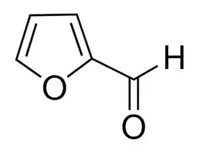
4-hydroxy-4-methyl-2-pentanone | 27.93 | 7.89 | 4.42 | 9.94 | 5.89 | 2.38 | 2.41 | 2.41 | 2.70 | 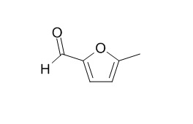  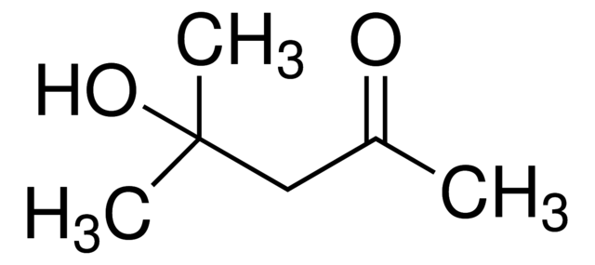
5-methyl-2-furan carboxaldehyde |  | 7.25 | 4.70 |  | 8.06 | 5.31 |  |  | 5.45
Phenol | 14.01 | 7.33 | 6.44 | 8.67 | 5.17 | 7.63 | 7.30 | 7.30 | 5.74 | 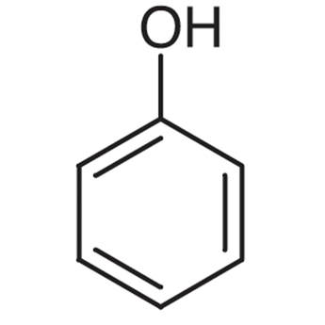
2-methoxy phenol | 9.17 | 8..92 | 4.36 | 10.29 | 8.00 | 4.66 | 10.37 | 10.37 | 6.34 | 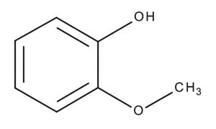
Apocynin |  | 5.14 |  | 3.04 | 4.12 | 7.75 | 1.67 | 1.67 | 2.70 | 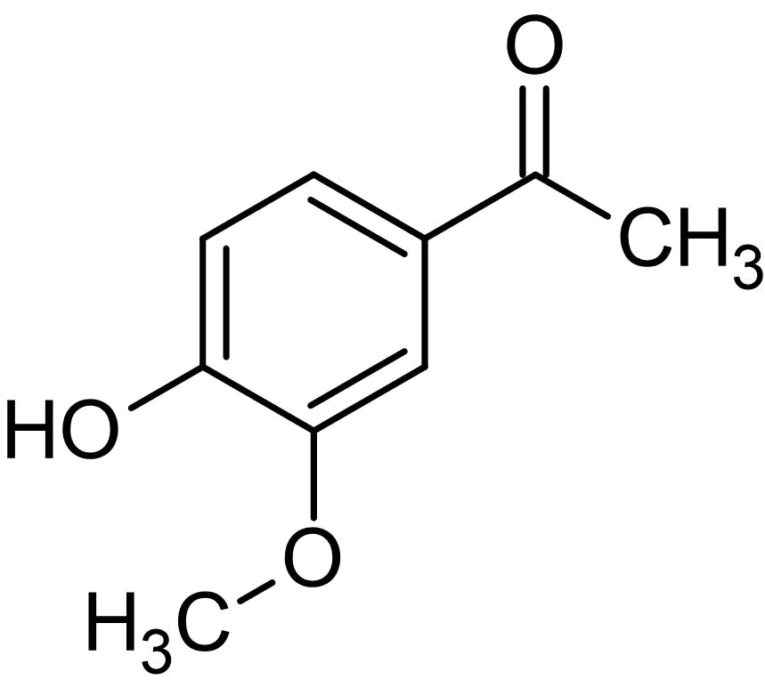  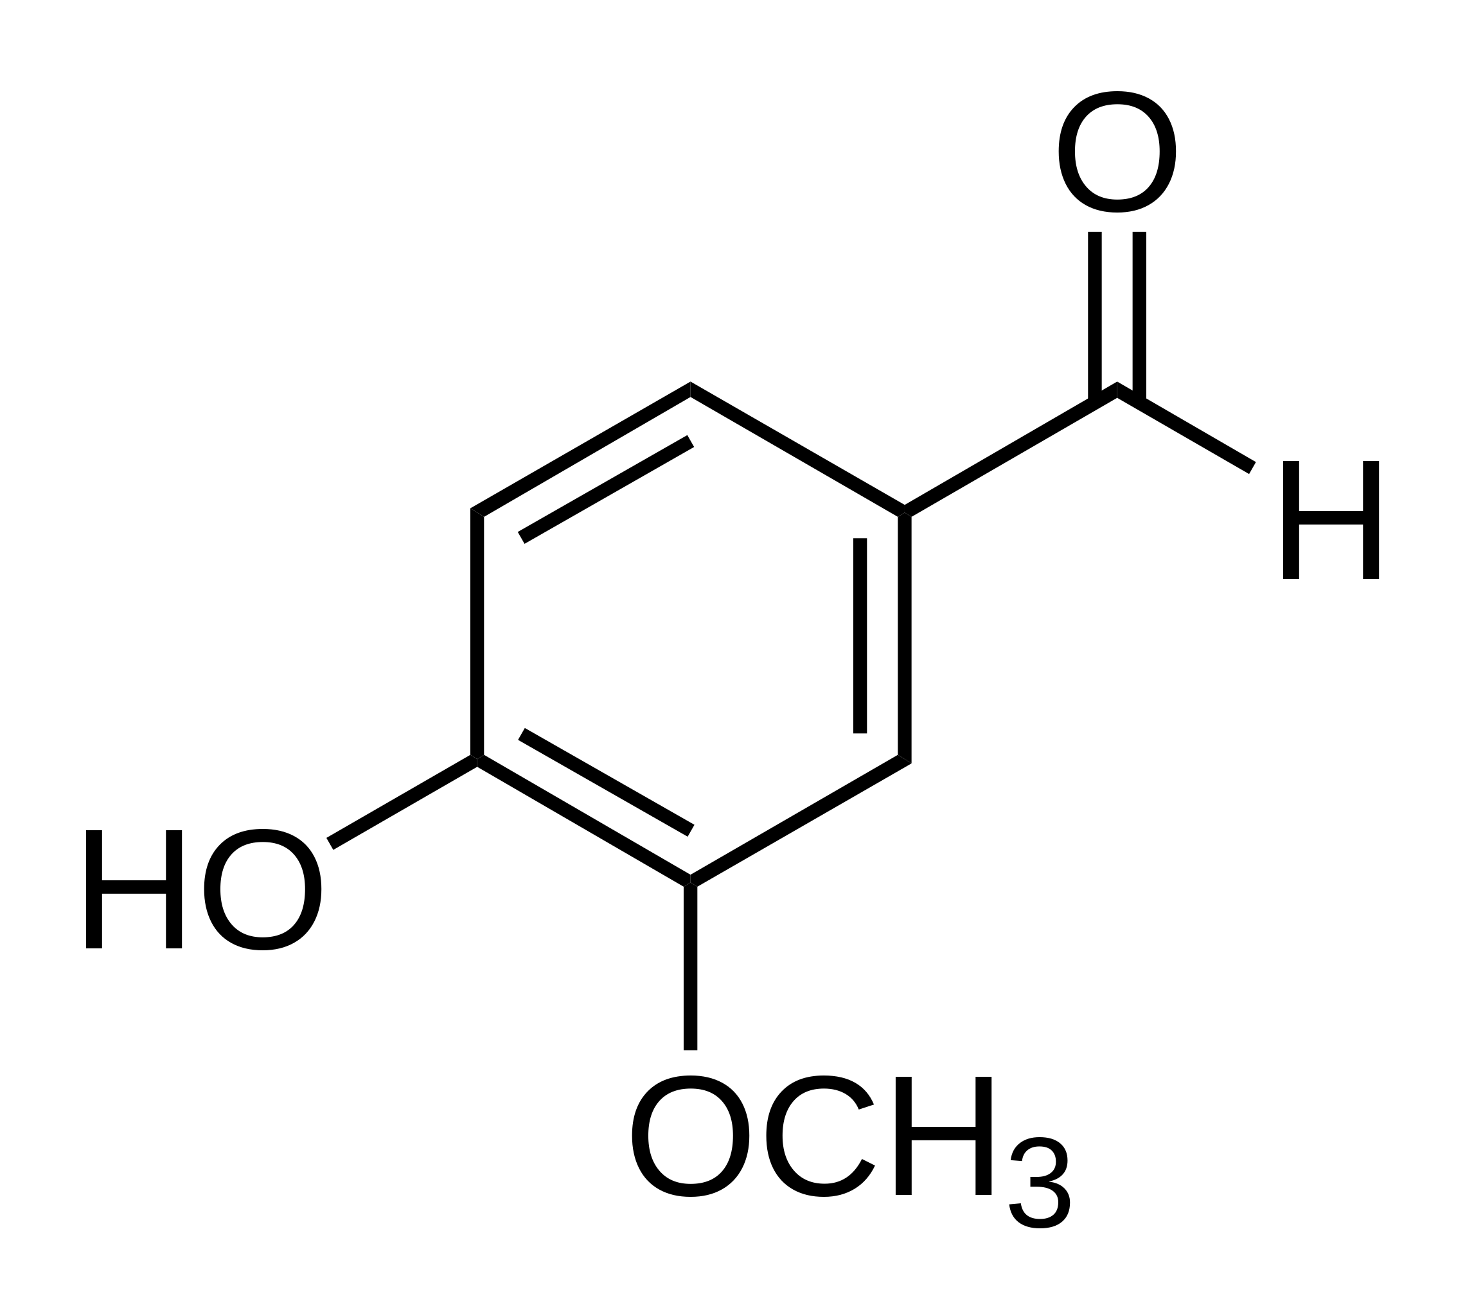
Vanillin |  | 3.00 | 3.58 |  |  | 7.45 |  | 1.14 | 2.70
2-furan methanol |  | 0.92 |  | 1.69 | 1.02 |  | 2.61 | 2.61 |  | 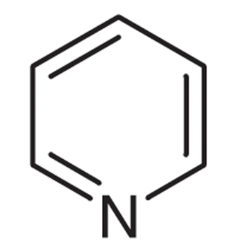
Pyridine |  |  | 1.08 |  | 1.67 |  | 1.51 | 1.25 | 0.58 | 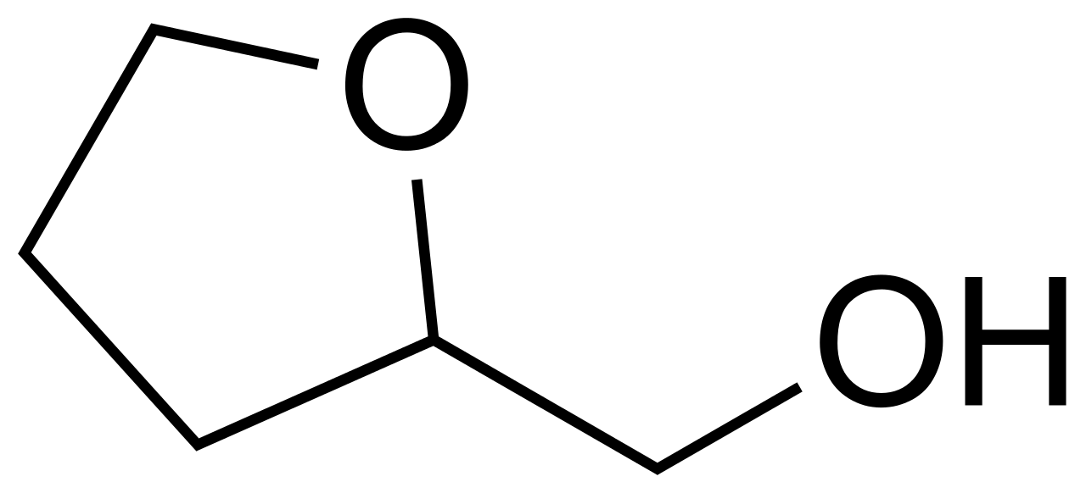
Benzoic acid methyl ester |  | 0.76 |  |  | 0.79 |  | 1.24 | 1.24 |  | 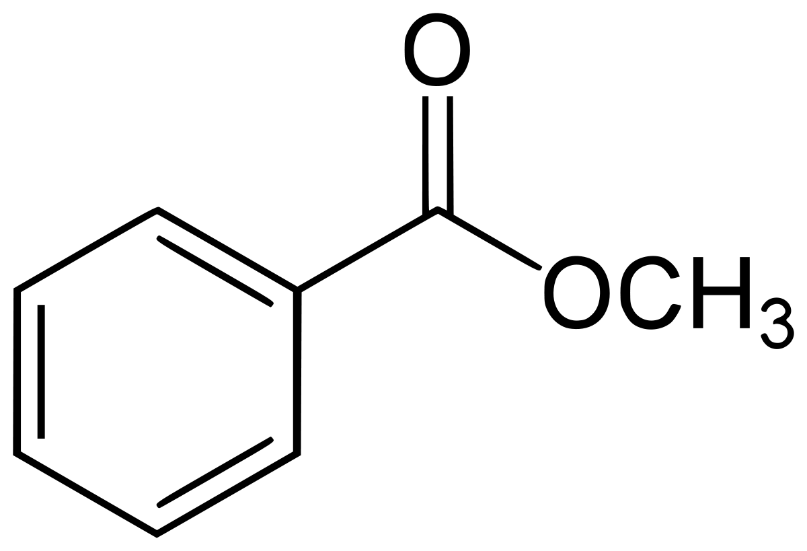

Ethyl pyrazine |  |  |  |  |  |  | 0.66 |  |  | 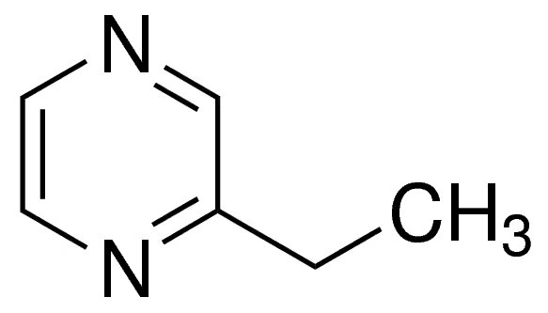
Styrene |  |  |  |  |  |  | 1.15 |  |  | 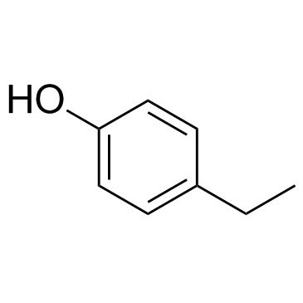  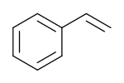
4-ethyl phenol |  | 1.70 |  | 3.58 | 1.32 |  | 2.54 | 2.54 | 0.82
Creosol | 5.01 | 1.53 |  | 3.14 | 1.59 |  | 2.71 | 2.71 | 2.01 | 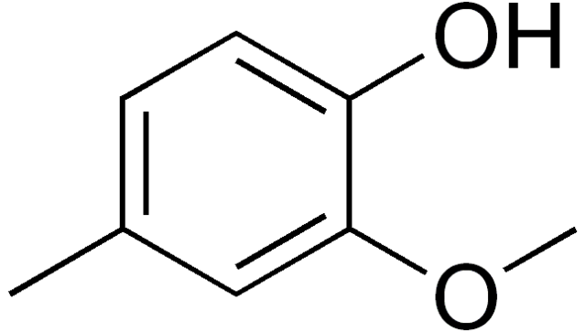
4-vinyl phenol | 10.77 |  |  | 11.93 |  |  | 7.37 |  |  | 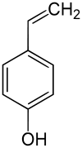
(E)-2-methoxy-5-(1-propenyl)-phenol |  |  |  | 1.01 |  |  | 0.90 |  |  | 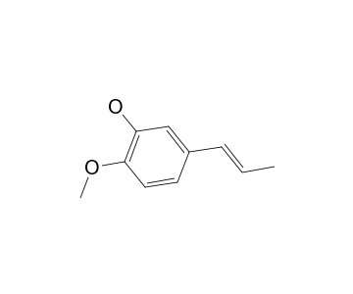
1-(4-hydroxy-3-methoxyphenyl)-2-propanone |  | 2.33 |  |  | 2.34 | 4.58 |  | 1.37 | 1.86 | 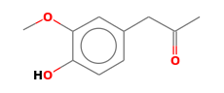  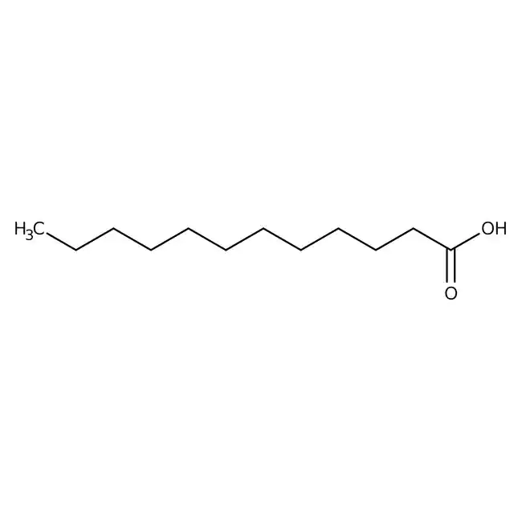
Dodecanoic acid |  | 2.00 | 3.76 |  | 2.88 | 4.80 |  |  | 1.46
n-hexadecenoic acid |  | 2.99 | 4.55 |  | 4.18 | 5.87 |  |  | 2.37 | 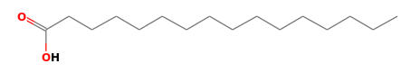  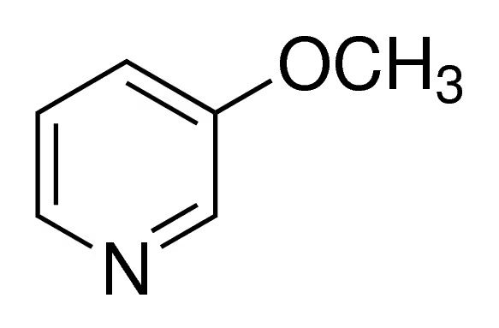
3-methoxy pyridine |  |  |  |  |  |  |  |  | 0.57
p-creosol |  | 0.59 |  | 1.45 |  |  | 1.15 | 1.15 |  | 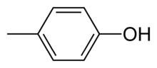
4-ethyl-2-methoxy phenol |  | 2.01 |  | 3.88 | 2.30 |  |  | 3.42 | 2.00 | 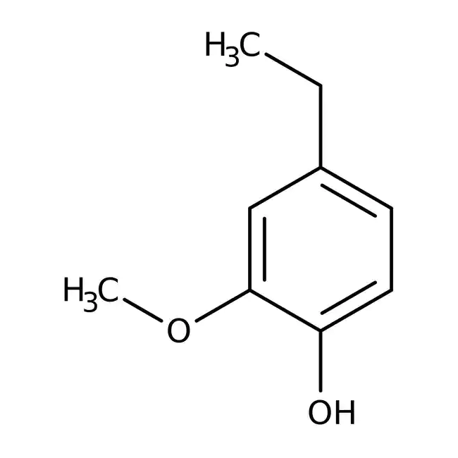

2,6-dimethoxy phenol |  | 3.88 | 2.56 |  | 2.75 |  |  | 4.74 | 4.72 | 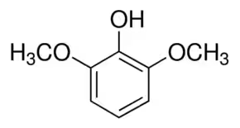
3-allyl-6-methoxy phenol |  |  |  |  |  |  |  | 0.90 |  | 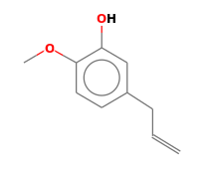
2-methoxy-4-propyl phenol |  |  |  |  |  |  |  |  | 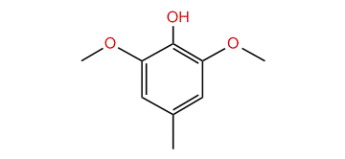 | 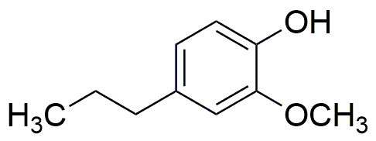
3,5-dimethoxy-4-hydroxy toluene |  | 1.02 |  |  |  |  |  |  | 1.61 | 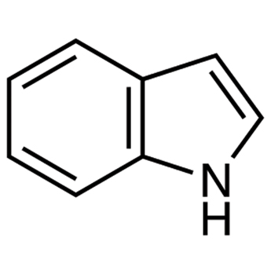
Indole |  |  |  | 1.32 |  |  | 1.17
2-methoxy-4-vinyl phenol |  |  |  | 7.64 |  |  | 7.58 |  |  | 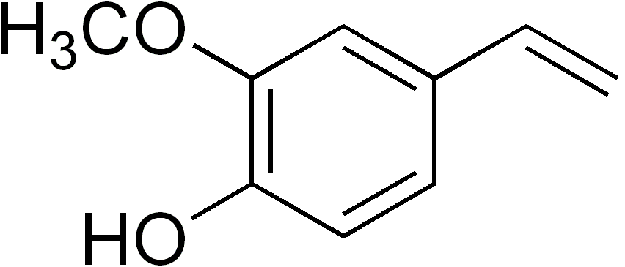  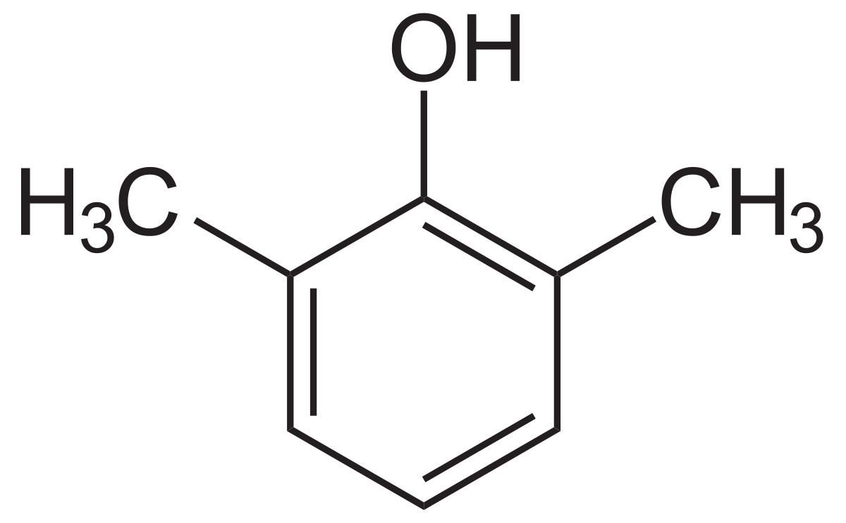
2,6-dimethyl phenol |  |  |  | 6.41 |  |  | 4.74 |  |  | 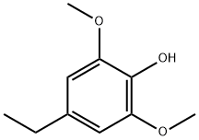
4-ethyl-2,6-dimethoxy phenol |  | 0.76 |  | 1.71 |  |  | 1.11 | 1.11 | 0.78 | 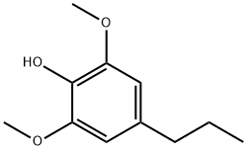
2,6-dimethoxy-4-propyl phenol |  |  |  |  |  |  |  |  |  | 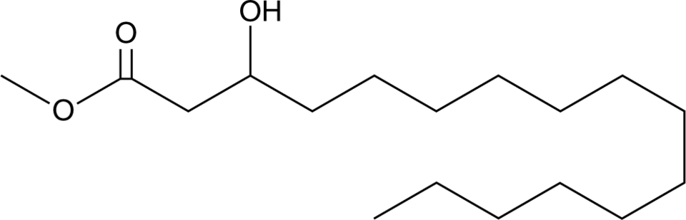
Hexadecanoic acid methyl ester |  |  |  | 0.81 |  |  |  |  |  | 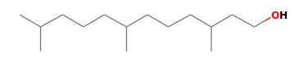
3,7,11-trimethyl-1-dodecanol |  |  |  |  |  |  |  |  |  | 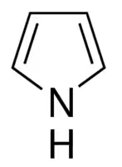
Pyrrole |  |  |  |  |  |  | 1.38

Melezitose |  |  |  |  |  | 9.96 |  |  | 6.22 | 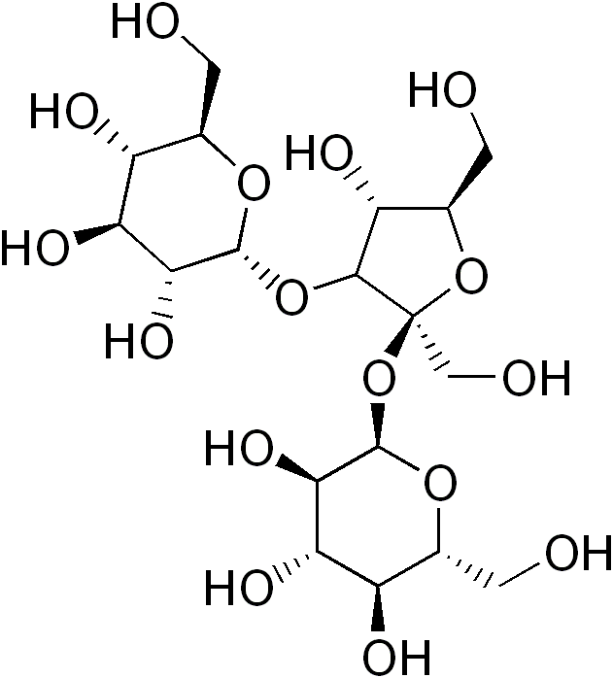
1-(2-furanyl)-ethanone |  |  |  |  |  |  |  |  | 0.44 | 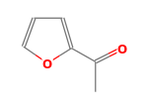  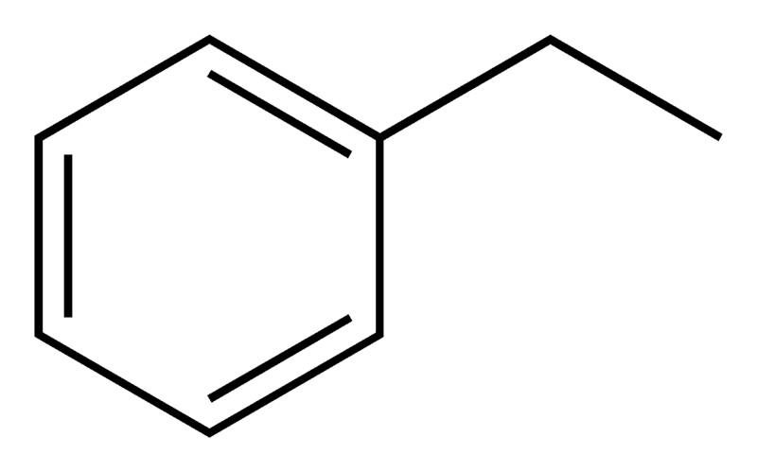
Ethyl benzene
3-phenoxy phenol |  |  |  |  |  |  |  |  |  | 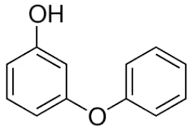
1-(4-hydroxy-3,5-dimethoxyphenyl)-ethanone |  | 2.12 |  |  |  |  |  | 0.92 | 1.52 | 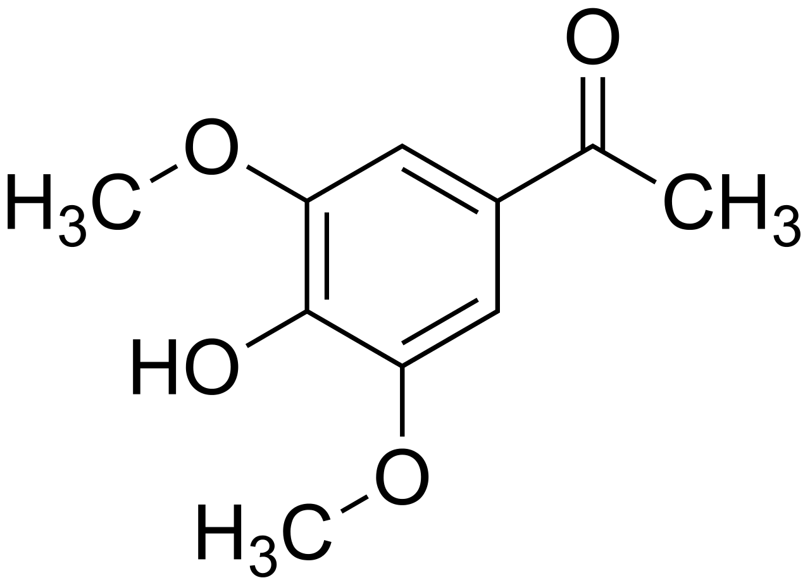  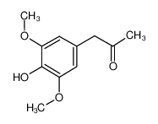
Syringylacetone |  | 1.06 |  |  |  |  |  | 0.59 | 1.76
i-propyl-12-methyl-tetradecanoate |  | 0.79 | 2.97 |  | 1.47 |  |  |  | 0.72 | 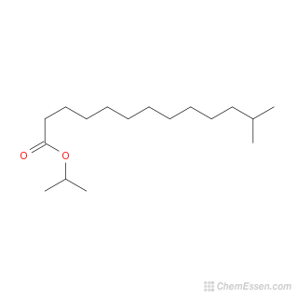  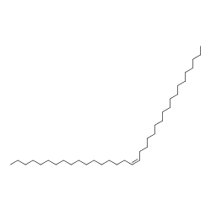
2(5H)-furanone |  |  |  |  |  |  |  |  |  | 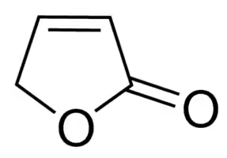
17-pentatriacontene |  | 0.91 | 1.83 |  | 1.93 |  |  |  | 0.66
Maltol |  |  |  |  |  |  |  |  |  | 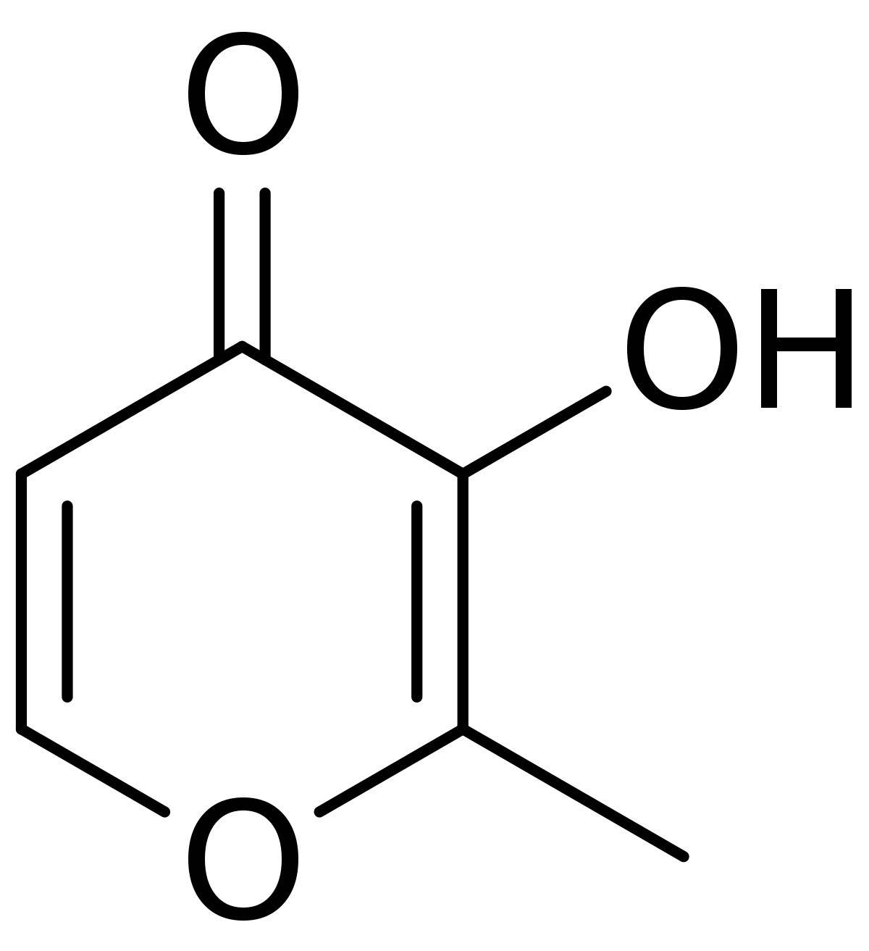
methyl 2-furoate |  |  |  |  |  |  |  |  |  | 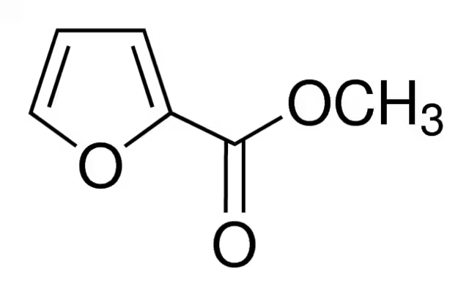
2-methyl pyrimidine |  |  |  |  |  |  | 4.03 |  |  | 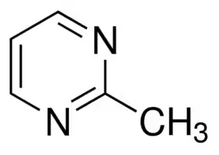

Table S12. Compositions of oil product from pyrolysis of CM, 10 wt% nitric acid-washed CM, 20 wt% nitric acid-washed CM for 2 min at different temperatures
Bio-oil composition | 375 ℃ |  |  | 400 ℃ |  |  | 425 ℃ |  |  | Structure
Bio-oil composition | Original | 10 wt% HNO₃ | 20 wt% HNO₃ | Original | 10 wt% HNO₃ | 20 wt% HNO₃ | Original | 10 wt% HNO₃ | 20 wt% HNO₃ | Structure
Furfural |  | 13.10 | 12.52 |  | 8.76 | 7.21 |  | 4.05 | 5.49
4-hydroxy-4-methyl-2-pentanone | 4.56 | 5.76 | 3.93 | 5.16 | 3.50 | 1.14 | 1.55 | 1.15 | 1.80
5-methyl-2-furan carboxaldehyde |  | 6.63 | 4.26 |  | 4.12 | 4.44 |  | 2.13
Phenol | 10.52 | 5.51 | 6.32 | 11.94 | 5.76 | 5.86 | 7.92 | 5.04 | 6.87
2-methoxy phenol | 12.77 | 5.65 | 5.85 | 16.95 | 6.57 | 9.50 | 10.92 | 6.51 | 8.23
Apocynin |  | 4.59 | 2.15 | 2.21 | 2.44 | 2.94 | 2.00 | 1.67 | 2.15
Vanillin |  | 2.04 | 2.50 |  |  | 3.81 |  | 0.80
2-furan methanol | 3.23 |  | 0.63 | 2.43 | 0.59 |  | 1.94 | 0.68 | 0.16
Pyridine |  |  | 0.77 |  | 0.55 |  | 0.61 | 0.24 | 0.49
Benzoic acid methyl ester |  |  | 0.52 | 2.00 | 0.50 |  | 1.04 | 0.61 | 0.95

Ethyl pyrazine |  |  |  |  |  |  | 0.39
Styrene
4-ethyl phenol | 2.69 | 1.59 | 0.63 | 6.06 | 1.86 | 1.18 | 3.60 | 1.79 | 1.12
Creosol | 3.82 | 2.04 | 2.31 | 3.13 | 2.61 | 3.93 | 2.29 | 3.06 | 3.35
4-vinyl phenol | 14.08 |  |  |  |  |  | 7.74
(E)-2-methoxy-5-(1-propenyl)-phenol |  |  |  |  |  |  | 0.88
1-(4-hydroxy-3-methoxyphenyl)-2-propanone |  | 2.18 | 1.57 |  | 1.78 | 2.47 |  | 1.30 | 1.16
Dodecanoic acid |  | 1.74 | 1.47 |  | 1.61 | 2.07 |  | 0.95 | 1.01
n-hexadecenoic acid |  | 3.36 | 1.16 |  | 2.54 | 2.80 |  | 2.15 | 1.00
3-methoxy pyridine |  |  | 0.83 |  | 0.75 | 0.99 |  | 0.61 | 1.39
p-creosol |  | 0.77 |  | 2.77 | 1.41 | 1.35 | 2.19 | 1.56
4-ethyl-2-methoxy phenol | 4.51 | 2.16 | 1.29 | 7.35 | 2.64 | 4.78 | 1.40 | 3.23 | 3.27

2,6-dimethoxy phenol |  | 4.72 | 4.06 |  | 4.14 | 3.84 |  | 4.34 | 4.71
3-allyl-6-methoxy phenol |  |  |  |  | 0.44 | 0.59 |  | 0.67 | 0.36
2-methoxy-4-propyl phenol |  |  |  |  |  | 1.02 |  | 0.93 | 0.81
3,5-dimethoxy-4-hydroxy toluene |  | 1.37 | 0.85 |  |  | 1.42 |  | 1.79 | 1.54
Indole |  |  |  | 1.55 |  |  | 1.90
2-methoxy-4-vinyl phenol | 12.01 |  |  | 6.11 |  |  | 8.66
2,6-dimethyl phenol | 7.99 |  |  | 6.52 |  |  | 5.44
4-ethyl-2,6-dimethoxy phenol | 2.22 | 1.02 | 0.55 | 2.32 | 0.94 | 1.20 | 1.40 | 2.21 | 1.05
2,6-dimethoxy-4-propyl phenol |  |  |  |  |  | 0.47 |  | 0.26 | 0.43
Hexadecanoic acid methyl ester |  |  |  | 1.48
3,7,11-trimethyl-1-dodecanol
Pyrrole |  |  |  |  |  |  | 0.54

Melezitose |  |  | 2.01 |  | 2.64 | 3.00 |  | 1.56 | 0.47
1-(2-furanyl)-ethanone |  |  | 0.52 |  | 0.37 |  |  | 0.31 | 0.54
Ethyl benzene
3-phenoxy phenol |  |  |  |  | 1.36 | 1.76 |  | 1.40
1-(4-hydroxy-3,5-dimethoxyphenyl)-ethanone |  | 2.05 | 1.20 |  | 1.67 | 0.88 |  | 0.98 | 0.85
Syringylacetone |  | 1.38 | 1.52 |  | 1.27 | 1.10 |  | 0.91 | 0.87
i-propyl-12-methyl-tetradecanoate |  | 1.29 | 0.74 |  | 0.67 | 1.12 |  | 0.54 | 0.45
2(5H)-furanone |  |  | 0.59 |  |  |  |  | 0.51 | 0.26
17-pentatriacontene |  | 0.62 | 0.59 |  | 0.74 | 0.91 |  | 0.27 | 0.35
Maltol |  |  |  |  | 1.49 | 1.63 |  | 1.15 | 1.40
methyl 2-furoate |  |  |  |  |  |  |  |  | 0.19
2-methyl pyrimidine |  |  |  | 1.60 |  |  | 1.51

Table S13. Compositions of oil product from pyrolysis of CM, 10 wt% nitric acid-washed CM, 20 wt% nitric acid-washed CM for 3 min at different temperatures
Bio-oil composition | 375 ℃ |  |  | 400 ℃ |  |  | 425 ℃ |  |  | Structure
Bio-oil composition | Original | 10 wt% HNO₃ | 20 wt% HNO₃ | Original | 10 wt% HNO₃ | 20 wt% HNO₃ | Original | 10 wt% HNO₃ | 20 wt% HNO₃ | Structure
Furfural |  | 9.99 | 9.49 |  | 5.58 | 5.15 |  | 3.35 | 3.92
4-hydroxy-4-methyl-2-pentanone | 3.06 | 1.98 | 2.18 | 1.51 | 1.93 | 0.58 | 1.32 | 0.84 | 1.25
5-methyl-2-furan carboxaldehyde |  | 5.75 | 4.51 |  | 3.69 | 4.15 |  | 1.83 | 1.45
Phenol | 9.28 | 6.60 | 6.59 | 6.96 | 6.71 | 5.69 | 6.94 | 4.73 | 6.84
2-methoxy phenol | 12.43 | 6.79 | 6.71 | 10.44 | 8.17 | 9.45 | 9.84 | 6.08 | 7.86
Apocynin | 1.96 | 3.15 | 2.04 | 2.10 | 2.16 | 1.48 | 2.03 | 1.69 | 1.56
Vanillin |  | 1.21 | 1.73 |  | 0.66 | 1.53 |  | 0.45 | 0.47
2-furan methanol | 2.46 | 0.86 | 0.40 | 2.03 | 0.60 | 0.36 | 1.56 | 0.51
Pyridine |  | 1.23 | 0.41 | 0.60 | 0.64 | 0.32 | 0.57 | 0.46 | 0.16
Benzoic acid methyl ester | 2.01 | 0.71 | 0.62 | 1.38 | 0.61 | 0.53 | 1.12 | 0.55 | 1.11

Ethyl pyrazine |  |  |  | 0.40 |  |  | 0.34
Styrene
4-ethyl phenol | 3.96 | 1.56 | 0.67 | 3.82 | 2.44 | 0.89 | 3.85 | 1.78 | 1.21
Creosol | 2.94 | 1.88 | 2.03 | 2.16 | 3.14 | 5.74 | 2.28 | 3.00 | 3.59
4-vinyl phenol | 5.23 |  |  | 6.79 |  |  | 4.99
(E)-2-methoxy-5-(1-propenyl)-phenol | 0.93 |  |  |  |  |  | 1.04
1-(4-hydroxy-3-methoxyphenyl)-2-propanone |  | 1.65 | 1.52 |  | 1.16 | 1.55 |  | 3.01 | 0.93
Dodecanoic acid |  | 1.32 | 1.32 |  | 1.23 | 1.17 |  | 0.86 | 1.06
n-hexadecenoic acid |  | 0.96 |  |  | 1.27 | 2.06 |  | 2.10 | 1.81
3-methoxy pyridine |  | 0.90 | 0.95 |  | 1.33 | 1.23 |  | 0.59 | 0.78
p-creosol | 1.82 | 1.17 | 0.66 | 2.05 | 2.03 | 1.27 | 2.17 | 1.54 | 1.39
4-ethyl-2-methoxy phenol | 5.36 | 2.56 | 1.79 | 4.28 | 3.94 | 5.76 | 4.39 | 3.05 | 3.38

2,6-dimethoxy phenol |  | 4.03 | 5.02 |  | 4.17 | 4.30 |  |  | 4.51
3-allyl-6-methoxy phenol |  | 0.46 |  |  | 0.36 | 0.49 |  |  | 0.46
2-methoxy-4-propyl phenol |  |  |  |  | 0.86 | 1.45 |  | 1.03
3,5-dimethoxy-4-hydroxy toluene |  | 1.07 | 1.24 |  | 1.66 | 1.76 |  | 1.62 | 2.07
Indole | 1.35 |  |  | 1.82 |  |  | 1.80
2-methoxy-4-vinyl phenol | 6.12 |  |  | 7.83 |  |  | 6.21
2,6-dimethyl phenol | 6.29 |  |  | 5.22 |  |  | 3.91
4-ethyl-2,6-dimethoxy phenol | 1.82 | 0.92 | 0.77 | 1.48 | 1.16 | 1.23 | 1.37 | 1.84 | 1.12
2,6-dimethoxy-4-propyl phenol |  |  |  |  | 0.49 | 0.50 | 0.31 | 0.21 | 0.52
Hexadecanoic acid methyl ester |  |  |  | 0.64 |  |  | 0.64
3,7,11-trimethyl-1-dodecanol | 0.77
Pyrrole |  |  |  | 0.75 |  |  | 0.59

Melezitose |  | 0.70 | 1.88 |  | 1.44 | 2.28 |  | 1.96 | 0.53
1-(2-furanyl)-ethanone |  | 0.54 | 0.46 |  | 0.48 | 0.53 |  | 0.37 | 0.37
Ethyl benzene
3-phenoxy phenol |  | 1.48 |  |  | 1.56 |  |  | 1.26 | 2.14
1-(4-hydroxy-3,5-dimethoxyphenyl)-ethanone |  | 1.58 | 1.07 |  | 1.04 | 0.69 |  | 0.86 | 0.62
Syringylacetone |  | 1.36 | 1.20 |  | 0.75 | 0.70 |  | 0.70 | 0.66
i-propyl-12-methyl-tetradecanoate |  | 0.51 | 0.47 |  | 0.66 | 0.70 |  | 0.48 | 0.51
2(5H)-furanone |  |  | 0.66 |  |  |  |  | 0.47
17-pentatriacontene |  | 0.80 | 0.49 |  | 0.74 | 0.88 |  | 0.22 | 0.43
Maltol |  |  | 2.12 |  | 1.61 | 1.61 |  | 1.24 | 1.34
methyl 2-furoate |  |  |  |  |  | 0.28 |  |  | 0.18
2-methyl pyrimidine | 0.85 |  |  | 1.66 |  |  | 1.23

Table S14. Compositions of oil product from pyrolysis of CM, 10 wt% nitric acid-washed CM, 20 wt% nitric acid-washed CM for 4 min at different temperatures
Bio-oil composition | 375 ℃ |  |  | 400 ℃ |  |  | 425 ℃ |  |  | Structure
Bio-oil composition | Original | 10 wt% HNO₃ | 20 wt% HNO₃ | Original | 10 wt% HNO₃ | 20 wt% HNO₃ | Original | 10 wt% HNO₃ | 20 wt% HNO₃ | Structure
Furfural |  | 6.46 | 4.46 |  | 2.89 | 3.99 |  | 1.18 | 2.33
4-hydroxy-4-methyl-2-pentanone | 2.80 | 1.81 | 1.01 | 0.92 | 1.20 | 0.54 | 0.77 | 0.79 | 0.77
5-methyl-2-furan carboxaldehyde |  | 4.75 | 1.99 |  | 1.87 | 2.53 |  | 1.06
Phenol | 8.72 | 8.06 | 7.28 | 7.20 | 4.06 | 5.19 | 7.33 | 4.71 | 3.78
2-methoxy phenol | 11.72 | 9.34 | 8.65 | 9.44 | 5.28 | 6.28 | 9.73 | 6.10 | 5.09
Apocynin | 2.85 | 2.95 | 1.80 | 1.37 | 1.25 | 1.15 | 1.02 | 1.29 | 1.14
Vanillin |  | 0.79 | 0.73 |  | 0.45 | 0.59 |  | 0.33 | 1.76
2-furan methanol | 1.51 | 0.78 |  | 1.73 | 0.52 | 0.55 | 1.18 | 0.33 | 0.26
Pyridine |  | 0.66 | 0.23 |  | 0.23 | 0.25 |  | 0.24 | 0.30
Benzoic acid methyl ester | 2.36 | 1.65 | 1.34 | 1.21 | 1.07 | 0.56 | 0.81 | 0.65 | 0.54

Ethyl pyrazine | 0.42 |  |  |  |  |  | 0.22
Styrene
4-ethyl phenol | 4.90 | 2.51 | 1.09 | 3.59 | 1.50 | 0.70 | 4.50 | 2.35 | 0.84
Creosol | 2.41 | 3.15 | 3.21 | 2.11 | 3.52 | 2.04 | 2.09 | 3.05 | 3.19
4-vinyl phenol | 3.31 |  |  | 6.67 |  |  | 4.47
(E)-2-methoxy-5-(1-propenyl)-phenol | 0.59 |  |  |  |  |  | 1.27
1-(4-hydroxy-3-methoxyphenyl)-2-propanone |  | 1.11 | 0.92 |  |  | 1.38 |  | 1.09 | 2.12
Dodecanoic acid |  | 1.34 | 1.14 |  | 0.96 | 0.68 |  |  | 0.55
n-hexadecenoic acid |  | 1.07 | 1.24 |  | 1.22 | 1.97 |  | 1.77 | 1.45
3-methoxy pyridine |  | 1.42 | 0.98 |  | 0.45 | 0.67 |  | 0.61 | 0.77
p-creosol | 1.73 | 2.01 | 0.80 | 2.06 | 1.22 | 0.70 | 2.55 | 1.78
4-ethyl-2-methoxy phenol |  |  | 3.26 | 4.43 | 2.66 | 2.26 | 5.47 | 3.80 | 2.19

2,6-dimethoxy phenol |  | 4.65 | 5.15 |  | 3.49 | 4.47 |  | 3.76 | 3.46
3-allyl-6-methoxy phenol |  |  | 0.50 |  | 0.74 | 0.50 |  | 0.88 | 0.74
2-methoxy-4-propyl phenol |  | 1.14 |  |  | 0.87 | 0.83 |  | 1.21
3,5-dimethoxy-4-hydroxy toluene |  | 1.40 | 1.72 |  | 1.51 | 1.49 |  | 1.79
Indole | 1.34 |  |  | 2.37 |  |  | 2.30
2-methoxy-4-vinyl phenol | 3.20 |  |  | 8.10 |  |  | 5.56
2,6-dimethyl phenol | 5.39 |  |  | 5.32
4-ethyl-2,6-dimethoxy phenol | 1.94 | 1.26 | 1.06 | 1.56 | 1.54 | 1.71 | 1.44 | 0.75 | 1.48
2,6-dimethoxy-4-propyl phenol | 1.05 | 0.59 | 0.43 |  | 0.25 | 0.23 | 0.26 | 0.43 | 0.45
Hexadecanoic acid methyl ester | 1.46 |  |  | 0.73 |  |  | 0.72
3,7,11-trimethyl-1-dodecanol | 0.81 |  |  | 0.96
Pyrrole | 0.37 |  |  |  |  |  | 0.33

Melezitose |  |  | 0.47 |  | 1.06 | 2.16 |  | 0.75 | 0.61
1-(2-furanyl)-ethanone |  | 0.39 | 0.40 |  | 0.30 | 0.39 |  | 0.33 | 0.37
Ethyl benzene
3-phenoxy phenol |  | 1.63 |  |  | 1.13 | 1.77 |  |  | 1.51
1-(4-hydroxy-3,5-dimethoxyphenyl)-ethanone |  | 0.85 | 0.67 |  | 0.98 | 0.65 |  | 0.67 | 0.78
Syringylacetone |  | 0.51 | 0.59 |  | 0.86 | 0.61 |  | 0.65 | 0.78
i-propyl-12-methyl-tetradecanoate |  | 0.61 | 0.54 |  | 0.57 | 0.63 |  | 0.49 | 0.49
2(5H)-furanone |  |  |  |  | 0.46 | 0.50 |  | 0.31 | 0.35
17-pentatriacontene |  | 0.73 | 0.51 |  | 0.47 | 0.64 |  | 0.30 | 0.34
Maltol |  | 1.57 | 1.73 |  | 1.45 | 1.75 |  | 1.24 | 1.53
methyl 2-furoate |  | 0.34 |  |  |  |  |  |  | 0.27
2-methyl pyrimidine | 0.85 |  |  | 0.55 |  |  | 0.24

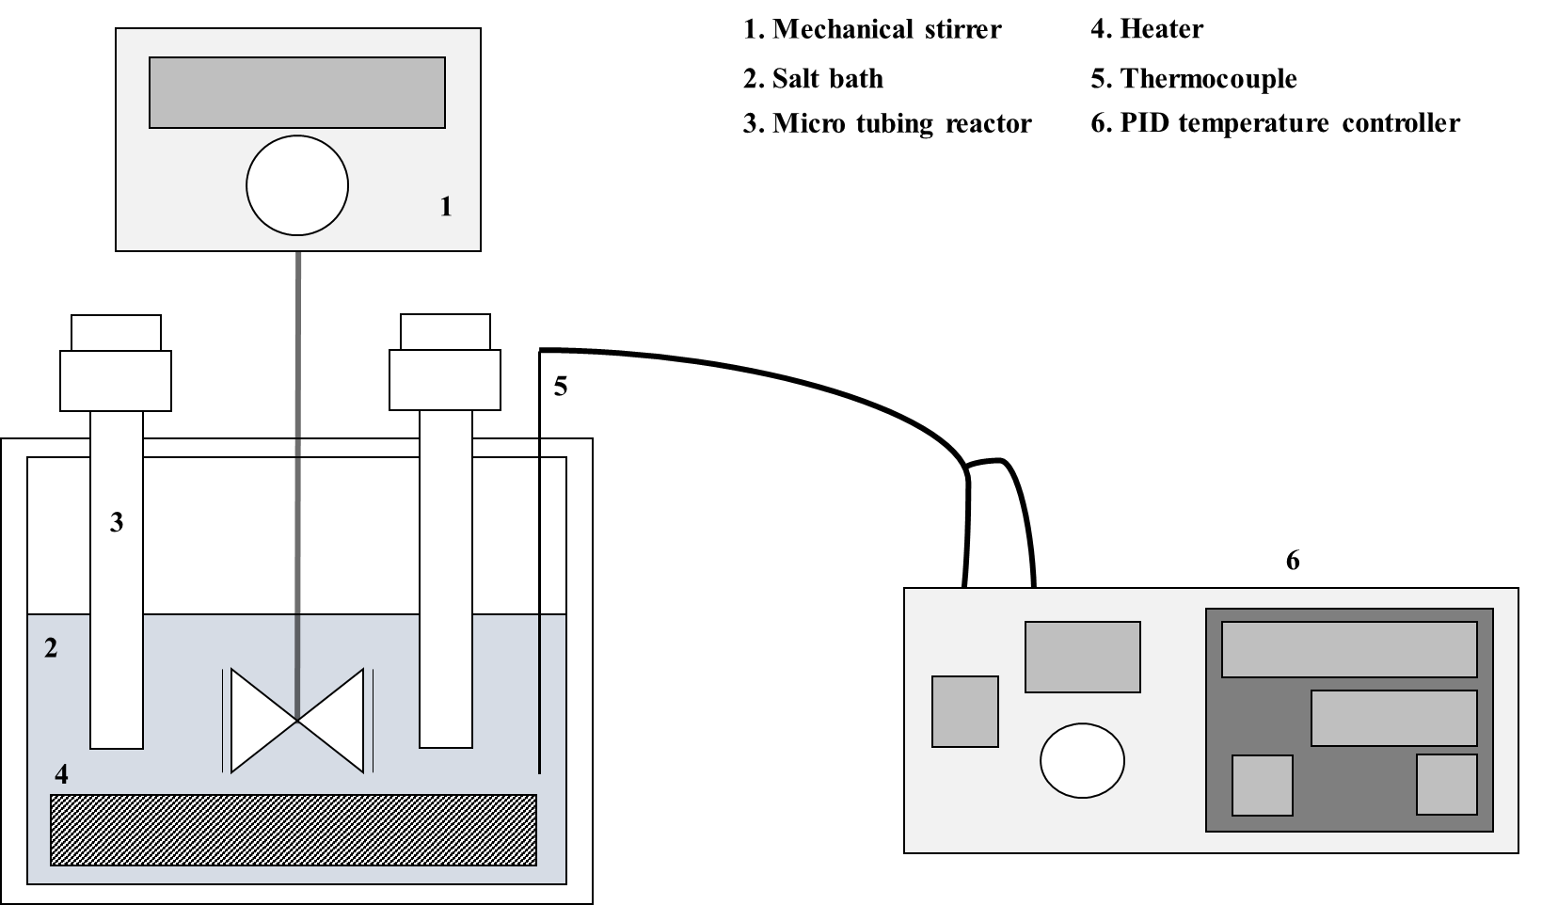
Fig. S1. Schematic diagram of a micro-tubing reactor

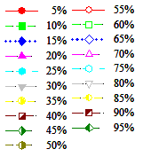
(c)
(b)
(a)
Fig. S2. Activation energies calculated from Eq. (1) at heating rates of 5, 10, 15, and 20 ℃/min at conversion values ranging from 5–95% for (a) CM, (b) 10 wt% nitric acid-washed CM, (c) 20 wt% nitric acid-washed CM.

