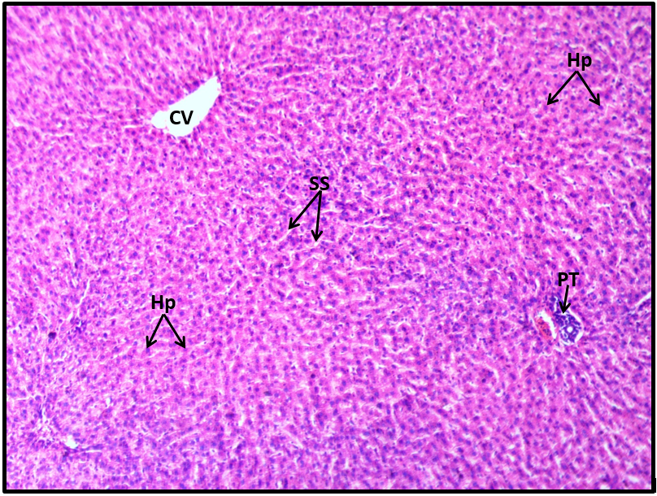
Plate 1: Light photomicrograph of Liver section from normal negative control rats treated with intraperitoneal sterile water injection only, showing normal histoarchitecture of the hepatic tissue. Features shown include normal central vein (CV), portal tract (PT), hepatocytes (Hp) and radiating sinusoidal spaces (SS). (Stain: H&E; Mag: x100)

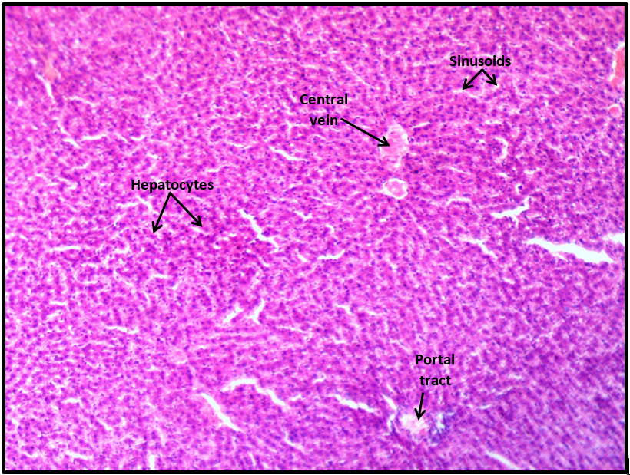
Plate 2: Light photomicrograph of Liver section from rats treated with 10mg/kg body weight of ethyl acetate fraction containing 5,7 - Dimethoxycoumarin showing no obvious histomorphological alteration consistent with drug-induced hepatotoxicity. (Stain: H&E; Mag: x100)

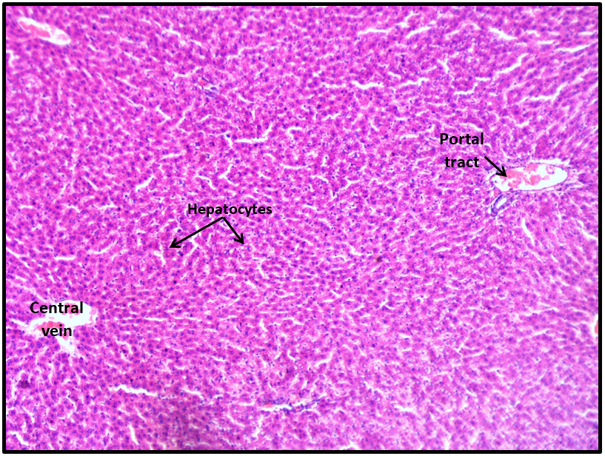
Plate 3: Light photomicrograph of Liver section from rats treated with 20mg/kg body weight of ethyl acetate fraction containing 5,7 - Dimethoxycoumarin showing intact tissue parenchyma. No significant difference in the microanatomical structure of the hepatic tissue is observed when compared to the negative control.(Stain: H&E; Mag: x100)

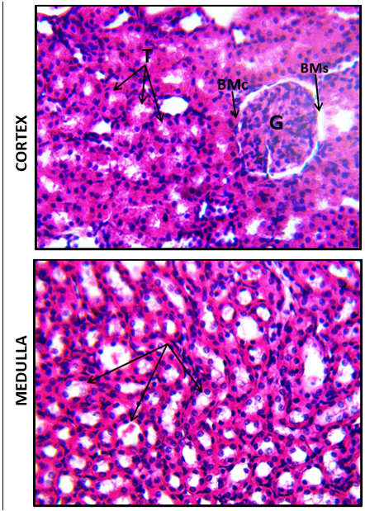
MEDULLA
CORTEX
Plate 4: Light photomicrographs of cortical and medullary regions of a Kidney section from normal negative control rats treated with sterile water only. Features in the cortex include normal glomerulus (G), tubules (T), Bowman’s capsule (BMc) and space (BMs). The medullary region shows many cross-sectioned collecting ducts and loops of Henle which appear normal. (Stain: H&E; Mag:x400)
.

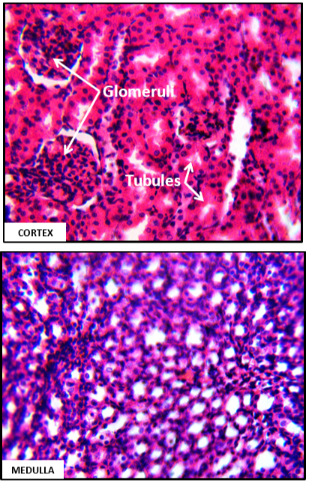
Plate 5: Light photomicrographsof Kidney section from rats treated with 10mg/kg body weight of ethyl acetate fraction containing 5,7 - Dimethoxycoumarin showing intact renal parenchyma. No significant difference in the microanatomical structure of the tissue is observed when compared to the control. (Stain: H&E; Mag: x400)

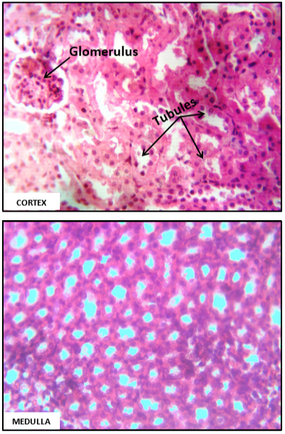
Plate 6: Light photomicrographs of Kidney section from rats treated with 20mg/kg body weight of ethyl acetate fraction containing 5,7 - Dimethoxycoumarin. Features shown reveal no obvious pathological changes following treatment. (Stain: H&E; Mag: x400)

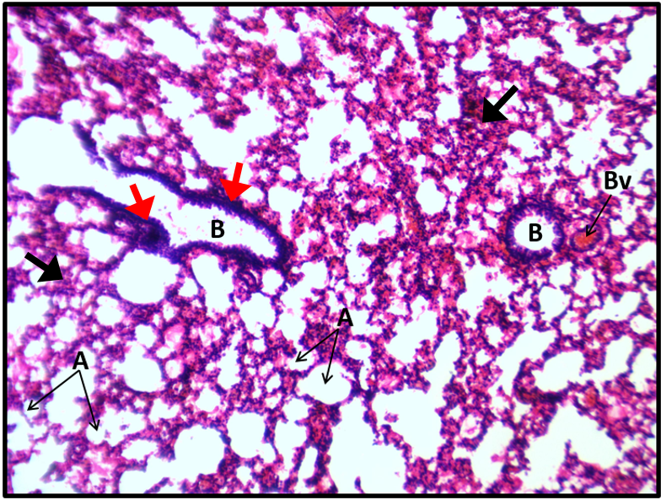
Plate 7: Light photomicrograph of Lung section from normal negative control rats treated with sterile water only, showing intact histoarchitectural features including alveoli (A), bronchioles (B) and blood vessels (Bv). However, mild changes including peribronchial infiltrates (red arrows), alveolar congestion and alveolar septal thickening (black arrows) are observed, rule out environmental effects.. (Stain: H&E; Mag: x100)

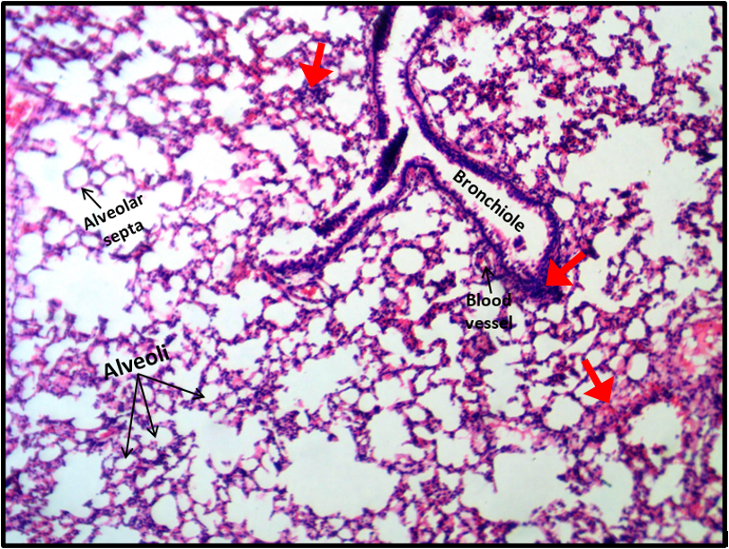
Plate 8: Light photomicrograph of Lung section from rats treated with 10mg/kg body weight of ethyl acetate fraction containing 5,7 - Dimethoxycoumarin showing no significant histoarchitectural damage of the respiratory tissue when compared to the control. There are evidence of mild congestion and cellular infiltration (thick red arrows) consistent with those observed in the normal negative control.(Stain: H&E; Mag: x100).

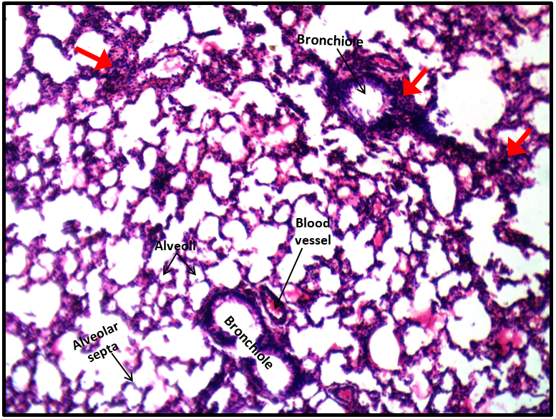
Plate 9: Light photomicrograph of Lungs section from rats treated with 20mg/kg body weight. of ethyl acetate fraction containing 5,7 - Dimethoxycoumarin showing no obvious histomorphological alteration when compared to the control.The mild congestion and cellular infiltration observed (thick red arrows) are similar to those shown in the negative control group, otherwise normal study. (Stain: H&E; Mag: x100)

Prof. Nkiruka Chinonyelum Azubuike
Histopathology and Cytology Unit
Faculty of Health Sciences and Technology
College of Medicine
University of Nigeria, Enugu Campus

