Supplementary Figures for:
Genetic architecture of smoking: Evaluating rare variant contribution from deep whole-genome sequencing of up to 26,000 individuals

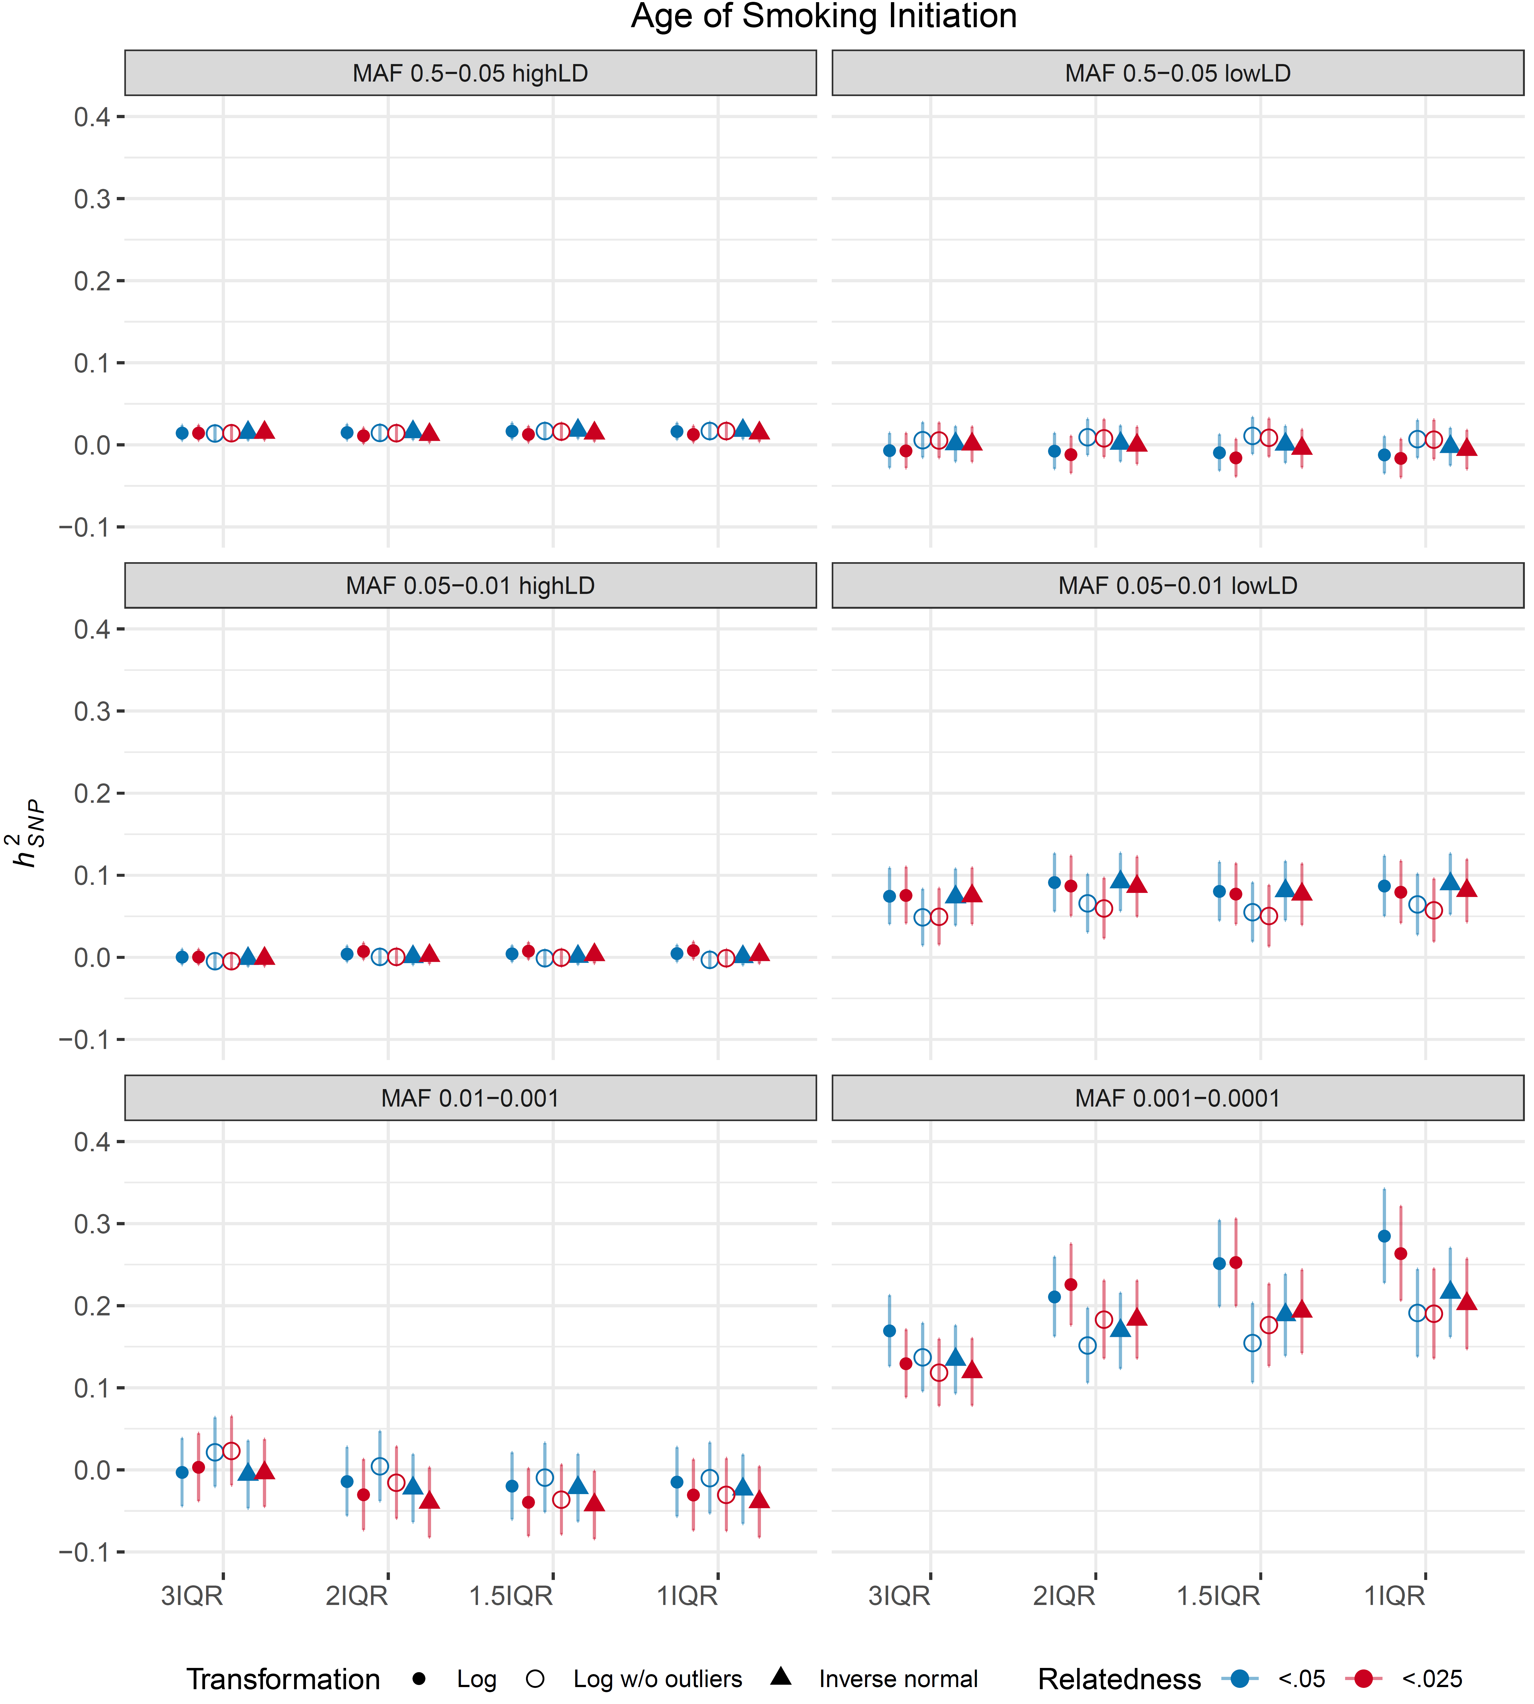 Figure S1. Sensitivity analysis of Age of Smoking Initiation. Shape indicates phenotype transformation method (Log: log transformation of residuals, Log w/o outliers: log transformation of residuals after removing outliers, inverse normal: rank-based inverse normal transformation of residuals). Colors indicate relatedness thresholds by which samples are filtered (red: .025, blue: .05). X-axis indicates ancestral variation filter with 1QR being the most conservative and 3IQR being the most liberal. Six different grids indicate heritability estimates for each LDMS bin.

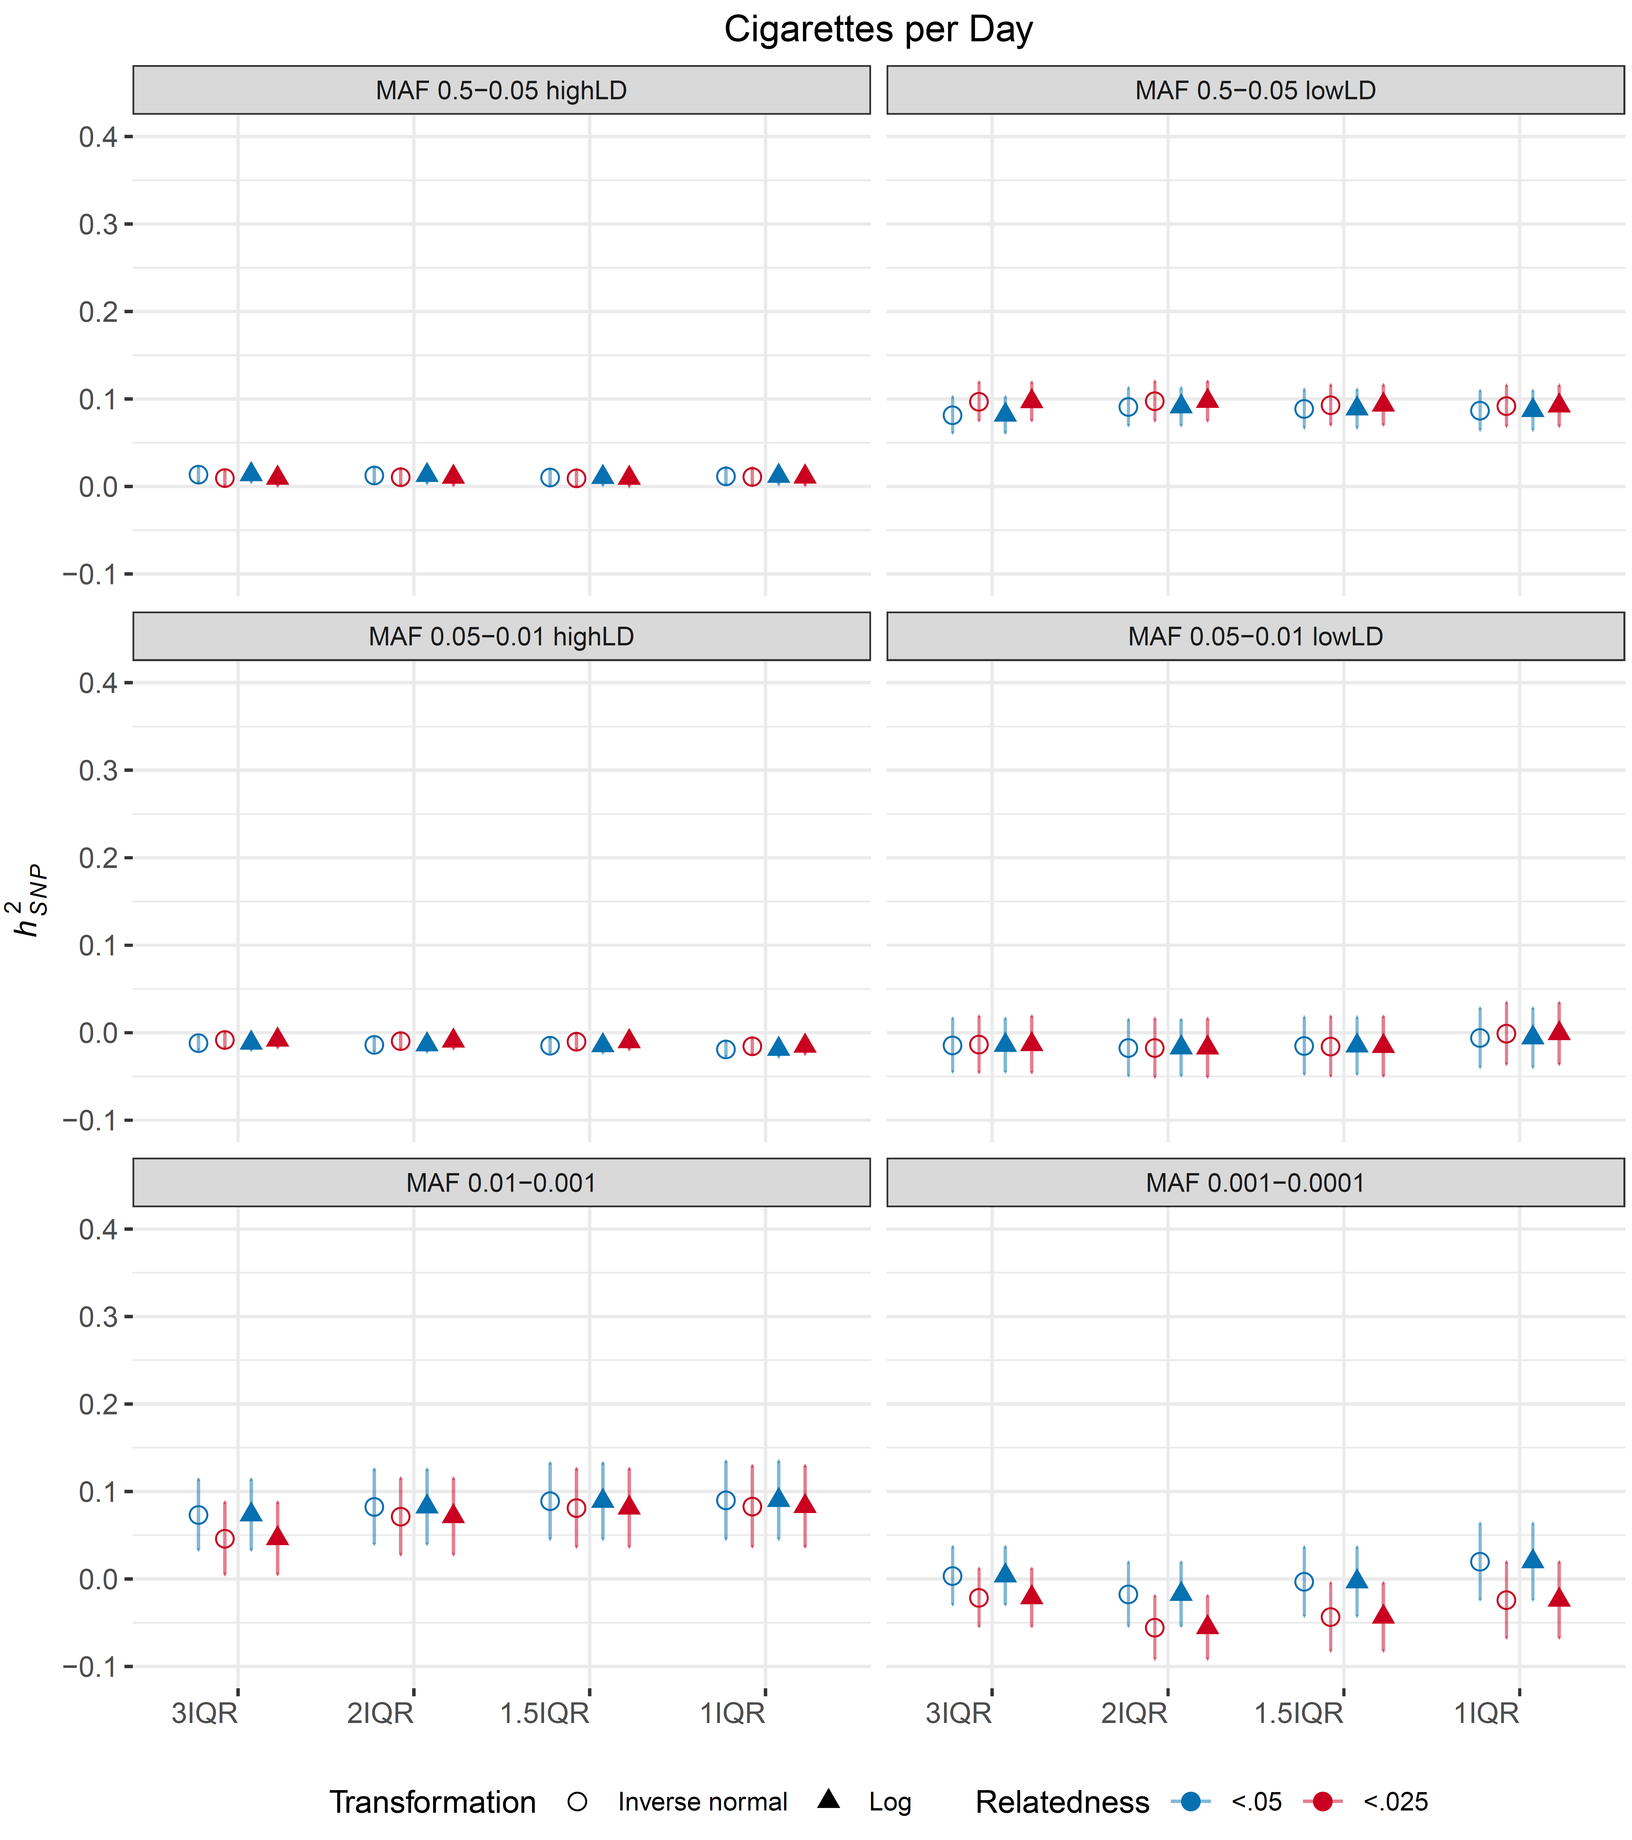
Figure S2. Sensitivity analysis of cigarettes per day. Shape indicates phenotype transformation method (Log: log transformation of residuals, inverse normal: rank-based inverse normal transformation of residuals). Colors indicate relatedness thresholds by which samples are filtered (red: .025, blue: .05). X-axis indicates ancestral variation filter with 1QR being the most conservative and 3IQR being the most liberal. Six different grids indicate heritability estimates for each LDMS bin.

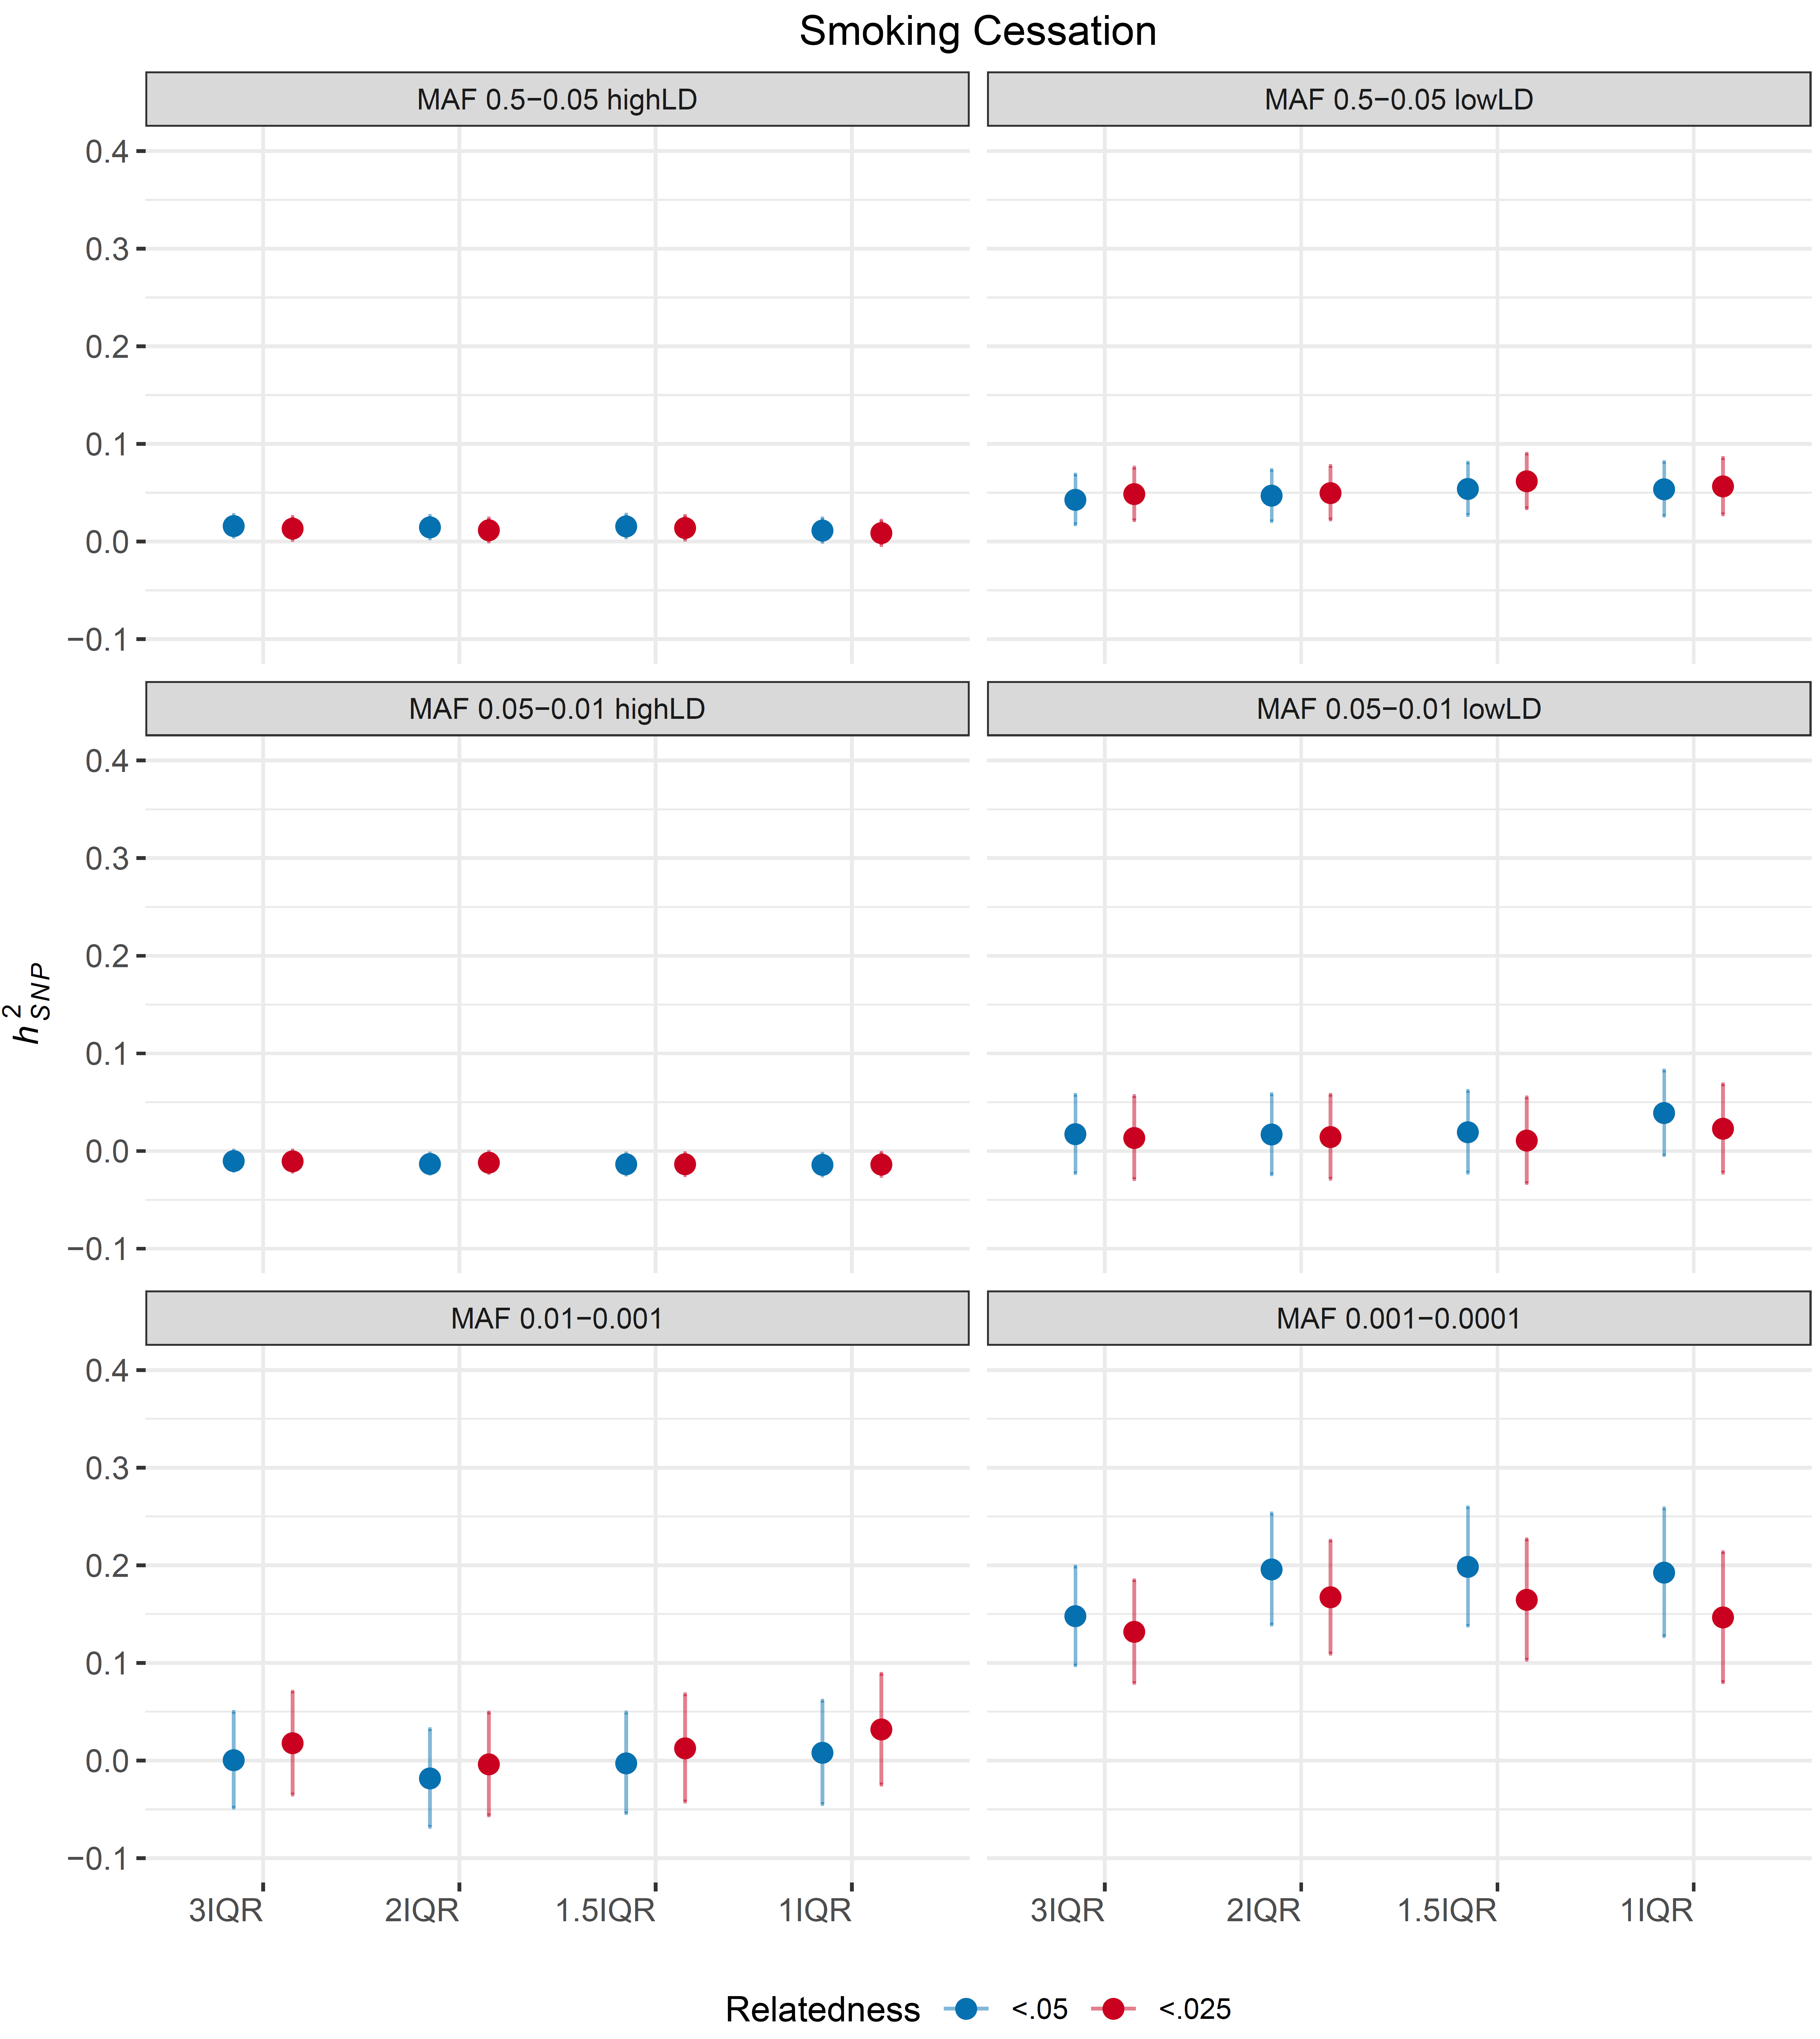
Figure S3. Sensitivity analysis of smoking cessation. Colors indicate relatedness thresholds by which samples are filtered (red: .025, blue: .05). X-axis indicates ancestral variation filter with 1QR being the most conservative and 3IQR being the most liberal. Six different grids indicate heritability estimates for each LDMS bin.

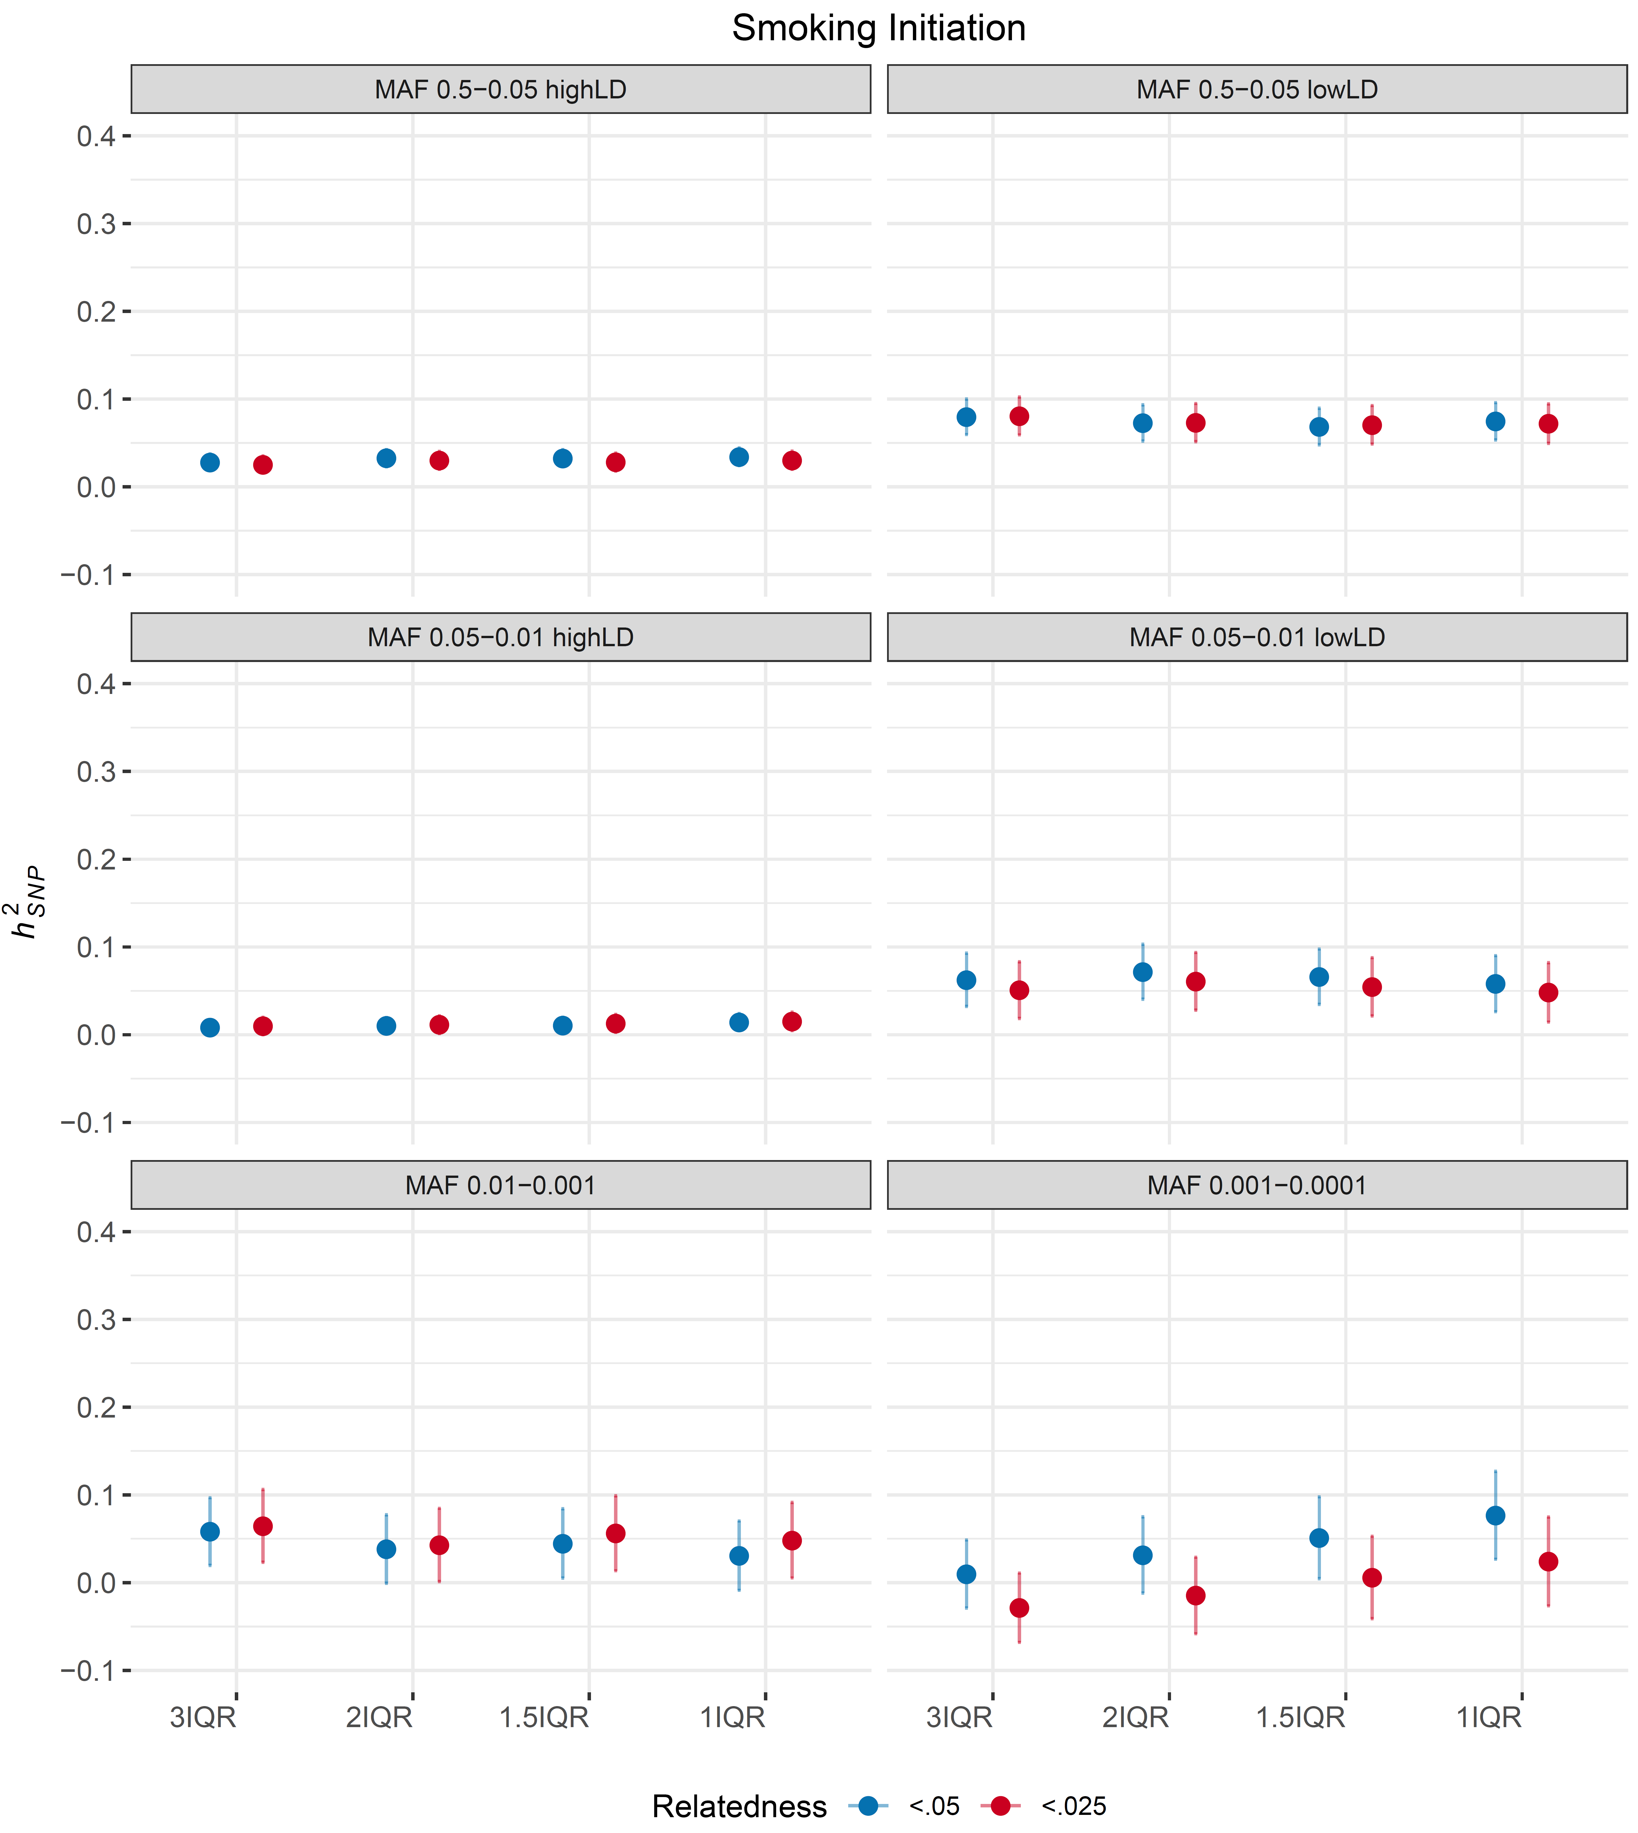
Figure S4. Sensitivity analysis of smoking cessation. Colors indicate relatedness thresholds by which samples are filtered out (red: .025, blue: .05). X-axis indicates ancestral variation filter with 1QR being the most conservative and 3IQR being the most liberal. Six different grids indicate heritability estimates for each LDMS bin.

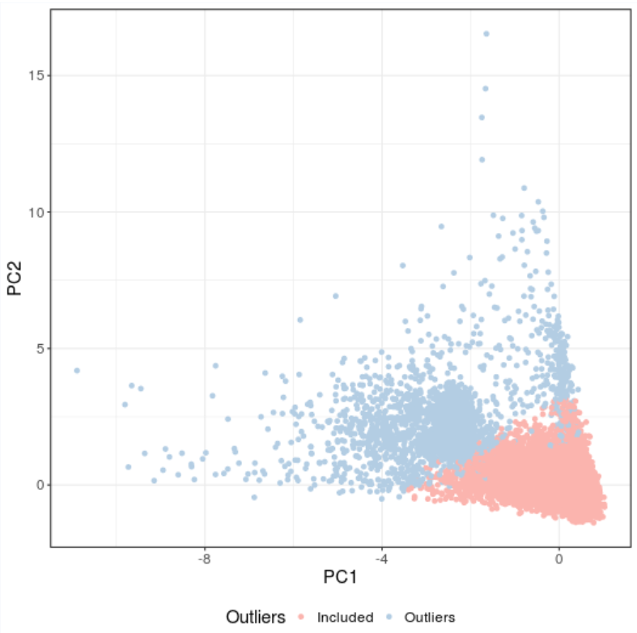
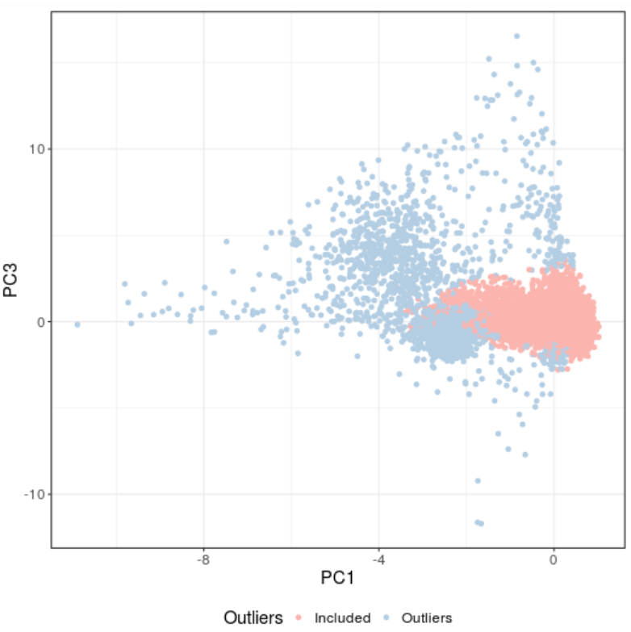
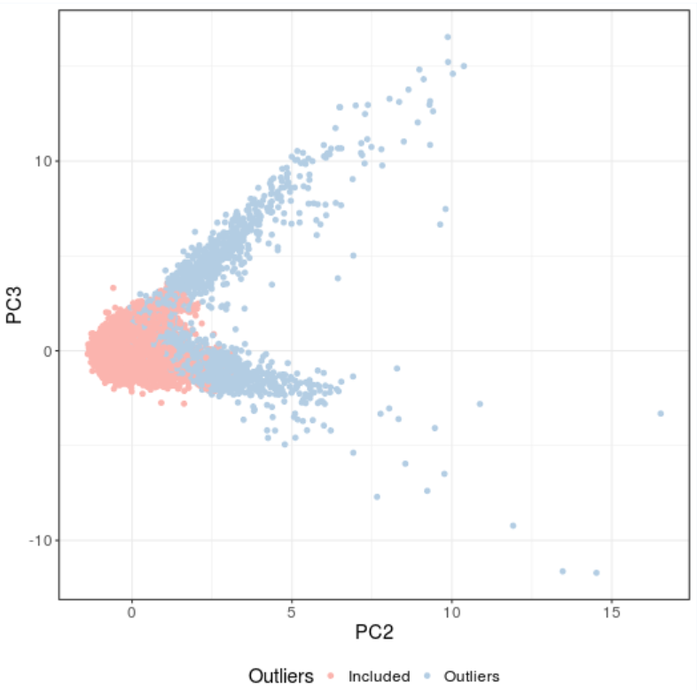
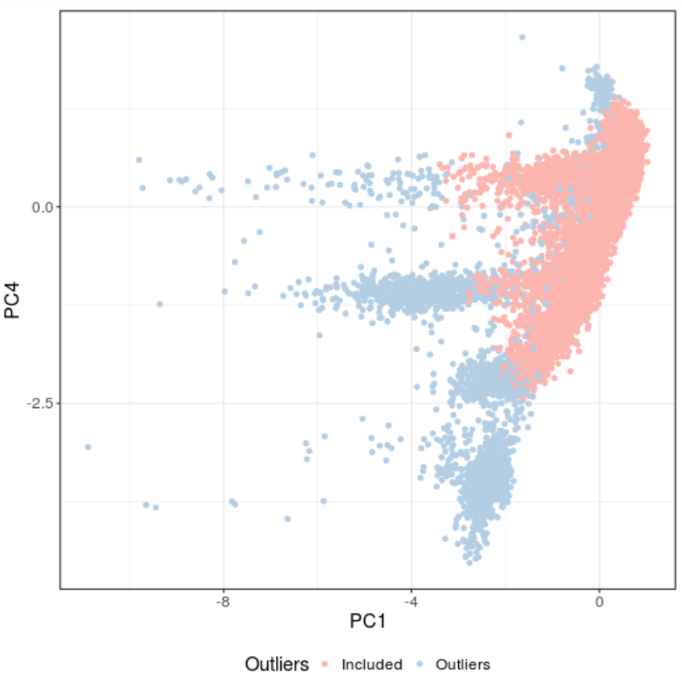
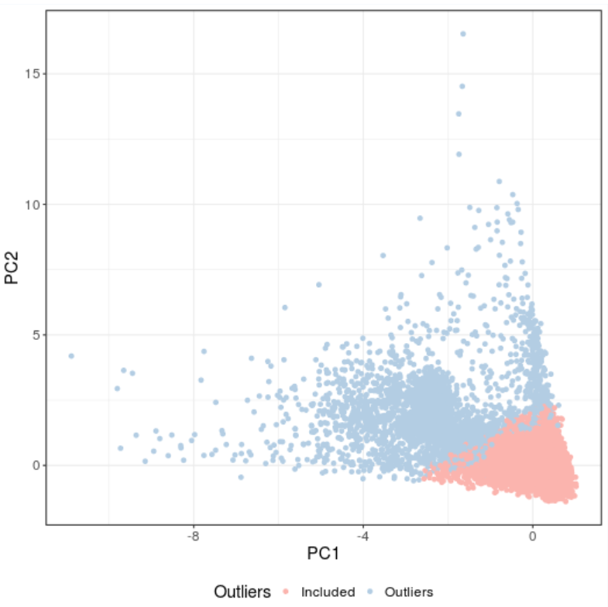
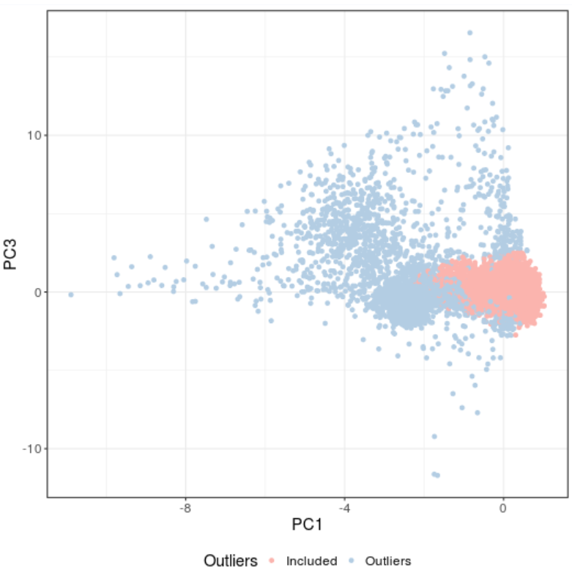
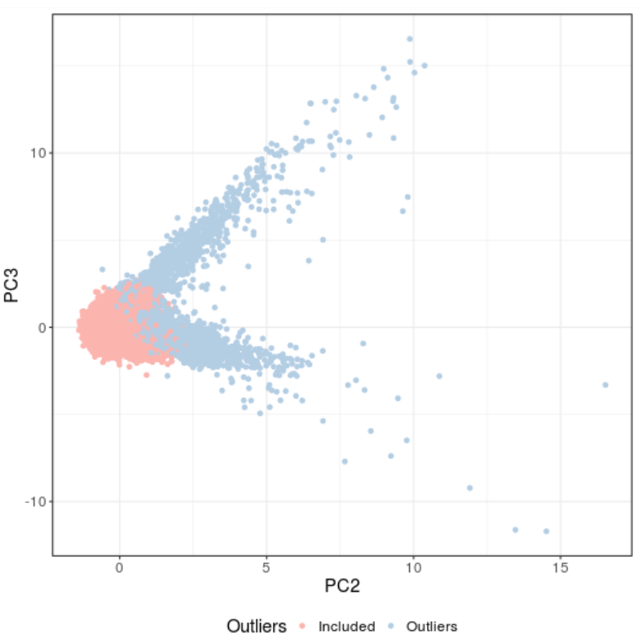
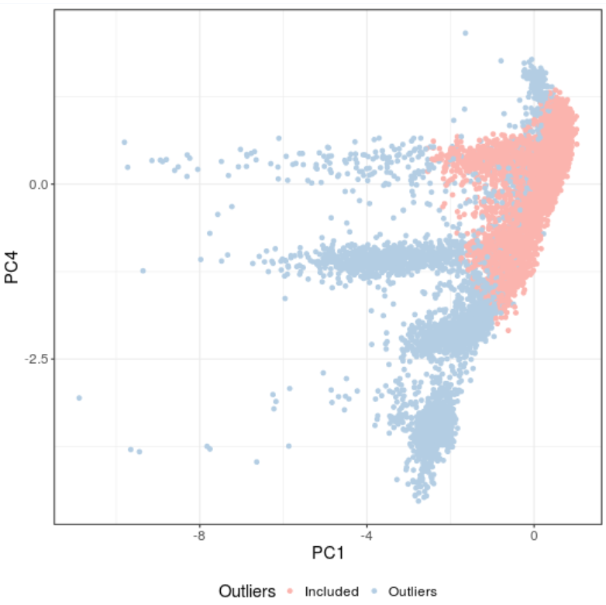
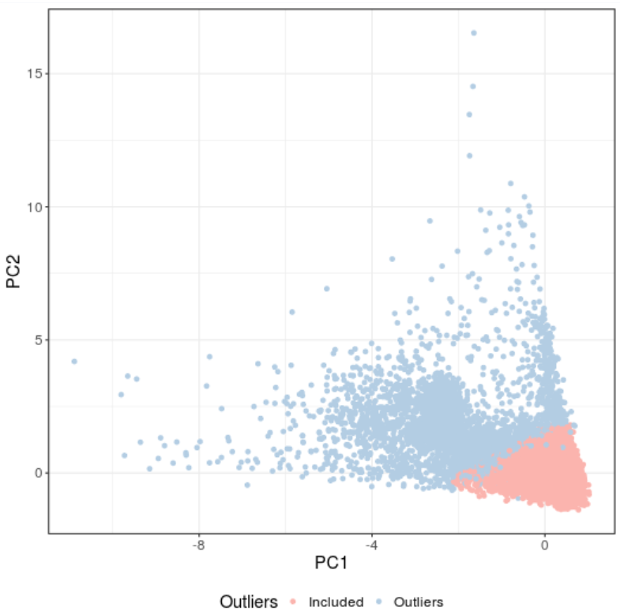
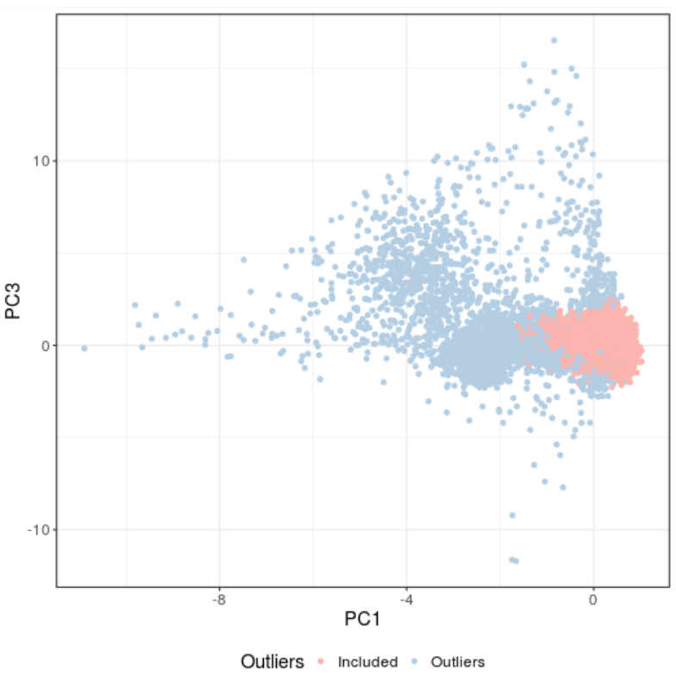
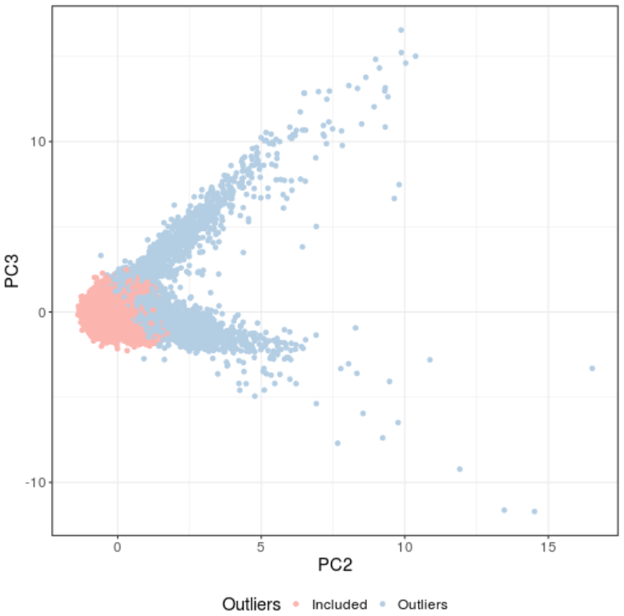
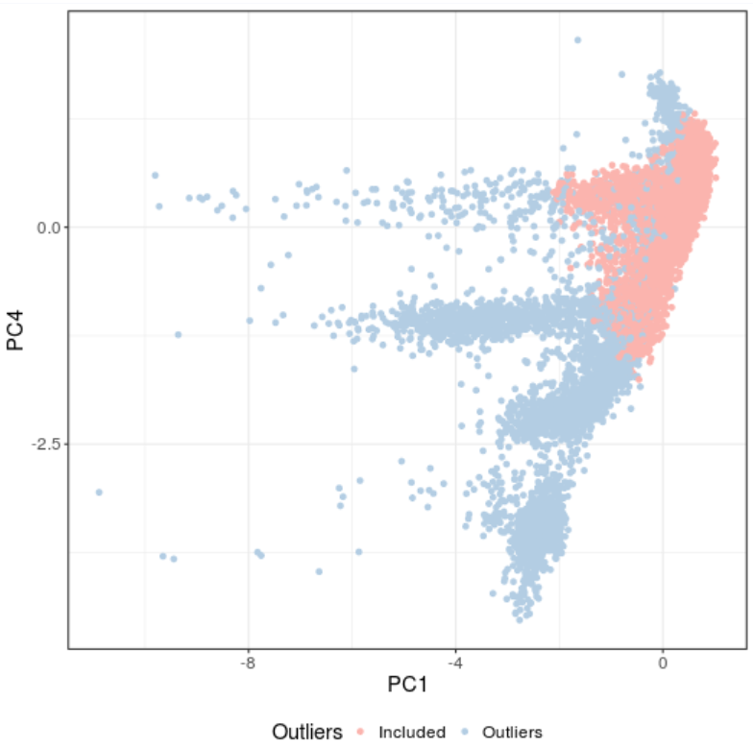
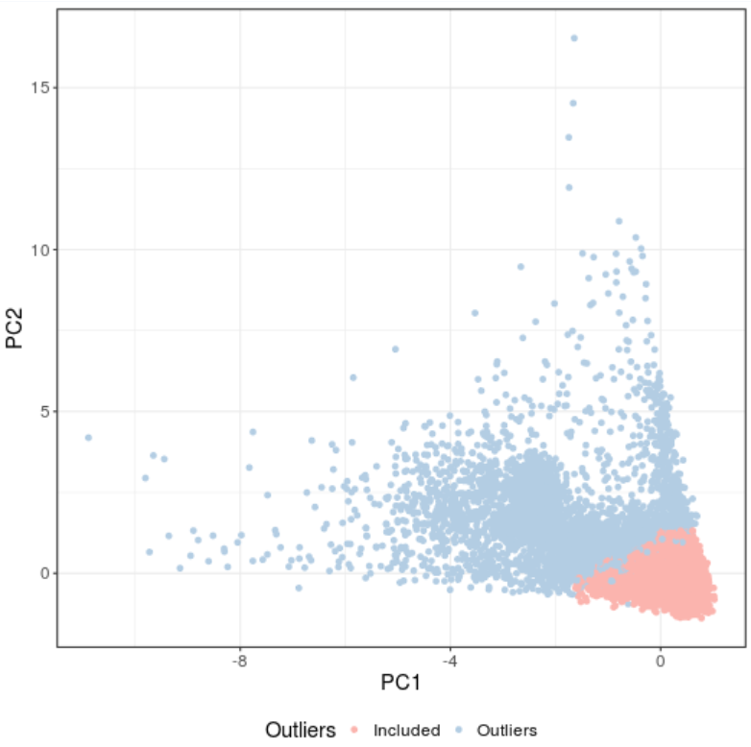
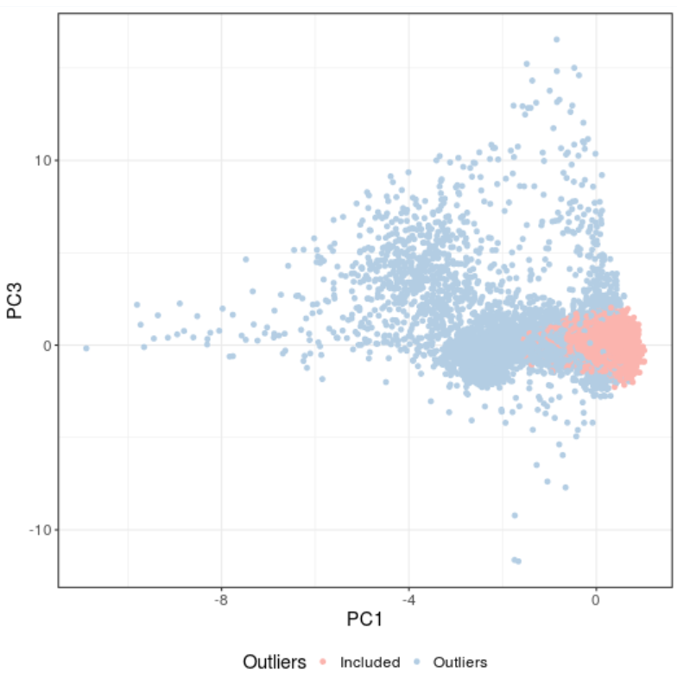
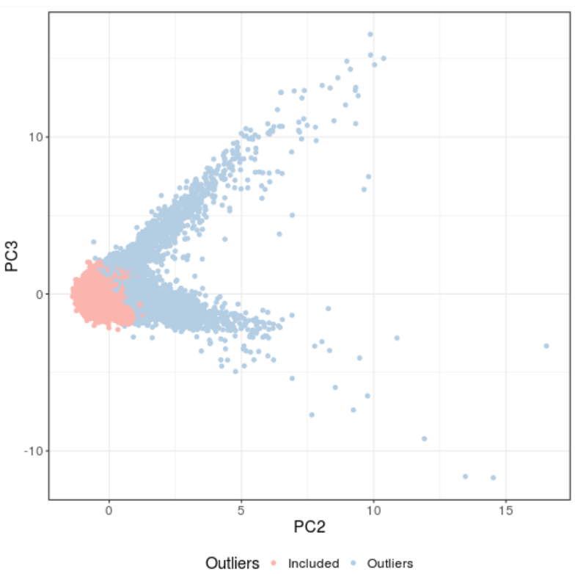
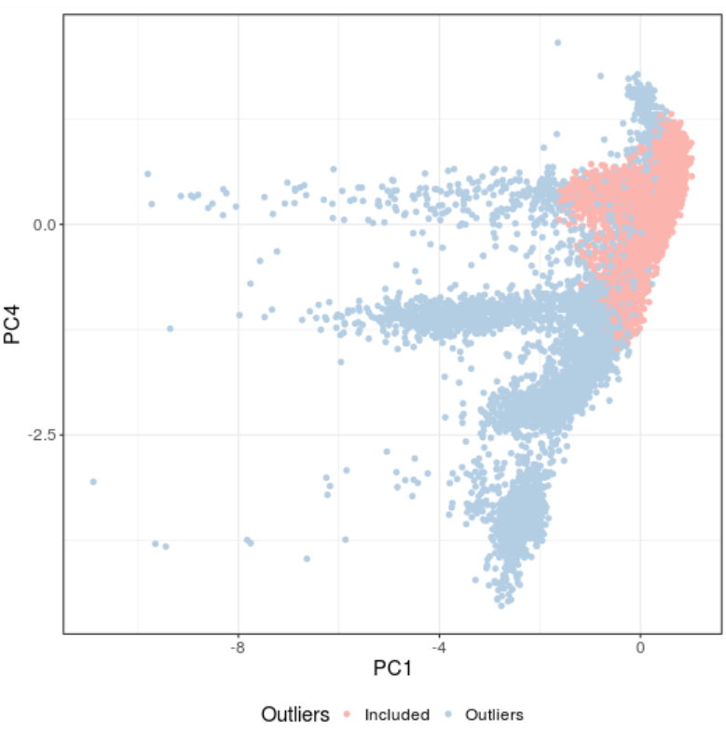
Figure S5. Principal components 1-4 of four different IQR samples. A, B, C, D each shows samples lying inside the 3*IQR, 2*IQR, 1.5*IQR, and 1*IQR range of the Euclidian distance of the PC 1 to 4. Red and blue dots each indicate samples included and excluded, respectively.
A
B
C
D

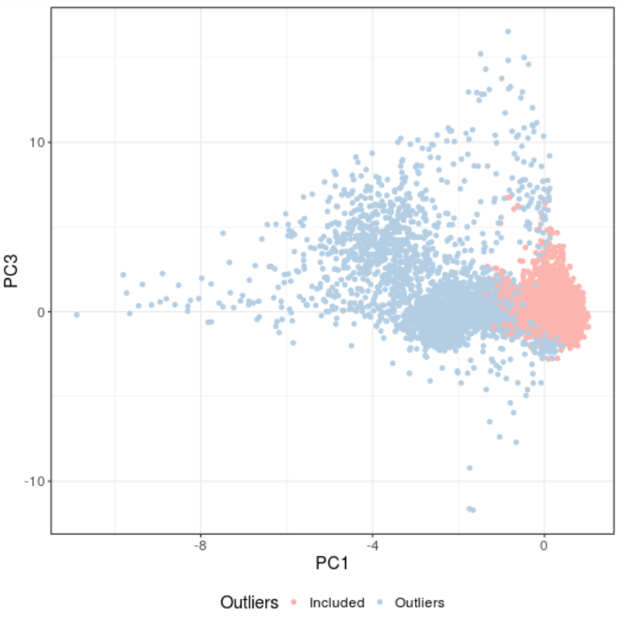
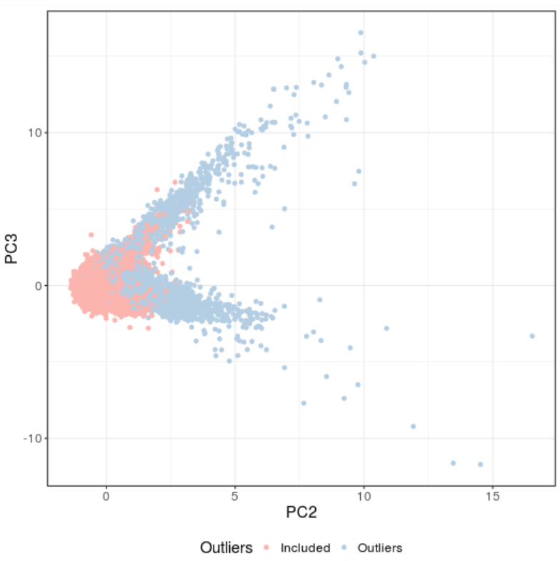
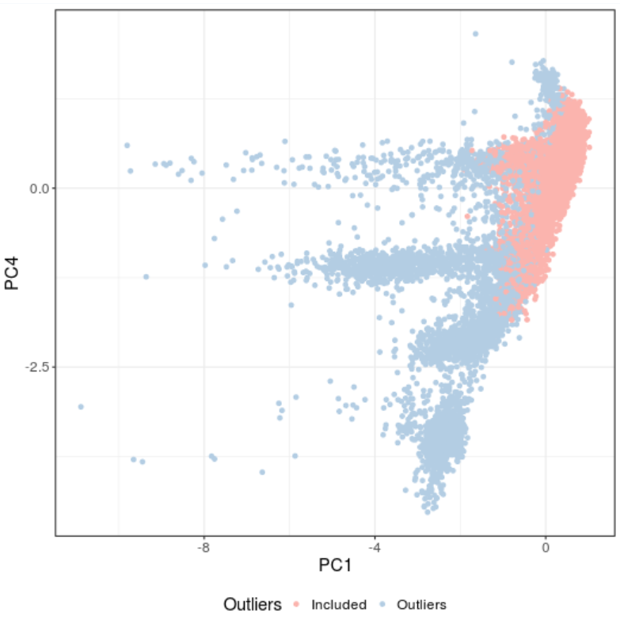
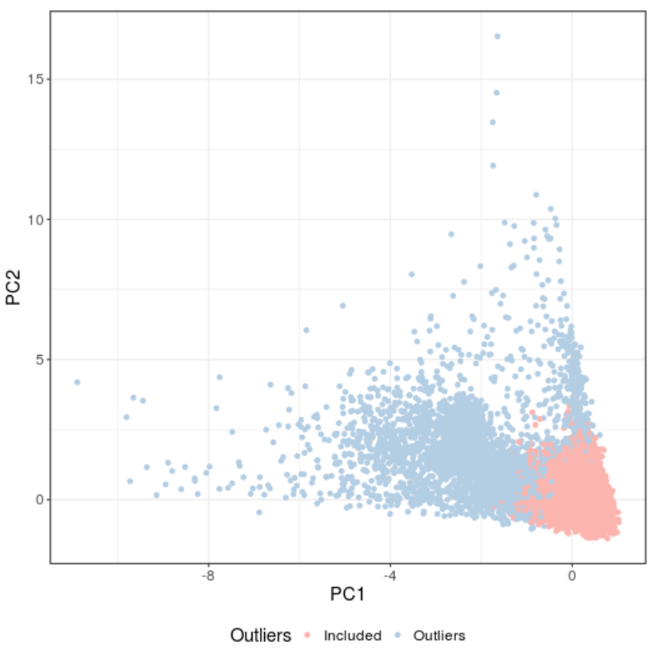
Figure S6. Principal components (PC) 1-4 of samples (red color) having PC scores within 6SD of PC1 and 2 of CEU group in 1000 Genome.

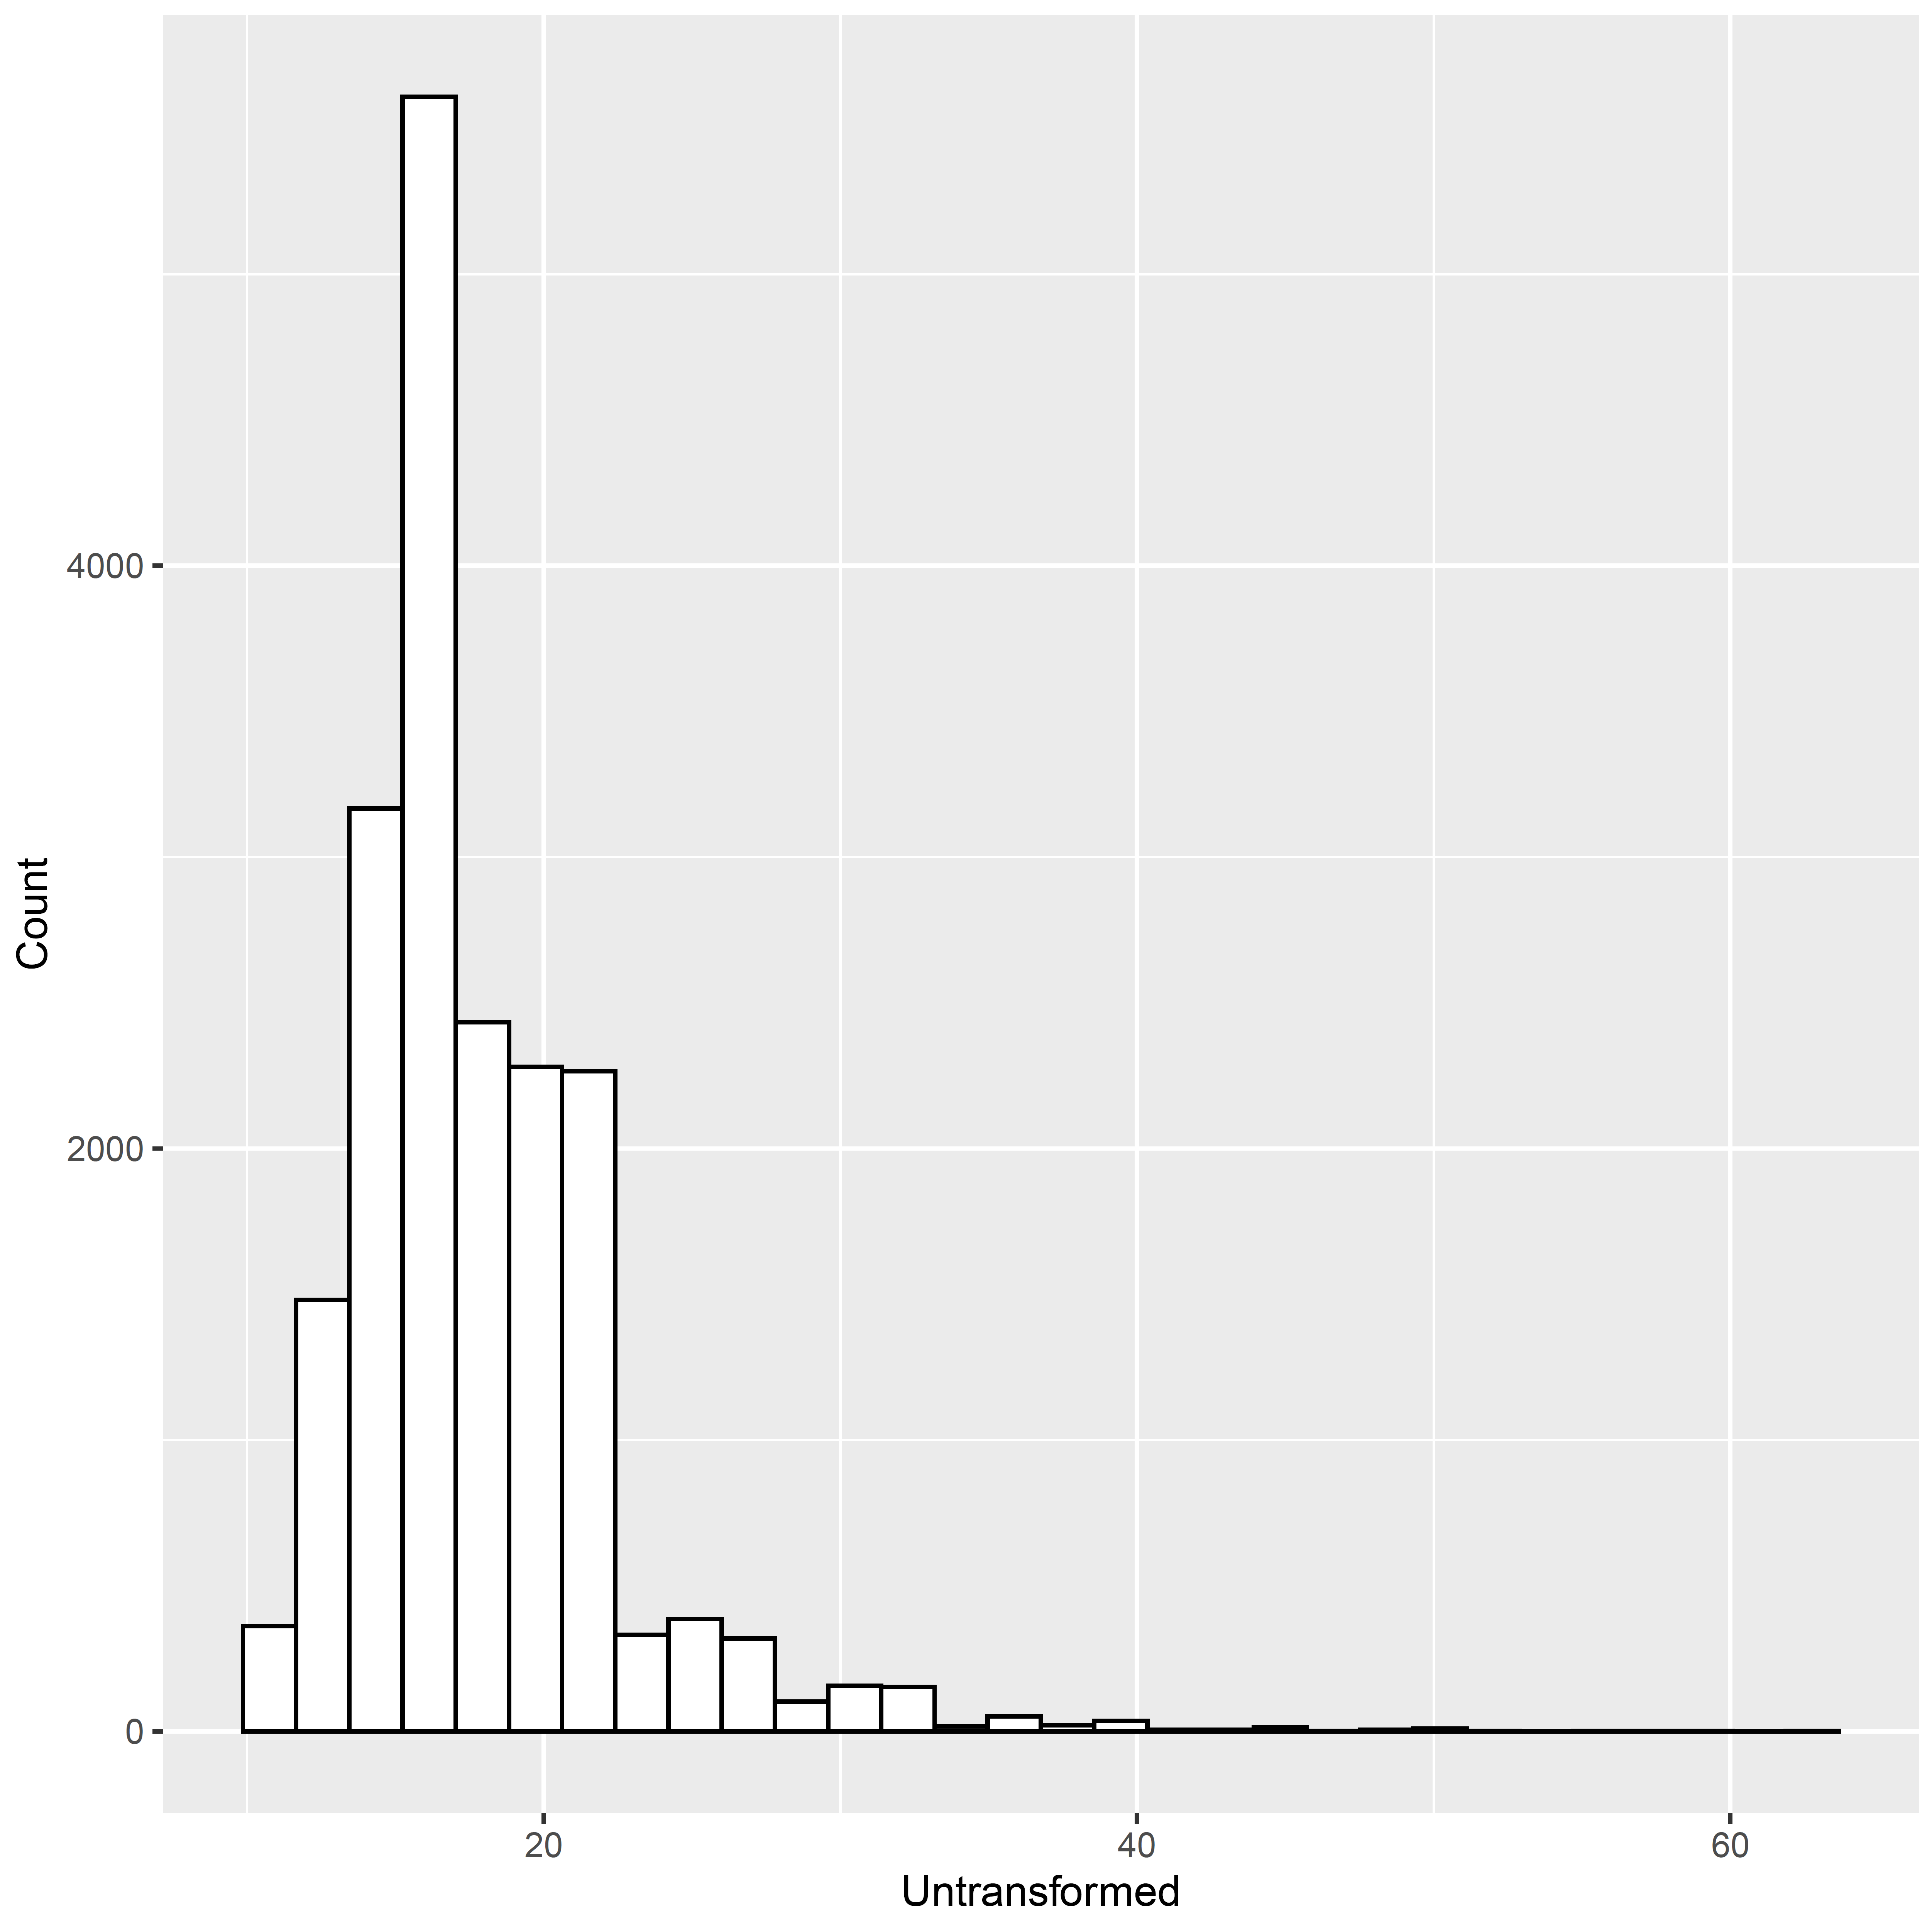
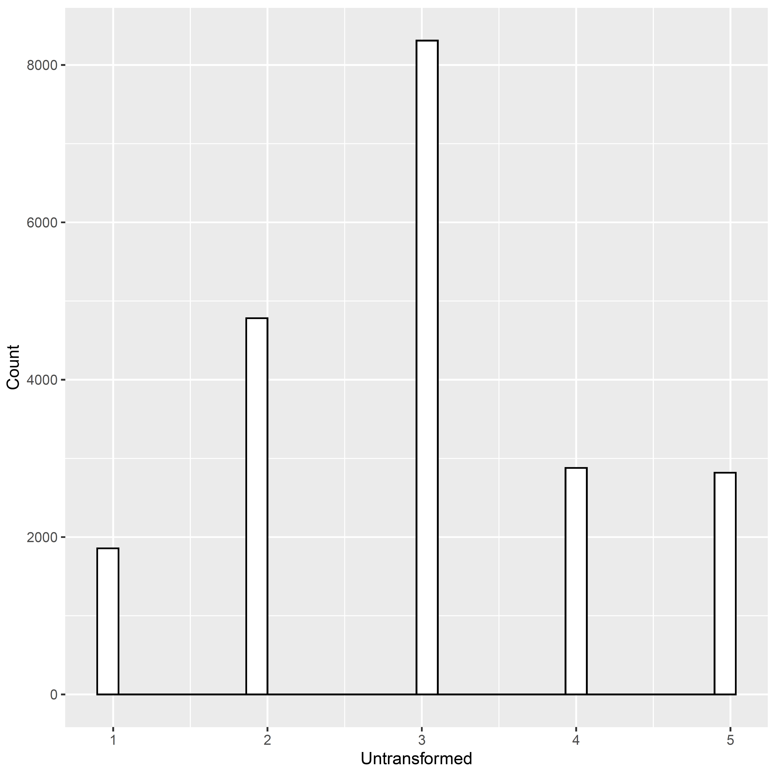
Age of Smoking Initiation
Cigarettes per Day

Figure S7. Phenotypic distribution before and after inverse normal transformation of residuals for quantitative phenotypes

