Halide perovskite and polymer composite film for bright light emitting devices

Maoding Cheng,^{a,b} Brooke Robinson,^{b} Manoj Shah,^{b} Araceli Herrera Mondragon,^{c} Roberto Gonzalez Rodriguez,^{c} Jingbiao Cui,^{c} Yuankun Lin,^{c} Anupama B. Kaul,^{d} Fumiya Watanabe,^{e} Grant Wangila,^{b} Mansour Mortazavi,^{b} Chao Yan,^{a*} Zhanhu Guo,^{f*} Qinglong Jiang^{b*}
ª School of Material Science and Engineering, Jiangsu University of Science and Technology, Zhenjiang, Jiangsu, 212100, PRC
^{b} Department of Chemistry and Physics, University of Arkansas, Pine Bluff, AR, 71601, USA
^{c} Department of Physics, University of North Texas, Denton, TX, 76203, USA
^{d} Department of Electrical Engineering, University of North Texas, Denton, TX, 76207
^{e} Center for Integrative Nanotechnology Sciences, University of Arkansas at Little Rock, Little Rock, AR, 72204,USA
^{f} Mechanical and Construction Engineering, Faculty of Engineering and Environment, Northumbria University, Newcastle Upon Tyne, NE18, UK
*Corresponding authors:
Chao Yan, E-mail: chaoyan@just.edu.cn; Zhanhu Guo, E-mail: zhanhu.guo@northumbria.ac.uk; Qinglong Jiang, E-mail: jiangq@uapb.edu

Experimental Section
Materials: Cesium bromide (CsBr, 99%, metals basis), Lead(Ⅱ) bromide (PbBr2, 98%), Dimethyl Sulfoxide (DMSO, GC Headspace Grade), Poly(ethylene oxide), Poly(methyl methacrylate) and Polyvinylpyrrolidone were purchased from Fisher Scientific. The white light emitting device was excited by a 365 nm optical wick which was purchased from Shenzhen Looking Long Technology company.
Device Fabrication: The preparation method for the Cs₄PbBr₆ precursor solution involved dissolving PbBr₂ and CsBr in a molar ratio of 1:4 in anhydrous DMSO at a concentration of 150 mg/mL. The FTO glass substrates were ultrasonically cleaned with detergent water, deionized water, acetone, and isopropanol for 5 minutes each. After drying, they were treated with plasma for 15 minutes. The perovskite solution was spin-coated onto the FTO glass and then placed in a vacuum oven at 120 °C, heating for 24 hours to obtain Cs₄PbBr₆ crystals. To this perovskite solution, 10 wt% PEO was added and stirred at 100 °C for 30 minutes. The mixed solution was then spin-coated onto the wick surface. The wick was placed in a vacuum oven at 120 °C and heated for 24 hours.
Measurements and Characterizations: Scanning Electron Microscope (SEM) used in the observations of our materials is JEOL JSM-7000F (JEOL USA, Peabody, MA) with a Schottky Field Emission gun. Samples were mounted on conductive glass substrates, and the images were captured at 15 kV bias without extra conductive coating. Optical images of the sample surface were captured using an AmScope MU900 High-performance Color CMOS C-Mount Microscope Camera. Fourier transform infrared spectroscopy (FTIR) spectra were carried out by commercial FTIR system (Ominic). Luminance−voltage and efficiency-voltage characteristics were measured on the programmed LabVIEW software controlling Keithely-6800+ Keithely-2410 system. PL spectra were measured using an Ocean Optics Compact Spectrometer UV-Vis Fiber Spectrometer Laboratory Spectrometer.

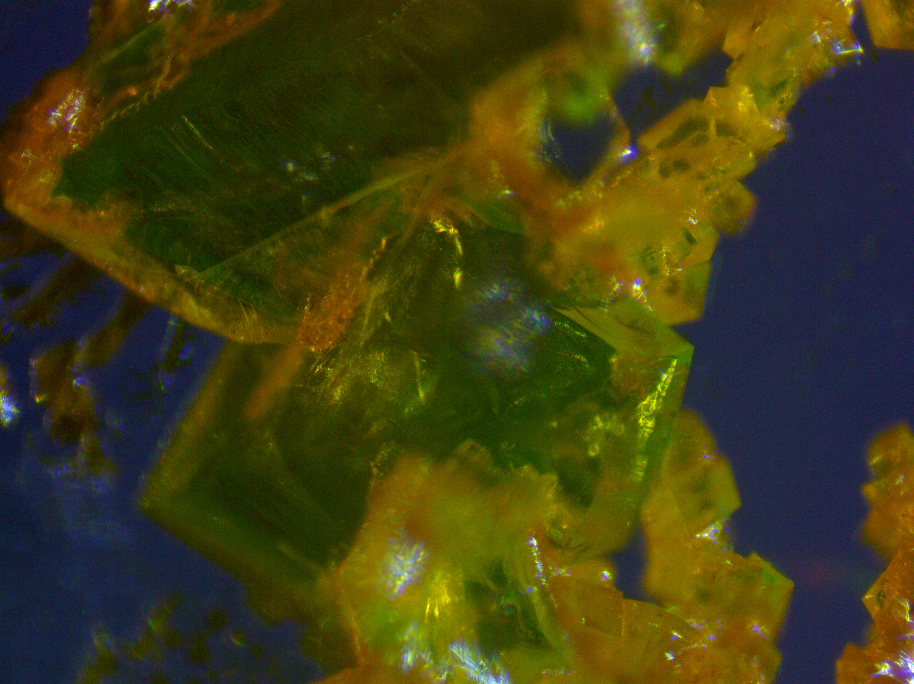
Fig. S1 Cs₄PbBr₆ and CsPbBr₃ crystals

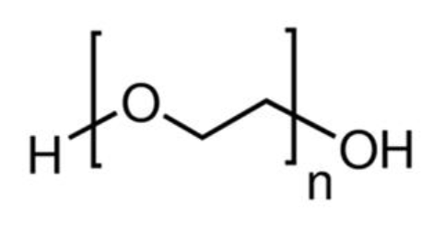
Fig. S2 Chemical structure of the PEO polymer

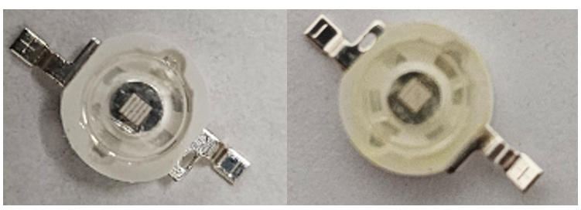
Fig. S3 Comparison of wick before and after spin-coating with Cs₄PbBr₆-PEO composite film

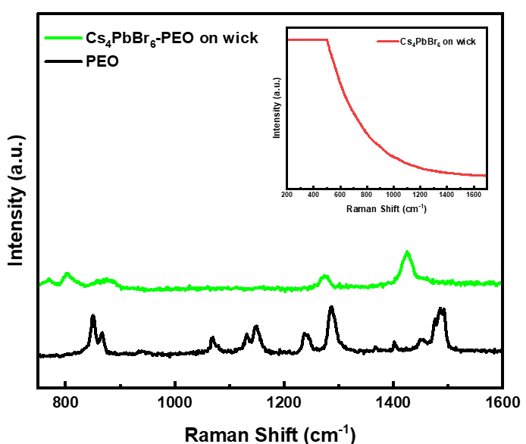
Fig. S4 Raman spectra of Cs₄PbBr₆-PEO composite film on wick, PEO and Cs₄PbBr₆ film on wick

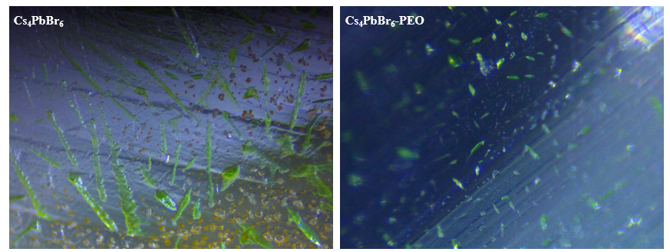
Fig. S5 Surface morphology of Cs₄PbBr₆ film and Cs₄PbBr₆-PEO film after several days in an indoor environment

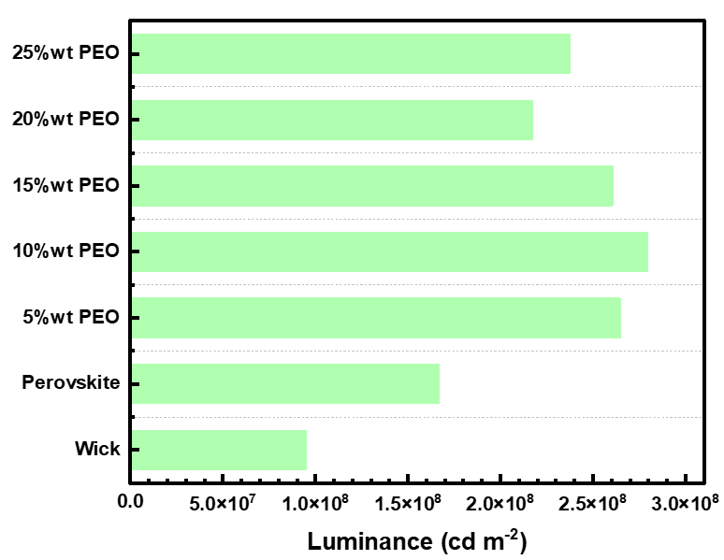
Fig. S6 Luminance of Different PEO concentrations in perovskite films

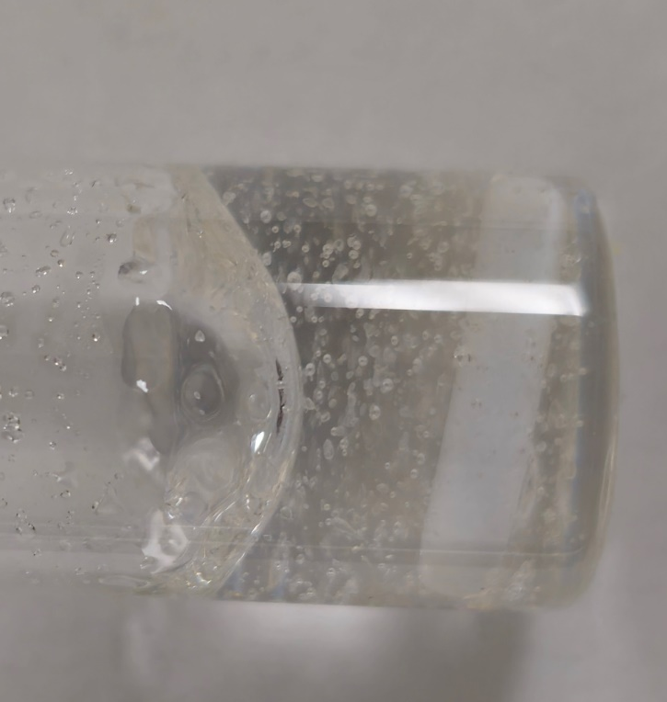
Fig. S7 Overloaded PEO and perovskite composite solution showing phase separation

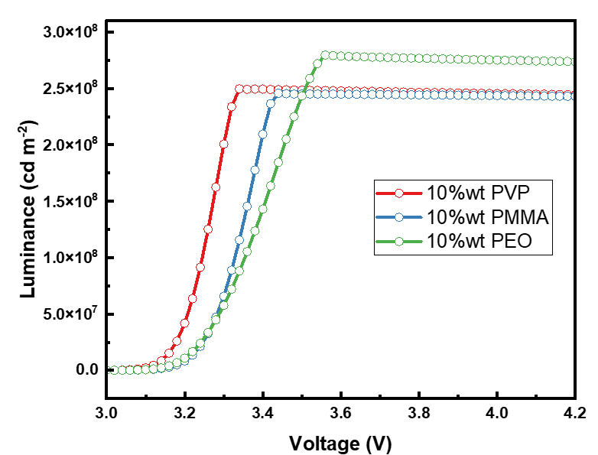S
Fig. S8 Luminance vs. Voltage for Different Polymer concentrations in perovskite films

