Pharmacokinetic study of carboplatin using various overweight-correcting dosing algorithms and biomarkers in patients with varying BMI categories

M.P. Kicken^{1,3,7}, C. Bethlehem, PharmD^{1,2}, K. Beunen, MSc⁴, Y. P. de Jong, MD⁵, T. van Voorthuizen, MD⁴; J.J. van den Hudding, PharmD¹; D.J.A.R. Moes, PharmD PhD⁶; M. van Luin, PharmD PhD^{1,8}; R. ter Heine⁷; H.J.M. Smit, MD PhD⁵; P.M.G. Filius, PharmD PhD¹; M.J. Deenen, PharmD PhD^{1,3,6}

¹ Department of Clinical Pharmacy, Rijnstate Hospital, Arnhem, the Netherlands
² Department of Clinical Pharmacy, Erasmus University Medical Center, Rotterdam, the Netherlands
³ Department of Clinical Pharmacy, Catharina Hospital, Eindhoven, the Netherlands
⁴ Department of Internal Medicine, Rijnstate Hospital, Arnhem, the Netherlands
⁵ Department of Pulmonology, Rijnstate Hospital, Arnhem, the Netherlands
⁶ Department of Clinical Pharmacy and Toxicology, Leiden University Medical Center, Leiden, the Netherlands
⁷ Department of Pharmacy, Radboud University Medical Center, Radboud Institute for Health Sciences, Nijmegen, the Netherlands
⁸ Department of Clinical Pharmacy, Meander Medical Center, Amersfoort, the Netherlands

SUPPLEMENTARY MATERIAL

Supplementary Table S1: formulas

Calvert formula [1]
$$DOSE \left[mg\right]={AUC}_{target}*(GFR+25)$$

Cockcroft Gault formula [2]
$$eGFR=estimated CrCL [mL/min]=\frac{\left(140-AGE\right)*WEIGHT}{0.815*{Cr}_{SERUM}}*0.85 \left[IF FEMALE\right]$$

Bénézet formula [3]
$$Bénézet [kg]=(IBW+ABW)*0.512$$

Schmitt et al. cystatin C formula [4]
$$CL [mL/min]=117.8*{\left(\frac{{Cr}_{SERUM}}{75}\right)}^{-0.450}*{\left(\frac{cystatin C}{1.0}\right)}^{-0.385}*{\left(\frac{WEIGHT}{65}\right)}^{+0.504}*{\left(\frac{AGE}{56}\right)}^{-0.366}*0.847 [IF FEMALE]$$

Flat dosing [5, 6]
$$Flat dosing \left[mg\right]=carboplatin population clearance \left[mL/min\right]*target AUC [mL/min*min]$$

CKD-EPI creatinine formula [7]
$$eGFR [mL/min/1.73m^{2}]=142*{\left(\frac{{Cr}_{SERUM}}{A}\right)}^{B}*{0.9938}^{AGE}*1.012 [IF FEMALE]$$

If female and:  - Serum creatinine ≤ 0.7: use A = 0.7 and B = -0.241  - Serum creatinine > 0.7: use A = 0.7 and B = -1.200 | If male and:  - Serum creatinine ≤ 0.9: use A = 0.9 and B = -0.302  - Serum creatinine > 0.9: use A = 0.9 and B = -1.200

CKD-EPI creatinine + cystatin C formula [7]
$$eGFR [mL/min/1.73m^{2}]=135*{\left(\frac{{Cr}_{SERUM}}{A}\right)}^{B}*{\left(\frac{{cystatin C}_{SERUM}}{C}\right)}^{D}*{0.9961}^{AGE}*0.963 [IF FEMALE]$$

If female and:  - Serum creatinine ≤ 0.7 and serum cystatin C ≤ 0.8:  A = 0.7, B = -0.219, C = 0.8, and D = -0.323  - Serum creatinine ≤ 0.7 and serum cystatin C > 0.8:  A = 0.7, B = -0.219, C = 0.8, and D = -0.778  - Serum creatinine > 0.7 and serum cystatin C ≤ 0.8:  A = 0.7, B = -0.544, C = 0.8, and D = -0.323  - Serum creatinine > 0.7 and serum cystatin C > 0.8:  A = 0.7, B = -0.544, C = 0.8, and D = -0.778 | If male and:  - Serum creatinine ≤ 0.9 and serum cystatin C ≤ 0.8:  A = 0.9, B = -0.144, C = 0.8, and D = -0.323  - Serum creatinine ≤ 0.9 and serum cystatin C > 0.8:  A = 0.9, B = -0.144, C = 0.8, and D = -0.778  - Serum creatinine > 0.9 and serum cystatin C ≤ 0.8:  A = 0.9, B = -0.544, C = 0.8, and D = -0.323  - Serum creatinine > 0.9 and serum cystatin C > 0.8:  A = 0.9, B = -0.544, C = 0.8, and D = -0.778

REFERENCES S1
1. Calvert AH, Newell DR, Gumbrell LA, O'Reilly S, Burnell M, Boxall FE, et al. Carboplatin dosage: prospective evaluation of a simple formula based on renal function. J Clin Oncol. 1989;7(11):1748-56.
2. Cockcroft DW, Gault MH. Prediction of creatinine clearance from serum creatinine. Nephron. 1976;16(1):31-41.
3. Bénézet S, Guimbaud R, Chatelut E, Chevreau C, Bugat R, Canal P. How to predict carboplatin clearance from standard morphological and biological characteristics in obese patients. Ann Oncol. 1997;8(6):607-9.
4. Schmitt A, Gladieff L, Lansiaux A, Bobin-Dubigeon C, Etienne-Grimaldi MC, Boisdron-Celle M, et al. A universal formula based on cystatin C to perform individual dosing of carboplatin in normal weight, underweight, and obese patients. Clin Cancer Res. 2009;15(10):3633-9.
5. Ekhart C, de Jonge ME, Huitema AD, Schellens JH, Rodenhuis S, Beijnen JH. Flat dosing of carboplatin is justified in adult patients with normal renal function. Clin Cancer Res. 2006;12(21):6502-8.
6. Ekhart C, Rodenhuis S, Schellens JH, Beijnen JH, Huitema AD. Carboplatin dosing in overweight and obese patients with normal renal function, does weight matter? Cancer Chemother Pharmacol. 2009;64(1):115-22.
7. Inker LA, Eneanya ND, Coresh J, Tighiouart H, Wang D, Sang Y, et al. New Creatinine- and Cystatin C-Based Equations to Estimate GFR without Race. N Engl J Med. 2021;385(19):1737-49.

Supplementary Table S2: different concentration curves of each patient
PATIENT 1 (BMI < 25 kg/m²): AUC = 5.57 mg/mL*min
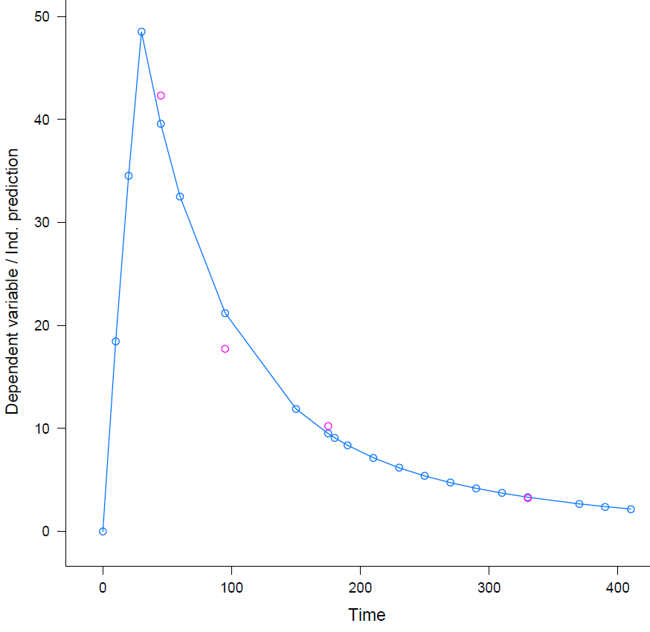

PATIENT 2 (BMI < 25 kg/m²): AUC = 5.49 mg/mL*min
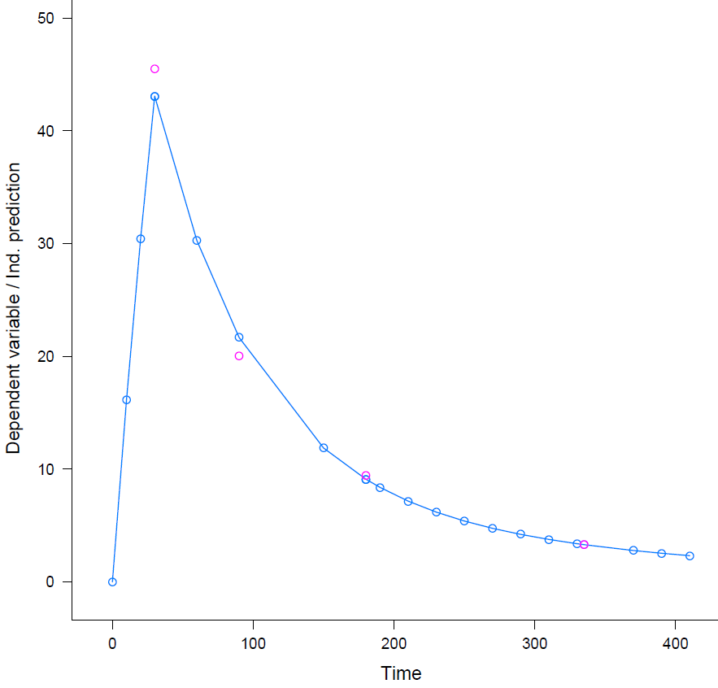
PATIENT 3 (BMI 25 – 30 kg/m²): AUC = 5.35 mg/mL*min
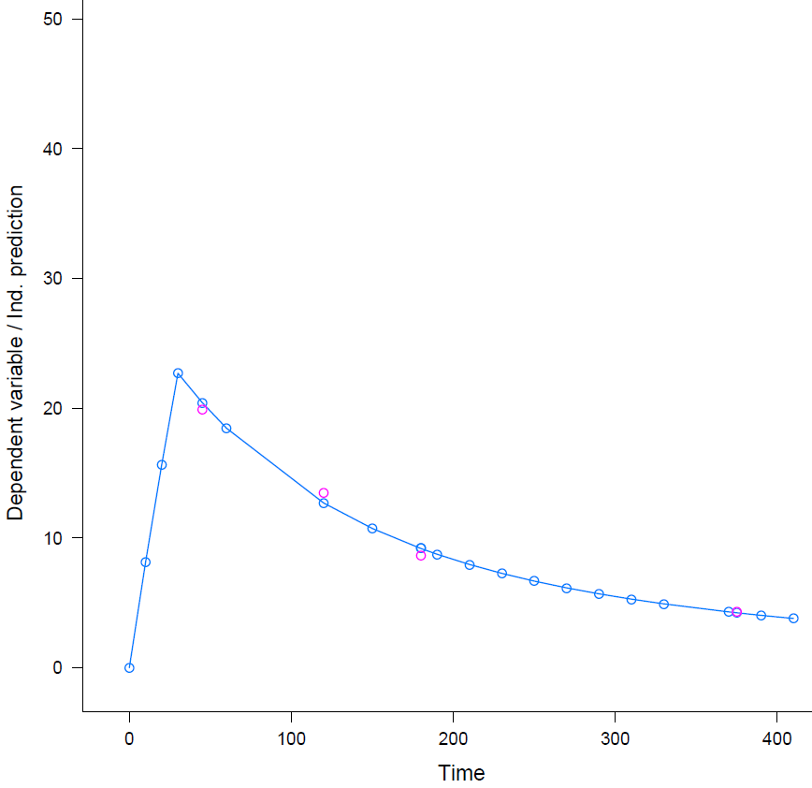

PATIENT 4 (BMI ≥ 30 kg/m²): AUC = 5.54 mg/mL*min
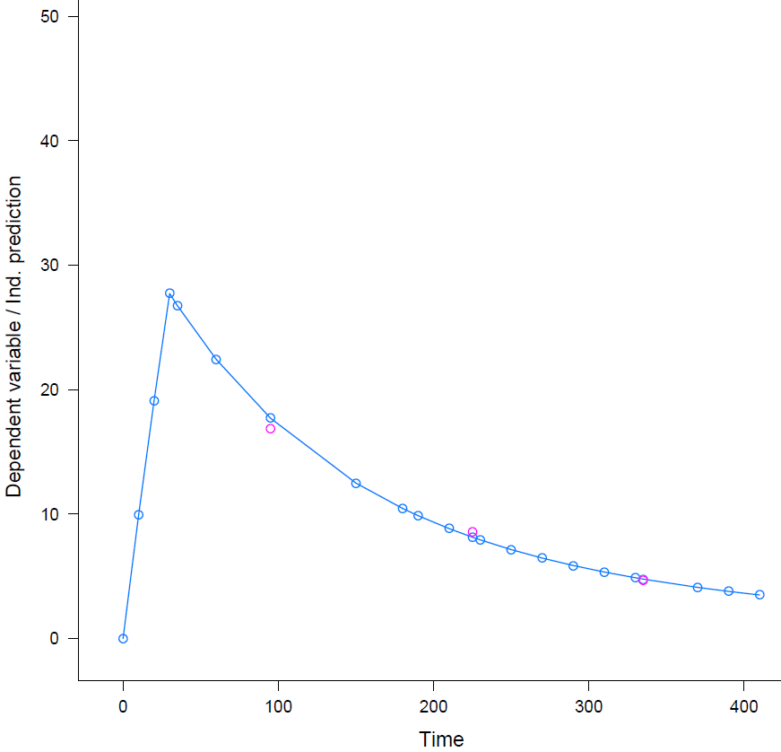
PATIENT 5 (BMI < 25 kg/m²): AUC = 6.49 mg/mL*min
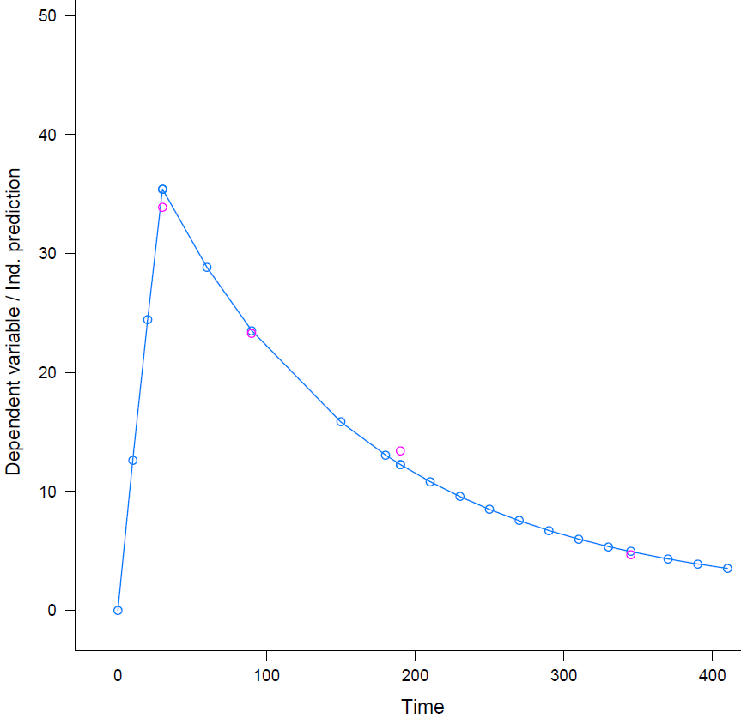

PATIENT 6 (BMI < 25 kg/m²): AUC = 5.72 mg/mL*min
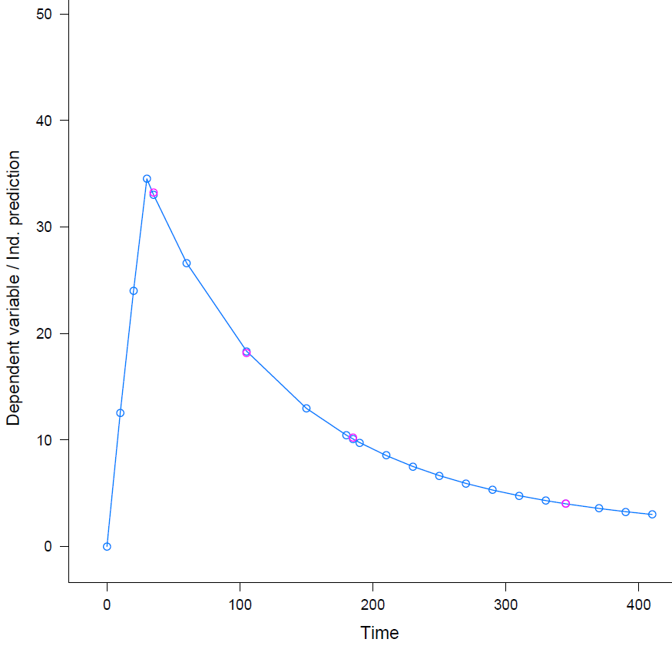
PATIENT 7 (BMI 25 – 30 kg/m²): AUC = 5.84 mg/mL*min
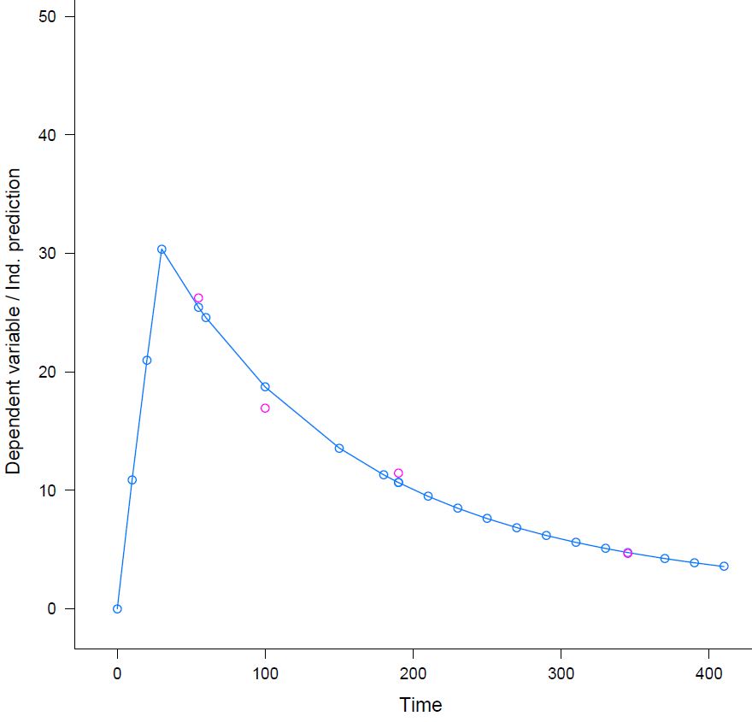

PATIENT 8 (BMI < 25 kg/m²): AUC = 4.81 mg/mL*min
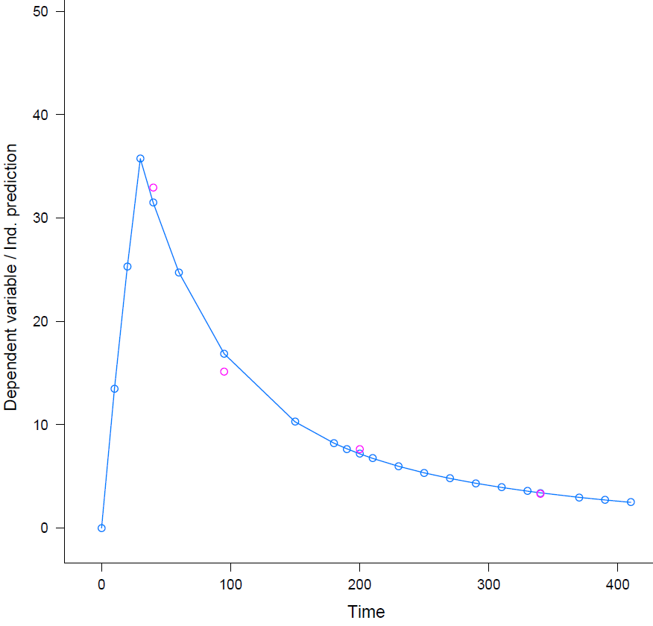
PATIENT 9 (BMI < 25 kg/m²): AUC = 5.29 mg/mL*min
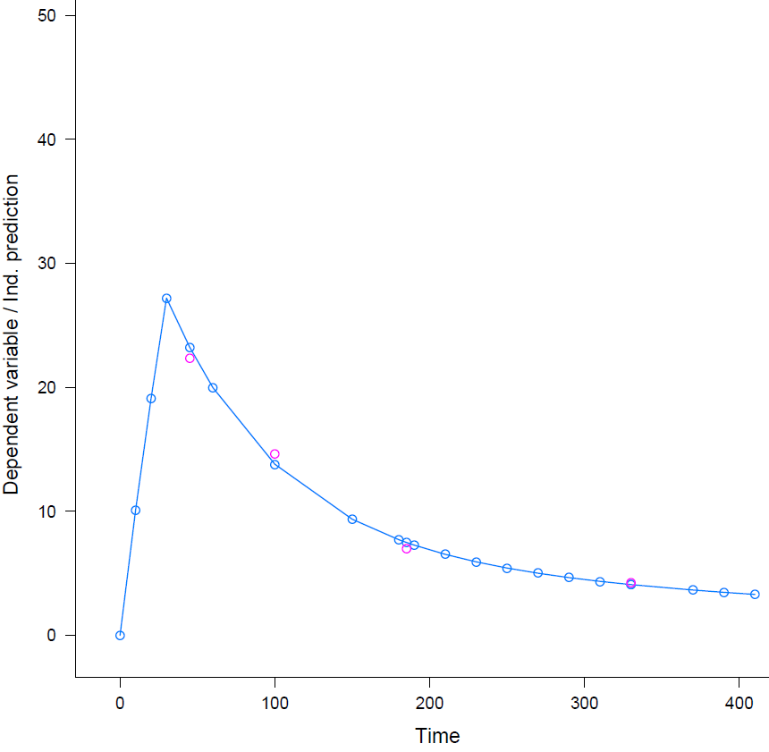

PATIENT 10 (BMI < 25 kg/m²): AUC = 5.77 mg/mL*min
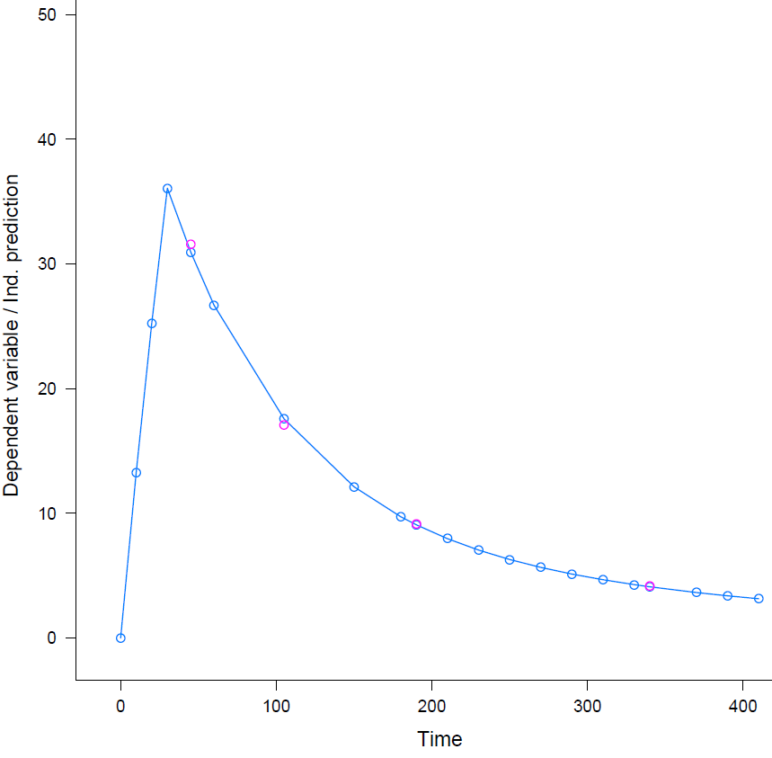
PATIENT 11 (BMI ≥ 30 kg/m²): AUC = 4.61 mg/mL*min
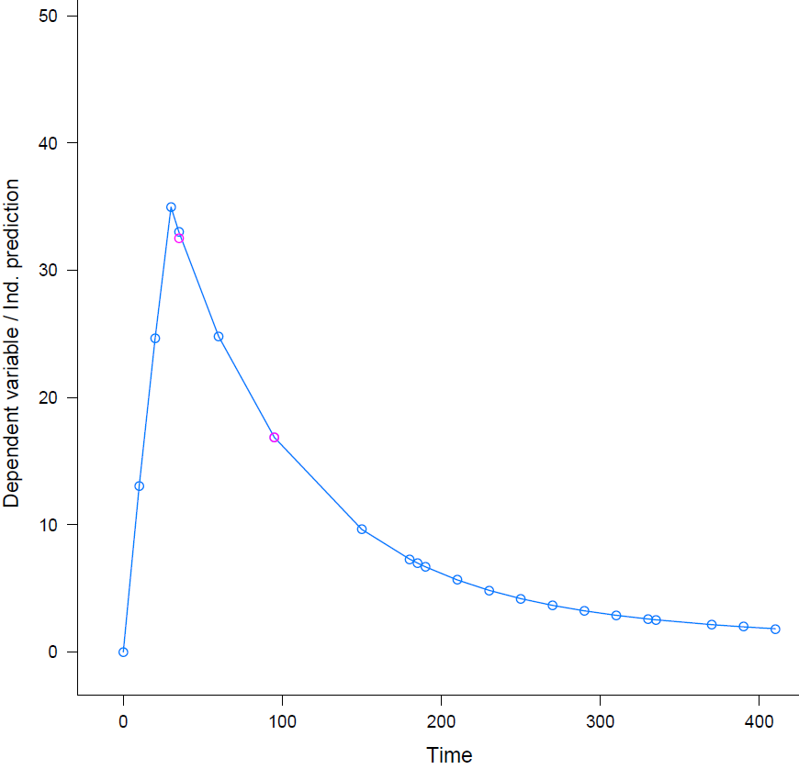

PATIENT 12 (BMI 25 – 30 kg/m²): AUC = 5.84 mg/mL*min
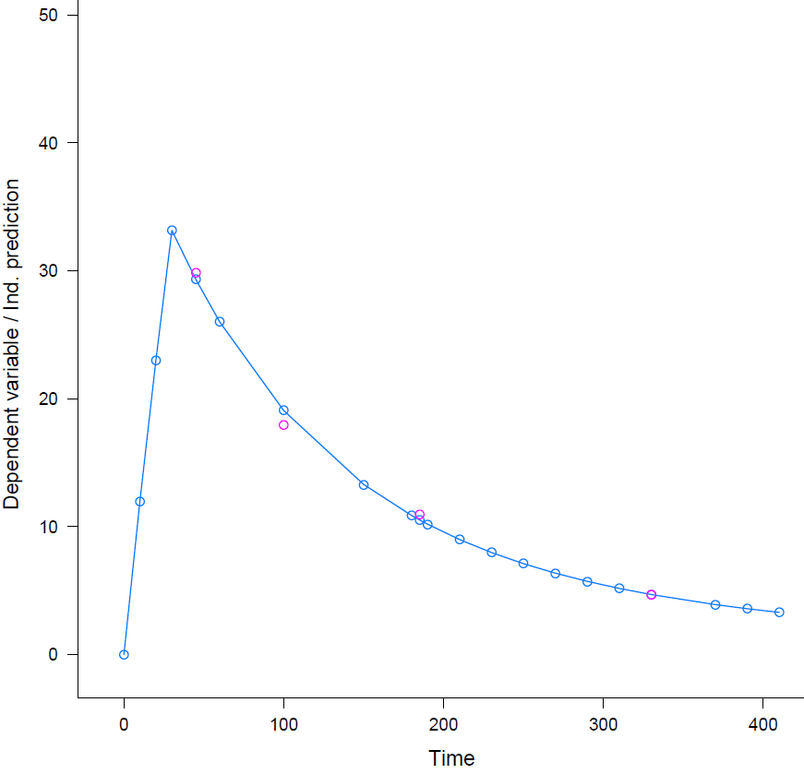
PATIENT 13 (BMI ≥ 30 kg/m²): AUC = 6.10 mg/mL*min
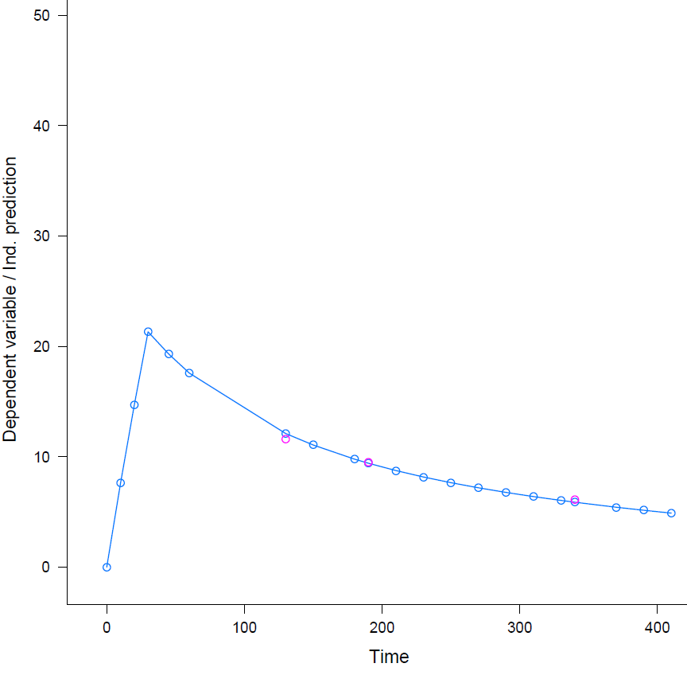

PATIENT 14 (BMI 25 – 30 kg/m²): AUC = 5.84 mg/mL*min
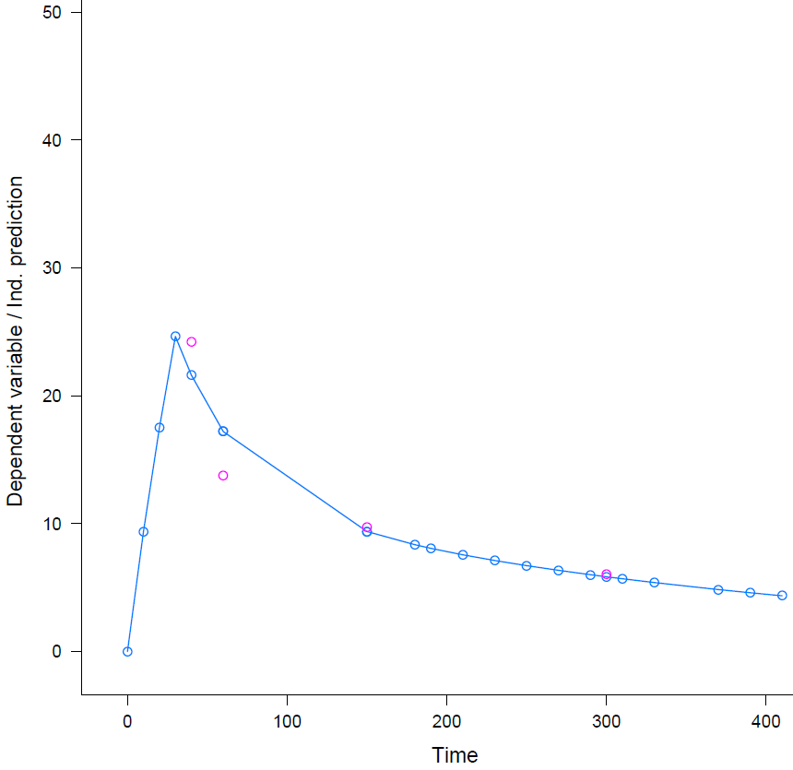

PATIENT 15 (BMI ≥ 30 kg/m²): AUC = 6.00 mg/mL*min
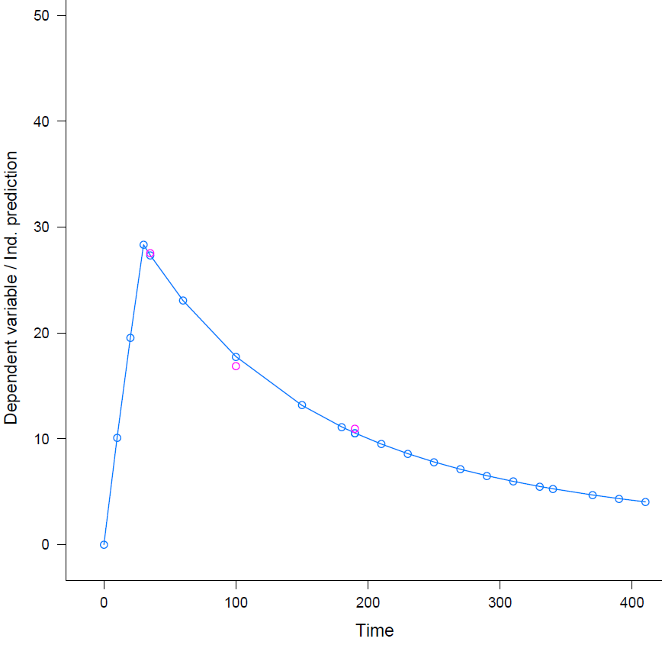

PATIENT 16 (BMI ≥ 30 kg/m²): AUC = 4.39 mg/mL*min
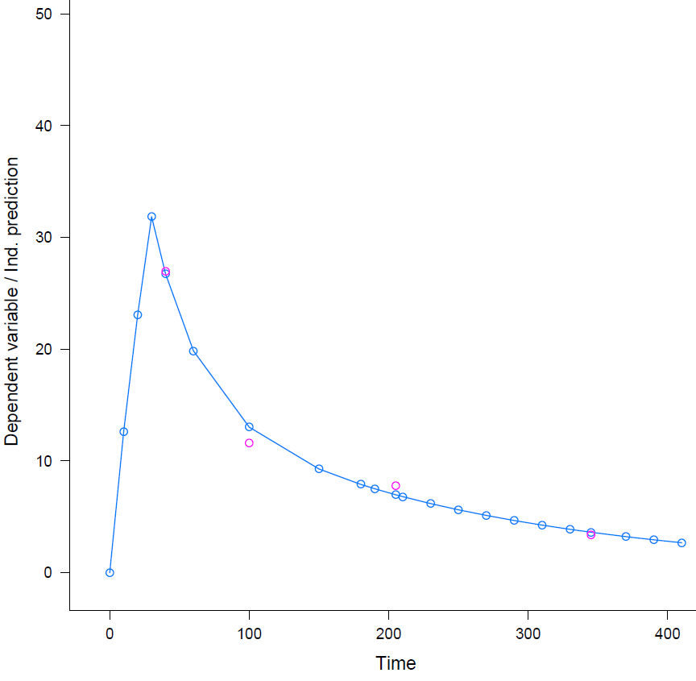
PATIENT 17 (BMI ≥ 30 KG/M²): AUC = 4.10 mg/mL*min
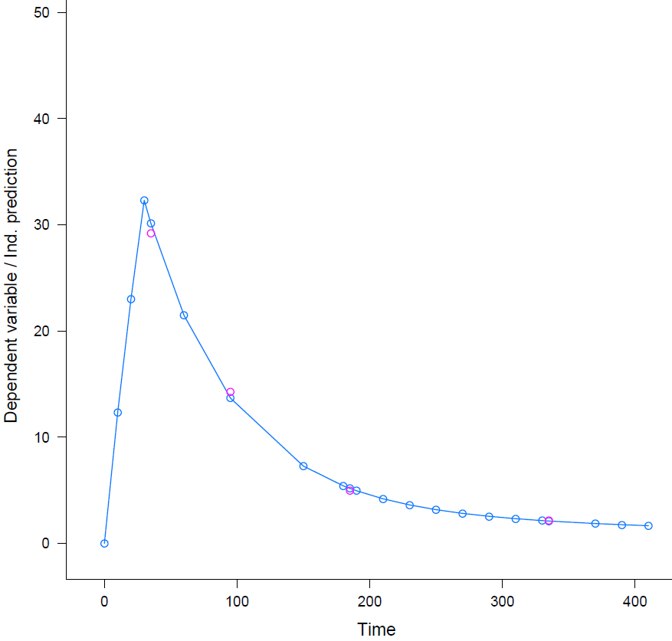

PATIENT 18 (BMI 25 – 30 KG/M²): AUC = 5.84 mg/mL*min
