Supplementary Information
Customizing designer cellulosomes for the valorization of industrially relevant substrates
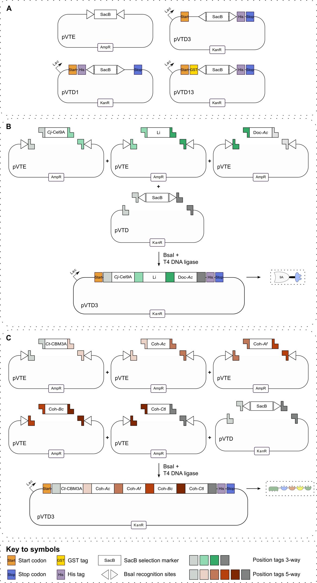
Figure S1: Schematic overview of the construction of DC components using the VersaTile technique. The VersaTile technique is a DNA assembly method, dedicated to the efficient construction of multimodular proteins in a combinatorial way. VersaTile follows a two-step approach, first the protein modules one wants to use are converted to tiles. Second, selected tiles can be assembled to construct the coding sequences of new modular proteins. A tile is defined as the coding sequence for a protein module that is made compatible with the VersaTile technique. The coding sequence is therefore flanked by position tags and BsaI recognition sites, and cloned in an entry vector, pVTE. BsaI cleavage within the position tags generates position-specific, single-stranded overhangs that can be assembled in a destination vector, pVTD. A. Overview of the entry and destination vectors used in this work. The different destination vectors allow the addition of specific N- or C-terminal tags to the assembled protein. pVTD1: N-terminal His-tag, pVTD3: C-terminal His-tag, pVTD13: N-terminal GST-tag and C-terminal His-tag. B. Schematic representation of the construction of DEs using the VersaTile shuffling three-way system, as described by Vanderstraeten et al. (1). pVTD contains the SacB negative selection marker, flanked by BsaI recognition sites and position tags. Each entry vector, pVTE, contains the coding sequence of a specific protein module, flanked by position tags and BsaI recognition sites. The white arrowhead indicates the BsaI recognition sites’ orientation, and as such indicates how the position tag will be cut. Note that the orientation differs between pVTD and pVTE. The restriction and ligation occur in one step by mixing the selected pVTEs and pVTD with BsaI and T4 DNA ligase. All vectors are digested by BsaI, resulting in complementary sticky ends, which are ligated by T4 DNA ligase. The resulting vector encodes a DE composed of the three selected tiles, in this example DE Cj-Cel9A—Li—Doc-Ac. C. Schematic representation of the construction of scaffoldins using the VersaTile shuffling five-way system, as described by Vanderstraeten et al. (1). This system follows an analogous set-up, except for the expanded number of six position tags. The resulting vector encodes a scaffoldin composed of the five selected tiles, in this example scaffoldin Ct-CBM3A—Coh-Ac—Coh-Af—Coh-Bc—Coh-CtI.
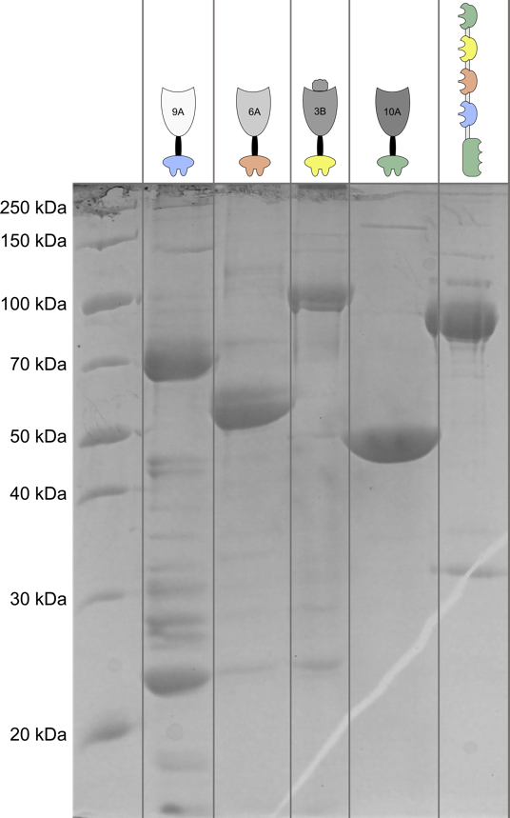

Figure S2: SDS-PAGE analysis of IMAC-purified DC components. Lane 1: marker, lane 2: Cj-Cel9A—Li—Doc-Ac (73 kDa), lane 3: Doc-Af—Li—Cj-Cel6A (58 kDa), lane 4: Doc-Bc—Li—Cj-Cel3B_{I} (102 kDa), lane 5: Cj-Xyn10A—Li—Doc-CtI (50 kDa), lane 6: Ct-CBM3A—Coh-Ac—Coh-Af—Coh-Bc—Coh-CtI (88 kDa).

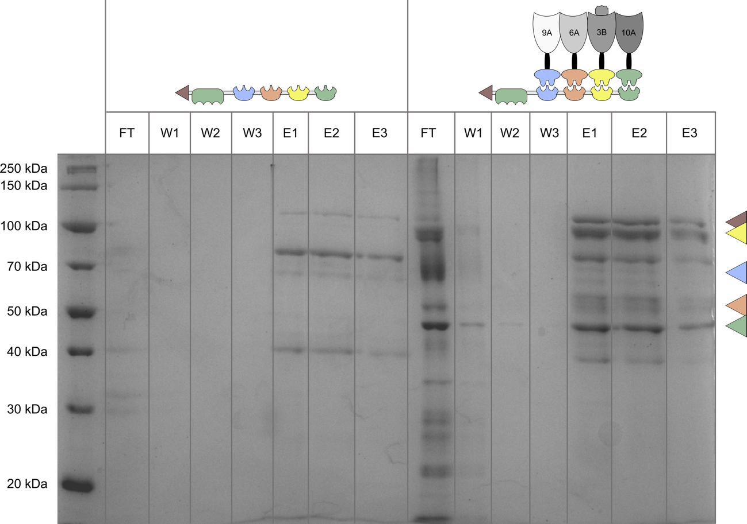
Figure S3: SDS-PAGE of fractions obtained after GST pull-down of the tetravalent DC. Lane 1: Marker; Lane 2, 3, 4, 5, 6, 7, 8: GST pull-down of the scaffoldin GST—Ct-CBM3A—Coh-Ac—Coh-Af—Coh-Bc—Coh-CtI (114 kDa, brown arrow). The flow-through (FT), three wash fractions (W1, W2 and W3) and three elution fractions (E1, E2 and E3) are loaded in respective lanes. Lane 9, 10, 11, 12, 13, 14, 15: GST pull-down of the tetravalent DC composed of GST—Ct-CBM3A—Coh-Ac—Coh-Af—Coh-Bc—Coh-CtI (114 kDa, brown arrow), Cj-Cel9A—Li—Doc-Ac (73 kDa, blue arrow), Doc-Af—Li—Cj-Cel6A (58 kDa, orange arrow), Doc-Bc—Li—Cj-Cel3B_{I} (102 kDa, yellow arrow), Cj-Xyn10A—Li—Doc-CtI (50 kDa, green arrow). The flow-through (FT), three wash fractions (W1, W2 and W3) and three elution fractions (E1, E2 and E3) are loaded in respective lanes.

Table S1: Selected wild-type enzymes originating from C. japonicus (2, 3). These wild-type enzymes were delineated, resulting in the CAZyme modules used in this work. The wild-type enzyme’s name, GenBank code and activity are given in the first, second and third column, respectively. In the fourth column, the glycoside hydrolase (GH) and if applicable CBM family is given. Column 5 mentions the primer sets used to construct CAZyme module tiles from genomic DNA. In case two primer sets (FW1/RV1 and FW2/RV2) are mentioned, both sets result in the same delineation, but flank the CAZyme module tiles by different position tags. In case of wild-type enzyme Cel3B, two different CAZyme modules were constructed. Primer sets A and B result in the module including and excluding a galactose-binding-like domain, respectively. Primer sets FW3/RV3 refer to the primers used to remove a BsaI recognition sites from the coding sequence, by performing an inverse PCR. The icon that is used for each enzyme in this work is shown in column 6. Column 7 mentions the molecular weight of the wild-type enzyme.
Name | GenBank | Activity | GH (CBM) family | Primer sets for CAZyme module delineation and inverse PCR  (5’-3’ direction) |  | Figure | Molecular weight (kDa)
Cel9A | ACE85757.1 | Endoglucanase | GH9,  CBM2 | FW1 | ATAGCTCTTCAAGAGGTCTCACCATGTGTACCTTGGGTGTGGCAC |  | 100
 |  |  |  | RV1 | ATAGCTCTTCACTTGGTCTCTGAACCCTGTGTTGCCGCAAAATCG |  | 100
Cel5B | ACE84076.1 | Endoglucanase | GH5,  CBM2 | FW1 | ATAGAAGACGTTAGAGGTCTCACCATGAGCGCACAAGCTGATGTCG |  | 60
 |  |  |  | RV1 | ATAGAAGACTAGCTTGGTCTCTGAACCATTGTTACAAACATTACCGCTTAGCGT |  | 60
 |  |  |  | FW3 | TTTGAAGACGTGAAACCAACGCCTGGGTCAGC |  | 60
 |  |  |  | RV3 | TTTGAAGACGTTTTCGCTGTTAGCCACAGCACC |  | 60
Cel5A | ACE82870.1 | Endoglucanase | GH5,  CBM2 | FW1 | ATAGAAGACGTTAGAGGTCTCACCATGCCCGGAACCGGTGTGTTC | 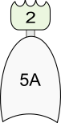 | 80
 |  |  |  | RV1 | ATAGAAGACTAGCTTGGTCTCTGAACCCAAACCCCACATATTGTGCAACAG |  | 80
 |  |  |  | FW2 | ATAGAAGACGTTAGAGGTCTCTCTGGTCCCGGAACCGGTGTGTTC |  | 80
 |  |  |  | RV2 | ATAGAAGACTAGCTTGGTCTCATACTTCAAACCCCACATATTGTGCAACAG |  | 80
Cel45A | ACE82688.1 | Endoglucanase | GH5,  CBM2 | FW1 | ATAGCTCTTCAAGAGGTCTCACCATGAGCGTCCCTCCTATTGACGG | 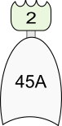 | 52
 |  |  |  | RV1 | ATAGCTCTTCACTTGGTCTCTGAACCGGGACAGGTGTTGCGAATATC |  | 52
 |  |  |  | FW2 | ATAGCTCTTCAAGAGGTCTCTCTGGTAGCGTCCCTCCTATTGACGG |  | 52
 |  |  |  | RV2 | ATAGCTCTTCACTTGGTCTCATACTTGGGACAGGTGTTGCGAATATC |  | 52
Cel6A | ACE85978.1 | Cellobiohydrolase | GH6,  CBM2 | FW1 | ATAGCTCTTCAAGAGGTCTCACCATGAATAGCAGCCAGGGC | 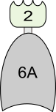 | 73
 |  |  |  | RV1 | ATAGCTCTTCACTTGGTCTCTGAACCTTGCAGTGGTGGATAAGCG |  | 73
 |  |  |  | FW2 | ATAGCTCTTCAAGAGGTCTCTCTGGTAATAGCAGCCAGGGC |  | 73
 |  |  |  | RV2 | ATAGCTCTTCACTTGGTCTCATACTTTTGCAGTGGTGGATAAGCG |  | 73
Cel3B | ACE83024.1 | β-Glucosidase | GH3 | FW.A1 | ATAGCTCTTCAAGAGGTCTCACCATGCTGTGGCCAAAAGTCACC |  | 89
 |  |  |  | RV.A1 | ATAGCTCTTCACTTGGTCTCTGAACCACCAACAACACCAAATGTTCC |  | 89
 |  |  |  | FW.A2 | ATAGCTCTTCAAGAGGTCTCTCTGGTCTGTGGCCAAAAGTCACC |  | 89
 |  |  |  | RV.A2 | ATAGCTCTTCACTTGGTCTCATACTTACCAACAACACCAAATGTTCC |  | 89
 |  |  |  | FW.B1 | ATAGCTCTTCAAGAGGTCTCACCATGCTGTGGCCAAAAGTCACC |  | 89
 |  |  |  | RV.B1 | ATAGCTCTTCACTTGGTCTCTGAACCCATGCTGATCCCCTCTTCAC |  | 89
 |  |  |  | FW.B2 | ATAGCTCTTCAAGAGGTCTCTCTGGTCTGTGGCCAAAAGTCACC |  | 89
 |  |  |  | RV.B2 | ATAGCTCTTCACTTGGTCTCATACTTCATGCTGATCCCCTCTTCAC |  | 89
Xyn10A | ACE85439.1 | Endoxylanase | GH10,  CBM2 | FW1 | ATAGCTCTTCAAGAGGTCTCACCATGAGCAGTAGCAGTTCGGTTGC |  | 65
 |  |  |  | RV1 | ATAGCTCTTCACTTGGTCTCTGAACCACGACCACTCAATGCCTCG |  | 65
Xyn11A | ACE84179.1 | Endoxylanase | GH11,  CBM60 | FW1 | ATAGCTCTTCAAGAGGTCTCACCATGTCGGTCAATGCCCAAACC | 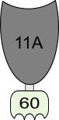 | 69
 |  |  |  | RV1 | ATAGCTCTTCACTTGGTCTCTGAACCAGGTGCAACAGCACGACC |  | 69

References
1. Vanderstraeten J, da Fonseca MJM, De Groote P, Grimon D, Gerstmans H, Kahn A, et al. Combinatorial assembly and optimisation of designer cellulosomes: a galactomannan case study. Biotechnol biofuels bioprod. 2022;15(1):60.
2. Gardner JG. Polysaccharide degradation systems of the saprophytic bacterium Cellvibrio japonicus. World J Microbiol Biotechnol. 2016;32(7):121.
3. Nelson CE, Attia MA, Rogowski A, Morland C, Brumer H, Gardner JG. Comprehensive functional characterization of the glycoside hydrolase family 3 enzymes from Cellvibrio japonicus reveals unique metabolic roles in biomass saccharification. Environ Microbiol. 2017;19(12):5025-39.

