Supplementary Material

Contents

Supplementary Material…………………………………………………………………………...2
Supplementary Figure……………………………………………………………………………..3
Supplementary Table………………………………………………………………………………7

Therapy process
LH protocol:
Surgery was performed by experienced surgeons with 10-15 years of experience in hepatic resection and more than 5 years of laparoscopic experience. All procedures were performed with the patients in a supine position under general anesthesia. LH was completed through the umbilical port. Pneumoperitoneum at 10-12mmHgwas first established using the Verres needle, and the abdomen was then punctured with trocars under direct vision. The primary and secondary incisions were made according to the location of the tumor. Intraoperative ultrasound was routinely used to evaluate the tumor burden, the liver remnant, and the possibility of a negative resection margin laparoscopically. The type of hepatectomy was defined according to established guidelines

TA protocol:
A cooled-shaft TA system with a 15-gauge, 18 cm-long cooled-shaft antenna was used in our study. The TA was performed by doctors with at least 3 years of experience in hepatic TA. All TA procedures were performed percutaneously under general anesthesia and real-time ultrasound guidance. The region of ablation was monitored by real-time US monitoring. TA emission was stopped when the hyperechoic zone covered the entire tumor including a safety margin. The ablation therapy included an ablative margin of healthy tissue of at least 5mm surrounding the tumor. For patients with tumors adjacent to the critical organs, an ablation margin of less than 5mm or conformal ablation was achieved with the assistance of a temperature monitor, artificial pleural effusion or ascites.

LH combine with TA protocol:
Endoscopic B-ultrasound was used to locate the tumor. The ablation was performed using 1-2 unipolar radiofrequency needles. The surgeon locates the tumor under ultrasound guidance and ablates the tumor in stereo. The extent of ablation was evaluated by ultrasound after ablation.
The ablation therapy included an ablative margin of healthy tissue of at least 5mm surrounding the tumor.

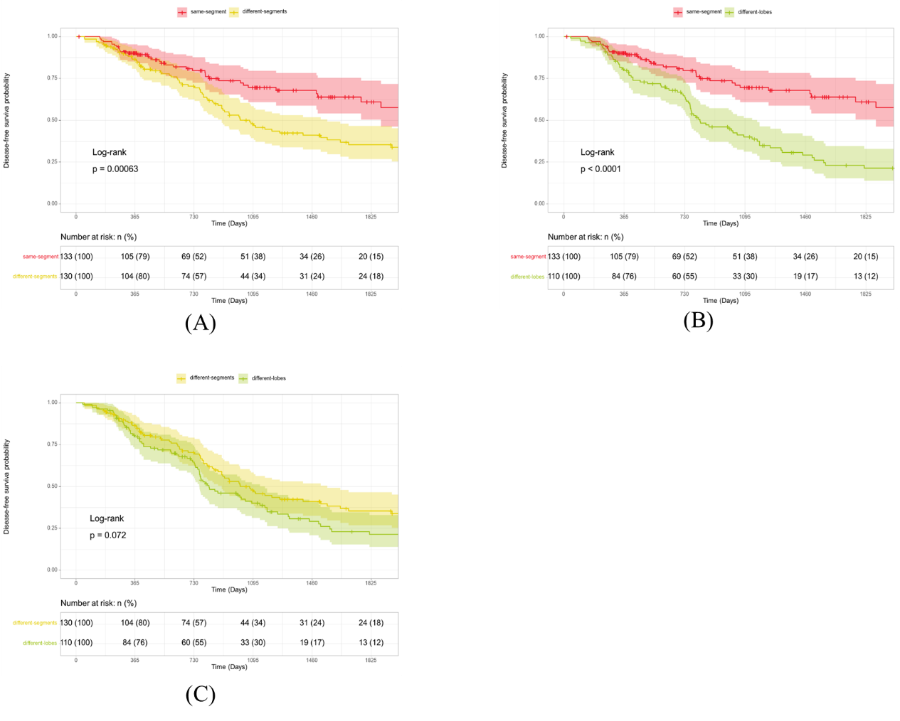
Supplement Figure 1: DFS among patients in different TD types. (A) same-segment vs different-segments; (B) same-segment vs different-lobes; (C) different-segments vs different-lobes.

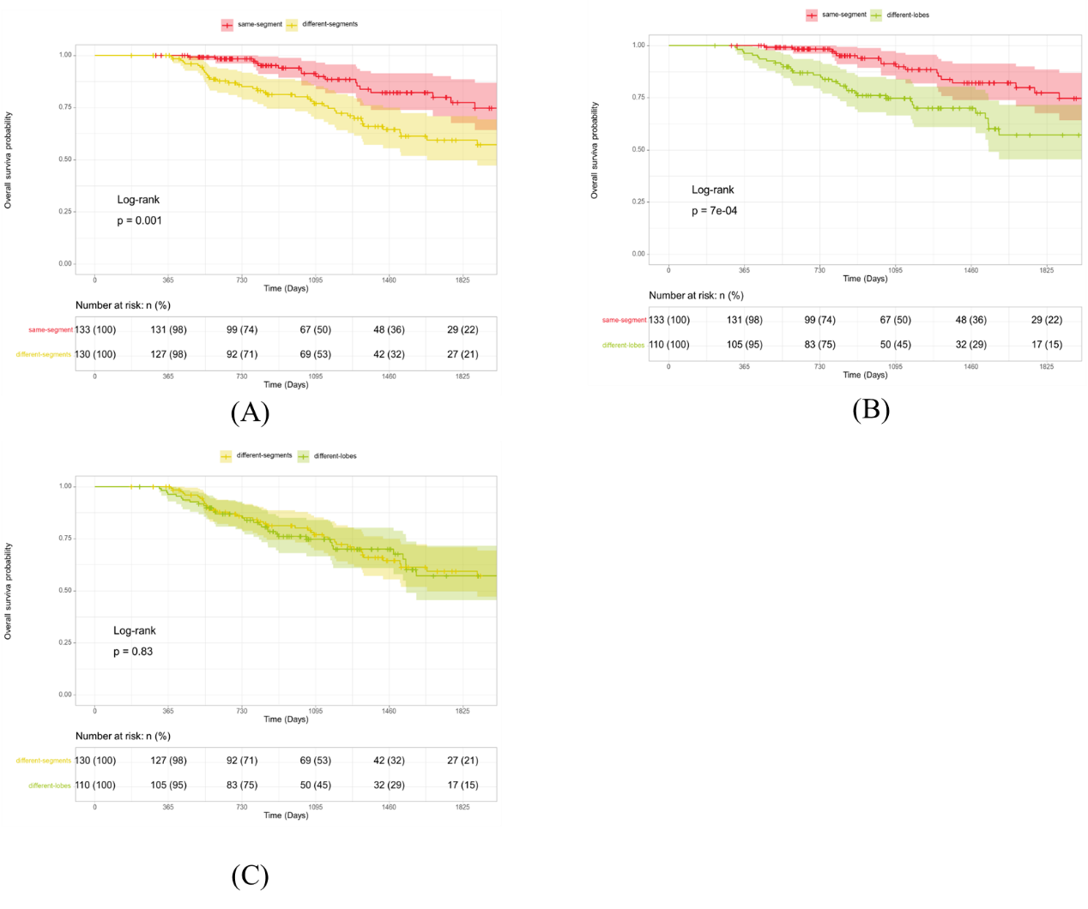
Supplement Figure 2: OS among patients in different TD types. (A) same-segment vs different-segments; (B) same-segment vs different-lobes; (C) different-segments vs different-lobes.

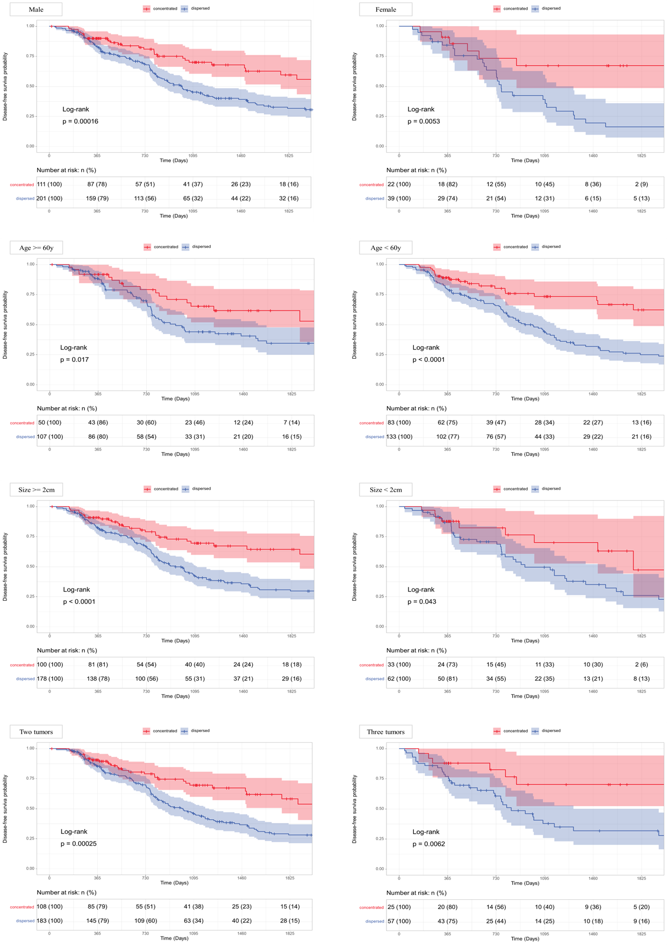
Supplement Figure 3: Subgroup analysis on DFS.

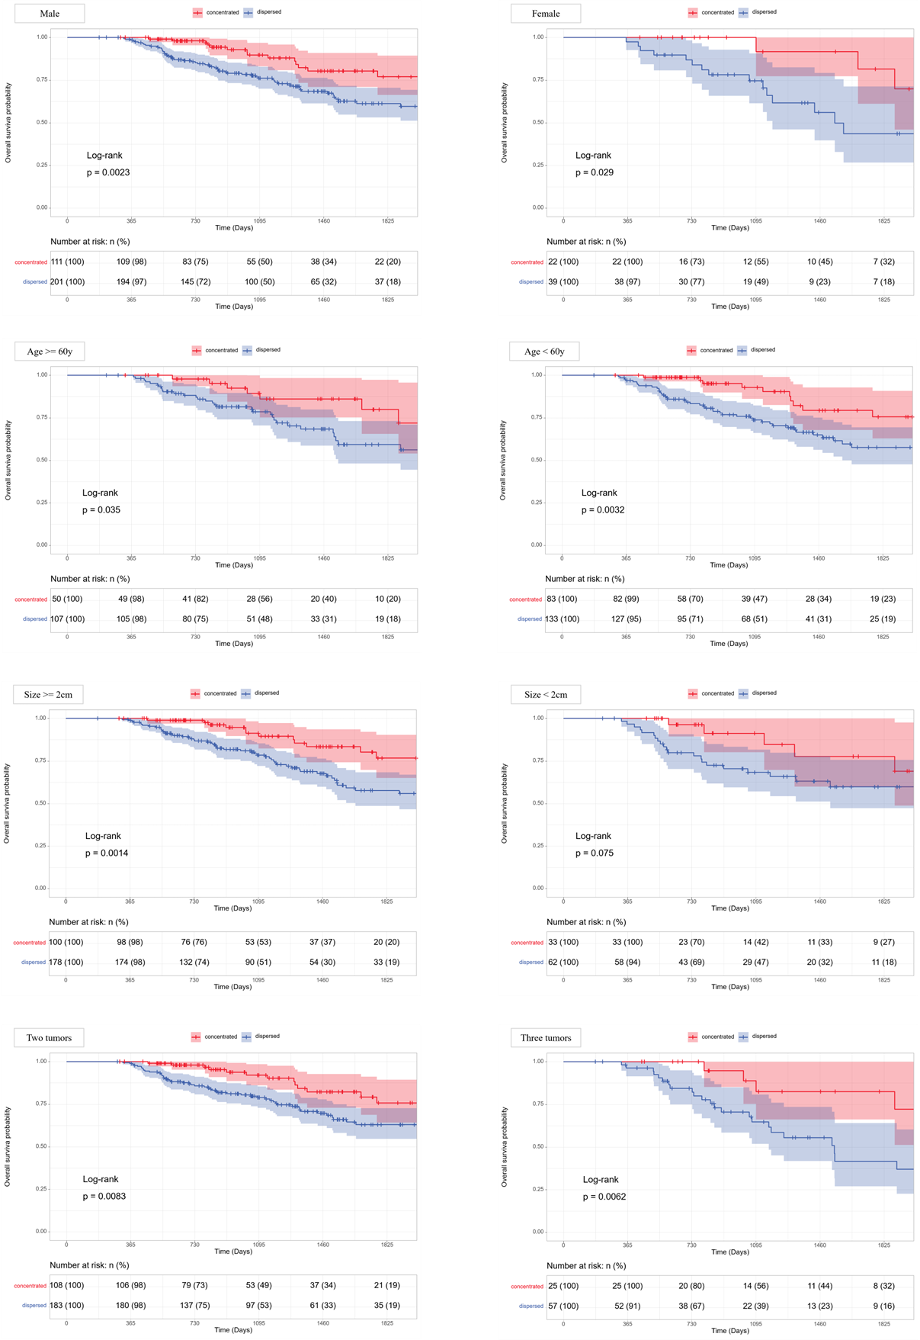
Supplement Figure 3: Subgroup analysis on OS

Supplement Table 1: Consistency of Tumor Distribution type
 | Classification based on MRI
Tumor Distribution type | Doctor 1 | Doctor 2 | Doctor 3
same-segment | 133 | 129 | 130
different-segments  (different segments but in same lobe) | 128 | 131 | 128
different-lobes | 112 | 113 | 115
 | Fleiss' Kappa = 0.803

Supplement Table 2: Baseline between concentrated and dispersed groups in Crude, PSM and IPTW cohorts
 |  | Crude cohort |  |  | PSM cohort |  |  | IPTW cohort
 |  | Concentrated  group | Dispersed  group | p | Concentrated  group | Dispersed  group | p | Concentrated  group | Dispersed  group | p
 |  | 133 | 240 |  | 122 | 122 |  | 355.7 | 382.7
Sex (%) | Female | 22 (16.5%) | 39 (16.2%) | 1 | 22 (18.0%) | 24 (19.7%) | 0.87 | 296.1 (83.3%) | 322.5 (84.3%) | 0.811
 | Male | 111 (83.5%) | 201 (83.8%) |  | 100 (82.0%) | 98 (80.3%) |  | 59.6 (16.7%) | 60.2 (15.7%)
Age (year) |  | 55.63±10.03 | 58.27±10.62 | 0.02 | 56.48±9.96 | 56.08±10.42 | 0.759 | 56.52±9.75 | 57.11±10.68 | 0.615
Child (%) | A | 132 (99.2%) | 236 (98.3%) | 0.79 | 121 (99.2%) | 119 (97.5%) | 0.614 | 352.6 (99.1%) | 377.8 (98.7%) | 0.733
 | B | 1 (0.8%) | 4 (1.7%) |  | 1 (0.8%) | 3 (2.5%) |  | 3.1 (0.9%) | 4.9 (1.3%)
ALT (U/L) |  | 42.41±27.89 | 36.08±23.98 | 0.022 | 41.80±27.28 | 41.24±26.35 | 0.869 | 39.91±27.70 | 39.85±27.21 | 0.986
AST (U/L) |  | 34.39±24.91 | 32.98±20.23 | 0.554 | 34.16±25.54 | 33.70±18.53 | 0.874 | 33.41±26.06 | 33.97±20.43 | 0.843
γ-GT (U/L) |  | 58.89±30.23 | 59.41±35.37 | 0.887 | 60.10±30.95 | 62.02±37.94 | 0.664 | 61.52±32.19 | 59.65±35.79 | 0.649
TP (g/L) |  | 67.80±6.06 | 66.85±6.52 | 0.167 | 67.71±6.10 | 67.80±6.25 | 0.909 | 67.41±6.00 | 67.28±6.43 | 0.856
ALB (g/L) |  | 39.29±4.56 | 39.36±5.04 | 0.882 | 39.28±4.56 | 39.42±4.83 | 0.82 | 39.54±4.40 | 39.35±5.06 | 0.707
TB (μmol/L) |  | 15.23±7.29 | 16.66±9.87 | 0.144 | 15.29±7.36 | 15.89±9.33 | 0.578 | 15.69±7.27 | 15.98±9.29 | 0.739
DB (μmol/L) |  | 6.04±2.97 | 6.16±4.55 | 0.791 | 6.02±2.95 | 5.83±3.98 | 0.664 | 6.11±3.01 | 6.58±5.98 | 0.565
PLT (10^9/L) |  | 138.36±54.10 | 119.32±52.45 | 0.001 | 136.00±53.79 | 129.35±53.02 | 0.332 | 127.76±51.94 | 125.20±54.48 | 0.681
INR |  | 1.11±0.10 | 1.13±0.15 | 0.148 | 1.11±0.10 | 1.10±0.14 | 0.581 | 1.12±0.10 | 1.13±0.15 | 0.635
AFP (%) | ≤20U/L | 77 (57.9%) | 124 (51.7%) | 0.295 | 67 (54.9%) | 68 (55.7%) | 1 | 191.4 (53.8%) | 200.9 (52.5%) | 0.825
 | ＞20U/L | 56 (42.1%) | 116 (48.3%) |  | 55 (45.1%) | 54 (44.3%) |  | 164.3 (46.2%) | 181.8 (47.5%)
Tumor number (%) | Double | 108 (81.2%) | 183 (76.2%) | 0.329 | 98 (80.3%) | 96 (78.7%) | 0.874 | 273.9 (77.0%) | 295.2 (77.1%) | 0.978
 | Three | 25 (18.8%) | 57 (23.8%) |  | 24 (19.7%) | 26 (21.3%) |  | 81.8 (23.0%) | 87.5 (22.9%)
Tumor Size (cm) |  | 2.37±0.57 | 2.30±0.57 | 0.21 | 2.35±0.56 | 2.30±0.57 | 0.518 | 2.32±0.56 | 2.31±0.57 | 0.914
Note: Values are mean ± standard deviation or number (%).
PSM = Propensity score macthing; IPTW = Inverse Probability of Treatment Weighting; ALT = Alanine aminotransferase; AST = Aspartate aminotransferase; γ-GT = γ-glutamyl transpeptidase; TP = Total Protein; ALB = Serum albumin; TB = Total bilirubin; DB = Direct Bilirubin; PTL = Platelets; INR = International normalized ratio; AFP = Alpha fetoprotein.

Supplement Tabel 3: The number of patients included in Consistency analysis and Classification analysis of pathology
 | Total number of patients | Tumor differentiation | AFP | Arg-1 | Hep Par1 | CK-19 | VEGF
Concentrated  group | 133 | 133 | 106 | 93 | 86 | 75 | 47
Dispersed  group | 240 | 240 | 192 | 168 | 156 | 136 | 84
Note: AFP = Alpha-FetoProtein; Arg-1 = Arginase-1; Hep Par1 = Hepatocyte Paraffin 1; CK-19 = Cytokeratin-19; VEGF = Vascular Endothlial Growth Factor.

