SUPPLEMENTAL MATERIALS

Exploring Microplastic Interactions with Reef-Building Corals Across Flow Conditions

Jeremy B. Axworthy^{1*}, Sicheng Wang¹, Ruth M. Sofield², Julio E. Chávez-Dorado³, Michelle H. DiBenedetto³, Jacqueline L. Padilla-Gamiño¹

¹ School of Aquatic and Fishery Sciences, University of Washington, Seattle, Washington, USA
² Environmental Sciences Department, The College of the Environment, Western Washington University, Bellingham WA, USA
³ Department of Mechanical Engineering, University of Washington, Seattle, Washington, USA

*jeremyax@uw.edu

Morphological traits
3D scanning
3D meshes of the coral fragments were obtained using the Artec Spider 3D scanner and Artec Studio 13 software, similar to the methods of Reichert et al. (2016). Coral fragments still attached to ceramic frag pugs were attached to modeling clay and placed in the center of a turntable. Each fragment was scanned on all sides by rotating the turntable manually and holding the scanner at a 45-degree angle to the fragment. For some larger fragments and ones with complex morphologies, multiple scans (up to three) were recorded from different angles. Individual frames within scans that had an error value above 0.3 were discarded. “Crop surroundings” was used on each scan to remove auxiliary surfaces and random noise. If multiple scans were taken, the “align” function was used to assemble them into the same position. “Global registration” was performed next to optimize the meshes for further processing. To remove outliers, “eliminate noise” was used, and then the scans were fused into a single mesh using the “smooth fusion” function. Visible abnormalities were removed using “erase flaws,” and the resulting meshes were reduced using “simplify mesh.” Finally, texture was applied to the meshes to show their surface color and textures, and the meshes were exported as .obj files.
Morphology metrics
The surface area and volume of the whole coral fragments, as well as the surface area of the up and downstream sides, were obtained from the 3D mesh .obj files using the “compute geometric measures” function in Meshlab (ver. 2022.02). The up and downstream sides of the meshes were obtained differently depending on species. For Leptoseris sp. and M. capitata, whose encrusting and plating morphologies result in mostly upward facing polyps, the mesh for each fragment was evenly divided into front and back halves using the “plane cut” tool in Meshmixer (vers. 3.5.474), and then each half was exported separately as .obj files. For M. digitata and P. acuta, whose polyps are orientated laterally, the meshes were divided into up and downstream facing sections by highlighting only the upstream side, then adjusting using the “select more” and “select less” functions, then making manual selections of individual polygons to make the margins even, using Blender (ver. 3.50). Each half was then exported separately as a .obj file.
Morphological traits, including two metrics for volume compactness: sphericity and convexity, and one metric for surface complexity: packing, were calculated based on the equations in Zawada et al. (2019b). Another metric for surface complexity, fractal dimension, was calculated using the Bouligand–Minkowski 3D Toolbox developed by (Reichert et al., 2017; https://www.facom.ufu.br/~backes/mink3d.html). Convex hulls of 3D models were produced using the “convex hull” function in MeshLab (ver. 2022.02). Surface area and volume measurements were determined using the “compute geometric measures” function in MeshLab.
Sphericity: The ratio of the surface area of a sphere with the same volume as the object (O_{vol}) and the surface area of the object (O_{sa}).
$$S= \frac{{π^{1/3}(6O_{vol})}^{2/3}}{O_{sa}}$$
Convexity: The ratio of the volume of the object (O_{vol}) and the volume of the convex hull around the object (C_{vol}).
$$C= \frac{O_{vol}}{C_{vol}}$$
Packing: The ratio of the surface area of the object (O_{sa}) and the surface area of the convex hull around the object (C_{sa}).
$$P= \frac{O_{sa}}{C_{sa}}$$
Fractal dimension: The slope of the ratio of the influence volume (V(r)) and the dilation radius (r). Where r = 8 because it resulted in the greatest differentiation in D among corals ⁴⁵.
$$D=3-\lim_{r→0}\frac{\log{(V\left(r\right))}}{\log{(r)}}$$

Supplementary Tables

Table S1: Summary statistics of morphometric measurements. S = sphericity; P = Packing; C = convexity; FD = fractal dimension.
 | Median S | Mean (±sd) S | Median P | Mean (±sd) P | Median C | Mean (±sd) C | Median FD | Mean (±sd) FD
Leptoseris sp. | 0.60 | 0.60±0.04 | 0.98 | 0.94±0.11 | 0.76 | 0.75±0.05 | 1.98 | 1.98±0.02
M. capitata | 0.50 | 0.51±0.07 | 0.93 | 0.89±0.17 | 0.46 | 0.46±0.11 | 2.05 | 2.05±0.04
M. digitata | 0.43 | 0.44±0.09 | 0.59 | 0.63±0.19 | 0.20 | 0.25±0.31 | 1.94 | 1.94±0.06
P. damicornis | 0.31 | 0.32±0.05 | 0.92 | 0.97±0.20 | 0.20 | 0.20±0.04 | 1.98 | 1.98±0.06

Table S2: Pearson’s correlation values for comparisons between morphological traits and microplastics ingestion and adhesions corrected for flow.
 | Packing | Sphericity | Convexity | Fractal dimension | Total ingestion | Total adhesion
Packing |  | 0.119 | 0.449*** | 0.391*** | -0.123 | -0.312**
Sphericity | 0.119 |  | 0.890*** | -0.071 | -0.174 | -0.007
Convexity | 0.449*** | 0.890*** |  | 0.052 | -0.186 | -0.125
Fractal dimension | 0.391*** | -0.071 | 0.052 |  | -0.114 | -0.233*
Total ingestion | -0.123 | -0.174 | -0.186 | -0.114 |  | 0.175
Total adhesion | -0.312** | -0.007 | -0.125 | -0.233* | 0.175
Computed correlation used pearson-method with listwise-deletion.

Table S3: Permutated ANOVA model summary statistics for microplastic (MP) ingestion rates corrected for different concentrations of each microplastic type.
 | SS | df | F | parametric P(>F) | resampled P(>F)
Species | 2.5403 | 3 | 5.9254 | 0.0006 | 0.0001
Flow | 0.5941 | 2 | 2.0786 | 0.1261 | 0.1268
MP_type | 4.4008 | 2 | 15.3981 | 0.0000 | 0.0001
Side | 0.0669 | 1 | 0.4684 | 0.4940 | 0.5106
Species:Flow | 1.4662 | 6 | 1.7100 | 0.1164 | 0.0963
Species:MP_type | 5.5414 | 6 | 6.4630 | 0.0000 | 0.0001
Flow:MP_type | 0.9046 | 4 | 1.5825 | 0.1775 | 0.1625
Species:Flow:MP_type | 2.7787 | 12 | 1.6204 | 0.0820 | 0.0587
Residuals | 77.0239 | 539

Table S4: Permutated ANOVA model summary statistics for microplastic (MP) ingestion rates corrected for different concentrations of each microplastic type and flow velocity.
 | SS | df | F | parametric P(>F) | resampled P(>F)
Species | 0.7753 | 3 | 7.1721 | 0.0001 | 0.0001
Flow | 0.0531 | 2 | 0.7373 | 0.4789 | 0.5048
MP_type | 1.1391 | 2 | 15.8074 | 0.0000 | 0.0001
Side | 0.0230 | 1 | 0.6387 | 0.4245 | 0.4536
Species:Flow | 0.3001 | 6 | 1.3880 | 0.2173 | 0.2053
Species:MP_type | 1.6506 | 6 | 7.6352 | 0.0000 | 0.0001
Flow:MP_type | 0.1142 | 4 | 0.7922 | 0.5305 | 0.5639
Species:Flow:MP_type | 0.5666 | 12 | 1.3104 | 0.2082 | 0.1839
Residuals | 19.4209 | 539

Table S5: Permutated ANOVA model summary statistics for microplastic (MP) adhesion rates corrected for different concentrations of each microplastic type.
 | SS | df | F | parametric P(>F) | resampled P(>F)
Species | 15.5778 | 3 | 22.6872 | 0.0000 | 0.0001
Flow | 9.3967 | 2 | 20.5277 | 0.0000 | 0.0001
MP.type | 12.9047 | 2 | 28.1912 | 0.0000 | 0.0001
Side | 4.1089 | 1 | 17.9523 | 0.0000 | 0.0001
Species:Flow | 9.9489 | 6 | 7.2446 | 0.0000 | 0.0001
Species:MP.type | 8.0791 | 6 | 5.8831 | 0.0000 | 0.0001
Flow:MP.type | 4.1541 | 4 | 4.5375 | 0.0013 | 0.0011
Species:Flow:MP.type | 4.4694 | 12 | 1.6273 | 0.0802 | 0.0806
Residuals | 123.3654 | 539

Table S6: Permutated ANOVA model summary statistics for microplastic (MP) adhesion rates corrected for different concentrations of each microplastic type and flow velocity.
 | SS | df | F | parametric P(>F) | resampled P(>F)
Species | 2.8238 | 3 | 17.3713 | 0.0000 | 0.0001
Flow | 0.1348 | 2 | 1.2441 | 0.2890 | 0.2849
MP.type | 3.0913 | 2 | 28.5252 | 0.0000 | 0.0001
Side | 0.9488 | 1 | 17.5101 | 0.0000 | 0.0001
Species:Flow | 2.1869 | 6 | 6.7266 | 0.0000 | 0.0001
Species:MP.type | 1.6052 | 6 | 4.9374 | 0.0001 | 0.0002
Flow:MP.type | 0.4935 | 4 | 2.2769 | 0.0599 | 0.0599
Species:Flow:MP.type | 0.9399 | 12 | 1.4455 | 0.1411 | 0.1424
Residuals | 29.2063 | 539

Table S7: Permutated ANOVA model summary statistics for microplastic (MP) adhesion rates on Montipora capitata, corrected for different concentrations of each microplastic type.
 | SS | df | F | parametric P(>F) | resampled P(>F)
Flow | 6.7812 | 2 | 12.5881 | 0.0000 | 0.0001
Condition | 14.0694 | 1 | 52.2352 | 0.0000 | 0.0001
MP.type | 9.5687 | 2 | 17.7628 | 0.0000 | 0.0001
Flow:Condition | 3.4133 | 2 | 6.3362 | 0.0020 | 0.0016
Flow:MP.type | 2.6706 | 4 | 2.4788 | 0.0444 | 0.0418
Condition:MP.type | 3.6631 | 2 | 6.8000 | 0.0013 | 0.0013
Flow:Condition:MP.type | 1.0798 | 4 | 1.0022 | 0.4068 | 0.4025
Residuals | 72.7238 | 270

Table S8: Permutated ANOVA model summary statistics for microplastic (MP) adhesion rates on Montipora capitata, corrected for different concentrations of each microplastic type and flow velocity.
 | SS | df | F | parametric P(>F) | resampled P(>F)
Flow | 0.5362 | 2 | 3.6056 | 0.0285 | 0.0243
Condition | 3.5656 | 1 | 47.9490 | 0.0000 | 0.0001
MP.type | 2.8932 | 2 | 19.4533 | 0.0000 | 0.0001
Flow:Condition | 0.0506 | 2 | 0.3403 | 0.7119 | 0.7187
Flow:MP.type | 0.6314 | 4 | 2.1228 | 0.0783 | 0.0725
Condition:MP.type | 0.9827 | 2 | 6.6073 | 0.0016 | 0.0015
Flow:Condition:MP.type | 0.1882 | 4 | 0.6328 | 0.6395 | 0.6448
Residuals | 20.0776 | 270

Supplemental Figures
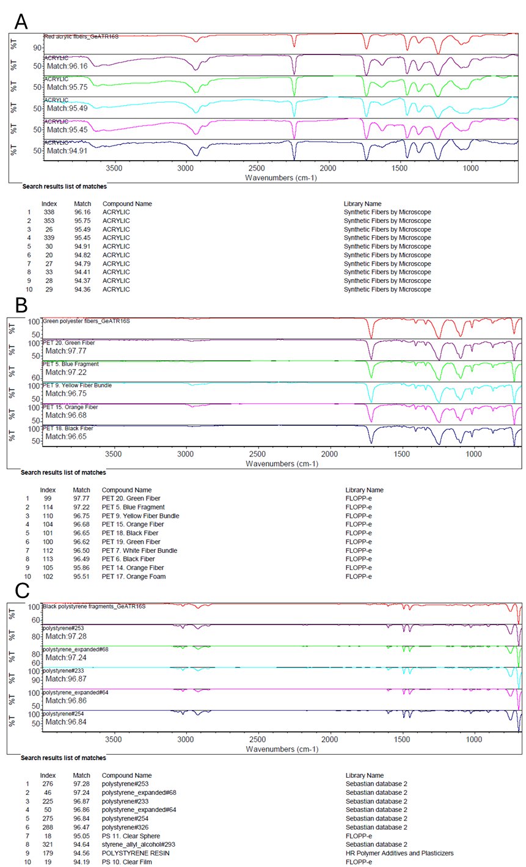
Figure S1: FTIR spectra of experimental microplastics and the top 10 library matches: A = acrylic fibers, B = polyester (PET) fibers, C = polystyrene fragments.
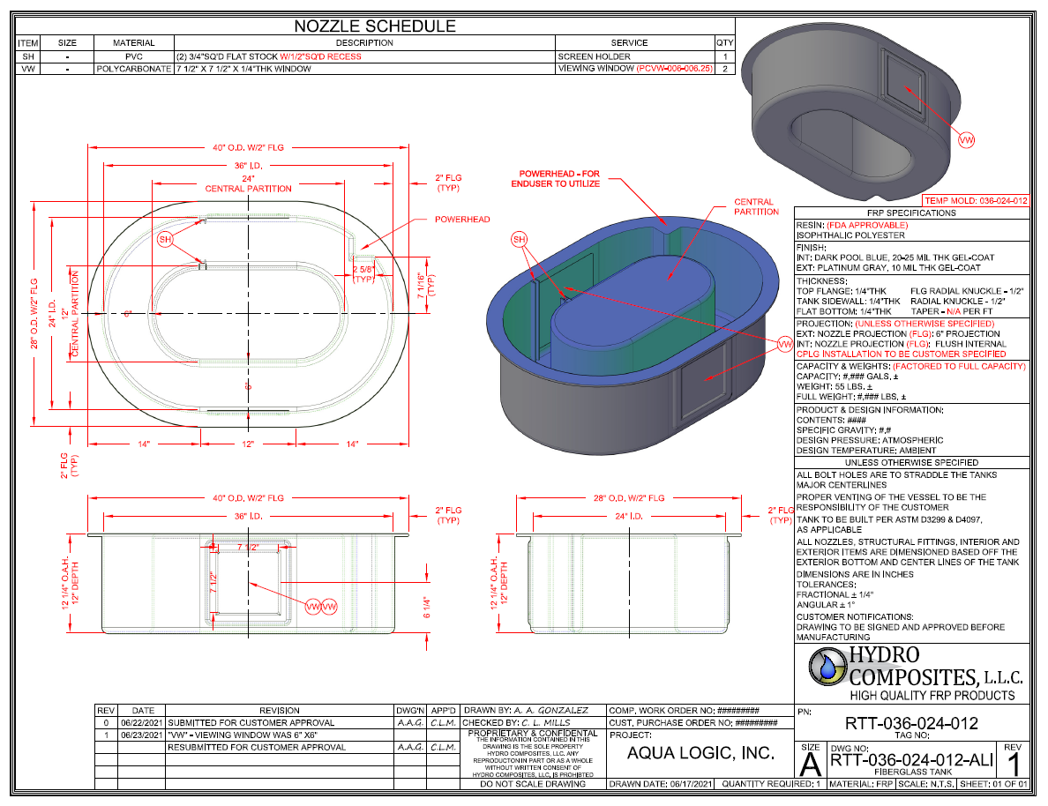
Figure S2: Schematics of the custom experimental flume system.

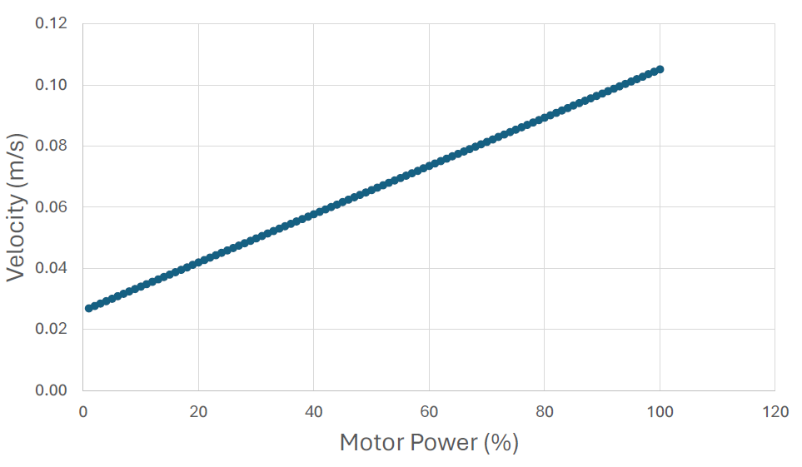
Figure S3: Calibration curve produced using particle tracking velocimetry to determine the water velocity corresponding to the pump output settings.

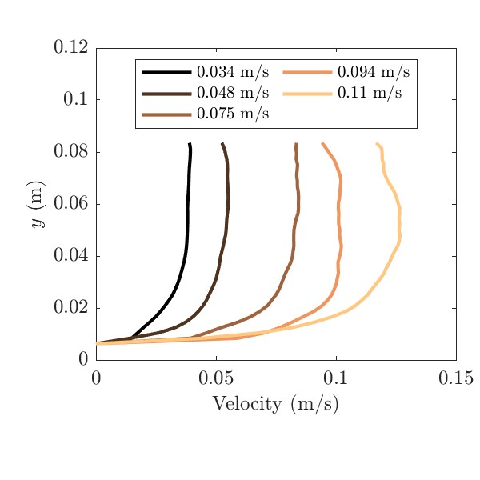
Figure S4: Velocity profiles measured using particle tracking velocimetry and their corresponding depth-averaged velocities (in legend box) of the pump settings we tested (1% = 0.034 m/s, 25% = 0.048 m/s, 50% = 0.075 m/s, 75% = 0.094 m/s and 100% = 0.11 m/s).

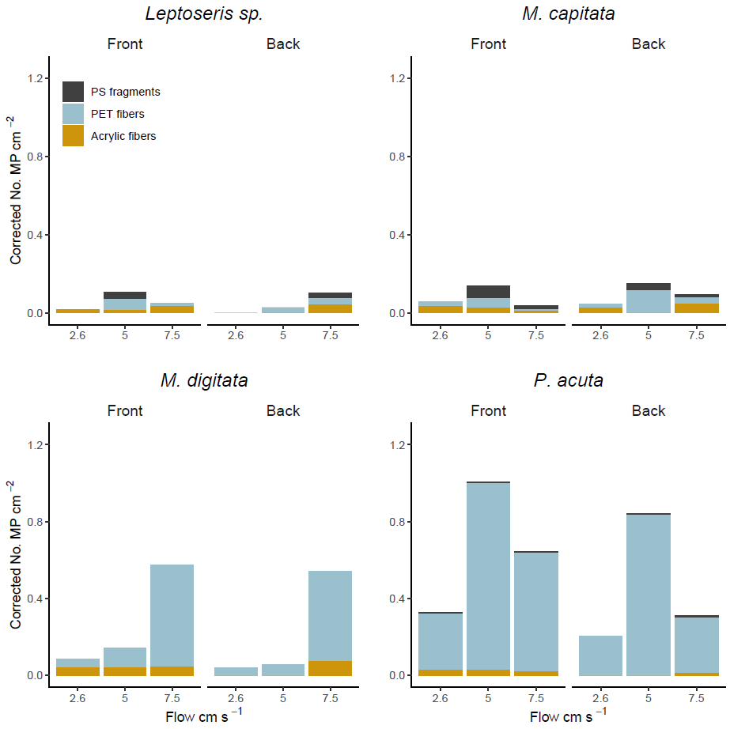
Figure S5: Mean corrected microplastics ingestion rates for each coral species under different flow velocities on the up- (front) and down- (back) stream sides of corals. Data are corrected for different concentrations of each microplastics type. PS = polystyrene, PET = polyester.

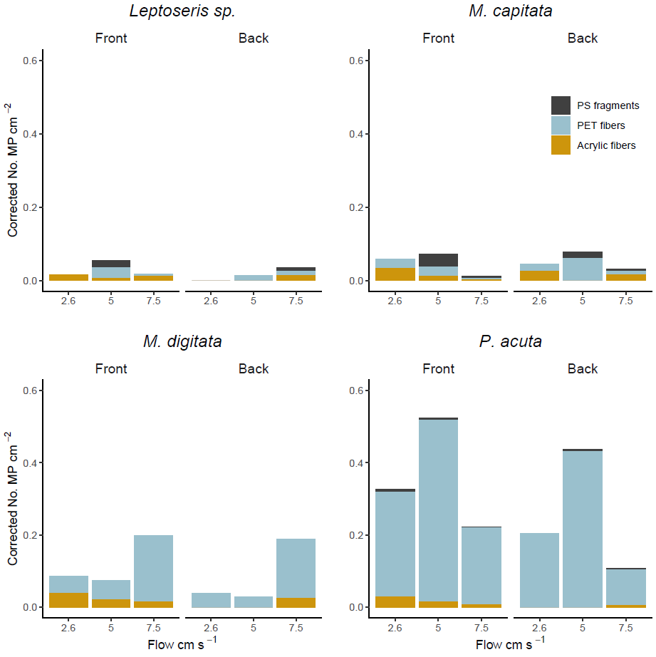
Figure S6: Mean corrected microplastics ingestion rates for each coral species under different flow velocities on the up- (front) and down- (back) stream sides of corals. Data are corrected for different concentrations of each microplastics type and for flow velocities. PS = polystyrene, PET = polyester.

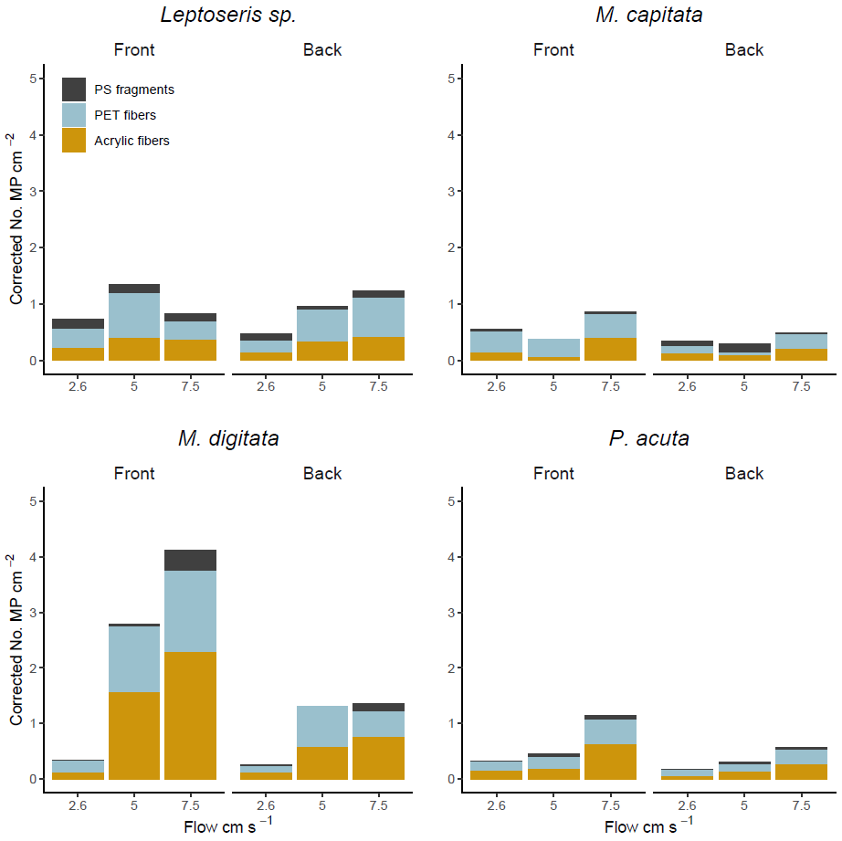
Figure S7: Mean corrected microplastics adhesion rates for each coral species under different flow velocities on the up- (front) and down- (back) stream sides of corals. Data are corrected for different concentrations of each microplastics type. PS = polystyrene, PET = polyester.

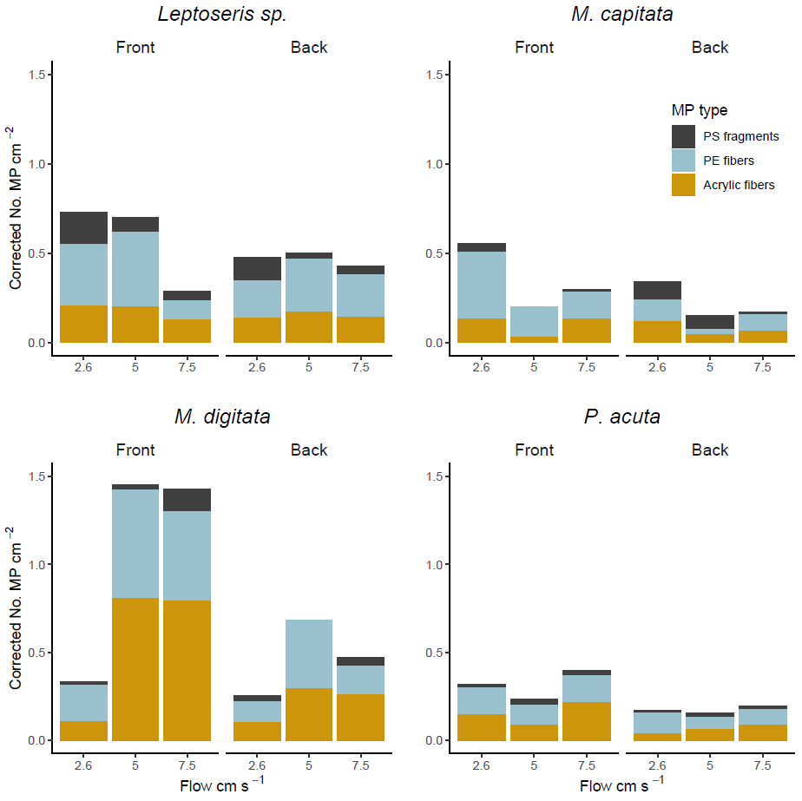
Figure S8: Mean corrected microplastics adhesion rates for each coral species under different flow velocities on the up- (front) and down- (back) stream sides of corals. Data are corrected for different concentrations of each microplastics type and for flow velocities. PS = polystyrene, PET = polyester.

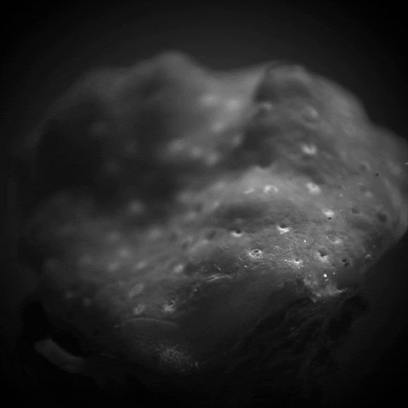
T
S

Figure S9: Mucus strand with microplastics embedded in it on the margin of living tissue and exposed skeleton of Montipora capitata.

