SUPPLEMENTARY MATERIALS

Structure-Informed Design of an Ultra Bright RNA-activated Fluorophore

Mo Yang^{1,4}, Peri R. Prestwood^{1,4}, Luiz F. M. Passalacqua², Sumirtha Balaratnam¹, Christopher R. Fullenkamp¹, J. Winston Arney³, Kevin M. Weeks³, Adrian Ferre-D’Amare², and John S. Schneekloth, Jr.^{1,} *

¹Chemical Biology Laboratory, Center for Cancer Research, National Cancer Institute, Frederick, MD 21702-1201, USA
²National Center for Advancing Translational Sciences, NIH, 9800 Medical Center Dr, Rockville, Maryland, 20850, USA.
³Department of Chemistry, University of North Carolina, Chapel Hill, NC 27599-3290.
⁴These authors contributed equally.

* To whom correspondence should be addressed. Tel: +1 301 228 4620; Fax: +1 301 846 6033; Email: schneeklothjs@mail.nih.gov

Table of Contents
Materials and Methods 3
General Information 3
High-throughput Screening Using Fragment Microarray 3
Circular dichroism (CD) characterization 4
Surface Plasmon Resonance (SPR) 4
Water ligand observed gradient spectroscopy (waterLOGSY) 5
Fluorescence competitive/cooperative binding assay 5
Binding affinity measurements by fluorescence titration 6
Crystallization and diffraction data collection 7
Structure determination and refinement 8
Cell culture and transfection 8
Cell fixation and staining 9
Confocal microscopy 9
Supplementary Figures and Tables 10
General chemistry methods 23
Synthesis 23
NMR Data 30
References 43

Materials and Methods

General Information

For this study, the Mango RNAs as well as other RNA samples were purchased from Dharmacon. The DNA samples for selectivity study were obtained from IDT. All the oligo nucleotide samples for biophysical/photophysical study were chemically synthesized and purified by HPLC. The corresponding sequences are summarized in Table S1.

High-throughput Screening Using Fragment Microarray

The discovery of a cooperative fragment binding to Mango II RNA aptamer was performed in a high-throughput manner using fragment microarrays. Similar to small molecule microarrays (SMMs) reported previously,¹ the glass slides (CapitalBio) were first chemically modified forming isocyanate terminals. Then, a total of 2214 fragments (10 mM in DMSO, Enamine) as well as control dyes (Alexa Fluor 647 and AlexaFluor 488, Invitrogen) were printed in duplicate by a robotic arrayer (Arrayit) equipped with 48 stealth micro-spotting pins (SMP3B), forming high-density microarrays. After evaporating the DMSO, the glass slides were treated with pyridine steam overnight so that the amine/hydroxyl containing fragments were covalently attached to the glass surfaces. After washing and drying, the microarray slides were ready to be used.
To begin with the screening, Mango II RNA with polyA and 5′-Cy5-poly(dT) were mixed (1:0.9, mol/mol) and annealed together in Mango buffer (10 mM Tris, pH7.0, 140 mM KCl, 1 mM MgCl₂) at 95 ℃ for 3 min, followed by snap cooling down on ice, and then kept at room temperature for 30 min before incubation. Then the folded RNA was diluted into the screening buffer (10 mM Tris, pH7.0, 140 mM KCl, 1 mM MgCl₂, 0.005% T20) to meet the final concentration of 250 nM. With a cover slip, the SMM slide was incubated with 10× tRNA (500 nM in screening buffer) for 2 h. Then, the slide was carefully washed by screening buffer and ddH₂O, then incubated with the annealed Mango II RNA with Cy5 fluorophore for another 2 h. After incubation, the slide was transferred into a 50 mL Falcon tube and gently washed with PBST, PBS and ddH₂O for 3 times in each buffer solution. Then, the slide was dried by centrifuging at 1,700 g for 2 min. Finally, the slide with fragment microarrays was imaged by a fluorescence scanner (InnoScan 1100 AL) at 635 nm (resolution: 5 µm). The fluorescent intensity of each spot was quantified by Innopsys Mapix software, and the hits were identified based on the criteria reported previously.

Circular dichroism (CD) characterization

The folded structure of Mango II RNA aptamer was characterized by CD using a J-1500 circular dichroism spectrometer (Jasco). To optimize the buffer condition, unlabeled RNA was prepared in different annealing buffer conditions at 5 µM concentration. The annealing procedure was the same as mentioned above. At room temperature, the CD spectra were recorded from 320 to 200 nm with an interval of 1 nm by using a 1 mm bandpass cuvette. Each spectrum was obtained by averaging the signals of three replicate scans. The results were presented after referencing the spectra of blank buffers correspondingly.

Surface Plasmon Resonance (SPR)

The SPR experiments were performed using BIAcore 3000 (Cytiva), based on the previously reported method with minor modifications. To avoid RNA degradation, the whole system was primed with ethanol and 50% RNase Zap aqueous solution (Invitrogen), followed by thoroughly washing with RNase-free water one day before running the actual experiments. Then, the instrument was primed with running buffer (10 mM Tris, pH 7.0, 140 mM KCl, 1 mM MgCl₂, 0.005% Tween 20) with 5% DMSO. At a flowrate of 5 µL/min, a CM5 chip surface was activated by EDC/NHS method for 15 min and conducted with 200 µg/mL streptavidin (SA) solution (diluted in 10 mM sodium acetate buffer, pH 4.5) for 20~30 min. After reaching a certain amount of immobilization, the surface was deactivated with 1 M ethanolamine (EA) aqueous solution (pH 8.5) for 10 min and regenerated with 10 mM NaOH for 2 min to remove the unbound protein. In parallel, Mango II-polyA RNA and 5′-biotin-labeled poly(dT) were mixed (1:0.9, mol/mol) and annealed according to the above method. After annealing, a total of 150 µL RNA solution was injected in the Fc2 for 30 min while keeping Fc1 blank (as a reference channel). Then, the system kept flowing the running buffer until the baseline was stable enough for further detection steps.
To detect the binding between compounds and RNA, a flowrate of 25 µL/min was used. Then, 50 µL compound solution at designated concentration was injected in Fc1 and Fc2 with 120 s for association and 200 s running for dissociation. The final binding curves were obtained by referencing the blank channel (Fc1). To determine dissociate constant (K_{D}), compound solutions with gradient concentrations were injected to obtain the dose-dependent response and the K_{D} value was calculated by fitting the curves using Langmuir 1:1 binding model and fixed Hillslope as 1.

Water ligand observed gradient spectroscopy (waterLOGSY)

A reference 1D-1H and 1D WaterLOGSY spectrum of 1 mM N-methyl-L-valine, 100 µM TO and 1 mM F2 was collected, followed by a separate sample containing 50 µM Mango II RNA aptamer, 1 mM N-methyl-L-valine, 100 µM TO and 1 mM F2. For NMR sample preparation, unlabeled Mango II RNA was folded by heating to 95 °C for 3 min, followed by placed on ice for 30 min. A sample of 100 µM TO, 1 mM F2 and 1 mM N-methyl-L-valine, was prepared in 10 mM NaH₂PO₄ buffer (pH 7.0, containing 140 mM KCl, 1 mM MgCl₂ and 5% DMSO-d₆), and 1D reference proton and waterLOGSY spectra with and without oligonucleotide were recorded. These spectra were recorded at 20 °C on a Bruker AVANCE III 500 MHz spectrometer equipped with TCI cryogenically cooled probe, as previously reported.² The “zgesgp” excitation sculpting water suppression pulse sequence from Bruker was used for data acquisition with 128 scans. All data were processed and visualized with MestReNova software (Version 8.1.2–11880).

Fluorescence competitive/cooperative binding assay

In this study, the fluorescence competitive/cooperative binding assay was carried out in black 384-well plates for a medium-throughput screen. Briefly, unlabeled Mango II RNA aptamer was prepared in Mango selective buffer and annealed according to the above method. Then, a certain amount of TO was mixed with folded RNA, resulting in 500 nM TO and 100 nM Mango RNA. After incubating the solution for 15 min, fragment solutions with designated concentrations were added in the RNA solution (final volume: 50 µL). The 384-well plate was incubated for another 15 min and briefly centrifuged. Then, the fluorescence intensities were measured by a plate reader (Synergy H1, BioTek) with an excitation wavelength of 510 nm and an emission of 535 nm. The data for each sample was presented by averaging three replicates in the plate.

Binding affinity measurements by fluorescence titration

The excitation and emission spectra for dye and Mango-dye complex were recorded by a spectrofluorometer (FluoroMax-4C, HORIBA). The dissociation constant (K_{D}) of RNA-dye complex was then obtained by performing a fluorescence titration. Briefly, a small molecule was prepared in Mango selection buffer (10 mM Tris, pH 7.0, 140 mM KCl, 1 mM MgCl₂, 0.005% Tween 20), then mixed with the freshly folded RNA (above-mentioned method), resulting in 200 nM RNA and 1 nM dye in a 0.1-cm pathlength quartz cuvette. With an irradiation at the maximum excitation wavelength, the emission spectrum ranging from 520 nm to 700 nm was recorded (interval: 1 nm; slit: 5 nm). Then, the solution was diluted with 1 nM dye solution at 1:1 ratio and incubated for 5 min for equilibrium. With a constant dye concentration (1 nM), the titration on RNA was performed and the fluorescent spectra were recorded. Then, the concentration-dependent curve was plotted by utilizing the datapoints at the emission peaks, and the curve was fitted to Hill equation (Eq. 1) in OriginLab for K_{D} measurement, according to the previously reported methods,³

$F=F_{0}+ \frac{F_{max}}{2}(K_{D}+\left[RNA\right] +\left[Dye\right]- \sqrt{{(\left[RNA\right]-[Dye])}^{2}+K_{D}\left(K_{D}+2\left[RNA\right]+2\left[Dye\right]\right)})$ (1)

where F is the fluorescent intensity at a certain concentration of RNA, F₀ is the fluorescence without RNA (zero concentration), F_{max} is the maximum signal of fluorescence. [RNA] and [Dye] represent the concentrations of Mango II RNA and small molecules, respectively.
For fluorescence turn-on value, a well-established protocol was used with minor changes.⁴ By considering the K_{D} values, the fluorescence maximum of the dye (0.5 µM) was measured in the absence and presence (4 µM) of Mango II RNA, with over 99.9% bound fraction of dye based on Eq. 2. The ratio (F_{Dye+RNA}/F_{Dye}) was defined as a turn-on fold value.

$K_{D}=\frac{({\left[Dye\right]}_{0}-[Dye])({\left[RNA\right]}_{0}-[RNA])}{[RNA-Dye]}$ (2)

Where [Dye]₀ and [RNA]₀ stand for the total/initial concentrations of samples in the cuvette, while [Dye], [RNA], and [RNA-Dye] represent the final concentrations of each component at equilibrium.

Crystallization and diffraction data collection

RNA (Crystallization construct – Mango II: 5′-GCG UAC GAA GGA GAG GAG AGG AAG AGG AGA GUA CGC-3′) was chemically synthesized (Dharmacon) and deprotected according to the manufacturer's protocol. RNAs were exchanged into 20 mM MOPS-KOH pH 7.0, 150 mM KCl and 10 μM EDTA by centrifugal ultrafiltration (3,000-Da cutoff, Millipore); filtered (0.1 μm cutoff, Amicon Ultrafree-MC, Millipore); and stored at −20 °C. Prior to use, RNA was heated to 85 °C for 3 min then allowed to cool at 21 °C for 10 minutes.
RNA was mixed with equimolar fluorophore, then incubated at room temperature for at least 10 min. For crystallization by the sitting drop (Mango II + SALAD2, Mango II + SALAD3, and Mango II + SALAD4) or hanging drop (Mango II + SALAD1) diffusion methods, 0.2 mL of RNA-fluorophore solution (150 mM) and 0.2 mL reservoir solution were mixed and equilibrated at 21 °C. Orthorhombic-shaped crystals grew to maximum dimensions of 100 × 35 × 35 mm³ over 3-10 days. Two min after addition of 0.4 mL of cryoprotectant solution (10 mM MOPS-KOH pH 7.0, 75 mM KCl, 5 μM EDTA, 75 mM fluorophore, 0.05 M HEPES sodium pH 7.5, 0.9 M ammonium acetate, and 30% v/v polyethylene glycol 400) to the drops, crystals were mounted in nylon loops and flash-frozen by plunging into liquid nitrogen. For each RNA, the reservoir and cryoprotectant solution are described below:
- Mango II + SALAD1: 0.1 M HEPES sodium pH 7.5, 2% v/v polyethylene glycol 400, 2% v/v tert-butanol, and 1.8 M ammonium acetate.
- Mango II + SALAD2: 0.1 M HEPES sodium pH 7.5, 2% v/v polyethylene glycol 400, 4% v/v acetonitrile, and 1.8 M ammonium acetate.
- Mango II + SALAD3: 0.1 M HEPES sodium pH 7.5, 2% v/v polyethylene glycol 400, 3% v/v 1,4-dioxane, and 1.8 M ammonium acetate.
- Mango II + SALAD4: 0.1 M HEPES sodium pH 7.5, 2% v/v polyethylene glycol 400, 0.3M NDSB-195, and 1.8 M ammonium acetate.
Diffraction data (Supplementary Table S2) were collected at 100 K using the rotation method at beamline 5.0.1 of the Advanced Light Source (ALS). Datasets were reduced using xia2⁵ with Dials⁶ or XDS.⁷

Structure determination and refinement

The structures of the Mango II complexed with the respective fluorophores were solved by molecular replacement using Phaser-MR⁸ and a search model consisting of the Mango II structure (PDB: 6C63). The solutions were subjected to manual rebuilding in Coot,⁹ interspersed with rounds of simulated annealing, energy minimization and individual B-factor refinement in Phenix.¹⁰ To determine the orientation of the fluorophores, it was built in any plausible pose according to the electron density, and the model refined. For all structures, the mean precision of atomic coordinates was estimated using Phenix.¹⁰ Refinement statistics are summarized in Supplementary Table S2. Structural figures were prepared with PyMOL (Version 2.0, Schrödinger, LLC). In addition, buried surface area was also calculated using PDBe PISA ('Protein interfaces, surfaces and assemblies' service at the European Bioinformatics Institute, http://www.ebi.ac.uk/pdbe/prot_int/pistart.html) v1.52 with a probe radius of 1.4 Å.¹¹

Cell culture and transfection

HEK-293T cells were grown in Dulbecco’s Modified Eagle’s Medium (DMEM) with 1% glutamine and 10% fetal bovine serum at 37ºC in 5% CO₂ in a humidified incubator according to ATCC’s recommendations. Imaged cells were grown directly in Mattek 35 mm glass coverslip dishes (part no.: P35GC-1.5-14-C). Approximately 250,000 cells were seeded 24 hours prior to transfection. Cells were transfected with 4 µg of pLenti-mCherry-Mango II x 24 plasmid purchased from Addgene (Plasmid #127587).¹² Transfections were performed using Fugene HD following the manufacturer’s instructions. After 24 hours, the media was removed, and new media containing 500 ng/µL of doxycycline was added to the cells. Cells were incubated for 4 hours to allow for sufficient induction, then were fixed.

Cell fixation and staining

A previously published fixation and staining protocol was followed.¹² To fix, cells were incubated with freshly prepared 4% PFA in 10 mM sodium phosphate buffer containing 140 mM potassium chloride and 1 mM magnesium chloride (PKM buffer) for 10 minutes at room temperature. The cells were then washed three times for five minutes each using PKM buffer. Cells were permeabilized by incubating for 10 minutes at room temperature in 0.2% Triton X-100 in PKM buffer. After washing three times for five minutes each in PKM buffer, cells were incubated at room temperature for 30 minutes with SALAD1 or TO1-biotin in PKM buffer. Cells were then washed once with PKM buffer. Imaging buffer, PBS containing 1 µg/mL Hoechst 33258, was then added to the dishes, and cells were imaged.

Confocal microscopy

Fixed cell confocal images were acquired on a Leica TCS SP8 microscope using a 63x oil objective lens and a pinhole of 1.0 Airy units. Mango II ligands were excited using the 488 nm laser and emission was collected from 513 to 556 nm. Hoechst 33258 stained DNA were imaged using the 405 nm laser for excitation and collecting emitted light between 410 and 484 nm. The 552 nm laser was used to excite mCherry and emission was collected between 594 and 630 nm. Detector gain and laser power were optimized to reduce background fluorescence while maintaining a good signal from in focus light, then kept constant for each experiment. Image analysis and quantification was performed using Fiji. Quantification was obtained by selecting a region of interest around cells expressing Mango II and measuring mean fluorescence intensity. Statistical significance was determined by t test.

Supplementary Figures and Tables

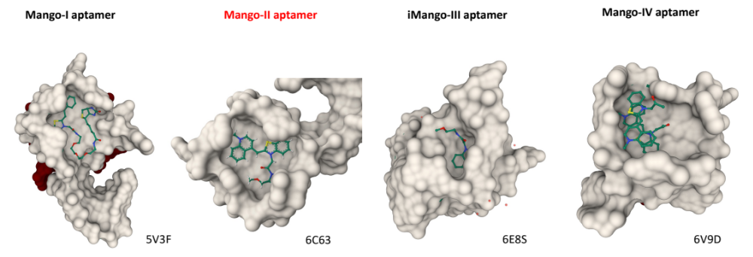

Figure S1. Structural information of thiazole orange (TO) derivatives in complex with four generations of Mango RNA aptamers (https://www.rcsb.org). Among them, Mango II aptamer was chosen as the study model for future experiments.

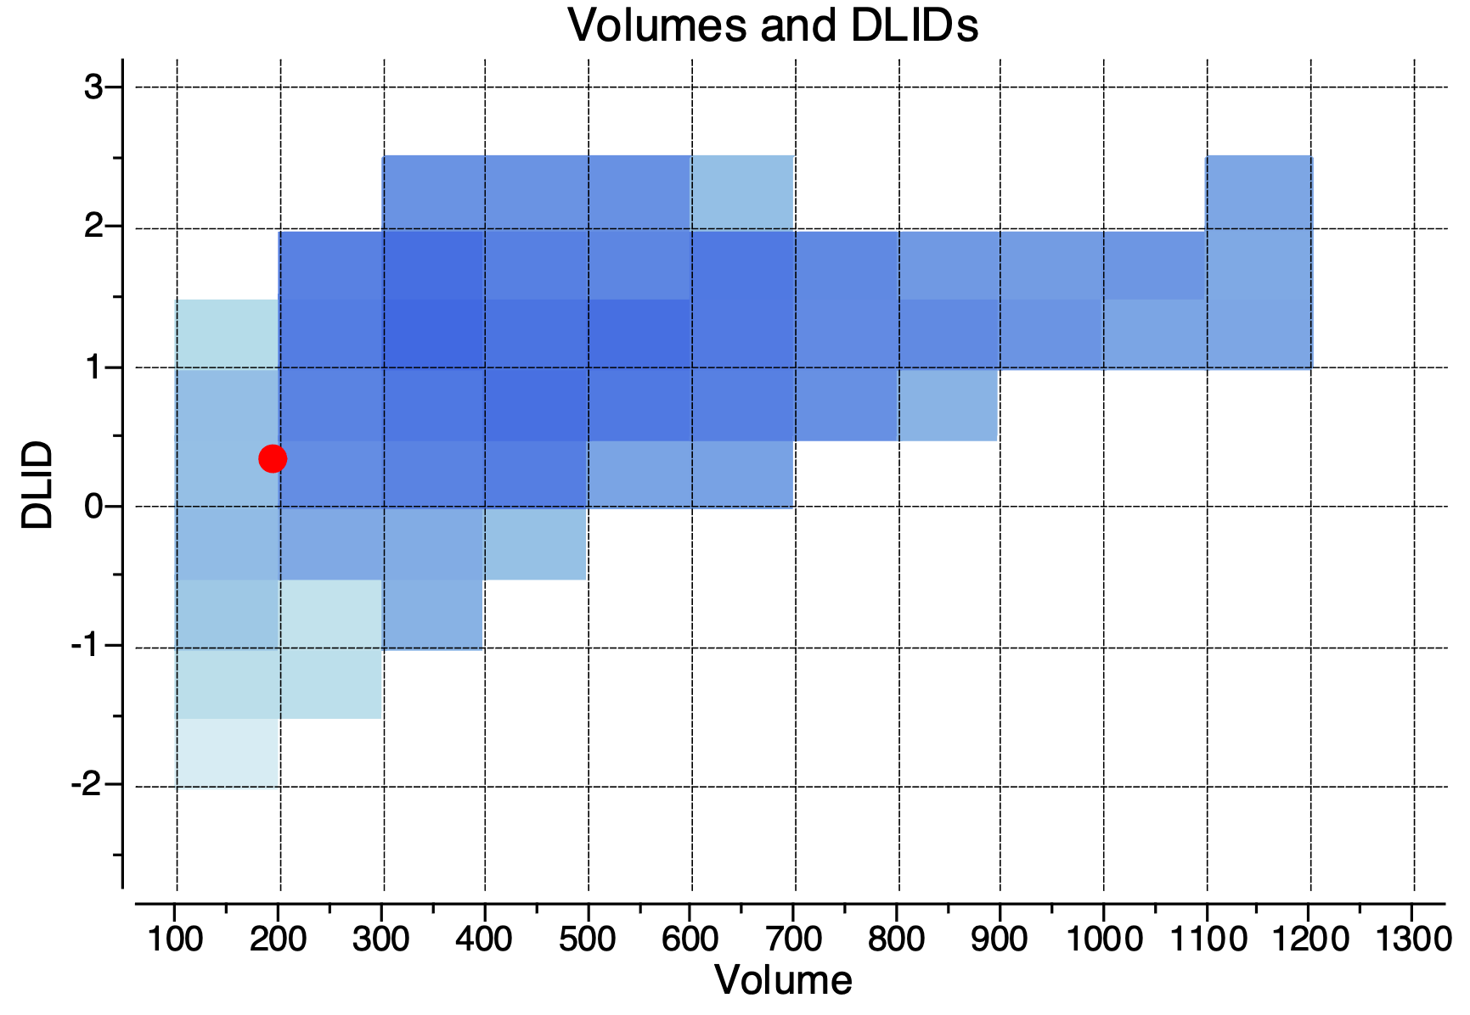

Figure S2. Hydrophobic pocket analysis on Mango II structure in presence of TO using ICM Molsoft pocket finder.

Figure S3. CD spectrum characterization of Mango II folding in different buffer conditions. Phosphate buffer: 10 mM Na₂HPO₄ /NaH₂PO₄, pH7.0, 140 mM KCl, 1 mM MgCl₂; Tris + KCl buffer: 10 mM Tris, pH7.0, 140 mM KCl, 1 mM MgCl₂; Tris + LiCl buffer: 10 mM Tris, pH7.0, 140 mM LiCl, 1 mM MgCl₂.

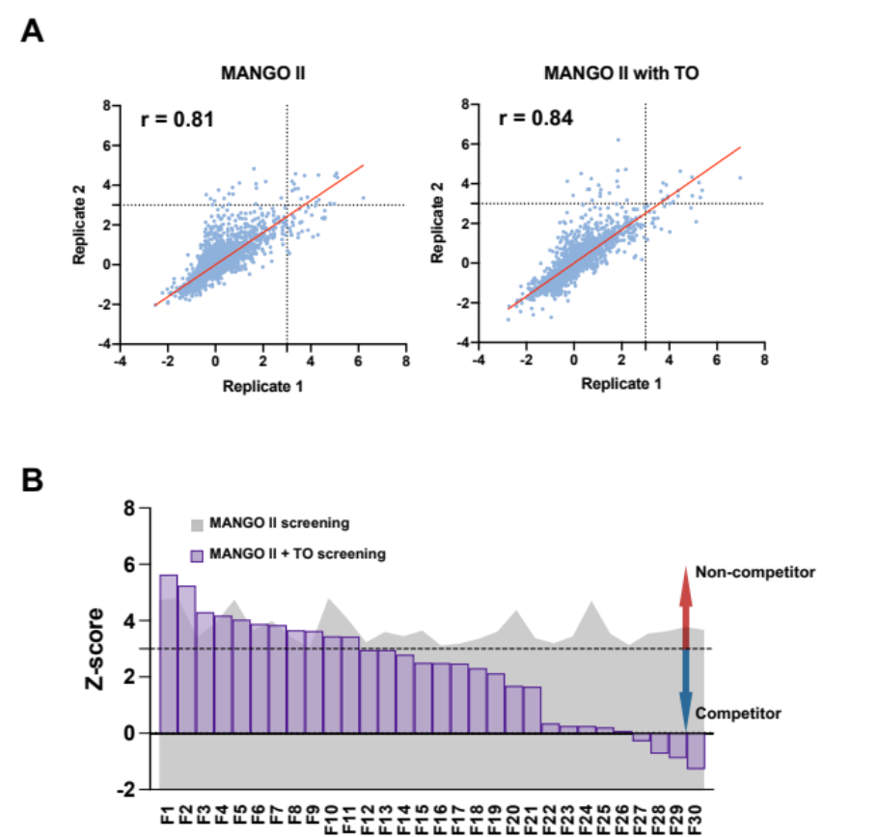

Figure S4. SMM results of Mango II RNA screening with/without TO. (A) Z-scores from duplicated screens and Pearson correlation coefficient. (B) Identification of non-competing or competing fragments from SMM study.

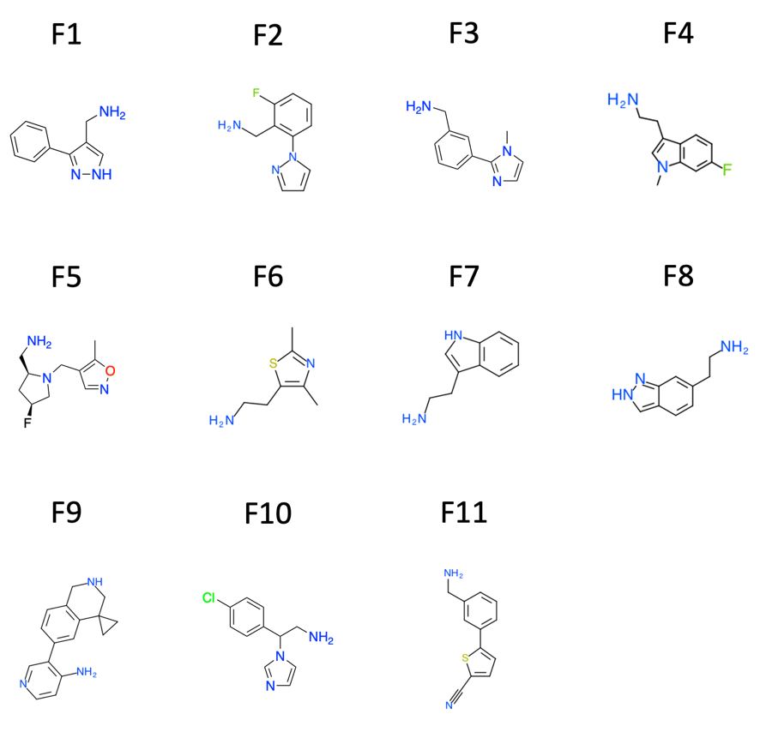

Figure S5. Chemical structures of non-competitive binders (F1~F11). Fragments were discovered by SMM screening using Mango II RNA solution in presence of TO.

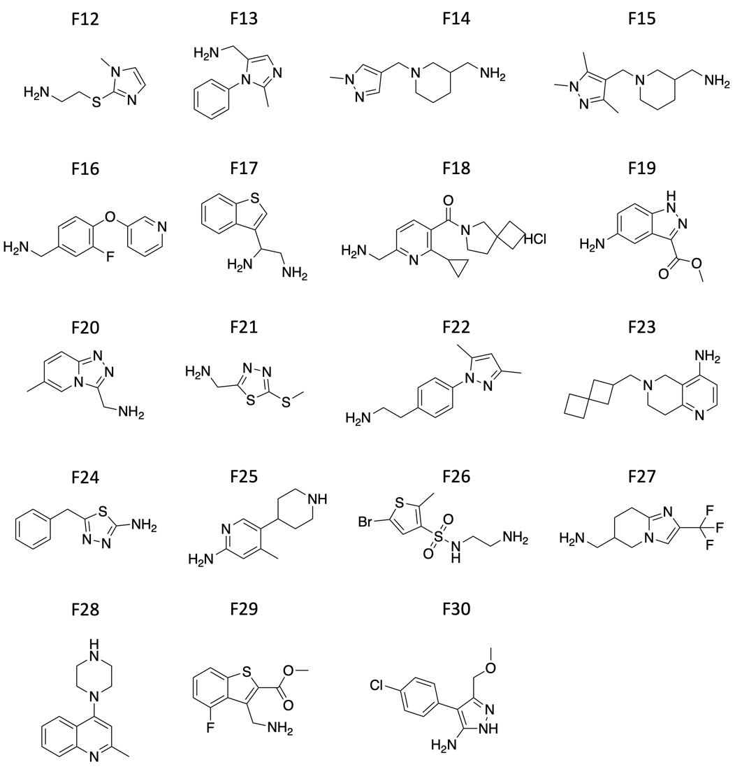

Figure S6. Chemical structures of competitive binders (F12~F30). Fragments were discovered by SMM screening using Mango II RNA solution in absence of TO.

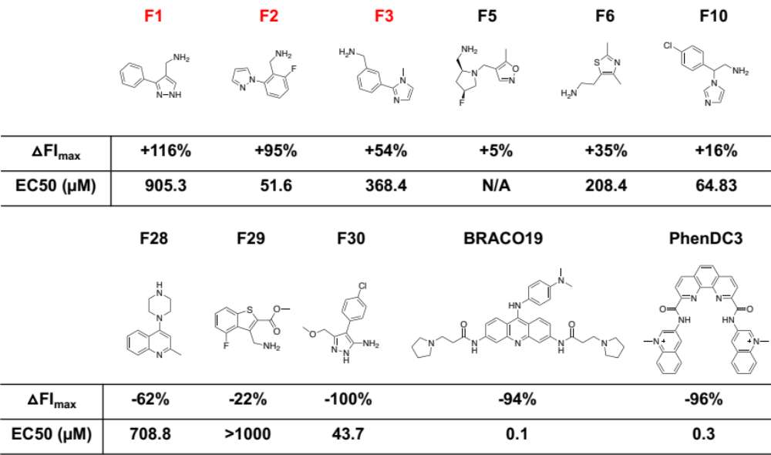

Figure S7. Quantitative analysis of the fluorescent enhancement/quenching that are affected by adding fragments/control molecules.

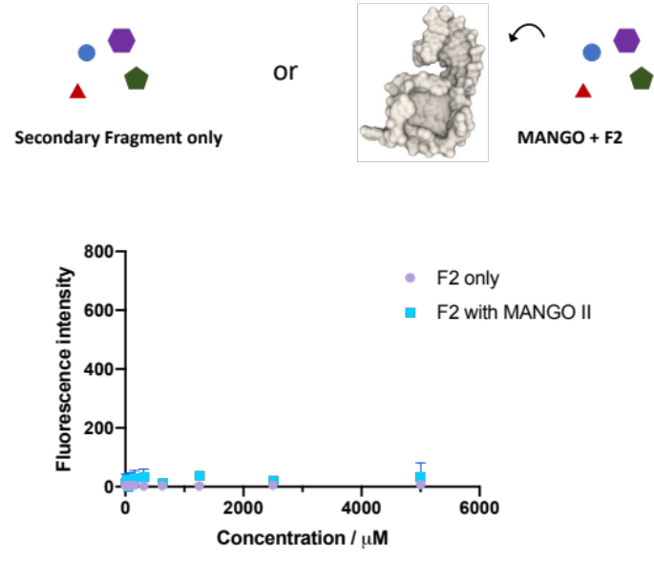

Figure S8. Fluorescence intensity measurement of fragment solutions in the absence or presence of 100 nM Mango II RNA aptamer. Various concentrations of fragment in Mango selective buffer were tested (Ex 510 nm, Em 535 nm).

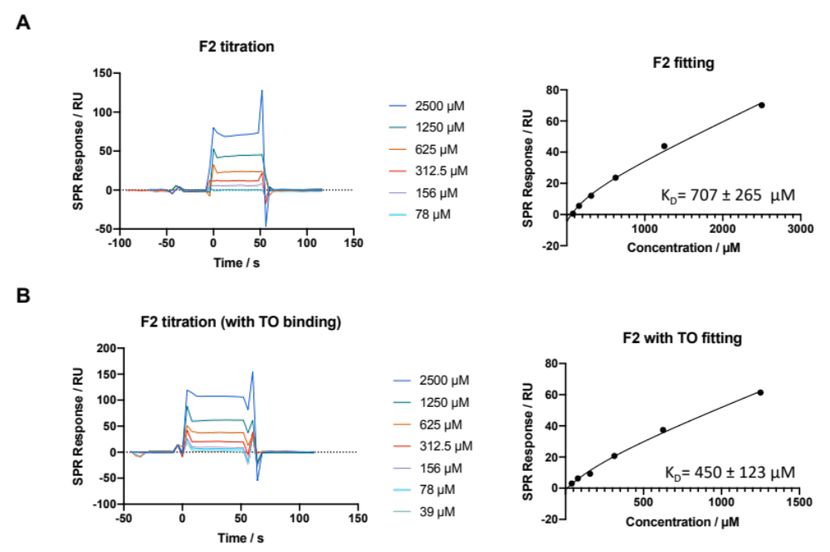

Figure S9. Affinity determination of F2 binding with Mango II RNA in absence (A) or presence (B) of TO by SPR titration.

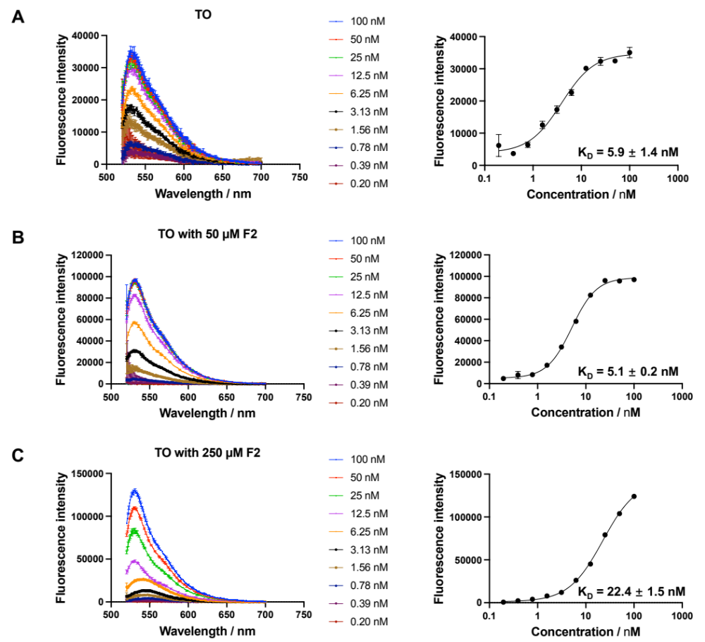

Figure S10. K_{D} determination by titrating Mango II RNA into TO solution in (A) absence or presence of (B) 50 µM or (C) 250 µM F2. The titration was performed in triplicate scanning by spectrofluorometer.

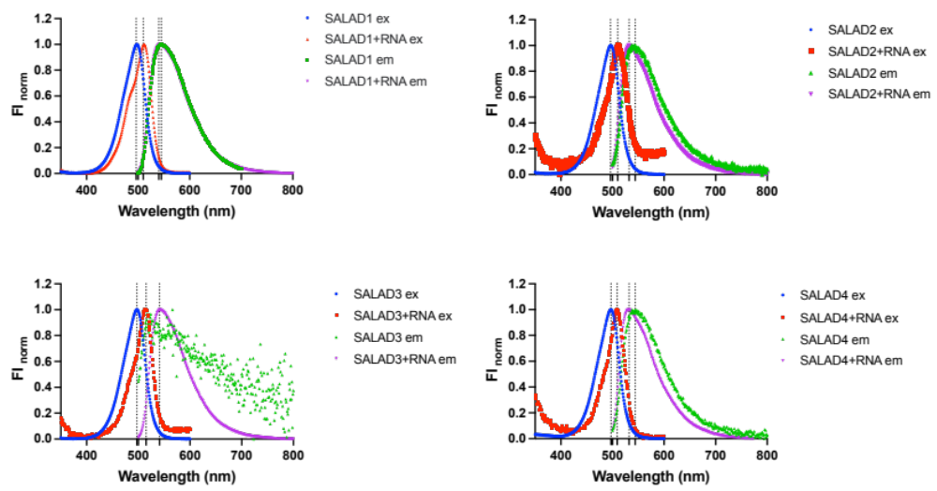

Figure S11. Normalized excitation and emission spectra for the four synthesized dyes (SALAD1, SALAD2, SALAD3, and SALAD4) in absence and presence of Mango II RNA.

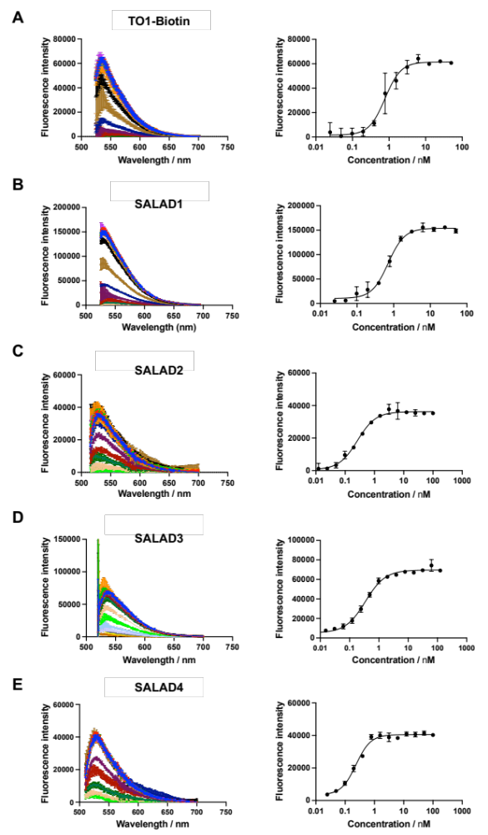

Figure S12. K_{D} measurements of five TO-derivatives by titrating Mango II RNA into dye solution by using a spectrofluorometer.

Figure S13. Secondary structure representation of Mango II complexed with a generic ligand (orange). Lines with embedded arrowheads and Leontis-Westhof symbols denote connectivity and base pairs, respectively.¹³ This color scheme is used throughout, except where noted.

Figure S14. Composite simulated annealing-omit 2|F_{o}| - |F_{c}| electron density maps for the (A) Mango II–SALAD1, (B) Mango II–SALAD2, (C) Mango II–SALAD3, and (D) Mango II–SALAD4 complexes contoured at 1.0 σ (gray meshes), superimposed on the respective final refined models.

Figure S15. Cartoon representations of the Mango II aptamer binding site complexed with (A) SALAD1, (B) SALAD2, (C) SALAD3, and (D) SALAD4 with fluorophores overlayed from the three independent complexes in the crystallographic asymmetric units, superimposed on chain A. Fluorophores from chains B and C are colored in gray and white, respectively. A22 is labeled in yellow for reference and purple spheres represent K⁺.

Table S1. Oligonucleotides for selectivity profiling of Mango compoundª

No. | Target | Structure | Length (nt) | Sequence
1 | Mango I | RNA G4 | 40 | 5′-GGC ACG UAC GAA GGG ACG GUG CGG AGA GGA GAG UAC GUG C-3'
2 | Mango II | RNA G4 | 41 | 5′-GGC ACG UAC GAA GGA GAG GAG AGG AAG AGG AGA GUA CGU GC-3'
3 | Mango III | RNA G4 | 46 | 5′-GGC ACG UAC GAA GGA AGG AUU GGU AUG UGG UAU AUU CGU ACG UGC C-3'
4 | Mango IV | RNA G4 | 42 | 5′-GGC ACG UAC CGA GGG AGU GGU GAG GAU GAG GCG AGU ACG UGC-3'
5 | NRAS | RNA G4 | 21 | 5′-UGU GGG AGG GGC GGG UCU GGG-3′
6 | DHX15 | RNA G4 | 31 | 5'-CGU GUG GGC UGU AGU AGC GGG AGG GGU GGG G-3'
7 | FSE | RNA PK | 74 | 5'-UUU GCG GUG UAA GUG CAG CCC GUC UUA CAC CGU GCG GCA CAG GCA CUA GUA CUG AUG UCG UAU ACA GGG CUU UU-3'
8 | PreQ1-RS | RNA PK | 33 | 5'-CUG GGU CGC AGU AAC CCC AGU UAA CAA AAC AAG-3'
9 | S2m | RNA SL | 47 | 5'-CAU UUU CAC CGA GGC CAC GCG GAG UAC GAU CGA GUG UAC AGU GAA CA-3'
10 | C-myc IRES D2 | RNA SL | 39 | 5'-GCG GGG AGG UGC CCA UUU GGG GAC ACU UCC CCG CCG CUG-3'
11 | U4U6 92 | RNA 3WJ | 92 | 5'-GGC CUU AUG CAC GGG AAA UAC GCA UAU CAG UGA GGA UUC GUC CGA GAU UGU GUU UUU GCU GGU GUA AAU CAG CAG UUC CCC UGC AUA AGG CU-3'
12 | Yeast tRNA | RNA complex | -- | --
13 | dsDNA | dsDNA | 26 | 5'-CAA TCG GAT CGA ATT CGA TCC GAT TG-3'  3'-GTT AGC CTA GCT TAA GCT AGG CTA AC-5'
14 | ssDNA | ssDNA | 31 | 5'-TGT CCC CAC ACC CCT GTC CCC ACA CCC CTG T-3'
15 | C-myc Pu27 | DNA G4 | 27 | 5'-TGG GGA GGG TGG GGA GGG TGG GGA AGG-3'
16 | N-myc | DNA G4 | 34 | 5′-AGG GGG TGG GAG GGG GCA TGC AGA TGC AGG GGG T-3′
17 | KRAS | DNA G4 | 35 | 5′-AGG GCG GTG TGG GAA GAG GGA AGA GGG GGA GGC AG-3′
18 | (CCCCTTT)_{n} | i-motif | 25 | 5′- (CCCCTTT)_{n}-3′

a. Running buffer: Mango selective buffer, 10 mM Tris, pH 7.0, 140 mM KCl, 1 mM MgCl₂, 0.005% T20. For i-motif, the buffer was adjusted to pH 4.5.

Table S2. Crystallographic statistics
 | Mango II–SALAD1 | Mango II–SALAD2 | Mango II–SALAD3 | Mango II–SALAD4
Data collection*†
Beamline | ALS 5.0.2 | ALS 5.0.2 | ALS 5.0.2 | ALS 5.0.2
Wavelength (Å) | 1.000 | 1.000 | 1.000 | 1.000
Space group | C 222₁ | C 222₁ | C 222₁ | C 222₁
Cell dimensions
a, b, c (Å) | 37.0 180.1 108.2 | 37.3 184.5 108.1 | 37.3 184.1 108.6 | 37.3 184.8 108.1
α, β, γ (°) | 90 90 90 | 90 90 90 | 90 90 90 | 90 90 90
Resolution (Å) | 54.1 - 2.9 | 54.1 - 2.8 | 54.3 - 2.8 | 70.2 - 2.8
R_{merge} | 0.178 (1.298) | 0.097 (3.158) | 0.125 (1.832) | 0.103 (3.174)
CC_{1/2} | 0.816 (0.65) | 0.998 (0.363) | 0.96 (0.301) | 0.907 (0.307)
<I>/<σ(I)> | 5.11 (0.62) | 14.25 (0.49) | 7.59 (0.39) | 10.4 (0.3)
Completeness (%) | 98.13 (91.94) | 99.27 (97.97) | 97.76 (93.66) | 95.59 (82.11)
Redundancy | 6.3 (6.4) | 12.9 (13.6) | 6.2 (6.7) | 13.1 (13.6)
Refinement
Resolution (Å) | 54.1 - 2.90 (3.08 -2.9) | 46.13 - 2.8 (2.95 - 2.8) | 54.3 - 3.0 (3.19 - 3.0) | 46.19 - 2.85 (3.03 – 2.85)
Unique reflections | 8365 (1277) | 9763 (1349) | 9150 (1212) | 9036 (1267)
R_{work} / R_{free} | 0.229 / 0.260 | 0.217 / 0.244 | 0.245 / 0.285 | 0.234 / 0.255
No. atoms
RNA | 2323 | 2334 | 2335 | 2315
Ligand/ion | 104 | 104 | 121 | 109
Water | 12 | 6 | 11 | 4
B-factors (Å²)
RNA | 77.0 | 96.9 | 66.2 | 90.4
Ligand/ion | 72.5 | 100.7 | 68.6 | 89.3
Water | 46.8 | 63.6 | 46.1 | 65.6
R.m.s. deviations
Bond lengths (Å) | 0.002 | 0.002 | 0.002 | 0.002
Bond angles (°) | 0.60 | 0.56 | 0.51 | 0.55
Mean precision (Å) | 0.51 | 0.38 | 0.48 | 0.60
PDB ID | 8VXX | 8VXZ | 8VY0 | 8VY1

*One crystal was used for each dataset. †Values in parentheses are for highest resolution shell.

General chemistry methods

Unless otherwise noted, all chemical reagents were obtained from commercial suppliers and used without further purification. Solvents were removed using a Buchi rotary evaporator under reduced pressure. Flash column chromatography was performed using a Teledyne ISCO CombiFlash Rf automated chromatography system.

High resolution mass spectrometry data were acquired on an Agilent 6520 Accurate-Mass Q-TOF LC/MS System, (Agilent Technologies, Inc.) equipped with a dual electro-spray source, operated in the positive-ion mode. Separation was performed on Zorbax 300SB-C18 Poroshell column (2.1 mm x 150 mm; particle size 5 mm). The analytes were eluted using a water/acetonitrile gradient with 0.1% formic acid. Data were acquired at high resolution (1,700 m/z), 4 GHz. To maintain mass accuracy during the run time, an internal mass calibration sample was infused continuously during the LC/MS runs. Data acquisition and analysis were performed using MassHunter Workstation Data Software, LCMS Data Acquisition (version B.06.01) and Qualitative Analysis (version B.07.00).

Synthesis
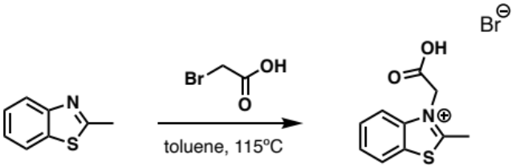

3-(Carboxymethyl)-2-methylbenzothiazolium bromide
Compound was synthesized by following a previously reported protocol.³ A solution of 2-methylbenzothiazole (4.78 g, 32 mmol) and 2-bromoacetic acid (6.5 g, 47 mmol) in toluene (100 mL) was heated to reflux and stirred for 24 hours. The mixture was returned to room temperature then filtered. The remaining solid was washed with toluene (3 x 25 mL), ether (2 x 25 mL), and acetonitrile (2 x 25 mL). The product was dried in vacuo to afford 5.05 g of purple solid (73%). ¹H NMR (500 MHz, DMSO-d₆): δ 8.47 (d, J = 8.3 Hz, 1H), 8.29 (d, J = 8.3 Hz, 1H), 7.90 (t, J = 7.7 Hz, 1H), 7.82 (t, J = 7.7 Hz, 1H), 5.77 (s, 2H), 3.20 (s, 3H); ¹³C NMR (125 MHz, DMSO-d₆): δ179.1, 166.6, 141.1, 129.6, 128.6, 128.3, 124.8, 116.6, 49.9, 17.0; HRMS: (ESI+) m/z calculated for C₁₀H₁₀NO₂S⁺ [M]⁺: 208.0432, found: 208.0430.

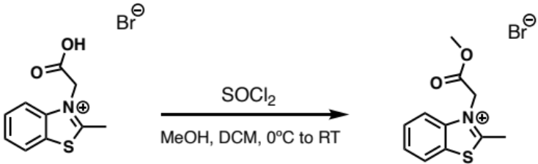

3-(2-Methoxy-2-oxoethyl)-2-methylbenzothiazolium bromide
A solution of 3-(carboxymethyl)-2-methylbenzothiazolium bromide (820 mg, 2.84 mmol) in dichloromethane (4 mL) and methanol (3 mL) was cooled to 0ºC while stirring, then thionyl chloride (0.21 mL, 2.84 mmol) was slowly added. The mixture was returned to room temperature and continued stirring for 22 hours. The mixture was then concentrated down onto celite in vacuo and purified by reverse phase ISCO flash column chromatography (10-40% acetonitrile + 0.1% TFA in water + 0.1% TFA) to afford 674 mg of yellow solid (79%). ¹H NMR (500 MHz, MeOD-d₄): δ 8.35 (d, J = 8.4 Hz, 1H), 8.19 (d, J = 8.4 Hz, 1H), 7.92 (t, J = 7.3 Hz, 1H), 7.85 (t, J = 7.6 Hz, 1H), 5.80 (s, 2H), 3.88 (s, 3H), 3.22 (s, 3H); ¹³C NMR (125 MHz, MeOD-d₄): δ 180.7, 166.8, 142.8, 131.3, 130.2, 130.0, 125.5, 117.6, 54.3, 50.8, 17.5; HRMS: (ESI+) m/z calculated for C₁₁H₁₂NO₂S⁺ [M]⁺: 222.0589, found: 222.0589.

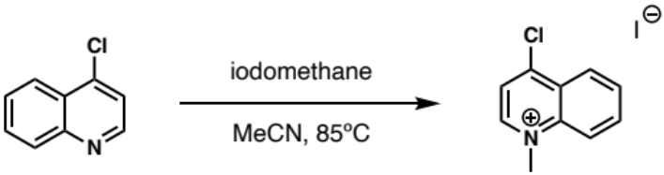

4-Chloro-1-methylquinolinium iodide
To a solution of 4-chloroquinolinium (2 g, 12.2 mmol) in acetonitrile (24 mL) was added iodomethane (2.3 mL, 36.7 mmol). The mixture was heated to reflux at 85ºC and stirred for four hours. The mixture was then returned to room temperature and concentrated down in vacuo. The resulting solid was triturated with ether, filtered, washed with ether (3 x 20 mL), and dried in vacuo to afford 3.7 g of yellow solid (98%). ¹H NMR (500 MHz, DMSO-d₆): δ 9.10 (d, J = 5.6 Hz, 1H), 8.88 (d, J = 5.6 Hz, 1H), 8.60 (t, J = 9.1 Hz, 1H), 8.48 (d, J = 8.9 Hz, 1H), 8.41 (d, J = 8.9 Hz, 1H), 8.33 (t, J = 8.9 Hz, 1H), 4.54 (s, 3H); ¹³C NMR (125 MHz, DMSO-d₆): δ 150.6, 148.6, 137.8, 136.6, 134.3, 133.7, 132.1, 126.6, 120.5, 45.8. HRMS: (ESI+) m/z calculated for C₁₀H₉ClN⁺ [M]⁺: 178.0424, found: 178.0425.

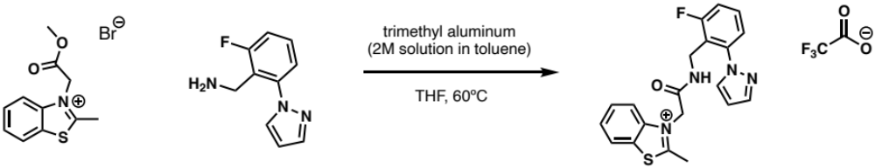

365A-059
To a solution of 2-fluoro-6-(1H-pyrazol-1-yl)benzenemethanamine (63 mg, 0.331 mmol) in tetrahydrofuran (5 mL) was slowly added trimethyl aluminum as a 2M solution in toluene (0.165 mL, 0.331 mmol). The mixture stirred at room temperature for 15 minutes, then 3-(2-methoxy-2-oxoethyl)-2-methylbenzothiazolium bromide (100 mg, 0.331 mmol) was added. The reaction was heated to 60ºC and stirred for two hours. The mixture was returned to room temperature and quenched with a saturated solution of Rochelle’s salt (6 mL). Dichloromethane (6 mL) was added, and the solution was vigorously stirred overnight. The organic layer was extracted using dichloromethane (10 mL x 3), then the organic layer and dichloromethane washings were washed using brine (10 mL) and dried (Na₂SO₄). The crude product was concentrated down onto celite in vacuo then purified by reverse phase ISCO flash column chromatography (10-100% acetonitrile + 0.1% TFA in water + 0.1% TFA) to afford 54 mg of purplish oil (35%). ¹H NMR (500 MHz, MeOD-d₄): δ 8.29 (d, J = 8.0 Hz, 1H), 8.02 (d, J = 8.3 Hz, 1H), 7.97 (d, J = 2.2 Hz, 1H), 7.89 (t, J = 8.4 Hz, 1H), 7.81 (t, J = 7.6 Hz, 1H), 7.73 (d, J = 2.2 Hz, 1H), 7.50-7.54 (m, 1H), 7.31 (d, J = 8.7 Hz, 1H), 7.28 (d, J = 8.3 Hz, 1H), 6.52 (t, J = 2.2 Hz, 1H), 5.53 (s, 2H), 4.46 (s, 2H), 3.15 (apt m, 3H); ¹³C NMR (125 MHz, MeOD-d₄): δ 180.3, 164.3, 164.3 (d, J¹_{C-F} = 249.3 Hz), 142.9, 142.5 (d, J³_{C-F} = 6.3 Hz), 142.3, 133.0, 131.4 (d, J³_{C-F} = 9.9 Hz), 131.2, 130.2, 129.9, 125.4, 123.1 (d, J⁴_{C-F} = 3.0 Hz), 121.9 (d, J²_{C-F} = 17.2 Hz), 117.2, 117.0 (d, J²_{C-F} = 22.6 Hz), 108.3, 51.7, 35.0, 35.0; HRMS: (ESI+) m/z calculated for C₂₀H₁₈FN₄OS⁺ [M]⁺: 381.1185, found: 381.1187.

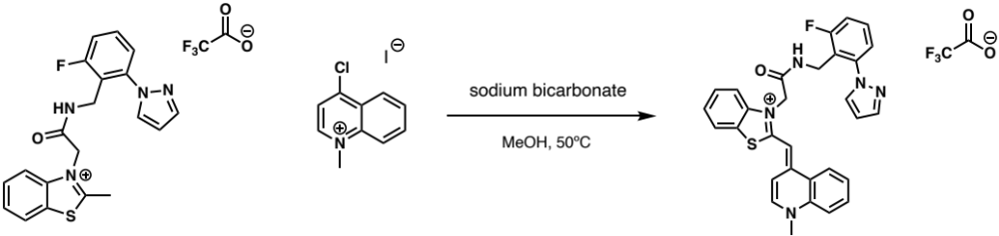

365A-061(SALAD1)
To a solution of 365A-059 (54 mg, 0.117 mmol) in methanol (5 mL) was added 4-chloro-1-methylquinolinium iodide (36 mg, 0.117 mmol) and sodium bicarbonate (20 mg, 0.234 mmol). The mixture was heated to 50ºC and stirred for 30 minutes. The reaction was then returned to room temperature and concentrated down in vacuo. The resulting residue was resuspended in ethanol, then filtered. The filtrate was concentrated down onto celite and purified by reverse phase ISCO Flash column chromatography (10-100% acetonitrile + 0.1% TFA in water + 0.1% TFA) to afford 19.4 mg of orange solid (27%). ¹H NMR (500 MHz, MeOD-d₄): δ 8.35 (d, J = 7.2 Hz, 1H), 8.33 (d, J = 7.9 Hz, 1H), 7.95-8.00 (m, 3H), 7.92 (t, J = 2.4 Hz, 1H), 7.77 (d, J = 7.3 Hz, 1H), 7.62 (t, J = 7.3 Hz, 1H), 7.54 (t, J = 2.9, 1H), 7.51 (d, J = 7.0 Hz, 1H), 7.47 (d, J = 8.2 Hz, 1H), 7.33-7.36 (m, 3H), 7.16 (d, J = 7.3 Hz, 1H), 7.04 (t, J = 8.5 Hz, 1H), 6.47 (d, J = 2.2 Hz, 1H), 5.18 (s, 2H), 4.41 (s, 2H), 4.16 (s, 3H); ¹³C NMR (125 MHz, MeOD-d₄): δ 167.1, 164.0 (d, J¹_{C-F} = 248.7 Hz), 161.6, 150.9, 145.9, 142.5 (d, J³_{C-F} = 6.3 Hz), 142.2, 141.7, 139.7, 134.6, 132.9, 131.2 (d, J³_{C-F} = 9.7 Hz), 129.4, 128.5, 126.1, 125.9, 125.8, 125.5, 123.7, 122.7, 122.7 (d, J⁴_{C-F} = 3.1 Hz), 122.0 (d, J²_{C-F} = 18.0 Hz), 119.0, 116.8 (d, J²_{C-F} = 22.7 Hz), 113.3, 110.1, 108.3, 49.3, 43.3, 34.7; HRMS: (ESI+) m/z calculated for C₃₀H₂₅FN₅OS⁺ [M]⁺: 522.1758, found: 522.1786.

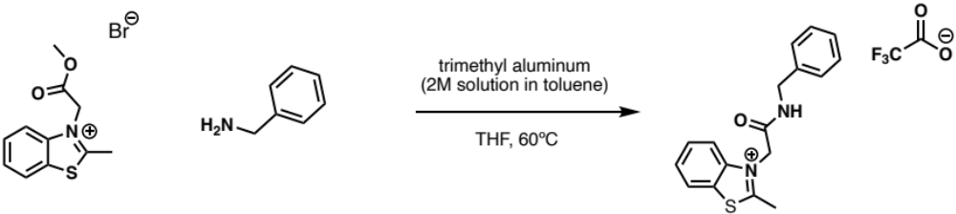

365A-083
To a solution of benzylamine (0.036 mL, 0.496 mmol) in tetrahydrofuran (5 mL) was slowly added trimethyl aluminum as a 2M solution in toluene (0.166 mL, 0.496 mmol). The mixture stirred at room temperature for 15 minutes, then 3-(2-methoxy-2-oxoethyl)-2-methylbenzothiazolium bromide (100 mg, 0.496 mmol) was added. The reaction was heated to 60ºC and stirred for two hours. The mixture was returned to room temperature and quenched with a saturated solution of Rochelle’s salt (6 mL). Dichloromethane (6 mL) was added, and the solution was vigorously stirred overnight. The organic layer was extracted using dichloromethane (10 mL x 3), then the organic layer and dichloromethane washings were washed using brine (10 mL) and dried (Na₂SO₄). The crude product was concentrated down onto celite in vacuo then purified by reverse phase ISCO Flash column chromatography (10-100% acetonitrile + 0.1% TFA in water + 0.1% TFA) to afford 30 mg of colorless oil (20%). ¹H NMR (500 MHz, MeOD-d₄): δ 8.32 (d, J = 7.8 Hz, 1H), 8.07 (d, J = 8.1 Hz, 1H), 7.89 (t, J = 6.9 Hz, 1H), 7.82 (t, J = 6.9 Hz, 1H), 7.33-7.34 (m, 4H), 7.28 (d, J = 6.3 Hz, 1H), 5.63 (s, 2H), 4.46 (s, 2H), 3.17-3.20 (apt m, 3H); ¹³C NMR (125 MHz, MeOD-d₄): δ 180.4, 165.0, 164.9, 142.9, 139.1, 131.2, 130.3, 130.0, 129.7, 128.9, 128.7, 125.5, 117.2, 51.9, 44.9, 44.8; HRMS: (ESI+) m/z calculated for C₁₇H₁₇N₂OS⁺ [M]⁺: 297.1062, found: 297.1062.

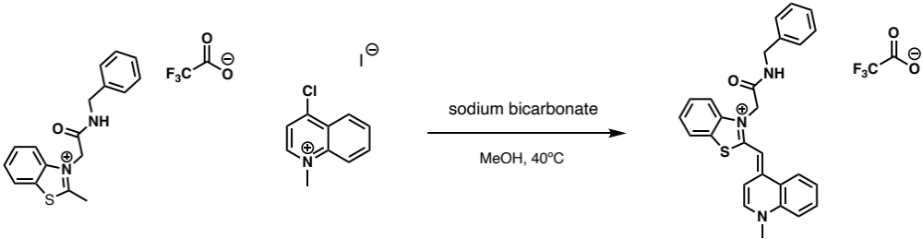

365A-084(SALAD2)
To a solution of 365A-083 (30 mg, 0.080 mmol) in methanol (5 mL) was added 4-chloro-1-methylquinolinium iodide (24 mg, 0.080 mmol) and sodium bicarbonate (13 mg, 0.159 mmol). The mixture was heated to 40ºC and stirred for three hours, then was concentrated down in vacuo. The resulting residue was resuspended in ethanol, then filtered. The filtrate was concentrated down onto celite and purified by reverse phase ISCO Flash column chromatography (10-100% acetonitrile + 0.1% TFA in water + 0.1% TFA) to afford 3 mg of orange solid (7%). ¹H NMR (500 MHz, MeOD-d₄): δ 8.46 (d, J = 7.9 Hz, 1H), 8.36 (d, J = 7.9 Hz, 1H), 8.07 (d, J = 9.1 Hz, 1H), 8.00 (t, J = 7.9 Hz, 1H), 7.89 (d, J = 7.9 Hz, 1H), 7.65 (t, J = 7.9 Hz, 1H), 7.59 (d, J = 6.1 Hz, 2H), 7.53 (d, J = 7.1 Hz, 1H), 7.42 (t, J = 6.2 Hz, 1H), 7.29-7.31 (apt m, 2H), 7.15-7.17 (apt m, 3H), 6.77 (s, 1H), 5.29 (s, 2H), 4.47 (s, 2H), 4.23 (s, 3H); ¹³C NMR (125 MHz, DMSO-d₆): δ 167.7, 162.0, 151.3, 146.1, 142.0, 139.9, 139.6, 134.6, 129.6, 129.4, 128.8, 128.5, 128.4, 126.1, 126.0, 123.8, 119.1, 113.4, 110.2, 89.0, 49.7, 49.6, 44.5, 43.3; HRMS: (ESI+) m/z calculated for C₂₇H₂₄N₃OS⁺ [M]⁺: 438.1635, found: 438.1642.

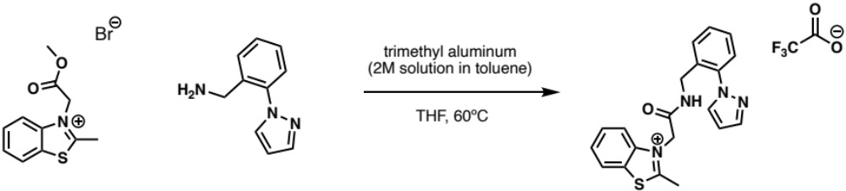

365A-085
To a solution of 2-(1H-pyrazol-1-yl)benzenemethanamine (86 mg, 0.496 mmol) in tetrahydrofuran (8 mL) was slowly added trimethyl aluminum as a 2M solution in toluene (0.25 mL, 0.496 mmol). The mixture stirred at room temperature for 15 minutes, then 3-(2-methoxy-2-oxoethyl)-2-methylbenzothiazolium bromide (150 mg, 0.496 mmol) was added. The reaction was heated to 60ºC and stirred for four hours. The mixture was returned to room temperature and quenched with a saturated solution of Rochelle’s salt (7 mL). Dichloromethane (7 mL) was added, and the solution was vigorously stirred overnight. The organic layer was extracted using dichloromethane (10 mL x 3), then the organic layer and dichloromethane washings were washed using brine (10 mL) and dried (Na₂SO₄). The crude product was concentrated down onto celite in vacuo then purified by reverse phase ISCO Flash column chromatography (5-60% acetonitrile + 0.1% TFA in water + 0.1% TFA) to afford 24 mg of purplish oil (11%). ¹H NMR (500 MHz, MeOD-d₄): δ 8.31 (d, J = 7.7 Hz, 1H), 8.05 (d, J = 7.7 Hz, 1H), 7.92 (d, J = 2.2 Hz, 1H), 7.89 (t, J = 7.1 Hz, 1H), 7.82 (t, J = 7.7, 1H), 7.74 (t, J = 3.0 Hz, 1H), 7.56-7.58 (apt m, 1H), 7.46-7.48 (apt m, 2H), 7.40-7.42 (apt m, 1H), 6.53 (d, J = 2.2, 1H), 5.58 (s, 2H), 4.39 (s, 2H), 3.14-3.17 (apt m, 3H); ¹³C NMR (125 MHz, MeOD-d₄): δ 180.4, 165.0, 142.9, 141.9, 140.6, 134.5, 132.8, 131.3, 131.2, 130.3, 130.2, 130.0, 129.9, 127.3, 125.4, 117.2, 108.0, 51.8, 41.3, 41.2; HRMS: (ESI+) m/z calculated for C₂₀H₁₉N₄OS⁺ [M]⁺: 363.1280, found: 363.1278.

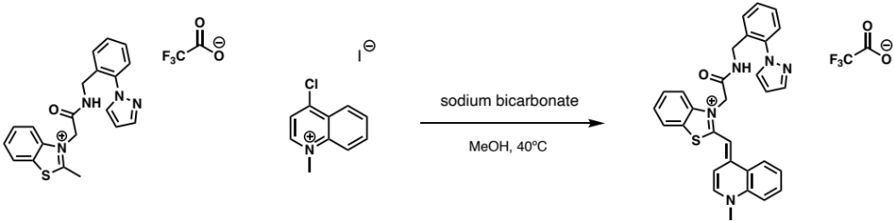

365A-087(SALAD3)
To a solution of 365A-085 (65 mg, 0.147 mmol) in methanol (5 mL) was added 4-chloro-1-methylquinolinium iodide (45 mg, 0.147 mmol) and sodium bicarbonate (25 mg, 0.294 mmol). The mixture was heated to 40ºC and stirred for three hours. The mixture was returned to room temperature, then was concentrated down in vacuo. The resulting residue was resuspended in ethanol, then filtered. The filtrate was concentrated down onto celite and purified by reverse phase ISCO Flash column chromatography (10-100% acetonitrile + 0.1% TFA in water + 0.1% TFA) to afford 4 mg of orange solid (4%). ¹H NMR (500 MHz, MeOD-d₄): δ 8.53 (s, 1H), 8.44 (d, J = 7.1 Hz, 1H), 8.35 (d, J = 8.1 Hz, 1H), 8.07 (d, J = 7.9 Hz, 1H), 8.00 (t, J = 7.5 Hz, 1H), 7.87-7.90 (m, 2H), 7.57-7.65 (m, 3H), 7.48 (d, J = 6.8 Hz, 2H), 7.42-7.45 (m, 1H), 7.22-7.25 (m, 2H), 7.11-7.14 (m, 1H), 6.71 (s, 1H), 6.48 (s, 1H), 5.27 (s, 2H), 4.34 (s, 2H), 4.24 (s, 3H); ¹³C NMR (125 MHz, MeOD-d₄): δ 192.3, 167.6, 161.6, 150.8, 145.9, 141.8, 141.7, 140.5, 139.6, 134.7, 134.6, 132.7, 131.2, 129.8, 129.6, 129.4, 128.5, 126.8, 126.1, 125.9, 125.8, 125.5, 123.7, 119.0, 113.2, 110.1, 108.0, 49.7, 43.3, 40.9; HRMS: (ESI+) m/z calculated for C₃₀H₂₆N₅OS⁺ [M]⁺: 504.1853, found: 504.1860.

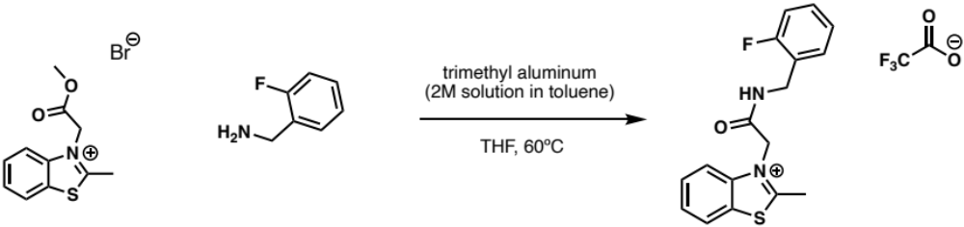

365A-086
To a solution of 2-fluorobenzylamine (62 mg, 0.496 mmol) in tetrahydrofuran (8 mL) was slowly added trimethyl aluminum as a 2M solution in toluene (0.25 mL, 0.496 mmol). The mixture stirred at room temperature for 15 minutes, then 3-(2-methoxy-2-oxoethyl)-2-methylbenzothiazolium bromide (150 mg, 0.496 mmol) was added. The reaction was heated to 60ºC and stirred for four hours. The mixture was returned to room temperature and quenched with a saturated solution of Rochelle’s salt (7 mL). Dichloromethane (7 mL) was added, and the solution was vigorously stirred overnight. The organic layer was extracted using dichloromethane (10 mL x 3), then the organic layer and dichloromethane washings were washed using brine (10 mL) and dried (Na₂SO₄). The crude product was concentrated down onto celite in vacuo then purified by reverse phase ISCO Flash column chromatography (5-60% acetonitrile + 0.1% TFA in water + 0.1% TFA) to afford 21.5mg of purplish oil (20%). ¹H NMR (500 MHz, MeOD-d₄): δ 8.32 (d, J = 8.2 Hz, 1H), 8.07 (d, J = 8.2 Hz, 1H), 7.89 (t, J = 7.8 Hz, 1H), 7.82 (t, J = 7.8 Hz, 1H), 7.40 (t, J = 7.8 Hz, 1H), 7.33 (q, 1H), 7.15 (t, J = 7.7 Hz, 1H), 7.12 (t, J = 9.5, 1H), 5.62 (s, 2H), 4.52 (s, 2H), 3.16-3.19 (apt m, 3H); ¹³C NMR (125 MHz, MeOD-d₄): δ 180.4, 165.0,163.3, 161.4, 142.9, 131.4, 131.4, 131.2, 130.9, 130.8, 130.3, 129.9, 125.9, 125.7, 125.5, 125.5, 125.4, 117.1, 116.5, 116.3, 51.8, 38.8, 38.7; HRMS: (ESI+) m/z calculated for C₁₇H₁₆FN₂OS⁺ [M]⁺: 315.0967, found: 315.0970.

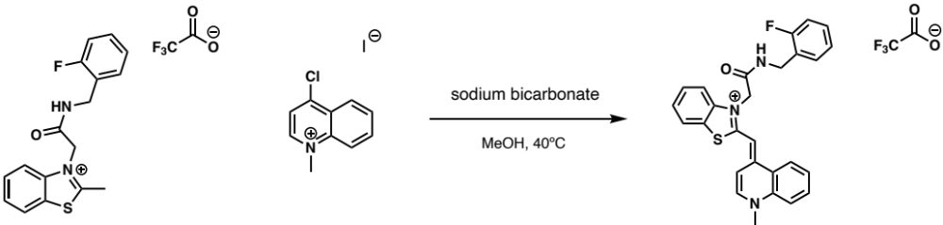

365A-088(SALAD4)
To a solution of 365A-086 (46 mg, 0.116 mmol) in methanol (5 mL) was added 4-chloro-1-methylquinolinium iodide (36 mg, 0.116 mmol) and sodium bicarbonate (19 mg, 0.232 mmol). The mixture was heated to 40ºC and stirred for six hours. The mixture was then returned to room temperature and was concentrated down in vacuo. The resulting residue was resuspended in ethanol, then filtered. The filtrate was concentrated down onto celite and purified by reverse phase ISCO Flash column chromatography (10-100% acetonitrile + 0.1% TFA in water + 0.1% TFA) to afford 2 mg of orange solid (3%). ¹H NMR (500 MHz, MeOD-d₄): δ 8.46 (d, J = 7.1 Hz, 1H), 8.38 (d, J = 8.4 Hz, 1H), 8.07 (d, J = 8.4 Hz, 1H), 7.99-8.03 (m, 1H), 7.89 (d, J = 7.9 Hz, 1H), 7.67-7.71 (m, 1H), 7.58-7.59 (m, 2H), 7.52 (d, J = 7.0, 1H), 7.40-7.43 (m, 1H), 7.37 (t, J = 7.7 Hz, 1H), 7.19-7.24 (m, 1H), 7.01 (t, J = 9.2 Hz, 1H), 6.96 (t, J = 7.8 Hz, 1H), 6.76 (s, 1H), 5.28 (s, 2H), 4.54 (s, 2H), 4.23 (s, 3H); ¹³C NMR (125 MHz, MeOD-d₄): δ 166.3, 161.8 (d, J¹_{C-F} = 244.5 Hz), 160.5, 153.1, 149.7, 144.6, 140.5, 138.4, 133.2, 130.0 (d, J³_{C-F} = 4.6 Hz), 129.3 (d, J³_{C-F} = 7.8 Hz), 128.0, 127.1, 124.8 (d, J²_{C-F} = 14.7 Hz), 124.6, 124.5, 124.1, 124.0 (d, J⁴_{C-F} = 3.8 Hz), 122.3, 117.7, 115.0 (d, J²_{C-F} = 21.4 Hz), 111.9, 108.8, 108.8, 41.9, 39.0, 37.1; HRMS: (ESI+) m/z calculated for C₂₇H₂₃FN₃OS⁺ [M+H]⁺: 457.1613, found: 457.1605.

NMR Data

365A-059

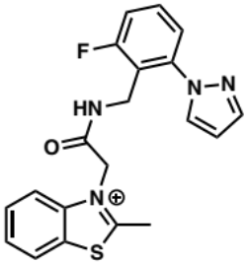
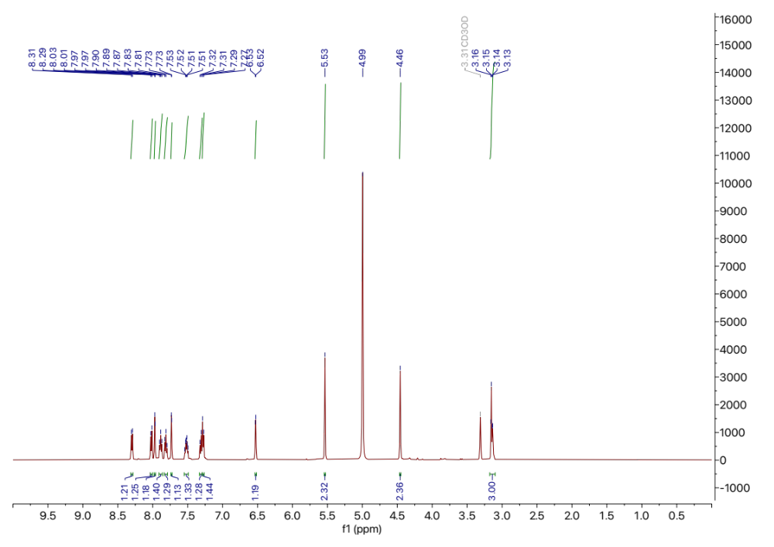
365A-059 ¹H NMR
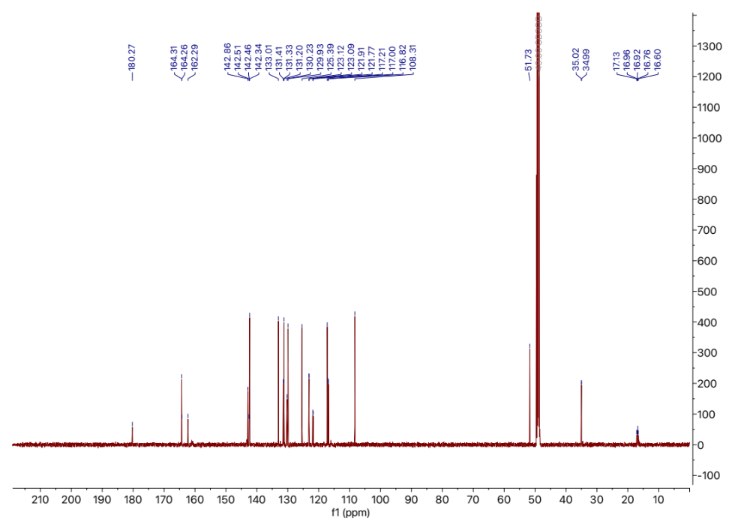
365A-059 ¹³C NMR

365A-061(SALAD1)

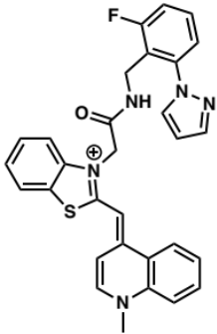
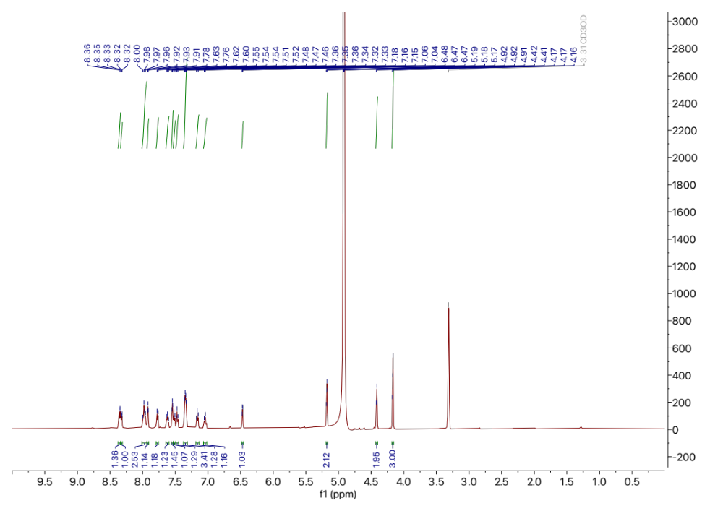
365A-061(SALAD1) ¹H NMR

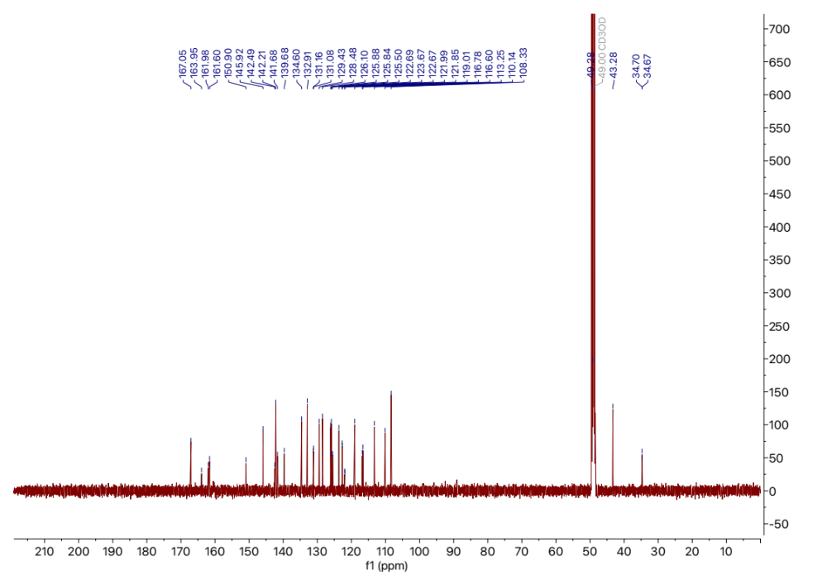
365A-061(SALAD1) ¹³C NMR

365A-083

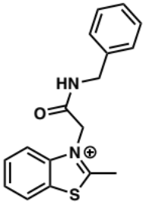

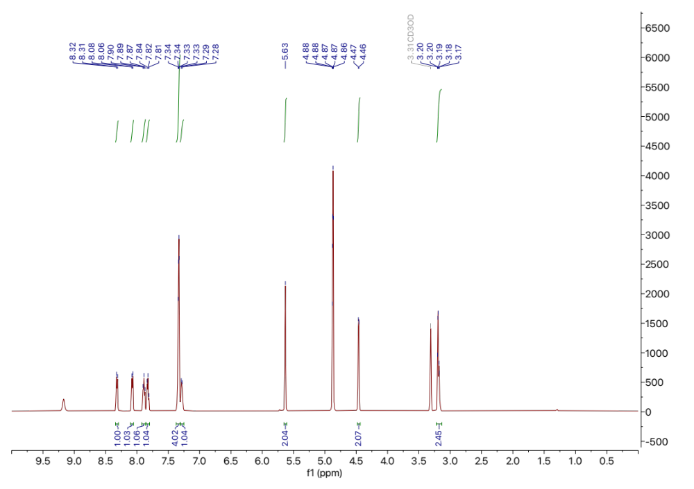
365A-083 ¹H NMR

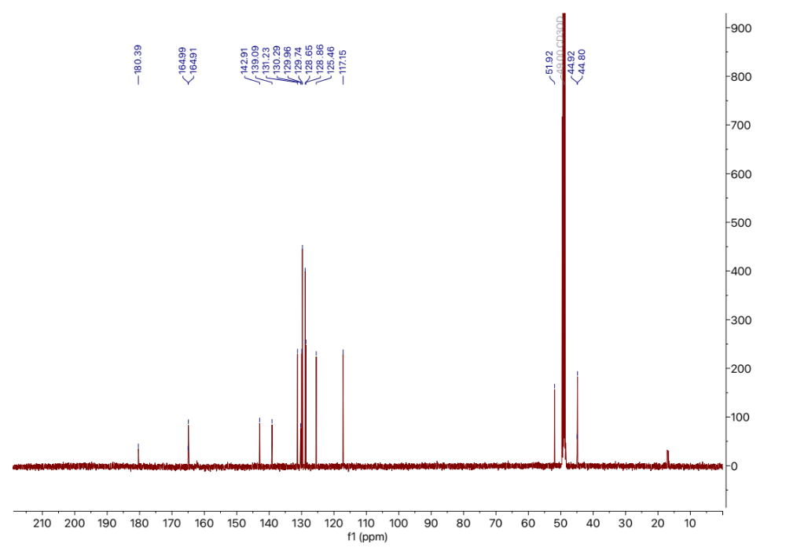
365A-083 ¹³C NMR

365A-084(SALAD2)

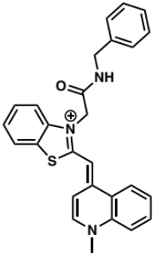

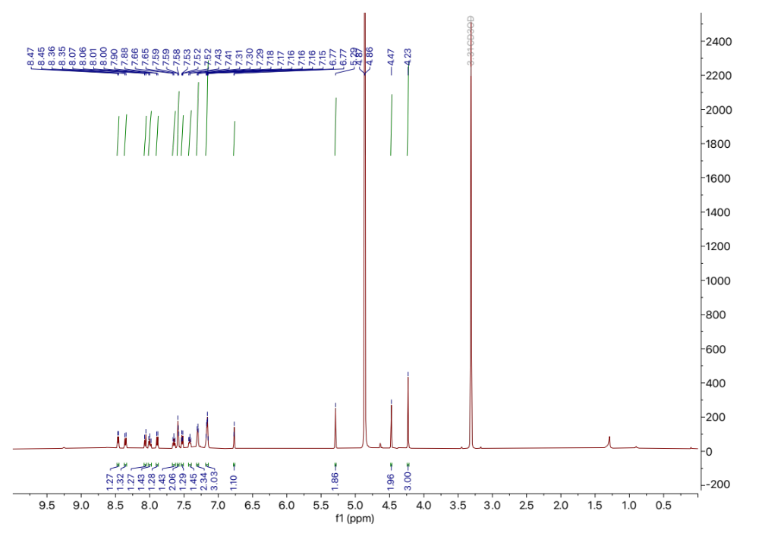
365A-084(SALAD2) ¹H NMR

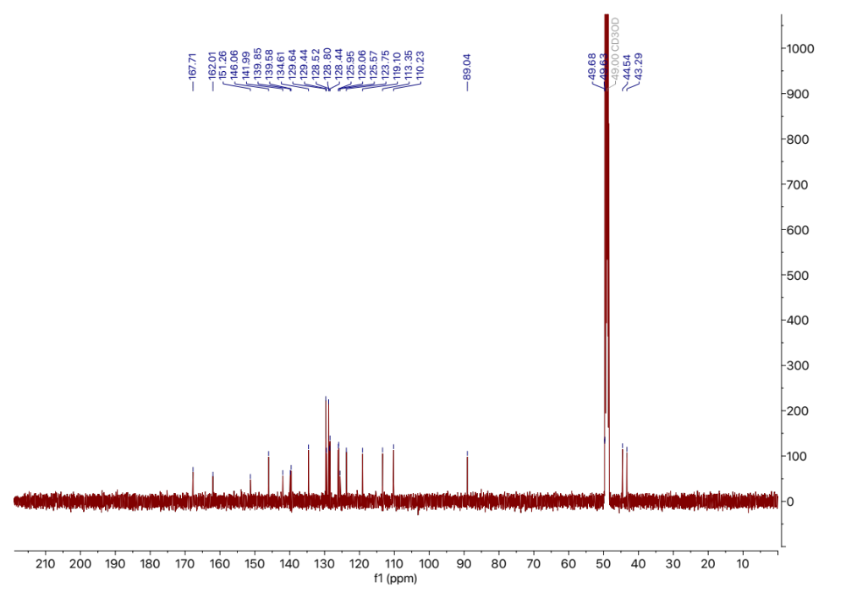
365A-084(SALAD2) ¹³C NMR

365A-085

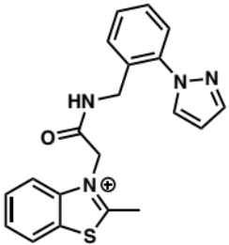

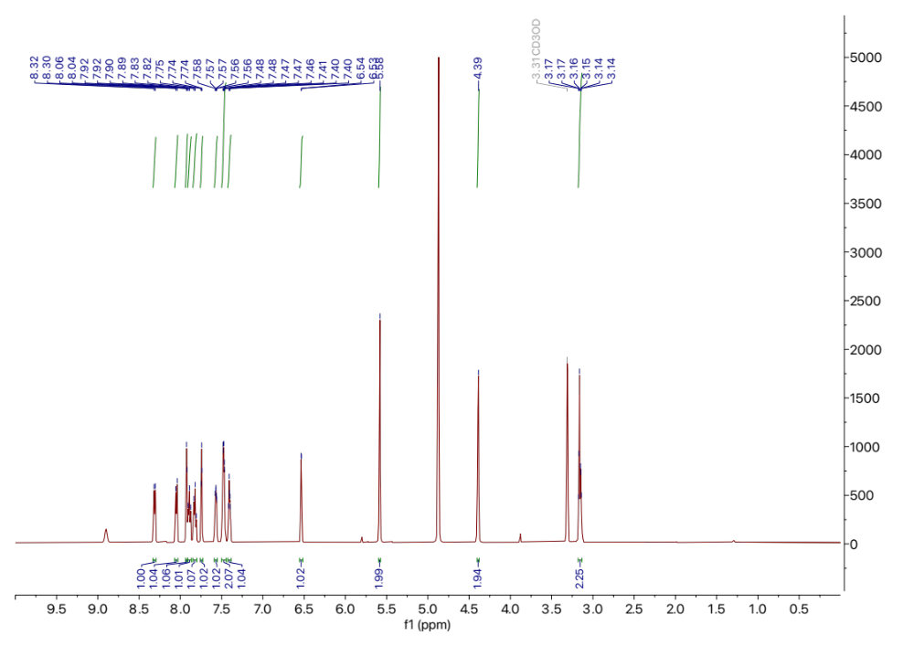
365A-085 ¹H NMR

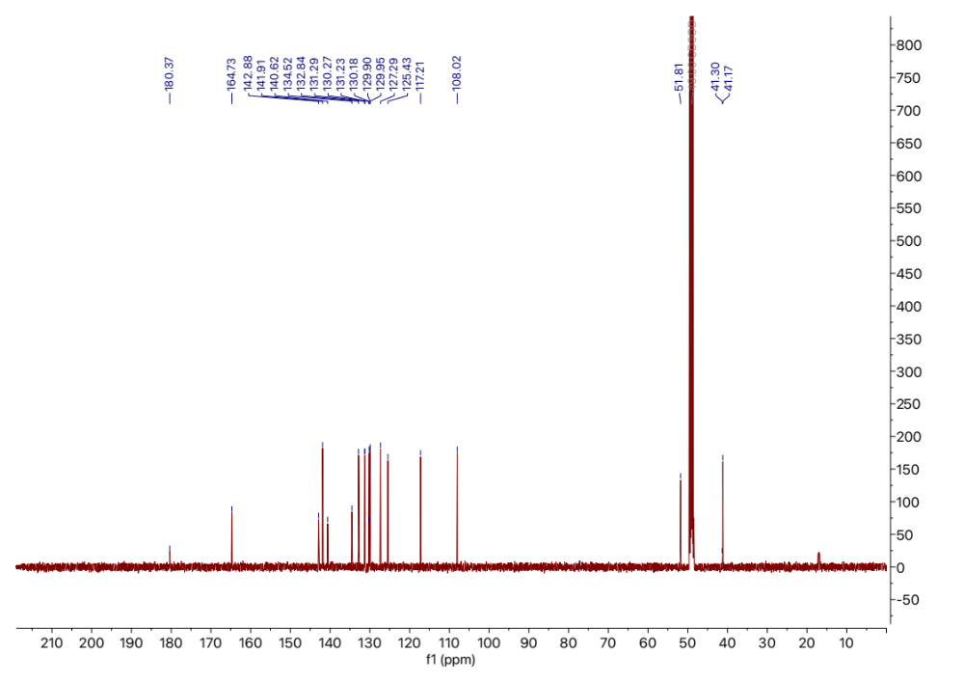
365A-085 ¹³C NMR

365A-087(SALAD3)

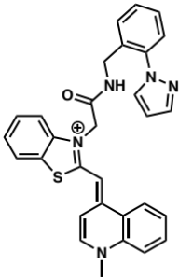

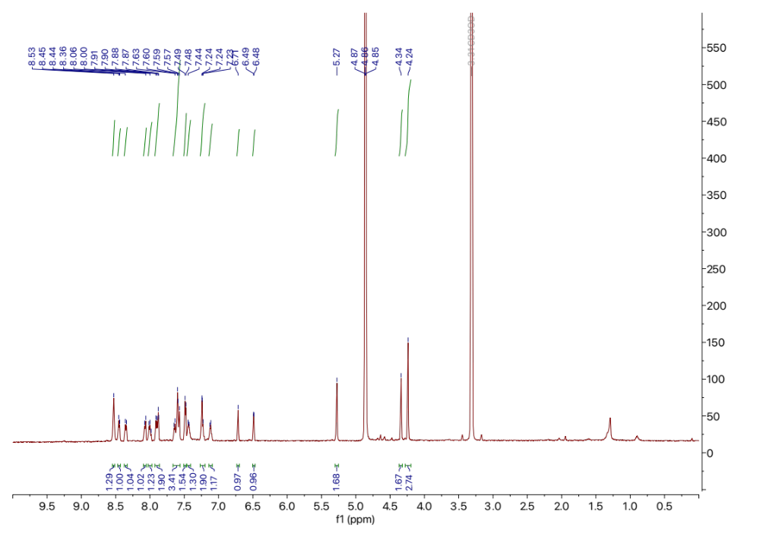
365A-087(SALAD3) ¹H NMR

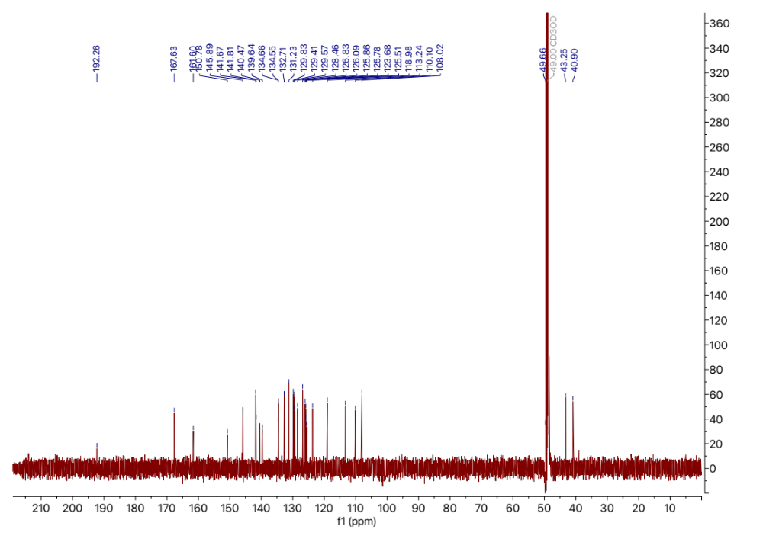
365A-087(SALAD3) ¹³C NMR

365A-086

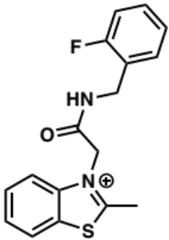
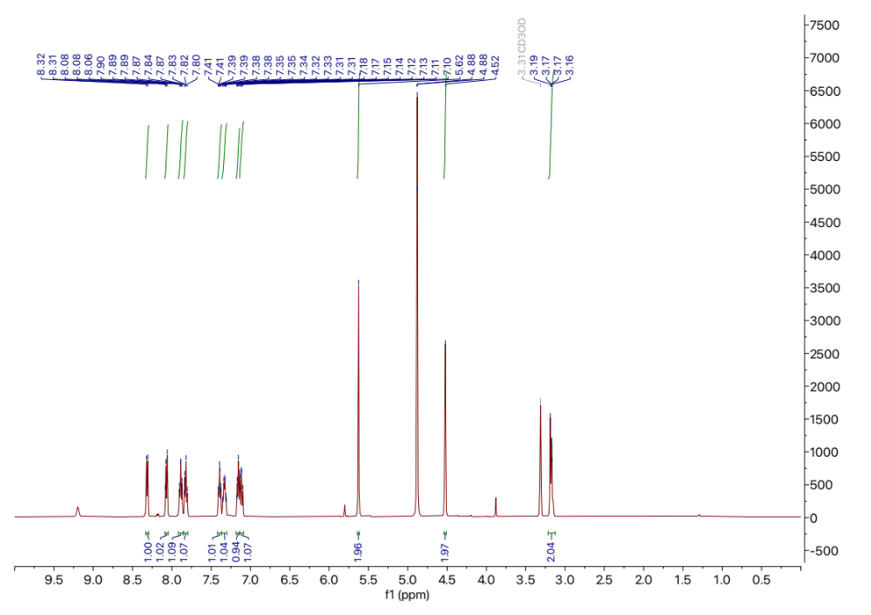
365A-086 ¹H NMR

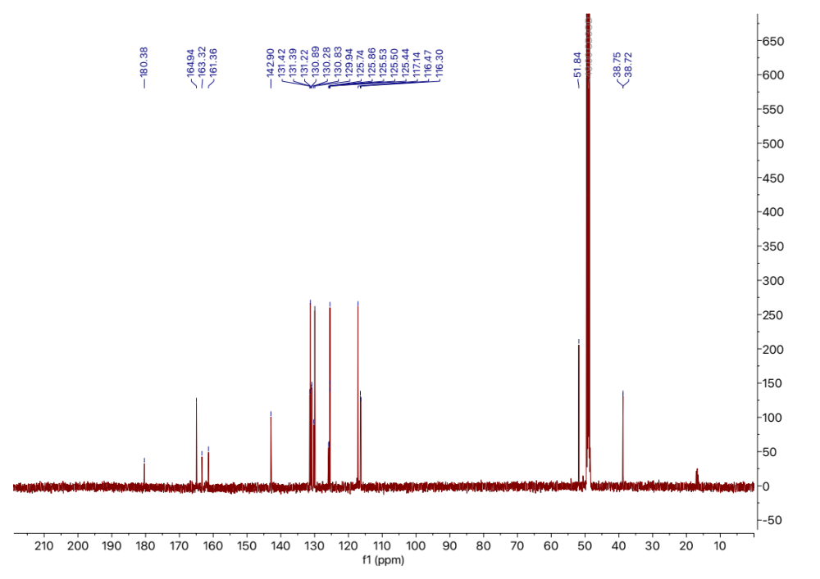
365A-086 ¹³C NMR

365A-088(SALAD4)

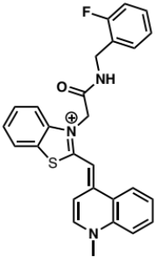

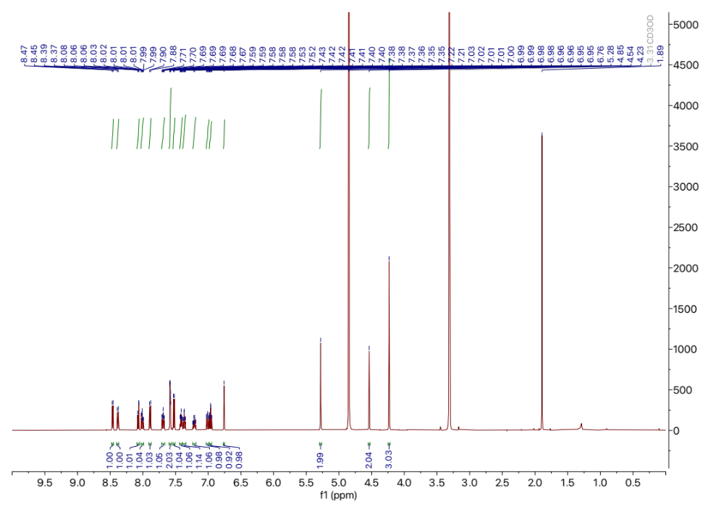
365A-088(SALAD4) ¹H NMR

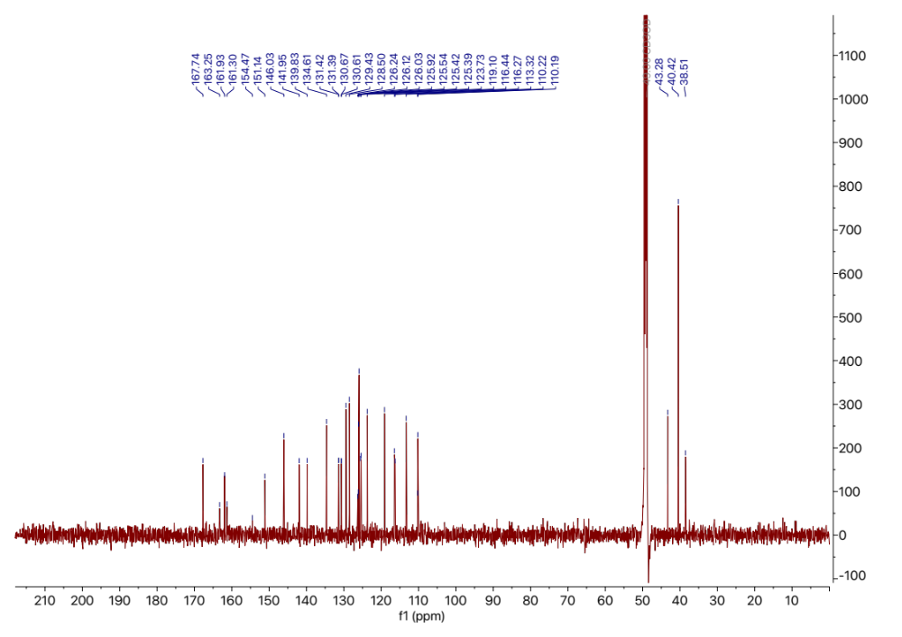
365A-088(SALAD4) ¹³C NMR

References

(1) Connelly, C. M.; Abulwerdi, F. A.; Schneekloth, J. S., Jr. Discovery of RNA Binding Small Molecules Using Small Molecule Microarrays. Methods Mol Biol 2017, 1518, 157-175. DOI: 10.1007/978-1-4939-6584-7_11 From NLM Medline.
(2) Calabrese, D. R.; Connelly, C. M.; Schneekloth, J. S., Jr. Ligand-observed NMR techniques to probe RNA-small molecule interactions. Methods Enzymol 2019, 623, 131-149. DOI: 10.1016/bs.mie.2019.05.030 From NLM Medline.
(3) Dolgosheina, E. V.; Jeng, S. C.; Panchapakesan, S. S.; Cojocaru, R.; Chen, P. S.; Wilson, P. D.; Hawkins, N.; Wiggins, P. A.; Unrau, P. J. RNA mango aptamer-fluorophore: a bright, high-affinity complex for RNA labeling and tracking. ACS Chem Biol 2014, 9 (10), 2412-2420. DOI: 10.1021/cb500499x From NLM Medline.
(4) Trachman, R. J., 3rd; Link, K. A.; Knutson, J. R.; Ferre-D'Amare, A. R. Characterizing Fluorescence Properties of Turn-on RNA Aptamers. Methods Mol Biol 2023, 2568, 25-36. DOI: 10.1007/978-1-0716-2687-0_3 From NLM Medline.
(5) Winter, G.: an expert system for macromolecular crystallography data reduction. J Appl Crystallogr 2010, 43, 186-190. DOI: 10.1107/S0021889809045701.
(6) Winter, G.; Waterman, D. G.; Parkhurst, J. M.; Brewster, A. S.; Gildea, R. J.; Gerstel, M.; Fuentes-Montero, L.; Vollmar, M.; Michels-Clark, T.; Young, I. D.; et al.: implementation and evaluation of a new integration package. Acta Crystallogr D 2018, 74, 85-97. DOI: 10.1107/S2059798317017235.
(7) Kabsch, W. Xds. Acta Crystallogr D Biol Crystallogr 2010, 66 (Pt 2), 125-132. DOI: 10.1107/S0907444909047337 From NLM Medline.
(8) McCoy, A. J.; Grosse-Kunstleve, R. W.; Adams, P. D.; Winn, M. D.; Storoni, L. C.; Read, R. J. Phaser crystallographic software. J Appl Crystallogr 2007, 40 (Pt 4), 658-674. DOI: 10.1107/S0021889807021206 From NLM PubMed-not-MEDLINE.
(9) Emsley, P.; Cowtan, K.:: model-building tools for molecular graphics. Acta Crystallogr D 2004, 60, 2126-2132. DOI: 10.1107/S0907444904019158.
(10) Adams, P. D.; Afonine, P. V.; Bunkóczi, G.; Chen, V. B.; Davis, I. W.; Echols, N.; Headd, J. J.; Hung, L. W.; Kapral, G. J.; Grosse-Kunstleve, R. W.; et al.: a comprehensive Python-based system for macromolecular structure solution. Acta Crystallogr D 2010, 66, 213-221. DOI: 10.1107/S0907444909052925.
(11) Krissinel, E.; Henrick, K. Inference of macromolecular assemblies from crystalline state. J Mol Biol 2007, 372 (3), 774-797. DOI: 10.1016/j.jmb.2007.05.022.
(12) Cawte, A. D.; Unrau, P. J.; Rueda, D. S. Live cell imaging of single RNA molecules with fluorogenic Mango II arrays. Nat Commun 2020, 11 (1), 1283. DOI: 10.1038/s41467-020-14932-7 From NLM Medline.
(13) Leontis, N. B.; Westhof, E. Geometric nomenclature and classification of RNA base pairs. RNA 2001, 7 (4), 499-512. DOI: 10.1017/s1355838201002515 From NLM Medline.

