Supplementary Information

Iridium(III)-catalyzed remote B(9)−H alkylation
of o-carboranes with nitrile template

Kyungsup Lee¹, Jiwon Kim¹, Bora Yang¹, Dongwook Kim^{2,3}, Phil Ho Lee^{1,4}*

¹Department of Chemistry, Kangwon National University, Chuncheon, 24341, Republic of Korea.
²Department of Chemistry, Korea Advanced Institute of Science and Technology, Daejeon, 34141, Republic of Korea.
³Center for Catalytic Hydrocarbon Functionalizations, Institute for Basic Science, Daejeon, 34141, Republic of Korea.
⁴Institute for Molecular Science and Fusion Technology, Kangwon National University, Chuncheon, 24341, Republic of Korea.

*Corresponding author. E-mail: phlee@kangwon.ac.kr

Table of Contents

1. Experimental Section S3
2. General Procedure for the Starting Meterials S4
3. General Procedure of the Ir(III)-Catalyzed B(9)-Alkylation of o-Carboranes S12
4. General Procedure for the Gram Scale Reaction S27
5. General Procedure for the Synthetic Application S28
6. General Procedure for the Identification of Regioisomers S34
7. X-Ray Crystallography S35
8. References S43
9. ¹H, ¹³C, ¹¹B, and ¹⁹F NMR Data S44

1. Experimental Section
Commercially available reagents were used without purification. Carboranes^{1,2} and alkenes³ were prepared according to literature methods. All reaction mixtures were stirred magnetically and were monitored by thin-layer chromatography using silica gel pre-coated glass plates, which were visualized with UV light, and then developed using a solution of KMnO₄. For reactions that require heating, oil bath was used as the source of heating. Flash column chromatography was carried out using silica gel (230-400 mesh). ¹H NMR (400 MHz), ¹³C{¹H} NMR (100 MHz), ¹¹B NMR (128 MHz), ¹¹B{¹H} NMR (128 MHz), and ¹⁹F NMR (377 MHz) spectra were recorded on NMR spectrometer. Deuterated chloroform and methanol were used as the solvent and chemical shift values (δ) are reported in parts per million relative to the residual signals of this solvent [δ 7.26 for ¹H (chloroform-d), δ 3.31 for ¹H (methanol-d₄), δ 77.2 for ¹³C{¹H} (chloroform-d), and δ 49.0 for ¹³C{¹H} (methanol-d₄)]. Infrared spectra were recorded on FT-IR spectrometer as either a thin film pressed between two sodium chloride plates or as a solid suspended in a potassium bromide disk. High resolution mass spectra (HRMS) was obtained by fast atom bombardment (FAB) using a double focusing magnetic sector mass spectroscopy and electron impact (EI) ionization technique (magnetic sector - electric sector double focusing mass analyzer) from the KBSI (Korea Basic Science Institute) at Daegu. Melting points were determined in open capillary tube. Single-crystal X-ray diffraction data were collected on a Bruker D8 QUEST with coated Parabar oil under N₂ gas stream at 173 K. The diffraction data were integrated, scaled, and reduced by using the Bruker APEX3 software. The crystal structures were solved by the SHELX structure solution program and refined by full-matrix least-squares calculations with the SHELXL.

2. General Procedure for the Starting Meterials
To a stirred solution of o-carborane acid (2.0 mmol, 1.0 equiv) in anhydrous CH₂Cl₂ (10 mL) was added DMF (1 drop) under N₂. The mixture was cooled to 0 ºC and oxalyl chloride (0.53 mL, 6.0 mmol, 3.0 equiv) was added dropwise. The solution was allowed to warm to 25 ºC and stirred for 1 h. Then, volatile matter was removed under reduced pressure. The residue was re-dissolved with anhydrous CH₂Cl₂ (10 mL) under a N₂ atmosphere.
R²R³NH (2.0 mmol, 1.0 equiv) and DMAP (24.5 mg, 0.2 mmol) were dissolved in anhydrous CH₂Cl₂ (10 mL) and stirred at 0 ºC. After the acyl chloride solution prepared above was added dropwise to the mixture, Et₃N (0.56 mL, 4.0 mmol, 2.0 equiv.) was slowly added. Then, the reaction was quenched with 1.0 N HCl (20 mL) and extracted with CH₂Cl₂ (3 x 20 mL). The organic phase was dried over MgSO₄, filtered, and concentrated under reduced pressure. The crude product was purified by column chromatography on silica gel and then concentrated under vacuum to give the carborane amide 1.

The following substrates were prepared according to the above general procedure.
1a: Yield: 591.2 mg (82%); R_{f} = 0.30 (EtOAc:Hexane = 1:3); White solid; Melting point: 119-121 ºC; ¹H NMR (400 MHz, CDCl₃) δ 7.58 (dd, J = 7.66 Hz, J = 1.62 Hz, 1H), 7.57-7.52 (m, 1H), 7.05 (td, J = 11.38 Hz, J = 0.52 Hz, 1H), 6.93 (d, J = 8.48 Hz, 1H), 4.29 (t, J = 4.86 Hz, 2H), 3.91 (s, 2H), 3.65 (s, 3H), 1.96 (s, 3H); ¹³C{¹H} NMR (100 MHz, CDCl₃) δ 160.1, 157.4, 134.7, 133.9, 121.7, 116.4, 111.9, 102.1, 78.2, 76.7, 66.9, 52.8, 41.9, 24.4; ¹¹B{¹H} NMR (128 MHz, CDCl₃) δ -0.33 (1B), -5.48 (1B), -8.83 (8B); IR (film): 2577, 2226, 1642, 1449, 1288, 1258, 754, 736 cm⁻¹; HRMS (EI) m/z: [M]⁺ Calcd for C₁₄H₂₄B₁₀N₂O₂ 362.2768; Found 362.2771.

1b: Yield: 754.9 mg (71%); R_{f} = 0.30 (EtOAc:Hexane = 1:2); White solid; Melting point: 133-135 ºC; ¹H NMR (400 MHz, CDCl₃) δ 8.29 (d, J = 9.12 Hz, 2H), 8.23 (d, J = 9.03 Hz, 2H), 7.51-7.47 (m, 2H), 7.06 (t, J = 7.60 Hz, 1H), 6.82 (d, J = 8.24 Hz, 1H), 4.68 (t, J = 5.28 Hz, 2H), 4.27 (t, J = 5.28 Hz, 2H), 2.11 (s, 3H); ¹³C{¹H} NMR (100 MHz, CDCl₃) δ 161.5, 158.9, 150.8, 143.4, 134.6, 134.2, 130.9, 124.1, 122.8, 115.7, 113.4, 102.7, 66.8, 48.1, 24.9; ¹¹B{¹H} NMR (128 MHz, CDCl₃) δ 0.76 (1B), -5.27 (1B), -9.24 - -10.74 (8B); IR (film): 2596, 2364, 1532, 1274, 1260, 1175, 761, 749 cm⁻¹; HRMS (EI) m/z: [M]⁺ Calcd for C₁₉H₂₅B₁₀N₃O₆S 533.2395; Found 533.2391.

1c: Yield: 866.2 mg (84%); R_{f} = 0.35 (EtOAc:Hexane = 1:1); White solid; Melting point: 161-163 ºC; ¹H NMR (400 MHz, CDCl₃) δ 8.42 (d, J = 8.92 Hz, 2H), 8.36 (d, J = 8.68 Hz, 2H), 7.69 (d, J = 7.72 Hz, 2H), 7.62-7.58 (m, 1H), 7.44-7.37 (m, 2H), 4.43 (t, J = 8.10 Hz, 2H), 3.13 (t, J = 8.08 Hz, 2H), 2.01 (s, 3H); ¹³C{¹H} NMR (100 MHz, CDCl₃) δ 162.2, 151.2, 143.3, 139.7, 133.6, 133.5, 131.3, 130.2, 128.4, 124.4, 117.7, 113.1, 79.7, 75.2, 48.9, 35.2, 24.6; ¹¹B{¹H} NMR (128 MHz, CDCl₃) δ 0.58 (1B), -5.28 (1B), -9.30 (6B), -11.00 (2B); IR (film): 2591, 1684, 1534, 1350, 1275, 1171, 763, 749 cm⁻¹; HRMS (EI) m/z: [M]⁺ Calcd for C₁₉H₂₅B₁₀N₃O₅S 517.2445; Found 571.2451.

1d: Yield: 603.0 mg (78%); R_{f} = 0.40 (EtOAc:Hexane = 1:1); White solid; Melting point: 90-92 ºC; ¹H NMR (400 MHz, CDCl₃) δ 7.56-7.50 (m, 2H), 7.04-7.01 (m, 1H), 6.94 (d, J = 8.44 Hz, 1H), 4.55-4.50 (m, 2H), 4.23-4.17 (m, 1H), 4.07 (dd, J = 9.20 Hz, J = 1.40 Hz, 1H), 4.02-3.95 (m, 1H), 2.35-2.27 (m, 1H), 2.22-2.11 (m, 2H), 2.04-1.90 (m, 1H), 1.87 (s, 3H); ¹³C{¹H} NMR (100 MHz, CDCl₃) δ 160.3, 155.9, 134.8, 133.7, 121.5, 116.3, 112.2, 101.8, 78.0, 77.8, 67.5, 60.2, 51.6, 26.8, 26.0, 24.0; ¹¹B{¹H} NMR (128 MHz, CDCl₃) δ -0.65 (1B), -5.65 (1B), -9.74 (8B); IR (film): 2950, 2885, 2577, 2226, 1639, 1287, 1261, 736 cm⁻¹; HRMS (EI) m/z: [M]⁺ Calcd for C₁₆H₂₆B₁₀N₂O₂ 388.2925; Found 388.2927.

1e: Yield: 569.1 mg (76%); R_{f} = 0.35 (EtOAc:Hexane = 1:3); White solid; Melting point: 92-94 ºC; ¹H NMR (400 MHz, CDCl₃) δ 7.58 (d, J = 7.68 Hz, J = 1.36 Hz, 1H), 7.56-7.52 (m, 1H), 7.05 (t, J = 7.60 Hz, 1H), 6.95 (d, J = 8.48 Hz, 1H), 6.41 (s, 1H), 4.19 (s, 2H), 1.98 (s, 3H), 1.51 (s, 6H); ¹³C{¹H} NMR (100 MHz, CDCl₃) δ 160.0, 157.5, 134.8, 133.9, 121.7, 116.0, 112.5, 101.9, 76.3, 75.9, 72.0, 55.5, 24.7, 24.0; ¹¹B{¹H} NMR (128 MHz, CDCl₃) δ -1.97 (1B), -5.46 (1B), -9.90 (8B); IR (film): 2932, 2579, 2230, 1695, 1450, 1291, 1254, 753 cm⁻¹; HRMS (EI) m/z: [M]⁺ Calcd for C₁₅H₂₆B₁₀N₂O₂ 376.2925; Found 376.2924.

1f: Yield: 644.6 mg (93%); R_{f} = 0.30 (EtOAc:Hexane = 1:3); White solid; Melting point: 117-119 ºC; ¹H NMR (400 MHz, CDCl₃) δ 7.59 (dd, J = 7.66 Hz, J = 1.58 Hz, 1H), 7.57-7.53 (m, 1H), 7.06 (t, J = 7.56 Hz, 1H), 6.93 (d, J = 8.48 Hz, 1H), 4.71 (s, 1H), 4.25 (t, J = 4.84 Hz, 2H), 3.85 (s, 2H), 3.59 (s, 3H); ¹³C{¹H} NMR (100 MHz, CDCl₃) δ 160.2, 159.4, 134.6, 134.0, 121.6, 116.4, 111.9, 102.3, 72.6, 66.8, 62.2, 52.2, 40.8; ¹¹B{¹H} NMR (128 MHz, CDCl₃) δ -1.52 (1B), -3.25 (1B), -8.57 (2B), -11.23 - -13.62 (m, 6B); IR (film): 3080, 2575, 2227, 1644, 1491, 1289, 1259, 754 cm⁻¹; HRMS (EI) m/z: [M]⁺ Calcd for C₁₃H₂₂B₁₀N₂O₂ 348.2612; Found 348.2614.

1g: Yield: 716.6 mg (89%); R_{f} = 0.30 (EtOAc:Hexane = 1:3); White solid; Melting point: 125-127 ºC; ¹H NMR (400 MHz, CDCl₃) δ 7.58 (dd, J = 7.68 Hz, J = 1.52 Hz, 1H), 7.56-7.51 (m, 1H), 7.04 (td, J = 11.39 Hz, J = 0.68 Hz, 1H), 6.91 (d, J = 8.53 Hz, 1H), 4.28 (t, J = 4.86 Hz, 2H), 3.89 (s, 2H), 3.67 (s, 3H), 1.55 (s, 2H), 1.40 (m, J = 8.03 Hz, 2H), 1.00-0.95 (m, 2H), 0.69 (t, J = 7.18 Hz, 3H), ¹³C{¹H} NMR (100 MHz, CDCl₃) δ 160.2, 157.1, 134.7, 133.9, 121.7, 116.4, 111.9, 102.1, 83.2, 77.9, 66.8, 53.0, 42.1, 36.0, 31.6, 22.2, 13.5; ¹¹B{¹H} NMR (128 MHz, CDCl₃) δ -0.64 (1B), -4.56 (1B), -9.86 (8B); IR (film): 2960, 2575, 2226, 1641, 1450, 1287, 1260, 752 cm⁻¹; HRMS (EI) m/z: [M]⁺ Calcd for C₁₇H₃₀B₁₀N₂O₂ 404.3238; Found 404.3234.

1h: Yield: 811.9 mg (93%); R_{f} = 0.30 (EtOAc:Hexane = 1:3); White solid; Melting point: 152-154 ºC; ¹H NMR (400 MHz, CDCl₃) δ 7.58 (dd, J = 7.70 Hz, J = 1.62 Hz, 1H), 7.53-7.49 (m, 1H), 7.25-7.23 (m, 3H), 7.08-7.01 (m, 3H), 6.92 (d, J = 8.52 Hz, 1H), 4.33 (s, 2H), 3.94 (s, 2H), 3.58 (s, 3H), 3.45 (s, 2H); ¹³C{¹H} NMR (100 MHz, CDCl₃) δ 160.1, 157.4, 135.1, 134.7, 133.9, 130.3, 128.5, 128.2, 121.7, 116.4, 111.9, 102.1, 82.7, 77.5, 67.0, 53.0, 41.8; ¹¹B{¹H} NMR (128 MHz, CDCl₃) δ -0.36 (1B), -4.16 (1B), -9.51 (8B); IR (film): 2937, 2573, 2226, 1640, 1492, 1288, 1260, 753 cm⁻¹; HRMS (EI) m/z: [M]⁺ Calcd for C₂₀H₂₈B₁₀N₂O₂ 438.3081; Found 438.3084.

1i: Yield: 685.7 mg (80%); R_{f} = 0.30 (EtOAc:Hexane = 1:3); White solid; Melting point: 156-158 ºC; ¹H NMR (400 MHz, CDCl₃) δ 7.58 (dd, J = 7.66 Hz, J = 1.50 Hz, 1H), 7.56-7.51 (m, 1H), 7.04 (td, J = 11.40 Hz, J = 0.84 Hz, 1H), 6.92 (d, J = 8.44 Hz, 1H), 4.28 (t, J = 4.84 Hz, 2H), 3.88 (s, 2H), 3.69 (s, 3H), 1.90 (d, J = 12.32 Hz, 2H), 1.76 (tt, J = 17.86 Hz, J = 3.38 Hz, 1H), 1.53 (d, J = 7.34 Hz, 2H), 1.34 (d, J = 10.68 Hz, 1H), 1.11 (qd, J = 20.91 Hz, J = 3.22 Hz, 2H), 0.93 (q, J = 13.06 Hz, 1H), 0.75 (q, J = 11.80 Hz, 2H); ¹³C{¹H} NMR (100 MHz, CDCl₃) δ 160.1, 156.9, 134.7, 133.9, 121.7, 116.4, 111.8, 102.1, 89.2, 79.1, 66.7, 53.1, 42.2, 41.9, 34.2, 26.6, 25.1; ¹¹B{¹H} NMR (128 MHz, CDCl₃) δ -1.08 (1B), -3.83 (1B), -9.98 (4B) , -11.26 (4B); IR (film): 2934, 2856, 2579, 2225, 1641, 1449, 1287, 1259 cm⁻¹; HRMS (EI) m/z: [M]⁺ Calcd for C₁₉H₃₂B₁₀N₂O₂ 430.3394; Found 430.3393.

1j: Yield: 418.4 mg (52%); R_{f} = 0.30 (EtOAc:Hexane = 1:3); White solid; Melting point: 159-161 ºC; ¹H NMR (400 MHz, CDCl₃) δ 7.58-7.52 (m, 2H), 7.04 (td, J = 11.36 Hz, J = 0.44 Hz, 1H), 6.92 (d, J = 8.48 Hz, 1H), 4.30 (t, J = 4.84 Hz, 2H), 3.83 (t, J = 4.66 Hz, 2H), 3.70 (s, 3H), 1.20 (s, 9H); ¹³C{¹H} NMR (100 MHz, CDCl₃) δ 160.1, 158.5, 134.7, 133.9, 121.6, 116.4, 111.7, 102.0, 96.0, 79.2, 66.1 , 53.2, 41.7, 39.2, 32.7; ¹¹B{¹H} NMR (128 MHz, CDCl₃) δ -0.66 (1B), -3.77 (1B), -10.13 (8B); IR (film): 2979, 2569, 2227, 1641, 1287, 1259, 754, 735 cm⁻¹; HRMS (EI) m/z: [M]⁺ Calcd for C₁₇H₃₀B₁₀N₂O₂ 404.3238; Found 404.3240.

1k: Yield: 743.7 mg (88%); R_{f} = 0.30 (EtOAc:Hexane = 1:3); White solid; Melting point: 138-140 ºC; ¹H NMR (400 MHz, CDCl₃) δ 7.61-7.58 (m, 3H), 7.53-7.49 (m, 1H), 7.07 (t, J = 7.58 Hz, 1H), 6.95-6.90 (m, 3H), 6.60 (d, J = 8.40 Hz, 1H), 3.61 (s, 7H); ¹³C{¹H} NMR (100 MHz, CDCl₃) δ 160.2, 155.9, 134.5, 133.7, 130.9, 130.2, 128.1, 121.4, 116.5, 111.9, 102.0, 85.6, 80.4, 66.6, 52.7, 42.1; ¹¹B{¹H} NMR (128 MHz, CDCl₃) δ 0.27 (1B), -3.29 (1B), -10.01 (8B); IR (film): 2955, 2574, 2226, 1644, 1287, 1260, 754, 735 cm⁻¹; HRMS (EI) m/z: [M]⁺ Calcd for C₁₉H₂₆B₁₀N₂O₂ 424.2925; Found 424.2928.

1l: Yield: 707.1 mg (81%); R_{f} = 0.30 (EtOAc:Hexane = 1:3); Yellow solid; Melting point: 125-127 ºC; ¹H NMR (400 MHz, CDCl₃) δ 7.58 (dd, J = 7.66 Hz, J = 1.58 Hz, 1H), 7.54-7.49 (m, 1H), 7.42 (s, 1H), 7.37 (d, J = 7.76 Hz, 1H), 7.06 (td, J = 11.38 Hz, J = 0.81 Hz, 1H), 6.79-6.72 (m, 2H), 6.61 (d, J = 8.48 Hz, 1H), 3.64 (s, 4H), 3.61 (s, 3H), 2.13 (s, 3H); ¹³C{¹H} NMR (100 MHz, CDCl₃) δ 160.0, 155.7, 138.0, 134.4, 133.5, 131.7, 131.0, 130.5, 127.8, 127.4, 121.3, 116.3, 111.6, 101.7, 85.6, 80.4, 66.5, 52.5, 41.8, 21.1; ¹¹B{¹H} NMR (128 MHz, CDCl₃) δ 0.11 (1B), -3.44 (1B), -10.00 (8B); IR (film): 2954, 2573, 2226, 1644, 1450, 1287, 1261, 733 cm⁻¹; HRMS (EI) m/z: [M]⁺ Calcd for C₂₀H₂₈B₁₀N₂O₂ 438.3081; Found 438.3085.

1m: Yield: 705.9 mg (78%); R_{f} = 0.30 (EtOAc:Hexane = 1:3); White solid; Melting point: 135-137 ºC; ¹H NMR (400 MHz, CDCl₃) δ 7.60 (dd, J = 7.64 Hz, J = 1.52 Hz, 1H), 7.53-7.48 (m, 3H), 7.06 (t, J = 7.64 Hz, 1H), 6.61 (d, J = 8.64 Hz, 1H), 6.44 (d, J = 8.76 Hz, 2H), 3.64 (s, 7H), 3.56 (s, 3H); ¹³C{¹H} NMR (100 MHz, CDCl₃) δ 160.9, 160.2, 156.0, 134.6, 133.7, 132.4, 123.0, 121.3, 116.5, 113.4, 111.6, 101.8, 86.1, 80.6, 66.6, 55.2, 52.6, 42.0; ¹¹B{¹H} NMR (128 MHz, CDCl₃) δ 0.22 (1B), -3.75 (1B), -10.18 (8B); IR (film): 2957, 2576, 2226, 1644, 1288, 1261, 1184, 754 cm⁻¹; HRMS (EI) m/z: [M]⁺ Calcd for C₂₀H₂₈B₁₀N₂O₃ 454.3030; Found 454.3033.

1n: Yield: 962.7 mg (96%); R_{f} = 0.30 (EtOAc:Hexane = 1:3); White solid; Melting point: 124-126 ºC; ¹H NMR (400 MHz, CDCl₃) δ 7.64-7.58 (m, 2H), 7.43 (d, J = 8.72 Hz, 2H), 7.10 (t, J = 7.54 Hz, 1H), 6.98 (d, J = 8.00 Hz, 2H), 6.64 (d, J = 8.44 Hz, 1H), 3.67-3.64 (m, 7H); ¹³C{¹H} NMR (100 MHz, CDCl₃) δ 160.0, 155.5, 135.2, 133.6, 132.2, 131.3, 129.9, 125.2, 121.4, 116.5, 111.6, 101.4, 84.4, 80.2, 66.4, 52.5, 42.0; ¹¹B{¹H} NMR (128 MHz, CDCl₃) δ 0.35 (1B), -3.03 (1B), -9.86 (8B); IR (film): 2575, 2226, 1644, 1490, 1450, 1287, 1261, 754 cm⁻¹; HRMS (EI) m/z: [M]⁺ Calcd for C₁₉H₂₅B₁₀N₂O₂Br 502.2030; Found 502.2026.

1o: Yield: 713.7 mg (81%); R_{f} = 0.30 (EtOAc:Hexane = 1:3); Yellow solid; Melting point: 129-131 ºC; ¹H NMR (400 MHz, CDCl₃) δ 7.62 (dd, J = 7.68 Hz, J = 1.60 Hz, 1H), 7.59-7.52 (m, 3H), 7.09 (t, J = 7.60 Hz, 1H), 6.60 (d, J = 8.48 Hz, 1H), 6.52 (t, J = 7.96 Hz, 2H), 3.65 (s, 4H), 3.62(s, 3H); ¹³C{¹H} NMR (100 MHz, CDCl₃) δ 163.6 (d, J = 252.8 Hz), 160.1, 155.8, 134.9, 133.7, 133.2 (d, J = 8.8 Hz), 127.0 (d, J = 3.2 Hz), 121.6, 116.5, 115.2 (d, J = 22.0 Hz), 111.6, 101.7, 84.7, 80.5, 66.6, 52.7, 42.2; ¹¹B{¹H} NMR (128 MHz, CDCl₃) δ 0.56 (1B), -3.11 (1B), -9.84 (8B); ¹⁹F NMR (376 MHz, CDCl3) δ -109.12; IR (film): 2581, 2226, 1645, 1492, 1289, 1261, 1165, 754 cm⁻¹; HRMS (EI) m/z: [M]⁺ Calcd for C₁₉H₂₅B₁₀N₂O₂F 442.2831; Found 442.2833.

1p: Yield: 462.8 mg (54%); R_{f} = 0.30 (EtOAc:Hexane = 1:3); Yellow solid; Melting point: 142-144 ºC; ¹H NMR (400 MHz, CDCl₃) δ 7.61 (dd, J = 7.68 Hz, J = 1.60 Hz, 1H), 7.56-7.51 (m, 1H), 7.22 (dd, J = 3.72 Hz, J = 1.20 Hz, 1H), 7.07 (td, J = 11.38 Hz, J = 0.77 Hz, 1H), 6.70 (d, J = 8.56 Hz, 2H), 6.44 (s, 1H), 3.76 (s, 2H), 3.69 (s, 5H); ¹³C{¹H} NMR (100 MHz, CDCl₃) δ 160.3, 155.8, 134.8, 134.5, 133.8, 132.4, 128.8, 126.9, 121.4, 116.5, 112.0, 102.1, 80.8, 80.2, 66.7, 52.8, 42.1; ¹¹B{¹H} NMR (128 MHz, CDCl₃) δ 0.31 (1B), -3.62 (1B), -10.09 (8B); IR (film): 2579, 2226, 1646, 1492, 1450, 1289, 1261, 752 cm⁻¹; HRMS (EI) m/z: [M]⁺ Calcd for C₁₇H₂₄B₁₀N₂O₂S 430.2489; Found 430.2491.

3. General Procedure of the Ir(III)-Catalyzed B(9)-Alkylation of o-Carboranes
A test tube equipped with a magnetic stirrer was charged with o-carborane amide 1 (0.2 mmol, 1.0 equiv), alkene 2 (0.3 mmol, 1.5 equiv), [Cp*IrCl₂]₂ (2.0 mol %), AgF (1.0 equiv), and HFIP (2 mL). After being stirred at 90 °C for 12 h, the mixture was cooled to room temperature, filtered through a short pad of Celite, and washed with EtOAc. After the volatiles were evaporated, the crude product was purified by column chromatography on silica gel to afford the alkylated product 3-5.

3a: Yield: 81.3 mg (91%); R_{f} = 0.30 (CH₂Cl₂:Hexane = 2:1); White solid; Melting point: 85-87 ºC; ¹H NMR (400 MHz, CDCl₃) δ 7.59 (dd, J = 7.66 Hz, J = 1.58 Hz, 1H), 7.57-7.53 (m, 1H), 7.06 (t, J = 7.58 Hz, 1H), 6.94 (d, J = 8.48 Hz, 1H), 4.29 (t, J = 4.84 Hz, 2H), 3.91 (s, 2H), 3.63 (s, 6H), 2.23-2.19 (m, 2H), 1.95 (s, 3H), 1.03 (t, J = 8.56 Hz, 2H); ¹³C{¹H} NMR (100 MHz, CDCl₃) δ 175.5, 160.1, 157.3, 134.7, 133.9, 121.6, 116.3, 111.9, 102.1, 75.6, 72.0, 66.9, 52.6, 51.4, 41.8, 33.8, 23.4, 11.8; ¹¹B{¹H} NMR (128 MHz, CDCl₃) δ 4.92 (1B), -0.13 (1B), -9.58 (8B); IR (film): 2947, 2584, 2227, 1643, 1288, 1246, 1162, 755 cm⁻¹; HRMS (EI) m/z: [M]⁺ Calcd for C₁₈H₃₀B₁₀N₂O₄ 448.3136; Found 448.3138.

3b: Yield: 48.0 mg (39%); R_{f} = 0.35 (CH₂Cl₂:Hexane = 1:1); White solid; Melting point: 168-170 ºC; ¹H NMR (400 MHz, CDCl₃) δ 8.29 (d, J = 9.05 Hz, 2H), 8.23 (d, J = 9.05 Hz, 2H), 7.51-7.47 (m, 1H), 7.06 (t, J = 5.06 Hz, 1H), 6.82 (d, J = 8.56 Hz, 1H), 4.66 (t, J = 5.22 Hz, 2H), 4.27 (t, J = 5.20 Hz, 2H), 3.63 (s, 3H), 2.22-2.18 (m, 2H), 2.11 (s, 3H), 1.04 (t, J = 8.44 Hz, 2H); ¹³C{¹H} NMR (100 MHz, CDCl₃) δ 175.4, 161.4, 158.8, 150.7, 143.5, 134.5, 134.2, 130.8, 124.1, 122.8, 115.6, 113.3, 102.7, 74.0, 73.4, 66.7, 51.5, 48.1, 33.8, 23.9, 11.8; ¹¹B{¹H} NMR (128 MHz, CDCl₃) δ 5.18 (1B), 0.79 (1B), -9.18 (8B); IR (film): 2950, 2590, 2228, 1727, 1532, 1251, 1172, 738 cm⁻¹; HRMS (EI) m/z: [M]⁺ Calcd for C₂₃H₃₁B₁₀N₃O₈S 619.2762; Found 619.2767.

3c: Yield: 79.6 mg (66%, 7.3:1 mixture of regioisomers); R_{f} = 0.30 (Et₂O:Hexane = 2:1); Yellow oil; Melting point: 139-141 ºC; ¹H NMR (400 MHz, CDCl₃) δ 8.43 (d, J = 8.76 Hz, 2H), 8.35 (d, J = 8.84 Hz, 2H), 7.69 (d, J = 7.72 Hz, 1H), 7.63-7.59 (m, 1H), 7.44-7.39 (m, 1H), 4.42 (t, J = 8.04 Hz, 2H), 3.64 (s, 0.36H), 3.63 (s, 2.64H), 3.14 (t, J = 8.00 Hz, 2H), 2.31 (t, J = 8.36 Hz, 0.24H), 2.19 (t, J = 8.46 Hz, 1.76H), 2.00 (s, 3H), 1.22 (t, J = 8.34 Hz, 0.24H), 1.03 (t, J = 8.42 Hz, 1.76H); ¹³C{¹H} NMR (100 MHz, CDCl₃) δ 175.2, 162.0, 151.1, 143.1, 139.6, 133.6, 133.4, 131.2, 130.2, 128.3, 124.3, 117.6, 112.9, 74.0, 73.3, 51.5, 48.8, 35.1, 33.6, 23.5, 11.6; ¹¹B{¹H} NMR (128 MHz, CDCl₃) δ 5.47 (1B), 0.97 (1B), -9.20 (8B); IR (film): 2949, 2588, 2225, 1728, 1532, 1348, 1169, 737 cm⁻¹; HRMS (EI) m/z: [M]⁺ Calcd for C₂₃H₃₁B₁₀N₃O₇S 603.2813; Found 403.2811.

3d: Yield: 47.0 mg (50%); R_{f} = 0.30 (Et₂O:Hexane = 1:1); Yellow oil; ¹H NMR (400 MHz, CDCl₃) δ 7.56-7.49 (m, 2H), 7.01 (td, J = 11.39 Hz, J = 0.77 Hz, 1H), 6.94 (d, J = 8.44 Hz, 1H), 4.54-4.49 (m, 2H), 4.20-4.14 (m, 1H), 4.07 (dd, J = 9.26 Hz, J = 1.50 Hz, 1H), 3.98-3.94 (m, 1H), 3.63 (s, 3H), 2.36-2.26 (m, 1H), 2.23-2.13 (m, 4H), 1.96-1.89 (m, 1H), 1.86 (s, 3H), 1.02 (t, J = 8.60 Hz, 2H); ¹³C{¹H} NMR (100 MHz, CDCl₃) δ 175.5, 160.3, 155.7, 134.7, 133.7, 121.4, 116.3, 112.1, 101.9, 76.6, 71.9, 67.4, 60.1, 51.42, 51.39, 33.8, 30.3, 26.7, 25.9, 23.0, 11.2; ¹¹B{¹H} NMR (128 MHz, CDCl₃) δ 4.83 (1B), -0.37 (1B), -9.71 (8B); IR (film): 2949, 2584, 2226, 1729, 1639, 1449, 1259, 735 cm⁻¹; HRMS (EI) m/z: [M]⁺ Calcd for C₂₀H₃₂B₁₀N₂O₄ 474.3293; Found 474.3295.

3e: Yield: 47.6 mg (52%, 2.5:1 mixture of regioisomers); R_{f} = 0.40 (Et₂O:Hexane = 1:1); Yellow solid; Melting point: 85-87 ºC; ¹H NMR (400 MHz, CDCl₃) δ 7.58 (dd, J = 7.66 Hz, J = 1.62 Hz, 1H), 7.55-7.51 (m, 1H), 7.04 (td, J = 11.40 Hz, J = 0.80 Hz, 1H), 6.94 (d, J = 8.48 Hz, 1H), 6.35 (s, 1H), 4.19 (s, 2H), 3.65 (s, 0.86H), 3.63 (s, 2.14H), 2.35-2.31 (m, 0.57H), 2.24-2.19 (m, 1.42H), 1.98 (s, 3H), 1.51 (s, 6H), 1.22 (t, J = 8.56 Hz, 0.57H), 1.04 (t, J = 8.58 Hz, 1.42H); ¹³C{¹H} NMR (100 MHz, CDCl₃) δ 175.5, 159.9, 157.4, 134.6, 133.8, 121.6, 116.0, 112.4, 102.2, 75.3, 72.0, 69.8, 55.4, 51.4, 33.9, 23.9, 23.0, 11.4; ¹¹B{¹H} NMR (128 MHz, CDCl₃) δ 5.21 (1B), -1.68 (1B), -9.74 (8B); IR (film): 2947, 2584, 2227, 1694, 1450, 1292, 1250, 754 cm⁻¹; HRMS (EI) m/z: [M]⁺ Calcd for C₁₉H₃₂B₁₀N₂O₄ 462.3293; Found 462.3290.

4a: Yield: 96.8 mg (99%); R_{f} = 0.40 (Et₂O:Hexane = 2:1); White solid; Melting point: 114-116 ºC; ¹H NMR (400 MHz, CDCl₃) δ 7.60-7.53 (m, 2H), 7.06 (t, J = 7.56 Hz, 1H), 6.95 (d, J = 8.44 Hz, 1H), 4.29 (t, J = 4.78 Hz, 2H), 4.03 (t, J = 6.68 Hz, 2H), 3.91 (s, 2H), 3.64 (s, 3H), 2.21-2.17 (m, 2H), 1.95 (s, 3H), 1.62-1.55 (m, 2H), 1.41-1.32 (m, 2H), 1.02 (t, J = 8.58 Hz, 2H), 0.92 (t, J = 7.36 Hz, 3H); ¹³C{¹H} NMR (100 MHz, CDCl₃) δ 175.3, 160.1, 157.3, 134.7, 133.9, 121.6, 116.4, 111.9, 102.0, 75.5, 72.0, 66.9, 64.1, 52.7, 41.8, 34.1, 30.8, 23.4, 19.2, 13.8, 12.0; ¹¹B{¹H} NMR (128 MHz, CDCl₃) δ 4.94 (1B), -0.14 (1B), -9.63 (8B); IR (film): 2958, 2585, 2227, 1725, 1644, 1288, 1244, 754 cm⁻¹; HRMS (EI) m/z: [M]⁺ Calcd for C₂₁H₃₆B₁₀N₂O₄ 490.3606; Found 490.3610.

4b: Yield: 89.7 mg (86%); R_{f} = 0.40 (Et₂O:Hexane = 2:1); White solid; Melting point: 132-134 ºC; ¹H NMR (400 MHz, CDCl₃) δ 7.59-7.52 (m, 2H), 7.40-7.29 (m, 5H), 7.05 (t, J = 7.58 Hz, 1H), 6.93 (d, J = 7.58 Hz, 1H), 5.08 (s, 2H), 4.28 (t, J = 4.80 Hz, 2H), 3.90 (s, 2H), 3.62 (s, 3H), 2.28-2.24 (m, 2H), 1.94 (s, 3H), 1.05 (t, J = 8.60 Hz, 2H); ¹³C{¹H} NMR (100 MHz, CDCl₃) δ 175.0, 160.1, 157.4, 136.4, 134.7, 133.9, 128.6, 128.3, 128.2, 121.6, 116.4, 111.9, 102.1, 75.6, 72.1, 67.0, 66.1, 52.7, 41.9, 34.1, 23.4, 11.8; ¹¹B{¹H} NMR (128 MHz, CDCl₃) δ 5.23 (1B), 0.13 (1B), -9.40 (8B); IR (film): 2925, 2587, 2227, 1730, 1644, 1289, 1260, 737 cm⁻¹; HRMS (EI) m/z: [M]⁺ Calcd for C₂₄H₃₄B₁₀N₂O₄ 524.3449; Found 524.3454.

4c: Yield: 80.3 mg (82%); R_{f} = 0.40 (Et₂O:Hexane = 2:1); White solid; Melting point: 119-121 ºC; ¹H NMR (400 MHz, CDCl₃) δ 7.59-7.53 (m, 2H), 7.06 (t, J = 7.52 Hz, 1H), 6.94 (d, J = 8.44 Hz, 1H), 4.29 (t, J = 8.44 Hz, 2H), 3.91 (s, 2H), 3.62 (s, 3H), 2.11 (t, J = 8.44 Hz, 2H), 1.96 (s, 3H), 1.42 (s, 9H), 0.98 (t, J = 8.44 Hz, 2H); ¹³C{¹H} NMR (100 MHz, CDCl₃) δ 174.5, 160.1, 157.4, 134.7, 133.9, 121.6, 116.3, 111.9, 102.1, 79.6, 75.5, 71.9, 66.9, 52.7, 41.7, 35.3, 28.2, 23.4, 11.7; ¹¹B{¹H} NMR (128 MHz, CDCl₃) δ 5.13 (1B), -0.11 (1B), -9.61 (8B); IR (film): 2976, 2586, 2227, 1723, 1644, 1257, 1145, 755 cm⁻¹; HRMS (EI) m/z: [M]⁺ Calcd for C₂₁H₃₆B₁₀N₂O₄ 390.3611; Found 490.3603.

4d: Yield: 100.7 mg (99%); R_{f} = 0.40 0.40 (Et₂O:Hexane = 3:1); Yellow solid; Melting point: 129-131 ºC; ¹H NMR (400 MHz, CDCl₃) δ 7.57 (dd, J = 7.66 Hz, J = 1.58 Hz, 1H), 7.55-7.51 (m, 1H), 7.37-7.32 (m, 2H), 7.21-7.17 (m, 1H), 7.07-7.02 (m, 3H), 6.92 (d, J = 8.44 Hz, 1H), 4.28 (t, J = 4.82 Hz, 2H), 3.90 (s, 2H), 3.62 (s, 3H), 2.48-2.43 (m, 2H), 1.97 (s, 3H), 1.16 (t, J = 8.48 Hz, 2H); ¹³C{¹H} NMR (100 MHz, CDCl₃) δ 173.5, 160.1, 157.3, 151.0, 134.7, 133.9, 129.4, 125.6, 121.7, 121.6, 116.3, 112.0, 102.1, 75.7, 72.2, 67.0, 52.7, 41.7, 34.2, 23.4, 11.6; ¹¹B{¹H} NMR (128 MHz, CDCl₃) δ 4.96 (1B), -0.06 (1B), -9.52 (8B); IR (film): 2944, 2586, 2227, 1756, 1645, 1492, 1290, 755 cm⁻¹; HRMS (FAB) m/z: [M+H]⁺ Calcd for C₂₃H₃₃B₁₀N₂O₄ 511.3370; Found 511.3372.

4e: Yield: 94.6 mg (88%); R_{f} = 0.25 (Et₂O:Hexane = 2:1); White solid; Melting point: 127-129 ºC; ¹H NMR (400 MHz, CDCl₃) δ 7.58 (dd, J = 7.68 Hz, J = 1.56 Hz, 1H), 7.55-7.51 (m, 1H), 7.04 (td, J = 11.39 Hz, J = 0.49 Hz, 1H), 6.99-6.95 (m, 2H), 6.92 (d, J = 8.48 Hz, 1H), 6.88-6.84 (m, 2H), 4.28 (t, J = 4.8 Hz, 2H), 3.91 (s, 2H), 3.78 (s, 3H), 3.63 (s, 3H), 2.45-2.41 (m, 2H), 1.97 (s, 3H), 1.15 (t, J = 8.48 Hz, 2H); ¹³C{¹H} NMR (100 MHz, CDCl₃) δ 173.8, 160.0, 157.2, 157.1, 144.5, 134.6, 133.8, 122.4, 121.6, 116.3, 114.4, 111.9, 102.0, 75.7, 72.2, 66.8, 55.6, 52.6, 41.6, 34.0, 23.3, 11.6; ¹¹B{¹H} NMR (128 MHz, CDCl₃) δ 4.71 (1B), -0.18 (1B), -9.68 (8B); IR (film): 2939, 2585, 2226, 1751, 1644, 1504, 1192, 735 cm⁻¹; HRMS (EI) m/z: [M]⁺ Calcd for C₂₄H₃₄B₁₀N₂O₅ 540.3398; Found 540.3402.

4f: Yield: 108.9 mg (86%); R_{f} = 0.35 (Et₂O:Hexane = 2:1); White solid; Melting point: 100-102 ºC; ¹H NMR (400 MHz, CDCl₃) δ 7.67-7.63 (m, 2H), 7.58 (dd, J = 7.66 Hz, J = 1.60 Hz, 1H), 7.56-7.51 (m, 1H), 7.07-7.03 (m, 1H), 6.93 (d, J = 8.46 Hz, 1H), 6.85-6.81 (m, 2H), 4.28 (t, J = 4.82 Hz, 2H), 3.91 (s, 2H), 3.63 (s, 3H), 2.46-2.42 (m, 2H), 1.97 (s, 3H), 1.14 (t, J = 8.45 Hz, 2H); ¹³C{¹H} NMR (100 MHz, CDCl₃) δ 173.1, 160.1, 157.2, 150.8, 138.4, 134.6, 133.8, 123.9, 121.6, 116.3, 111.9, 102.1, 89.5, 75.7, 72.2, 66.9, 52.6, 41.7, 34.1, 23.4, 11.6; ¹¹B{¹H} NMR (128 MHz, CDCl₃) δ 4.63 (1B), -0.21 (1B), -9.71 (8B); IR (film): 2937, 2585, 2226, 1753, 1643, 1480, 1110, 735 cm⁻¹; HRMS (FAB) m/z: [M]⁺ Calcd for C₂₃H₃₁¹¹B₈¹⁰B₂IN₂O₄ 634.2332; Found 634.2353.

4g: Yield: 56.4 mg (51%); R_{f} = 0.30 (Et₂O:Hexane = 3:1); White solid; Melting point: 150-152 ºC; ¹H NMR (400 MHz, CDCl₃) δ 8.26-8.22 (m, 2H), 7.59-7.52 (m, 2H), 7.29-7.03 (m, 2H), 7.04 (td, J = 11.40 Hz, J = 0.64 Hz, 1H), 6.94 (d, J = 8.44 Hz, 1H), 4.30 (t, J = 4.82 Hz, 2H), 3.92 (s, 2H), 3.65 (s, 3H), 2.52-2.48 (m, 2H), 1.98 (s, 3H), 1.16 (t, J = 8.40 Hz, 2H); ¹³C{¹H} NMR (100 MHz, CDCl₃) δ 172.5, 160.1, 157.2, 155.9, 145.1, 134.7, 133.8, 125.2, 122.5, 121.6, 116.3, 111.9, 102.0, 75.8, 72.4, 66.9, 52.7, 41.8, 34.1, 23.4, 11.4; ¹¹B{¹H} NMR (128 MHz, CDCl₃) δ 4.71 (1B), -0.09 (1B), -9.56 (8B); IR (film): 2942, 2587, 2227, 1758, 1644, 1345, 1105, 734 cm⁻¹; HRMS (FAB) m/z: [M]⁺ Calcd for C₂₃H₃₁¹¹B₈¹⁰B₂N₃O₆ 553.3216; Found 553.3236.

4h: Yield: 103.8 mg (96%); R_{f} = 0.20 (Et₂O:Hexane = 2:1); Yellow oil; ¹H NMR (400 MHz, CDCl₃) δ 7.57 (dd, J = 7.66 Hz, J = 1.62 Hz, 1H), 7.55-7.50 (m, 1H), 7.26-7.21 (m, 1H), 7.06-7.02 (m, 1H), 6.92 (d, J = 8.47 Hz, 1H), 6.75-6.73 (m, 1H), 6.67-6.61 (m, 2H), 4.27 (t, J = 4.80 Hz, 2H), 3.90 (s, 2H), 3.77 (s, 3H), 3.62 (s, 3H), 2.47-2.42 (m, 2H), 1.97 (s, 3H), 1.15 (t, J = 8.48 Hz, 2H); ¹³C{¹H} NMR (100 MHz, CDCl₃) δ 173.4, 160.5, 160.1, 157.2, 152.0, 134.6, 133.8, 129.7, 121.6, 116.3, 113.9, 112.0, 111.5, 107.6, 102.0, 75.7, 72.2, 66.8, 55.4, 52.6, 41.6, 34.1, 23.4, 11.7; ¹¹B{¹H} NMR (128 MHz, CDCl₃) δ 4.94 (1B), -0.01 (1B), -9.53 (8B); IR (film): 2941, 2585, 2227, 1756, 1644, 1489, 1136, 1042 cm⁻¹; HRMS (EI) m/z: [M]⁺ Calcd for C₂₄H₃₄B₁₀N₂O₅ 540.3398; Found 540.3400.

4i: Yield: 107.1 mg (99%); R_{f} = 0.35 (Et₂O:Hexane = 2:1); White solid; Melting point: 107-109 ºC; ¹H NMR (400 MHz, CDCl₃) δ 7.57 (dd, J = 7.64 Hz, J = 1.60 Hz, 1H), 7.55-7.51 (m, 1H), 7.40 (dd, J = 7.96 Hz, J = 1.52 Hz, 1H), 7.28-7.23 (m, 1H), 7.14 (td, J = 7.14 Hz, J = 1.60 Hz, 1H), 7.10 (dd, J = 7.96 Hz, J = 1.56 Hz, 1H), 7.05 (t, J = 7.58 Hz, 1H), 6.93 (d, J = 8.48 Hz, 1H), 4.28 (t, J = 4.80 Hz, 2H), 3.91 (s, 2H), 3.63 (s, 3H), 2.53-2.49 (m, 2H), 1.97 (s, 3H), 1.19 (t, J = 8.56 Hz, 2H); ¹³C{¹H} NMR (100 MHz, CDCl₃) δ 172.6, 160.1, 157.3, 147.3, 134.7, 133.9, 130.3, 127.8, 127.0, 126.9, 123.9, 121.6, 116.4, 112.0, 102.1, 75.7, 72.2, 66.9, 52.7, 41.8, 33.8, 23.4, 11.4; ¹¹B{¹H} NMR (128 MHz, CDCl₃) δ 4.90 (1B), 0.02 (1B), -9.55 (8B); IR (film): 2940, 2587, 2227, 1763, 1645, 1476, 1110, 754 cm⁻¹; HRMS (FAB) m/z: [M+H]⁺ Calcd for C₂₃H₃₂B₁₀ClN₂O₄ 545.2981; Found 545.2987.

4j: Yield: 73.0 mg (85%); R_{f} = 0.30 (Et₂O:Hexane = 3:1); White solid; Melting point: 105-107 ºC; ¹H NMR (400 MHz, CDCl₃) δ 7.59-7.53 (m, 2H), 7.06 (t, J = 7.40 Hz, 1H), 6.95 (d, J = 8.44 Hz, 1H), 4.29 (t, J = 4.86 Hz, 2H), 3.92 (s, 2H), 3.63 (s, 3H), 2.32 (t, J = 8.32 Hz, 2H), 2,09 (s, 3H), 1.96 (s, 3H), 0.95 (t, J = 8.26 Hz, 2H); ¹³C{¹H} NMR (100 MHz, CDCl₃) δ 210.5, 160.1, 157.2, 134.7, 133.8, 121.6, 116.3, 112.0, 102.0, 75.9, 66.8, 52.6, 43.8, 41.7, 29.4, 23.3, 10.5; ¹¹B{¹H} NMR (128 MHz, CDCl₃) δ 5.16 (1B), -0.14 (1B), -9.62 (8B); IR (film): 2919, 2584, 2226, 1710, 1643, 1288, 1259, 733 cm⁻¹; HRMS (EI) m/z: [M]⁺ Calcd for C₁₈H₃₀B₁₀N₂O₃ 432.3187; Found 432.3182.

4k: Yield: 60.3 mg (73%); R_{f} = 0.30 (Et₂O:Hexane = 1:1); White solid; Melting point: 103-105 ºC; ¹H NMR (400 MHz, CDCl₃) δ 7.59-7.53 (m, 2H), 7.06 (t, J = 7.60 Hz, 1H), 6.94 (d, J = 8.48 Hz, 1H), 4.29 (t, J = 4.84 Hz, 2H), 3.92 (s, 2H), 3.63 (s, 3H), 2.18 (t, J = 8.28 Hz, 2H), 1.96 (s, 3H), 1.09 (t, J = 8.14 Hz, 2H); ¹³C{¹H} NMR (100 MHz, CDCl₃) δ 160.1, 157.0, 134.7, 133.9, 121.7, 121.6, 116.3, 112.0, 102.1, 75.9, 72.9, 66.9, 52.7, 41.8, 23.4, 16.3, 13.1; ¹¹B{¹H} NMR (128 MHz, CDCl₃) δ 3.77 (1B), -0.24 (1B), -9.69 (8B); IR (film): 2943, 2586, 2226, 1644, 1288, 1259, 754, 737 cm⁻¹; HRMS (EI) m/z: [M]⁺ Calcd for C₁₇H₂₇B₁₀N₃O₂ 415.3034; Found 415.3036.

4l: Yield: 96.0 mg (91%); R_{f} = 0.45 (EtOAc:Hexane = 1:1); White solid; Melting point: 127-129 ºC; ¹H NMR (400 MHz, CDCl₃) δ 7.88-7.86 (m, 2H), 7.66-7.62 (m, 1H), 7.59-7.52 (m, 4H), 7.06 (t, J = 7.60 Hz, 1H), 6.93 (d, J = 8.46 Hz, 1H), 4.28 (t, J = 4.85 Hz, 2H), 3.89 (s, 2H), 3.60 (s, 3H), 2.97-2.93 (m, 2H), 1.93 (s, 3H), 1.11-1.06 (m, 2H); ¹³C{¹H} NMR (100 MHz, CDCl₃) δ 160.0, 156.9, 139.0, 134.7, 133.9, 133.5, 129.2, 128.2, 121.7, 116.3, 111.9, 102.0, 75.8, 72.7, 66.7, 57.0, 56.8, 52.7, 41.7, 23.3, 8.9; ¹¹B{¹H} NMR (128 MHz, CDCl₃) δ 3.68 (1B), -0.32 (1B), -9.76 (8B); IR (film): 2552, 2228, 1492, 1450, 1290, 1261, 1145, 749 cm⁻¹; HRMS (FAB) m/z: [M+H]⁺ Calcd for C₂₂H₃₃B₁₀N₂O₄S 531.3091; Found 531.3095.

4m: Yield: 126.3 mg (92%); R_{f} = 0.30 (Et₂O:Hexane = 2:1); Yellow solid; Melting point: 193-195 ºC; ¹H NMR (400 MHz, CDCl₃) δ 7.58-7.51 (m, 2H), 7.25 (d, J = 8.48 Hz, 1H), 7.07-7.03 (m, 1H), 6.94 (d, J = 8.48 Hz, 1H), 6.82 (dd, J = 8.44 Hz, J = 2.44 Hz, 1H), 6.78 (d, J = 2.36 Hz, 1H), 4.28 (t, J = 4.78 Hz, 2H), 3.91 (s, 2H), 3.63 (s, 3H), 2.89-2.87 (m, 2H), 2.53-2.37 (m, 4H), 2.29-2.23 (m, 1H), 2.18-1.93 (7H), 1.67-1.35 (m, 6H), 1.14 (t, J = 8.52 Hz, 2H), 0.89 (s, 3H); ¹³C{¹H} NMR (100 MHz, CDCl₃) δ 220.8, 173.7, 160.0, 157.1, 148.8, 137.8, 137.0, 134.6, 133.8, 126.3, 121.6, 121.5, 118.8, 116.3, 111.9, 101.9, 75.6, 72.1, 66.8, 52.5, 50.4, 47.9, 44.1, 41.6, 38.0, 35.8, 34.1, 31.5, 29.3, 26.3, 25.7, 23.3, 21.6, 13.8, 11.6; ¹¹B{¹H} NMR (128 MHz, CDCl₃) δ 5.07 (1B), 0.06 (1B), -9.57 (8B); IR (film): 2930, 2586, 2226, 1735, 1644, 1491, 1121, 732 cm⁻¹; HRMS (FAB) m/z: [M+H]⁺ Calcd for C₃₅H₄₉B₁₀N₂O₅ 687.4572; Found 678.4580.

5a: Yield: 70.7 mg (82%); R_{f} = 0.30 (EtOAc:Hexane = 1:2); White solid; Melting point: 109-111 ºC; ¹H NMR (400 MHz, CDCl₃) δ 7.59 (dd, J = 7.68 Hz, J = 1.56 Hz, 1H), 7.58-7.53 (m, 1H), 7.07 (t, J = 7.54 Hz, 1H), 6.93 (d, J = 8.24 Hz, 1H), 4.68 (s, 1H), 4.24 (t, J = 4.84 Hz, 2H), 3.84 (s, 2H), 3.65 (s, 3H), 3.58 (s, 3H), 2.36-2.32 (m, 2H), 1.23 (t, J = 8.58 Hz, 2H); ¹³C{¹H} NMR (100 MHz, CDCl₃) δ 175.4, 160.2, 159.3, 134.6, 134.0, 121.6, 116.4, 111.9, 102.3, 71.3, 66.8, 60.9, 52.2, 51.6, 40.8, 34.1, 10.6; ¹¹B{¹H} NMR (128 MHz, CDCl₃) δ 2.21 (1B), -1.12 (1B), -2.79 (1B), -9.43 (1B), -13.99 (6B); IR (film): 3079, 2948, 2596, 2227, 1731, 1644, 1250, 756 cm⁻¹; HRMS (EI) m/z: [M]⁺ Calcd for C₁₇H₂₈B₁₀N₂O₄ 434.2980; Found 434.2983.

5b: Yield: 96.3 mg (99%); R_{f} = 0.30 (EtOAc:Hexane = 1:2); White solid; Melting point: 74-76 ºC; ¹H NMR (400 MHz, CDCl₃) δ 7.59-7.53 (m, 2H), 7.06 (t, J = 7.59 Hz, 1H), 6.94 (d, J = 8.44 Hz, 1H), 4.29 (t, J = 4.75 Hz, 2H), 3.89 (s, 2H), 3.67 (s, 3H), 3.63 (s, 3H), 2.23-2.19 (m, 2H), 2.07 (t, J = 8.44 Hz, 2H), 1.43-1.34 (m, 2H), 1.04 (t, J = 8.51 Hz, 2H), 0.96-0.95 (m, 2H), 0.69-0.67 (m, 3H); ¹³C{¹H} NMR (100 MHz, CDCl₃) δ 175.5, 160.0, 156.8, 134.6, 133.7, 121.5, 116.2, 111.7, 101.8, 76.9, 76.6, 66.5, 52.9, 51.3, 42.0, 34.8, 33.8, 31.6, 22.0, 13.4, 11.7; ¹¹B{¹H} NMR (128 MHz, CDCl₃) δ 5.82 (1B), -0.58 (1B), -9.78 (8B); IR (film): 2956, 2930, 2585, 2566, 2227, 1729, 1642, 755 cm⁻¹; HRMS (EI) m/z: [M]⁺ Calcd for C₂₁H₃₆B₁₀N₂O₄ 490.3606; Found 490.3608.

5c: Yield: 88.6 mg (85%); R_{f} = 0.30 (EtOAc:Hexane = 1:2); White solid; Melting point: 125-127 ºC; ¹H NMR (400 MHz, CDCl₃) δ 7.58 (dd, J = 7.66 Hz, J = 1.58 Hz, 1H), 7.54-7.50 (m, 1H), 7.25-7.20 (m, 3H), 7.08-7.01 (m, 3H), 6.93 (d, J = 8.44 Hz, 1H), 4.33 (s, 2H), 3.93 (s, 2H), 3.61 (s, 3H), 3.57 (s, 3H), 3.45 (s, 2H), 2.21-2.17 (m, 2H), 1.04-1.00 (m, 2H); ¹³C{¹H} NMR (100 MHz, CDCl₃) δ 175.6, 160.1, 157.3, 135.2, 134.7, 133.9, 130.3, 128.5, 128.1, 121.7, 116.4, 111.9, 102.1, 76.6, 76.4, 66.9, 52.9, 51.4, 41.8, 40.8, 33.8, 12.0; ¹¹B{¹H} NMR (128 MHz, CDCl₃) δ 6.05 (1B), -0.37 (1B), -9.49 - -10.55 (8B); IR (film): 2948, 2564, 2226, 1729, 1640, 1288, 1258, 735 cm⁻¹; HRMS (EI) m/z: [M]⁺ Calcd for C₂₄H₃₄B₁₀N₂O₄ 524.3449; Found 524.3453.

5d: Yield: 90.9 mg (88%); R_{f} = 0.30 (EtOAc:Hexane = 1:2); White solid; Melting point: 117-119 ºC; ¹H NMR (400 MHz, CDCl₃) δ 7.58-7.52 (m, 2H), 7.05 (t, J = 7.62 Hz, 1H), 6.93 (d, J = 8.48 Hz, 1H), 4.28 (t, J = 4.64 Hz, 2H), 3.87 (s, 2H), 3.68 (s, 3H), 3.63 (s, 3H), 2.24-2.20 (m, 2H), 1.89 (d, J = 12.36 Hz, 2H),1.78 (t, J = 11.80 Hz, 1H), 1.53 (d, J = 12.00 Hz, 2H), 1.34 (d, J = 11.52 Hz, 1H), 1.17-1.03 (m, 4H), 0.97-0.87 (m, 1H), 0.79-0.73 (m, 2H); ¹³C{¹H} NMR (100 MHz, CDCl₃) δ 175.6, 160.1, 156.8, 134.6, 133.8, 121.6, 116.3, 111.7, 102.0, 82.9, 77.9, 66.6, 53.0, 51.4, 42.1, 41.0, 34.3, 33.9, 26.5, 25.0, 12.0; ¹¹B{¹H} NMR (128 MHz, CDCl₃) δ 6.75 (1B), -0.80 (1B), -9.57 - -10.91 (8B); IR (film): 2932, 2855, 2562, 2226, 1731, 1641, 1288, 735 cm⁻¹; HRMS (EI) m/z: [M]⁺ Calcd for C₂₃H₃₈B₁₀N₂O₄ 516.3762; Found 516.3761.

5e: Yield: 96.3 mg (99%); R_{f} = 0.30 (EtOAc:Hexane = 1:2); White solid; Melting point: 118-120 ºC; ¹H NMR (400 MHz, CDCl₃) δ 7.58-7.53 (m, 2H), 7.05 (t, J = 7.52 Hz, 1H), 6.92 (d, J = 8.48 Hz, 1H), 4.30 (t, J = 4.78 Hz, 2H), 3.87 (t, J = 4.56 Hz, 2H), 3.69 (s, 3H), 3.63 (s, 3H), 2.22 (t, J = 8.60 Hz, 2H), 1.19 (s, 9H), 1.05 (t, J = 8.54 Hz, 2H); ¹³C{¹H} NMR (100 MHz, CDCl₃) δ 175.5, 160.0, 158.3, 134.7, 133.7, 121.5, 116.4, 111.7, 101.8, 89.3, 78.0, 66.0, 53.1, 51.4, 41.6, 38.4, 33.8, 32.8, 11.6; ¹¹B{¹H} NMR (128 MHz, CDCl₃) δ 6.65 (1B), -0.49 (1B), -9.31 (8B); IR (film): 2948, 2562, 2227, 1731, 1643, 1289, 1258, 756 cm⁻¹; HRMS (EI) m/z: [M]⁺ Calcd for C₂₁H₃₆B₁₀N₂O₄ 490.3606; Found 490.3607.

5f: Yield: 100.3 mg (99%); R_{f} = 0.35 (EtOAc:Hexane = 1:2); White solid; Melting point: 109-111 ºC; ¹H NMR (400 MHz, CDCl₃) δ 7.62-7.57 (m, 3H), 7.54-7.50 (m, 1H), 7.10-7.06 (m, 1H), 6.94-6.88 (m, 3H), 6.60 (d, J = 8.44 Hz, 1H), 3.65 (s, 3H), 3.62 (s, 3H), 3.603-3.598 (m, 4H), 2.30-2.26 (m, 2H), 1.15-1.10 (m, 2H); ¹³C{¹H} NMR (100 MHz, CDCl₃) δ 175.6, 160.1, 155.7, 134.4, 133.6, 131.0, 130.1, 128.0, 121.3, 116.5, 111.8, 101.9, 79.4, 79.1, 66.5, 52.6, 51.5, 42.0, 33.8, 12.0; ¹¹B{¹H} NMR (128 MHz, CDCl₃) δ 7.30 (1B), 0.48 (1B), -9.71 (8B); IR (film): 2949, 2591, 2564, 2226, 1730, 1644, 1159, 733 cm⁻¹; HRMS (EI) m/z: [M]⁺ Calcd for C₂₃H₃₂B₁₀N₂O₄ 510.3293; Found 510.3289.

5g: Yield: 103.3 mg (99%); R_{f} = 0.30 (EtOAc:Hexane = 1:2); White solid; Melting point: 111-113 ºC; ¹H NMR (400 MHz, CDCl₃) δ 7.58 (dd, J = 7.58 Hz, J = 1.42 Hz, 1H), 7.54-7.50 (m, 1H), 7.42 (s, 1H), 7.37 (d, J = 7.80 Hz, 1H), 7.09-7.05 (m, 1H), 6.78-6.71 (m, 2H), 6.62 (d, J = 8.44 Hz, 1H), 3.65-3.60 (m, 10H), 2.30-2.25 (m, 2H), 2.12 (s, 3H), 1.12 (t, J = 8.56 Hz, 2H); ¹³C{¹H} NMR (100 MHz, CDCl₃) δ 175.5, 160.1, 155.9, 138.0, 134.4, 133.6, 132.0, 131.0, 130.1, 127.8, 127.8, 121.3, 116.3, 111.7, 101.9, 79.6, 79.2, 66.6, 52.6, 51.5, 41.9, 33.8, 21.2, 12.1; ¹¹B{¹H} NMR (128 MHz, CDCl₃) δ 7.08 (1B), 0.32 (1B), -9.79 (8B); IR (film): 2949, 2592, 2563, 2226, 1730, 1644, 1288, 734 cm⁻¹; HRMS (EI) m/z: [M]⁺ Calcd for C₂₄H₃₄B₁₀N₂O₄ 524.3449; Found 524.3453.

5h: Yield: 106.7 mg (99%); R_{f} = 0.35 (EtOAc:Hexane = 1:1); White solid; Melting point: 112-114 ºC; ¹H NMR (400 MHz, CDCl₃) δ 7.60 (dd, J = 7.64 Hz, J = 1.64 Hz, 1H), 7.53-7.49 (m, 3H), 7.06 (td, J = 11.39 Hz, J = 0.69 Hz, 1H), 6.62 (d, J = 8.44 Hz, 1H), 6.43 (d, J = 8.48 Hz, 2H), 3.65-3.63 (m, 10H), 3.55 (s, 3H), 2.29-2.25 (m, 2H), 1.14-1.09 (m, 2H); ¹³C{¹H} NMR (100 MHz, CDCl₃) δ 175.6, 160.9, 160.2, 156.0, 134.6, 133.7, 132.6, 122.3, 121.3, 116.5, 113.45, 113.38, 111.6, 101.8, 101.8, 80.0, 79.3, 66.6, 55.2, 52.6, 51.5, 42.0, 33.9, 11.9; ¹¹B{¹H} NMR (128 MHz, CDCl₃) δ 6.77 (1B), 0.40 (1B), -9.94 (8B); IR (film): 2949, 2591, 2563, 2226, 1730, 1644, 1259, 733 cm⁻¹; HRMS (EI) m/z: [M]⁺ Calcd for C₂₄H₃₄B₁₀N₂O₅ 540.3398; Found 530.3398.

5i: Yield: 106.0 mg (90%); R_{f} = 0.25 (EtOAc:Hexane = 1:3); White solid; Melting point: 125-127 ºC; ¹H NMR (400 MHz, CDCl₃) δ 7.64-7.58 (m, 2H), 7.45-7.42 (m, 2H), 7.10 (t, J = 7.58 Hz, 1H), 6.97 (d, J = 7.64 Hz, 2H), 6.66 (d, J = 8.40 Hz, 1H), 3.65 (s, 10H), 2.29-2.25 (m, 2H), 1.14-1.10 (m, 2H); ¹³C{¹H} NMR (100 MHz, CDCl₃) δ 175.3, 160.0, 155.6, 135.1, 133.6, 132.5, 131.3, 129.5, 125.1, 121.5, 116.4, 111.7, 101.5, 79.0, 78.4, 66.5, 52.6, 51.4, 42.0, 33.7, 12.1; ¹¹B{¹H} NMR (128 MHz, CDCl₃) δ 7.43 (1B), 0.51 (1B), -9.64 (8B); IR (film): 2949, 2591, 2567, 2226, 1730, 1644, 1287, 732 cm⁻¹; HRMS (EI) m/z: [M]⁺ Calcd for C₂₃H₃₁B₁₀BrN₂O₄ 588.2398; Found 588.2401.

5j: Yield: 86.3 mg (82%); R_{f} = 0.30 (EtOAc:Hexane = 1:2); White solid; Melting point: 148-150 ºC; ¹H NMR (400 MHz, CDCl₃) δ 7.62-7.53 (m, 4H), 7.09 (t, J = 7.56 Hz, 1H), 6.61 (d, J = 8.40 Hz, 1H), 6.53 (t, J = 7.30 Hz, 2H), 3.65-3.63 (m, 10H), 2.29-2.25 (m, 2H), 1.12 (t, J = 8.40 Hz, 2H); ¹³C{¹H} NMR (100 MHz, CDCl₃) δ 175.4, 163.5 (d, J = 252.73 Hz), 162.2, 160.1, 155.7, 134.8, 133.6, 133.3 (d, J = 8.70 Hz), 126.3 (d, J = 3.17 Hz), 121.5, 116.4, 115.1 (d, J = 21.89 Hz), 111.6, 101.6, 79.2, 78.7, 66.5, 52.6, 51.5, 42.0, 33.8, 12.1; ¹¹B{¹H} NMR (128 MHz, CDCl₃) δ 7.38 (1B), 0.63 (1B), -9.68 (8B); ¹⁹F NMR (376 MHz, CDCl3) δ -109.12; IR (film): 2950, 2572, 2225, 1727, 1644, 1244, 1165, 756 cm⁻¹; HRMS (EI) m/z: [M]⁺ Calcd for C₂₃H₃₁B₁₀FN₂O₄ 528.3198; Found 528.3196.

5k: Yield: 77.3 mg (90%); R_{f} = 0.30 (EtOAc:Hexane = 1:2); White solid; Melting point: 110-112 ºC; ¹H NMR (400 MHz, CDCl₃) δ 7.61 (dd, J = 7.66 Hz, J = 1.62 Hz, 1H), 7.56-7.52 (m, 1H), 7.21 (dd, J = 3.72 Hz, J = 1.20 Hz, 1H), 7.08 (td, J = 7.59 Hz, J = 0.71 Hz, 1H), 6.72-6.68 (m, 2H), 6.43 (s, 1H), 3.75-3.65 (m, 10H), 2.28-2.23 (m, 2H), 1.12-1.08 (m, 2H); ¹³C{¹H} NMR (100 MHz, CDCl₃) δ 175.5, 160.3, 155.6, 134.5, 134.1, 133.7, 132.5, 128.8, 126.9, 121.4, 116.5, 111.9, 102.0, 79.5, 74.3, 66.6, 52.8, 51.5, 42.1, 33.8, 12.1; ¹¹B{¹H} NMR (128 MHz, CDCl₃) δ 6.85 (1B), 0.39 (1B), -9.82 (8B); IR (film): 2949, 2593, 2567, 2226, 1730, 1645, 1288, 1162 cm⁻¹; HRMS (EI) m/z: [M]⁺ Calcd for C₂₁H₃₀B₁₀N₂O₄S 516.2862; Found 516.2861.

4. General Procedure for the Gram Scale Reaction
A test tube equipped with a magnetic stirrer was charged with 1a (1.00 g, 2.77 mmol, 1.0 equiv), 2 (4.16 mmol, 1.5 equiv), [Cp*IrCl₂]₂ (2.0 mol %), AgF (1.0 equiv), and HFIP (28 mL). After being stirred at 90 °C for 12 h, the mixture was cooled to room temperature, filtered through a short pad of Celite, and washed with EtOAc. After the volatiles were evaporated, the crude product was purified by column chromatography on silica gel to afford the alkylated product 3a (1.22 g, 98%) or 4l (1.33 g, 91%).

5. General Procedure for the Synthetic Application
3a or 4l (2.0 mmol, 1.0 equiv) and K₂CO₃ (1.38 g, 10.0 mmol, 5.0 equiv) were dissolved in MeOH (20 mL). The resulting solution was stirred at 25 ºC for 12 h. Then, the reaction mixture was diluted with water (40 mL). After concentrated under reduced pressure, the reaction mixture was extracted with DCM (3 x 40 mL). The organic phase was dried over MgSO₄, filtered, and concentrated under reduced pressure. The crude product was purified by column chromatography on silica gel and then concentrated under vacuum to give the product 6 (92%) or 7 (86%) as a white solid.

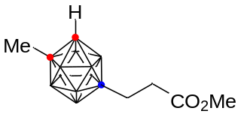
6: Yield: 449.6 mg (92%); R_{f} = 0.35 (Et₂O:Hexane = 1:3); White solid; Melting point: 93-95 ºC; ¹H NMR (400 MHz, CDCl₃) δ 3.63 (s, 3H), 3.58 (s, 1H), 2.22-2.18 (m, 2H), 2.04 (s, 3H), 1.01 (t, J = 8.34 Hz, 2H); ¹³C{¹H} NMR (100 MHz, CDCl₃) δ 175.8, 64.5, 60.7, 51.5, 34.0, 25.1, 11.5; ¹¹B{¹H} NMR (128 MHz, CDCl₃) δ 3.74 (1B), -1.41 (1B), -8.77 (2B), -11.17 - -12.73 (7B); IR (film): 3052, 2588, 1720, 1435, 1264, 1249, 1169, 732 cm⁻¹; HRMS (EI) m/z: [M]⁺ Calcd for C₇H₂₀B₁₀O₂ 246.2394; Found 246.2396.

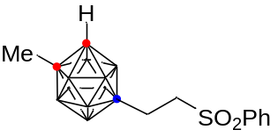
7: Yield: 561.9 mg (86%); R_{f} = 0.40 (EtOAc:Hexane = 1:2); White solid; Melting point: 171-173 ºC; ¹H NMR (400 MHz, CDCl₃) δ 7.87 (d, J = 7.68 Hz, 2H), 7.65-7.61 (m, 1H), 7.56-7.53 (m, 2H), 3.59 (s, 1H), 2.97-2.92 (m, 2H), 2.02 (s, 3H), 1.08-1.04 (m, 2H); ¹³C{¹H} NMR (100 MHz, CDCl₃) δ 139.0, 133.5, 129.2, 128.1, 65.3, 61.0, 57.0, 24.9, 8.6; ¹¹B{¹H} NMR (128 MHz, CDCl₃) δ 2.35 (1B), -1.74 (1B), -8.98 (-2B), -11.10 - -12.81 (6B); IR (film): 3052, 2586, 2562, 1305, 1144, 1084, 733, 687 cm⁻¹; HRMS (FAB) m/z: [M+H]⁺ Calcd for C₁₁H₂₃B₁₀O₂S 329.2349; Found 329.2352.

6 (0.2 mmol, 1.0 equiv) and LiOH.H₂O (0.6 mmol, 3.0 equiv) were dissolved in THF/MeOH/H₂O (4.8 mL/ 3.2 mL / 1.6 mL). The resulting solution was stirred at 25 ºC for 12 h. Then, the reaction mixture was diluted with water (20 mL). After concentrated under reduced pressure, the reaction mixture was quenched with 1.0 M HCl (10 mL) and extracted with DCM (3 x 20 mL). The organic phase was dried over MgSO₄, filtered, and concentrated under reduced pressure. The crude product was purified by column chromatography on silica gel and then concentrated under vacuum to give the carboxylic acid 8 as a white solid.

8: Yield: 40.3 mg (87%); R_{f} = 0.40 (Et₂O:Hexane = 2:1); White solid; Melting point: 183-185 ºC; ¹H NMR (400 MHz, methanol-d₄) δ 4.52 (s, 1H), 2.15-2.05 (m, 2H), 2.05 (s, 3H), 0.93 (t, J = 8.48 Hz, 2H); ¹³C{¹H} NMR (100 MHz, methanol-d₄) δ 179.1, 66.4, 63.0, 35.0, 24.9, 12.7; ¹¹B{¹H} NMR (128 MHz, methanol-d₄) δ 3.50 (1B), -1.94 (1B), -9.00 (2B), -11.13 - -12.67 (6B); IR (film): 3062, 2923, 2852, 2594, 1704, 1264, 1027, 732 cm⁻¹; HRMS (EI) m/z: [M]⁺ Calcd for C₆H₁₈B₁₀O₂ 232.2237; Found 232.2238.

6 (0.2 mmol, 1.0 equiv) was dissolved in DCM (6 mL) and stirred at -78 °C under a N₂ atmosphere. DIBAL-H (1.0 M in hexane, 0.44 mL, 0.44 mmol, 2.2 equiv) was slowly added to the reaction mixture. The resulting solution was stirred at 25 ºC for 2 h. After MeOH (6 mL) was added to the mixture, the resulting solution was stirred at 25 ºC for 30 min. Then, the solution was diluted with water (20 mL). After concentrated under reduced pressure, the reaction mixture was extracted with DCM (3 x 20 mL). The organic phase was dried over MgSO₄, filtered, and concentrated under reduced pressure. The crude product was purified by column chromatography on silica gel and then concentrated under vacuum to give the alcohol 9 as a white solid.

9: Yield: 38.1 mg (88%); R_{f} = 0.40 (Et₂O:Hexane = 3:1); White solid; Melting point: 71-73 ºC; ¹H NMR (400 MHz, CDCl₃) δ 3.55 (s, 1H), 3.54 (t, J = 6.80 Hz, 2H), 2.04 (s, 3H), 1.52-1.44 (m, 2H), 0.67 (t, J = 7.54 Hz, 2H); ¹³C{¹H} NMR (100 MHz, CDCl₃) δ 65.4, 64.1, 60.7, 33.1, 25.1, 12.3; ¹¹B{¹H} NMR (128 MHz, CDCl₃) δ 4.43 (1B), -1.29 (1B), -8.68 (2B), -11.21 - -12.70 (6B); IR (film): 3332, 2930, 2884, 2583, 1437, 1055, 992, 732 cm⁻¹; HRMS (FAB) m/z: [M-OH]⁺ Calcd for C₆H₁₉B₁₀ 201.2417; Found 201.2415.

7 (1.0 mmol, 1.0 equiv) in THF (10 mL) was cooled to -78 ºC under N₂, to which was slowly added LDA (2.0 M in THF, 0.55 mL, 1.1 mmol, 1.1 equiv). The resulting solution was stirred at -78 ºC for 1 h. After the CO₂ gas was added to the solution at -78 ºC for 30 minutes through bubbling, the mixture was warmed to 25 ºC and stirred for 3 h. After removal of THF and addition of water (20 mL), the solution was extracted with hexane (3 x 20 mL) to recover the residual 7. The aqueous layer was acidified with 3.0 M HCl (10 mL). Then, the resultant solution was extracted with Et₂O (3 x 20 mL). The organic phase was dried over MgSO₄, filtered, and concentrated under reduced pressure to give the carboxylic acid 10 as white solid.

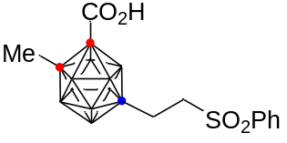
10: Yield: 307.1 mg (83%); R_{f} = 0.45 (MeOH:CH₂Cl₂ = 1:10); White solid; Melting point: 140-142 ºC; ¹H NMR (400 MHz, CDCl₃) δ 10.31 (s, 1H), 7.88-7.86 (m, 2H), 7.67 (t, J = 7.44 Hz, 1H), 7.57 (t, J = 7.70 Hz, 2H), 3.04-2.99 (m, 2H), 2.13 (s, 3H), 1.10-1.06 (m, 2H); ¹³C{¹H} NMR (100 MHz, CDCl₃) δ 160.7, 138.0, 134.1, 129.5, 128.2, 72.0, 70.5, 57.0, 23.7, 8.7; ¹¹B{¹H} NMR (128 MHz, CDCl₃) δ 3.32 (1B), -1.14 (1B), -9.70 (8B); IR (film): 2589, 2567, 1747, 1264, 1141, 1082, 980, 733 cm⁻¹; HRMS (FAB) m/z: [M+Na]⁺ Calcd for C₁₂H₂₂B₁₀O₄SNa 395.2067; Found 395.2070.

A test tube equipped with a magnetic stirrer was charged with o-carborane acid 10 (0.2 mmol, 1.0 equiv), 3-phenyl-1,4,2-dioxazol-5-one (2.0 equiv), [Cp*IrCl₂]₂ (2.5 mol %), AgSbF₆ (10.0 mol %), NaOAc (1.0 equiv), and DCE (2.0 mL) under a N₂ atmosphere. After being stirred at 25 °C for 1 h, the reaction mixture was stirred at 80 ºC for 1 h. The mixture was cooled to room temperature, filtered through a short pad of Celite, and washed with EtOAc. After the volatiles were evaporated, the crude product was purified by column chromatography on silica gel to afford the amidated product 11.

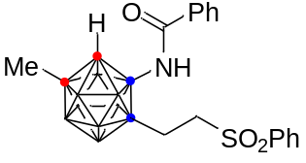
11: Yield: 81.6 mg (92%); R_{f} = 0.25 (EtOAc:Hexane = 1:2); White solid; Melting point: 83-85 ºC; ¹H NMR (400 MHz, CDCl₃) δ 7.86-7.83 (m, 2H), 7.80-7.78 (m, 2H), 7.61-7.57 (m, 1H), 7.54-7.47 (m, 3H), 7.44-7.41 (m, 2H), 6.34 (s, 1H), 5.09 (s, 1H), 3.04 (t, J = 8.52 Hz, 2H), 2.05 (s, 3H), 1.30-1.16 (m, 2H); ¹³C{¹H} NMR (100 MHz, CDCl₃) δ 170.3, 139.1, 134.3, 133.5, 132.0, 129.2, 128.7, 128.0, 127.4, 64.7, 61.1, 56.3, 25.0, 7.2; ¹¹B{¹H} NMR (128 MHz, CDCl₃) δ 1.88 (1B), -3.53 (2B), -10.21 - -15.30 (7B); IR (film): 3344, 3059, 2590, 1655, 1468, 1267, 1145, 735 cm⁻¹; HRMS (EI) m/z: [M]⁺ Calcd for C₁₈H₂₇B₁₀NO₃S 447.2642; Found 447.2640.

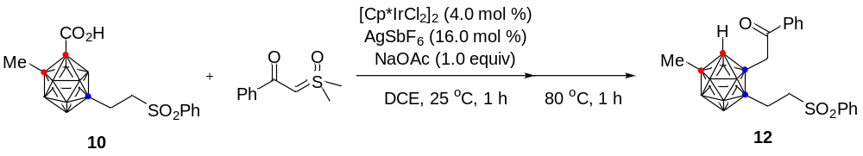
A test tube equipped with a magnetic stirrer was charged with o-carborane acid 10 (0.2 mmol, 1.0 equiv), sulfoxonium ylide (0.4 mmol, 2.0 equiv), [Cp*IrCl₂]₂ (4.0 mol %), AgSbF₆ (16.0 mol %), NaOAc (1.0 equiv), and DCE (2.0 mL) under a N₂ atmosphere. After being stirred at 25 °C for 1 h, the reaction mixture was stirred at 80 ºC for 1 h. The mixture was cooled to room temperature, filtered through a short pad of Celite, and washed with EtOAc. After the volatiles were evaporated, the crude product was purified by column chromatography on silica gel to afford the amidated product 12.

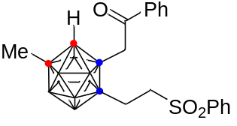
12: Yield: 72.2 mg (81%); R_{f} = 0.25 (CH₂Cl₂:Hexane = 1:1); Yellow oil; ¹H NMR (400 MHz, CDCl₃) δ 7.94-7.92 (m, 2H), 7.90-7.88 (m, 2H), 7.66-7.49 (m, 6H), 4.05 (s, 1H), 3.01-2.88 (m, 2H), 2.87 (d, J = 14.06 Hz, 1H), 2.72 (d, J = 13.82 Hz, 1H), 1.99 (s, 3H), 1.18-1.14 (m, 2H); ¹³C{¹H} NMR (100 MHz, CDCl₃) δ 201.2, 139.1, 137.3, 133.5, 129.2, 128.9, 128.6, 128.1, 66.6, 62.1, 56.7, 26.4, 25.0, 7.5; ¹¹B{¹H} NMR (128 MHz, CDCl₃) δ 2.43 (1B), -2.06 (1B), -5.37 (1B), -8.50 - -11.75 (7B); IR (film): 3049, 2923, 2585, 2561, 1666, 1273, 1144, 733 cm⁻¹; HRMS (EI) m/z: [M]⁺ Calcd for C₁₉H₂₈B₁₀O₃S 446.2690; Found 446.2687.

6. General Procedure for Identification of Regioisomers
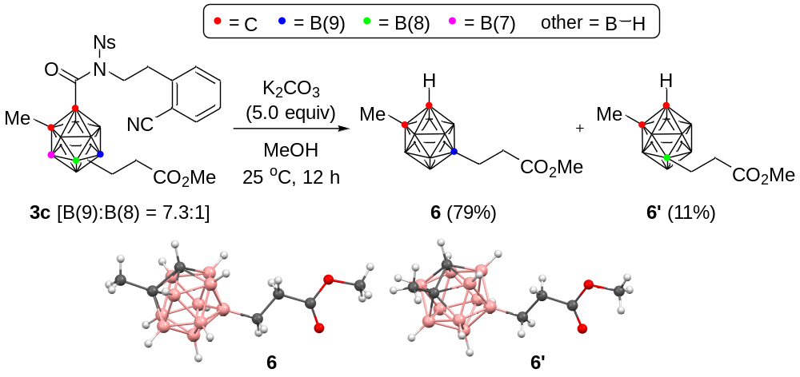
3c (601.7 mg, 1.0 mmol, 1.0 equiv) and K₂CO₃ (691.1 mg, 5.0 mmol, 5.0 equiv) were dissolved in MeOH (10 mL). The resulting solution was stirred at 25 ºC for 12 h. Then, the reaction mixture was diluted with water (20 mL). After concentrated under reduced pressure, the reaction mixture was extracted with DCM (3 x 20 mL). The organic phase was dried over MgSO₄, filtered, and concentrated under reduced pressure. The crude product was purified by column chromatography on silica gel and then concentrated under vacuum to give the product 6 and 6’ as a white solid. The structures of 6 and 6’ were unambiguously identified through X-ray crystallography.

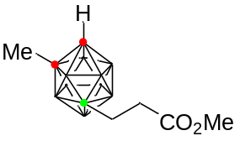
6’: Yield: 26.7 mg (11%); R_{f} = 0.25 (Et₂O:Hexane = 1:3); White solid; Melting point: 93-95 ºC; ¹H NMR (400 MHz, CDCl₃) δ 3.67 (s, 3H), 3.55 (s, 1H), 2.37-2.32 (m, 2H), 2.02 (s, 3H), 1.26-1.20 (m, 2H); ¹³C{¹H} NMR (100 MHz, CDCl₃) δ 175.6, 69.3, 60.5, 51.6, 34.3, 26.0, 10.8; ¹¹B{¹H} NMR (128 MHz, CDCl₃) δ 1.55 (1B), -1.30 (1B), -6.27 (1B), -9.94 -11.57 (4B), -12.76 - -13.22 (2B), -14.76 (1B); IR (film): 3053, 2949, 2918, 2588, 1726, 1436, 1250, 1150 cm⁻¹; HRMS (EI) m/z: [M]⁺ Calcd for C₇H₂₀B₁₀O₂ 246.2394; Found 246.2396.

7. X-Ray Crystallography
5b (20 mg) was dissolved in ether (1 mL) in 4 mL glass vial and hexane (2 mL) was slowly added to form a separate layer. The vial was open cap. Vapor diffusion afforded crystals of the composition 5b suitable for X-ray diffraction within 1 day at room temperature. A block-like specimen of C₂₁H₃₆B₁₀N₂O₄ was used for the X-ray crystallographic analysis. The X-ray intensity data were measured. (ellipsoid = 40%, CCDC = 2330895)
Table S1. Crystal Data and Structure Refinement for 5b
Empirical formula C₂₁ H₃₆ B₁₀ N₂ O₄
Formula weight 488.62
Temperature 173(2) K
Wavelength 0.71073 Å
Crystal system Monoclinic
Space group P2₁/n
Unit cell dimensions a = 15.078(2) Å α = 90°
b = 7.6102(10) Å β = 101.804(3)°
c = 24.484(3) Å γ = 90°
Volume 2750.0(6) Å³
Z 4
Density (calculated) 1.180 Mg/m³
Absorption coefficient 0.073 mm⁻¹
F(000) 1032
Crystal size 0.139 x 0.132 x 0.053 mm³
Theta range for data collection 2.639 to 25.998°.
Index ranges –18<=h<=18, –9<=k<=9, –30<=l<=30
Reflections collected 50604
Independent reflections 5407 [R(int) = 0.0835]
Completeness to theta = 25.242° 99.9 %
Absorption correction Semi-empirical from equivalents
Max. and min. transmission 0.7453 and 0.5782
Refinement method Full-matrix least-squares on F²
Data / restraints / parameters 5407 / 229 / 393
Goodness-of-fit on F² 1.043
Final R indices [I>2sigma(I)] R1 = 0.0536, wR2 = 0.1278
R indices (all data) R1 = 0.0730, wR2 = 0.1400
Largest diff. peak and hole 0.347 and –0.282 e·Å^{–3}

6 (20 mg) was dissolved in ether (1 mL) in 4 mL glass vial and hexane (2 mL) was slowly added to form a separate layer. The vial was open cap. Vapor diffusion afforded crystals of the composition 6 suitable for X-ray diffraction within 1 day at room temperature. A block-like specimen of C₇H₂₀B₁₀O₂ was used for the X-ray crystallographic analysis. The X-ray intensity data were measured. (ellipsoid = 40%, CCDC = 2193880)
Table S2. Crystal Data and Structure Refinement for 6
Empirical formula C₇ H₂₀ B₁₀ O₂
Formula weight 244.33
Temperature 296(2) K
Wavelength 0.71073 Å
Crystal system Triclinic
Space group P-1
Unit cell dimensions a = 9.7430(7) Å α = 68.639(2)°
b = 12.8416(9) Å β = 73.349(2)°
c = 13.3773(9) Å γ = 75.244(2)°
Volume 1472.03(18) Å³
Z 4
Density (calculated) 1.102 Mg/m³
Absorption coefficient 0.061 mm⁻¹
F(000) 512
Crystal size 0.265 x 0.135 x 0.098 mm³
Theta range for data collection 2.471 to 25.227°.
Index ranges –11<=h<=11, –15<=k<=15, –16<=l<=15
Reflections collected 30218
Independent reflections 5275 [R(int) = 0.0440]
Completeness to theta = 25.227° 99.3 %
Absorption correction Semi-empirical from equivalents
Max. and min. transmission 0.7452 and 0.6940
Refinement method Full-matrix least-squares on F²
Data / restraints / parameters 5275 / 0 / 347
Goodness-of-fit on F² 1.059
Final R indices [I>2sigma(I)] R1 = 0.0779, wR2 = 0.2272
R indices (all data) R1 = 0.0958, wR2 = 0.2414
Largest diff. peak and hole 0.252 and –0.217 e·Å^{–3}

6’ (20 mg) was dissolved in ether (1 mL) in 4 mL glass vial and hexane (2 mL) was slowly added to form a separate layer. The vial was open cap. Vapor diffusion afforded crystals of the composition 6’ suitable for X-ray diffraction within 1 day at room temperature. A block-like specimen of C₇H₂₀B₁₀O₂ was used for the X-ray crystallographic analysis. The X-ray intensity data were measured. (ellipsoid = 40%, CCDC = 2196032)
Table S3. Crystal Data and Structure Refinement for 6’
Empirical formula C₇ H₂₀ B₁₀ O₂
Formula weight 244.33
Temperature 296(2) K
Wavelength 0.71073 Å
Crystal system Monoclinic
Space group P2₁/c
Unit cell dimensions a = 11.5932(11) Å α = 90°
b = 8.0472(7) Å β = 100.021(3)°
c = 15.9375(15) Å γ = 90°
Volume 1464.2(2) Å³
Z 4
Density (calculated) 1.108 Mg/m³
Absorption coefficient 0.061 mm⁻¹
F(000) 512
Crystal size 0.209 x 0.181 x 0.041 mm³
Theta range for data collection 2.596 to 25.532°.
Index ranges –12<=h<=14, –9<=k<=9, –19<=l<=19
Reflections collected 21910
Independent reflections 2723 [R(int) = 0.0530]
Completeness to theta = 25.242° 99.6 %
Absorption correction Semi-empirical from equivalents
Max. and min. transmission 0.7452 and 0.7003
Refinement method Full-matrix least-squares on F²
Data / restraints / parameters 2723 / 0 / 174
Goodness-of-fit on F² 1.045
Final R indices [I>2sigma(I)] R1 = 0.0587, wR2 = 0.1655
R indices (all data) R1 = 0.0822, wR2 = 0.1850
Largest diff. peak and hole 0.202 and –0.176 e·Å^{–3}

10 (20 mg) was dissolved in ether (1 mL) in 4 mL glass vial and hexane (2 mL) was slowly added to form a separate layer. The vial was open cap. Vapor diffusion afforded crystals of the composition 10 suitable for X-ray diffraction within 1 day at room temperature. A block-like specimen of C₁₂H₂₂B₁₀O₄S was used for the X-ray crystallographic analysis. The X-ray intensity data were measured. (ellipsoid = 40%, CCDC = 2324602)
Table S4. Crystal Data and Structure Refinement for 10
Empirical formula C₁₂ H₂₂ B₁₀ O₄ S
Formula weight 370.45
Temperature 203(2) K
Wavelength 0.71073 Å
Crystal system Monoclinic
Space group P2/n
Unit cell dimensions a = 18.7959(12) Å α = 90°
b = 11.2435(7) Å β = 99.440(2)°
c = 55.771(3) Å γ = 90°
Volume 11626.6(12) Å³
Z 24
Density (calculated) 1.270 Mg/m³
Absorption coefficient 0.182 mm⁻¹
F(000) 4608
Crystal size 0.177 x 0.064 x 0.062 mm³
Theta range for data collection 1.957 to 26.029°.
Index ranges –23<=h<=23, –13<=k<=13, –63<=l<=68
Reflections collected 132578
Independent reflections 22767 [R(int) = 0.1189]
Completeness to theta = 25.242° 99.8 %
Absorption correction Semi-empirical from equivalents
Max. and min. transmission 0.7453 and 0.6210
Refinement method Full-matrix least-squares on F²
Data / restraints / parameters 22767 / 805 / 1647
Goodness-of-fit on F² 1.179
Final R indices [I>2sigma(I)] R1 = 0.0889, wR2 = 0.1643
R indices (all data) R1 = 0.1263, wR2 = 0.1787
Largest diff. peak and hole 0.399 and –0.423 e·Å^{–3}

8. References
- Toppino, A. et al. High yielding preparation of dicarba-closo-dodecaboranes using a silver(I) mediated dehydrogenative alkyne-insertion reaction. Inorg. Chem. 52, 8743-8749 (2013).
- Lyu, H. Quan, Y. & Xie, Z. Palladium-catalyzed direct dialkenylation of cage B−H bonds in o-carboranes through cross-coupling reactions. Angew. Chem., Int. Ed. 54, 10623-10626 (2015).
- Monguchi, Y. et al. Palladium-catalyzed C–H monoalkoxylation of α,β-unsaturated carbonyl compounds. ACS Catal. 6, 3994-3997 (2016).

9. ¹H, ¹³C, ¹¹B, and ¹⁹F NMR data
¹H NMR (400 MHz, CDCl₃)
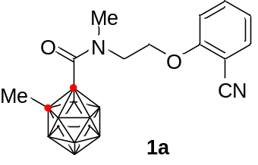
¹³C NMR (100 MHz, CDCl₃)
¹¹B NMR (128 MHz, CDCl₃)

¹¹B{¹H} NMR (128 MHz, CDCl₃)

¹H NMR (400 MHz, CDCl₃)

¹³C NMR (100 MHz, CDCl₃)
¹¹B NMR (128 MHz, CDCl₃)

¹¹B{¹H} NMR (128 MHz, CDCl₃)

¹H NMR (400 MHz, CDCl₃)

¹³C NMR (100 MHz, CDCl₃)
¹¹B NMR (128 MHz, CDCl₃)

¹¹B{¹H} NMR (128 MHz, CDCl₃)

¹H NMR (400 MHz, CDCl₃)

¹³C NMR (100 MHz, CDCl₃)
¹¹B NMR (128 MHz, CDCl₃)

¹¹B{¹H} NMR (128 MHz, CDCl₃)

¹H NMR (400 MHz, CDCl₃)

¹³C NMR (100 MHz, CDCl₃)
¹¹B NMR (128 MHz, CDCl₃)

¹¹B{¹H} NMR (128 MHz, CDCl₃)

¹H NMR (400 MHz, CDCl₃)

¹³C NMR (100 MHz, CDCl₃)
¹¹B NMR (128 MHz, CDCl₃)

¹¹B{¹H} NMR (128 MHz, CDCl₃)

¹H NMR (400 MHz, CDCl₃)

¹³C NMR (100 MHz, CDCl₃)
¹¹B NMR (128 MHz, CDCl₃)

¹¹B{¹H} NMR (128 MHz, CDCl₃)

¹H NMR (400 MHz, CDCl₃)

¹³C NMR (100 MHz, CDCl₃)
¹¹B NMR (128 MHz, CDCl₃)

¹¹B{¹H} NMR (128 MHz, CDCl₃)

¹H NMR (400 MHz, CDCl₃)

¹³C NMR (100 MHz, CDCl₃)
¹¹B NMR (128 MHz, CDCl₃)

¹¹B{¹H} NMR (128 MHz, CDCl₃)

¹H NMR (400 MHz, CDCl₃)

¹³C NMR (100 MHz, CDCl₃)

¹¹B NMR (128 MHz, CDCl₃)

¹¹B{¹H} NMR (128 MHz, CDCl₃)

¹H NMR (400 MHz, CDCl₃)

¹³C NMR (100 MHz, CDCl₃)

¹¹B NMR (128 MHz, CDCl₃)

¹¹B{¹H} NMR (128 MHz, CDCl₃)
¹H NMR (400 MHz, CDCl₃)

¹³C NMR (100 MHz, CDCl₃)

¹¹B NMR (128 MHz, CDCl₃)

¹¹B{¹H} NMR (128 MHz, CDCl₃)
¹H NMR (400 MHz, CDCl₃)

¹³C NMR (100 MHz, CDCl₃)

¹¹B NMR (128 MHz, CDCl₃)

¹¹B{¹H} NMR (128 MHz, CDCl₃)
¹H NMR (400 MHz, CDCl₃)

¹³C NMR (100 MHz, CDCl₃)

¹¹B NMR (128 MHz, CDCl₃)

¹¹B{¹H} NMR (128 MHz, CDCl₃)

¹H NMR (400 MHz, CDCl₃)

¹³C NMR (100 MHz, CDCl₃)

¹¹B NMR (128 MHz, CDCl₃)

¹¹B{¹H} NMR (128 MHz, CDCl₃)

¹⁹F{¹H} NMR (377 MHz, CDCl₃)
¹H NMR (400 MHz, CDCl₃)

¹³C NMR (100 MHz, CDCl₃)

¹¹B NMR (128 MHz, CDCl₃)

¹¹B{¹H} NMR (128 MHz, CDCl₃)

¹H NMR (400 MHz, CDCl₃)

¹³C NMR (100 MHz, CDCl₃)

¹¹B NMR (128 MHz, CDCl₃)

¹¹B{¹H} NMR (128 MHz, CDCl₃)

¹H NMR (400 MHz, CDCl₃)

¹³C NMR (100 MHz, CDCl₃)

¹¹B NMR (128 MHz, CDCl₃)

¹¹B{¹H} NMR (128 MHz, CDCl₃)

¹H NMR (400 MHz, CDCl₃)

¹³C NMR (100 MHz, CDCl₃)

¹¹B NMR (128 MHz, CDCl₃)

¹¹B{¹H} NMR (128 MHz, CDCl₃)

¹H NMR (400 MHz, CDCl₃)

¹³C NMR (100 MHz, CDCl₃)

¹¹B NMR (128 MHz, CDCl₃)

¹¹B{¹H} NMR (128 MHz, CDCl₃)

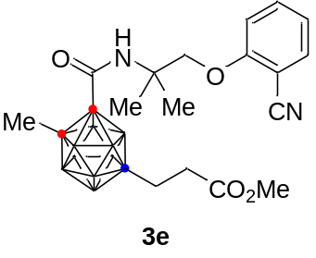¹H NMR (400 MHz, CDCl₃)

¹³C NMR (100 MHz, CDCl₃)

¹¹B NMR (128 MHz, CDCl₃)

¹¹B{¹H} NMR (128 MHz, CDCl₃)

¹H NMR (400 MHz, CDCl₃)
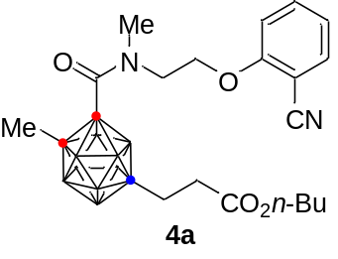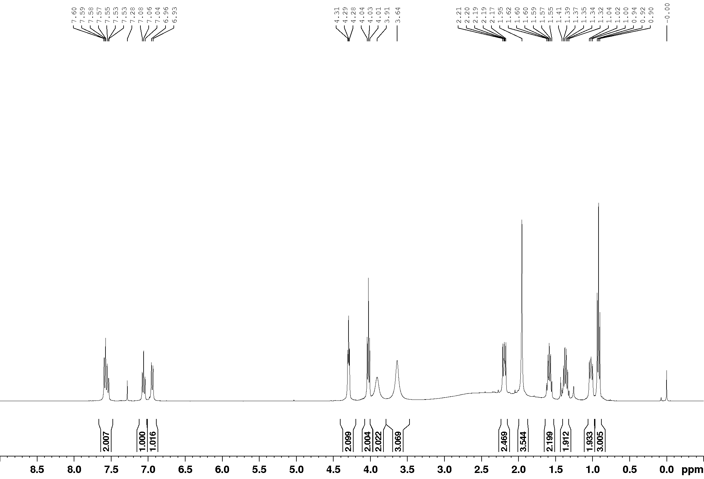

¹³C NMR (100 MHz, CDCl₃)
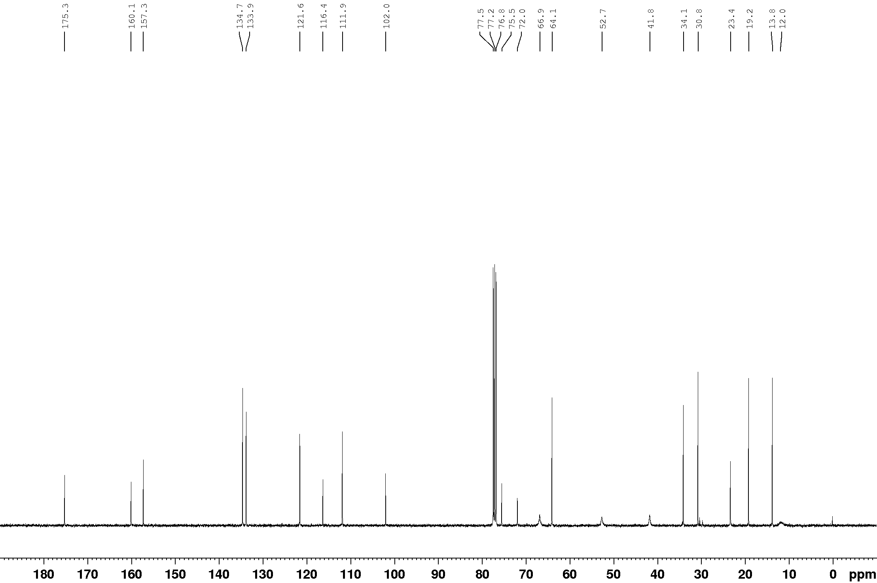

¹¹B NMR (128 MHz, CDCl₃)
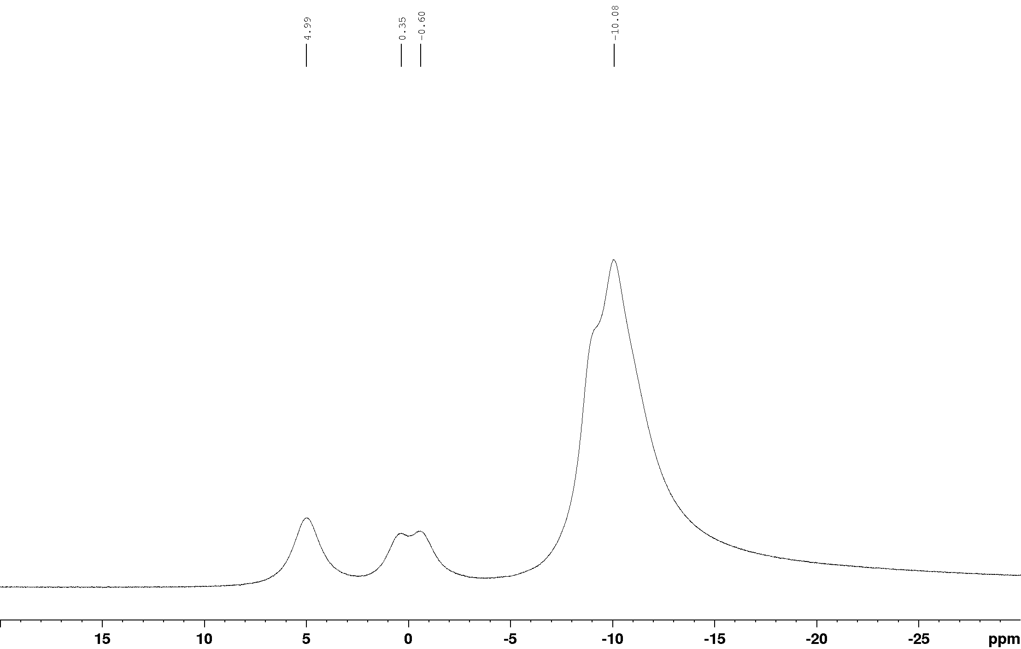

¹¹B{¹H} NMR (128 MHz, CDCl₃)
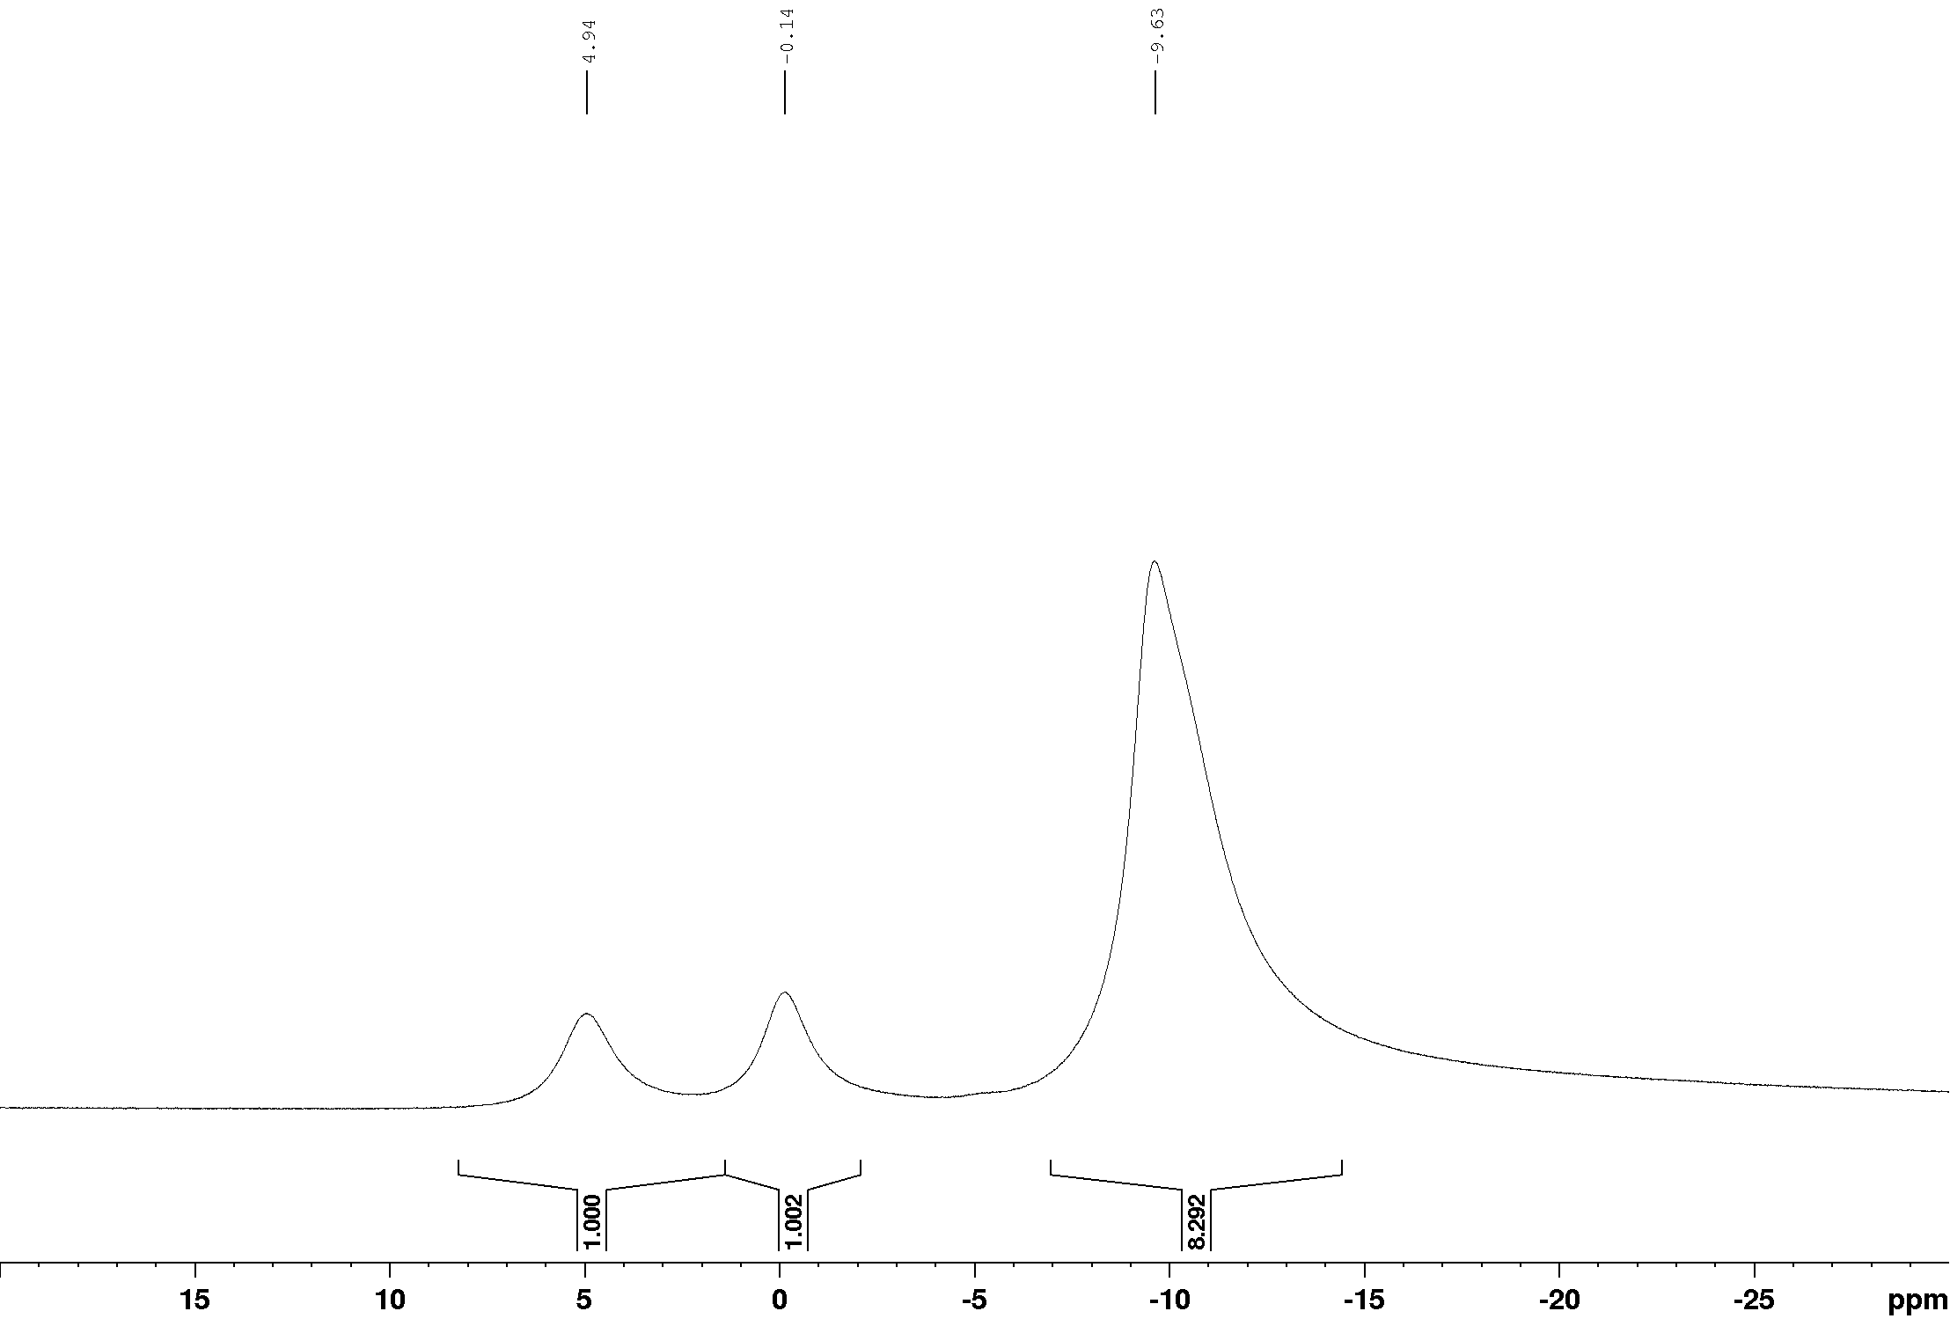

¹H NMR (400 MHz, CDCl₃)
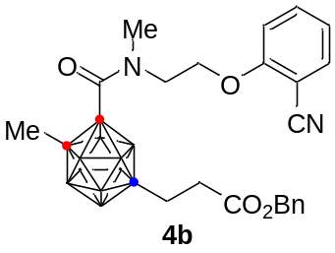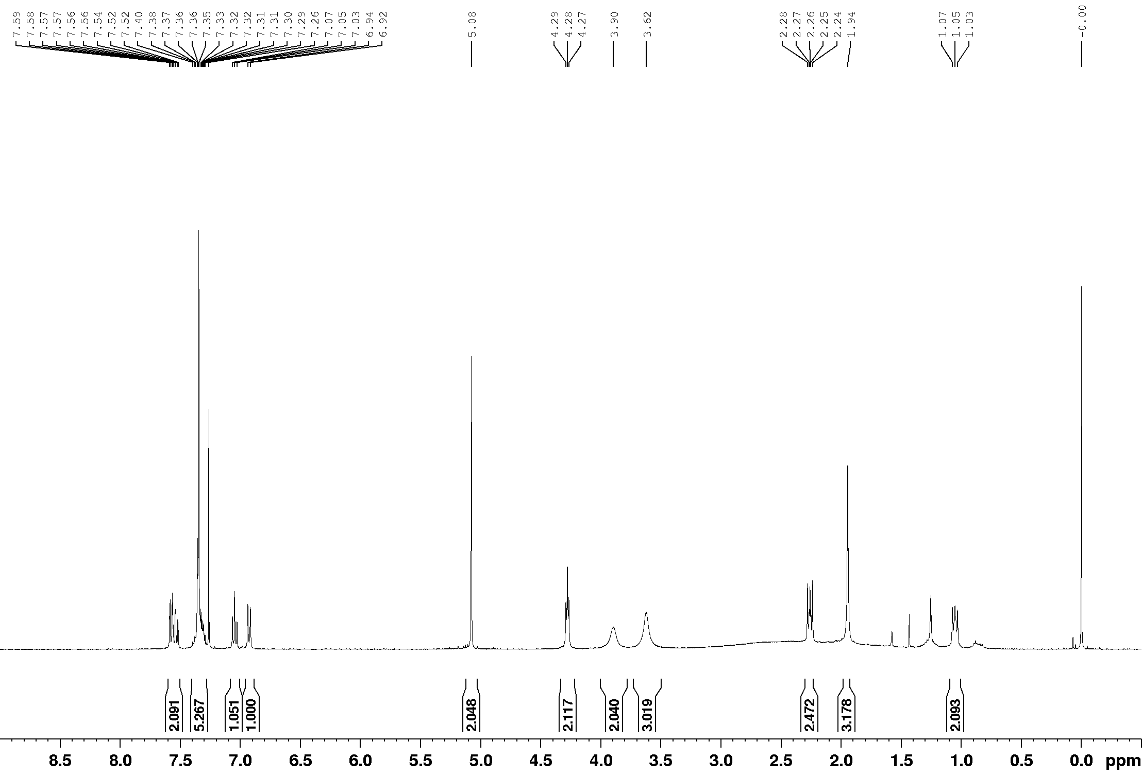

¹³C NMR (100 MHz, CDCl₃)
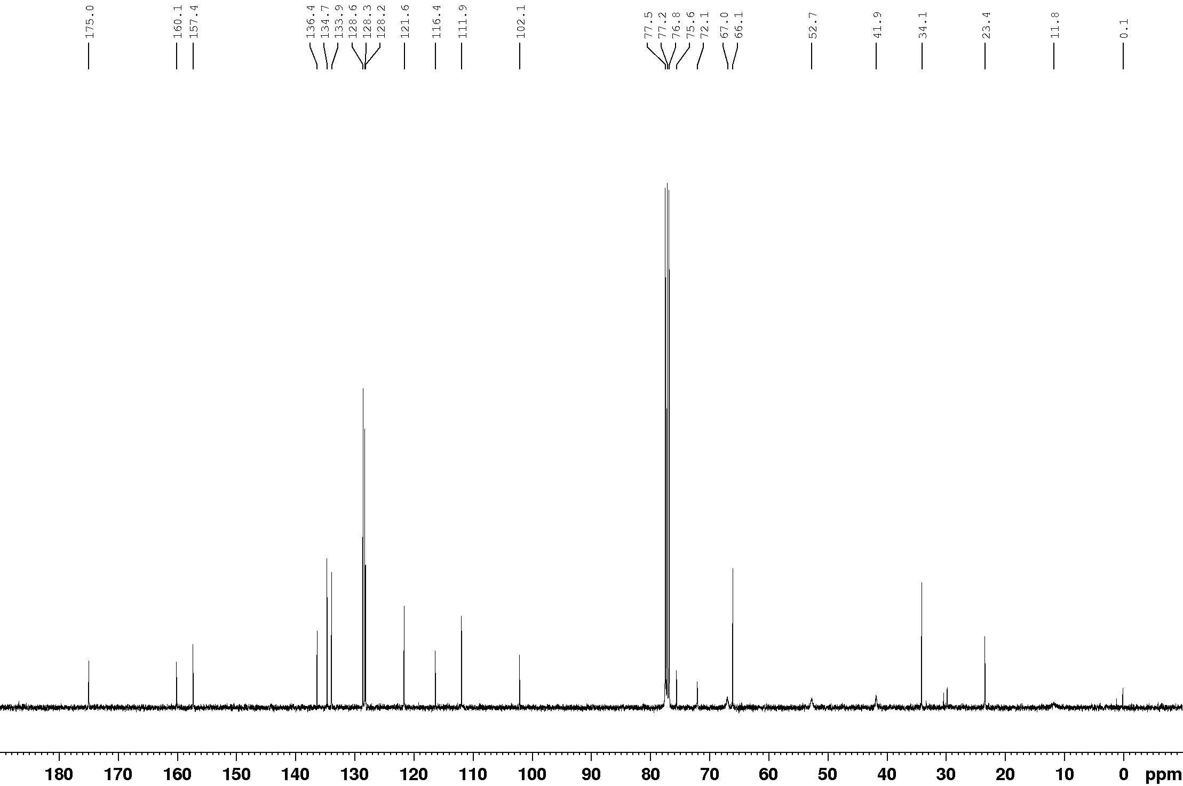

¹¹B NMR (128 MHz, CDCl₃)
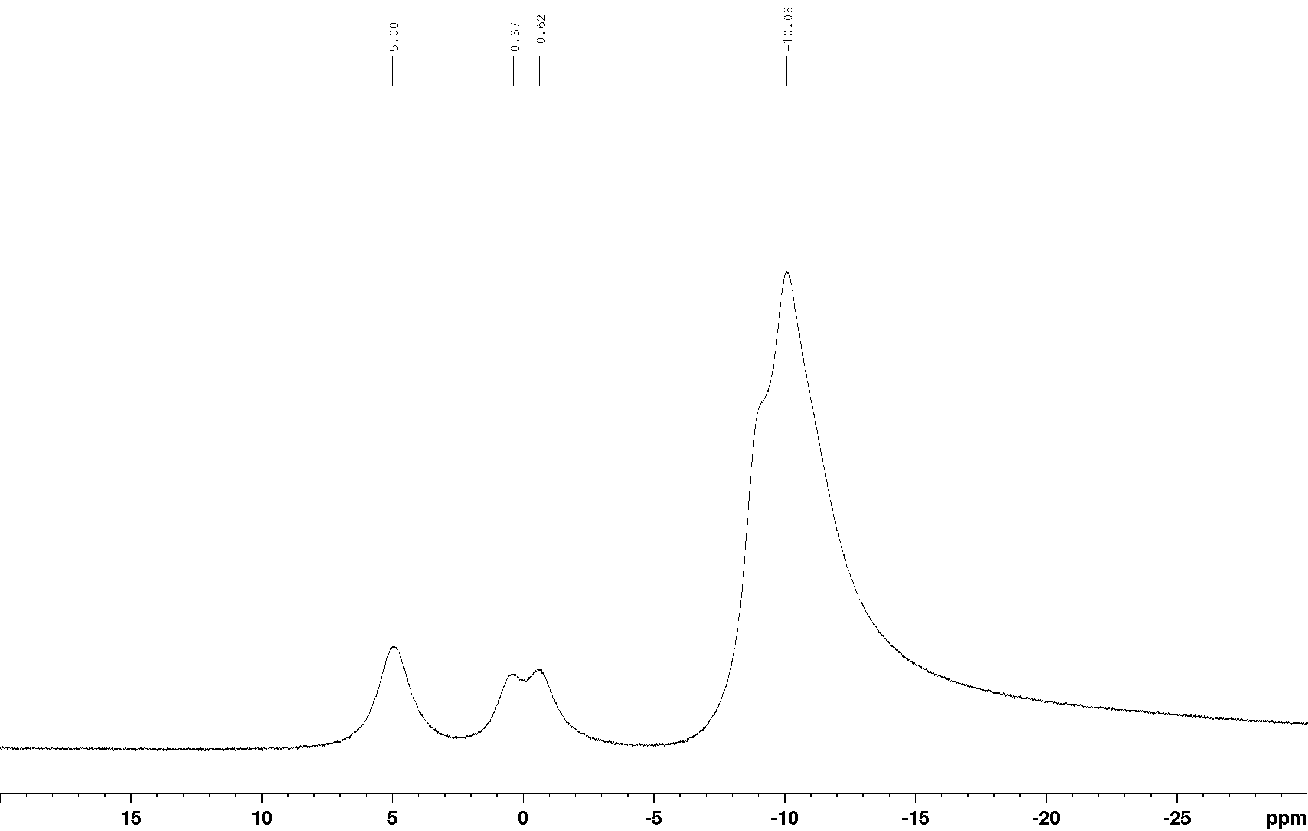

¹¹B{¹H} NMR (128 MHz, CDCl₃)
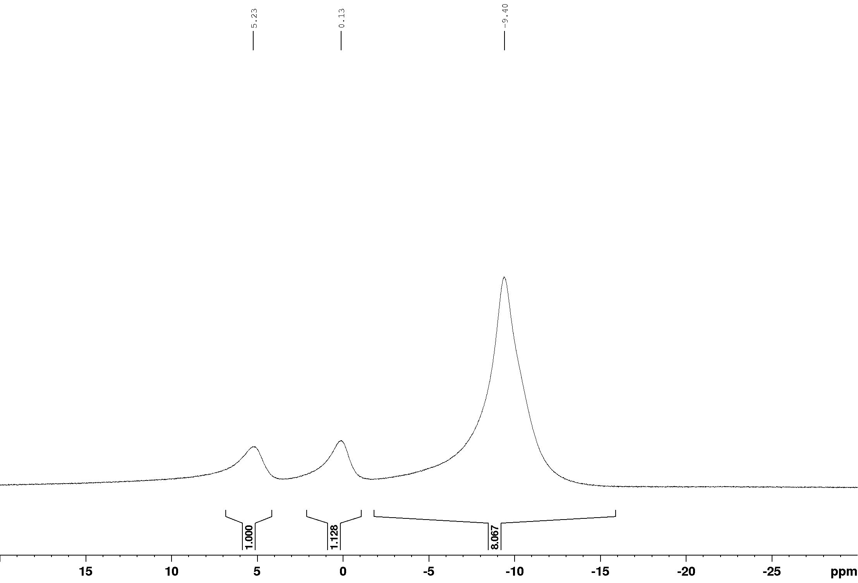

¹H NMR (400 MHz, CDCl₃)
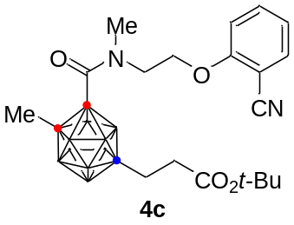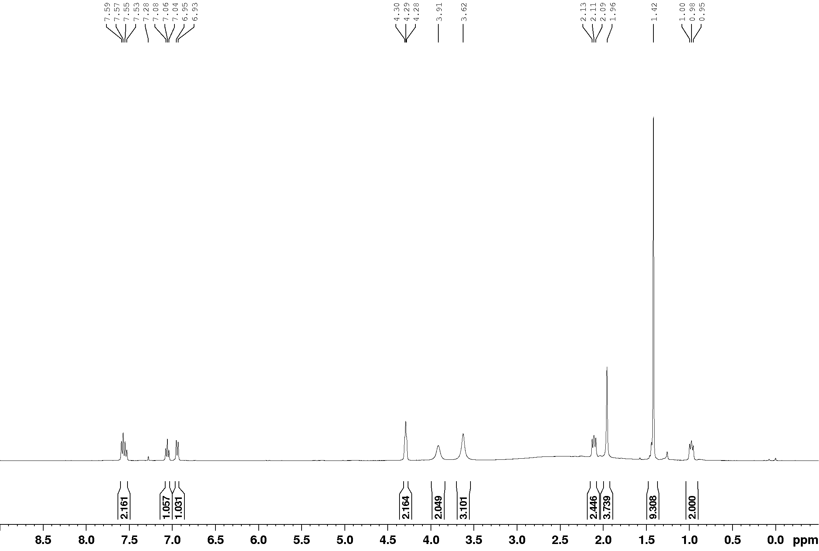

¹³C NMR (100 MHz, CDCl₃)
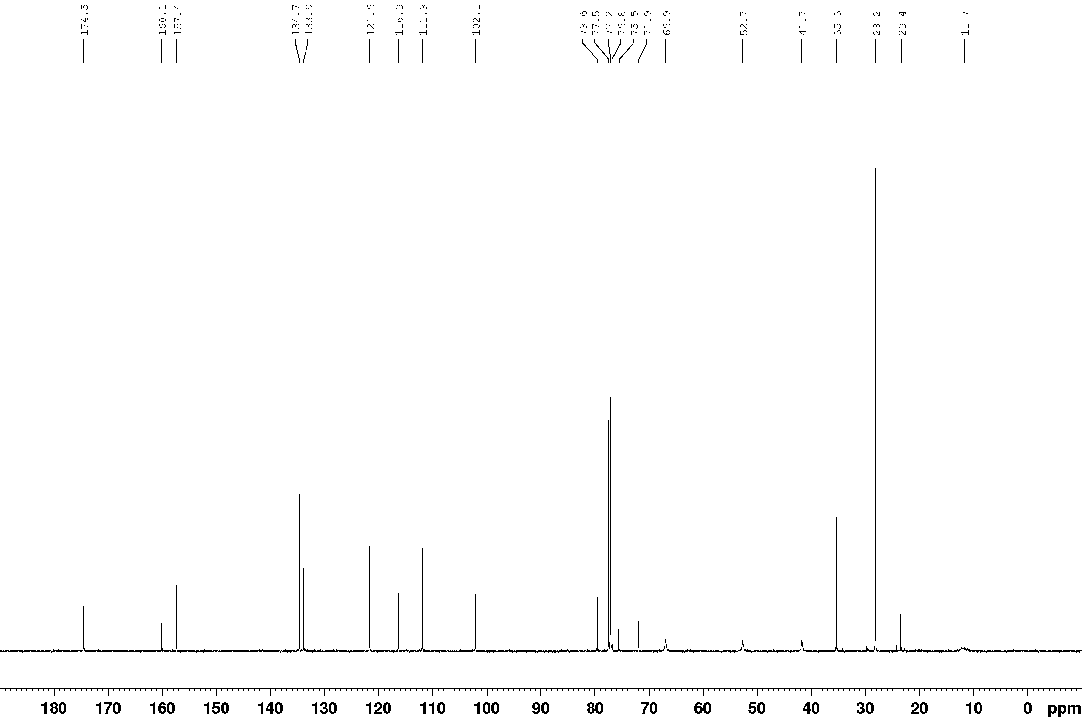

¹¹B NMR (128 MHz, CDCl₃)
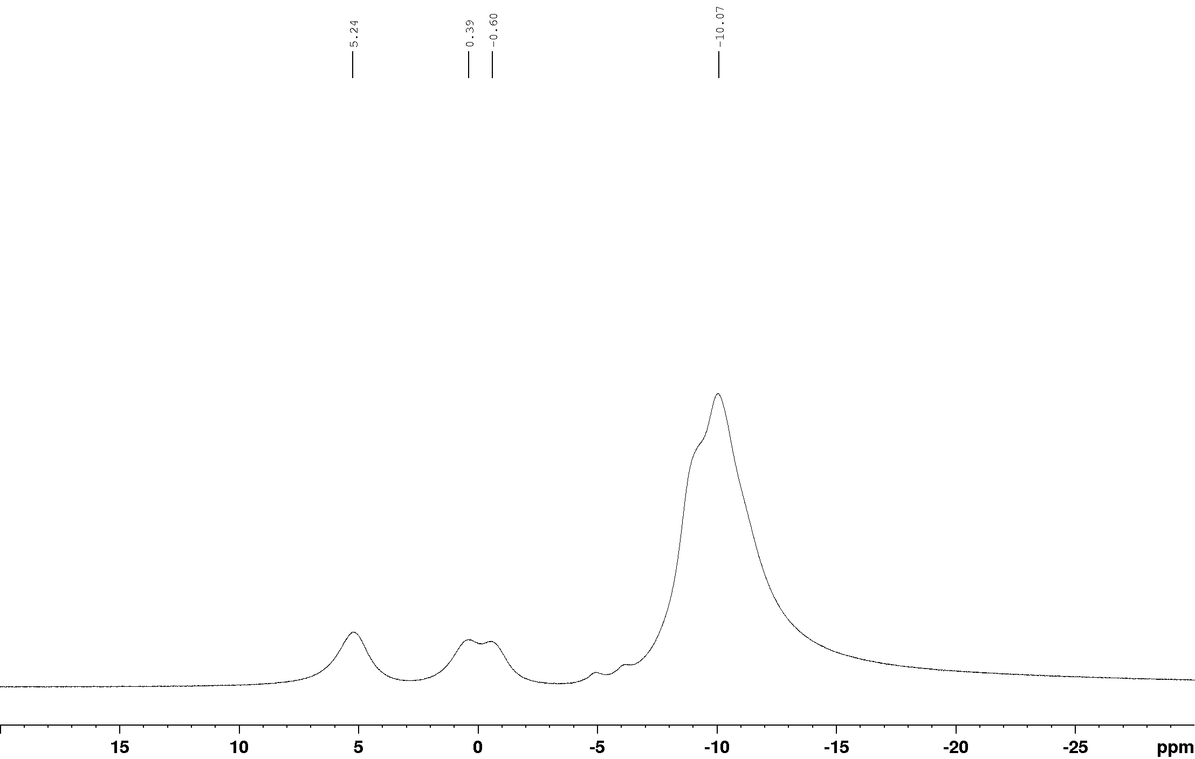

¹¹B{¹H} NMR (128 MHz, CDCl₃)
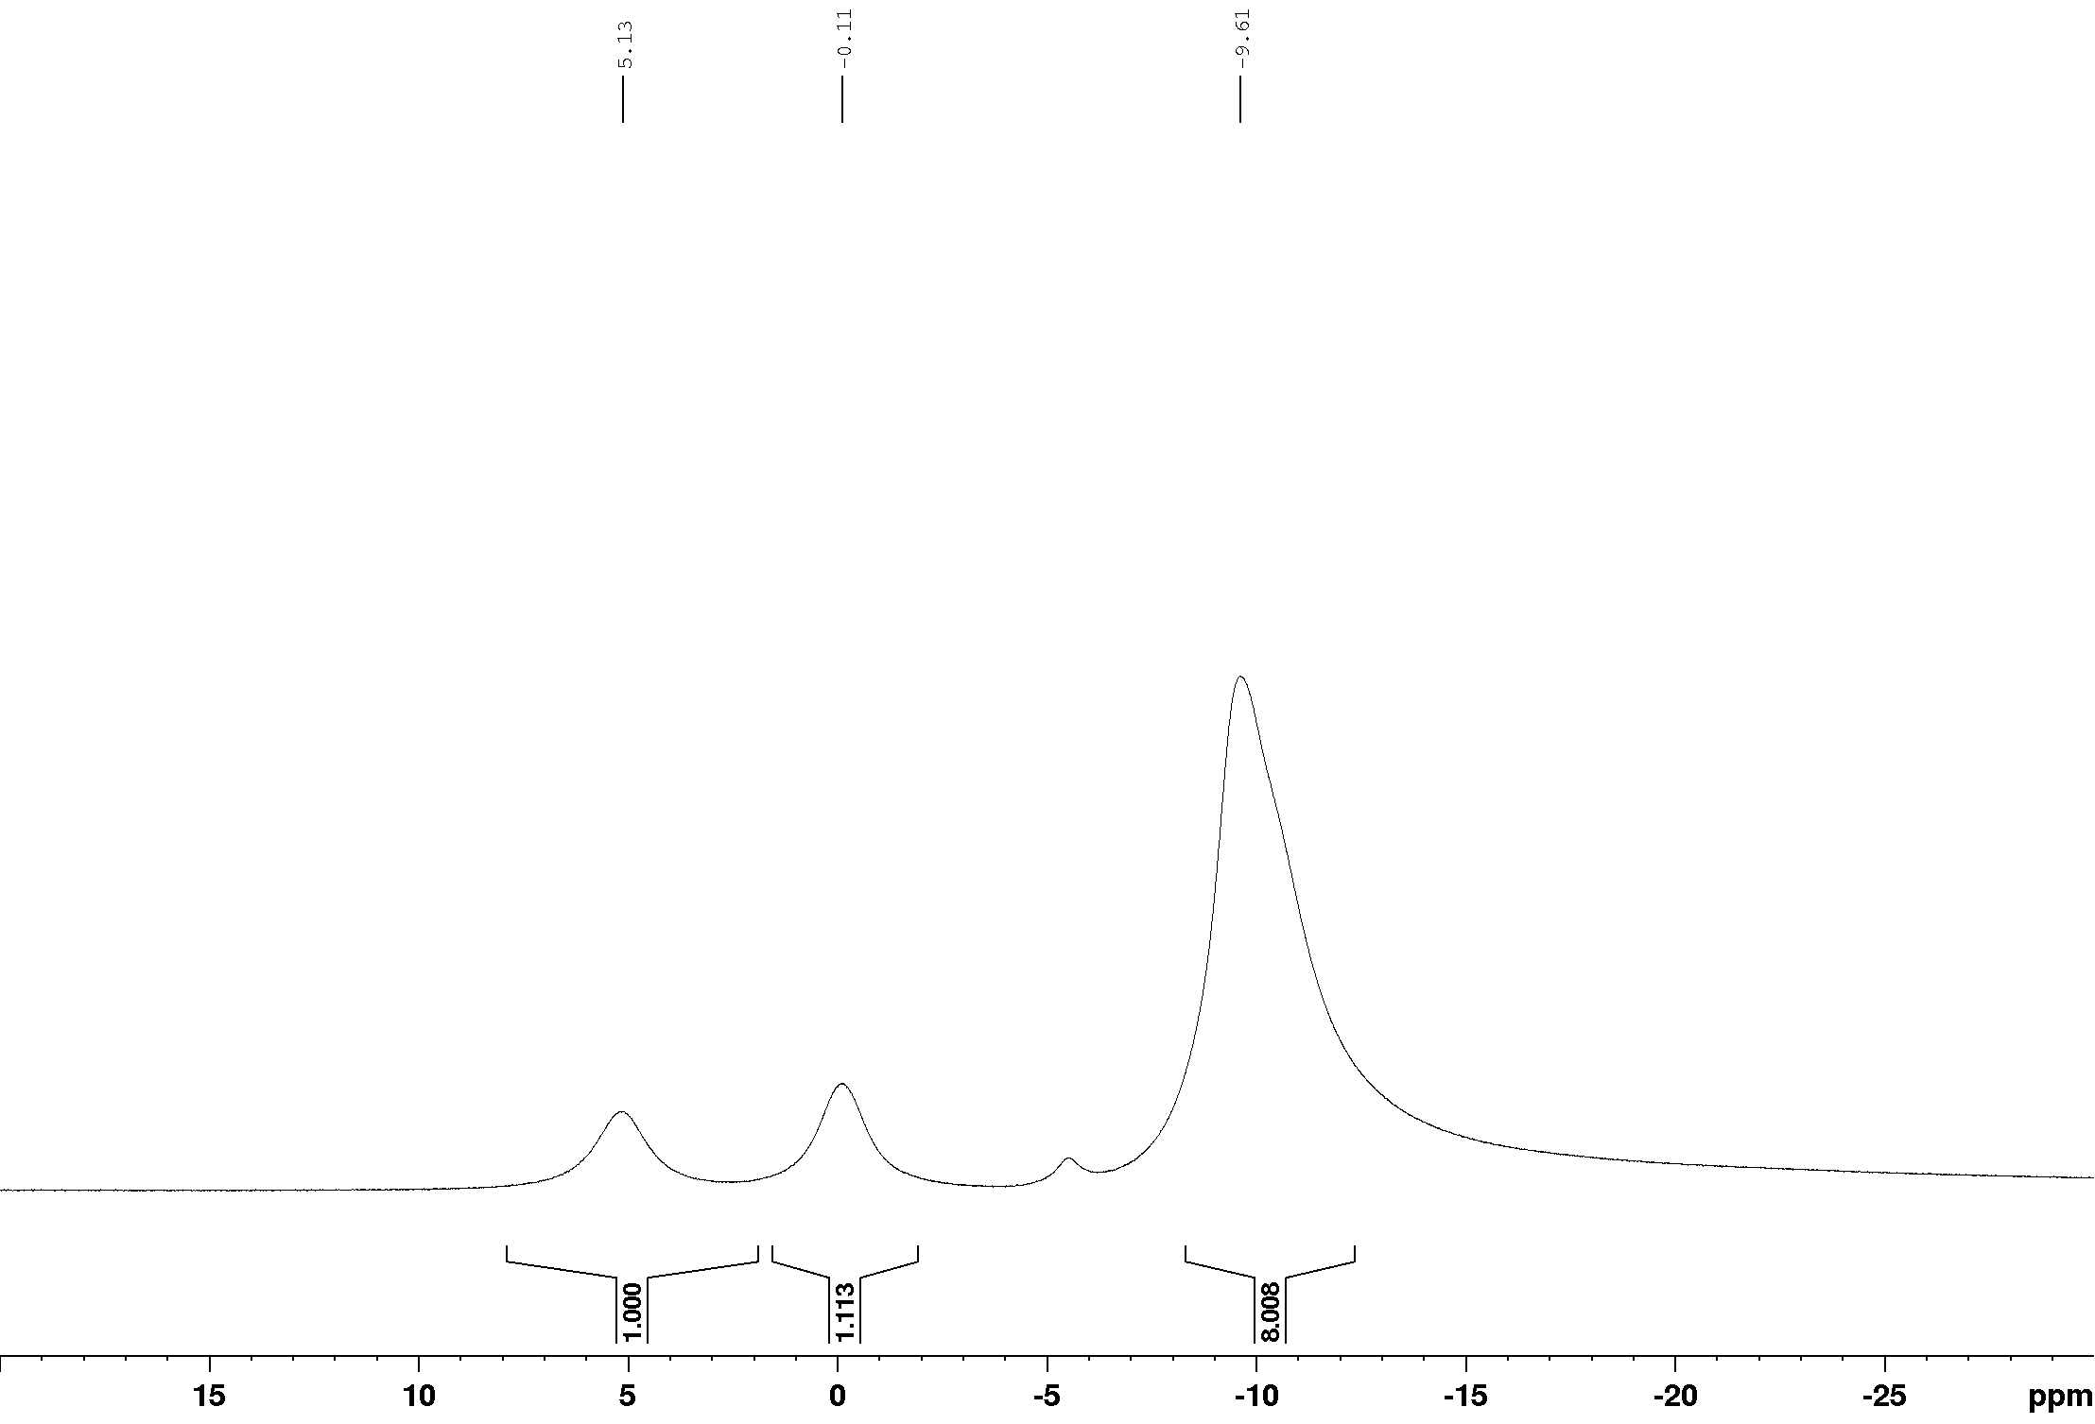

¹H NMR (400 MHz, CDCl₃)
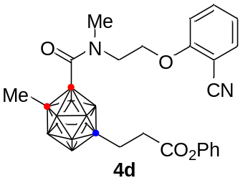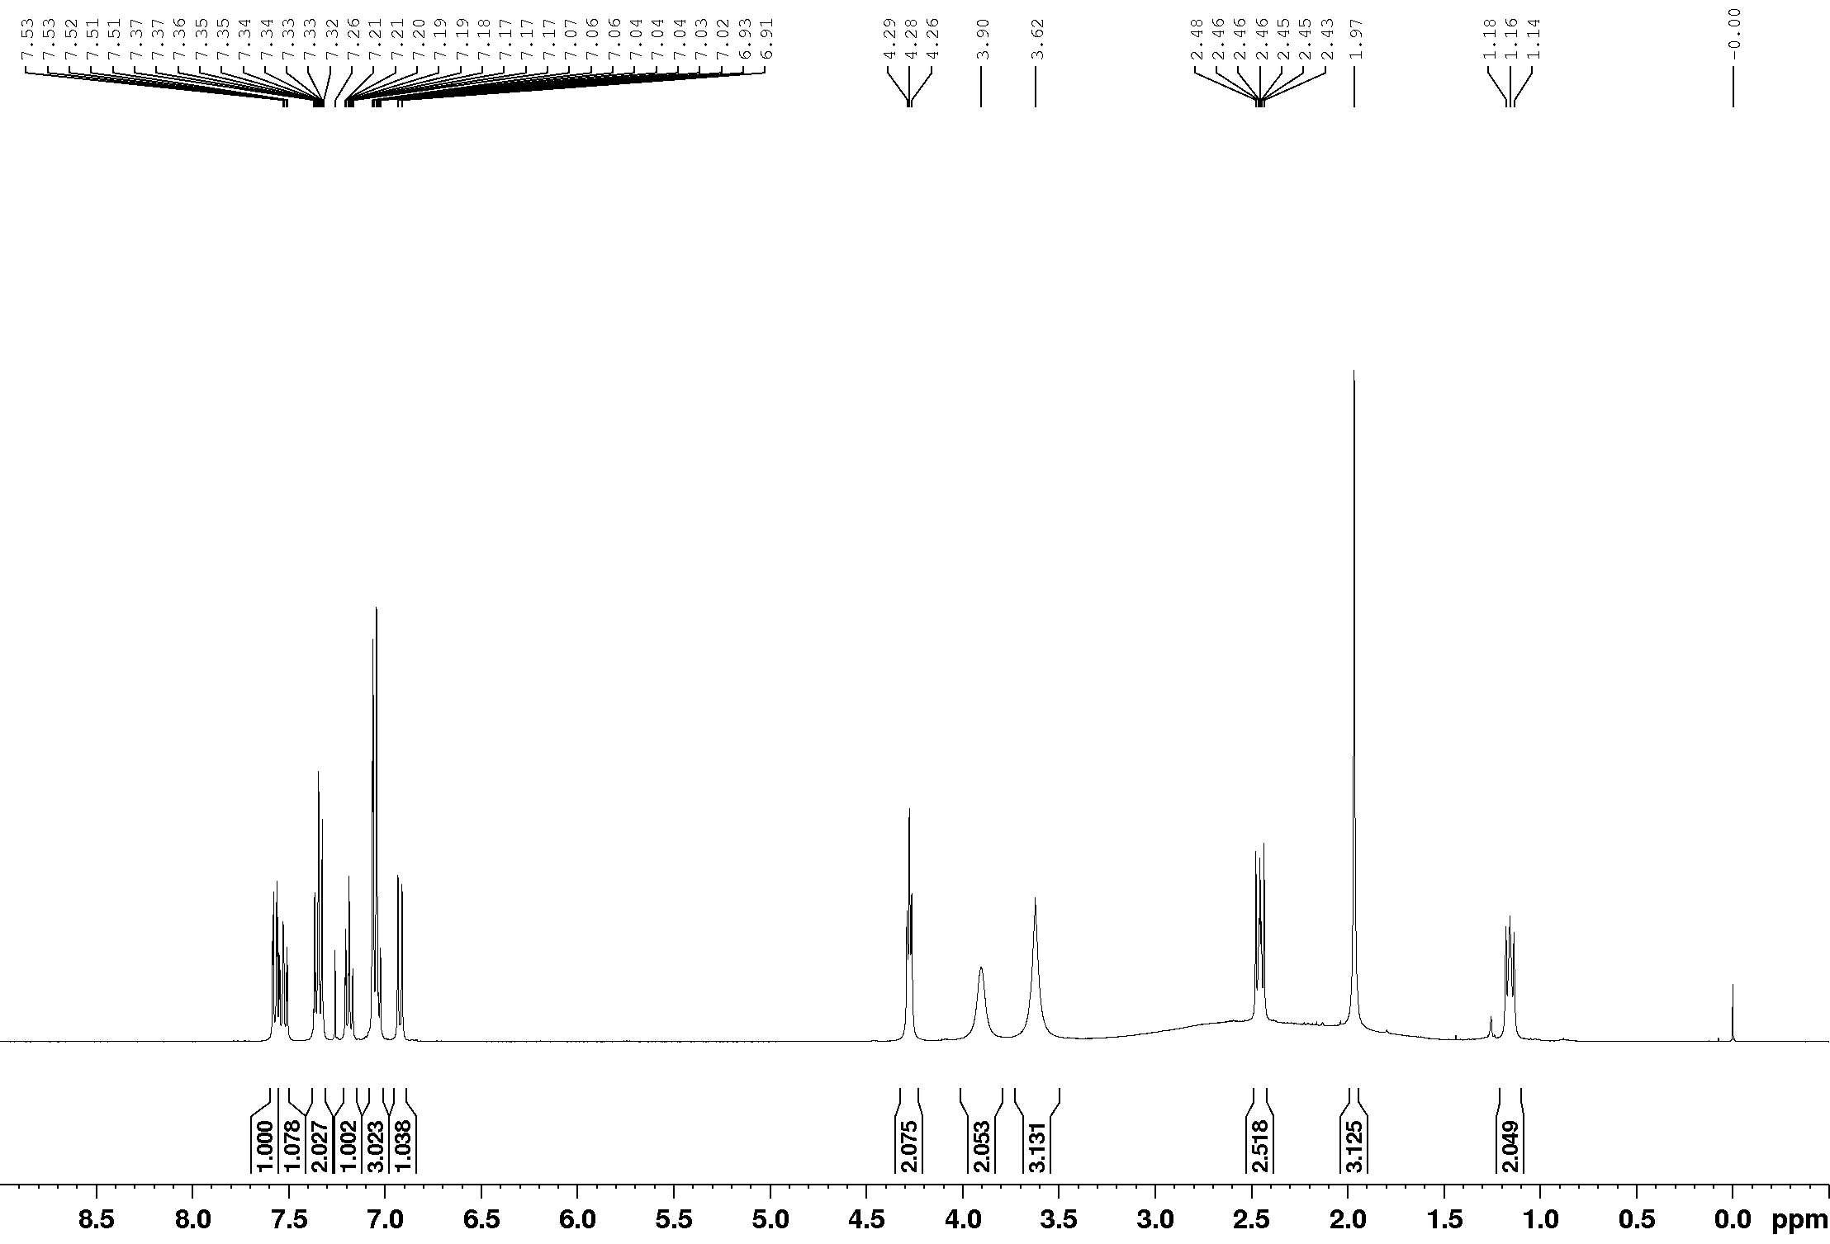

¹³C NMR (100 MHz, CDCl₃)
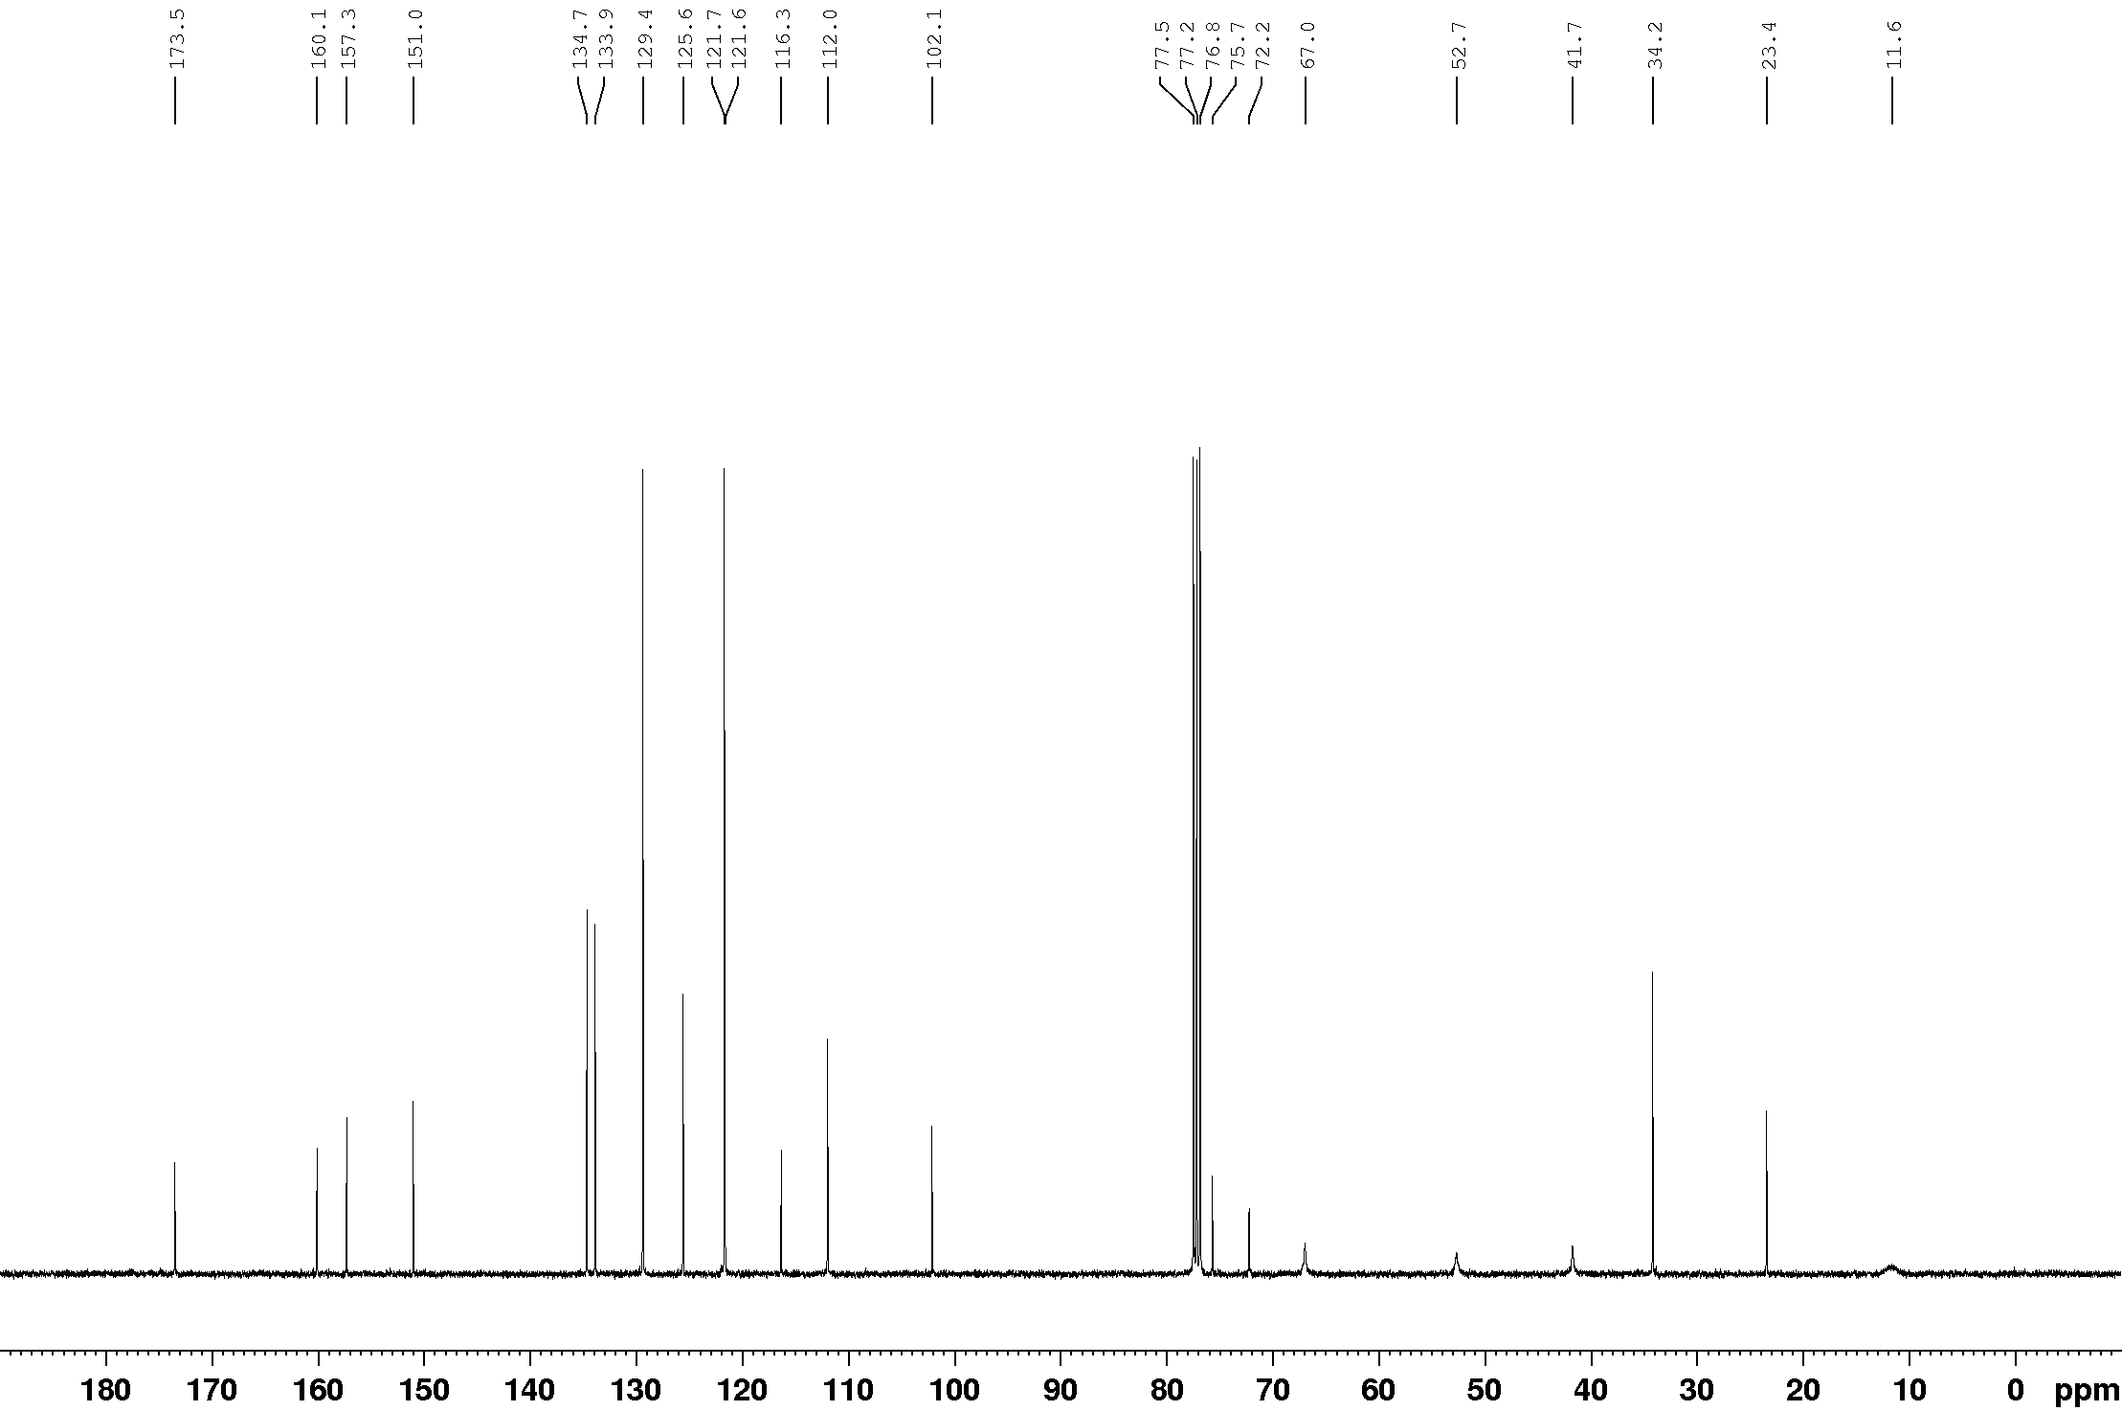

¹¹B NMR (128 MHz, CDCl₃)
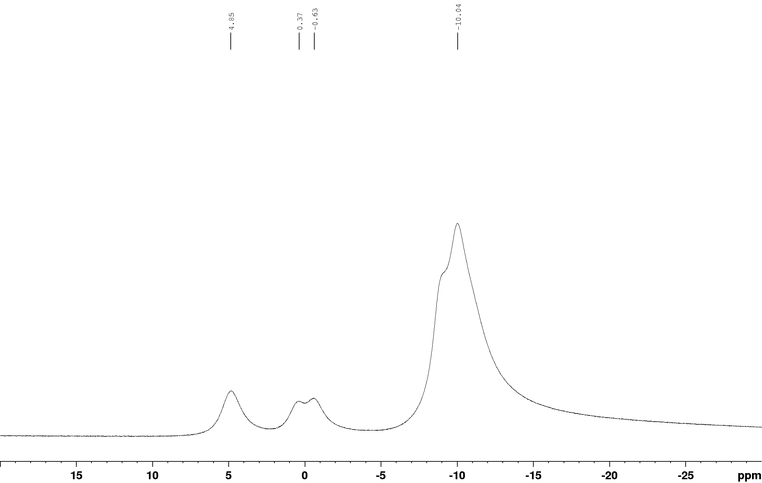

¹¹B{¹H} NMR (128 MHz, CDCl₃)
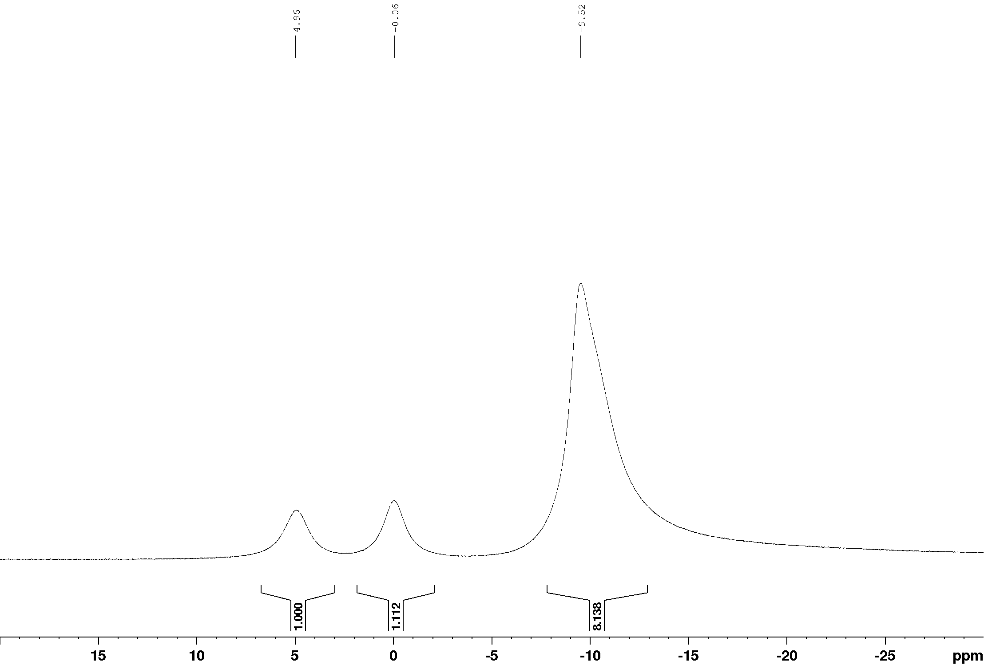

¹H NMR (400 MHz, CDCl₃)
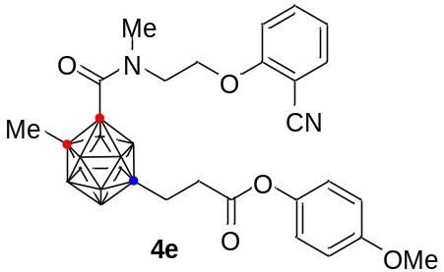

¹³C NMR (100 MHz, CDCl₃)

¹¹B NMR (128 MHz, CDCl₃)

¹¹B{¹H} NMR (128 MHz, CDCl₃)

¹H NMR (400 MHz, CDCl₃)
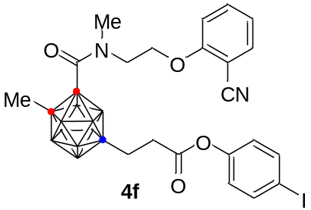

¹³C NMR (100 MHz, CDCl₃)

¹¹B NMR (128 MHz, CDCl₃)

¹¹B{¹H} NMR (128 MHz, CDCl₃)

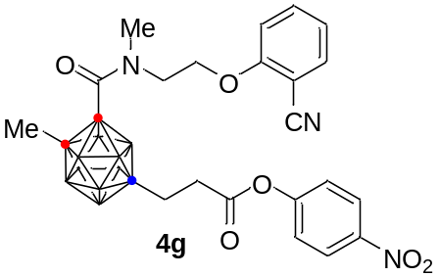¹H NMR (400 MHz, CDCl₃)

¹³C NMR (100 MHz, CDCl₃)

¹¹B NMR (128 MHz, CDCl₃)
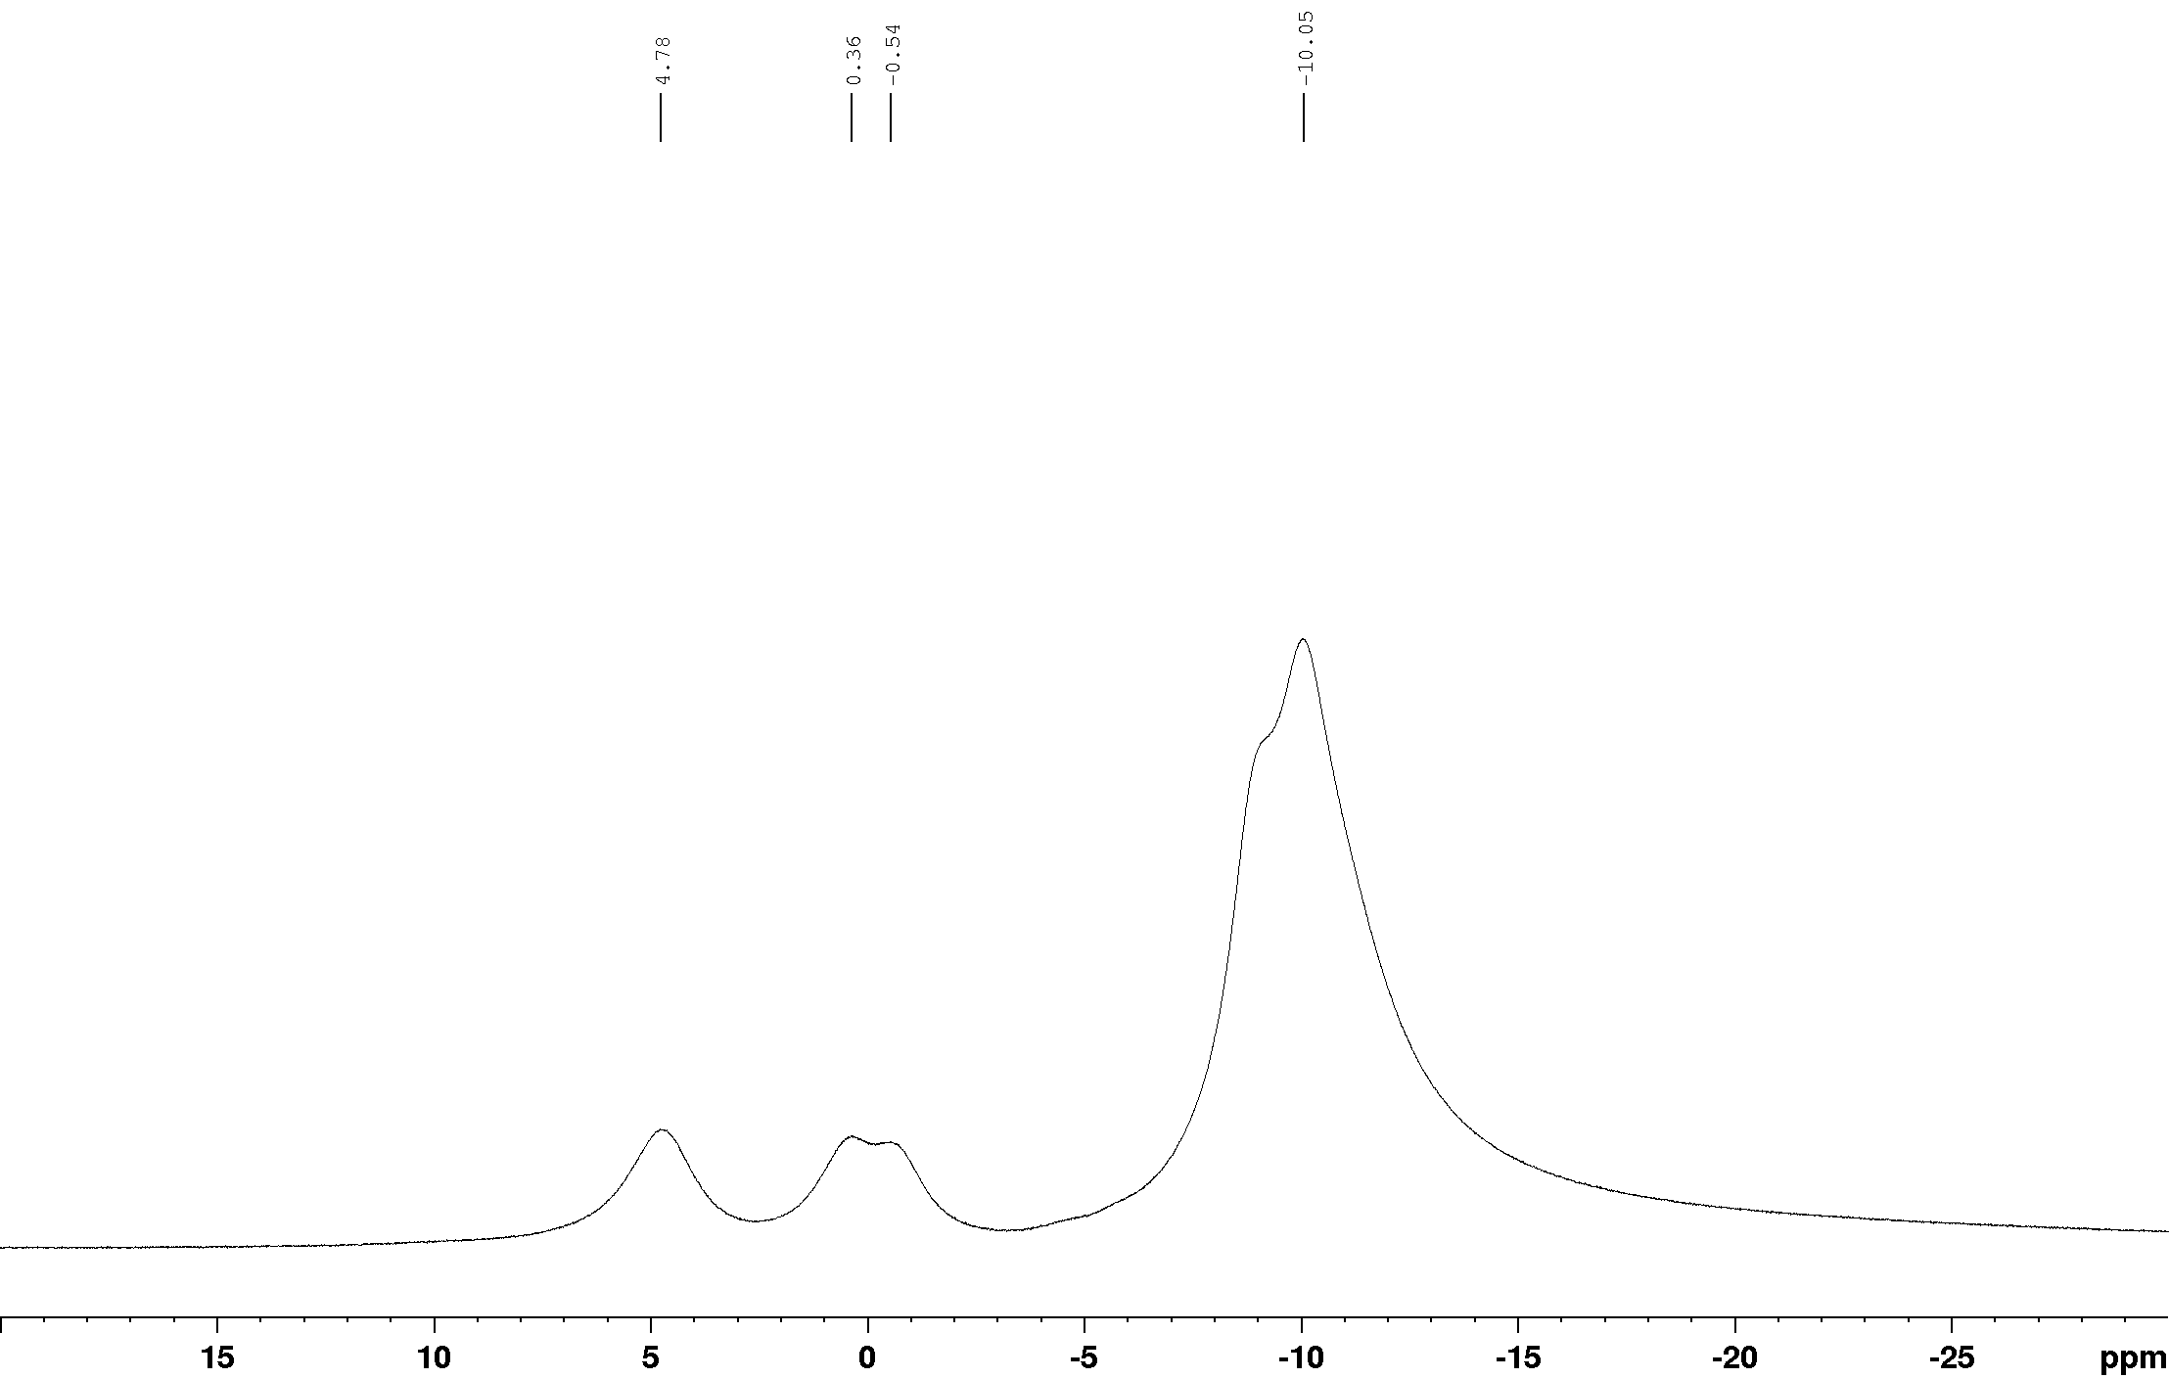

¹¹B{¹H} NMR (128 MHz, CDCl₃)

¹H NMR (400 MHz, CDCl₃)
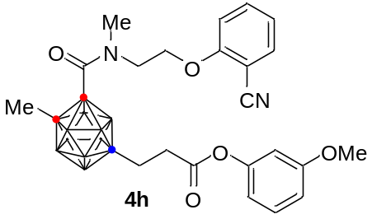

¹³C NMR (100 MHz, CDCl₃)

¹¹B NMR (128 MHz, CDCl₃)

¹¹B{¹H} NMR (128 MHz, CDCl₃)
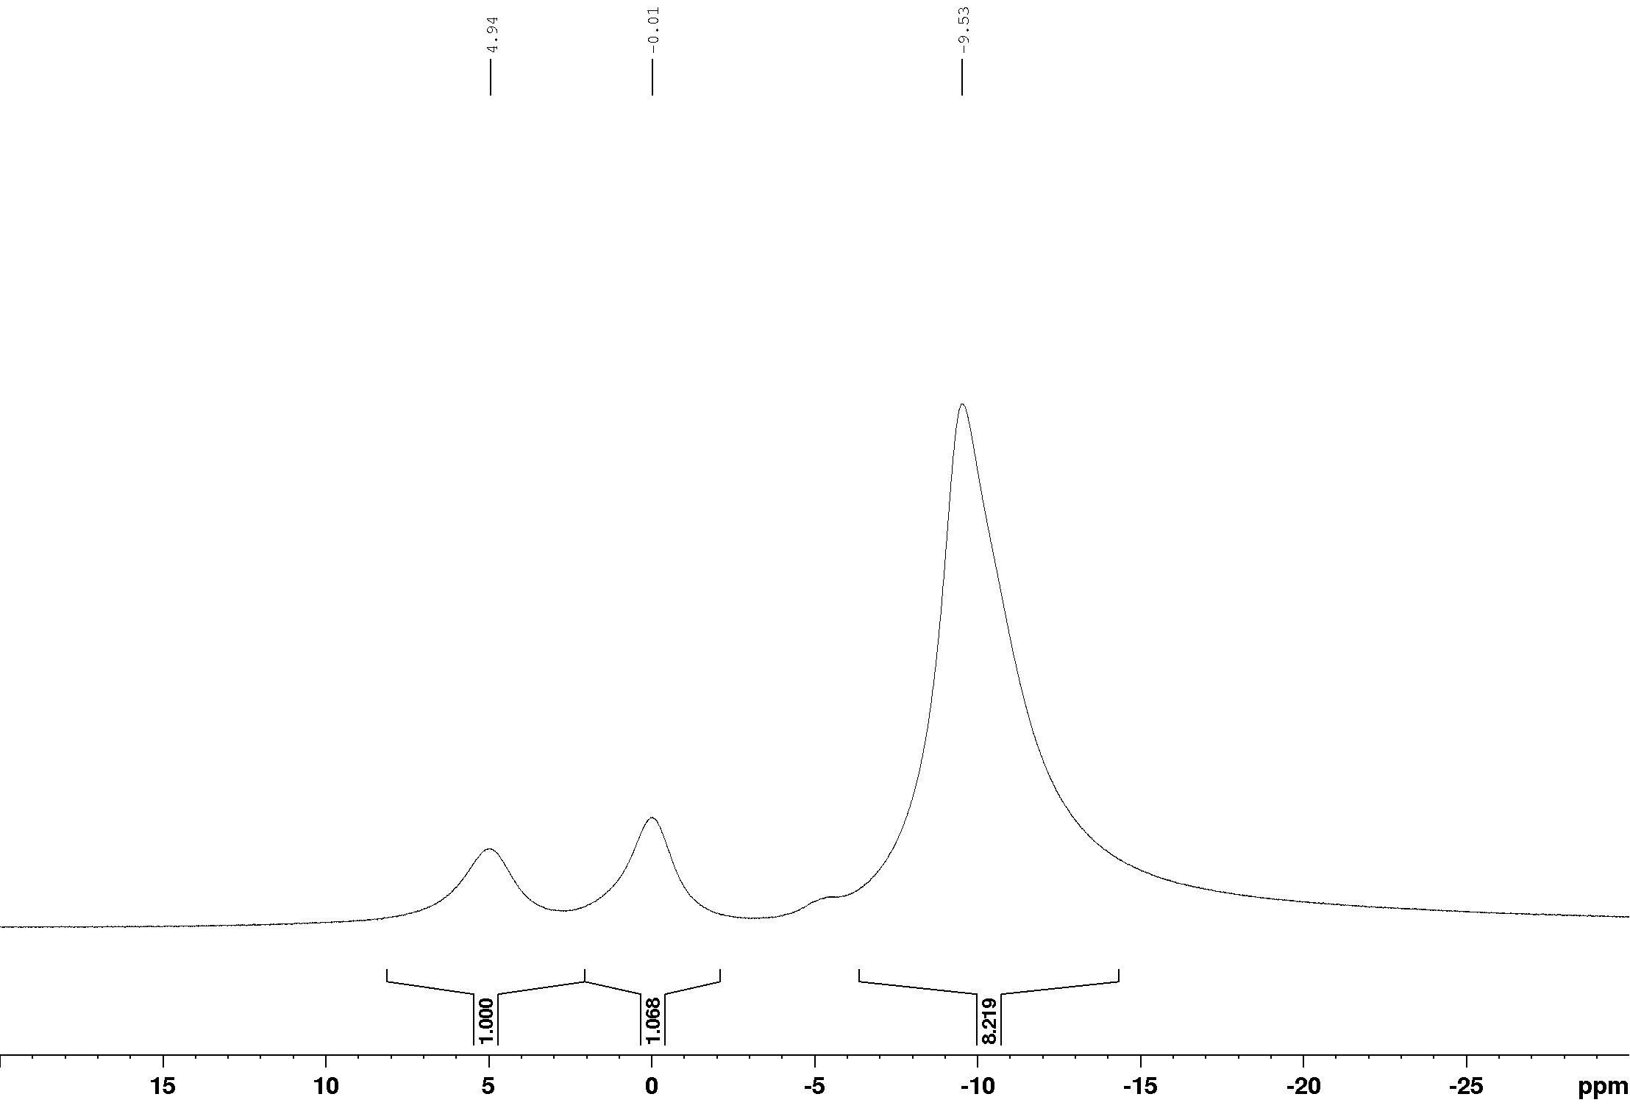

¹H NMR (400 MHz, CDCl₃)
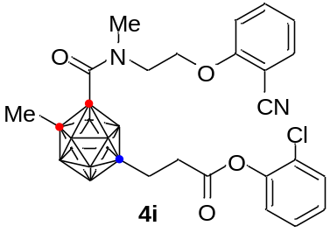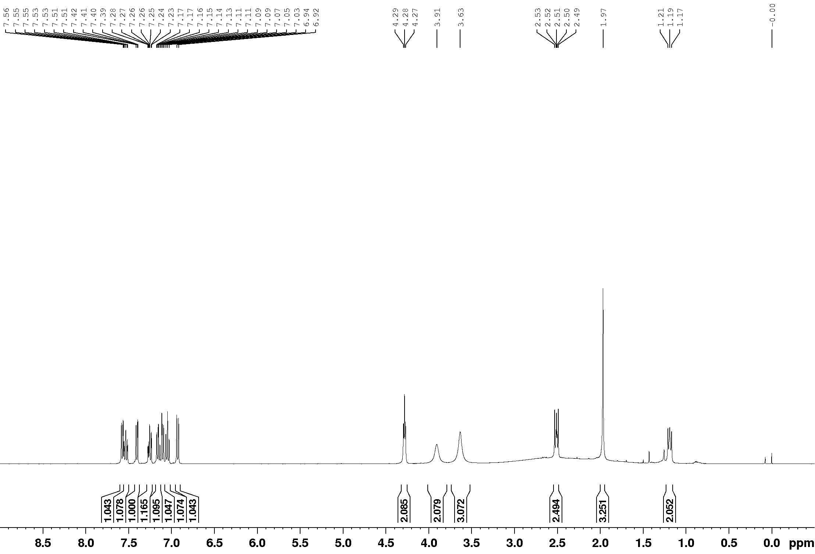

¹³C NMR (100 MHz, CDCl₃)
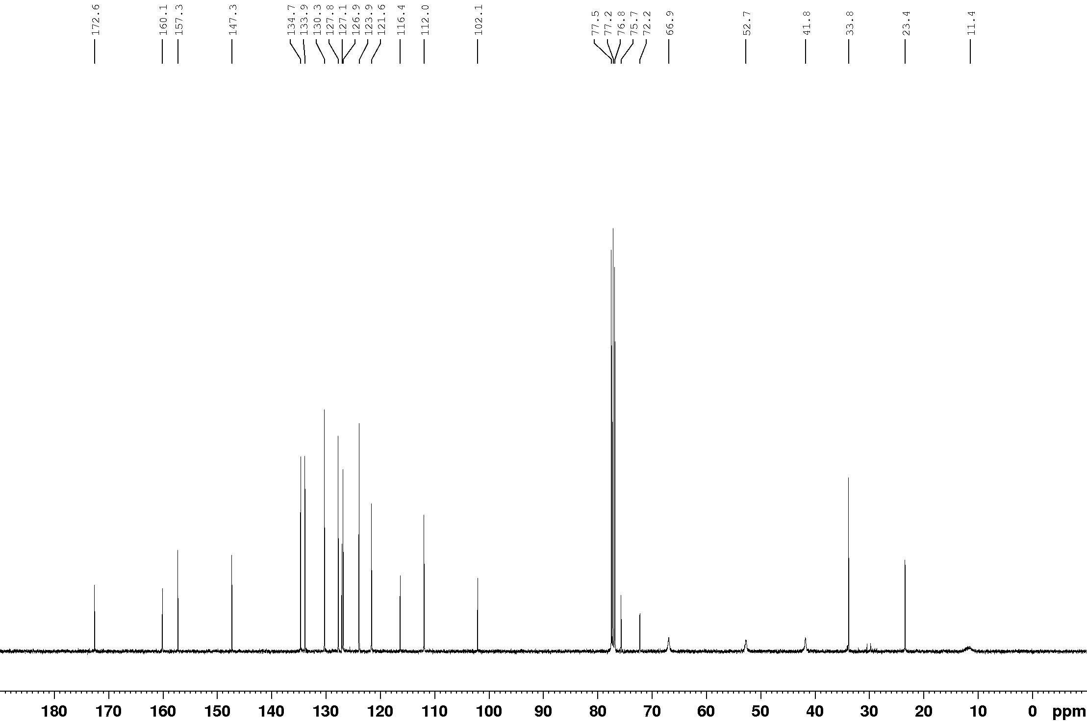

¹¹B NMR (128 MHz, CDCl₃)
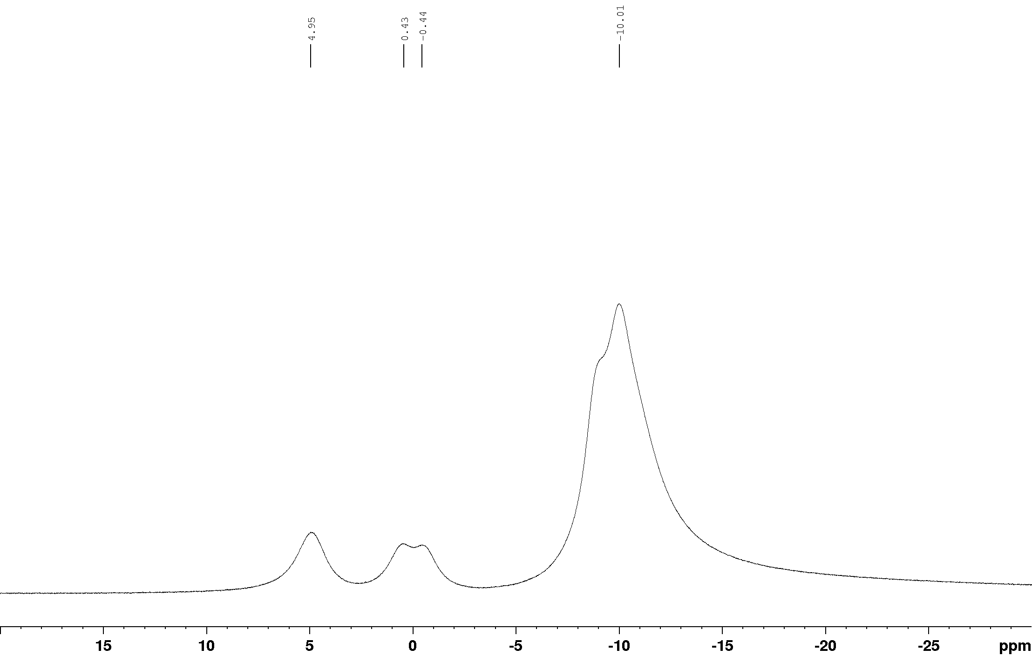

¹¹B{¹H} NMR (128 MHz, CDCl₃)
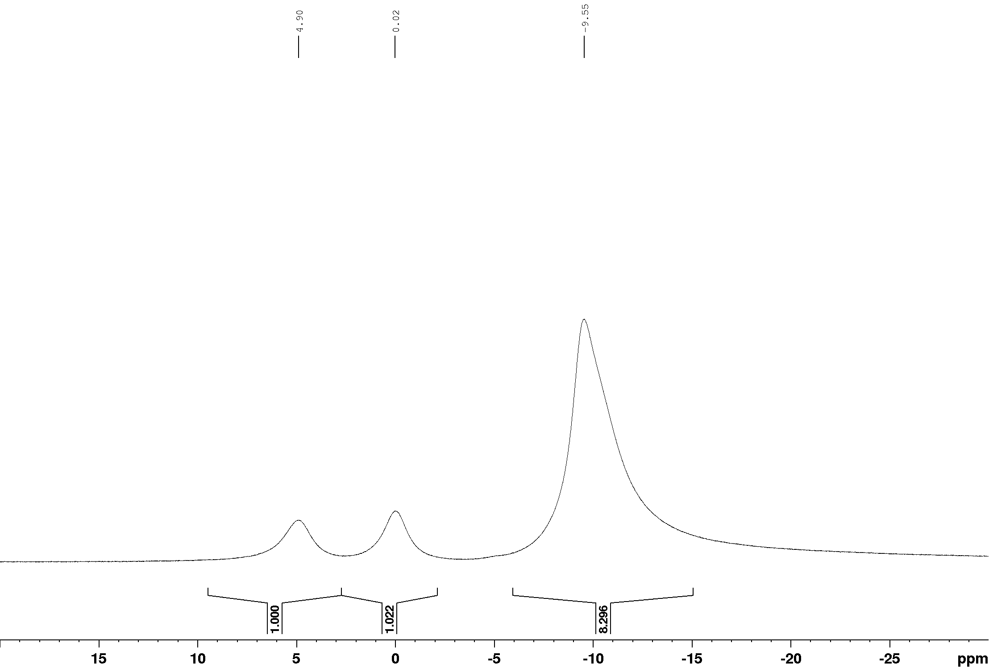

¹H NMR (400 MHz, CDCl₃)
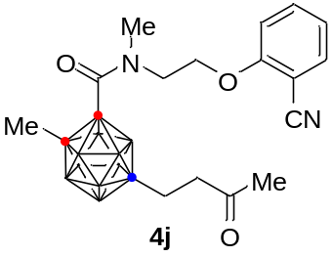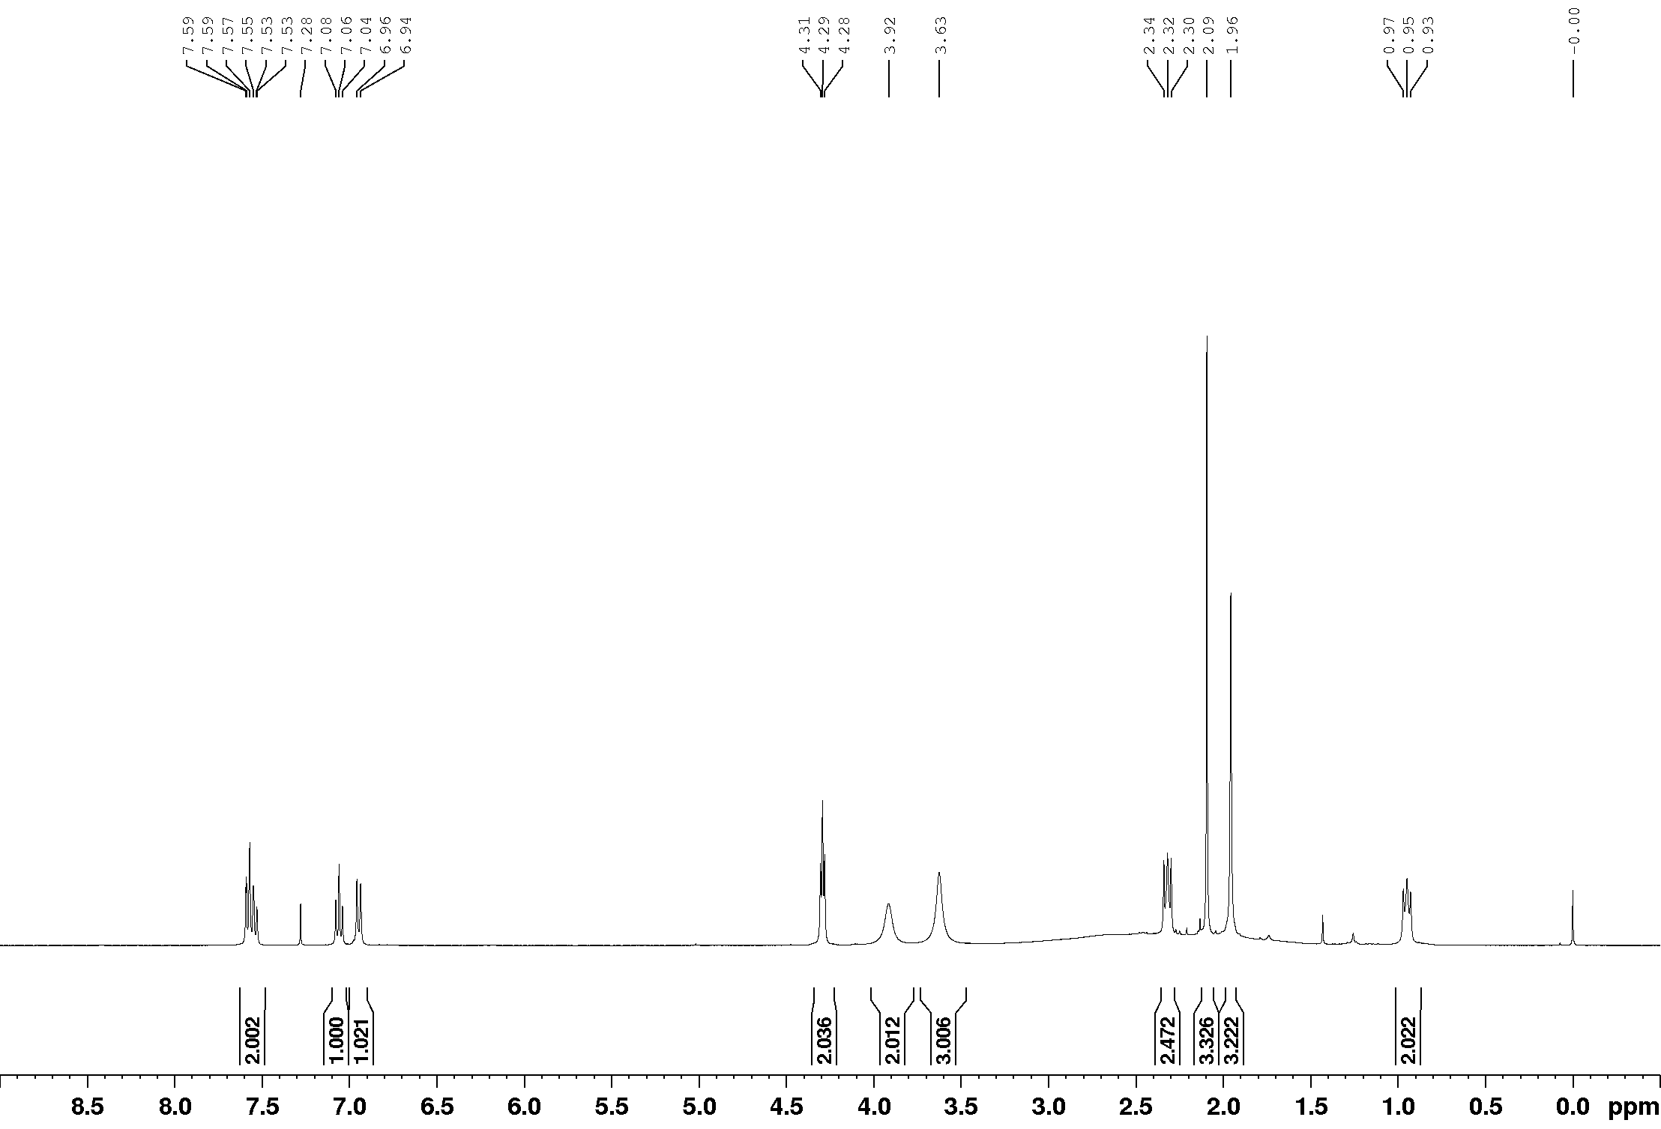

¹³C NMR (100 MHz, CDCl₃)
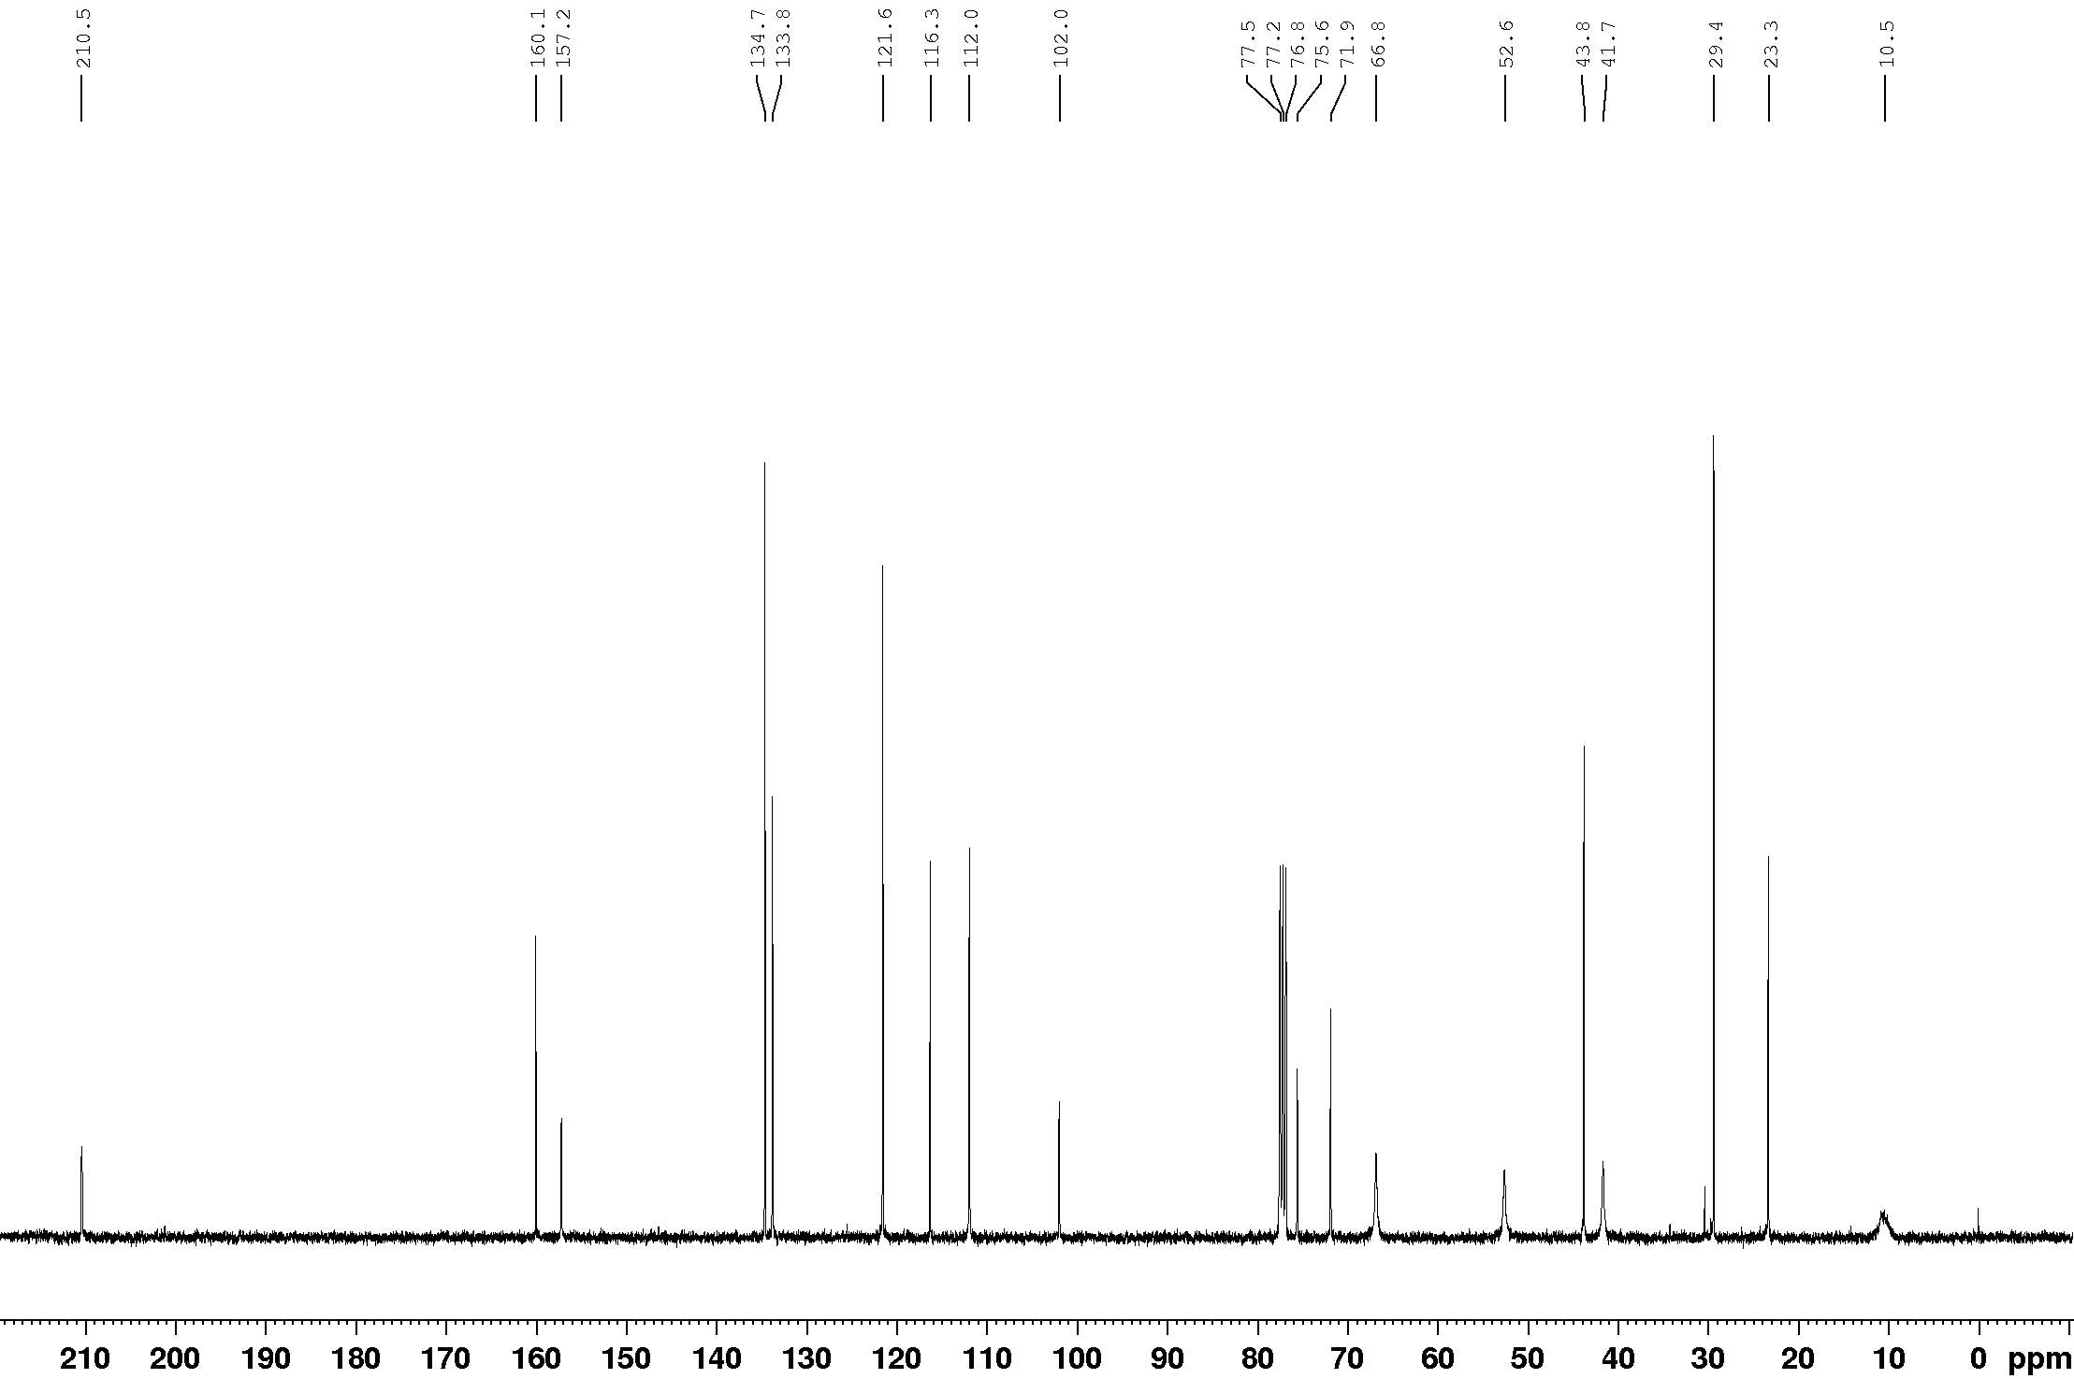

¹¹B NMR (128 MHz, CDCl₃)
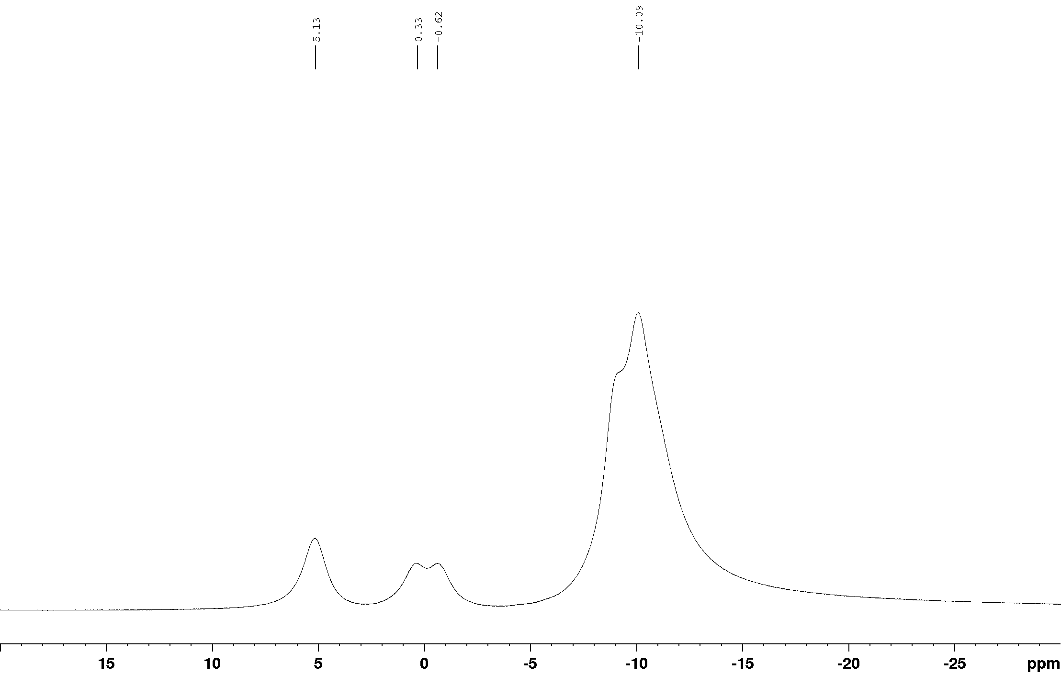

¹¹B{¹H} NMR (128 MHz, CDCl₃)
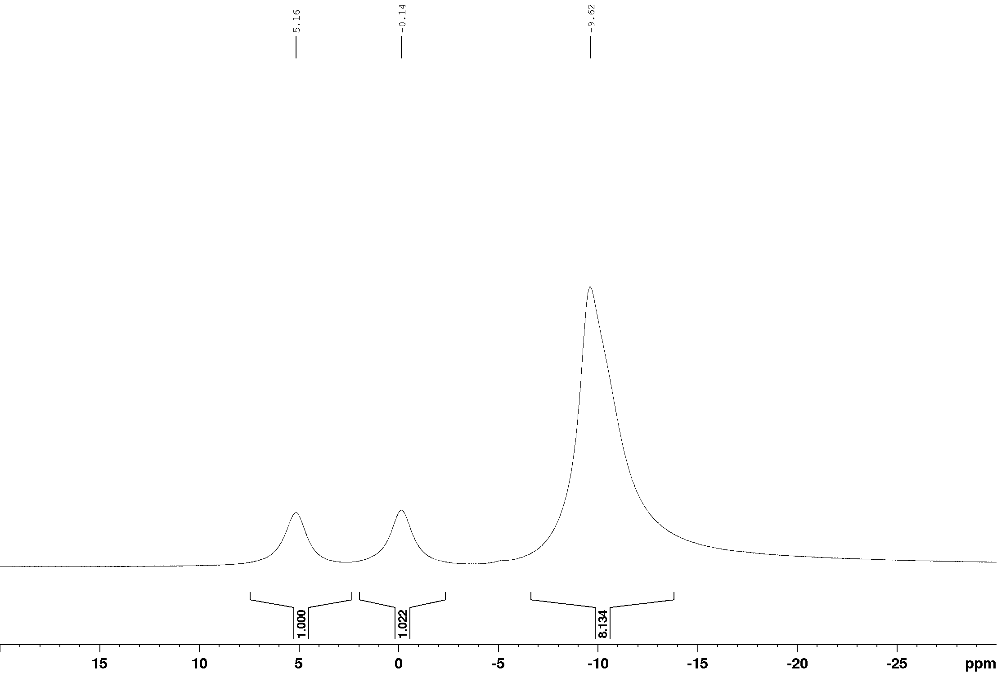

¹H NMR (400 MHz, CDCl₃)
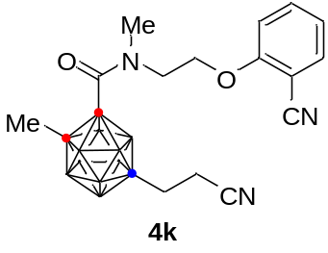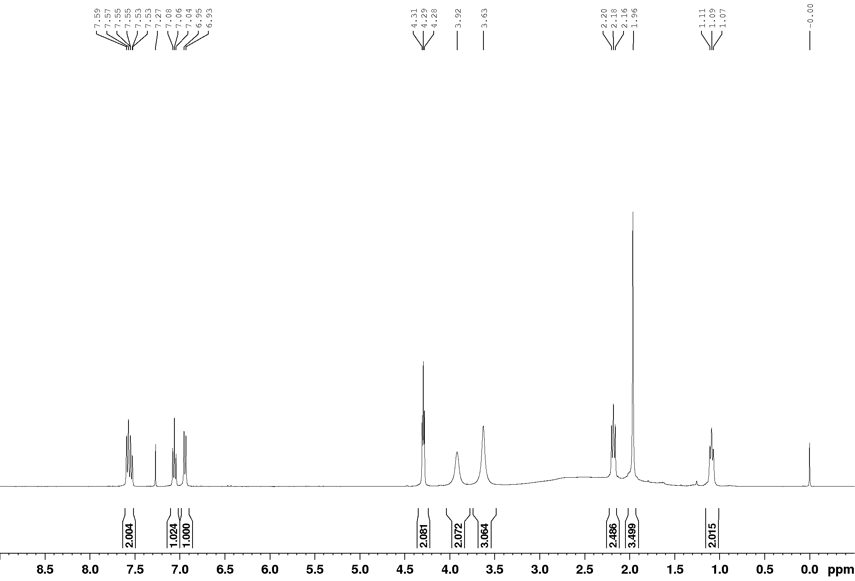

¹³C NMR (100 MHz, CDCl₃)
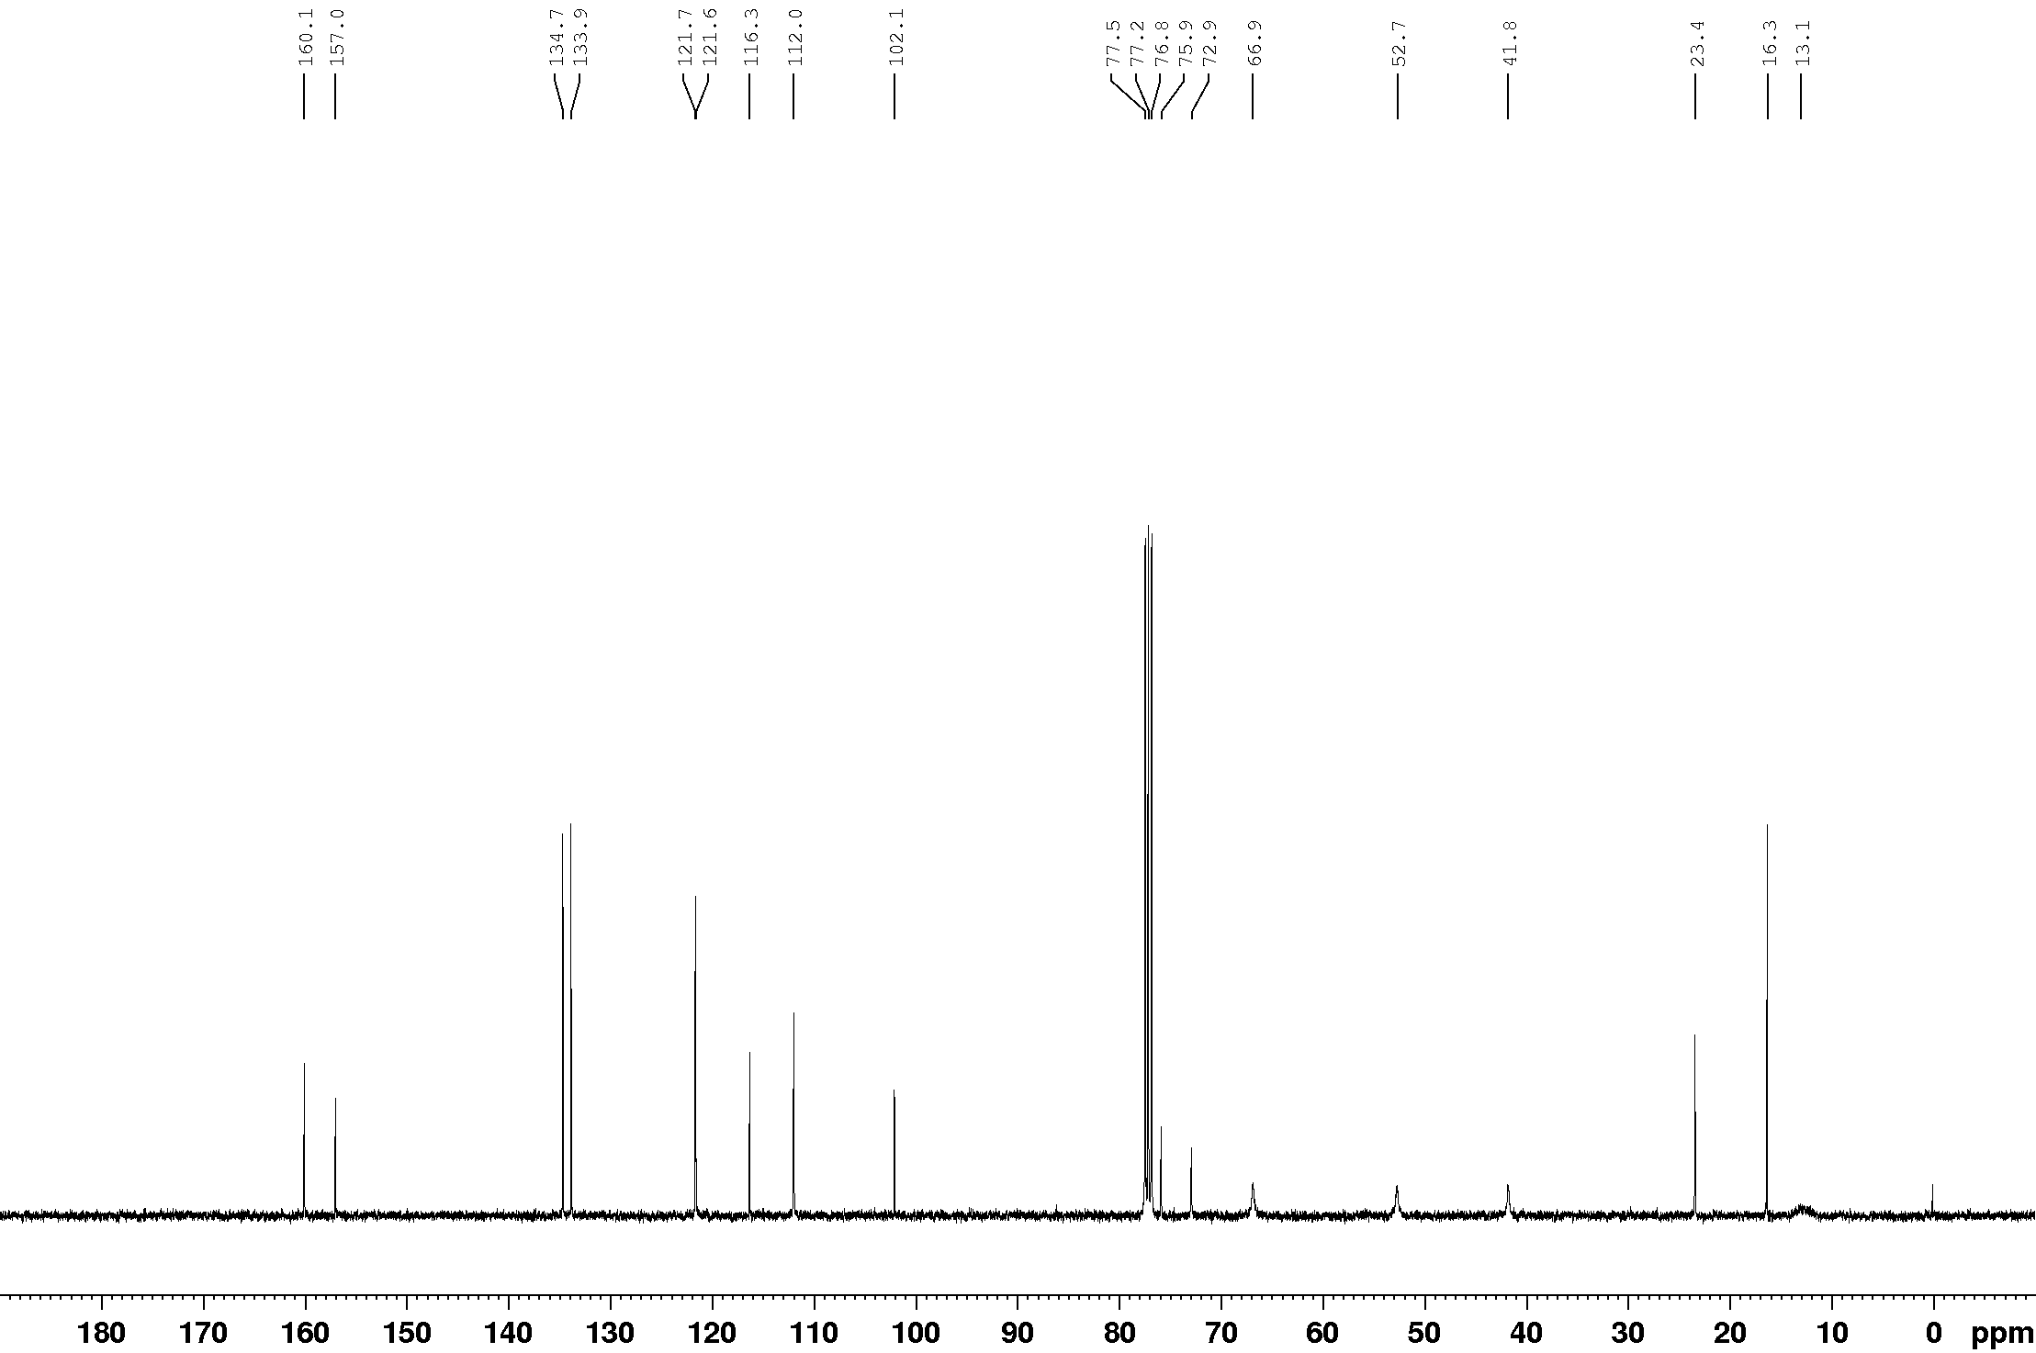

¹¹B NMR (128 MHz, CDCl₃)
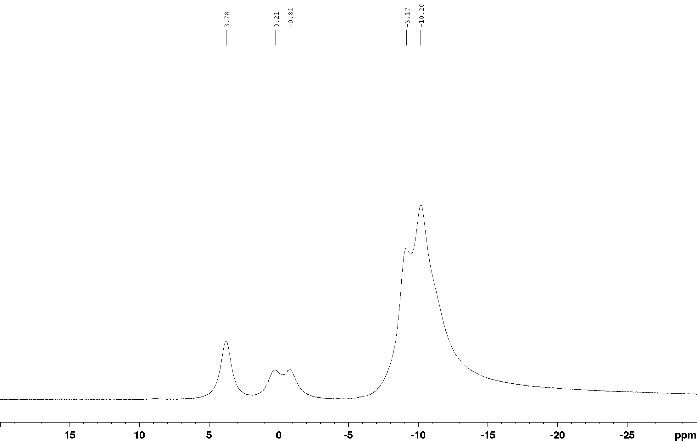

¹¹B{¹H} NMR (128 MHz, CDCl₃)
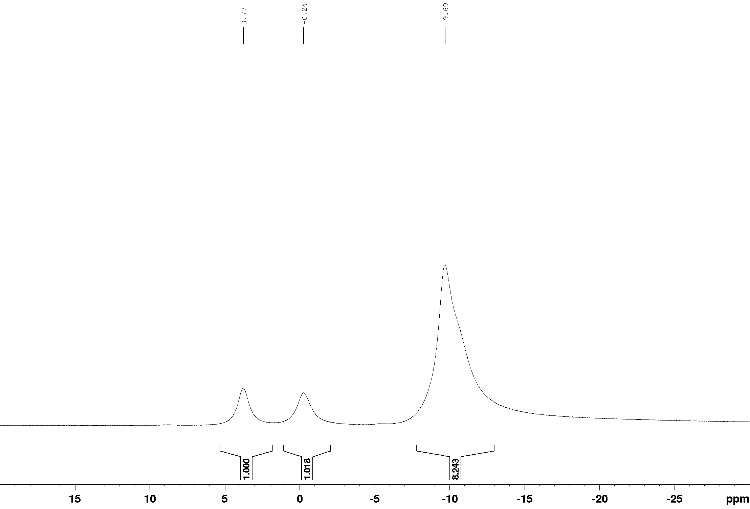

¹H NMR (400 MHz, CDCl₃)
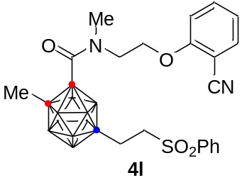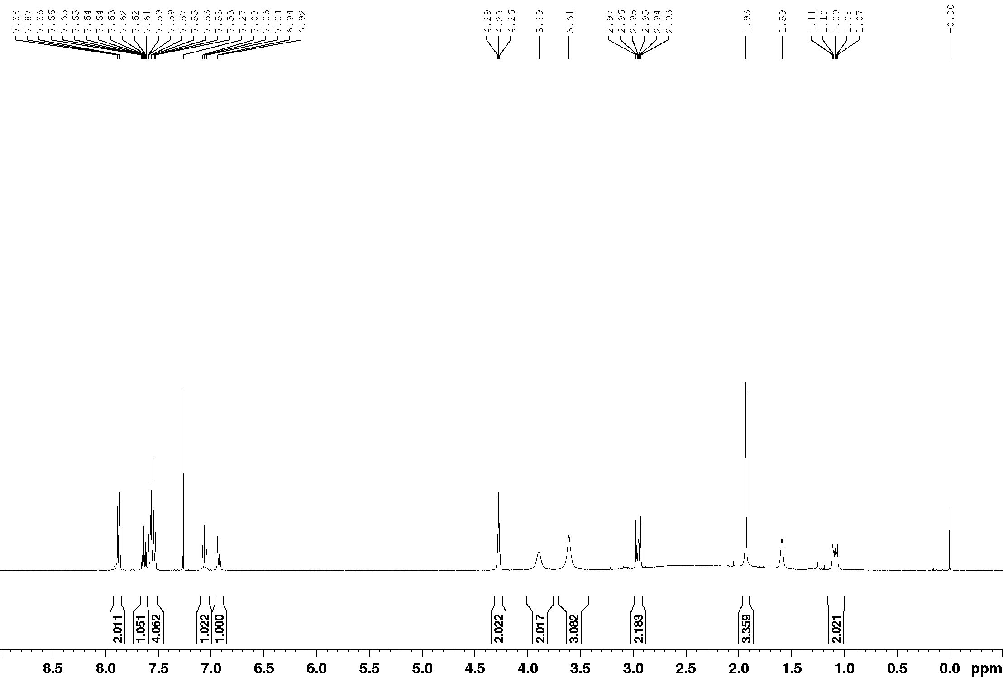

¹³C NMR (100 MHz, CDCl₃)
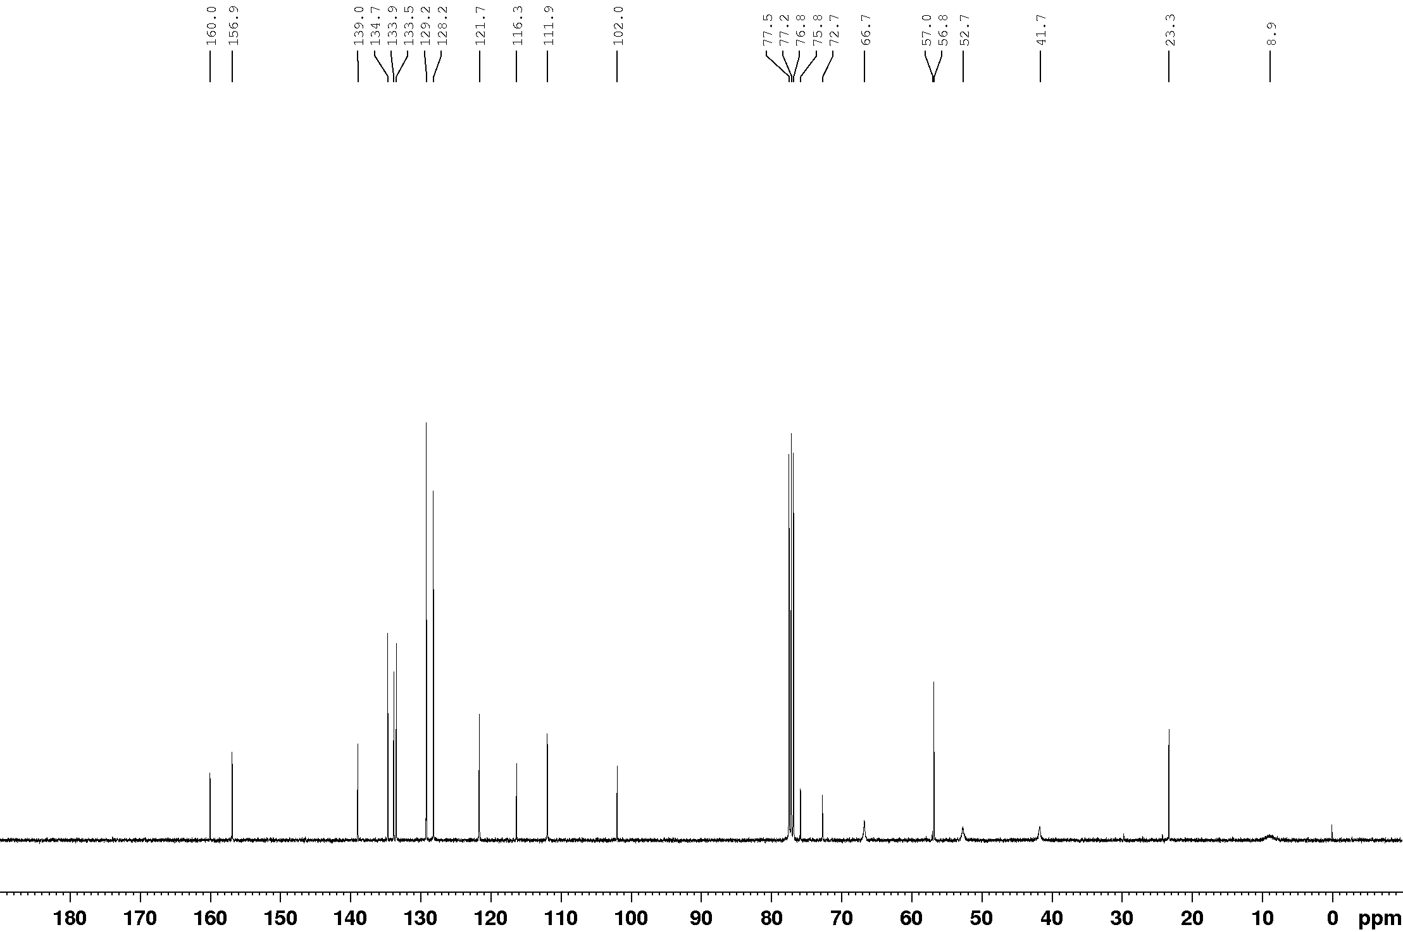

¹¹B NMR (128 MHz, CDCl₃)
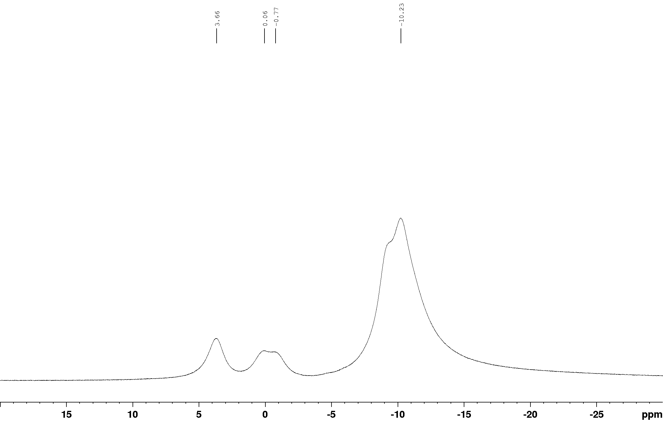

¹¹B{¹H} NMR (128 MHz, CDCl₃)
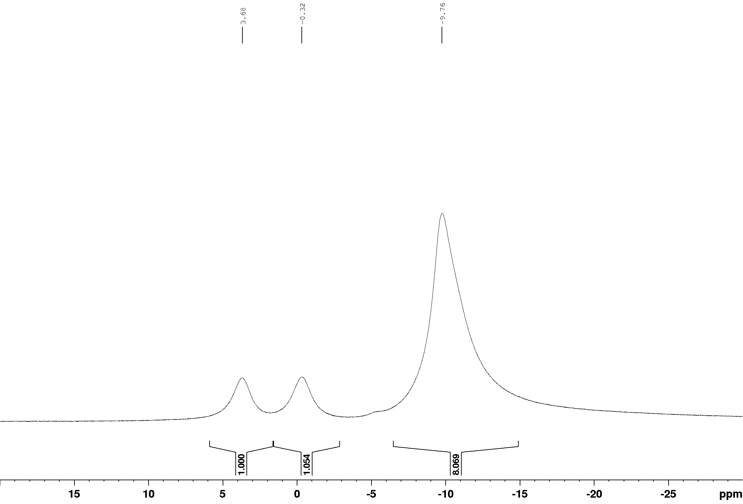

¹H NMR (400 MHz, CDCl₃)
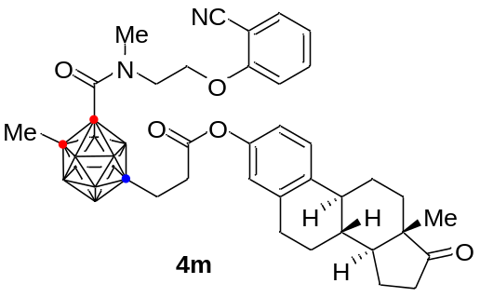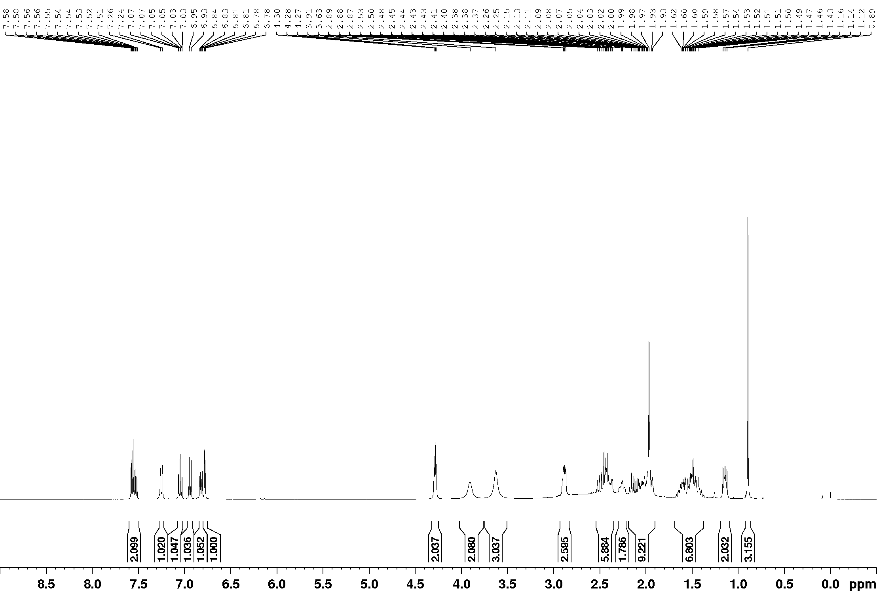

¹³C NMR (100 MHz, CDCl₃)
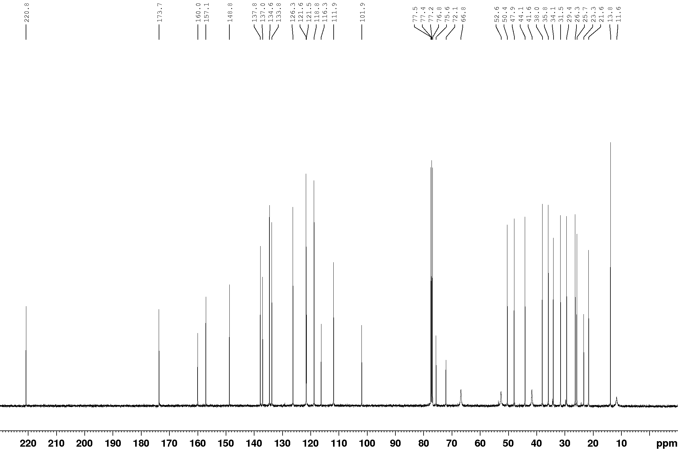

¹¹B NMR (128 MHz, CDCl₃)
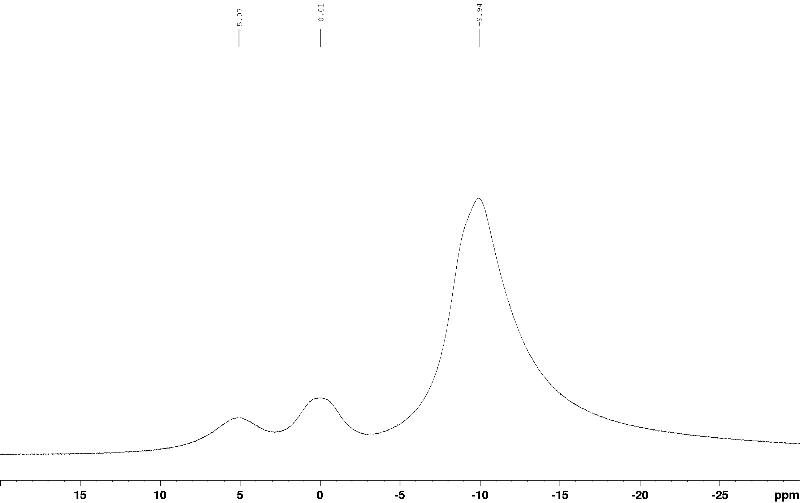

¹¹B{¹H} NMR (128 MHz, CDCl₃)
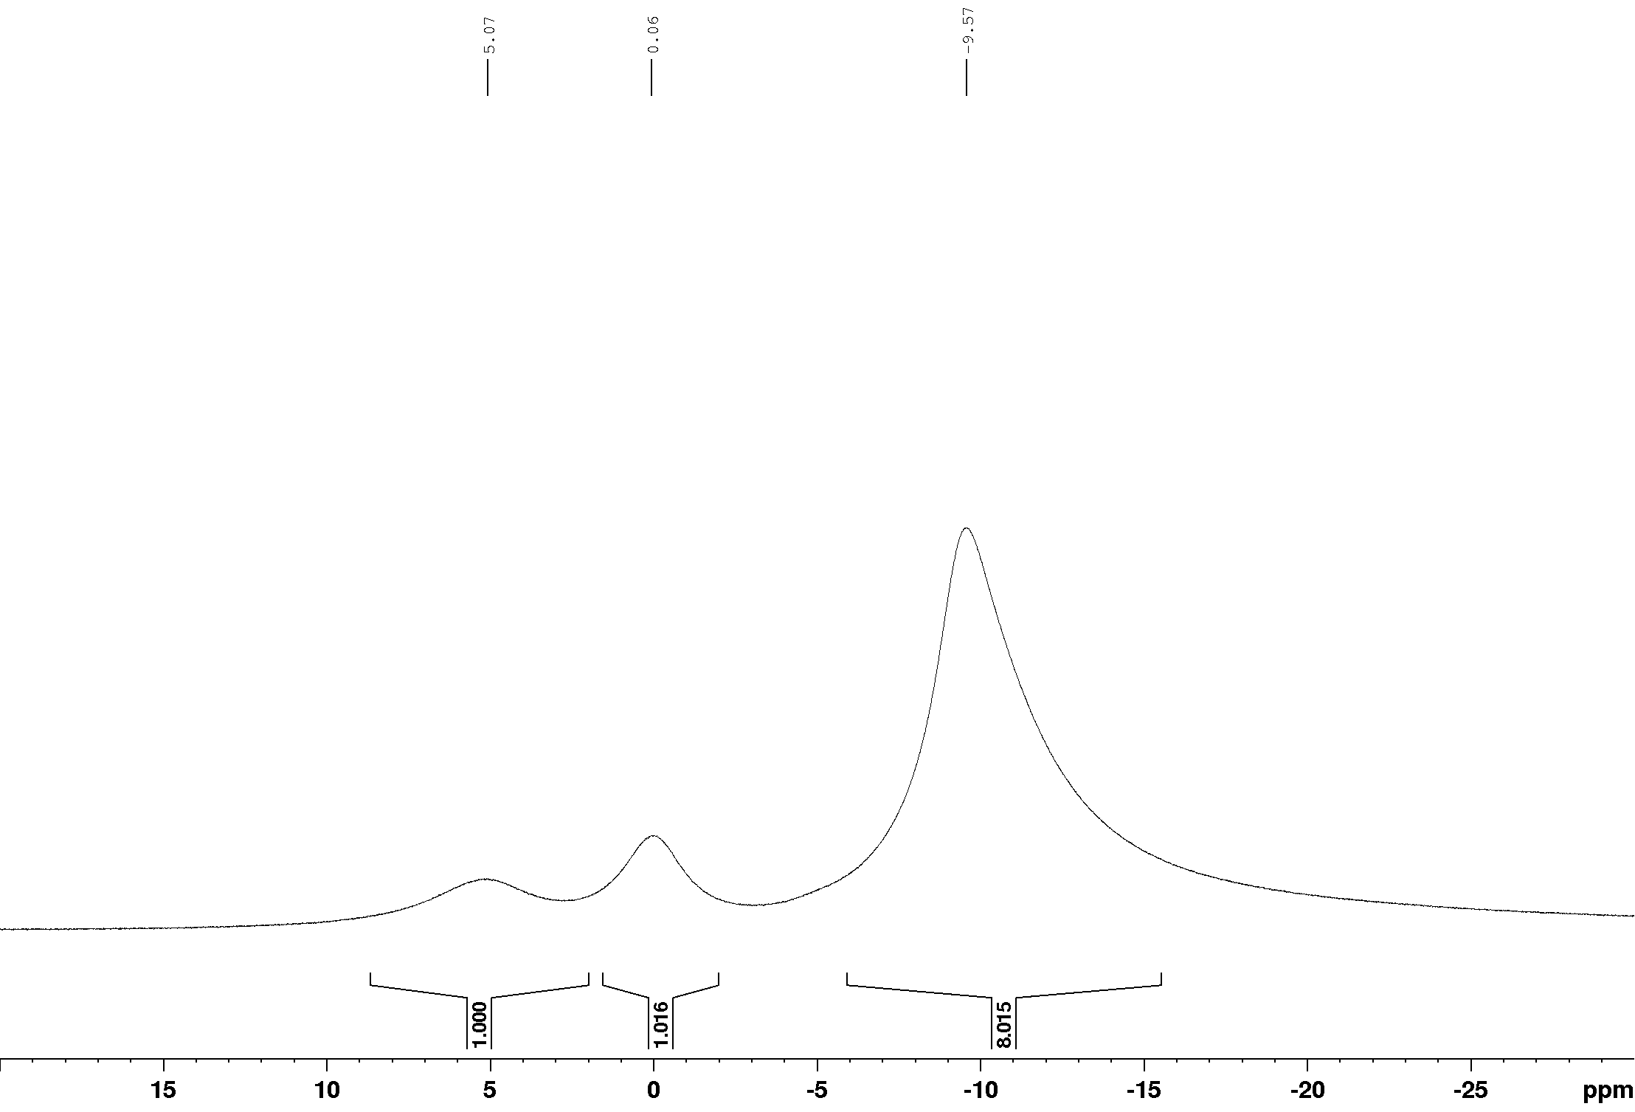

¹H NMR (400 MHz, CDCl₃)
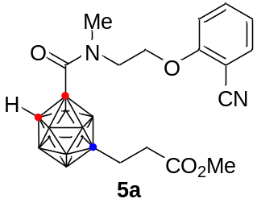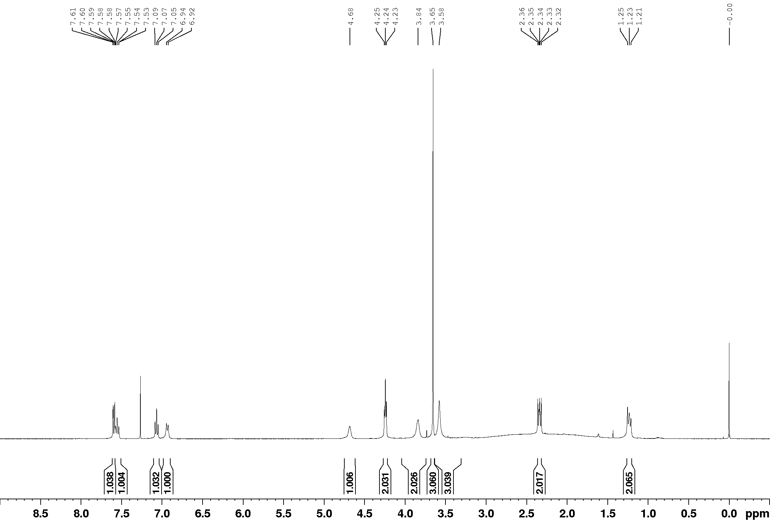
¹³C NMR (100 MHz, CDCl₃)
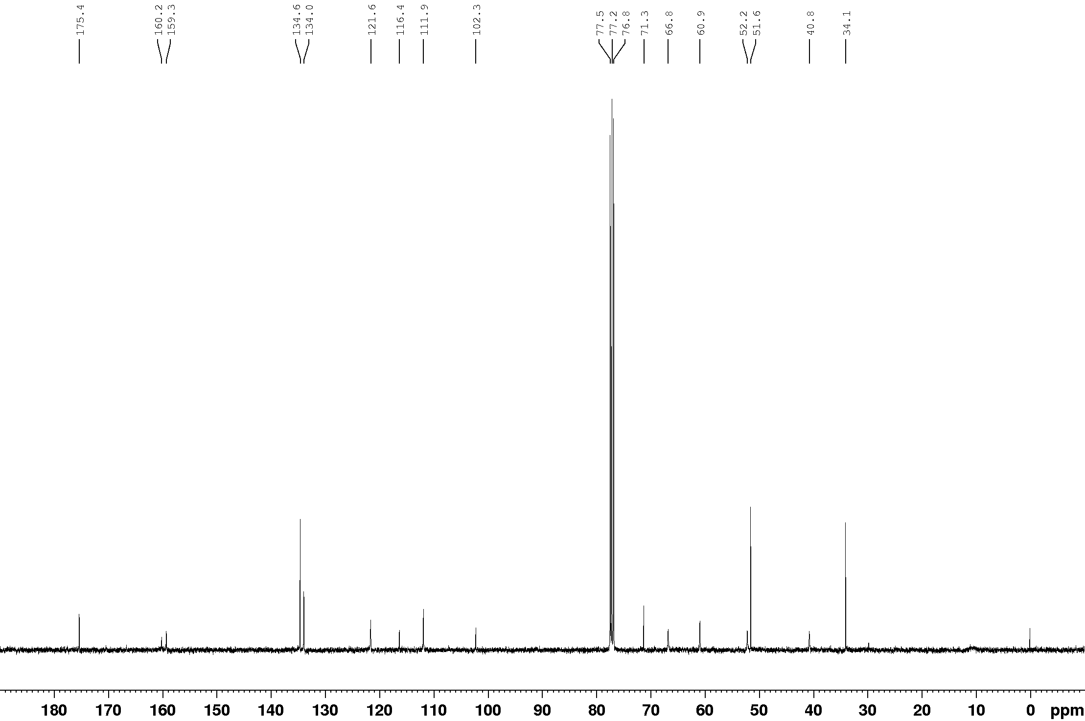
¹¹B NMR (128 MHz, CDCl₃)
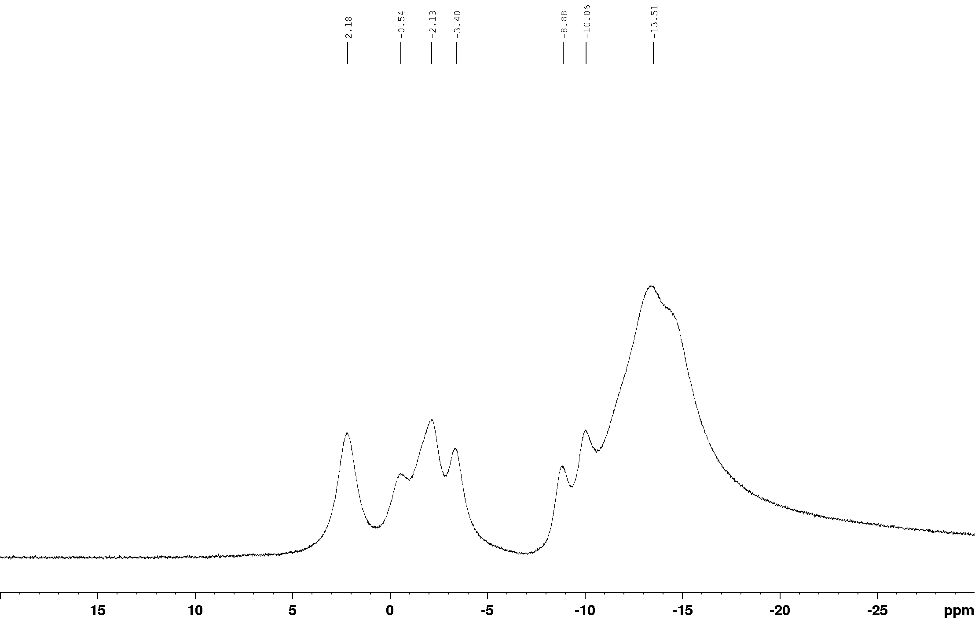
¹H NMR (400 MHz, CDCl₃)
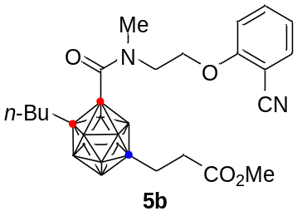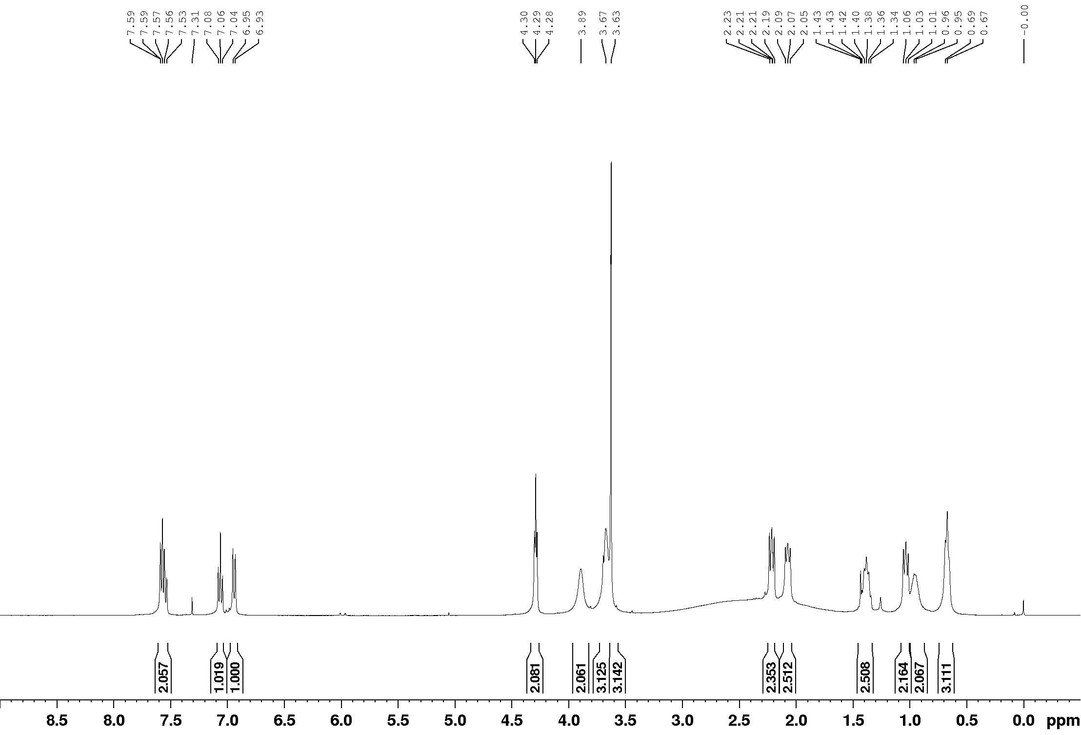

¹³C NMR (100 MHz, CDCl₃)
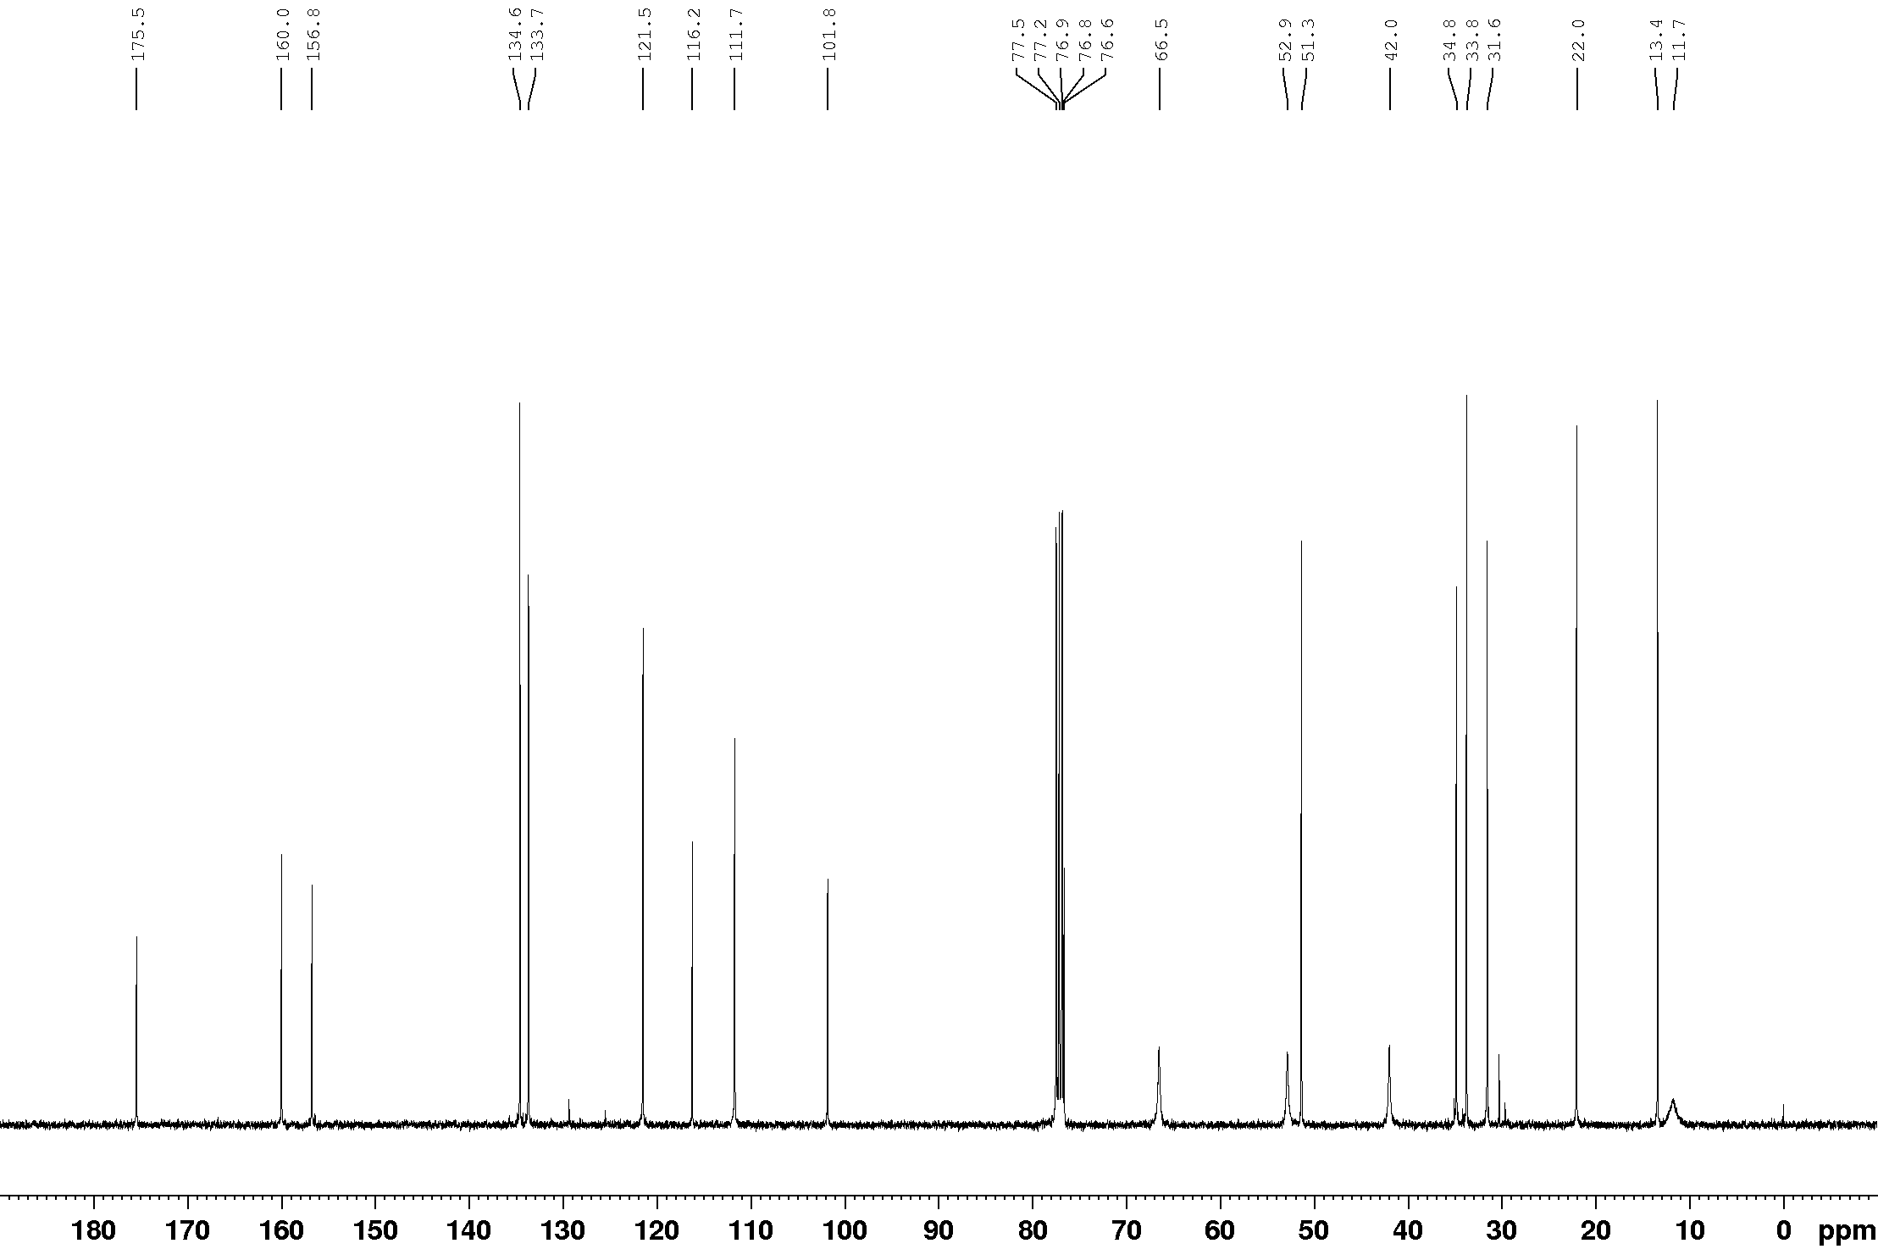

¹¹B NMR (128 MHz, CDCl₃)
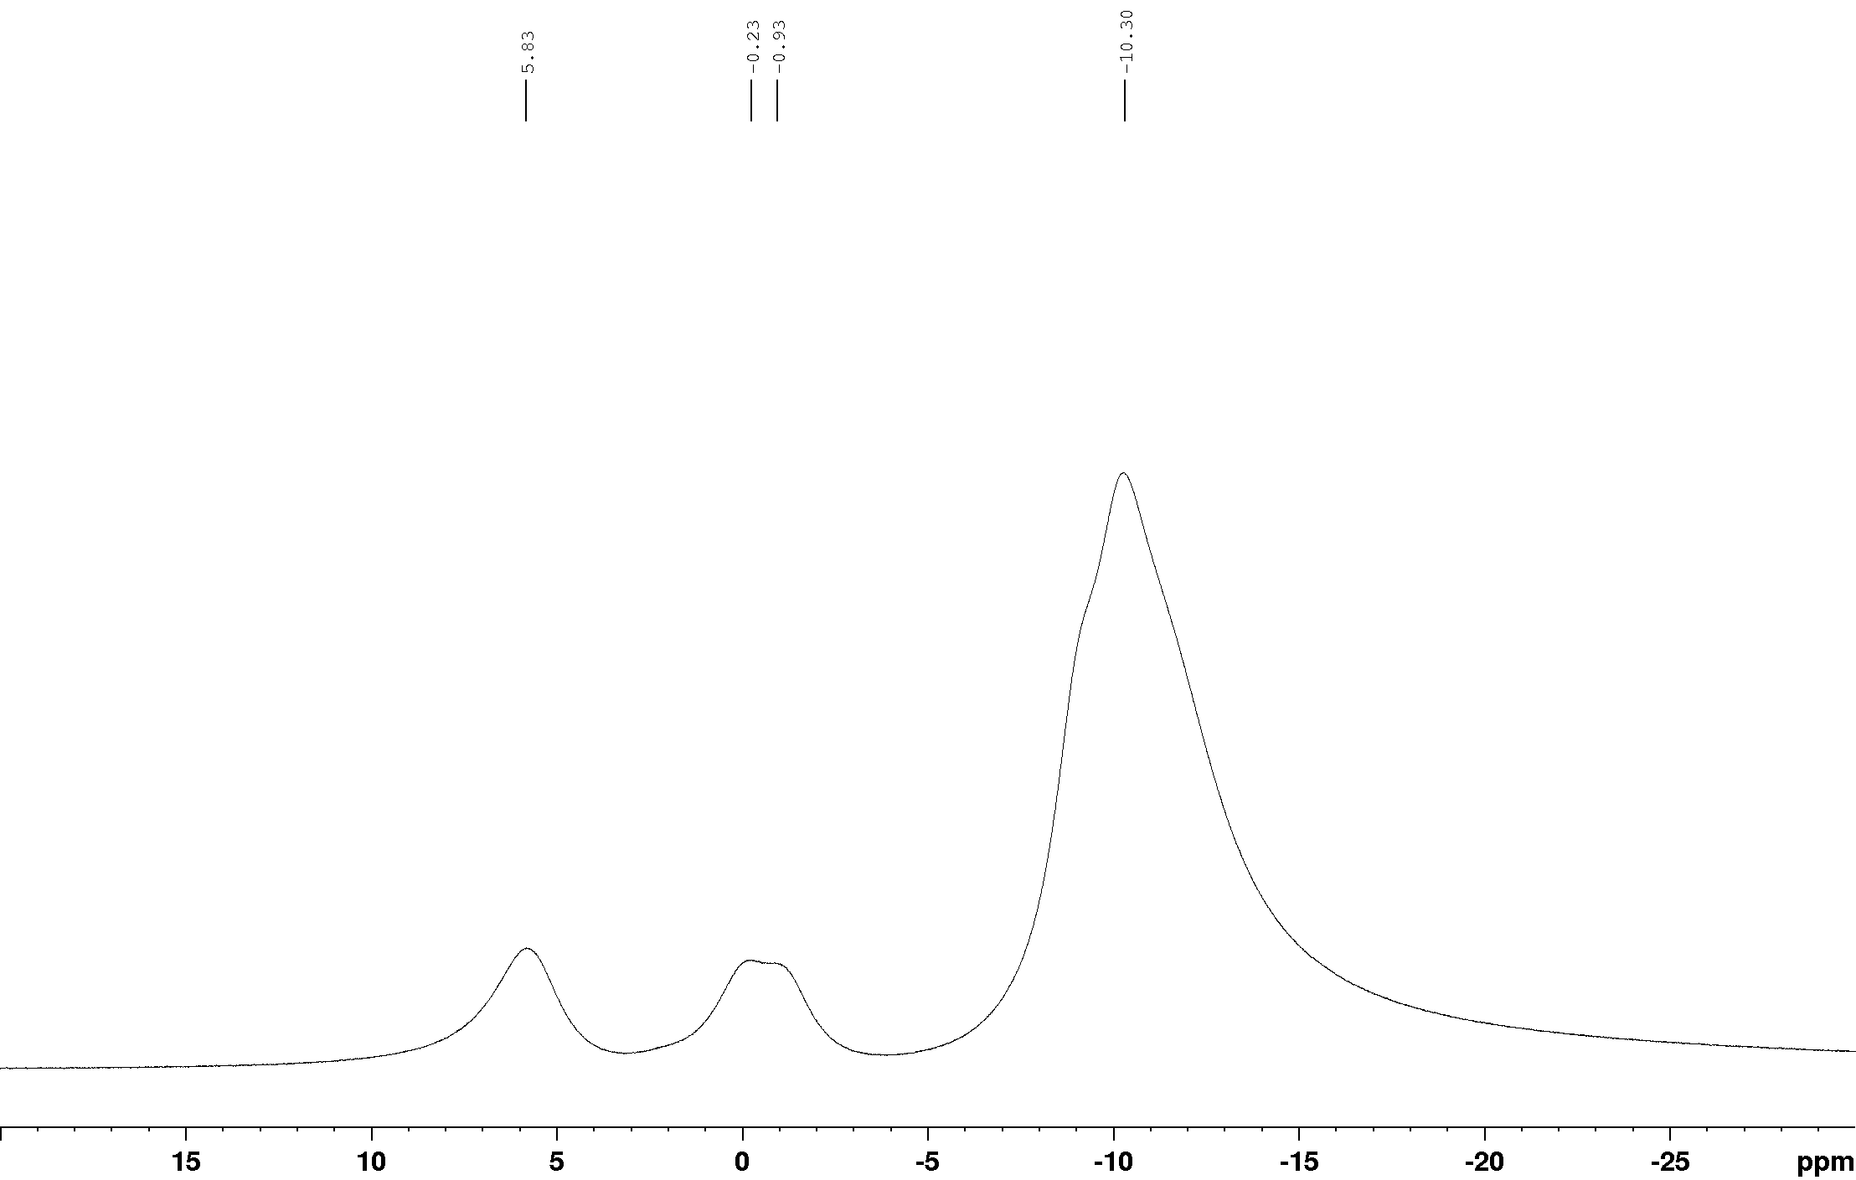

¹¹B{¹H} NMR (128 MHz, CDCl₃)
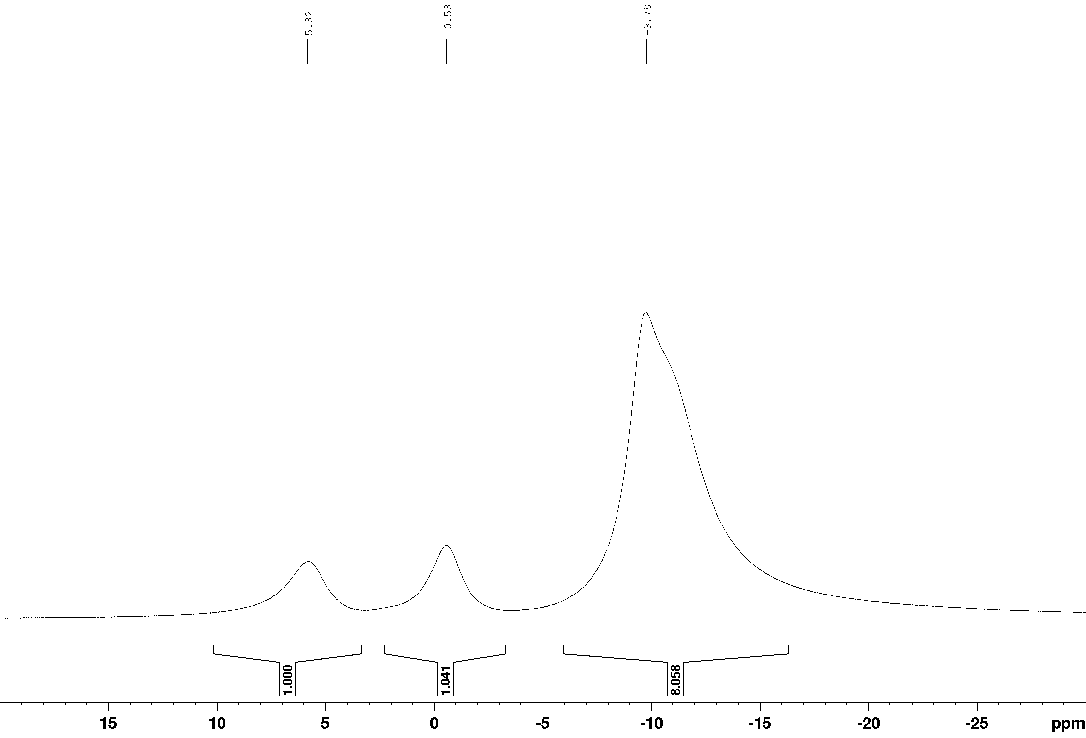

¹H NMR (400 MHz, CDCl₃)
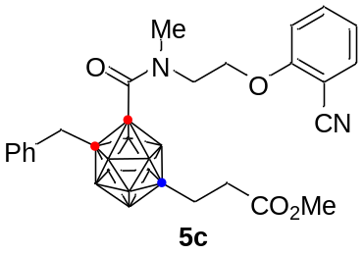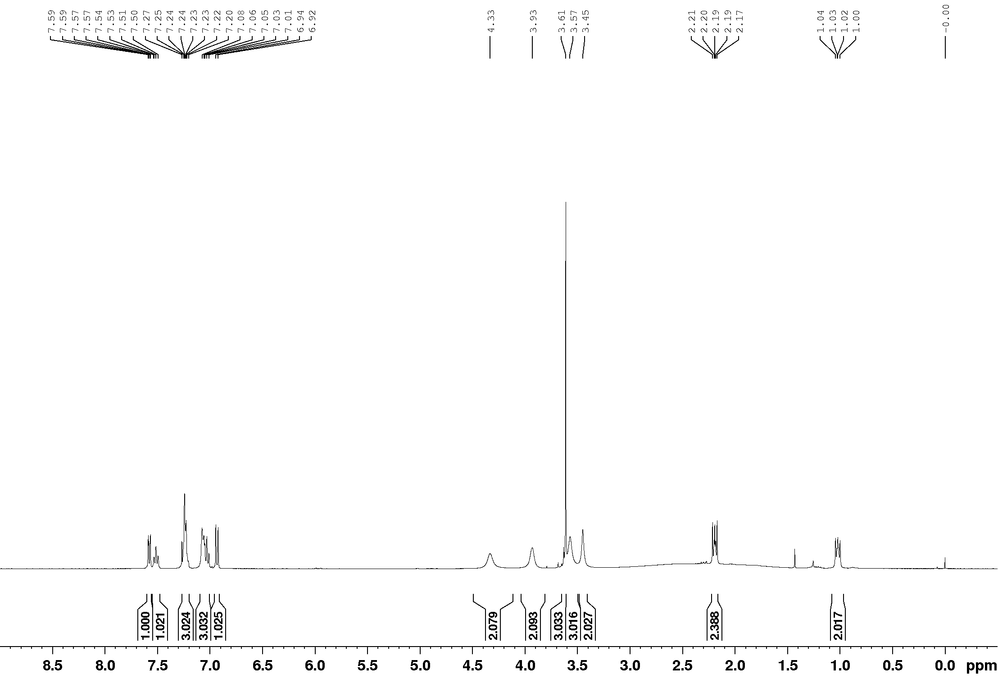

¹³C NMR (100 MHz, CDCl₃)
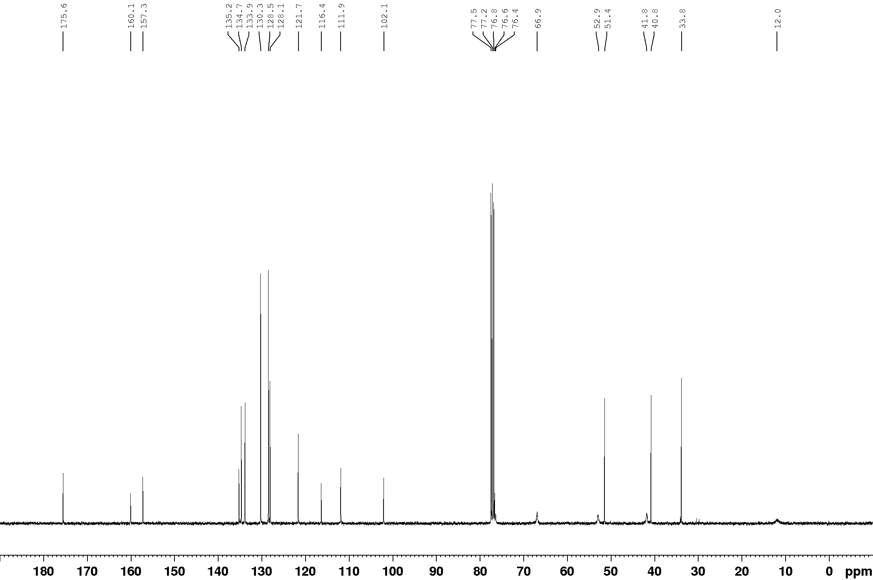

¹¹B NMR (128 MHz, CDCl₃)
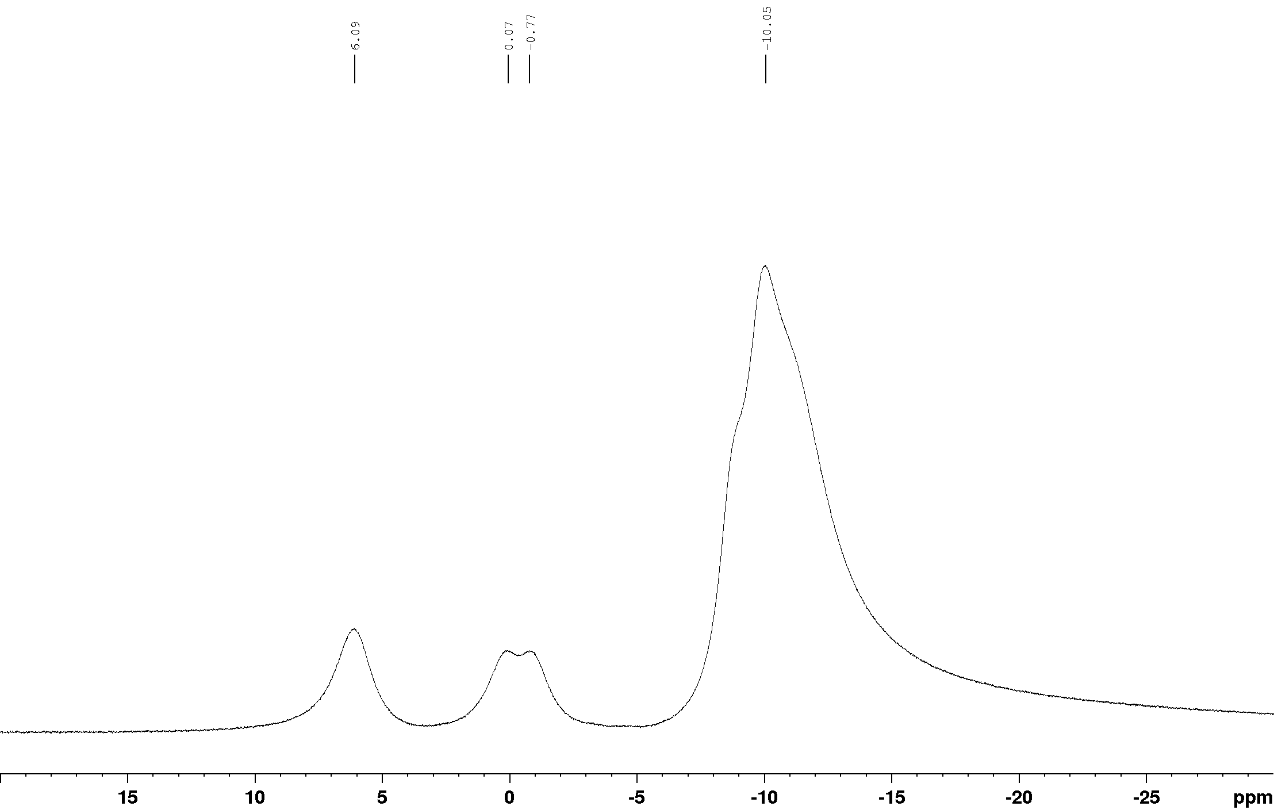

¹¹B{¹H} NMR (128 MHz, CDCl₃) 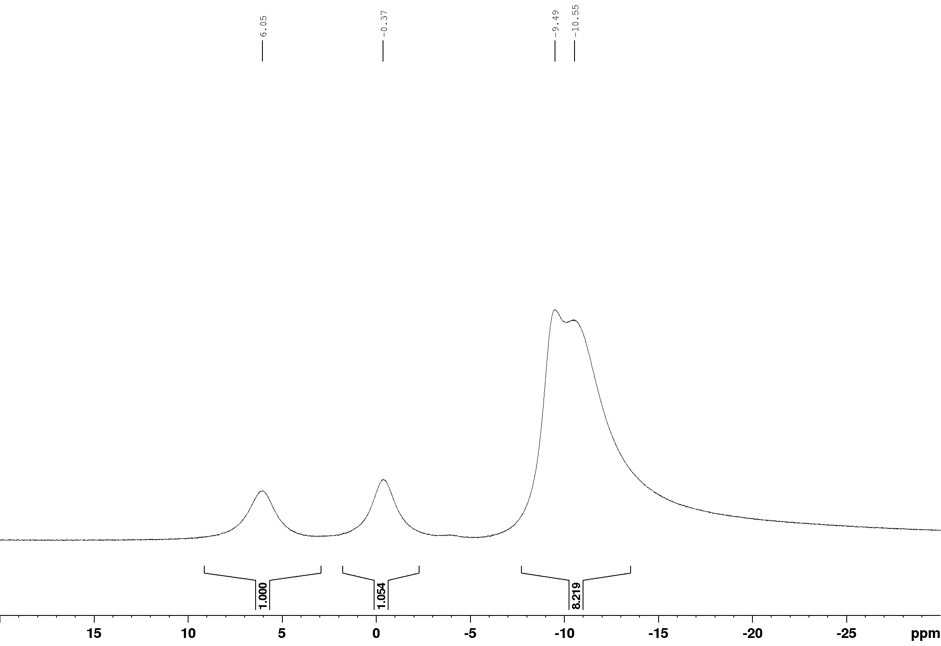

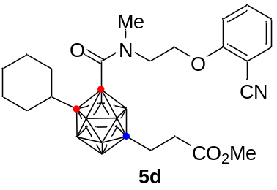¹H NMR (400 MHz, CDCl₃)

¹³C NMR (100 MHz, CDCl₃)
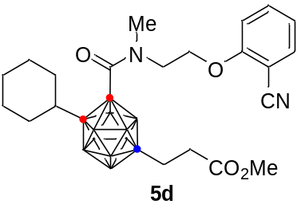

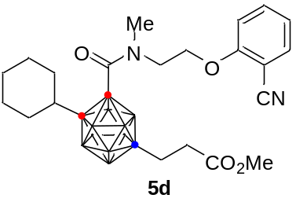¹¹B NMR (128 MHz, CDCl₃)

¹¹B{¹H} NMR (128 MHz, CDCl₃)

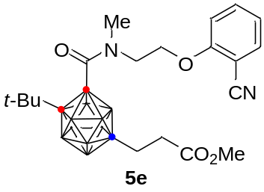¹H NMR (400 MHz, CDCl₃)

¹³C NMR (100 MHz, CDCl₃)

¹¹B NMR (128 MHz, CDCl₃)

¹¹B{¹H} NMR (128 MHz, CDCl₃)

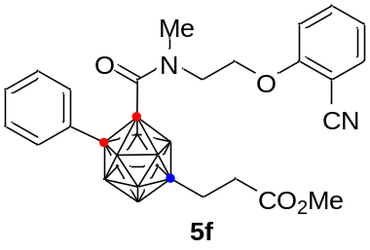¹H NMR (400 MHz, CDCl₃)

¹³C NMR (100 MHz, CDCl₃)

¹¹B NMR (128 MHz, CDCl₃)

¹¹B{¹H} NMR (128 MHz, CDCl₃)
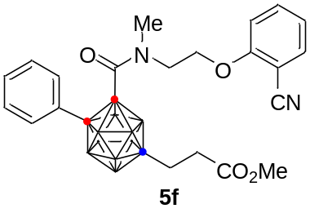

¹H NMR (400 MHz, CDCl₃)
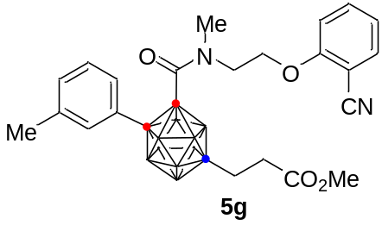

¹³C NMR (100 MHz, CDCl₃)

¹¹B NMR (128 MHz, CDCl₃)

¹¹B{¹H} NMR (128 MHz, CDCl₃)

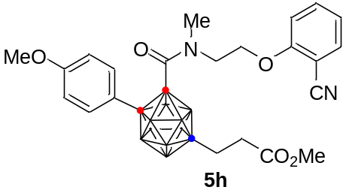¹H NMR (400 MHz, CDCl₃)

¹³C NMR (100 MHz, CDCl₃)

¹¹B NMR (128 MHz, CDCl₃)

¹¹B{¹H} NMR (128 MHz, CDCl₃)

¹H NMR (400 MHz, CDCl₃)
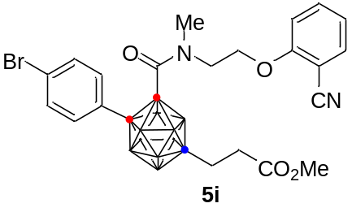

¹³C NMR (100 MHz, CDCl₃)

¹¹B NMR (128 MHz, CDCl₃)

¹¹B{¹H} NMR (128 MHz, CDCl₃)

¹H NMR (400 MHz, CDCl₃)
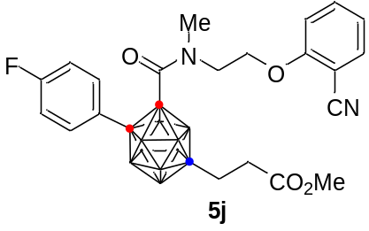

¹³C NMR (100 MHz, CDCl₃)

¹¹B NMR (128 MHz, CDCl₃)

¹¹B{¹H} NMR (128 MHz, CDCl₃)

¹⁹F{¹H} NMR (377 MHz, CDCl₃)
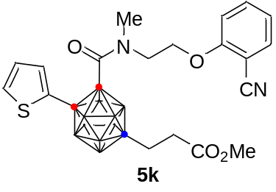¹H NMR (400 MHz, CDCl₃)

¹³C NMR (100 MHz, CDCl₃)

¹¹B NMR (128 MHz, CDCl₃)

¹¹B{¹H} NMR (128 MHz, CDCl₃)

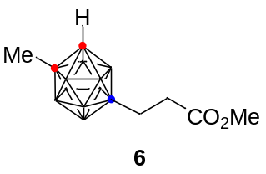¹H NMR (400 MHz, CDCl₃)

¹³C NMR (100 MHz, CDCl₃)

¹¹B NMR (128 MHz, CDCl₃)

¹¹B{¹H} NMR (128 MHz, CDCl₃)

¹H NMR (400 MHz, CDCl₃)
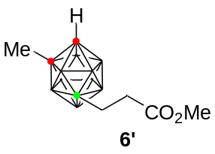

¹³C NMR (100 MHz, CDCl₃)
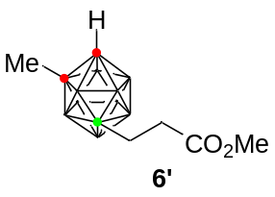

¹¹B NMR (128 MHz, CDCl₃)

¹¹B{¹H} NMR (128 MHz, CDCl₃)

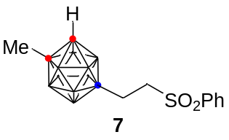¹H NMR (400 MHz, CDCl₃)

¹³C NMR (100 MHz, CDCl₃)

¹¹B NMR (128 MHz, CDCl₃)

¹¹B{¹H} NMR (128 MHz, CDCl₃)

¹H NMR (400 MHz, methanol-d₄)
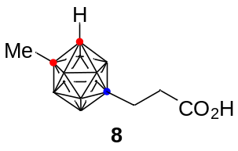

¹³C NMR (100 MHz, methanol-d₄)

¹¹B NMR (128 MHz, methanol-d₄)

¹¹B{¹H} NMR (128 MHz, methanol-d₄)
¹H NMR (400 MHz, CDCl₃)
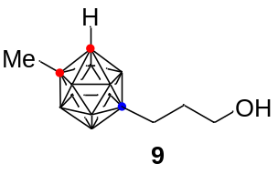

¹³C NMR (100 MHz, CDCl₃)

¹¹B NMR (128 MHz, CDCl₃)

¹¹B{¹H} NMR (128 MHz, CDCl₃)
¹H NMR (400 MHz, CDCl₃)
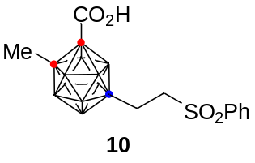

¹³C NMR (100 MHz, CDCl₃)

¹¹B NMR (128 MHz, CDCl₃)

¹¹B{¹H} NMR (128 MHz, CDCl₃)
¹H NMR (400 MHz, CDCl₃)
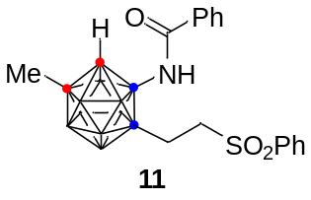

¹³C NMR (100 MHz, CDCl₃)

¹¹B NMR (128 MHz, CDCl₃)

¹¹B{¹H} NMR (128 MHz, CDCl₃)
¹H NMR (400 MHz, CDCl₃)
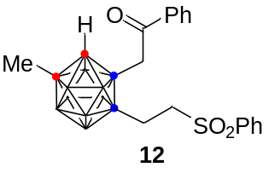

¹³C NMR (100 MHz, CDCl₃)

¹¹B NMR (128 MHz, CDCl₃)

¹¹B{¹H} NMR (128 MHz, CDCl₃)
