Supplementary Materials
Table S1. Model fit indices for situations participants would support latent classes 2–5
NC | AIC | CAIC | BIC | Entropy | G²
2 | 98,775.84 | 99,010.67 | 98,981.67 | 0.89 | 15,601.059
3 | 92,471.68 | 92,827.97 | 92,783.97 | 0.83 | 9,266.905
4 | 90,065.83 | 90,543.58 | 90,484.58 | 0.82 | 6,831.052
5 | 89,382.33 | 89,981.55 | 89,907.55 | 0.77 | 6,117.555
Note: NC = Number of classes; AIC = Akaike's information criterion; CAIC =consistent Akaike information criterion; BIC = Bayesian information criterion; G² = G square statistics; LMR LRT = Lo-Mendell-Rubin adjusted likelihood ratio test; p-value (A) = Bootstrap p-value for absolute model fit; p-value (B) = Bootstrap p-value for relative model fit
We used the latent class analysis (LCA) method to identify underlying profiles of attitudes toward abortion, which were assessed by situations the participants would support. LCA is a statistical technique that identifies unobserved (latent) groups within populations to characterize their heterogeneity (21). The LCA approach assumes that membership in a class is explainable by mutually exclusive patterns of observed variables across categorical sets of indicators (22). We first fitted a series of models with one to ten classes using poLCA (23) and retained a four-class model with the lowest Bayesian information criterion (BIC) and better entropy (0.82). We then evaluated models with two to five classes using glca (24) functions in R 4.3.1 (25). The latent classes were modeled based on 14 binary variables measuring situations the participants would support. Finally, we retained a four-class model. Missing data was imputed using the full information maximum likelihood model.
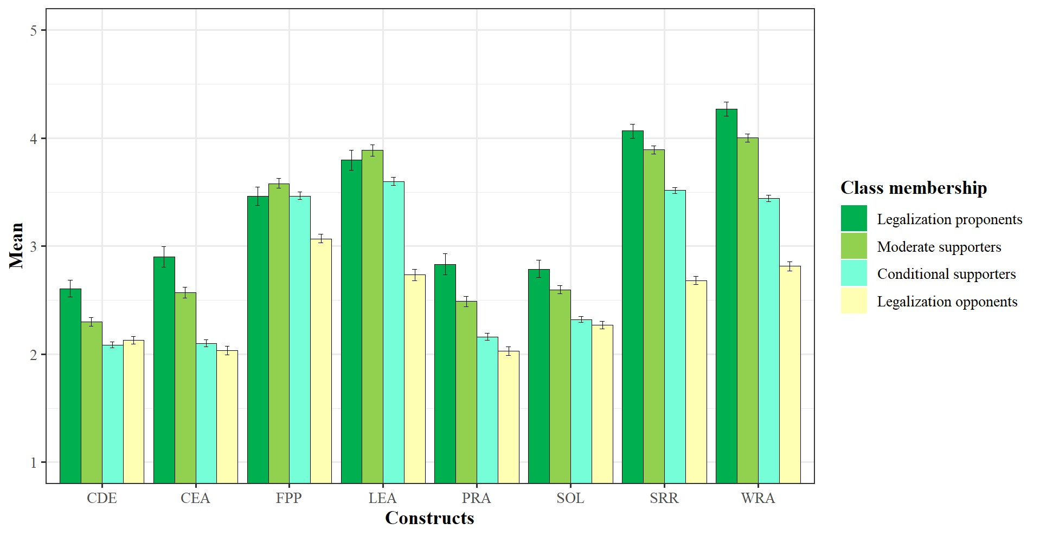
Figure S1. Mean scores of the constructs stratified by the latent class membership
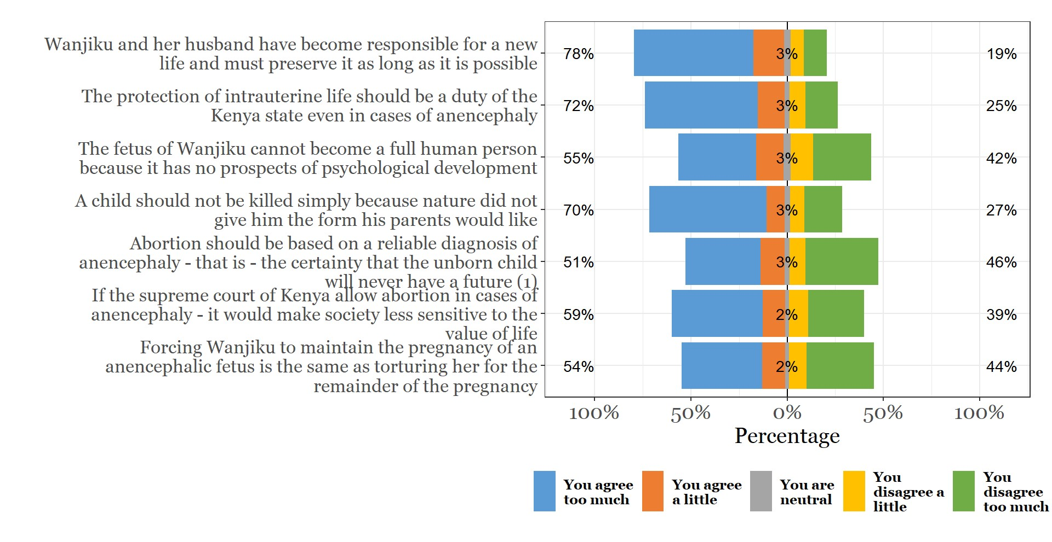
Figure S2. Profiles of attitude toward abortion in cases of fetal anomaly (statements 1-7: conservative statements
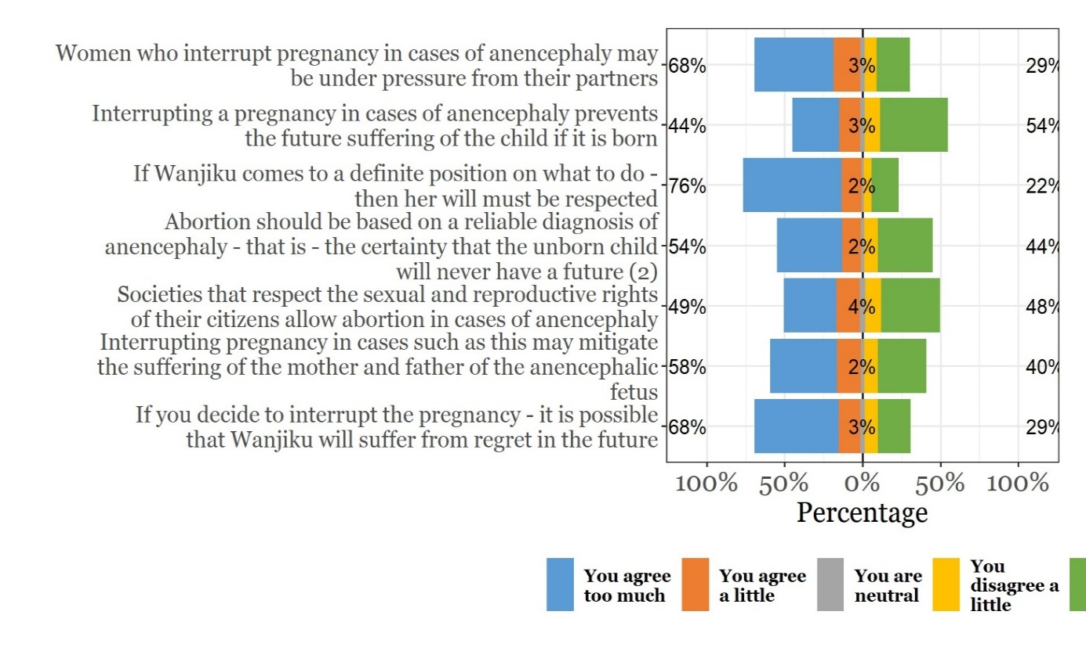
Figure S3. Profiles of attitude toward abortion in cases of fetal anomaly (statements 8-14)
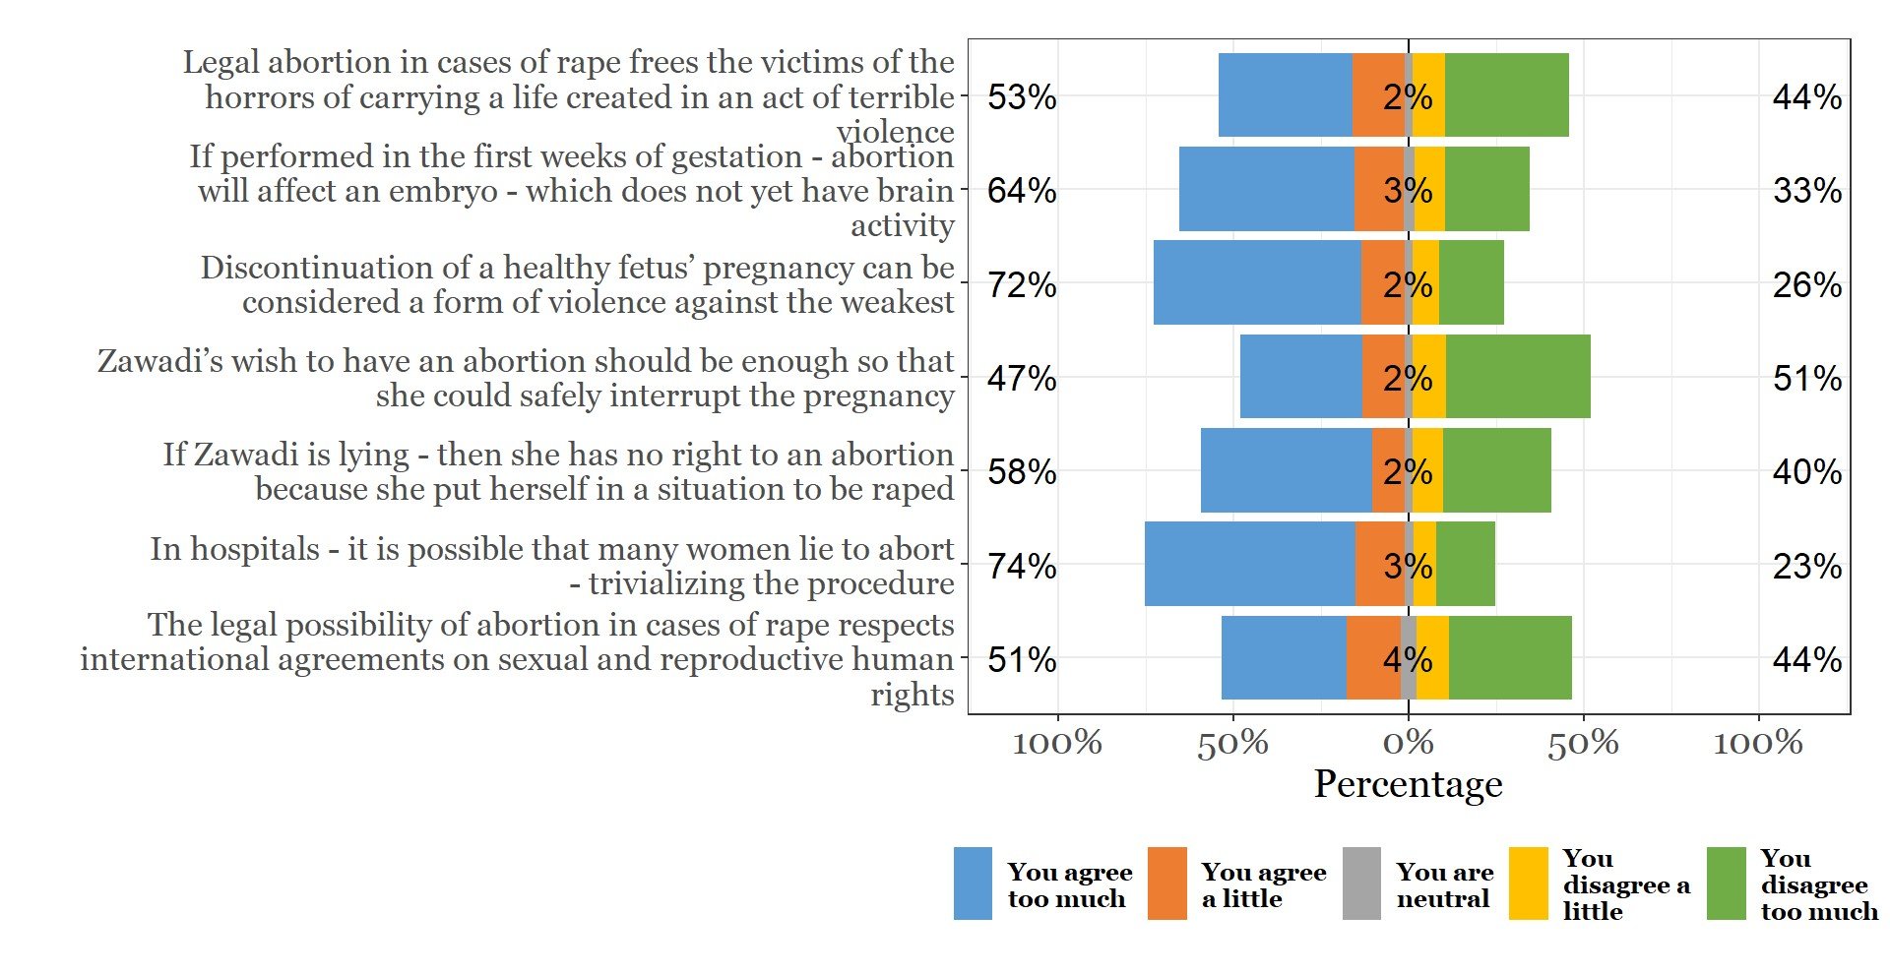
Figure S4. Profiles of attitude toward abortion in cases of rape (statements 1-7)
Figure S5. Profiles of attitude toward abortion in cases of rape (statements 8-14)
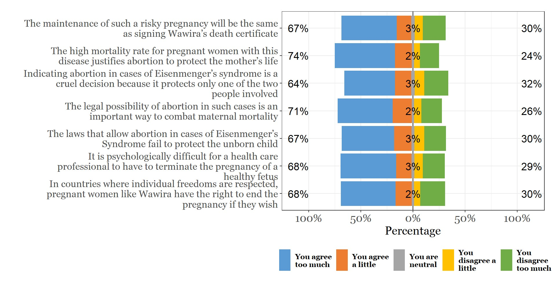
Figure S6. Profiles of attitude toward abortion when pregnancy poses a threat to life and health (statements 1-7)
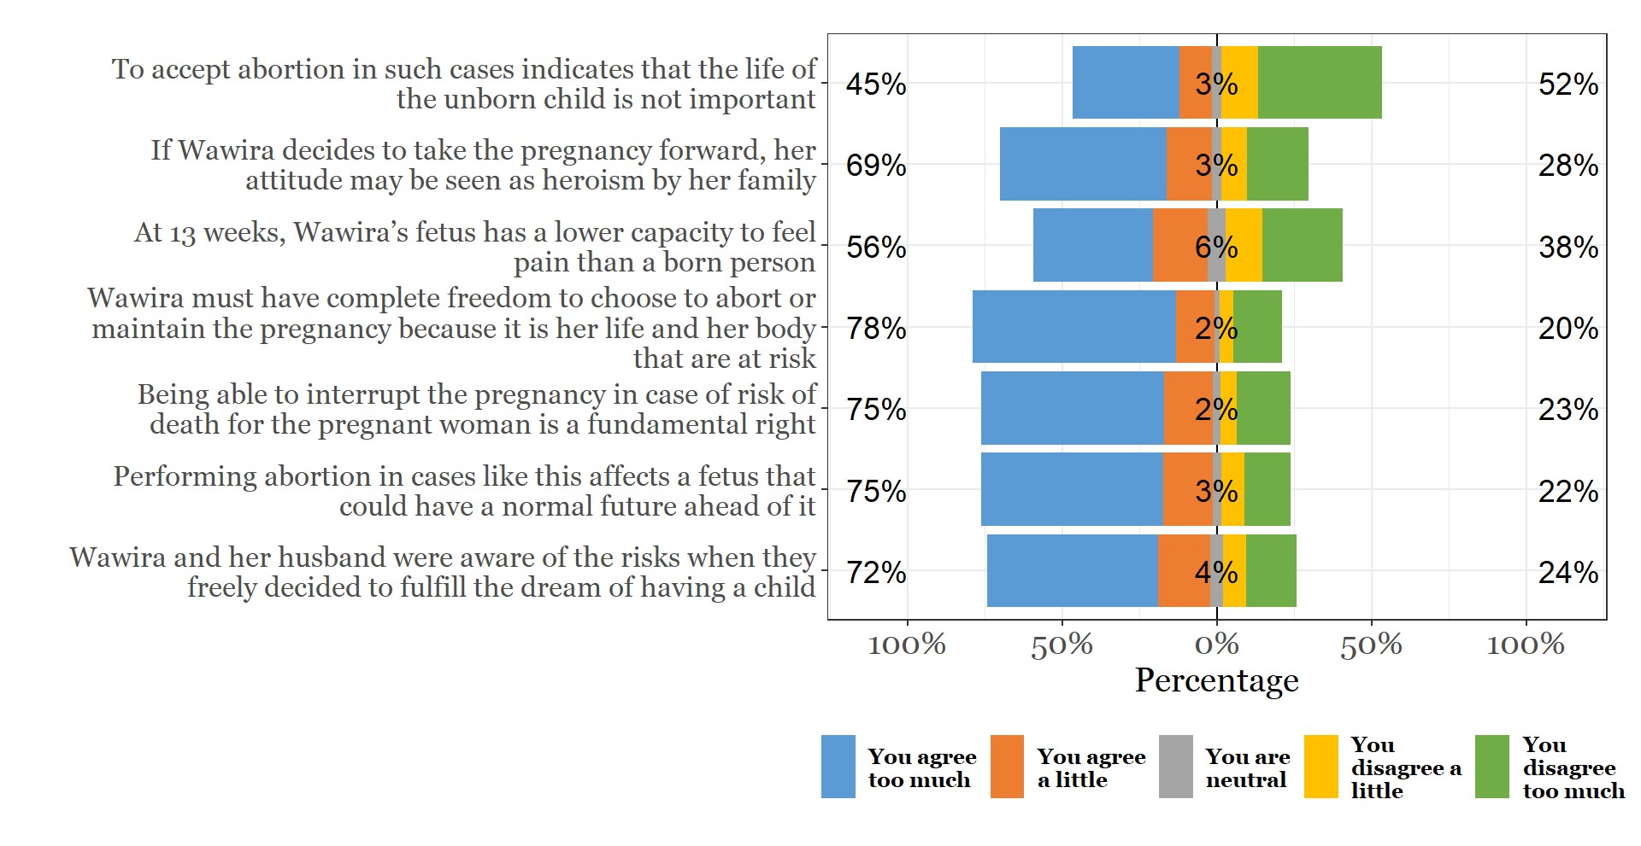
Figure S7. Profiles of attitude toward abortion when pregnancy poses a threat to life and health (statements 8-14)

Vignettes and accompanying questions and items
1. FETAL ANOMALY
Now, I am going to tell you a story. Please, listen to the story carefully. After the story, I will ask you a few questions.
Wanjiku and her husband wanted a baby from the very beginning of their marriage because they felt very lonely without a child. Then, they received the news that Wanjiku was pregnant with great joy. However, at 16 weeks, when the first ultrasound was performed, the doctor noticed that the fetus was anencephalic, that is, it had no brain. Upon hearing the diagnosis, Wanjiku’s first thought was to let him be born. However, she fears that keeping her pregnancy will cause even more suffering to her, her husband, and her fetus. Being in the second trimester of pregnancy, Wanjiku realizes that keeping or interrupting the pregnancy will be a difficult decision.
NOW KEEP THIS STORY ABOUT WANJIKU IN MIND AS YOU ANSWER THE NEXT FEW QUESTIONS
FA1 | Are you in favor of the right to abort in this situation? | Very favorable | ⃝ 1 | Select one
FA1 | Are you in favor of the right to abort in this situation? | Favorable | ⃝ 2 | Select one
FA1 | Are you in favor of the right to abort in this situation? | A little favorable | ⃝ 3 | Select one
FA1 | Are you in favor of the right to abort in this situation? | A little contrary | ⃝ 4 | Select one
FA1 | Are you in favor of the right to abort in this situation? | Contrary | ⃝ 5 | Select one
FA1 | Are you in favor of the right to abort in this situation? | Very contrary | ⃝ 6 | Select one
FA2 | Are you in favor of the possibility of this type of abortion being performed by the Kenya public health system? | Very favorable | ⃝ 1 | Select one
FA2 |  | Favorable | ⃝ 2 | Select one
FA2 |  | A little favorable | ⃝ 3 | Select one
FA2 |  | A little contrary | ⃝ 4 | Select one
FA2 |  | Contrary | ⃝ 5 | Select one
FA2 |  | Very contrary | ⃝ 6 | Select one
FA3 | Would you do anything to support a woman to secure an abortion in that  circumstance? | Certainly would NOT support | ⃝ 1 | Select one
FA3 |  | Probably would NOT support | ⃝ 2 | Select one
FA3 |  | Probably would support | ⃝ 3 | Select one
FA3 |  | Certainly would support | ⃝ 4 | Select one
FA3 |  | I don't know if I would support | ⃝ 5 | Select one
NOW, TELL ME HOW MUCH YOU AGREE WITHTHE STATEMENTS BELOW. Please, respond to the statements about Wanjiku’s situation
FA4 | Wanjiku and her husband have become responsible for a new life and must preserve it as long as it is possible | I agree too much | ⃝ 1 | Select one
FA4 |  | I agree a little | ⃝ 2 | Select one
FA4 |  | I am indifferent | ⃝ 3 | Select one
FA4 |  | I disagree a little | ⃝ 4 | Select one
FA4 |  | I disagree too much | ⃝ 5 | Select one
FA4 |  | I do not know | ⃝ 6 | Select one
FA5 | The protection of intrauterine life should be a duty of the Kenya state even in cases of anencephaly | I agree too much | ⃝ 1 | Select one
FA5 |  | I agree a little | ⃝ 2 | Select one
FA5 |  | I am indifferent | ⃝ 3 | Select one
FA5 |  | I disagree a little | ⃝ 4 | Select one
FA5 |  | I disagree too much | ⃝ 5 | Select one
FA5 |  | I do not know | ⃝ 6 | Select one
FA6 | The fetus of Wanjiku cannot become a full human person because it has no prospects of psychological development | I agree too much | ⃝ 1 | Select one
FA6 |  | I agree a little | ⃝ 2 | Select one
FA6 |  | I am indifferent | ⃝ 3 | Select one
FA6 |  | I disagree a little | ⃝ 4 | Select one
FA6 |  | I disagree too much | ⃝ 5 | Select one
FA6 |  | I do not know | ⃝ 6 | Select one
FA7 | A child should not be killed simply because nature did not give him the form his parents would like | I agree too much | ⃝ 1 | Select one
FA7 |  | I agree a little | ⃝ 2 | Select one
FA7 |  | I am indifferent | ⃝ 3 | Select one
FA7 |  | I disagree a little | ⃝ 4 | Select one
FA7 |  | I disagree too much | ⃝ 5 | Select one
FA7 |  | I do not know | ⃝ 6 | Select one
FA8 | Abortion should be based on a reliable diagnosis of anencephaly, that is, the certainty that the unborn child will never have a future | I agree too much | ⃝ 1 | Select one
FA8 |  | I agree a little | ⃝ 2 | Select one
FA8 |  | I am indifferent | ⃝ 3 | Select one
FA8 |  | I disagree a little | ⃝ 4 | Select one
FA8 |  | I disagree too much | ⃝ 5 | Select one
FA8 |  | I do not know | ⃝ 6 | Select one
FA9 | If the supreme court of Kenya allows abortion in cases of anencephaly, it would make society less sensitive to the value of life | I agree too much | ⃝ 1 | Select one
FA9 |  | I agree a little | ⃝ 2 | Select one
FA9 |  | I am indifferent | ⃝ 3 | Select one
FA9 |  | I disagree a little | ⃝ 4 | Select one
FA9 |  | I disagree too much | ⃝ 5 | Select one
FA9 |  | I do not know | ⃝ 6 | Select one
FA10 | Forcing Wanjiku to maintain the pregnancy of an anencephalic fetus is the same as torturing her for the remainder of the pregnancy | I agree too much | ⃝ 1 | Select one
FA10 |  | I agree a little | ⃝ 2 | Select one
FA10 |  | I am indifferent | ⃝ 3 | Select one
FA10 |  | I disagree a little | ⃝ 4 | Select one
FA10 |  | I disagree too much | ⃝ 5 | Select one
FA10 |  | I do not know | ⃝ 6 | Select one
FA11 | Women who interrupt pregnancy in cases of anencephaly may be under pressure from their partners | I agree too much | ⃝ 1 | Select one
FA11 |  | I agree a little | ⃝ 2 | Select one
FA11 |  | I am indifferent | ⃝ 3 | Select one
FA11 |  | I disagree a little | ⃝ 4 | Select one
FA11 |  | I disagree too much | ⃝ 5 | Select one
FA11 |  | I do not know | ⃝ 6 | Select one
FA12 | Interrupting a pregnancy in cases of anencephaly prevents the future suffering of the child if it is born. | I agree too much | ⃝ 1 | Select one
FA12 |  | I agree a little | ⃝ 2 | Select one
FA12 |  | I am indifferent | ⃝ 3 | Select one
FA12 |  | I disagree a little | ⃝ 4 | Select one
FA12 |  | I disagree too much | ⃝ 5 | Select one
FA12 |  | I do not know | ⃝ 6 | Select one
FA13 | If Wanjiku comes to a definite position on what to do, then her will must be respected | I agree too much | ⃝ 1 | Select one
FA13 |  | I agree a little | ⃝ 2 | Select one
FA13 |  | I am indifferent | ⃝ 3 | Select one
FA13 |  | I disagree a little | ⃝ 4 | Select one
FA13 |  | I disagree too much | ⃝ 5 | Select one
FA13 |  | I do not know | ⃝ 6 | Select one
FA14 | Abortion should be based on a reliable diagnosis of anencephaly, that is, the certainty that the unborn child will never have a future | I agree too much | ⃝ 1 | Select one
FA14 |  | I agree a little | ⃝ 2 | Select one
FA14 |  | I am indifferent | ⃝ 3 | Select one
FA14 |  | I disagree a little | ⃝ 4 | Select one
FA14 |  | I disagree too much | ⃝ 5 | Select one
FA14 |  | I do not know | ⃝ 6 | Select one
FA15 | Societies that respect the sexual and reproductive rights of their citizens allow abortion in cases of anencephaly | I agree too much | ⃝ 1 | Select one
FA15 |  | I agree a little | ⃝ 2 | Select one
FA15 |  | I am indifferent | ⃝ 3 | Select one
FA15 |  | I disagree a little | ⃝ 4 | Select one
FA15 |  | I disagree too much | ⃝ 5 | Select one
FA15 |  | I do not know | ⃝ 6 | Select one
FA16 | Interrupting pregnancy in cases such as this may mitigate the suffering of the mother and father of the anencephalic fetus | I agree too much | ⃝ 1 | Select one
FA16 |  | I agree a little | ⃝ 2 | Select one
FA16 |  | I am indifferent | ⃝ 3 | Select one
FA16 |  | I disagree a little | ⃝ 4 | Select one
FA16 |  | I disagree too much | ⃝ 5 | Select one
FA16 |  | I do not know | ⃝ 6 | Select one
FA17 | If you decide to interrupt the pregnancy, it is possible that Wanjiku will suffer from regret in the future | I agree too much | ⃝ 1 | Select one
FA17 |  | I agree a little | ⃝ 2 | Select one
FA17 |  | I am indifferent | ⃝ 3 | Select one
FA17 |  | I disagree a little | ⃝ 4 | Select one
FA17 |  | I disagree too much | ⃝ 5 | Select one
FA17 |  | I do not know | ⃝ 6 | Select one
2. RAPE PREGNANCY
Now, I am going to tell you a story. Please, listen to the story carefully. After the story, I will ask you a few questions.
Zawadi is 23 years old, evangelic, and single. She was raped in her home by a gang of armed men. Due to fear, she neither sought immediate care, told her parents, nor reported to the police. She became pregnant as a cause of the rape. When she realized she was pregnant, she felt at risk, frightened, and without options. At that moment, she sought care in a primary health unit, where she was advised of the legal possibilities of interrupting the pregnancy and what would be necessary if she decided to perform it. However, Zawadi remained confused. More than once, she was told that she is responsible for the pregnancy because some did not believe that she was raped and other felt she put herself at risk of being raped. In addition, the induction of abortion contradicts her religious beliefs. Deeply distressed and without any support from friends or family, Zawadi does not know what to do.
NOW KEEP THIS STORY ABOUT ZAWADI IN MIND AS YOU ANSWER THE NEXT FEW QUESTIONS
RP1 | Are you in favor of the right to abort in this situation? | Very favorable | ⃝ 1 | Select one
RP1 | Are you in favor of the right to abort in this situation? | Favorable | ⃝ 2 | Select one
RP1 | Are you in favor of the right to abort in this situation? | A little favorable | ⃝ 3 | Select one
RP1 | Are you in favor of the right to abort in this situation? | A little contrary | ⃝ 4 | Select one
RP1 | Are you in favor of the right to abort in this situation? | Contrary | ⃝ 5 | Select one
RP1 | Are you in favor of the right to abort in this situation? | Very contrary | ⃝ 6 | Select one
RP2 | Are you in favor of the possibility of this type of abortion being performed by the Kenya public health system? | Very favorable | ⃝ 1 | Select one
RP2 |  | Favorable | ⃝ 2 | Select one
RP2 |  | A little favorable | ⃝ 3 | Select one
RP2 |  | A little contrary | ⃝ 4 | Select one
RP2 |  | Contrary | ⃝ 5 | Select one
RP2 |  | Very contrary | ⃝ 6 | Select one
RP3 | Would you do anything to support a woman to secure an abortion in that circumstance? | Certainly would NOT support | ⃝ 1 | Select one
RP3 |  | Probably would NOT support | ⃝ 2 | Select one
RP3 |  | Probably would support | ⃝ 3 | Select one
RP3 |  | Certainly would support | ⃝ 4 | Select one
RP3 |  | I don't know if I would support | ⃝ 5 | Select one
NOW, TELL ME HOW MUCH YOU AGREE WITH
THE STATEMENTS BELOW. Please, respond to the statements about Zawadi’s situation
RP4 | The right to abortion in rape cases is an important way to combat maternal mortality | I agree too much | ⃝ 1 | Select one
RP4 |  | I agree a little | ⃝ 2 | Select one
RP4 |  | I am indifferent | ⃝ 3 | Select one
RP4 |  | I disagree a little | ⃝ 4 | Select one
RP4 |  | I disagree too much | ⃝ 5 | Select one
RP4 |  | I do not know | ⃝ 6 | Select one
RP5 | Zawadi is now suffering because of rape, but may suffer even more if she aborts and feels guilty | I agree too much | ⃝ 1 | Select one
RP5 |  | I agree a little | ⃝ 2 | Select one
RP5 |  | I am indifferent | ⃝ 3 | Select one
RP5 |  | I disagree a little | ⃝ 4 | Select one
RP5 |  | I disagree too much | ⃝ 5 | Select one
RP5 |  | I do not know | ⃝ 6 | Select one
RP6 | The right to abortion in cases of sexual violence contravenes the constitutional principle of the defense of life | I agree too much | ⃝ 1 | Select one
RP6 |  | I agree a little | ⃝ 2 | Select one
RP6 |  | I am indifferent | ⃝ 3 | Select one
RP6 |  | I disagree a little | ⃝ 4 | Select one
RP6 |  | I disagree too much | ⃝ 5 | Select one
RP6 |  | I do not know | ⃝ 6 | Select one
RP7 | The unborn child should not be killed because Zawadi was unable to defend herself from a gang of armed men’s sexual aggression. | I agree too much | ⃝ 1 | Select one
RP7 |  | I agree a little | ⃝ 2 | Select one
RP7 |  | I am indifferent | ⃝ 3 | Select one
RP7 |  | I disagree a little | ⃝ 4 | Select one
RP7 |  | I disagree too much | ⃝ 5 | Select one
RP7 |  | I do not know | ⃝ 6 | Select one
RP8 | In a secular state, the possibility of terminating pregnancy in cases of sexual violence is guaranteed | I agree too much | ⃝ 1 | Select one
RP8 |  | I agree a little | ⃝ 2 | Select one
RP8 |  | I am indifferent | ⃝ 3 | Select one
RP8 |  | I disagree a little | ⃝ 4 | Select one
RP8 |  | I disagree too much | ⃝ 5 | Select one
RP8 |  | I do not know | ⃝ 6 | Select one
RP9 | The right to termination of pregnancy in cases of violence mitigates the suffering of women | I agree too much | ⃝ 1 | Select one
RP9 |  | I agree a little | ⃝ 2 | Select one
RP9 |  | I am indifferent | ⃝ 3 | Select one
RP9 |  | I disagree a little | ⃝ 4 | Select one
RP9 |  | I disagree too much | ⃝ 5 | Select one
RP9 |  | I do not know | ⃝ 6 | Select one
RP10 | Zawadi must keep in mind that life is sacred regardless of how it was created | I agree too much | ⃝ 1 | Select one
RP10 |  | I agree a little | ⃝ 2 | Select one
RP10 |  | I am indifferent | ⃝ 3 | Select one
RP10 |  | I disagree a little | ⃝ 4 | Select one
RP10 |  | I disagree too much | ⃝ 5 | Select one
RP10 |  | I do not know | ⃝ 6 | Select one
RP11 | Legal abortion in cases of rape frees the victims of the horrors of carrying a life created in an act of terrible violence | I agree too much | ⃝ 1 | Select one
RP11 |  | I agree a little | ⃝ 2 | Select one
RP11 |  | I am indifferent | ⃝ 3 | Select one
RP11 |  | I disagree a little | ⃝ 4 | Select one
RP11 |  | I disagree too much | ⃝ 5 | Select one
RP11 |  | I do not know | ⃝ 6 | Select one
RP12 | If performed in the first weeks of gestation, abortion will affect an embryo, which does not yet have brain activity | I agree too much | ⃝ 1 | Select one
RP12 |  | I agree a little | ⃝ 2 | Select one
RP12 |  | I am indifferent | ⃝ 3 | Select one
RP12 |  | I disagree a little | ⃝ 4 | Select one
RP12 |  | I disagree too much | ⃝ 5 | Select one
RP12 |  | I do not know | ⃝ 6 | Select one
RP13 | Discontinuation of a healthy fetus’ pregnancy can be considered a form of violence against the weakest | I agree too much | ⃝ 1 | Select one
RP13 |  | I agree a little | ⃝ 2 | Select one
RP13 |  | I am indifferent | ⃝ 3 | Select one
RP13 |  | I disagree a little | ⃝ 4 | Select one
RP13 |  | I disagree too much | ⃝ 5 | Select one
RP13 |  | I do not know | ⃝ 6 | Select one
RP14 | Zawadi’s wish to have an abortion should be enough so that she could safely interrupt the pregnancy | I agree too much | ⃝ 1 | Select one
RP14 |  | I agree a little | ⃝ 2 | Select one
RP14 |  | I am indifferent | ⃝ 3 | Select one
RP14 |  | I disagree a little | ⃝ 4 | Select one
RP14 |  | I disagree too much | ⃝ 5 | Select one
RP14 |  | I do not know | ⃝ 6 | Select one
RP15 | If Zawadi is lying - then she has no right to an abortion because she put herself in a situation to be raped | I agree too much | ⃝ 1 | Select one
RP15 |  | I agree a little | ⃝ 2 | Select one
RP15 |  | I am indifferent | ⃝ 3 | Select one
RP15 |  | I disagree a little | ⃝ 4 | Select one
RP15 |  | I disagree too much | ⃝ 5 | Select one
RP15 |  | I do not know | ⃝ 6 | Select one
RP16 | In hospitals, it is possible that many women lie to abort, trivializing the procedure | I agree too much | ⃝ 1 | Select one
RP16 |  | I agree a little | ⃝ 2 | Select one
RP16 |  | I am indifferent | ⃝ 3 | Select one
RP16 |  | I disagree a little | ⃝ 4 | Select one
RP16 |  | I disagree too much | ⃝ 5 | Select one
RP16 |  | I do not know | ⃝ 6 | Select one
RP17 | The legal possibility of abortion in cases of rape respects international agreements on sexual and reproductive human rights | I agree too much | ⃝ 1 | Select one
RP17 |  | I agree a little | ⃝ 2 | Select one
RP17 |  | I am indifferent | ⃝ 3 | Select one
RP17 |  | I disagree a little | ⃝ 4 | Select one
RP17 |  | I disagree too much | ⃝ 5 | Select one
RP17 |  | I do not know | ⃝ 6 | Select one
3. RISK TO WOMAN'S LIFE
Now, I am going to tell you a story. Please, listen to the story carefully. After the story, I will ask you a few questions.
Pregnant for 13 weeks, Wawira is a carrier of a rare Eisenmenger’s Syndrome. The problem has a high rate of maternal mortality. It leads the person to not be able to perform the simplest physical activities without feeling a lack of air and fatigue. The only form of healing it, is a heart transplant combined with a lung transplant. In the case of pregnancy, the medical indication is termination. Even abortion involves risk for women, but is lower than maintaining the pregnancy, especially if performed during the first trimester.
Anyway, Wawira and her husband desire very much to have a child. And, for the moment, the fetus is in perfect formation.
NOW KEEP THIS STORY ABOUT WAWIRA IN MIND AS YOU ANSWER THE NEXT FEW QUESTIONS
RL1 | Are you in favor of the right to abort in this situation? | Very favorable | ⃝ 1 | Select one
RL1 | Are you in favor of the right to abort in this situation? | Favorable | ⃝ 2 | Select one
RL1 | Are you in favor of the right to abort in this situation? | A little favorable | ⃝ 3 | Select one
RL1 | Are you in favor of the right to abort in this situation? | A little contrary | ⃝ 4 | Select one
RL1 | Are you in favor of the right to abort in this situation? | Contrary | ⃝ 5 | Select one
RL1 | Are you in favor of the right to abort in this situation? | Very contrary | ⃝ 6 | Select one
RL2 | Are you in favor of the possibility of this type of abortion being performed by the Kenya public health system? | Very favorable | ⃝ 1 | Select one
RL2 |  | Favorable | ⃝ 2 | Select one
RL2 |  | A little favorable | ⃝ 3 | Select one
RL2 |  | A little contrary | ⃝ 4 | Select one
RL2 |  | Contrary | ⃝ 5 | Select one
RL2 |  | Very contrary | ⃝ 6 | Select one
RL3 | Would you do anything to support a woman to secure an abortion in that circumstance? | Certainly would NOT support | ⃝ 1 | Select one
RL3 |  | Probably would NOT support | ⃝ 2 | Select one
RL3 |  | Probably would support | ⃝ 3 | Select one
RL3 |  | Certainly would support | ⃝ 4 | Select one
RL3 |  | I don't know if I would support | ⃝ 5 | Select one
NOW, TELL ME HOW MUCH YOU AGREE WITH
THE STATEMENTS BELOW. Please, respond to the statements about Wawira’s situation
RL4 | The maintenance of such a risky pregnancy will be the same as signing Wawira’s death certificate | I agree too much | ⃝ 1 | Select one
RL4 |  | I agree a little | ⃝ 2 | Select one
RL4 |  | I am indifferent | ⃝ 3 | Select one
RL4 |  | I disagree a little | ⃝ 4 | Select one
RL4 |  | I disagree too much | ⃝ 5 | Select one
RL4 |  | I do not know | ⃝ 6 | Select one
RL5 | The high mortality rate for pregnant women with this disease justifies abortion to protect the mother’s life | I agree too much | ⃝ 1 | Select one
RL5 |  | I agree a little | ⃝ 2 | Select one
RL5 |  | I am indifferent | ⃝ 3 | Select one
RL5 |  | I disagree a little | ⃝ 4 | Select one
RL5 |  | I disagree too much | ⃝ 5 | Select one
RL5 |  | I do not know | ⃝ 6 | Select one
RL6 | Indicating abortion in cases of Eisenmenger’s syndrome is a cruel decision because it protects only one of the two people involved | I agree too much | ⃝ 1 | Select one
RL6 |  | I agree a little | ⃝ 2 | Select one
RL6 |  | I am indifferent | ⃝ 3 | Select one
RL6 |  | I disagree a little | ⃝ 4 | Select one
RL6 |  | I disagree too much | ⃝ 5 | Select one
RL6 |  | I do not know | ⃝ 6 | Select one
RL7 | The legal possibility of abortion in such cases is an important way to combat maternal mortality | I agree too much | ⃝ 1 | Select one
RL7 |  | I agree a little | ⃝ 2 | Select one
RL7 |  | I am indifferent | ⃝ 3 | Select one
RL7 |  | I disagree a little | ⃝ 4 | Select one
RL7 |  | I disagree too much | ⃝ 5 | Select one
RL7 |  | I do not know | ⃝ 6 | Select one
RL8 | The laws that allow abortion in cases of Eisenmenger’s Syndrome fail to protect the unborn child | I agree too much | ⃝ 1 | Select one
RL8 |  | I agree a little | ⃝ 2 | Select one
RL8 |  | I am indifferent | ⃝ 3 | Select one
RL8 |  | I disagree a little | ⃝ 4 | Select one
RL8 |  | I disagree too much | ⃝ 5 | Select one
RL8 |  | I do not know | ⃝ 6 | Select one
RL9 | It is psychologically difficult for a health care professional to have to terminate the pregnancy of a healthy fetus | I agree too much | ⃝ 1 | Select one
RL9 |  | I agree a little | ⃝ 2 | Select one
RL9 |  | I am indifferent | ⃝ 3 | Select one
RL9 |  | I disagree a little | ⃝ 4 | Select one
RL9 |  | I disagree too much | ⃝ 5 | Select one
RL9 |  | I do not know | ⃝ 6 | Select one
RL10 | In countries where individual freedoms are respected, pregnant women like Wawira have the right to end the pregnancy if they wish | I agree too much | ⃝ 1 | Select one
RL10 |  | I agree a little | ⃝ 2 | Select one
RL10 |  | I am indifferent | ⃝ 3 | Select one
RL10 |  | I disagree a little | ⃝ 4 | Select one
RL10 |  | I disagree too much | ⃝ 5 | Select one
RL10 |  | I do not know | ⃝ 6 | Select one
RL11 | To accept abortion in such cases indicates that a banalization of the life of the unborn child has happened | I agree too much | ⃝ 1 | Select one
RL11 |  | I agree a little | ⃝ 2 | Select one
RL11 |  | I am indifferent | ⃝ 3 | Select one
RL11 |  | I disagree a little | ⃝ 4 | Select one
RL11 |  | I disagree too much | ⃝ 5 | Select one
RL11 |  | I do not know | ⃝ 6 | Select one
RL12 | If Wawira decides to take the pregnancy forward, her attitude may be seen as heroism by her family | I agree too much | ⃝ 1 | Select one
RL12 |  | I agree a little | ⃝ 2 | Select one
RL12 |  | I am indifferent | ⃝ 3 | Select one
RL12 |  | I disagree a little | ⃝ 4 | Select one
RL12 |  | I disagree too much | ⃝ 5 | Select one
RL12 |  | I do not know | ⃝ 6 | Select one
RL13 | At 13 weeks, Wawira’s fetus has a lower capacity to feel pain than a born person | I agree too much | ⃝ 1 | Select one
RL13 |  | I agree a little | ⃝ 2 | Select one
RL13 |  | I am indifferent | ⃝ 3 | Select one
RL13 |  | I disagree a little | ⃝ 4 | Select one
RL13 |  | I disagree too much | ⃝ 5 | Select one
RL13 |  | I do not know | ⃝ 6 | Select one
RL14 | Wawira must have complete freedom to choose to abort or maintain the pregnancy because it is her life and her body that are at risk | I agree too much | ⃝ 1 | Select one
RL14 |  | I agree a little | ⃝ 2 | Select one
RL14 |  | I am indifferent | ⃝ 3 | Select one
RL14 |  | I disagree a little | ⃝ 4 | Select one
RL14 |  | I disagree too much | ⃝ 5 | Select one
RL14 |  | I do not know | ⃝ 6 | Select one
RL15 | Being able to interrupt the pregnancy in case of risk of death for the pregnant woman is a fundamental right | I agree too much | ⃝ 1 | Select one
RL15 |  | I agree a little | ⃝ 2 | Select one
RL15 |  | I am indifferent | ⃝ 3 | Select one
RL15 |  | I disagree a little | ⃝ 4 | Select one
RL15 |  | I disagree too much | ⃝ 5 | Select one
RL15 |  | I do not know | ⃝ 6 | Select one
RL16 | Performing abortion in cases like this affects a fetus that could have a normal future ahead of it | I agree too much | ⃝ 1 | Select one
RL16 |  | I agree a little | ⃝ 2 | Select one
RL16 |  | I am indifferent | ⃝ 3 | Select one
RL16 |  | I disagree a little | ⃝ 4 | Select one
RL16 |  | I disagree too much | ⃝ 5 | Select one
RL16 |  | I do not know | ⃝ 6 | Select one
RL17 | Wawira and her husband were aware of the risks when they freely decided to fulfill the dream of having a child. | I agree too much | ⃝ 1 | Select one
RL17 |  | I agree a little | ⃝ 2 | Select one
RL17 |  | I am indifferent | ⃝ 3 | Select one
RL17 |  | I disagree a little | ⃝ 4 | Select one
RL17 |  | I disagree too much | ⃝ 5 | Select one
RL17 |  | I do not know | ⃝ 6 | Select one

