Supplementary file
Figures (page 1-6) and tables (page 7-8)
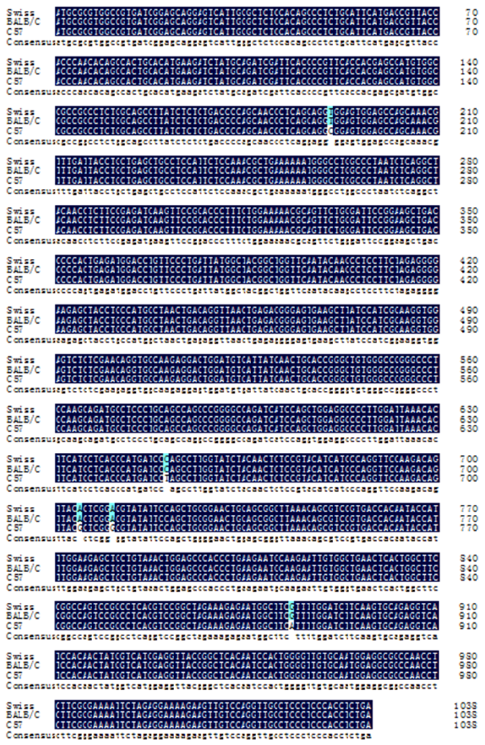
Figure S1. DNA sequence alignment of DAAO CDS from Swiss, Balb/c and C57.

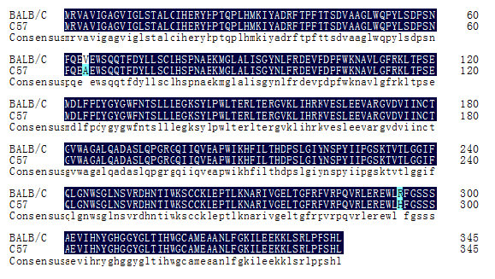
Figure S2. Protein sequence alignment of DAAO CDS in Balb/c and C57.

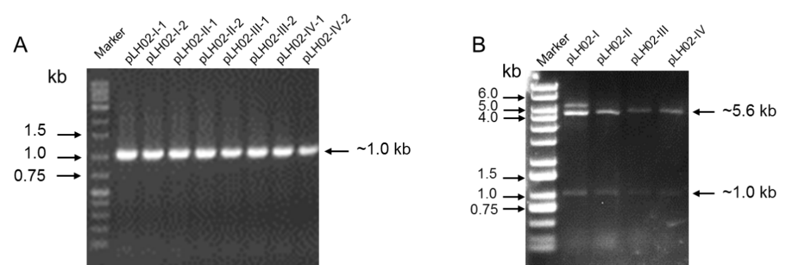
Figure S3. Gel electrophoresis of plasmid pLH02- I, II, III, IV. (A) Gel electrophoresis of the PCR-amplified fragments using plasmid pLH02-I, II, III, IV as templates. The 1.0 kb PCR products were the different DAAO CDS inserted into the plasmids.(B) Gel electrophoresis of the NdeI and EcoRI digested plasmid pLH02- I, II, III, IV.

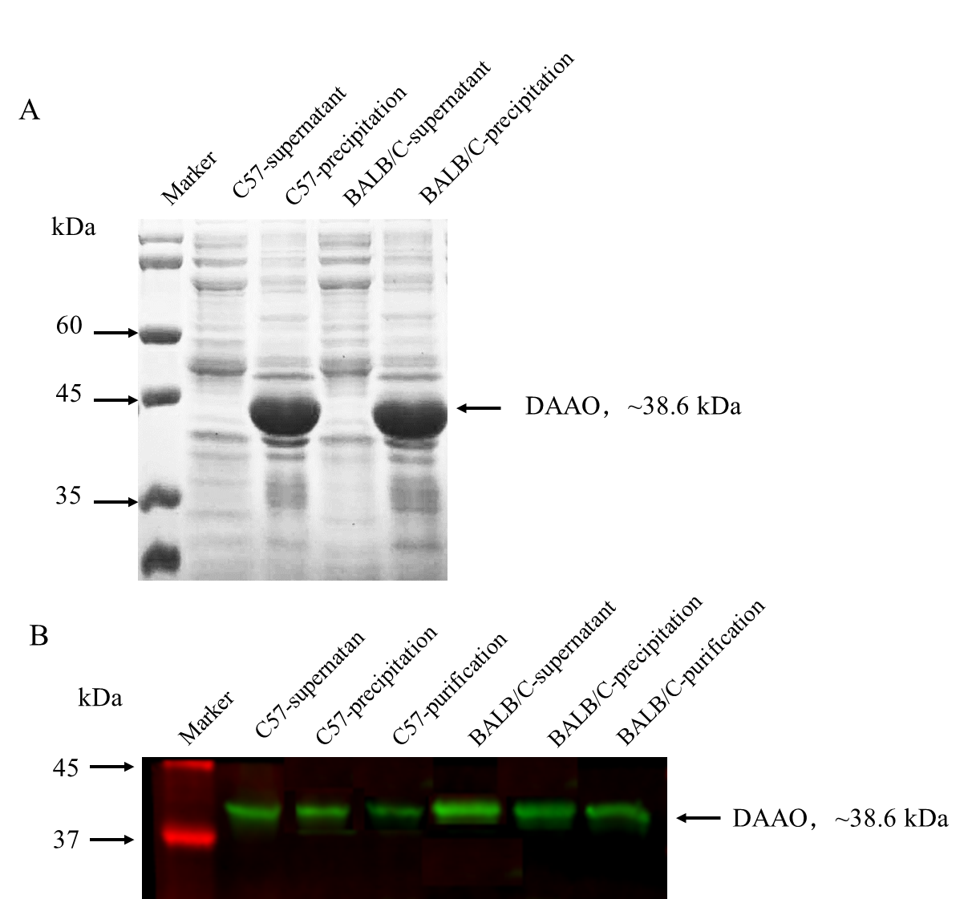
Figure S4. SDS-PAGE analysis and Western blot analysis of heterologous expressed DAAO protein from mouse C57 and Balb/c. (A) SDS-PAGE analysis of C57 and Balb/c DAAO, molecular weight of heterologous expressed DAAO was 38.6 kDa. (B) Specific binding of DAAO antibody and DAAO protein was detected by western blot.

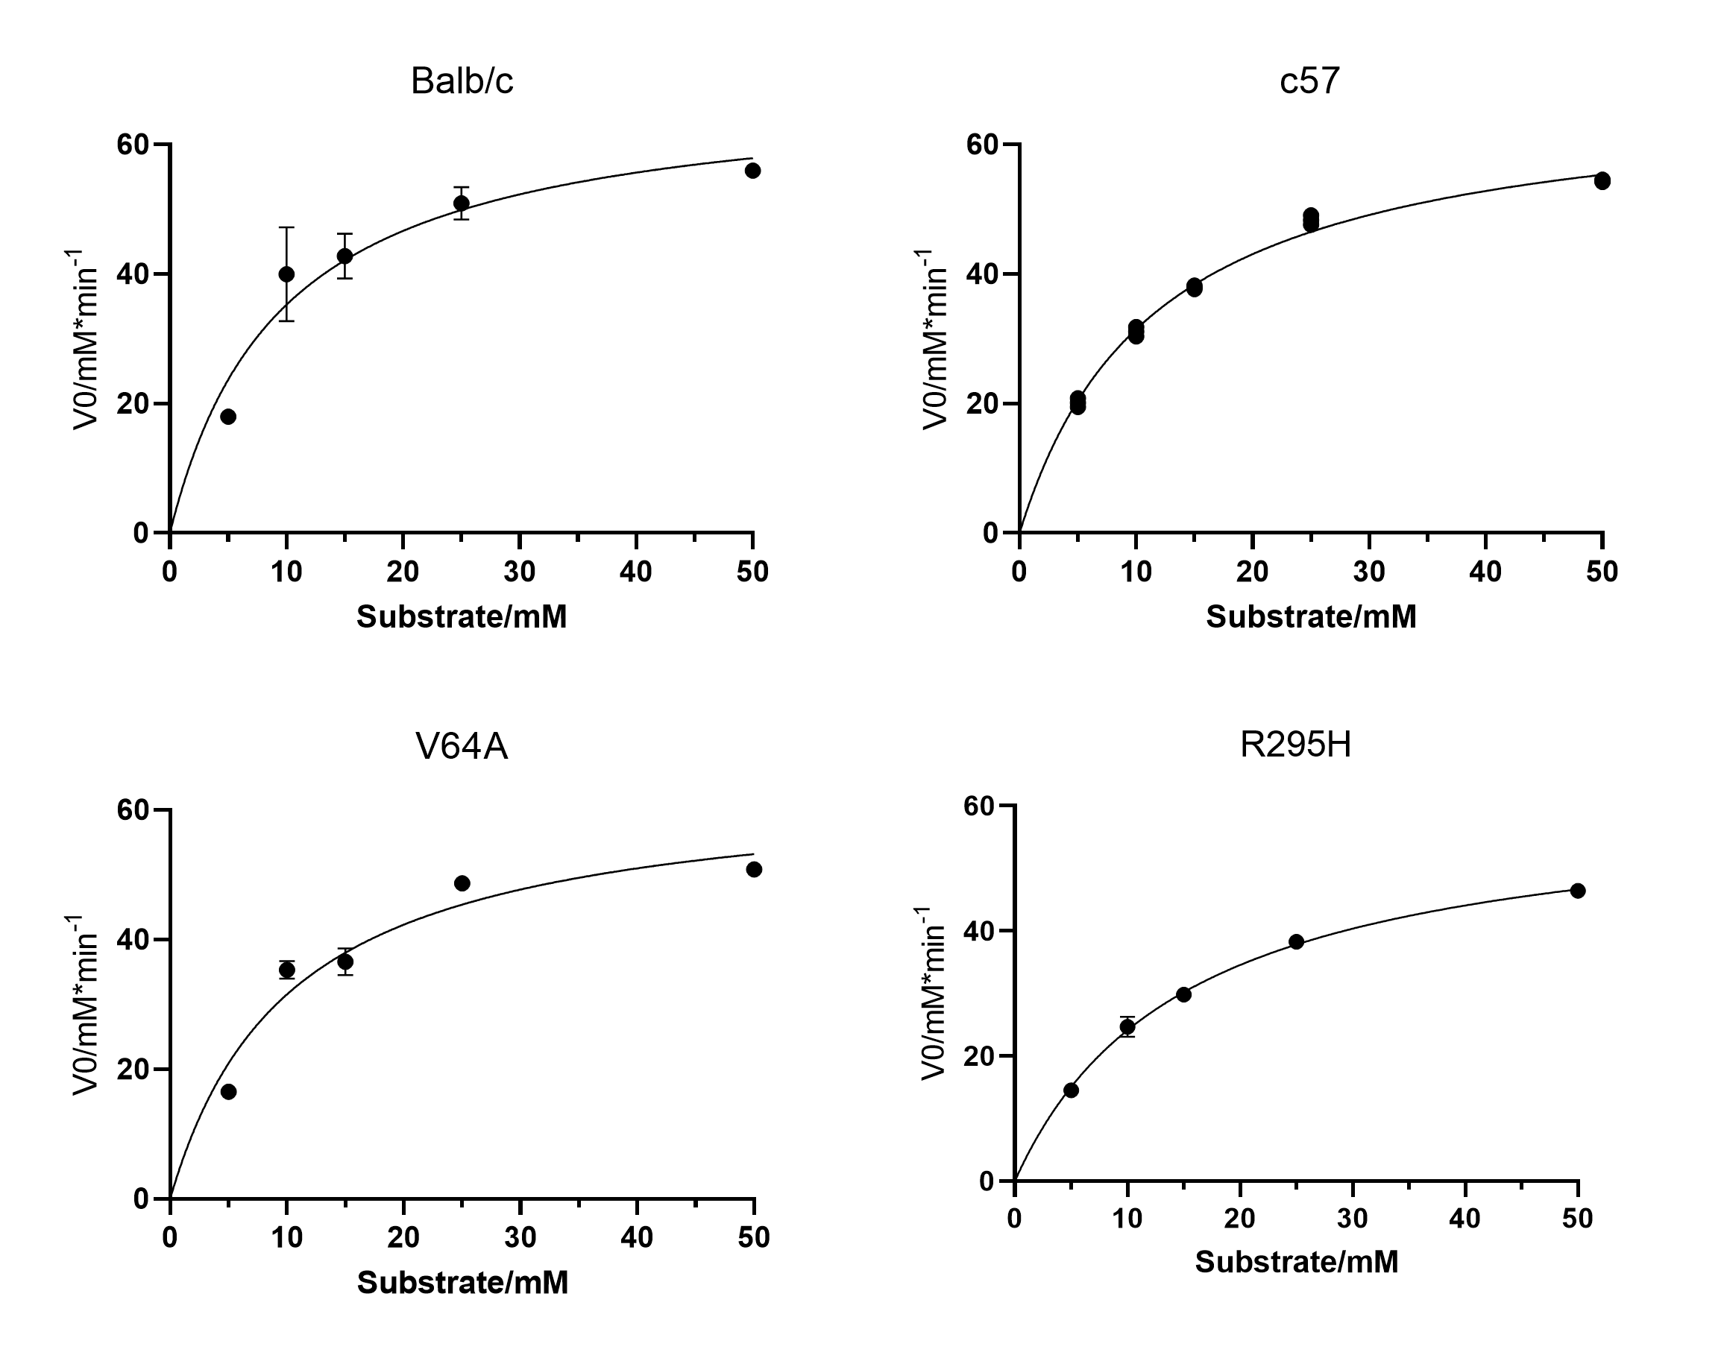
Figure S5. Km value calculation for mDAAO mutants.

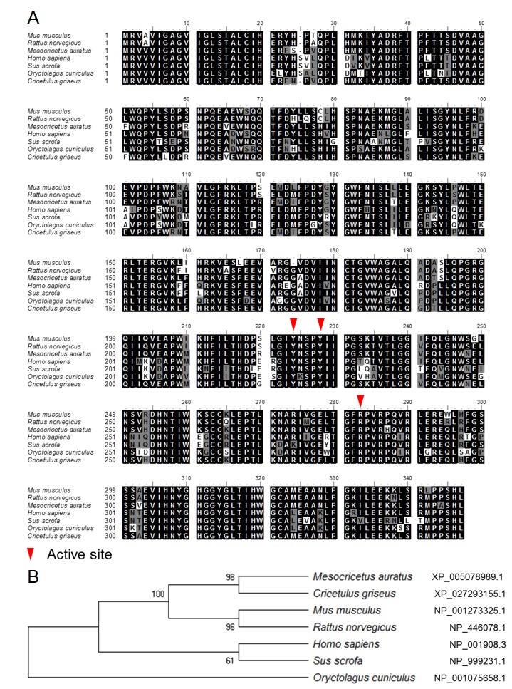
Figure S6. Homology analysis of DAAO amino acid sequences. (A) DAAO amino acid sequences in different mammals. Red triangles represented the key active amino acids; (B) Phylogenetic analysis of DAAOs.

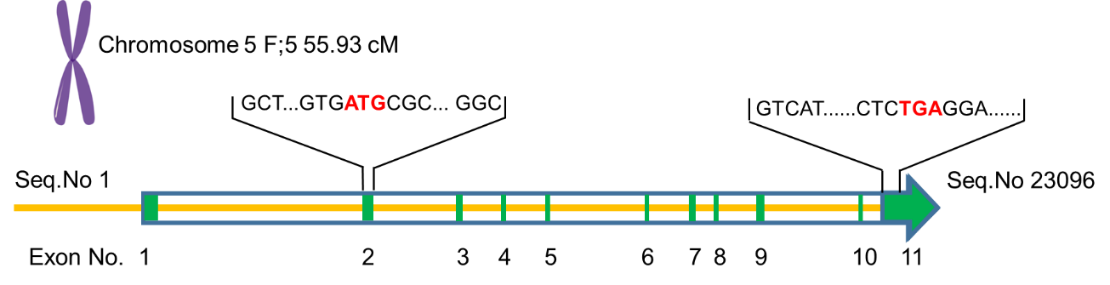
Figure S7. Diagram of daao gene in mice. The daao gene on chromosome 5 comprises 11 known exons. The start codon ATG and stop codon TGA are located in exon 2 and 11 respectively, and the entire sequence composed of each exon between ATG and TGA is the daao coding sequence, with a total of 1038 nt.

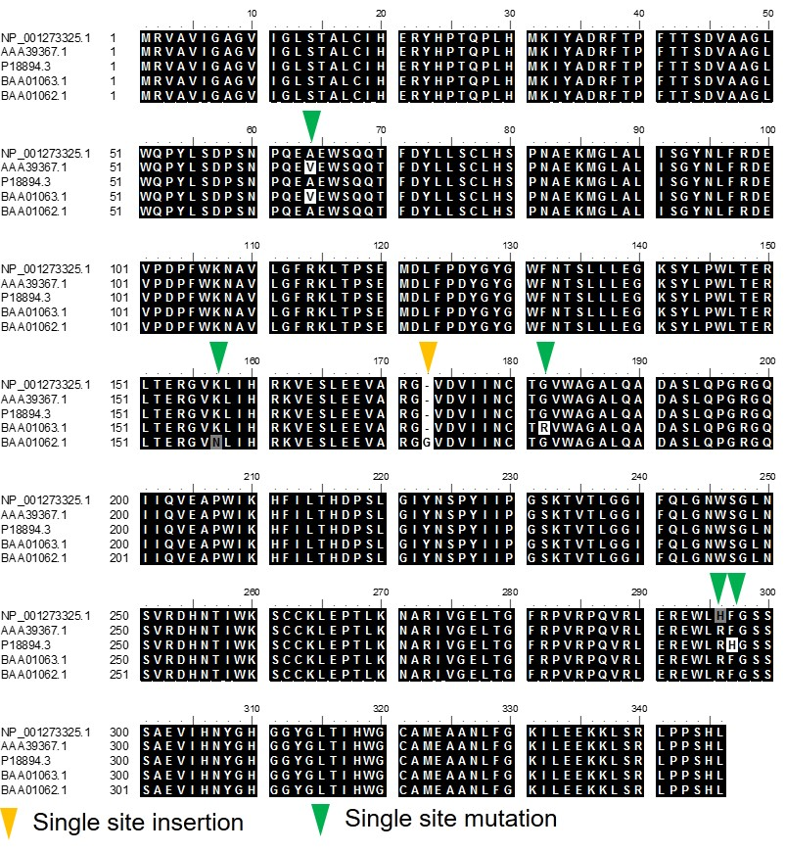
Figure S8. Amino acid sequence alignment of DAAOs from different Mus musculus strains. Amino acid insertion is highlighted by yellow triangle, and green triangle shows the single site mutaiton of DAAO amino acid sequence.

Table S1. Strains and plasmids used in this work.
Strains and plasmids | Relevant properties | Source
Escherichia coli
TOP10 | F⁻ mcrA Δ(mrr-hsdRMS-mcrBC) φ80lacZΔM15 ΔlacX74 recA1 endA1 araD139 Δ (ara, leu)7997 galE15 galK λ – rspL(Str^{R}) nupG | Yeasen
BL21(DE3) | F’ ompT hsdSB (r_{B}⁻m_{B}⁻) gal dcm(DE3) | Yeasen
Plasmids
pET28a | kan, P_{T7}, His₆-tag | Novagen
pBluescript SK(+) | ori (fl), ori (pUC18), bla, lacZ | Sangon Biotech
pLH01-I | pBluescript SK with daao CDS cloned from BALB/c mouse | This work
pLH01-II | pBluescript SK with daao CDS cloned from C57BL/6J mouse | This work
pLH02-I | pET28a with daao CDS cloned from BALB/c mouse | This work
pLH02-II | pET28a with daao CDS cloned from C57BL/6J mouse | This work
pLH02-III | pLH02-I with R295H mutation | This work
pLH02-IV | pLH02-I with V64A mutation | This work

Table S2. Primers used in this study.
Primers | Sequences (from 5' to 3') | Application
daao-F | AAACATATGCGCGTGGCCGTGATC | For daao CDS cloning
daao-R | AAAGAATTCTCAGAGGTGGGAGGGAGG | For daao CDS cloning
A64/R295-F | GAAGAAGAGAATGGCTTCGTTTTGGATCTTCAAGTGC | For DAAO^{V64A} mutation by PCR
V64/H295-F | GAAGAAGAGAATGGCTTCATTTTGGATCTTCAAGTGC | For DAAO^{R295H} mutation by PCR
295-R | GAAGCCATTCTCTTCTTCAGGGTGGGCTCCAGTTTACAG | For DAAO^{V64A} and DAAO^{R295H} mutation by PCR

