Figure S1. Funnel plots for the causal effect of kidney stones on osteoporosis
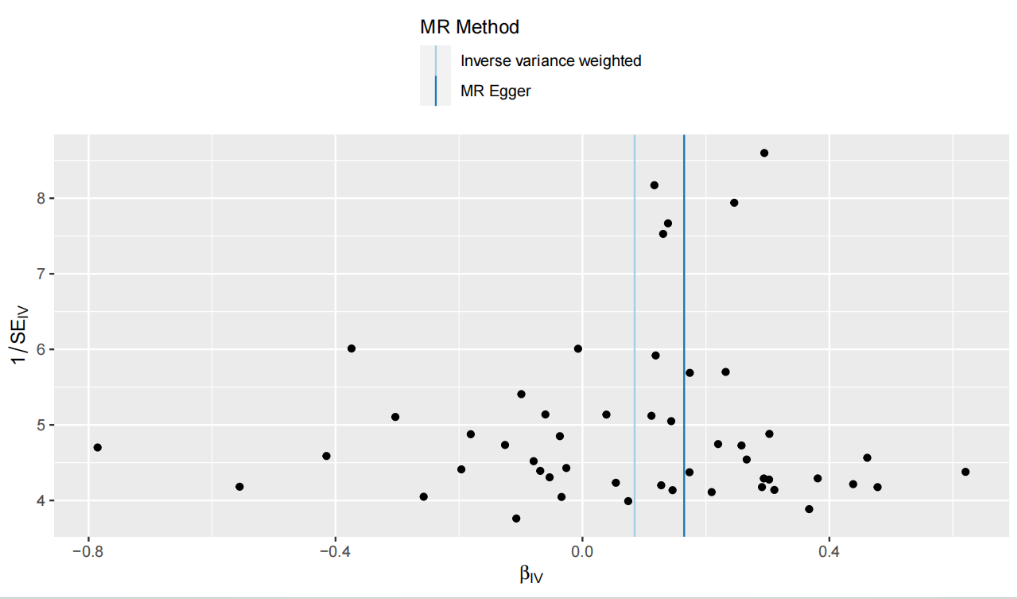
Figure S2. “MR-effect” analysis plots for MR analyses of the impact of each single SNP of kidney stones on osteoporosis
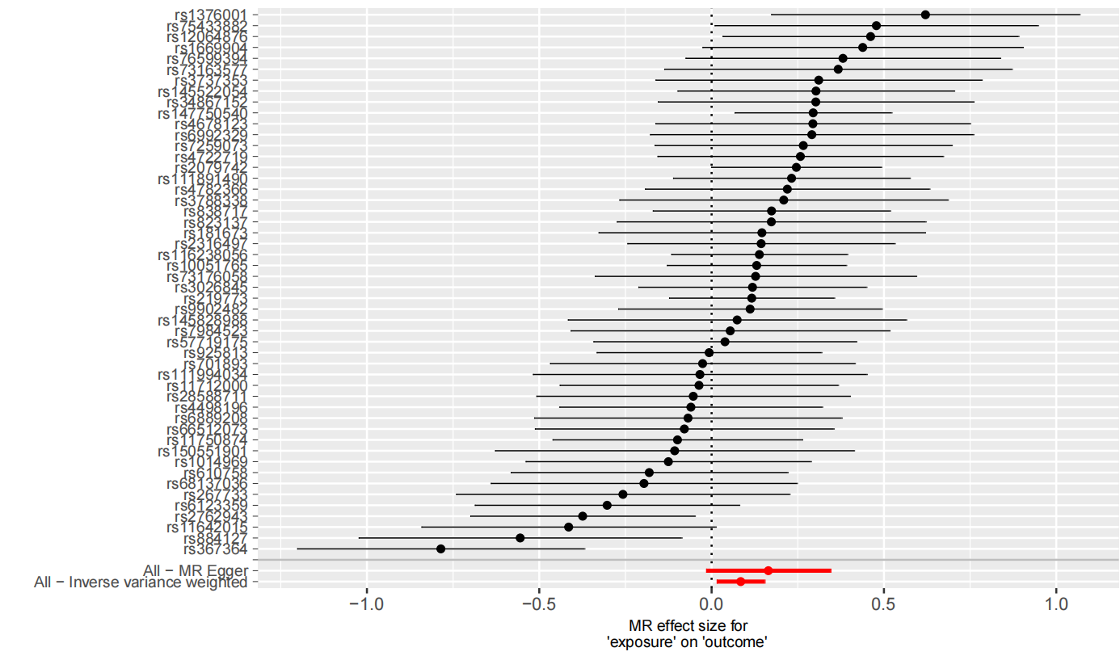
Figure S3. “Leave-one-out” analysis plots for the causal impact of kidney stones on osteoporosis

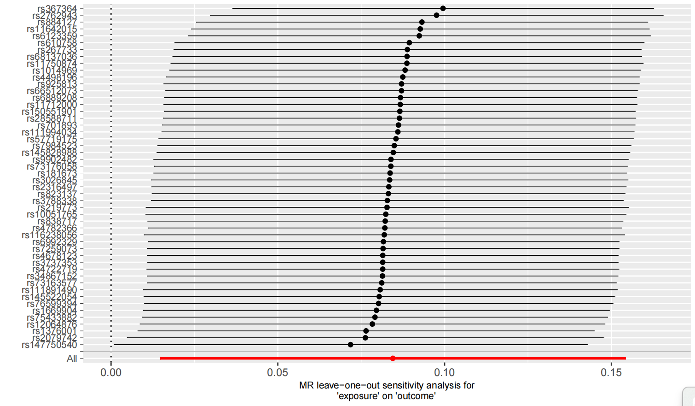
Figure S4. Scatter plots for the causal effect of osteoporosis on kidney stones 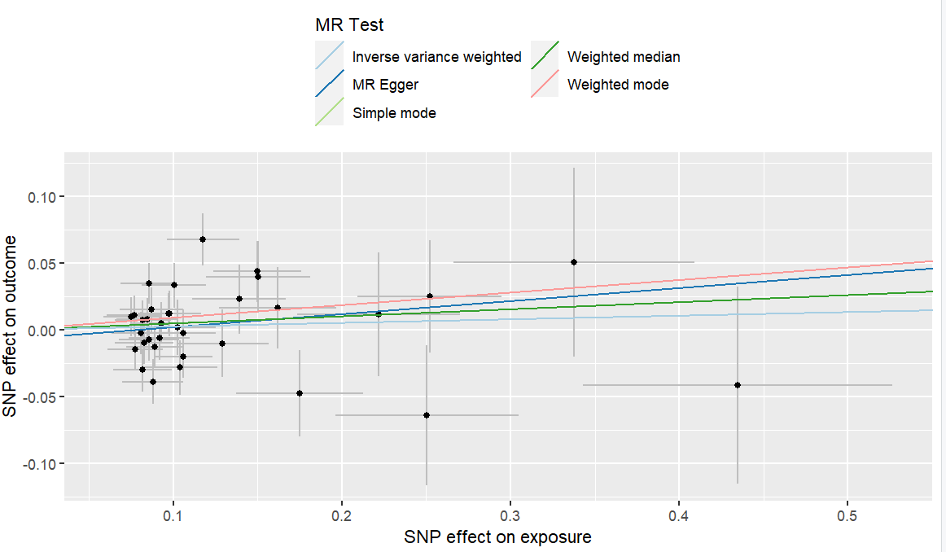
Figure S5. Funnel plots for the causal effect of osteoporosis on kidney stones
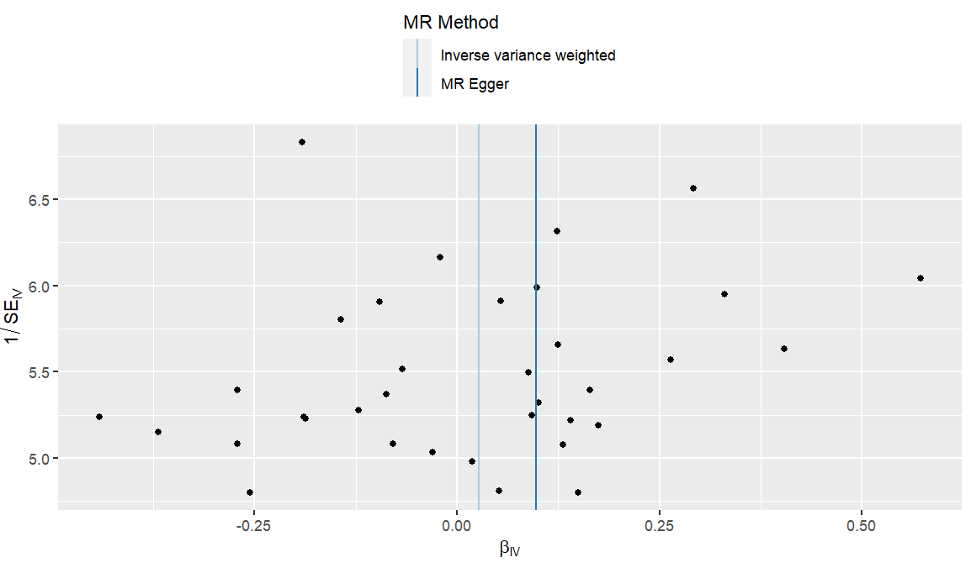
Figure S6. “MR-effect” analysis plots for MR analyses of the impact of each single SNP of osteoporosis on kidney stones

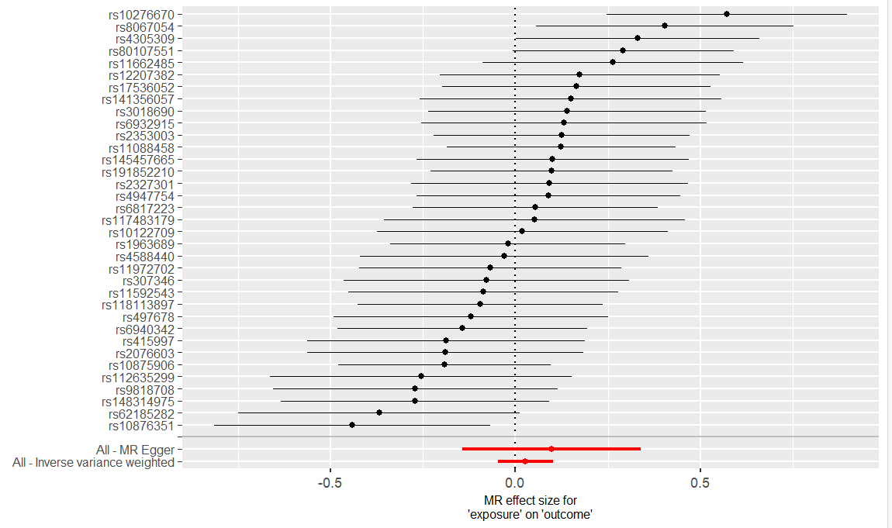

Figure S7. “Leave-one-out” analysis plots for the causal impact of osteoporosis on kidney stones

