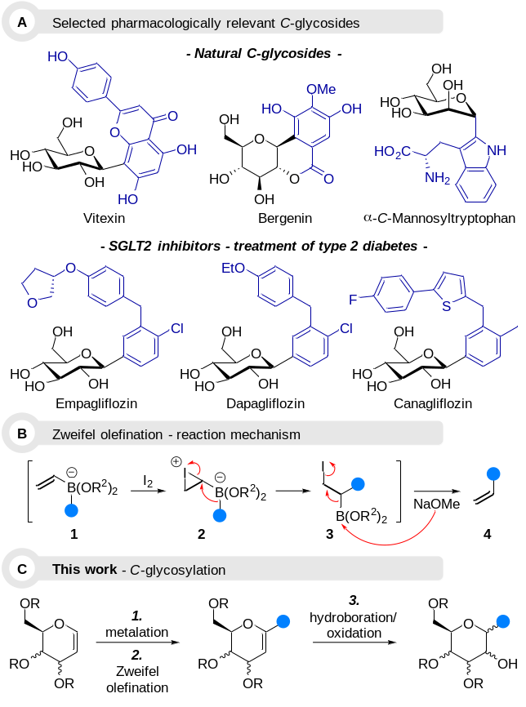
Scheme 1 A. General mechanism of the Zweifel olefination; B. Selected examples of pharmacologically relevant C-glycosides; C. Our strategic design to stereoselectively access C-glycosides via a sequence of Zweifel olefination/Brown oxidation.
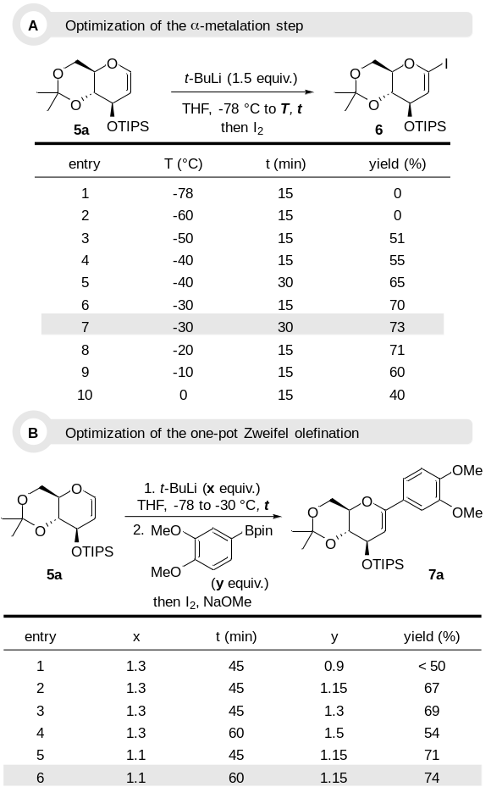
Scheme 2 A. Condition optimizations for the α-O-metalation step, controlled by iodolysis; B. Optimization of the Zweifel olefination step using a m,p-dimethoxyarylboronic ester as benchmark reagent.
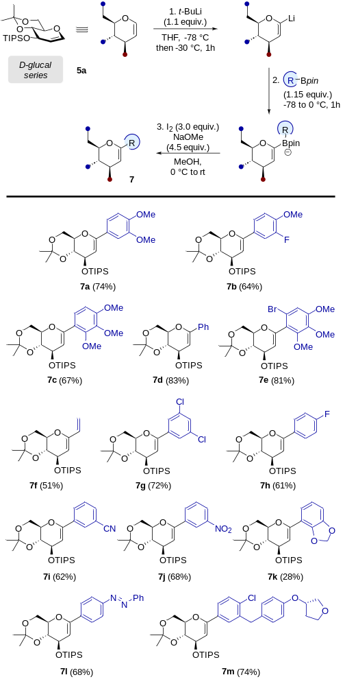
Scheme 3 Zweifel olefination’s scope on D-Glucal substrates.
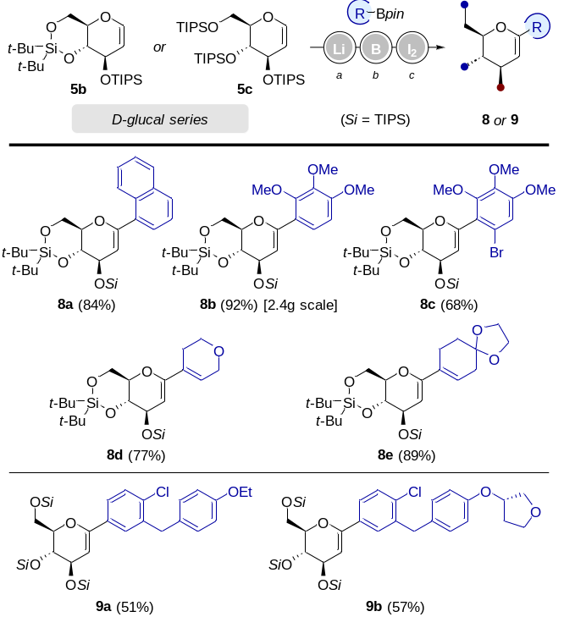
ª t-BuLi (1.3 equiv.), THF, -78 to -30 °C, 30 min. ^{b} RBpin (1.15 equiv.), -78 to 0 °C, 1h. ^{c} I₂ (3.0 equiv.), NaOMe (4.5 equiv.), MeOH, 0 °C to rt.
Scheme 4 Variation of protecting groups on D-Glucal substrates.
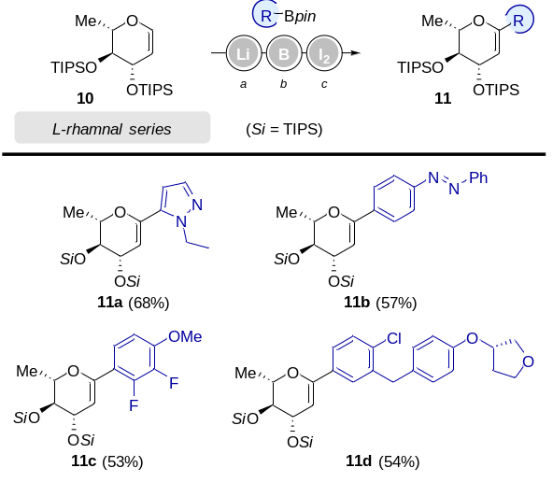
ª t-BuLi (1.3 equiv.), THF, -78 to -30 °C, 30 min. ^{b} RBpin (1.15 equiv.), -78 to 0 °C, 1h. ^{c} I₂ (3.0 equiv.), NaOMe (4.5 equiv.), MeOH, 0 °C to rt.
Scheme 5 Scope of Zweifel’s olefination on L-Rhamnal substrates.
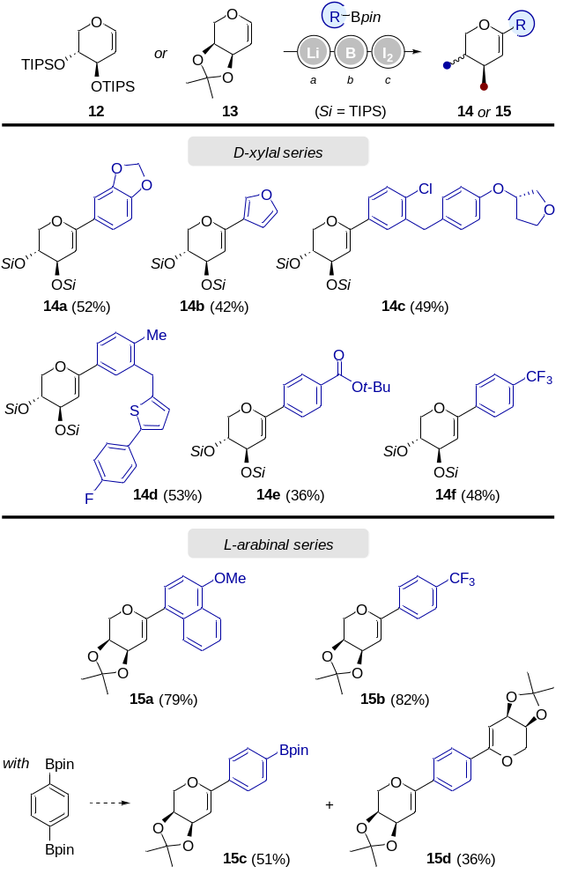
ª t-BuLi (1.1 equiv.), THF, -78 to -30 °C, 30 min. ^{b} RBpin (1.15 equiv.), -78 to 0 °C, 1h for the D-Xylal series, 30 min for the L-arabinal series. ^{c} I₂ (3.0 equiv.), NaOMe (4.5 equiv.), MeOH, 0 °C to rt.
Scheme 6 Scope of Zweifel’s olefination on D-Xylal and L-Arabinal substrates.

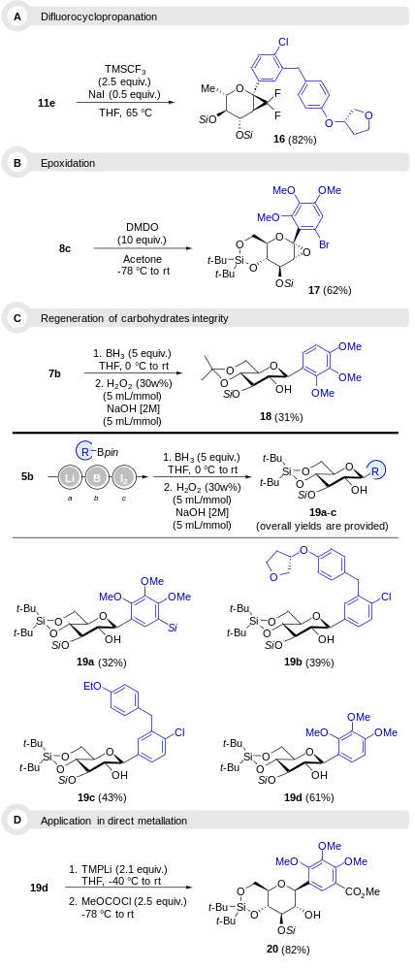
Scheme 7 Further applications of glycal-based C-glycosides.

