Appendix 1

Supplementary Table 1. The inclusion criteria and exclusion criteria.

Inclusion Criteria | Above 18 years of age, exhibit clear consciousness, possess adequate language skills, have no communication barriers, and willing to undergo clinical investigation and provide informed consent by signing the consent form.
Exclusion Criteria | The presence of concomitant heart, cerebrovascular, liver, kidney, hematopoietic system, or other primary diseases that could potentially interfere with the study.

Supplementary Table 2. Demographic characteristics, Hp status of PLGC and non-PLGC participants.
Groups | Counts | Age  (years±SD) | Gender  (male/female) | Hp  (+/-)
Non-PLGC | 206 | 48.4±13.5 | 103/103 | 46/160
PLGC | 178 | 59.0±9.7 | 94/84 | 29/149

Supplementary Table 3. Demographic characteristics, Hp status and time interval between pathological diagnoses (T1-T0).
T0 | T1 | Counts | Age  (years±SD) | Gender  (male/female) | Hp  (+/-) | T1-T0  (years±SD)
Non-PLGC | Non-Pro | 119 | 44.9±13.0 | 60/59 | 29/90 | 3.7±0.5
Non-PLGC | Pro | 87 | 53.0±12.8 | 43/44 | 17/70 | 3.2±0.7
PLGC | Non-Pro | 75 | 58.3±9.5 | 34/41 | 15/60 | 3.0±0.7
PLGC | Pro | 25 | 57.8±10.5 | 16/9 | 3/22 | 3.3±0.6

Supplementary Table 4. Performance evaluation of PLGC prediction. Acc: Accuracy, Spe: specificity, Sen: sensitivity, F1: F1 score
Method | Model | Acc | Spe | Sen | F1 | AUC
Multimodal | Late | 0.75 | 0.64 | 0.88 | 0.77 | 0.79
Multimodal | Intermediate | 0.70 | 0.50 | 0.94 | 0.75 | 0.80
Multimodal | Attention_GT | 0.72 | 0.51 | 0.97 | 0.77 | 0.83
Unimodal | Clinico | 0.61 | 0.33 | 0.94 | 0.70 | 0.72
Unimodal | Tongue | 0.72 | 0.57 | 0.89 | 0.75 | 0.75
Unimodal | Endoscopic | 0.77 | 0.82 | 0.71 | 0.74 | 0.78
Unimodal | Attention_GT | 0.72 | 0.51 | 0.97 | 0.77 | 0.83

Supplementary Table 5. Performance evaluation of disease progression risk prediction for Non-PLGC patients.
Method | Model | Acc | Spe | Sen | F1 | AUC
Multimodal | Late | 0.73 | 0.72 | 0.74 | 0.70 | 0.79
Multimodal | Intermediate | 0.74 | 0.69 | 0.80 | 0.73 | 0.77
Multimodal | Attention_GT | 0.76 | 0.71 | 0.84 | 0.76 | 0.84
Unimodal | Clinico | 0.57 | 0.37 | 0.85 | 0.64 | 0.67
Unimodal | Tongue | 0.69 | 0.66 | 0.75 | 0.68 | 0.72
Unimodal | Endoscopic | 0.78 | 0.82 | 0.71 | 0.74 | 0.81
Unimodal | Attention_GT | 0.76 | 0.71 | 0.84 | 0.76 | 0.84

Supplementary Table 6. Performance evaluation of disease progression risk prediction for PLGC patients.
Method | Model | Acc | Spe | Sen | F1 | AUC
Unimodal | Clinico | 0.55 | 0.47 | 0.80 | 0.49 | 0.61
Unimodal | Endoscopic | 0.74 | 0.75 | 0.72 | 0.60 | 0.74

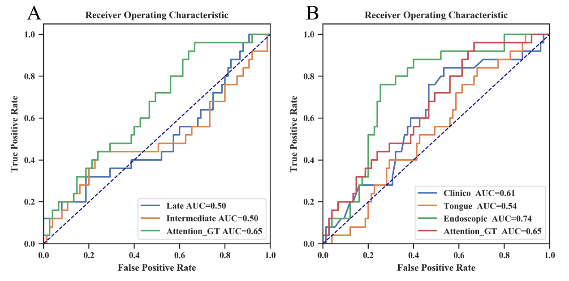
Supplementary Figure 1. Comparison of prediction of progression risks in PLGC patients. A. Comparison on multimodal fusion. B. Comparison on unimodal data.

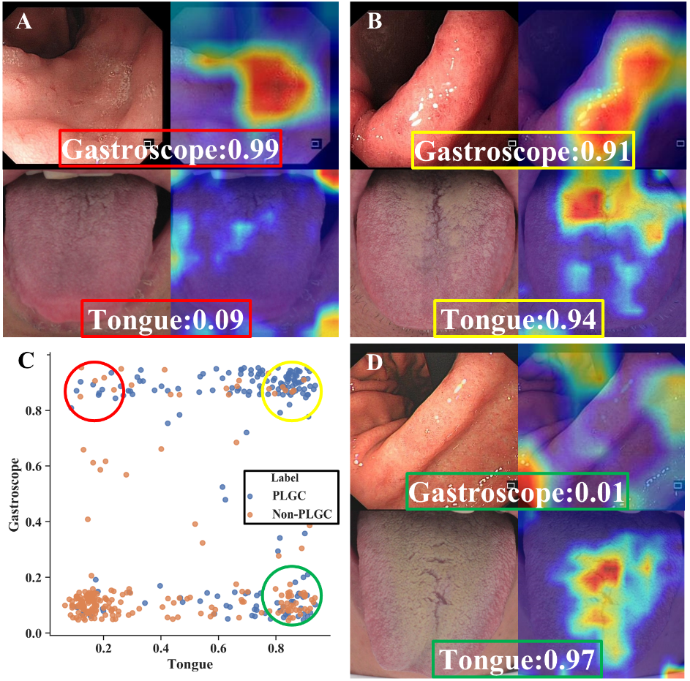
Supplementary Figure 2. Correlation analysis for paired endoscopic and tongue images of patients on PLGC prediction.

