Table 2. Test volatiles information
serial number | Compound | Purity (%) | the structural formula (chemistry) | Manufacturer
1 | dimethyl sulfide | 97.1 | 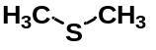 | Chengdu Alfa Biotechnology Co.,Ltd.
2 | (E)-2-hexenal2 | 97.2 | 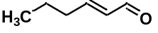 | Chengdu MingRui Biotechnology Co.,Ltd
3 | ethylbenzene | 99 | 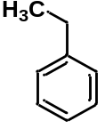 | Chengdu MingRui Biotechnology Co.,Ltd
4 | p-Xylene | 99.1 | 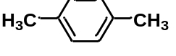 | Chengdu MingRui Biotechnology Co.,Ltd
5 | o-Xylene 1,2 | 99 | 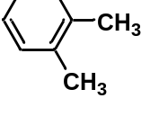 | Chengdu MingRui Biotechnology Co.,Ltd
6 | styrene | 99 | 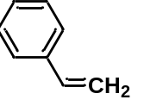 | Chengdu MingRui Biotechnology Co.,Ltd
7 | benzaldehyde | 97.8 | 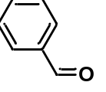 | Chengdu Alfa Biotechnology Co.,Ltd.
8 | furan, 2-pentyl | 93.5 | 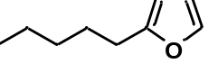 | Chengdu MingRui Biotechnology Co.,Ltd
9 | 3-hexen-1-ol, acetate, (Z) | 95.9 | 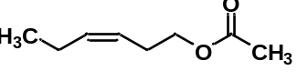 | Chengdu MingRui Biotechnology Co.,Ltd
10 | benzyl alcohol | 95.5 | 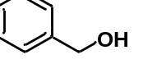 | Chengdu Alfa Biotechnology Co.,Ltd.
11 | benzaldehyde, 2-hydroxy | 98.8 | 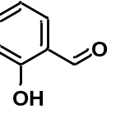 | Chengdu MingRui Biotechnology Co.,Ltd
12 | 1,6-dioxaspiro[4.4]nonane, 2-ethyl | 95.4 | 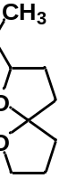 | Dr. Ehrenstorfer
13 | butanoic acid, 3-hexenyl ester, (Z) | 97.8 | 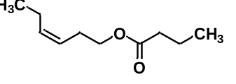 | Chengdu MingRui Biotechnology Co.,Ltd
14 | cis-3-hexenyl isovalerate | 98.8 | 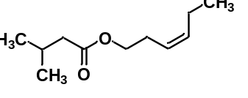 | Chengdu MingRui Biotechnology Co.,Ltd
15 | pentadecanal | 96.5 |  | Chengdu Alfa Biotechnology Co.,Ltd.

