Flow diagram for inclusion and exclusion of patients.
111 preterm infants of
- Intrauterine period less than 32th weeks
- Birth weight of more than 1,000g
8 were excluded with 5-minute Apgar score < 6,
5 were excluded with vasopressors use before or during phototherapy,
1 was excluded with major congenital anomalies(Patau syndrome),
4 died before or during phototherapy.

93 preterm infants
Phototherapy group
(n = 82)
Control group
(n = 11)

Supplementary 1. Phototherapy thresholds by birth weight and age in hours for preterm infants
Birth weight(g) | ~24hr | ~48hr | ~72hr | ~96hr | ~120h | 120h~
~999g | 5 | 6 | 6 | 8 | 8 | 10
1000~1499g | 6 | 8 | 8 | 10 | 10 | 12
1500~2499g | 8 | 10 | 12 | 15 | 15 | 15
2500g~ | 10 | 12 | 15 | 18 | 18 | 18

Supplementary 2. Test of Normality (Shapiro-Wilk test)
Control group |  |  | Phototherapy group
Mean BP | W | p | Mean BP | W | p
Difference | 0.976 | <0.001 | Difference | 0.982 | <0.001
Heart rate | W | p | Heart rate | W | p
Difference | 0.986 | 0.010 | Difference | 0.998 | 0.040

Supplementary 3. Trends of body temperature
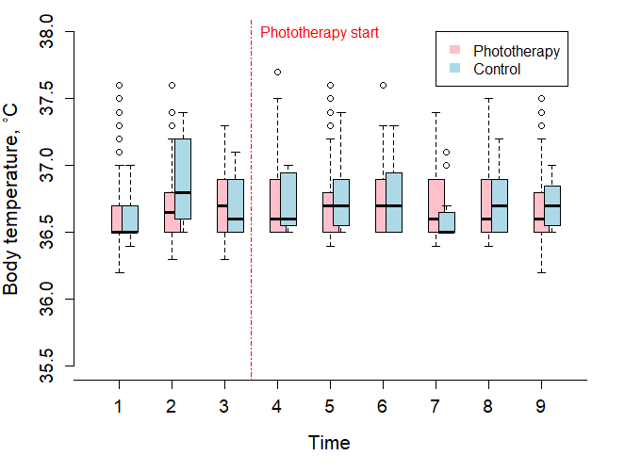

Supplementary 4. Results of Friedman test(post-hoc) for in-group analysis
MAP analysis in PT group |  |  | MAP analysis in control group
Friedman rank sum test |  |  | Friedman rank sum test
Friedman x2 | 101.55 |  | Friedman x2 | 60.76
df | 23 |  | df | 23
p-value | <0.001 |  | p-value | 0.307
HR analysis in PT group |  |  | HR analysis in control group
Friedman rank sum test |  |  | Friedman rank sum test
Friedman x2 | 151.06 |  | Friedman x2 | 40.63
df | 23 |  | df | 23
p-value | <0.001 |  | p-value | 0.013
BT analysis in PT group |  |  | BT analysis in control group
Friedman rank sum test |  |  | Friedman rank sum test
Friedman x2 | 23.9 |  | Friedman x2 | 18.8
df | 23 |  | df | 23
p-value | 0.409 |  | p-value | 0.713

Supplementary 5. In-group differences of HR, control group(post-hoc)
Row  - Column | 1 | 2 | 3 | 4 | 5 | 6 | 7 | 8
2 | -1.6  (1.000)
3 | -1.4  (1.000) | 0.3  (1.000)
4 | -1.9  (0.970) | -0.3  (1.000) | -0.5  (1.000)
5 | -1.4  (1.000) | 0.2  (1.000) | 0  (1.000) | 0.5  (1.000)
6 | -3.1  (0.031)* | -1.5  (1.000) | -1.7  (1.000) | -1.2  (1.000) | -1.7  (1.000)
7 | -2.1  (0.646) | -0.5  (1.000) | -0.7  (1.000) | -0.2  (1.000) | -0.6  (1.000) | 1.0  (1.000)
8 | -1.1  (1.000) | 0.5  (1.000) | 0.3  (1.000) | 0.8  (1.000) | 0.3  (1.000) | 2.0  (0.815) | 0.9  (1.000)
9 | -1.1  (1.000) | 0.5  (1.000) | 0.3  (1.000) | 0.8  (1.000) | 0.3  (1.000) | 2.0  (0.787) | 1.9  (1.000) | 1.0  (1.000)

Supplementary 6. Review of previous studies; changes of vital signs and vasoactive mediators after phototherapy in preterm infants
Studies | IUP, Weight | BP | HR | BT | NO | Endothelin
Ergenekon et al., 2002 | 36 weeks, 2.9kg | N/S | N/S | N/A | ↑* | N/A
Turan et al., 2004 | 32 weeks, 2.0kg | N/S | ↑ | ↑ | N/S | N/A
Liu et al., 2008 | <32 weeks | ↓ | ↑ | N/A | ↑** | ↑**
Liu et al., 2008 | 32~36 weeks | N/S | N/S | N/A | ↑** | N/S
Liu et al., 2008 | >37 weeks | N/S | N/S | N/A | N/S | N/S
Our study | 30 weeks, 1.4kg | ↑ | ↑ | N/S | N/A | N/A
N/S = not significant, N/A = not available, * = urine, ** = blood

