Supplementary Table 1 Normality tests for the quantitative data
Variables | Shapiro-Wilk test P value
Variables | Total  (n=361) | Train  (n=252) | Valid  (n=109)
NLR | <0.001 | <0.001 | <0.001
PLR | <0.001 | <0.001 | <0.001
ALR | <0.001 | <0.001 | <0.001
GLR | <0.001 | <0.001 | <0.001
LMR | <0.001 | <0.001 | <0.001
GPR | <0.001 | <0.001 | <0.001
SIRI | <0.001 | <0.001 | <0.001
SII | <0.001 | <0.001 | <0.001
CAR | <0.001 | <0.001 | <0.001
Diameter | <0.001 | <0.001 | <0.001
WBC | <0.001 | 0.001 | 0.018
PLT | <0.001 | <0.001 | <0.001
NEUT | <0.001 | <0.001 | <0.001
LYMPH | <0.001 | <0.001 | 0.004
MONO | <0.001 | <0.001 | <0.001
INR | <0.001 | <0.001 | <0.001
CRP | <0.001 | <0.001 | <0.001
ALB | <0.001 | <0.001 | <0.001
ALT | <0.001 | <0.001 | <0.001
AST | <0.001 | <0.001 | <0.001
GGT | <0.001 | <0.001 | <0.001
ALP | <0.001 | <0.001 | <0.001
TBIL | <0.001 | <0.001 | <0.001
DBIL | <0.001 | <0.001 | <0.001
lnAFP | <0.001 | <0.001 | <0.001

Supplementary Table 2 Multicollinearity diagnostics in SPSS linear models
Variables | Tolerance | VIF | Variables | Tolerance | VIF
Gender | 0.816 | 1.225 | WBC | 0.032 | 31.372
Age | 0.809 | 1.236 | PLT | 0.083 | 12.09
HBV | 0.068 | 14.702 | NEUT | 0.032 | 31.354
HCV | 0.224 | 4.469 | LYMPH | 0.057 | 17.657
HV | 0.081 | 12.296 | MONO | 0.05 | 20.011
NLR | 0.064 | 15.687 | INR | 0.54 | 1.852
PLR | 0.074 | 13.465 | CRP | 0.006 | 164.488
ALR | 0.107 | 9.383 | ALB | 0.587 | 1.704
GLR | 0.094 | 10.653 | ALT | 0.228 | 4.39
LMR | 0.108 | 9.265 | AST | 0.209 | 4.792
GPR | 0.433 | 2.31 | GGT | 0.089 | 11.238
SIRI | 0.042 | 23.986 | ALP | 0.251 | 3.984
SII | 0.05 | 19.846 | TBIL | 0.352 | 2.844
CAR | 0.006 | 171.884 | DBIL | 0.811 | 1.232
Diameter | 0.584 | 1.714 | lnAFP | 0.768 | 1.303

Supplementary Table 3 Multivariable Logistic regression analysis for Diameter, WBC, CRP, and lnAFP (Before calculating cutoff value)
Variables | B | P | OR  (95%CI)
CRP | 0.068 | 0.001 | 1.071  (1.027-1.117)
WBC | 0.215 | 0.017 | 1.240  (1.039-1.479)
Diameter | 0.110 | 0.025 | 1.116  (1.014-1.228)
lnAFP | 0.210 | 0.000 | 1.234  (1.110-1.371)
Constant | -3.538 | 0.000 | 0.029

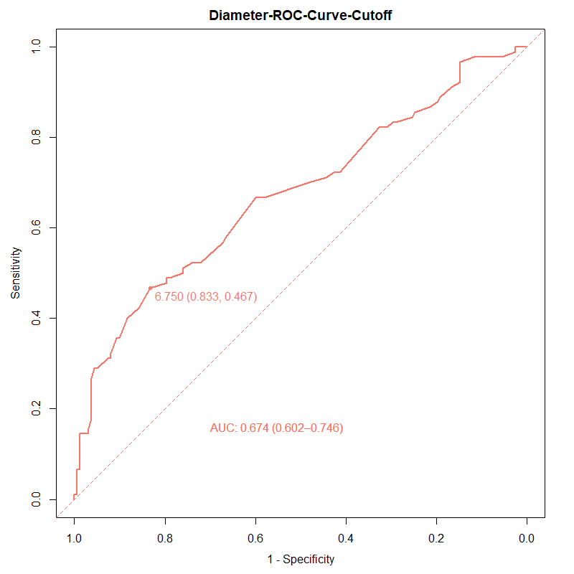
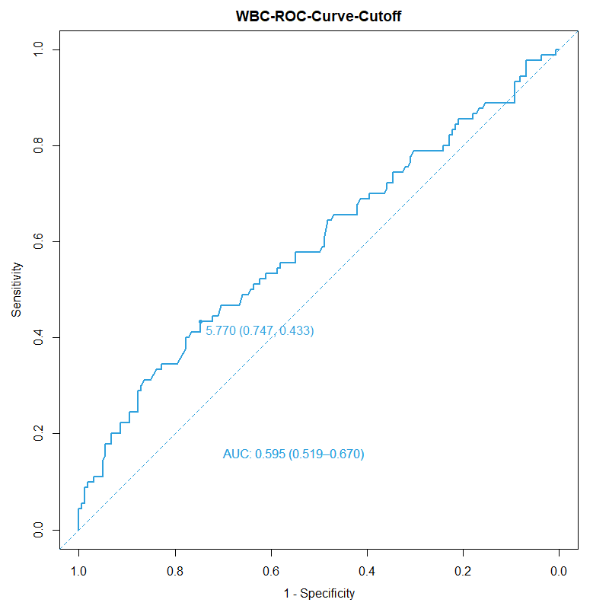
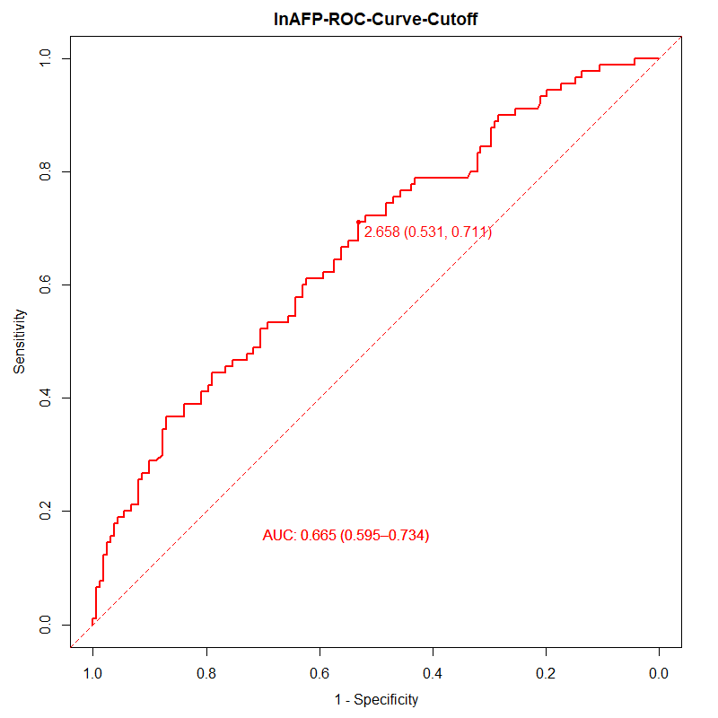
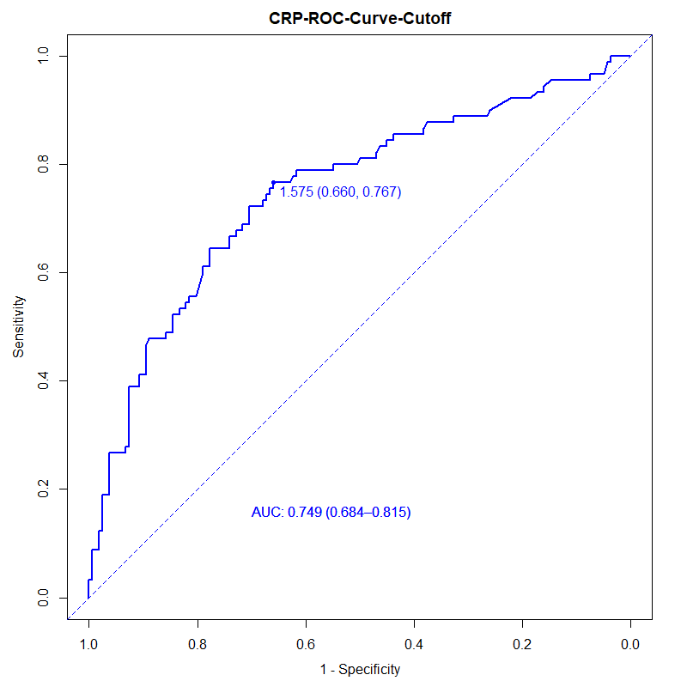
Supplementary Figure 1 Cutoff value for Diameter, WBC, CRP, and lnAFP

