Supplemental materials

Non-native Red-billed Blue Magpie Urocissa erythrorhyncha expanded in lowlands with moderate forest cover, with no significant impact on native common bird occupancy, in Shikoku, southern Japan

Hirohito MATSUDA, Kazuhiro KAWAMURA, Motoki HIGA, Shigeho SATO, Hitoshi TANIOKA, Yuichi YAMAURA
Ornithological Science

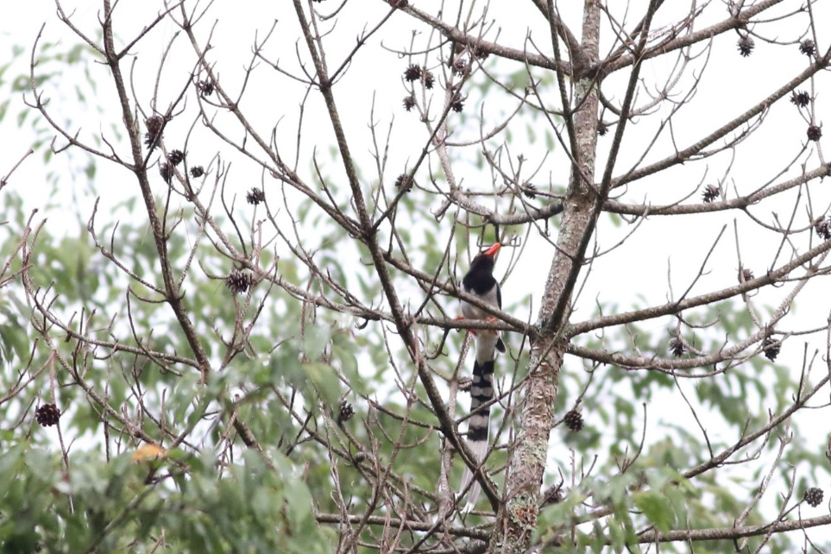
Fig. S1. Photograph of a magpie that approached in response to magpie call playback.

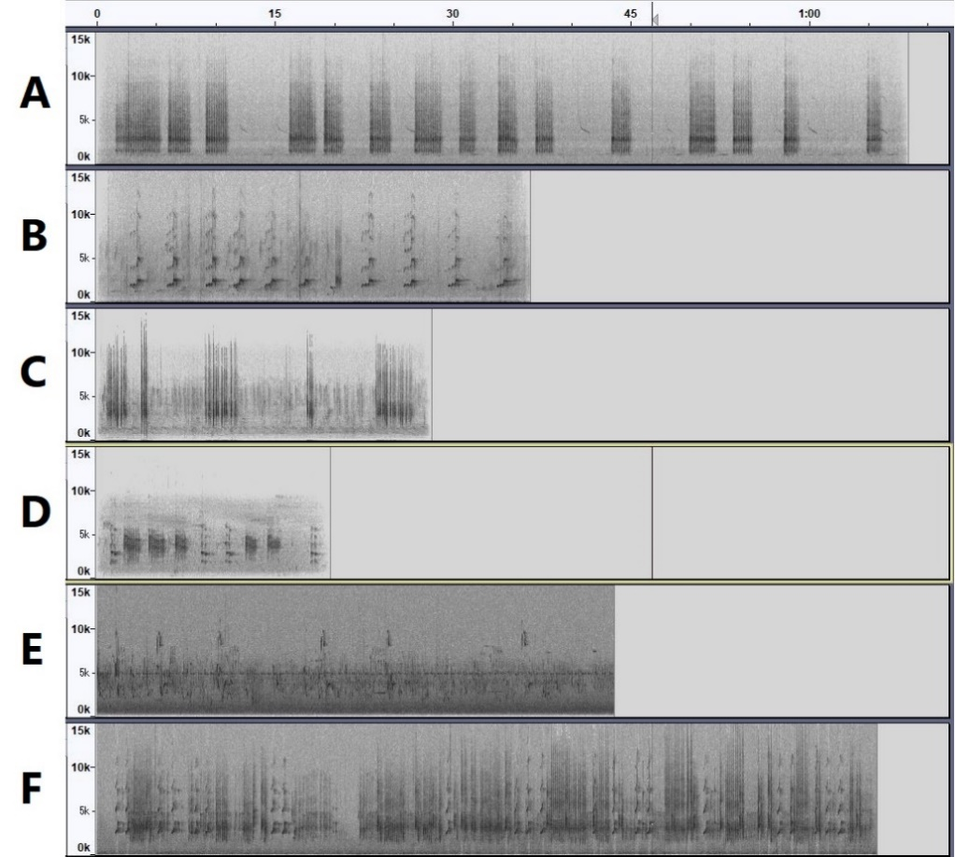
Fig. S2. Spectrograms of sound sources for each type of magpie call. Five types calls were downloaded from the xeno-canto database (call A: XC547761, call B: XC37776, call C: XC473124, call E: XC182995, call F: XC 183396 [https://xeno-canto.org/species/Urocissa-erythroryncha]) and a call recorded in our study area (call D: [https://www.bird-research.jp/1_shiryo/search.cgi?data00=%E3%82%B5%E3%83%B3%E3%82%B8%E3%83%A3%E3%82%AF]).
Table S1. Model selection results for explanatory variables of magpie occupancy (a–e) and detection probability (f–h). Each factor was used separately as an explanatory variable in various forms. Forest100–1000, forest cover within each scale; Nat.fore, natural forest proportion to forest; Elev, elevation within 100 m; TPI, Topographic Position Index; Distance, distance from the escape point; Call.A–F, playback of each magpie call; Date, survey date; Time, survey time in the evening (reference category: morning). Bold indicates explanatory variables in the final model used to predict magpie distribution.
(a) | Coefficient | SE | z | Wald p | AIC
Forest100 | -0.40 | 0.35 | -1.16 | 0.24 | 375.8
Forest100² | -0.32 | 0.41 | -0.78 | 0.43 | 376.5
Forest100 | -0.63 | 0.42 | -1.50 | 0.13 | 376.0
Forest100² | -0.56 | 0.43 | -1.30 | 0.19
Forest200 | -0.31 | 0.34 | -0.92 | 0.36 | 376.3
Forest200² | -0.20 | 0.36 | -0.56 | 0.58 | 376.9
Forest200 | -0.62 | 0.45 | -1.37 | 0.17 | 376.8
Forest200² | -0.50 | 0.43 | -1.16 | 0.25
Forest400 | -0.45 | 0.35 | -1.30 | 0.19 | 375.4
Forest400² | -0.47 | 0.46 | -1.03 | 0.30 | 376.0
Forest400 | -0.87 | 0.49 | -1.78 | 0.07 | 374.1
Forest400² | -0.92 | 0.56 | -1.64 | 0.10
Forest600 | -0.42 | 0.34 | -1.23 | 0.22 | 375.7
Forest600² | -0.67 | 0.49 | -1.36 | 0.17 | 374.8
Forest600 | -1.15 | 0.56 | -2.06 | 0.04 | 371.2
Forest600² | -1.24 | 0.60 | -2.07 | 0.04
Forest800 | -0.39 | 0.34 | -1.15 | 0.25 | 375.8
Forest800² | -0.23 | 0.33 | -0.69 | 0.49 | 376.5
Forest800 | -0.98 | 0.51 | -1.93 | 0.05 | 374.1
Forest800² | -0.63 | 0.42 | -1.49 | 0.14
Forest1000 | -0.33 | 0.34 | -0.99 | 0.32 | 376.2
Forest1000² | -0.13 | 0.25 | -0.53 | 0.59 | 376.8
Forest1000 | -0.88 | 0.50 | -1.76 | 0.08 | 375.4
Forest1000² | -0.44 | 0.32 | -1.37 | 0.17

(b) | Coefficient | SE | z | Wald p | AIC
Nat.fore | 0.50 | 0.36 | 1.40 | 0.16 | 375.1
Nat.fore² | -0.59 | 0.45 | -1.30 | 0.19 | 375.3
Nat.fore | 0.70 | 0.46 | 1.52 | 0.13 | 374.6
Nat.fore² | -0.76 | 0.52 | -1.47 | 0.14

(c) | Coefficient | SE | z | Wald p | AIC
Elev | -1.66 | 0.65 | -2.54 | 0.01 | 365.9
log(Elev) | -0.86 | 0.37 | -2.31 | 0.02 | 370.9

(d) | Coefficient | SE | z | Wald p | AIC
TPI | -0.01 | 0.34 | -0.04 | 0.97 | 377.2
TPI² | -0.62 | 0.53 | -1.17 | 0.24 | 375.0
TPI | 0.23 | 0.43 | 0.54 | 0.59 | 376.7
TPI² | -0.66 | 0.52 | -1.27 | 0.20

(e) | Coefficient | SE | z | Wald p | AIC
Distance | -0.31 | 0.35 | -0.91 | 0.36 | 376.4
log(Distance) | -0.22 | 0.32 | -0.68 | 0.50 | 376.7

(f) | Coefficient | SE | z | Wald p | AIC
Call.A | 0.58 | 0.32 | 1.83 | 0.07 | 376.4
Call.B | 0.53 | 0.28 | 1.88 | 0.06 | 376.4
Call.C | 1.08 | 0.36 | 2.96 | 0.00 | 369.5
Call.D | 1.00 | 0.30 | 3.38 | 0.00 | 367.7
Call.E | 0.43 | 0.31 | 1.36 | 0.18 | 378.0
Call.F | 0.55 | 0.28 | 1.96 | 0.05 | 376.0

(g) | Coefficient | SE | z | Wald p | AIC
Date | -0.29 | 0.14 | -2.08 | 0.04 | 375.5
Date² | -0.25 | 0.15 | -1.66 | 0.10 | 377.1
Date | -0.47 | 0.18 | -2.59 | 0.01 | 371.2
Date² | -0.41 | 0.17 | -2.42 | 0.02

(h) | Coefficient | SE | z | Wald p | AIC
Time | -0.58 | 0.28 | -2.06 | 0.04 | 375.6
-------------------------------------------------------------------------------------------------------------------------

Fig. S3. Relationships between the detection probability of native species and survey conditions [(a–d) survey date, (e–h) survey time] estimated by the multispecies occupancy model. (a–d) Lines are predictions in the morning. (e–h) Broken line represents the reference category (morning); dots and bars represent expected detection probability on the evening of 30 May.
Table S2. Estimation results of the observation process in the multispecies occupancy model. See Table S1 for details.
Species | Variable | Coefficient | SE | Z | Wald p
Red-billed Blue Magpie | Intercept | -2.23 | 0.51 | -4.38 | 0.00
Red-billed Blue Magpie | Time | -0.79 | 0.30 | -2.64 | 0.01
Red-billed Blue Magpie | Date | -0.54 | 0.18 | -3.02 | 0.00
Red-billed Blue Magpie | Date² | -0.43 | 0.17 | -2.51 | 0.01
Red-billed Blue Magpie | Call.A | 0.30 | 0.48 | 0.62 | 0.54
Red-billed Blue Magpie | Call.B | 0.22 | 0.43 | 0.51 | 0.61
Red-billed Blue Magpie | Call.C | 0.47 | 0.52 | 0.91 | 0.36
Red-billed Blue Magpie | Call.D | 0.75 | 0.43 | 1.75 | 0.08
Red-billed Blue Magpie | Call.E | -0.08 | 0.50 | -0.16 | 0.88
Red-billed Blue Magpie | Call.F | 0.41 | 0.45 | 0.91 | 0.36
Narcissus Flycatcher | Intercept | -1.93 | 0.43 | -4.55 | 0.00
Narcissus Flycatcher | Time | -0.14 | 0.35 | -0.40 | 0.69
Narcissus Flycatcher | Date | -8.02 | 1.37 | -5.86 | 0.00
Narcissus Flycatcher | Date² | -4.67 | 0.83 | -5.60 | 0.00
Varied Tit | Intercept | -1.11 | 0.34 | -3.26 | 0.00
Varied Tit | Time | 0.22 | 0.36 | 0.62 | 0.54
Varied Tit | Date | -1.83 | 0.41 | -4.52 | 0.00
Varied Tit | Date² | -0.62 | 0.32 | -1.95 | 0.05
Japanese Tit | Intercept | -0.68 | 0.16 | -4.26 | 0.00
Japanese Tit | Time | -0.63 | 0.19 | -3.37 | 0.00
Japanese Tit | Date | -1.36 | 0.15 | -8.96 | 0.00
Japanese Tit | Date² | -0.34 | 0.13 | -2.67 | 0.01
Japanese Bush Warbler | Intercept | 1.51 | 0.15 | 10.05 | 0.00
Japanese Bush Warbler | Time | -0.13 | 0.16 | -0.77 | 0.44
Japanese Bush Warbler | Date | -1.67 | 0.13 | -13.19 | 0.00
Japanese Bush Warbler | Date² | -1.51 | 0.12 | -12.54 | 0.00
Table S3. Estimation results of the ecological process in the multispecies occupancy model. Intercept represents magpie occupancy probability in sites where all native species were absent or that of native species in sites where the magpie is absent. When paired species assumed to interact were present, these occupancies changed. For example, negative values of “magpie present” in ecological processes for native species indicate that native species occupancy was decreased by the presence of the magpie. See Table S1 for details.
Species | Variables | Coefficient | SE | z | Wald p
Red-billed Blue Magpie  [Magpie] | Intercept | -1.02 | 1.69 | -0.60 | 0.55
Red-billed Blue Magpie  [Magpie] | Flycatcher present | -0.05 | 0.78 | -0.07 | 0.95
Red-billed Blue Magpie  [Magpie] | Varied Tit present | -0.29 | 0.92 | -0.32 | 0.75
Red-billed Blue Magpie  [Magpie] | Japanese Tit present | 1.43 | 0.90 | 1.59 | 0.11
Red-billed Blue Magpie  [Magpie] | Warbler present | -0.23 | 1.33 | -0.17 | 0.86
Red-billed Blue Magpie  [Magpie] | Forest600 | -1.28 | 0.92 | -1.40 | 0.16
Red-billed Blue Magpie  [Magpie] | Forest600² | -2.73 | 1.45 | -1.89 | 0.06
Red-billed Blue Magpie  [Magpie] | Elev | -3.58 | 1.43 | -2.50 | 0.01
Narcissus Flycatcher  [Flycatcher] | Intercept | -0.15 | 0.63 | -0.24 | 0.81
Narcissus Flycatcher  [Flycatcher] | Magpie present | -0.05 | 0.78 | -0.07 | 0.95
Narcissus Flycatcher  [Flycatcher] | Forest600 | -0.84 | 0.50 | -1.68 | 0.09
Narcissus Flycatcher  [Flycatcher] | Forest600² | -0.78 | 0.50 | -1.56 | 0.12
Varied Tit | Intercept | -1.36 | 0.47 | -2.91 | 0.00
Varied Tit | Magpie present | -0.29 | 0.92 | -0.32 | 0.75
Japanese Tit | Intercept | 0.22 | 0.43 | 0.51 | 0.61
Japanese Tit | Magpie present | 1.43 | 0.90 | 1.59 | 0.11
Japanese Tit | Nat.fore | 0.22 | 0.43 | 0.51 | 0.61
Japanese Tit | TPI | 0.86 | 0.41 | 2.12 | 0.03
Japanese Bush Warbler  [Warbler] | Intercept | 2.64 | 0.76 | 3.46 | 0.00
Japanese Bush Warbler  [Warbler] | Magpie present | -0.23 | 1.33 | -0.17 | 0.86

Table S4. Model selection results for explanatory variables of native species occupancy [(a–d) Narcissus Flycatcher, (e–h) Varied Tit, (i–l) Japanese Tit, (m–p) Japanese Bush Warbler]. Estimation results for models in which each factor was included separately as an explanatory variable in various forms. We used the single-species occupancy model (see Table S1 for details). We considered forest cover with radii up to 600 m. Bold indicates explanatory variables that were included in the multispecies occupancy model. As explanatory variables for detection probability, we included survey season, its quadratic term, and survey time.
Narcissus Flycatcher
(a) | Coefficient | SE | z | Wald p | AIC
Forest100 | -0.05 | 0.34 | -0.14 | 0.89 | 279.6
Forest100² | 0.01 | 0.38 | 0.03 | 0.98 | 279.6
Forest100 | -0.05 | 0.36 | -0.14 | 0.89 | 281.6
Forest100² | -0.01 | 0.40 | -0.02 | 0.98
Forest200 | -0.38 | 0.34 | -1.13 | 0.26 | 278.3
Forest200² | 0.31 | 0.31 | 0.98 | 0.33 | 278.6
Forest200 | -0.28 | 0.39 | -0.71 | 0.48 | 280.1
Forest200² | 0.17 | 0.37 | 0.47 | 0.64
Forest400 | -0.62 | 0.36 | -1.73 | 0.08 | 276.4
Forest400² | 0.36 | 0.39 | 0.92 | 0.36 | 278.8
Forest400 | -0.58 | 0.39 | -1.47 | 0.14 | 278.4
Forest400² | 0.10 | 0.45 | 0.22 | 0.83
Forest600 | -0.39 | 0.34 | -1.14 | 0.26 | 278.3
Forest600² | -0.37 | 0.41 | -0.91 | 0.37 | 278.6
Forest600 | -0.83 | 0.48 | -1.73 | 0.08 | 277.1
Forest600² | -0.77 | 0.48 | -1.61 | 0.11

(b) | Coefficient | SE | z | Wald p | AIC
Nat.fore | -0.07 | 0.34 | -0.20 | 0.84 | 279.6
Nat.fore² | -0.18 | 0.41 | -0.44 | 0.66 | 279.4
Nat.fore | -0.07 | 0.35 | -0.20 | 0.84 | 281.4
Nat.fore² | -0.18 | 0.41 | -0.44 | 0.66

(c) | Coefficient | SE | z | Wald p | AIC
Elev | -0.07 | 0.34 | -0.22 | 0.83 | 279.5
log(Elev) | 0.03 | 0.33 | 0.08 | 0.93 | 279.6

(d) | Coefficient | SE | z | Wald p | AIC
TPI | 0.43 | 0.34 | 1.26 | 0.21 | 278.0
TPI² | -0.07 | 0.27 | -0.26 | 0.79 | 279.5
TPI | 0.69 | 0.44 | 1.57 | 0.12 | 278.7
TPI² | -0.34 | 0.32 | -1.04 | 0.30

Varied Tit
(e) | Coefficient | SE | z | Wald p | AIC
Forest100 | 0.31 | 0.42 | 0.74 | 0.46 | 244.1
Forest100² | -0.40 | 0.51 | -0.79 | 0.43 | 244.0
Forest100 | 0.28 | 0.46 | 0.60 | 0.55 | 245.6
Forest100² | -0.37 | 0.54 | -0.67 | 0.50
Forest200 | -0.05 | 0.40 | -0.13 | 0.90 | 244.6
Forest200² | 0.08 | 0.36 | 0.24 | 0.81 | 244.6
Forest200 | -0.01 | 0.45 | -0.01 | 0.99 | 246.6
Forest200² | 0.08 | 0.42 | 0.20 | 0.84
Forest400 | -0.44 | 0.40 | -1.09 | 0.28 | 243.4
Forest400² | 0.50 | 0.43 | 1.15 | 0.25 | 243.4
Forest400 | -0.29 | 0.42 | -0.67 | 0.50 | 244.9
Forest400² | 0.36 | 0.48 | 0.75 | 0.45
Forest600 | -0.30 | 0.39 | -0.77 | 0.44 | 244.1
Forest600² | -0.15 | 0.44 | -0.33 | 0.74 | 244.5
Forest600 | -0.54 | 0.52 | -1.04 | 0.30 | 245.3
Forest600² | -0.41 | 0.50 | -0.81 | 0.42

(f) | Coefficient | SE | z | Wald p | AIC
Nat.fore | 0.27 | 0.41 | 0.66 | 0.51 | 244.2
Nat.fore² | -0.07 | 0.48 | -0.15 | 0.88 | 244.6
Nat.fore | 0.28 | 0.42 | 0.67 | 0.50 | 246.2
Nat.fore² | -0.10 | 0.49 | -0.21 | 0.84

(g) | Coefficient | SE | z | Wald p | AIC
Elev | -0.03 | 0.40 | -0.07 | 0.94 | 244.6
log(Elev) | -0.02 | 0.38 | -0.04 | 0.97 | 244.6

(h) | Coefficient | SE | z | Wald p | AIC
TPI | 0.41 | 0.39 | 1.05 | 0.29 | 243.5
TPI² | -0.16 | 0.39 | -0.42 | 0.67 | 244.4
TPI | 0.80 | 0.56 | 1.42 | 0.16 | 244.0
TPI² | -0.47 | 0.45 | -1.04 | 0.30

Japanese Tit
(i) | Coefficient | SE | z | Wald p | AIC
Forest100 | 0.28 | 0.33 | 0.85 | 0.40 | 753.2
Forest100² | 0.45 | 0.40 | 1.14 | 0.25 | 752.5
Forest100 | 0.49 | 0.38 | 1.29 | 0.20 | 752.8
Forest100² | 0.62 | 0.41 | 1.52 | 0.13
Forest200 | 0.24 | 0.32 | 0.73 | 0.46 | 753.4
Forest200² | 0.12 | 0.32 | 0.39 | 0.70 | 753.8
Forest200 | 0.41 | 0.39 | 1.05 | 0.30 | 754.6
Forest200² | 0.32 | 0.37 | 0.85 | 0.39
Forest400 | 0.11 | 0.32 | 0.35 | 0.73 | 753.8
Forest400² | -0.09 | 0.38 | -0.23 | 0.82 | 753.9
Forest400 | 0.10 | 0.34 | 0.29 | 0.78 | 755.8
Forest400² | -0.05 | 0.40 | -0.12 | 0.91
Forest600 | 0.10 | 0.32 | 0.32 | 0.75 | 753.8
Forest600² | -0.29 | 0.33 | -0.88 | 0.38 | 753.1
Forest600 | -0.04 | 0.36 | -0.12 | 0.90 | 755.1
Forest600² | -0.31 | 0.37 | -0.84 | 0.40

(j) | Coefficient | SE | z | Wald p | AIC
Nat.fore | 0.75 | 0.36 | 2.07 | 0.04 | 749.2
Nat.fore² | 0.00 | 0.39 | 0.00 | 1.00 | 753.9
Nat.fore | 0.75 | 0.37 | 2.05 | 0.04 | 751.1
Nat.fore² | 0.07 | 0.42 | 0.16 | 0.88

(k) | Coefficient | SE | z | Wald p | AIC
Elev | -0.46 | 0.33 | -1.38 | 0.17 | 752.0
log(Elev) | -0.43 | 0.34 | -1.29 | 0.20 | 752.2

(l) | Coefficient | SE | z | Wald p | AIC
TPI | 0.64 | 0.38 | 1.71 | 0.09 | 750.6
TPI² | 0.13 | 0.27 | 0.47 | 0.64 | 753.7
TPI | 0.67 | 0.39 | 1.72 | 0.09 | 752.5
TPI² | -0.09 | 0.33 | -0.26 | 0.80

Japanese Bush Warbler
(m) | Coefficient | SE | z | Wald p | AIC
Forest100 | -0.51 | 0.69 | -0.74 | 0.46 | 959.1
Forest100² | 0.91 | 0.99 | 0.92 | 0.36 | 958.6
Forest100 | -1.23 | 1.69 | -0.73 | 0.47 | 959.6
Forest100² | 1.65 | 1.87 | 0.88 | 0.38
Forest200 | -0.51 | 0.72 | -0.70 | 0.48 | 959.2
Forest200² | 1.12 | 1.23 | 0.91 | 0.36 | 958.4
Forest200 | -0.67 | 1.17 | -0.57 | 0.57 | 960.0
Forest200² | 1.23 | 1.41 | 0.87 | 0.38
Forest400 | -0.29 | 0.64 | -0.46 | 0.65 | 959.5
Forest400² | 0.99 | 1.10 | 0.90 | 0.37 | 958.6
Forest400 | -0.25 | 0.86 | -0.29 | 0.77 | 960.5
Forest400² | 0.97 | 1.13 | 0.86 | 0.39
Forest600 | -0.52 | 0.72 | -0.72 | 0.47 | 959.1
Forest600² | 1.00 | 1.13 | 0.89 | 0.38 | 958.6
Forest600 | -0.71 | 1.16 | -0.61 | 0.54 | 960.1
Forest600² | 1.16 | 1.37 | 0.85 | 0.40

(n) | Coefficient | SE | z | Wald p | AIC
Nat.fore | 0.43 | 0.64 | 0.67 | 0.50 | 959.3
Nat.fore² | 0.01 | 0.73 | 0.01 | 0.99 | 959.7
Nat.fore | 0.45 | 0.69 | 0.66 | 0.51 | 961.2
Nat.fore² | 0.09 | 0.76 | 0.12 | 0.91

(o) | Coefficient | SE | z | Wald p | AIC
Elev | 0.04 | 0.62 | 0.07 | 0.94 | 959.7
log(Elev) | -0.07 | 0.60 | -0.12 | 0.91 | 959.7

(p) | Coefficient | SE | z | Wald p | AIC
TPI | 2.55 | 1.68 | 1.52 | 0.13 | 954.7
TPI² | -0.02 | 0.44 | -0.04 | 0.97 | 959.7
TPI | 75.80 | 71.30 | 1.06 | 0.29 | 951.9
TPI² | 37.40 | 35.30 | 1.06 | 0.29

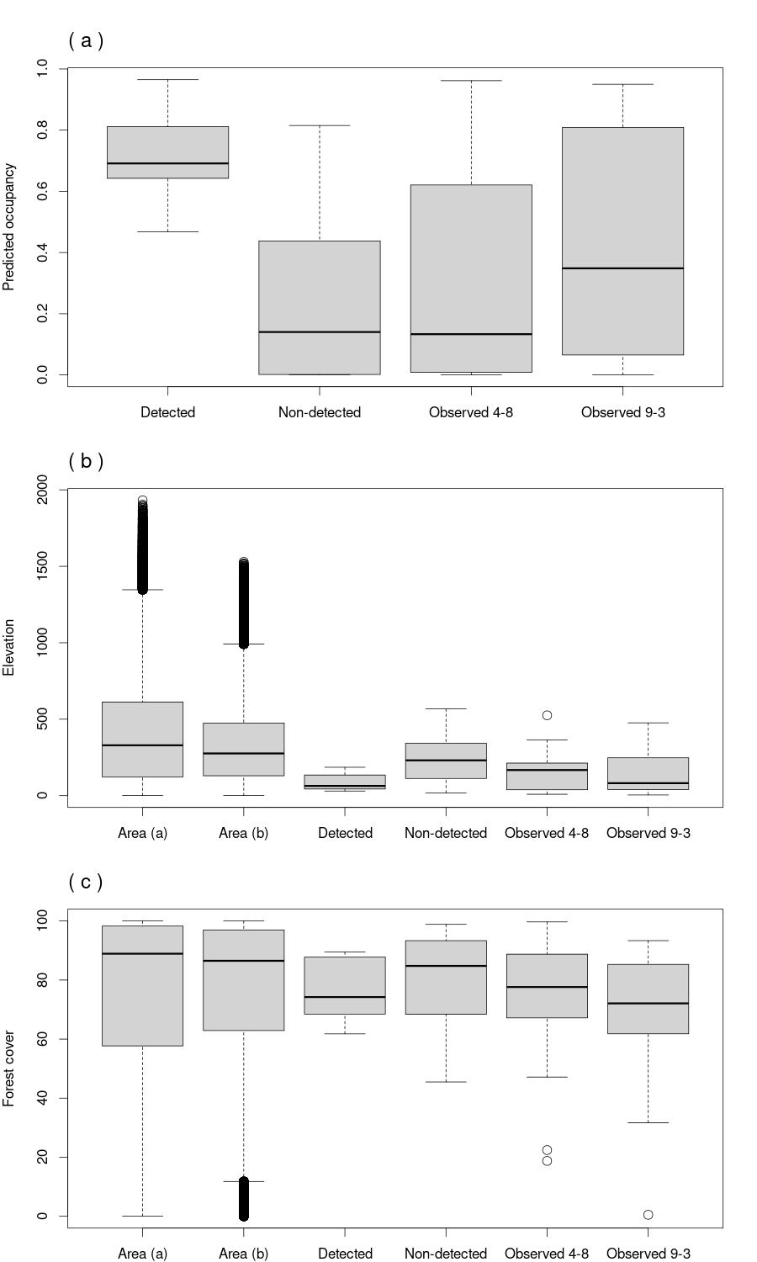
Fig. S4. Comparisons of (a) predicted occupancy probability, (b) elevation, and (c) forest cover at our survey sites where the Red-billed Blue Magpie was detected, as well as non-detected sites and locations of previous magpie observations from April to August (to match our survey season) and from September to March. (b, c) Elevation and forest cover across Shikoku (Area (a); see Fig. 5a) and the survey region (Area (b); see Fig. 5b).

