Supplementary information

Supplementary table
Table S1. Rice varieties investigated and their heading dates.
Variety | Origin | Heading date
Shuusoushu | China | July-24
ARC 7047 | India | July-30
ARC 11094 | India | August-02
Kaluheenati | Sri Lanka | August-05
Hong Cheuh Zai | China | August-06
Kasalath | India | August-06
Keiboba | China | August-06
Owarihatamochi | Japan | August-06
Tupa 121-3 | Bangladesh | August-06
ARC 7291 | India | August-08
Koshihikari | Japan | August-08
Muha | India | August-10
Lebed | Philippines | August-11
Takanari | Japan | August-11
Basilanon | Philippines | August-14
IR 64 | Philippines | August-14
Calotoc | Philippines | August-16
Deng Pao Zhai | China | August-19
Khau Mac Kho | Vietnam | August-21
LAC 23 | Liberia | August-28
Naba | India | August-28
Bei Khe | Cambodia | August-30

Supplementary figures
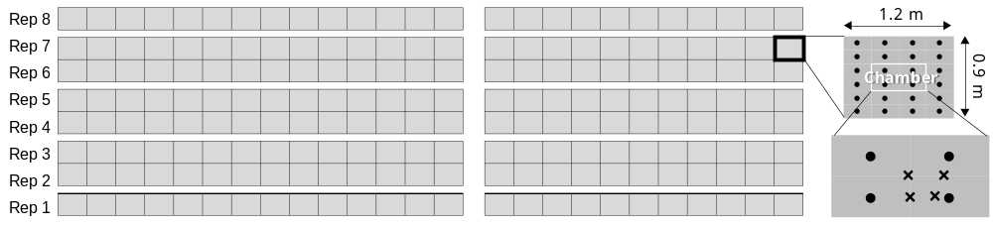
Fig. S1. Plot design, gas sampling area, and soil water sampling points. Filled circles show the positions of rice hills and x marks show the sampling points of soil water.

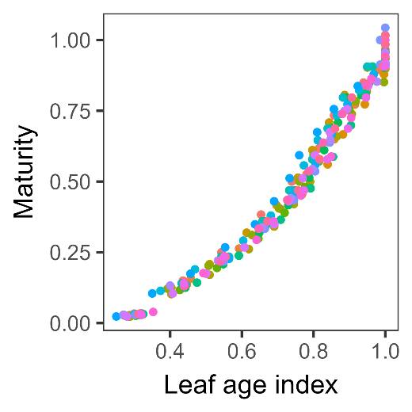
Fig. S2. The relationship between the leaf age index and maturity index. The leaf age index was calculated by the plant age in leaf number divided by the total number of leaves of the main culm. Leaf age observations were conducted on two hills per variety, at intervals of 3 to 7 days for all rice varieties. Maturity index is determined using the formula: Maturity index = (observation date – transplanting date) / (heading date – transplanting date). Various colors in the legend denote different rice varieties.

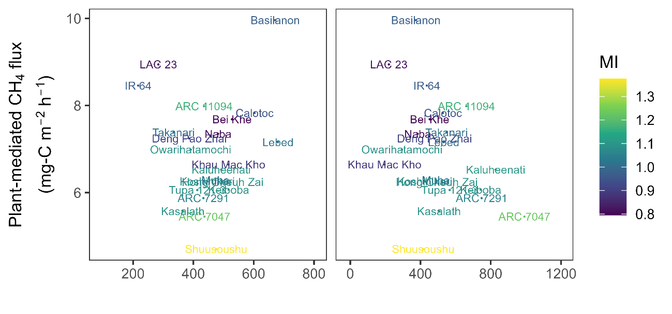
Fig. S3. Plant-mediated CH₄ flux at Stage 3 as a function of straw and panicle weight. Symbols were color coded based on maturity index, calculated as (measurement date – transplanting date) / (heading date – transplanting date).

