Extended Data Table S1 | The average transport in the main straits of the ITF and the one standard deviation range during the mooring observation periods (1996.11-1998.07 for Arlindo, 2004.01-2011.08 and 2013.08-2017.08 for INSTANT and MITF programs).
Straits | HYCOM | Mooring | GLORYS12V1
Makassar  (0-700 m; 116.5-118.8°E, 3°S) | 11.3±3.71 | 11.1±3.29 | 11.6±2.52
Timor  (0-1890 m; 122.6°E, 11.2°S-11.7°S) | 8.69±1.35 | 7.36±2.19 | 8.01±1.67
Ombai  (0-1100 m; 125°E, 8.4°S-8.7°S) | 4.63±0.78 | 4.97±2.47 | 5.81±2.28
Lombok  (0-300 m; 115.5°E-116.3°E, 8.3°S) | 2.28±1.53 | 2.6±1.44 | 2.17±1.82

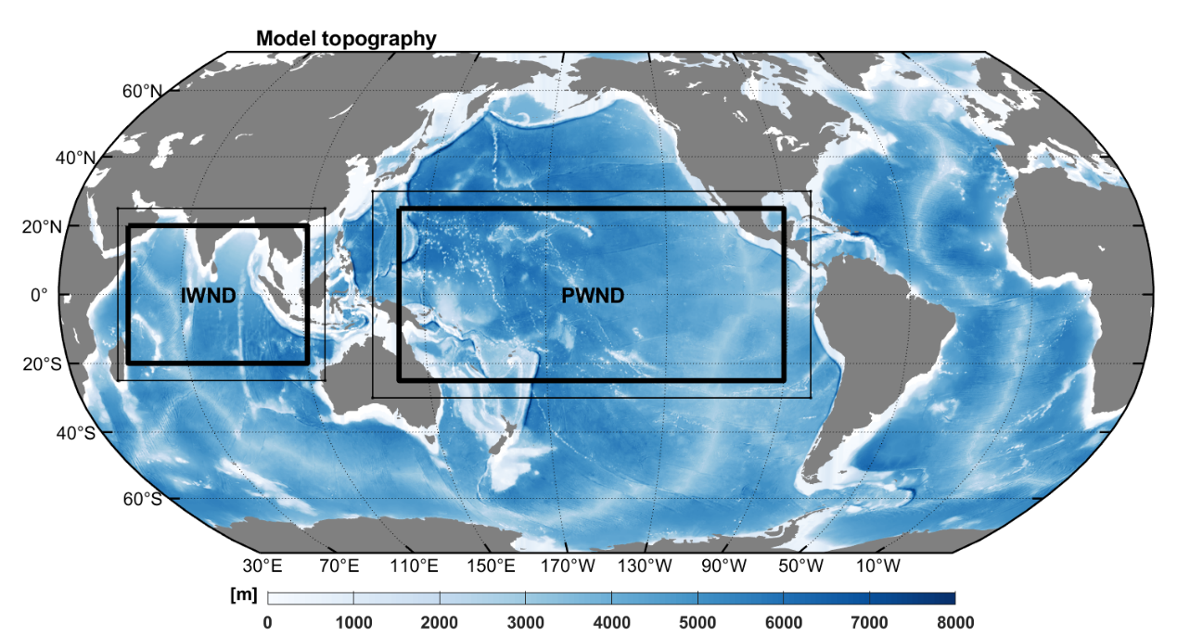Extended Data Fig. S1 | Experimental regions for PWND and IWND. Color shading denotes the topography (m) from ETOPO1. Black rectangles mark the areas retaining wind stress variability in the PWND and IWND, respectively. Wind stress inside the thick black boxes uses the hourly wind stress from January 2014 through September 2022, and those outside of the thin lines are retained as repeated 2013 hourly wind stress. The areas between the thick and thin lines denote the transition zone where realistic wind stress is gradually altered to 2013 wind stress, with a 5° width in IWND and 5° zonal and 10° meridional widths in PWND.
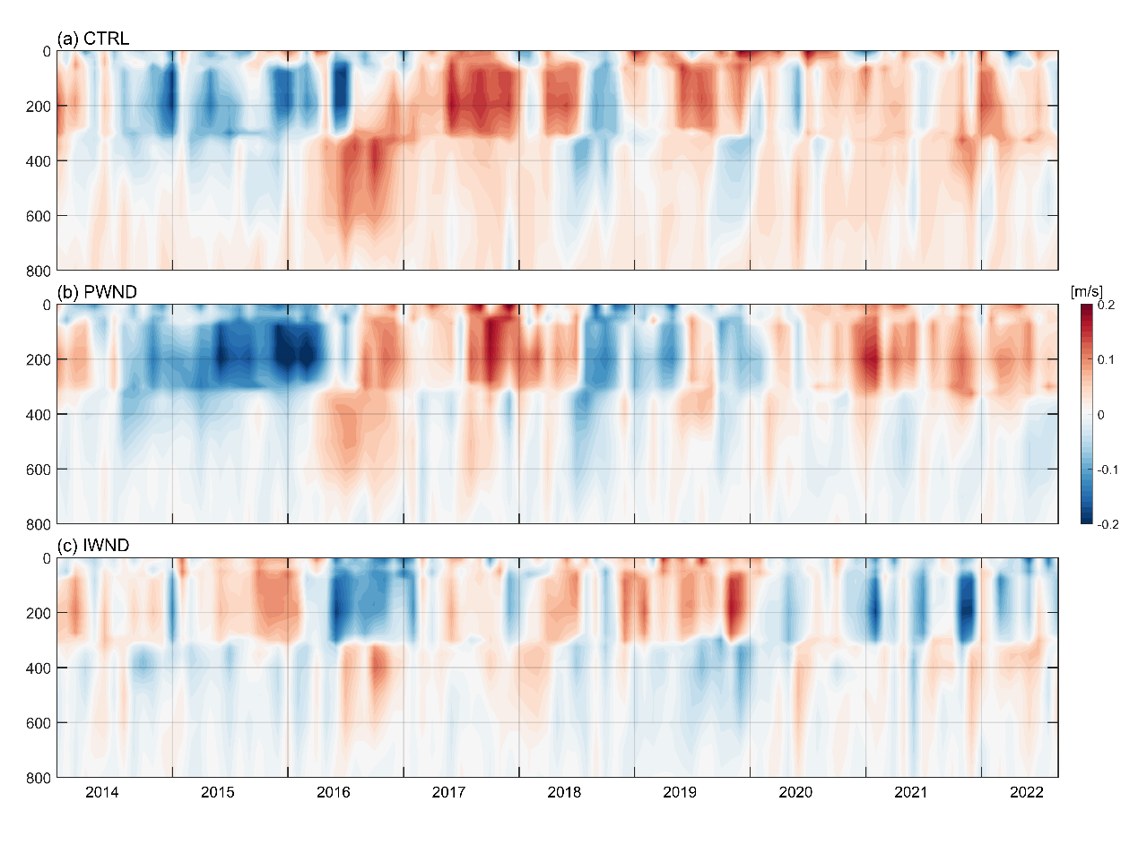
Extended Data Fig. S2 | Along strait velocity of Makassar strait in HYCOM experiments. Along strait velocity (m/s) over the upper 800 m in the Makassar Strait from January 2014 to September 2022 for a, CTRL, b, PWND and c, IWND. The currents are averaged in a box of 2.5°S - 3.5°S, 116°E - 119.2°E, near the mooring location of INSTANT observation at 2°51.9′ S, 118°27.3′.
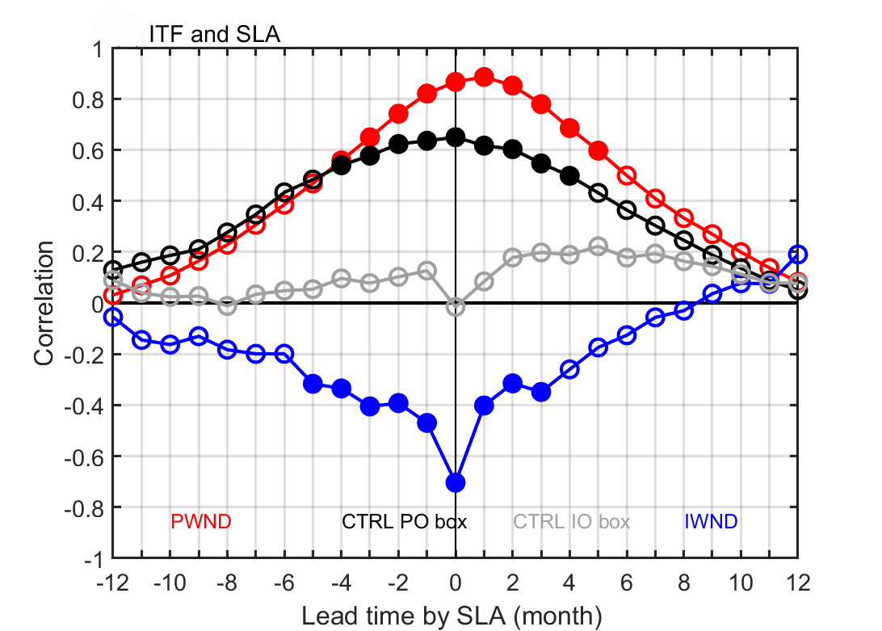
Extended Data Fig. S3 | Lead–lag correlations of the ITF anomaly with SLA. Correlations between ITF anomaly and SLA averaged in sensitivity regions from HYCOM experiments. Correlations between SLAs averaged in Northwestern Pacific box (PO box) and ITFA from PWND (red) and CTRL (black); compared with correlations between SLAs averaged in IO box and ITFA from IWND (blue) and CTRL (grey). Correlation values exceeding 95% significance test are plotted as solid dots.
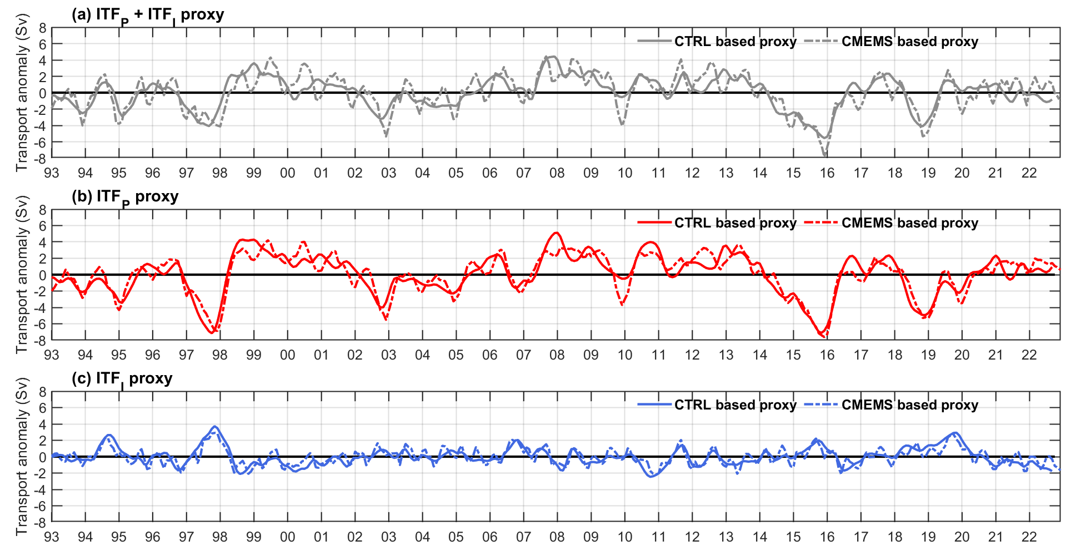Extended Data Fig. S4 | SLA-based proxies for the ITF. a, Monthly ITF_{P} + ITF_{I} proxy based on SLA using the formula developed in this research, solid and dashed lines refer to results based on CTRL and CMEMS, respectively. b, as in a, but for monthly ITF_{P}. c, as in a, but for monthly ITF_{I}.
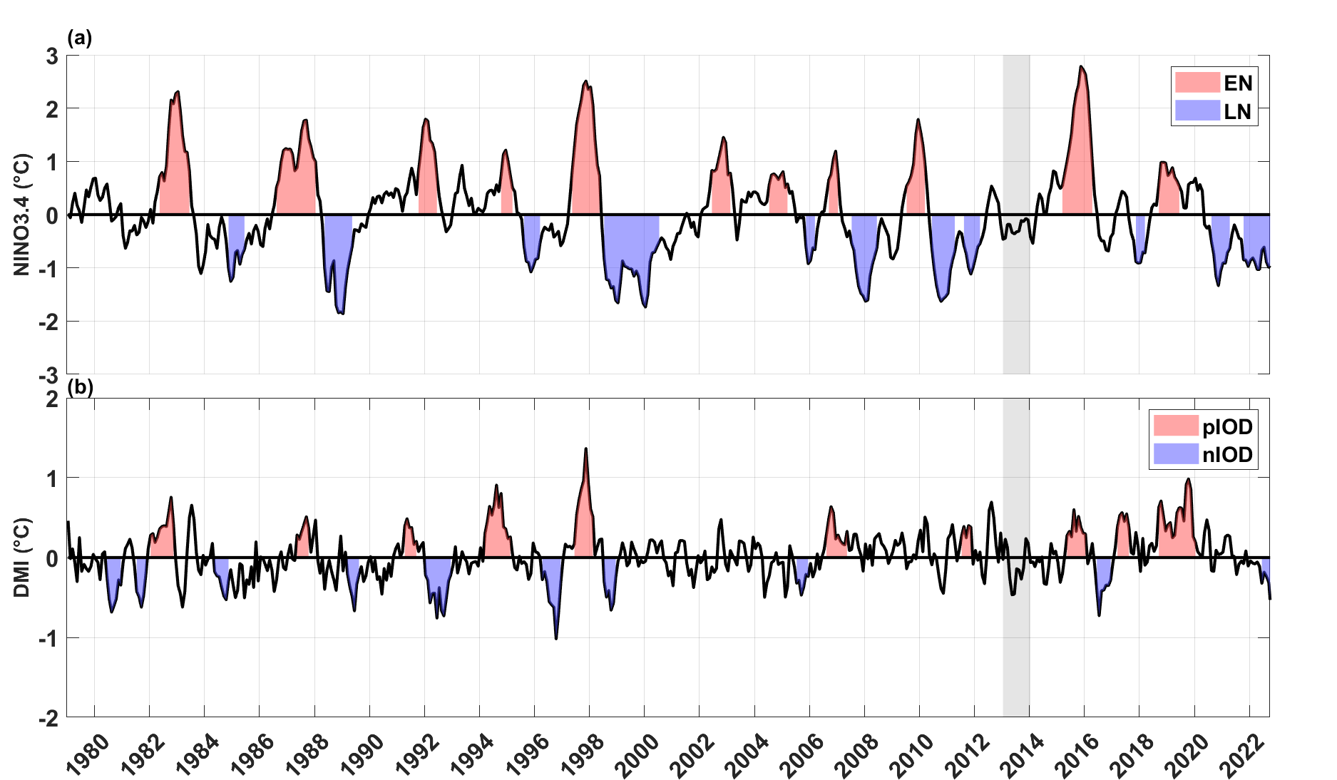
Extended Data Fig. S5 | ENSO and IOD events since 1979. Time series of a, Niño3.4 SST anomaly and b, DMI indexes in 1979–2022 based on HadISST dataset, downloaded from NOAA Climate Prediction Center. The red and blue shadings mark the months of El Nino (pIOD) and La Nina (nIOD) events. The 0.5 °C and 0.5 standard deviation (0.16°C) thresholds for consecutive 3 months are adopted for identifying ENSO and IOD events, respectively. Grey shadings denote the 2013 period, which presents a neutral state of both events

